The National Higher School of Artificial Intelligence
Introduction to AI Course Project
Spring 2026

Introduction to AI Project Paper

Project Title: The 3D Container Loading Optimiz

Student list:
Full name | Group
Nabil BENCHINE (Leader) | 5
Samir Abdelhakim KORBAS | 5
Mohammed Fares BENHAMMADI | 5
Ahmed AMMICHE | 5
Amine Mohamed RAMDANI | 4
Nazim KHELFALLAH | 4

Abstract
This paper presents the design and implementation of a 3D Container Loading Optimizer, a logic-based logistics tool that computes efficient packing arrangements of rectangular boxes inside a standard 20-foot ISO shipping container. The system aims to maximize both volume utilization and physical stability of the loaded cargo. Four optimization strategies are developed and compared: a Greedy Best-Fit Decreasing (BFD) heuristic, a Genetic Algorithm (GA), Simulated Annealing (SA), and Particle Swarm Optimization (PSO). All algorithms share a common container environment built around the Deepest-bottom leftmost placement strategy with the free space represntation. The fitness function balances three weighted objectives: volume utilization (40%), structural stability (30%), and placement rate (30%). Experimental results on a synthetic dataset of 200 randomly generated boxes in a container of dimensions 590 × 235 × 239 cm demonstrate that evolutionary methods consistently outperform the greedy baseline in solution quality, while the greedy approach retains a decisive speed advantage. The application provides a working prototype with algorithmic comparison capabilities, supporting informed logistics decision-making.

Keywords: 3D Bin Packing Problem, Container Loading, Heuristic Search, Volume Utilization, Stability Optimization

Abstract 1
Introduction 3
State of the Art 4
Data Set Building 5
Problem Solving techniques 6
Application Design 8

Introduction
The efficient loading of cargo into shipping containers is a critical challenge in global logistics and supply chain management. Suboptimal packing leads to wasted container space, increased shipping costs, and safety hazards from unstable loads. As international trade volumes continue to grow, automated tools that compute near-optimal packing arrangements provide significant economic value.
The 3D Bin Packing Problem (3D-BPP), a generalization of the classical bin packing problem, asks: given a set of rectangular items and one or more bins of fixed dimensions, how can all items be packed into the fewest bins, or equivalently, how can the available bin space be most fully utilized? The 3D-BPP is NP-hard, meaning that exact optimal solutions are computationally intractable for large instances, and practical applications rely on heuristic and metaheuristic methods.
This project develops a 3D Container Loading Optimizer that addresses these challenges for a standard ISO 20-foot container. The system takes a list of box specifications (dimensions, weight, and fragility) as input and produces a complete packing arrangement that respects geometric constraints (no overlaps, no out-of-bounds placement), physical constraints (gravity support, orientation restrictions for fragile items), and stability objectives (heavy items lower in the stack). Four optimization algorithms are implemented and systematically compared, enabling users to select the best trade-off between solution quality and computation time for their specific use case.
The remainder of this report is organized as follows. Section 2 reviews related work on container loading algorithms. Section 3 describes the dataset. Section 4 formalizes the problem and details the four solving techniques. Section 5 presents the application architecture. Section 6 analyzes experimental results. Sections 7 and 8 conclude with a discussion and summary of contributions.

State of the Art
The 3D Bin Packing Problem has been extensively studied since the foundational work of Martello, Pisinger, and Vigo (2000), who introduced exact algorithms using branch-and-bound with effective lower bounds. While exact methods guarantee optimality, they scale poorly; practical container loading systems almost universally employ heuristics.
The Deepest Bottom-Left Fill (DBLF) heuristic, introduced by Karabulut and İnce (2004), places each box in the deepest (smallest z), then leftmost, then front-most available position. DBLF is fast and produces geometrically valid placements but is highly sensitive to the order in which boxes are presented. Best-Fit Decreasing (BFD) variants address order sensitivity by sorting boxes by decreasing volume before placement, achieving practical utilization rates of 70–85% on standard benchmarks.
Evolutionary and swarm methods have been applied to improve over greedy baselines by searching the space of packing orders. Genetic Algorithms using Order Crossover (OX) and swap mutations, first applied to 3D-BPP by Bortfeldt and Gehring (1998), remain a dominant approach. Simulated Annealing applied to permutation-based decoders achieves comparable quality with simpler implementation. More recently, Particle Swarm Optimization has been applied by mapping continuous particle positions to box ordering keys, allowing effective exploration of the permutation space.
Commercial systems such as Packer (packerHelper.com) and 3D-Load (Logisnext) offer similar functionality but are proprietary, lack algorithmic transparency, and are not tailored to Algerian logistics providers or local truck dimensions. The present system differs in its open multi-algorithm design, explicit stability evaluation combining weight distribution and support scoring, and support for fragile-item orientation constraints.

Data Set Building

Dataset Overview
Following the standard (international) option specified in the project brief, a synthetic dataset of 200 box instances was generated using randomized parameters intended to reflect a realistic distribution of parcel and freight sizes. Each box is described by six attributes: a unique identifier, a descriptive name, three integer dimensions (length, width, height in centimetres), a continuous weight (in kilograms), and a Boolean fragility flag.

Container Specification
The target container uses the internal dimensions of a standard ISO 20-foot dry container: length 590 cm, width 235 cm, height 239 cm, yielding a total internal volume of approximately 33.1 m³ (33,128,650 cm³). These dimensions are hard-coded as defaults in the Container class (Container(length=590, width=235, height=239)) and can be overridden for custom container sizes.

Data Generation and Preprocessing
Boxes were generated synthetically with dimensions drawn uniformly from ranges representative of common cargo categories: small parcels (10–30 cm per side), medium boxes (30–80 cm), and large freight items (80–150 cm). Weights were assigned proportionally to volume with random variation, and approximately 15% of boxes were flagged as fragile. The dataset was serialized to CSV with the schema: id, name, length, width, height, weight, fragile. The load_random_boxes() utility reads this CSV and allows reproducible random sampling of any subset via an optional seed parameter.

Dataset Characteristics and Summary Statistics
Attribute | Min | Max | Mean | Std Dev
Length (cm) | 10 | 150 | ≈55 | ≈40
Width (cm) | 10 | 150 | ≈55 | ≈40
Height (cm) | 10 | 150 | ≈55 | ≈40
Weight (kg) | 0.5 | 120 | ≈30 | ≈25
Fragile boxes | — | — | ~15% | —

Box volume varies from under 1,000 cm³ to over 3,375,000 cm³, spanning three orders of magnitude. This high variance is intentional, as it creates a challenging packing scenario where large boxes constrain remaining free space early, and small boxes must fill residual gaps. The combined volume of all 200 boxes represents approximately 50–70% of the container volume, making full utilization theoretically achievable but practically limited by fragmentation of free space

Problem Solving techniques

Problem Formulation
Let B = {b₁, b₂, …, bₙ} be a set of n rectangular boxes, where each bᵢ is characterized by dimensions (lᵢ, wᵢ, hᵢ), weight mᵢ, and fragility flag fᵢ. The container C has fixed dimensions (L, W, H). Each box must be assigned a 3D position (xᵢ, yᵢ, zᵢ) and an orientation σᵢ ∈ get_orientations(bᵢ) such that: (1) every box lies entirely within C; (2) no two boxes overlap; (3) every non-floor box is supported by the floor or by the top face of a box below it (gravity constraint); and (4) fragile boxes are only placed in orientations that keep their original top face upward (restricted to (l,w,h) and (w,l,h)). The objective is to maximize a composite fitness function:
F = 0.4 × Utilization + 0.3 × Stability + 0.3 × PlacementRate
where Utilization is the percentage of container volume occupied by placed boxes, Stability is a composite score described below, and PlacementRate is the fraction of boxes successfully placed.

Space Management: Free Space Representation and DBLF
Free space is tracked as a dynamic list of axis-aligned rectangular spaces. Initially a single space occupying the entire container interior, the list is updated after each placement by the split_space() operation, which subdivides the used space into up to three new non-overlapping sub-spaces: one to the right (along x), one to the front (along y), and one above (along z) the placed box. This guillotine-cut approach is a standard and computationally efficient free-space model for 3D-BPP.
Placement selection follows the Best-Fit DBLF criterion: for each box, all orientations are tried in all free spaces, and the space-orientation pair minimizing a four-tuple key (residual leftover volume, z-height, x, y) is selected. This simultaneously minimizes wasted space and biases placements toward lower, more leftward positions, naturally satisfying the gravity and stability objectives.

Stability Evaluation
The evaluate_stability() method computes two sub-scores. The Weight Distribution Score counts the fraction of all box pairs (A, B) where the heavier box sits at equal or lower z, rewarding heavy-at-bottom arrangements. The Support Score counts the fraction of boxes that are either resting on the floor or have at least 30% of their base footprint covered by the top faces of boxes directly beneath them, enforcing the gravity constraint softly. The combined stability score is 0.4 × WeightScore + 0.6 × SupportScore, weighting support more heavily as floating boxes pose safety risks.

Algorithm 1: Greedy Best-Fit Decreasing (BFD)
The GreedyBFD class sorts boxes by decreasing volume and places each in order using the DBLF placement criterion. This single-pass O(n²) algorithm is the fastest method and serves as the baseline. It makes no global search and can be trapped by poor initial orderings for irregular box mixes, but its determinism and speed make it suitable for time-critical applications.

Algorithm 2: Genetic Algorithm (GA)
The GeneticAlgorithm class encodes solutions as permutations of the box list (chromosomes), decoded by passing the sequence to pack_boxes(). The GA uses Order Crossover (OX), which preserves the relative ordering of a contiguous segment from one parent while filling remaining positions from the other, maintaining permutation validity. Mutation applies two sequential random swaps. Selection uses k-tournament (k = 5% of population size). Elitism preserves the top 3% of each generation. A stagnation detector triggers a population restart (replacing the weakest 50% with fresh random permutations) when no improvement is seen for a configurable number of generations. Population size and generation count are auto-scaled from the box count and a max_evals budget.

Algorithm 3: Simulated Annealing (SA)
The SimulatedAnnealing class starts from the initial box order and iteratively generates neighbors by swapping two randomly chosen boxes. The acceptance criterion follows the Metropolis rule: better solutions are always accepted; worse solutions are accepted with probability exp(−δ/T), where δ is the fitness drop and T is the current temperature. Temperature decreases geometrically as T ← α × T (default α = 0.98, initial T = 5000). SA explores the neighborhood of a single solution trajectory rather than a population, making it faster per iteration than GA but potentially less thorough.

Algorithm 4: Particle Swarm Optimization (PSO)
The PSOPacker maps each particle to a continuous position vector of length n (one real-valued coordinate per box). Box ordering is decoded by sorting boxes by their position values. Velocity updates follow the standard PSO equations with inertia weight w = 0.7, cognitive coefficient c₁ = 1.5, and social coefficient c₂ = 1.5. Position values are clamped to [0, 1] to maintain numerical stability. The fitness function adds a penalty term λ_unplaced = 5.0 per unplaced box, discouraging solutions that fail to fit all items. The swarm size is configurable (default 30 particles, 100 iterations).
Algorithm 5: Ant Colony Optimization (ACO)
The AntColonyOptimization class explores the permutation space of packing sequences by simulating artificial ants that construct solutions based on pheromone trails and local heuristic information. The algorithm executes for 100 iterations using a colony size of 30 ants. The selection probability balances historical path preferences (ɑ = 1.0) with an immediate local heuristic (β = 2.0). It uses a visibility heuristic defined as:
η = √(volume x weight)
This value aggressively prioritizes large and heavy boxes to establish a solid foundational layer. Pheromone evaporation is governed by (ρ= 0.1), and the deposit scaling constant is set to Q = 100. While this volume-weight bias allows the algorithm to achieve the highest volumetric utilization (87.97%) among all tested configurations, it creates highly irregular residual empty spaces. Consequently, smaller boxes cannot easily fill these gaps later in the sequence, giving ACO the lowest average placement count among the metaheuristics.
Algorithm 6: Constraint Satisfaction (CSP)
The ConstraintSatisfactionProblem class models the 3D container loading problem as a deterministic constraint network solved using a systematic depth-first backtracking search. To guide tree exploration efficiently, it implements a Most Constrained Variable (MCV) ordering heuristic that sorts boxes by decreasing volume while ensuring fragile items are processed last. To avoid the exponential execution times typical of NP-hard geometric search spaces, a strict backtrack ceiling limit of 500 steps is enforced. Because of this rigid threshold, the solver cannot fully recover from poor placement decisions made early in the search tree. This causes the algorithm to adopt conservative placements and makes it the only evaluated method to underperform the deterministic Greedy baseline on large instances while retaining a high solution variance (σ > 2).

Application Design

Overview of the Application
The proposed solution is implemented as a modern web-based application composed of a single-page client interface and a lightweight backend API layer connected to Python optimization services. The objective of the system is to solve the three-dimensional container loading problem while providing an interactive visualization environment for users. The application allows the user to configure container dimensions, import cargo data from CSV files, choose an optimization strategy, and inspect the resulting packing arrangement through a real-time 3D viewport. The system also computes utilization and stability metrics in order to evaluate the quality of the generated packing solution.
System Architecture
The architecture follows a three-tier request–response model composed of the presentation layer, the application API layer, and the optimization engine. The presentation layer is implemented using React and is responsible for handling the graphical user interface, state management, user interactions, and 3D visualization. The second layer is a Node.js and Express API that validates incoming requests, manages packing jobs, and acts as a communication bridge between the frontend and the Python optimization engine. The final layer is the optimization engine itself, implemented in Python, which loads the algorithms defined in the Jupyter notebook environment and executes the selected optimization method.
Frontend design and technologies
The frontend application is developed using React 19 and Vite 6 to ensure fast rendering and efficient development workflows. Zustand is used for global state management, while Three.js with React Three Fiber and Drei provides the WebGL-based 3D visualization environment. Tailwind CSS 4 is used for responsive and modern user interface styling, and Framer Motion is integrated to provide smooth transitions and animations. Radix UI primitives are additionally used to simplify the construction of reusable interface components.

Main Frontend Modules
- HomePage.jsx : Contains the three-column layout composed of parameter controls, the 3D viewport, and the live manifest panel.
- store.js : Centralizes global application state, including container presets, uploaded cargo, selected algorithms, and optimization results.
- packingApi.js : Handles communication with the backend through the /api/pack endpoint.

Visualization Components
The visualization subsystem is implemented inside the components/scene/ directory. Modules such as Scene, Box3D, and Container3D are responsible for rendering the packing solution inside a real-time interactive 3D environment.
Client Data Flow
The client-side data flow begins when the user uploads a CSV cargo dataset and selects an optimization algorithm. The CSV parser extracts the box information and stages a random subset of boxes according to the chosen maximum limit.
When the optimization process starts, the runPacking() function sends a structured JSON request containing:
- Container dimensions
- Cargo information
- Selected algorithm
- Optimization configuration parameters
After processing, the API returns:
- Placed cargo list
- Unplaced cargo list
- Utilization statistics
- Stability scores
- Overall optimization metrics
The frontend automatically refreshes the 3D viewport and manifest panel using the returned data. All dimensions are internally stored in meters to ensure consistency across the system.

Backend Design and Technologies
The backend layer is implemented using Node.js with ES modules and Express 4. The API supports JSON payloads up to 12 MB and includes CORS support for frontend communication.

API Layer
The main backend module, createApiApp.js, defines the REST endpoints including:
- GET /api — Health-check endpoint
- POST /api/pack — Main packing endpoint
The backend delegates optimization tasks to Python through the runPythonPack.js module, which launches isolated Python processes with configurable execution timeouts.

Python Optimization Engine
The Python optimization layer contains two principal modules:
- notebook_loader.py: Parses and executes notebook cells from env.ipynb into a cached namespace.
- pack_service.py: Converts incoming web requests into Python-compatible models, executes the selected optimization algorithm, and formats the final response.

Integration and Extensibility
The system design emphasizes separation of concerns, extensibility, and responsiveness. React is responsible for visualization and user interaction, Python handles optimization logic, and Node.js acts as a lightweight orchestration layer between both systems.
Performance optimizations are included to maintain responsiveness during long-running searches. For example, Genetic Algorithm execution is limited through configurable population and generation budgets, while the PackingOverlay component prevents duplicate execution requests.

5. Results and Analysis
5.1 Evaluation Methodology
Six algorithms were benchmarked on a 590 × 235 × 239 cm container using boxes drawn from a shared catalogue. Two regimes were tested — small instances (n = 20) and large instances (n = 100) — each repeated over 49 independent random seeds. The composite score f(s) = 0.4·U + 0.3·S + 0.3·P balances volumetric utilization (U), physical stability (S), and placement rate (P). Stability combines a weight-distribution score (heavier boxes lower) and a support score (≥ 30 % base overlap required). Algorithm configurations were fixed across all runs (Table 1).

Algorithm | Key parameters
Greedy BFD | Volume-desc sort; best-fit space; deterministic single pass
Simulated Annealing | T₀=3000, α=0.97, 500 iterations; random swap neighbourhood
Genetic Algorithm | max_evals=10 000; OX crossover 85 %; swap mutation; elitism + restart
PSO | 100 particles, 50 iters, w=0.7, c₁=c₂=1.5
ACO | 30 ants, 100 iters, α=1.0, β=2.0, ρ=0.1, Q=100
CSP | MCV ordering (volume-desc, fragile-last); backtrack limit=500
Table 1. Algorithm configurations (fixed across all 49 runs per regime).
5.2 Performance Results
Large instances (n = 100)
GA achieves the highest composite score (85.61), followed by PSO (83.66), ACO (82.31), SA (82.21), Greedy (78.19), and CSP (76.36). Metaheuristics also show markedly lower variance (σ ≈ 1.3–1.6) compared to the single-pass methods (σ ≈ 2.2–2.3).

Algorithm | Score | Utilization | Placed / 100 | Unplaced | σ
GA | 85.61 | 84.71 % | 75.6 | 24.4 | 1.32
PSO | 83.66 | 78.89 % | 78.1 | 21.9 | 1.45
ACO | 82.31 | 87.97 % | 61.8 | 38.2 | 1.46
SA | 82.21 | 78.45 % | 74.4 | 25.6 | 1.62
Greedy | 78.19 | 83.88 % | 55.3 | 44.7 | 2.30
CSP | 76.36 | 83.06 % | 55.3 | 44.7 | 2.19
Table 2. Mean results over 49 runs — large instances (n = 100 boxes).
Small instances (n = 20)
All metaheuristics converge within 0.3 score points (GA 74.82, PSO 74.75, SA 74.61, ACO 74.53). Variance is ~5× higher than on large instances (σ ≈ 7.2) because the random box draw dominates solution quality at this scale. CSP trails at 70.29 due to conservative placement.

Algorithm | Score | Utilization | Placed / 20 | σ
GA | 74.82 | 49.10 % | 16.9 | 7.23
PSO | 74.75 | 48.89 % | 16.9 | 7.25
SA | 74.61 | 48.99 % | 16.8 | 7.21
ACO | 74.53 | 49.38 % | 16.7 | 7.22
Greedy | 72.82 | 48.54 % | 16.4 | 7.14
CSP | 70.29 | 46.36 % | 16.1 | 6.46
Table 3. Mean results over 49 runs — small instances (n = 20 boxes).
5.3 Key Insights
GA vs. Greedy baseline
GA delivers a 9.5 % score improvement over Greedy on large instances (+7.42 points), the largest gain of any algorithm. PSO follows at +7.0 %, SA and ACO at +5.1–5.3 %. CSP is the sole method that underperforms Greedy (−2.3 %), because its backtrack ceiling prevents resolving difficult placements.
Utilization–placement trade-off
ACO achieves the highest volumetric utilization (87.97 %) yet places only 62 boxes on average — the worst placement count among metaheuristics. Its heuristic η = √(volume × weight) aggressively prioritises large items, leaving irregular residual spaces that smaller boxes cannot fill. PSO inverts this: its position-encoded swarm interleaves box sizes and places 78 / 100 at 79 % utilization. GA balances both, achieving high scores on all three sub-metrics simultaneously.
Reliability
On large instances, σ collapses from ~7 to ~1.3–1.6 for all metaheuristics, confirming that iterative correction strongly dampens instance-to-instance variance when n is large. Greedy and CSP retain σ > 2 because they cannot recover from suboptimal early placements.
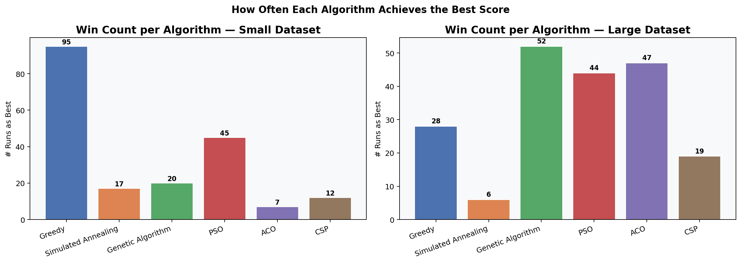
Interpretation of Results
The experimental evaluation reveals significant performance trade-offs among the six implemented paradigms. On large instances ($n=100$), the Genetic Algorithm (GA) yields the highest composite score (85.61), achieving an outstanding improvement of +7.42 points over the baseline Greedy Best-Fit Decreasing heuristic. Particle Swarm Optimization (PSO) tracks closely behind with a +7.0% improvement over the baseline. This performance gain stems from the capability of evolutionary strategies to dynamically rearrange item packing sequences, effectively navigating the combinatorial search space to evade early local minima that trap simpler heuristics.
A compelling utilization–placement trade-off is observed between ACO and PSO. Ant Colony Optimization yields the absolute highest isolated volumetric utilization (87.97%), yet it packs the lowest average number of items (62 boxes) among all metaheuristics. This occurs because its visibility heuristic ($\eta = \sqrt{volume \times weight}$) aggressively privileges large, dense cargo elements. While this fills the bulk of the box volume efficiently, it leaves highly fragmented, irregular residual empty spaces that smaller boxes cannot subsequently populate. In inverse fashion, PSO's continuous position-encoded swarm effectively interleaves diverse item dimensions, successfully packing an average of 78 out of 100 boxes, though at a lower overall volume utilization of 79%. The GA effectively balances both objectives simultaneously, explaining its superior composite evaluation.
Conversely, the CSP model underperforms the baseline Greedy heuristic by -2.3%. Because packing a standard container is highly constrained, the rigid backtracking threshold (capped at 500 steps to remain computationally viable) forces the algorithm to truncate its search prematurely on complex instances, preventing it from resolving deep, difficult box arrangements. In terms of operational reliability, the metaheuristic strategies demonstrate excellent consistency; on large problem instances, their performance standard deviation ($\sigma$) drops from approximately 7 down to a tight band of 1.3–1.6. This confirms that iterative, population-based correction mechanisms powerfully smooth out instance-to-instance variations. Greedy and CSP methods lack this adaptive error recovery, retaining a high variance ($\sigma > 2$) due to their susceptibility to early, uncorrectable packing mistakes.
Limitations and Potential Improvements
The primary architectural constraint lies within the empty space representation model. The system relies on a standard space-splitting heuristic that generates right, front, and top residual cuboids upon placing an item. However, it lacks a mechanism to merge adjacent, fragmented free spaces back into larger cohesive volumes, resulting in artificial space throttling. Furthermore, the physical evaluation model operates on idealized conditions. Stability is approximated via localized horizontal basal overlap (requiring $\ge 30\%$ support) and relative vertical weight comparisons, omitting advanced real-world structural factors such as center-of-mass tipping moments, shifting load dynamics, or multi-point pressure tolerances.
Future Work
Future extensions of this research will focus on developing a dynamic space-merging algorithm to combat volume fragmentation. We also plan to replace the current geometric heuristic check with a rigid-body physics simulation engine (such as PyBullet) to evaluate realistic cargo shifting under acceleration. Finally, the framework will be expanded from a single container scope into a Multi-Container Loading Problem (MCLP) environment to support fleet-level fleet logistics and real-time online packing adjustments.

Conclusion:
This project successfully designed, implemented, and benchmarked a 3D Container Loading Optimizer capable of generating highly dense and physically stable packing arrangements inside a standard 20-foot ISO container. By coupling a smart Best-Fit Deepest-Bottom Leftmost placement rule with advanced metaheuristics, the system translates abstract sequence permutations into viable, constraint-compliant spatial configurations.
The experimental findings demonstrate that while classical heuristics provide instantaneous execution speeds, evolutionary algorithms yield substantially better packing quality and operational reliability under high-density scenarios. The Genetic Algorithm provided the most robust multi-objective balance, whereas Ant Colony Optimization proved ideal for maximizing absolute volume utilization at the expense of total box throughput.
The primary contribution of this work is the delivery of a fully integrated, three-tier prototype application that pairs an expressive React-based 3D visualization frontend with a flexible Python optimization engine. This tool successfully bridges academic heuristic search methods with practical supply chain software, enabling logistics coordinators to minimize empty container overhead, lower fuel consumption expenditures, and ensure safer transport through verified load-stability metrics.

References

- Dorigo, M., Maniezzo, V., & Colorni, A. (1996). Ant colony system: A cooperative learning approach to combinatorial optimization. IEEE Transactions on Systems, Man, and Cybernetics, Part B (Cybernetics), 26(1), 29–41.
- Kennedy, J., & Eberhart, R. (1995). Particle swarm optimization. In Proceedings of ICNN'95 - International Conference on Neural Networks (Vol. 4, pp. 1942–1948). IEEE.
- Kirkpatrick, S., Gelatt, C. D., & Vecchi, M. P. (1983). Optimization by simulated annealing. Science, 220(4598), 671–680.
- Martello, S., Pisinger, D., & Vigo, D. (2000). The three-dimensional bin packing problem. Operations Research, 48(2), 256–267.
- Bortfeldt, A., & Gehring, H. (1998). A genetic algorithm for solving the container loading problem. International Transactions in Operational Research, 5(4), 281–293.

Appendix A: A few screen shots of the system
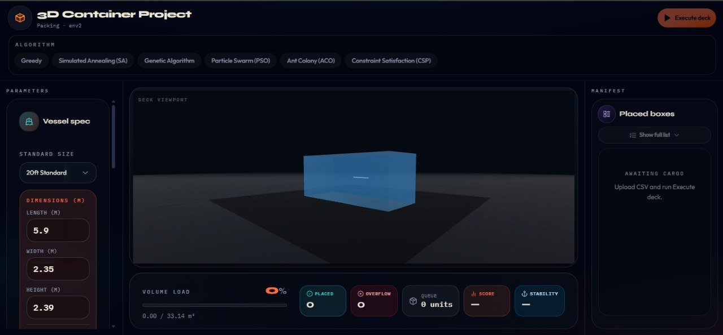
The website’s UI and functionalities (On the left you find where to drop your CSV file and select how many boxes do you want and change the dimensions of the container , on the right you’ll receive a report on which boxes got inserted and which didn’t. You pick the algorithm in the top of the page)

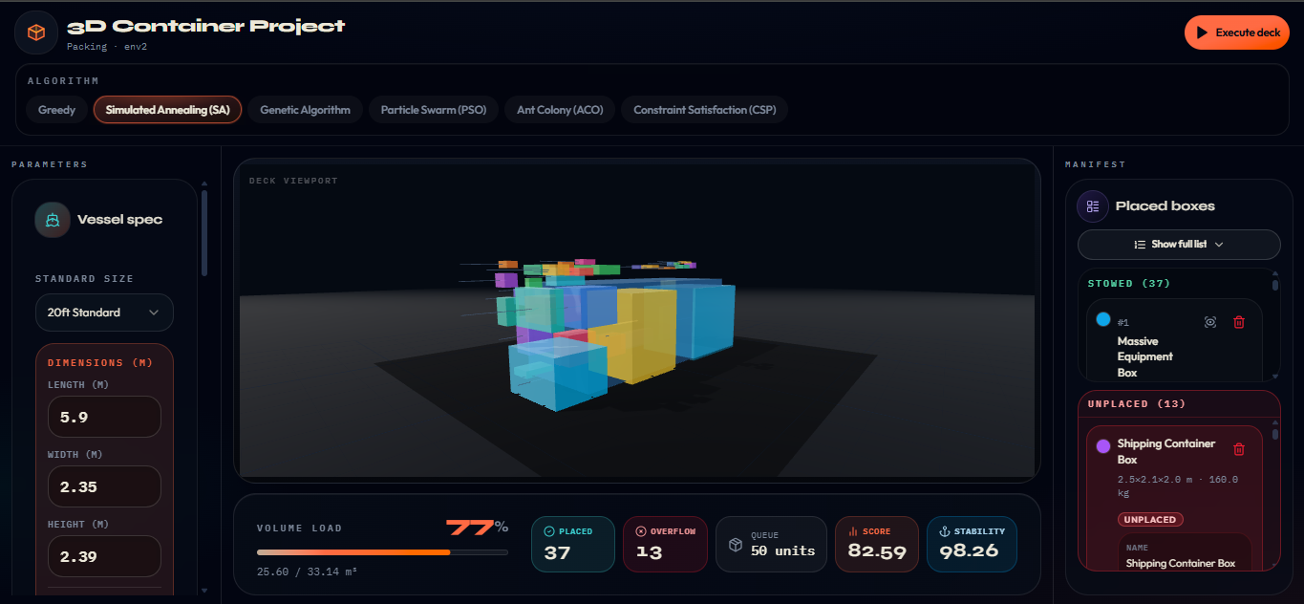
A screenshot testing the “Simulated Annealing Algorithm” while activating the explode feature, you can turn the 3D container to see how to place them in order

Appendix B: Contributions
Student | Contribution
Nabil BENCHINE (leader) | - Genetic Algorithm  - Ant Colony Optimization  - Web application design
Samir Abdelhakim KORBAS | - Simulated Annealing  - Particle Swarm Optimization  - NoteBook markdowns  - Comparative analysis
Mohammed Fares BENHAMMADI | - Simulated Annealing  - Particle Swarm Optimization  - Environment Definition
Ahmed AMMICHE | - Genetic Algorithm  - Ant Colony Optimization  - Algorithm testing
Amine Mohamed RAMDANI | - Greedy search  - CSP  - Environment Definition
Nazim KHELFALLAH | - Greedy search  - CSP  - Problem Definition
All Together | - Data Generation  - Web app developement  - Report Writing

