PharChain

Group 10

* Ignasius Denni Hermawan (00000045479)
* Jonathan Gautama Djuasa (00000069525)
* Reuben Christoper Lengkong (00000056873)

# Introduction and Background

Includes project idea, requirement, scope, goal, and motive. Make sure the statements mentioned here are realistic, reasonable, and straightforward.

# Design

Includes how the product works and product architecture (on-chain and off-chain). Make sure the statements are intuitive and accurate according to Section I. Include visualization to help your explanation.

## Product Flow

This template has been particularly made, so you can use navigation to jump between sections and use styles straight out of the box. To check on navigation, go to “View > Navigation Panel > Checklist to True“. To use preset style, go to “Home > Styles > Pop Up”. Other tips, you can check all text’s style using draft mode. First, set the style text in “File > More... > Options > Advanced > Display > Style area panel width ... > Set to 1.5 cm”. You can enable draft mode in “View > Draft”.

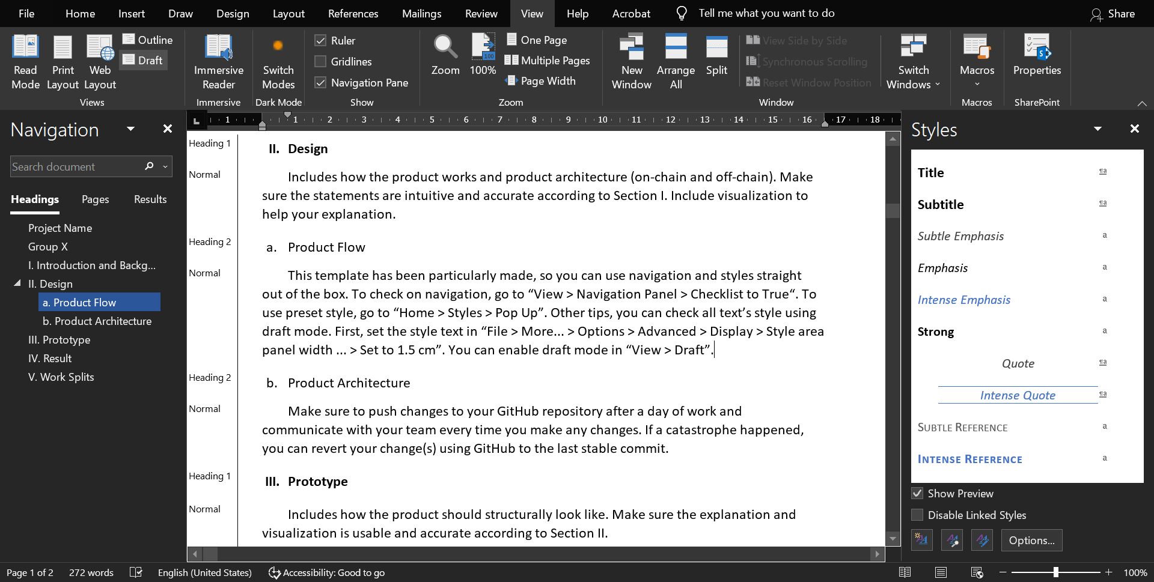

1. Word appearance after all the tips steps have been implemented.

## Product Architecture

Make sure to push changes to your GitHub repository after a day of work and communicate with your team every time you make any changes. If a catastrophe happened, you can revert your change(s) using GitHub to the last stable commit.

# Prototype

Includes how the product should structurally look like. Make sure the explanation and visualization is usable and accurate according to Section II.

# Result

Includes the screenshot of the resulting product. Keep it short and concise.

# Work Splits

* Alfred Kuhlman: 60%
  + Programmed the smart contract and oracle to handle data and flow control.
* Full Name: 40%
  + Designed the webpage UIs.
  + Implemented and programmed webpage functionality.