
MALAD KANDIVALI EDUCATION SOCIETY’S
NAGINDAS KHANDWALA COLLEGE OF COMMERCE, ARTS & MANAGEMENT STUDIES & SHANTABEN NAGINDAS KHANDWALA COLLEGE OF SCIENCE
MALAD [W], MUMBAI – 64
AUTONOMOUS INSTITUTION
(Affiliated To University Of Mumbai)
Reaccredited ‘A’ Grade by NAAC | ISO 9001:2015 Certified

CERTIFICATE

Name: Ms. NADAR BENCY BABY GOPAL
Roll No: 327 Programme: BSc IT Semester: III

This is certified to be a bonafide record of practical works done by the above student in the college laboratory for the course Data Structures (Course Code: 2032UISPR) for the partial fulfilment of Third Semester of BSc IT during the academic year 2020-21.
The journal work is the original study work that has been duly approved in the year 2020-21 by the undersigned.

_____________________  External Examiner |  | ____________________  Mr. Gangashankar Singh  (Subject-In-Charge)
Date of Examination: | (College Stamp)

Class: S.Y. B.Sc. IT Sem- III Roll No: 327

Subject: Data Structures
INDEX
Sr No | Date | Topic | Sign
1 | 04/09/2020 | Implement the following for Array:  - Write a program to store the elements in 1-D array and provide an option to perform the operations like searching, sorting, merging, reversing the elements.  - Write a program to perform the Matrix addition, Multiplication and Transpose Operation.
2 | 11/09/2020 | Implement Linked List. Include options for insertion, deletion and search of a number, reverse the list and concatenate two linked lists.
3 | 18/09/2020 | Implement the following for Stack:  - Perform Stack operations using Array implementation. b.  - Implement Tower of Hanoi.  - WAP to scan a polynomial using linked list and add two polynomials.  - WAP to calculate factorial and to compute the factors of a given no.  (i) using recursion, (ii) using iteration
4 | 25/09/2020 | Perform Queues operations using Circular Array implementation.
5 | 01/10/2020 | Write a program to search an element from a list. Give user the option to perform Linear or Binary search.
6 | 09/10/2020 | WAP to sort a list of elements. Give user the option to perform sorting using Insertion sort, Bubble sort or Selection sort.
7 | 16/10/2020 | Implement the following for Hashing:  - Write a program to implement the collision technique.  - Write a program to implement the concept of linear probing.
8 | 23/10/2020 | Write a program for inorder, postorder and preorder traversal of tree.

PRACTICAL NO: 1

AIM: Implement the following for Array:
1a. Write a program to store the elements in 1-D array and provide an option to perform the operations like searching, sorting, merging, reversing the elements.

GITHUB URL:https://github.com/Bencybaby1234/DSprac

THEORY: Array is a container which can hold a fix number of items and these items should be of the same type. Most of the data structures make use of arrays to implement their algorithms. Following are the important terms to understand the concept of Array.

Element− Each item stored in an array is called an element.

Index − Each location of an element in an array has a numerical index, which is used to identify the element.
Basic Operations
Following are the basic operations supported by an array.
Traverse − print all the array elements one by one.
Insertion − Adds an element at the given index.
Search − Searches an element using the given index or by the value.
Sorting-Means Arranging the Element in particular order. i.e. Ascending or Descending order.

CODE :
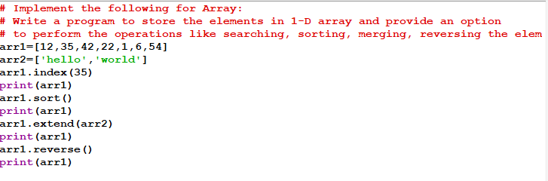

OUTPUT :

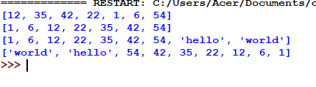
PRACTICAL NO: 1

AIM: Implement the following for Array:

1b. Write a program to perform the Matrix addition, Multiplication and Transpose Operation

GITHUB URL: https://github.com/Bencybaby1234/DSprac

THEORY:
Matrix is a special case of two dimensional array where each data element is of strictly same size. So every matrix is also a two dimensional array but not vice versa.
Matrices are very important data structures for many mathematical and scientific calculations. As we have already discussed two dimensional array data structure in matrices . In Python, we can implement a matrix as nested list (list inside a list).

We can treat each element as a row of the matrix. For example X = [[1, 2], [4, 5], [3, 6]] would represent a 3x2 matrix. T

he first row can be selected as X[0]. And, the element in first row, first column can be selected as X[0][0].
Multiplication of two matrices X and Y is defined only if the number of columns in X is equal to the number of rows Y.

If X is a n x m matrix and Y is a m x l matrix then, XY is defined and has the dimension n x l (but YX is not defined). Here are a couple of ways to implement matrix multiplication in Python.

CODE:
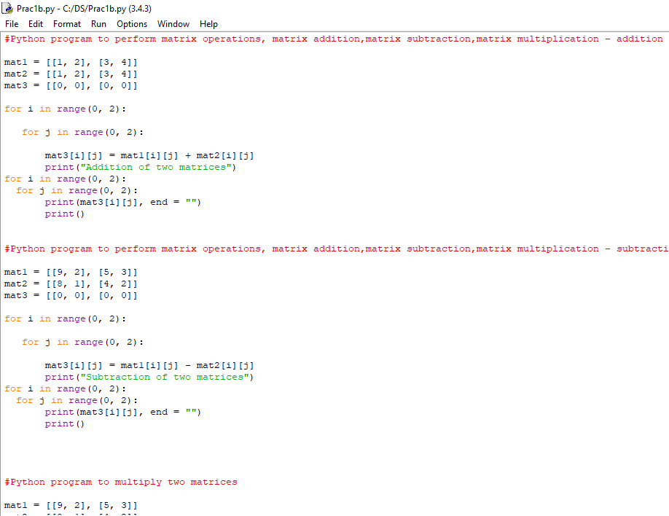
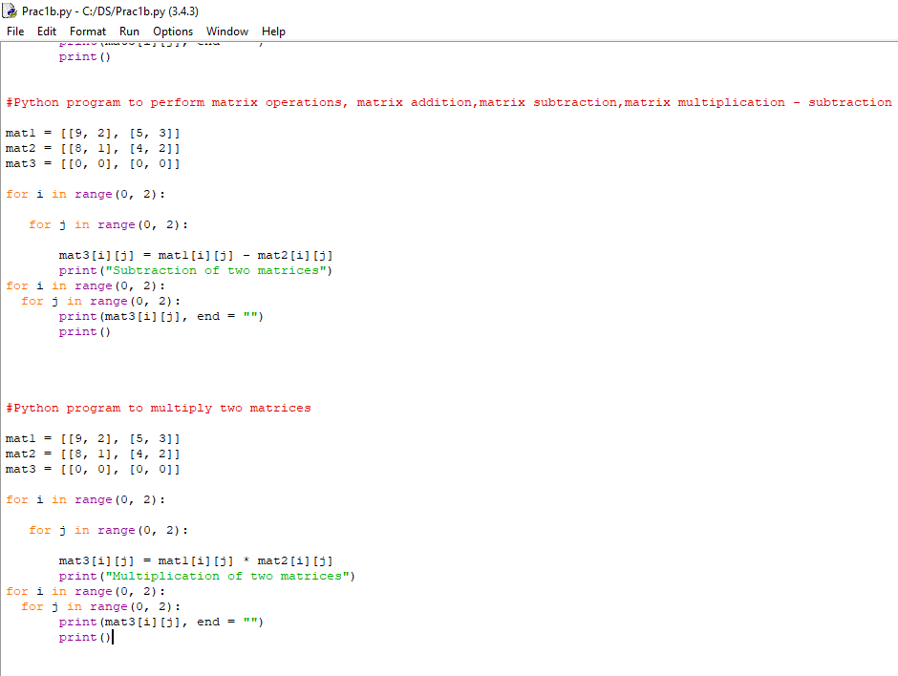
OUTPUT:
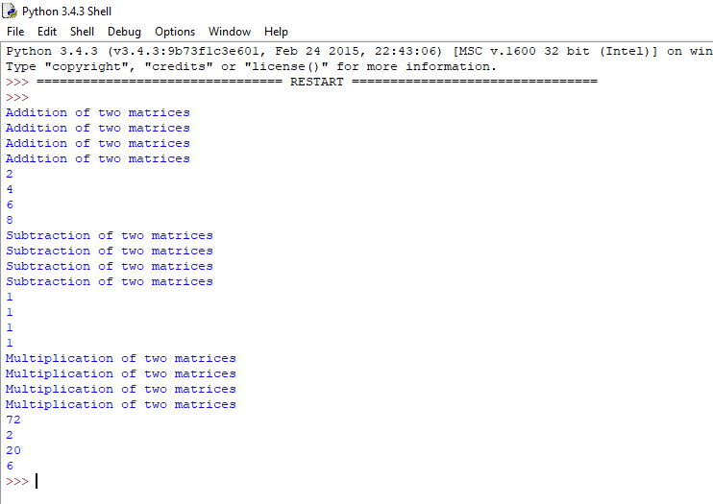

Practical 2

Aim :-Implement Linked List. Include options for insertion, deletion and search of a number, reverse the list and concatenate two linked lists

GITHUB URL:https://github.com/Bencybaby1234/DSprac

Theory:
A linked list is a sequence of data elements, which are connected together via links.
Each data element contains a connection to another data element in form of a pointer.
Python does not have linked lists in its standard library.

We implement the concept of linked lists using the concept of nodes as discussed in the previous chapter.

We have already seen how we create a node class and how to traverse the elements of a node. In this chapter we are going to study the types of linked lists known as singly linked lists.

In this type of data structure there is only one link between any two data elements. We create such a list and create additional methods to insert, update and remove elements from the list.

CODE :
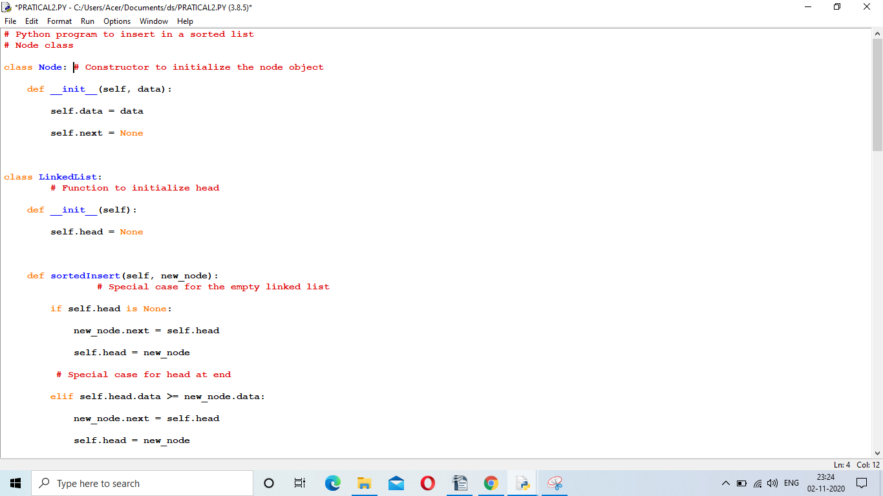

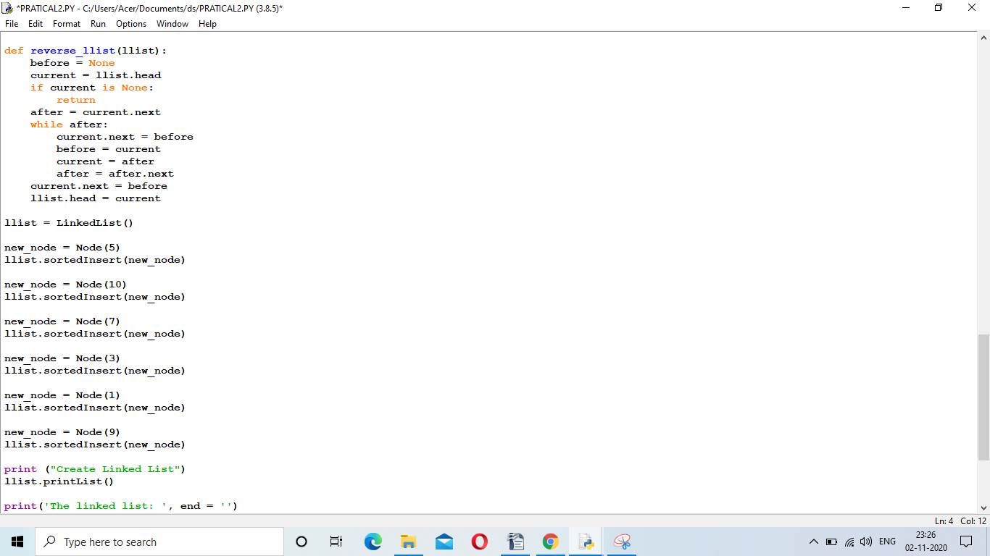
OUTPUT:
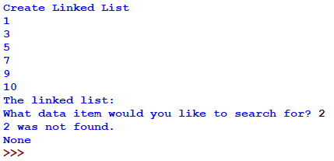

PRACTICAL NO: 3

AIM: Implement the following for Stack:
- Perform Stack operations using Array implementation.

GITHUB URL: https://github.com/Bencybaby1234/DSprac

THEORY:
Array is a container which can hold a fix number of items and these items should be of the same type. Most of the data structures make use of arrays to implement their algorithms.

Following are the important terms to understand the concept of Array.

Element− Each item stored in an array is called an element.
Index − Each location of an element in an array has a numerical index, which is used to identify the element.
CODE :
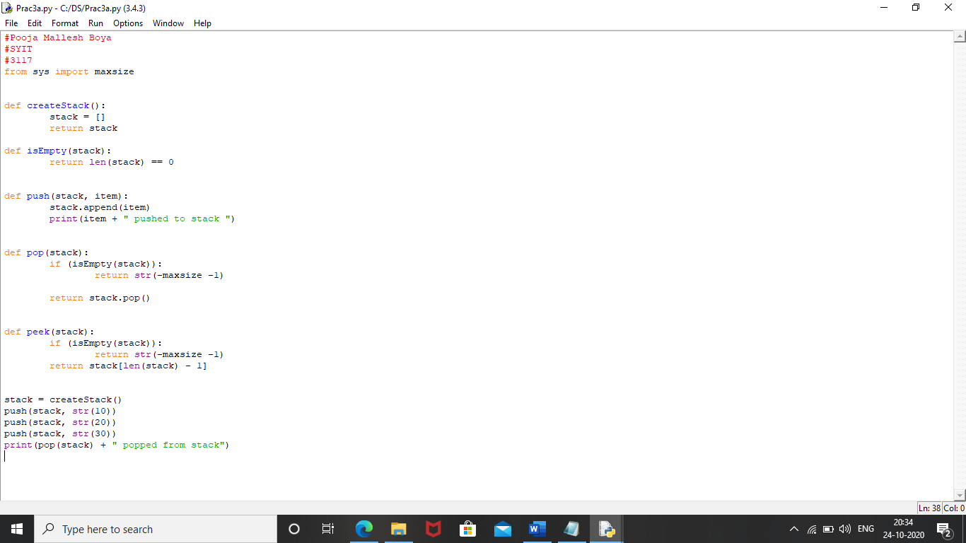
OUTPUT :
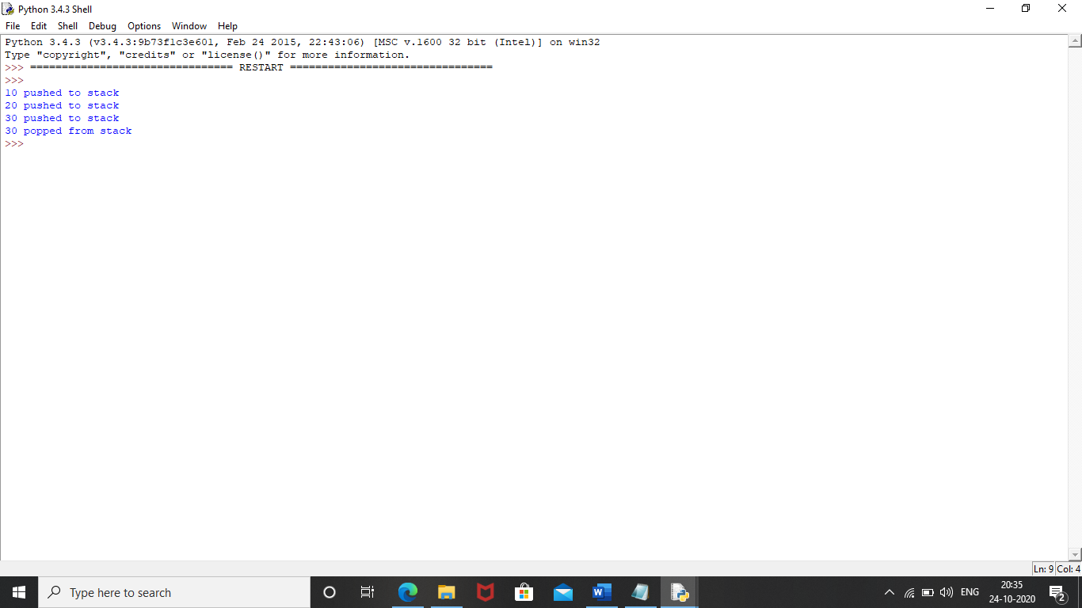

PRACTICAL NO: 3

AIM: Implement Tower of Hanoi
.
GITHUB URL: https://github.com/Bencybaby1234/DSprac

THEORY:

Tower of Hanoi is a mathematical puzzle where we have three rods and n disks.

The objective of the puzzle is to move the entire stack to another rod, obeying the following simple rules:
- Only one disk can be moved at a time.
- Each move consists of taking the upper disk from one of the stacks and placing it on top of another stack i.e. a disk can only be moved if it is the uppermost disk on a stack.
- No disk may be placed on top of a smaller disk.
CODE :
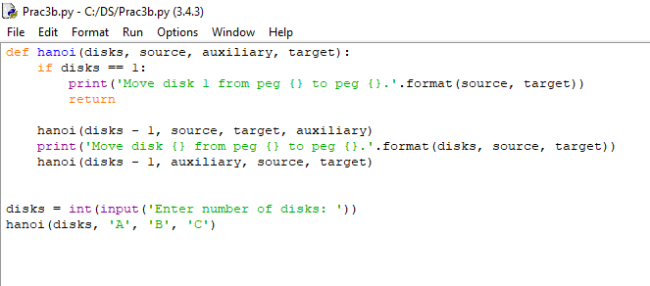
OUTPUT :
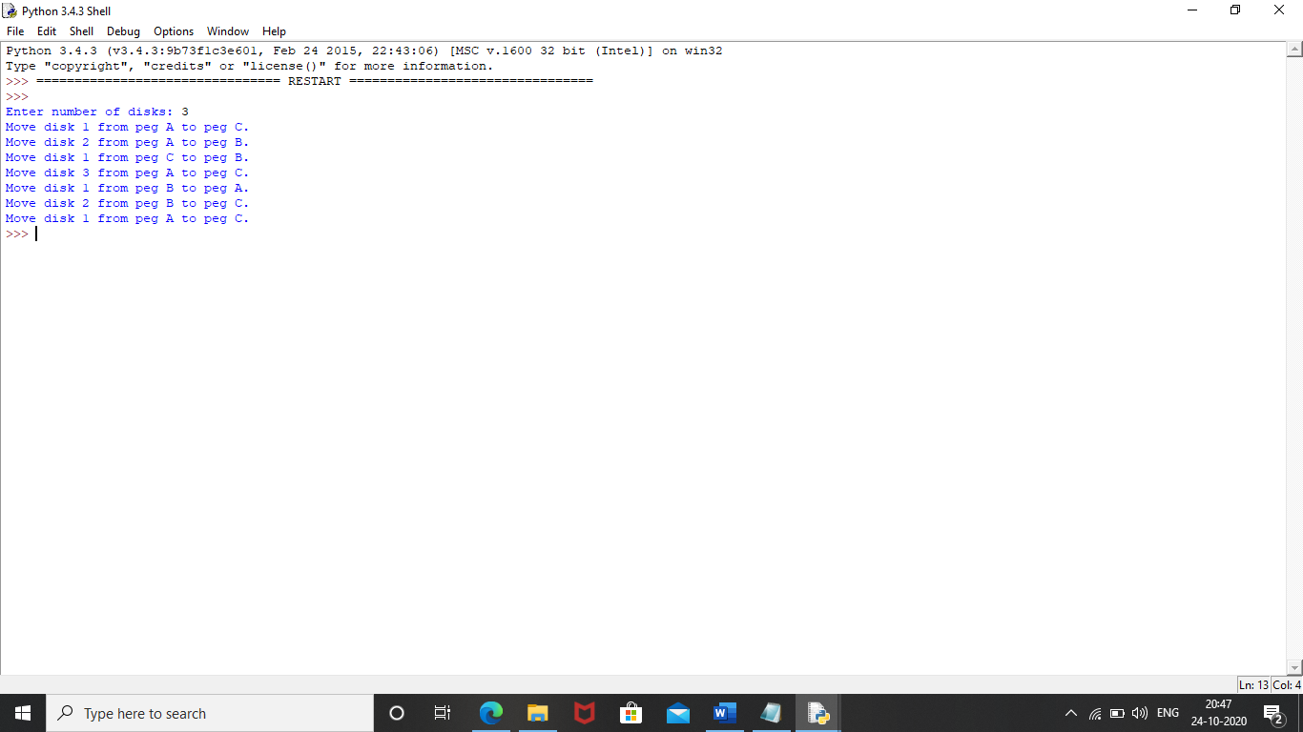

PRACTICAL NO: 3

AIM: WAP to scan a polynomial using linked list and add two polynomials.

GITHUB URL:https://github.com/Bencybaby1234/DSprac

THEORY:

A linked list is a sequence of data elements, which are connected together via links.

Each data element contains a connection to another data element in form of a pointer.

Python does not have linked lists in its standard library. We implement the concept of linked lists using the concept of nodes as discussed in the previous chapter.

We have already seen how we create a node class and how to traverse the elements of a node. In this chapter we are going to study the types of linked lists known as singly linked lists. In this type of data structure there is only one link between any two data elements.

We create such a list and create additional methods to insert, update and remove elements from the list.
CODE :
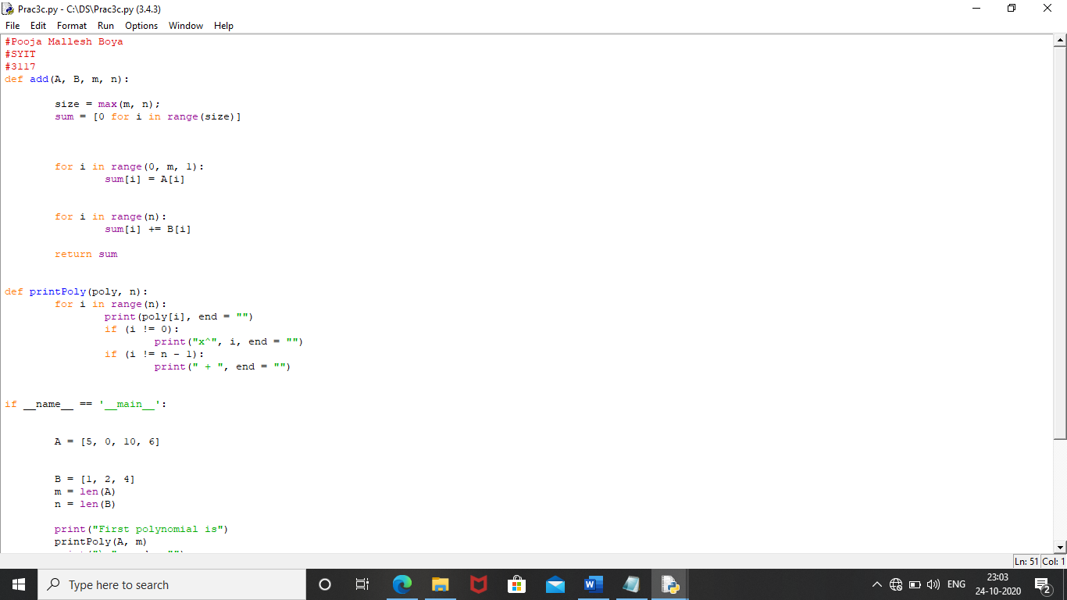
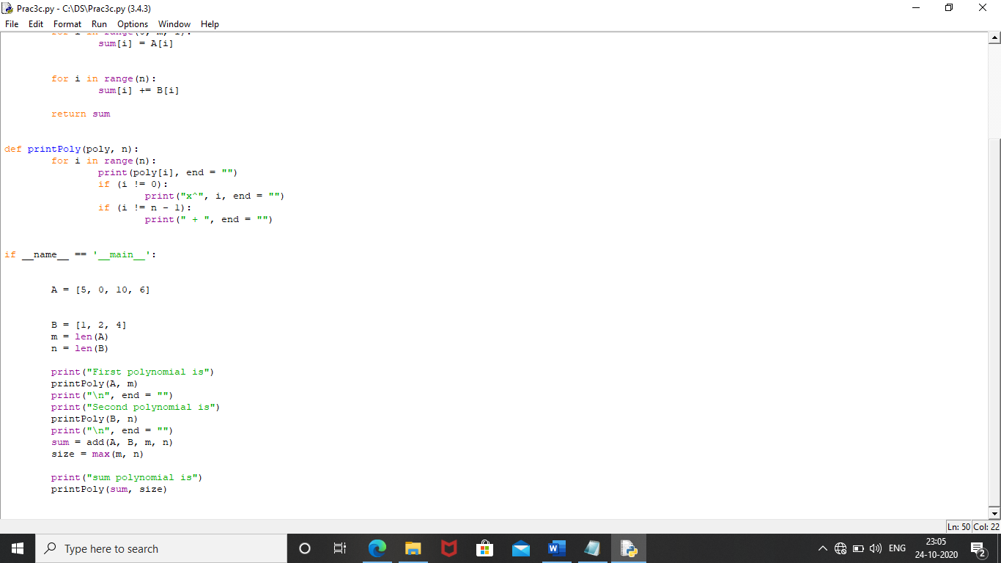
OUTPUT :
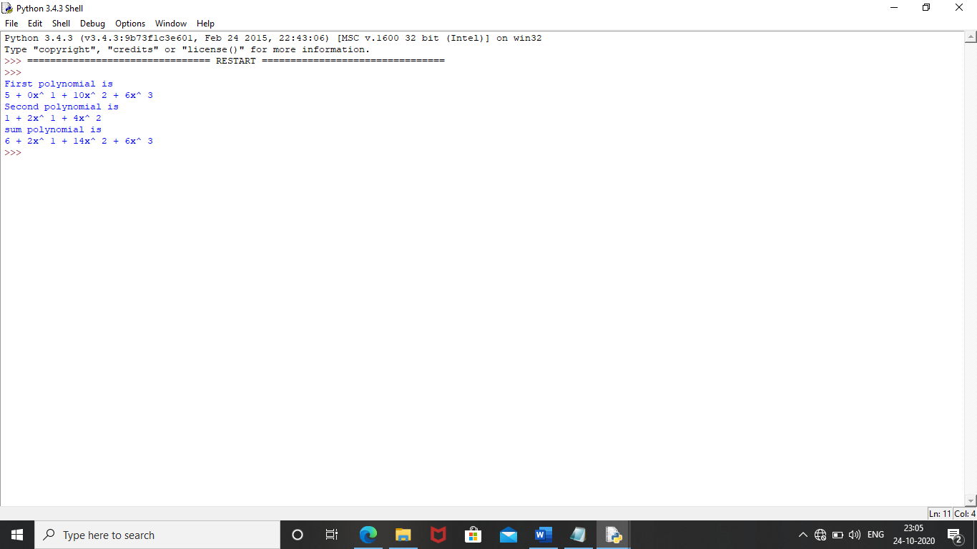

PRACTICAL NO: 3

AIM: WAP to calculate factorial and to compute the factors of a given no.
- using recursion, (ii) using iteration.

GITHUB URL: https://github.com/Bencybaby1234/DSprac

THEORY:
The factorial of a number is the product of all the integers from 1 to that number.
For example, the factorial of 6 is 1*2*3*4*5*6 = 720. Factorial is not defined for negative numbers and the factorial of zero is one, 0! = 1.
Recursion
In Python, we know that a function can call other functions. It is even possible for the function to call itself. These types of construct are termed as recursive functions.
Iteration
Repeating identical or similar tasks without making errors is something that computers do well and people do poorly. Repeated execution of a set of statements is called iteration. Because iteration is so common,Python provides several language features to make it easier.

CODE :
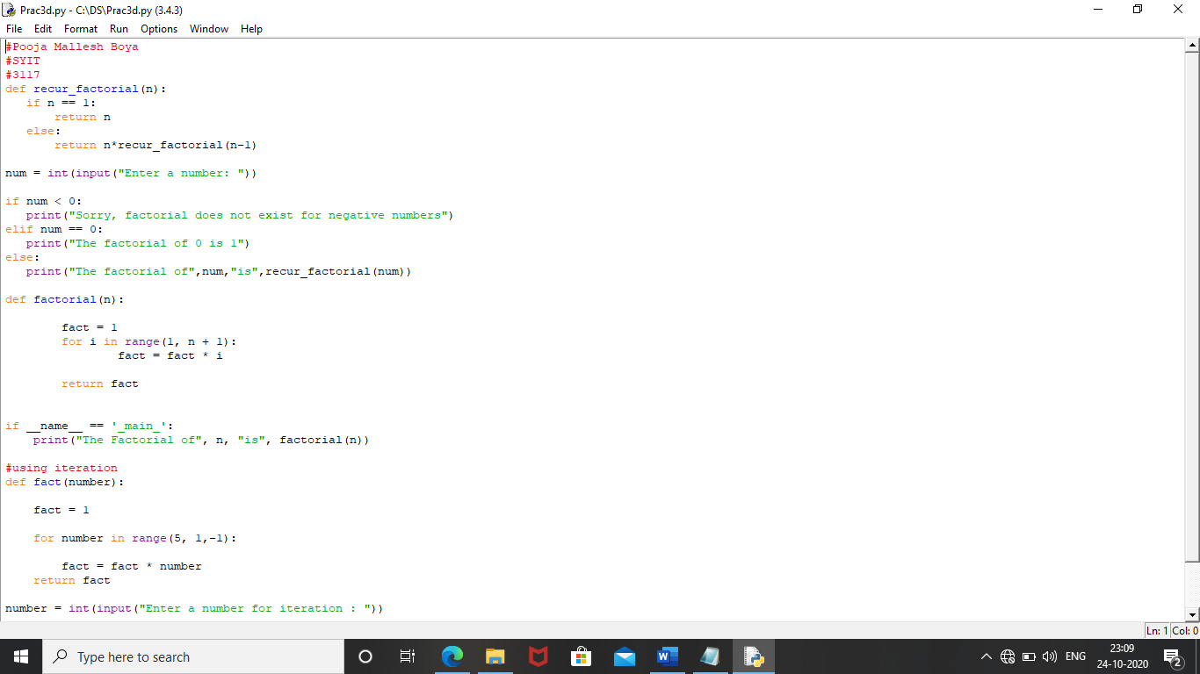
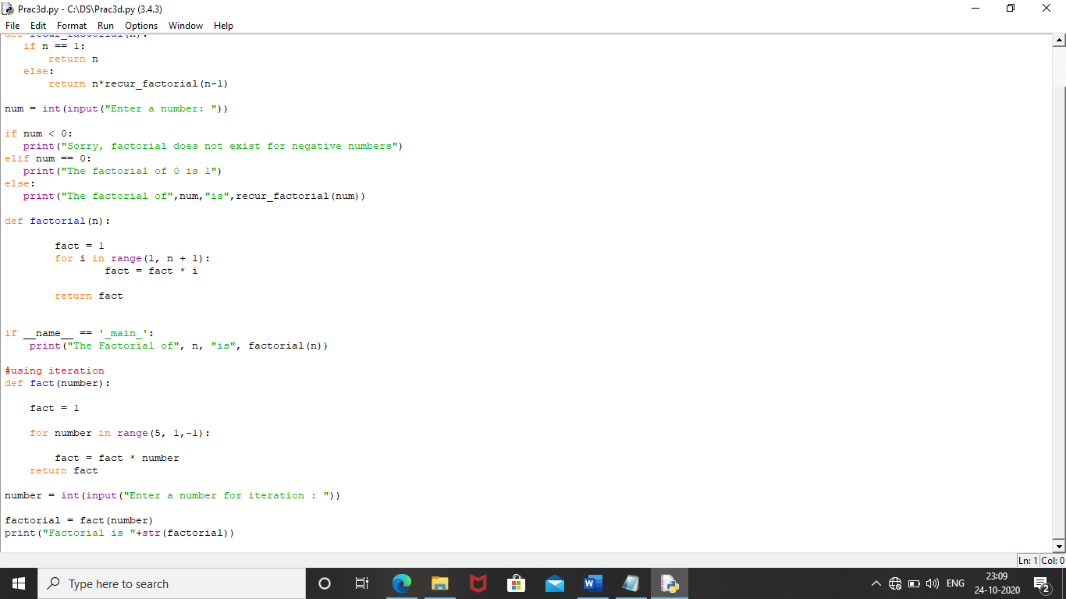
OUTPUT :
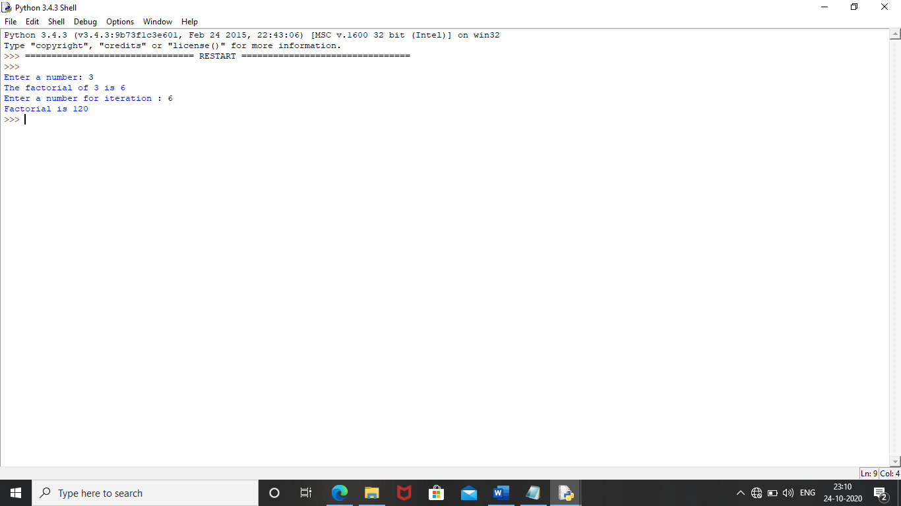

PRACTICAL NO: 4

AIM: Perform Queues operations using Circular Array implementation.

GITHUB URL:https://github.com/Bencybaby1234/DSprac

THEORY:
A Circular Queue is a queue data structure but circular in shape, therefore after the last position, the next place in the queue is the first position.

We recommend you to first go through the Linear Queue tutorial before Circular queue, as we will be extending the same implementation.

In case of Linear queue, we did not had the head and tail pointers because we used python List for implementing it.

But in case of a circular queue, as the size of the queue is fixed, hence we will set a maxSize for our list used for queue implementation.
CODE :
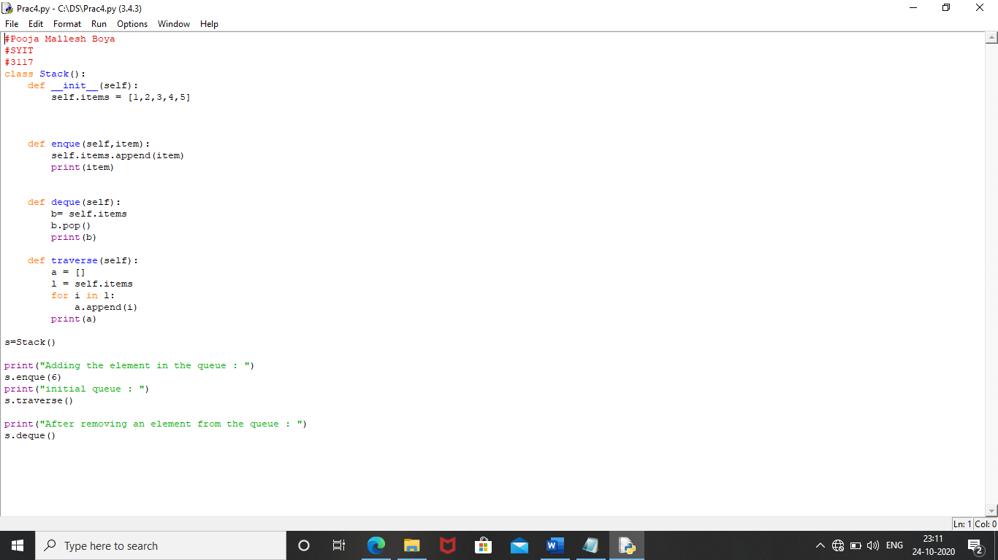

OUTPUT :
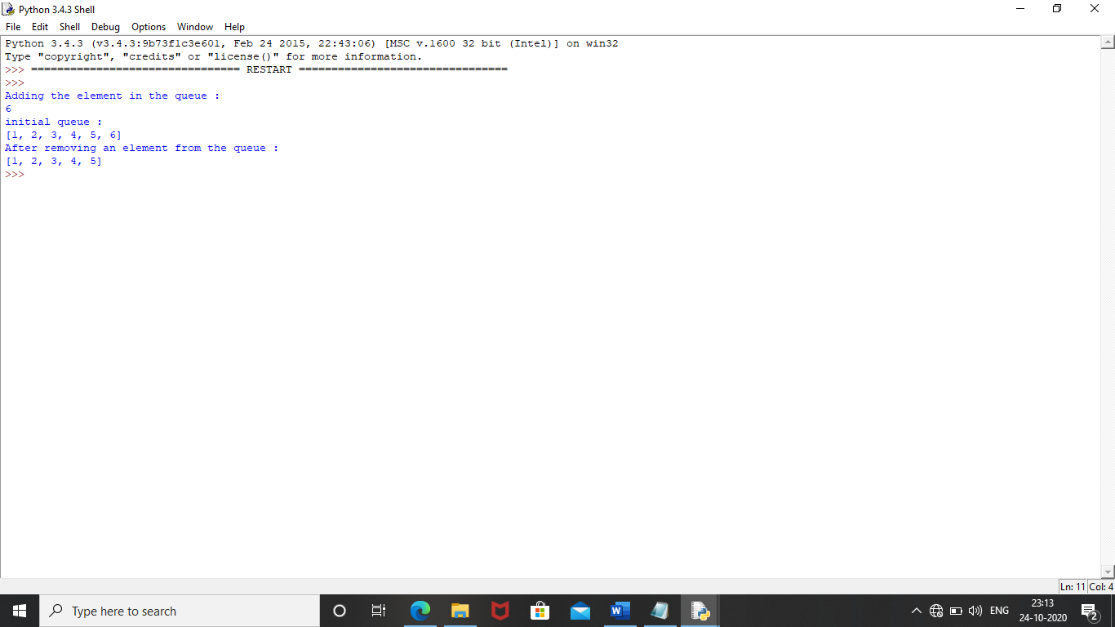

PRACTICAL NO: 5

AIM: Write a program to search an element from a list. Give user the option to perform Linear or Binary search.

GITHUB URL: https://github.com/Bencybaby1234/DSprac

THEORY:
Searching is a very basic necessity when you store data in different data structures.

The simplest approach is to go across every element in the data structure and match it with the value you are searching for. This is known as Linear search.

It is inefficient and rarely used, but creating a program for it gives an idea about how we can implement some advanced search algorithms.

Linear Search: In this type of search, a sequential search is made over all items one by one. Every item is checked and if a match is found then that particular item is returned, otherwise the search continues till the end of the data structure.

Binary Search: Search a sorted array by repeatedly dividing the search interval in half. Begin with an interval covering the whole array. If the value of the search key is less than the item in the middle of the interval, narrow the interval to the lower half. Otherwise narrow it to the upper half. Repeatedly check until the value is found or the interval is empty.

CODE :
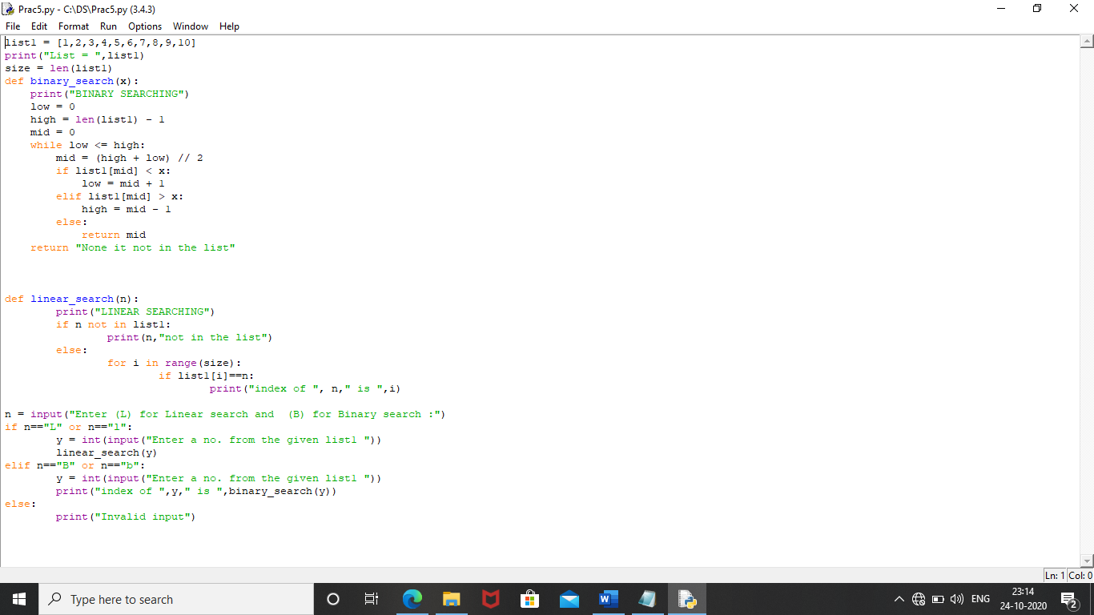
OUTPUT :
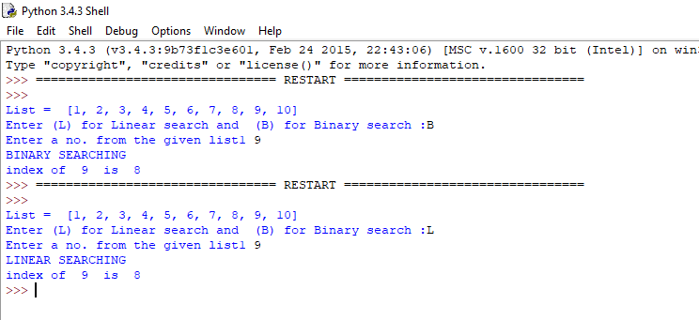

PRACTICAL NO: 6

AIMWAP to sort a list of elements. Give user the option to perform sorting using Insertion sort, Bubble sort or Selection sort.

GITHUB URL: https://github.com/Bencybaby1234/DSprac

THEORY:

Sorting refers to arranging data in a particular format.

Sorting algorithm specifies the way to arrange data in a particular order. Most common orders are in numerical or lexicographical order.

The importance of sorting lies in the fact that data searching can be optimized to a very high level, if data is stored in a sorted manner.

Sorting is also used to represent data in more readable formats. Below we see five such implementations of sorting in python.

Bubble Sort It is a comparison-based algorithm in which each pair of adjacent elements is compared and the elements are swapped if they are not in order.

Insertion Sort Insertion sort involves finding the right place for a given element in a sorted list. So in beginning we compare the first two elements and sort them by comparing them. Then we pick the third element and find its proper position among the previous two sorted elements.

This way we gradually go on adding more elements to the already sorted list by putting them in their proper position. Selection Sort In selection sort we start by finding the minimum value in a given list and move it to a sorted list.
Then we repeat the process for each of the remaining elements in the unsorted list. The next element entering the sorted list is compared with the existing elements and placed at its correct position. So at the end all the elements from the unsorted list are sorted.
CODE :
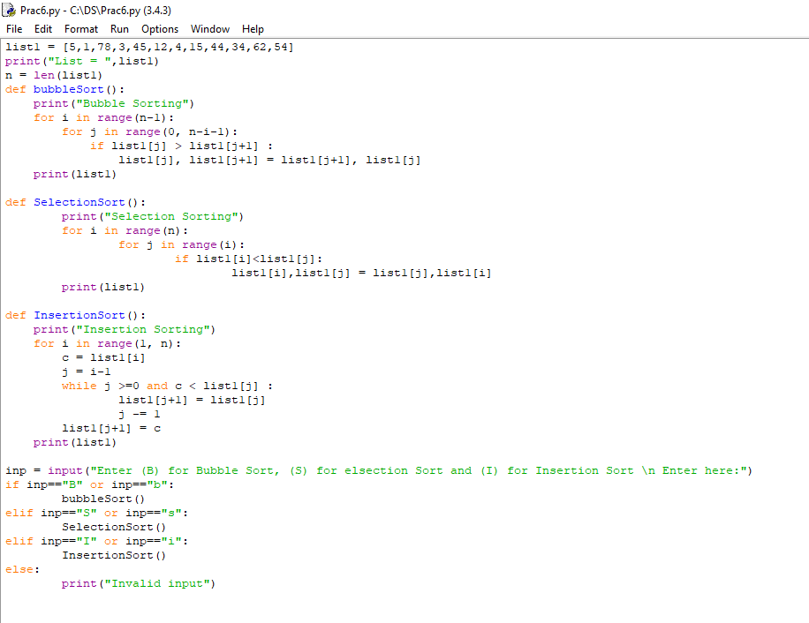

OUTPUT :
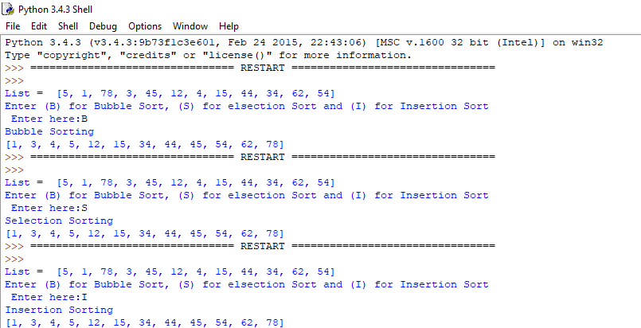

PRACTICAL NO: 7

AIM: Implement the following for Hashing:
- Write a program to implement the collision technique
.
GITHUB URL:https://github.com/Bencybaby1234/DSprac

THEORY:
Hash tables are a type of data structure in which the address or the index value of the data element is generated from a hash function.

That makes accessing the data faster as the index value behaves as a key for the data value.

In other words Hash table stores key-value pairs but the key is generated through a hashing function.the search and insertion function of a data element becomes much faster as the key values themselves become the index of the array which stores the data.In Python, the Dictionary data types represent the implementation of hash tables. The Keys in the dictionary satisfy the following requirements.

The keys of the dictionary are hash able i.e. the are generated by hashing function which generates unique result for each unique value supplied to the hash function.

• The order of data elements in a dictionary is not fixed.Name:
CODE :
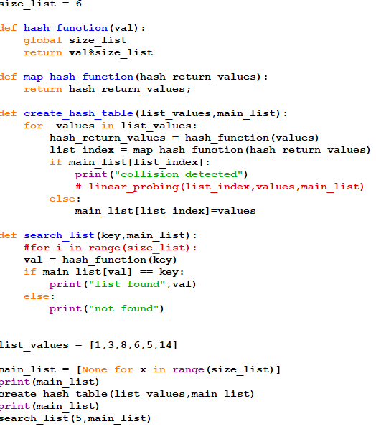

OUTPUT:
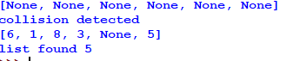

PRACTICAL:7

AIM: Write a program to implement the concept of linear probing.

GITHUB URL: https://github.com/Bencybaby1234/DSprac

THEORY:
Hashing is an important Data Structure which is designed to use a special function called the Hash function which is used to map a given value with a particular key for faster access of elements.

The efficiency of mapping depends of the efficiency of the hash function used.
In Open Addressing, all to are stored in the hash table itself. So at any point, size of table must be greater than or equal to total number of keys (Note that we can increase table size by copying old data if needed).

CODE :
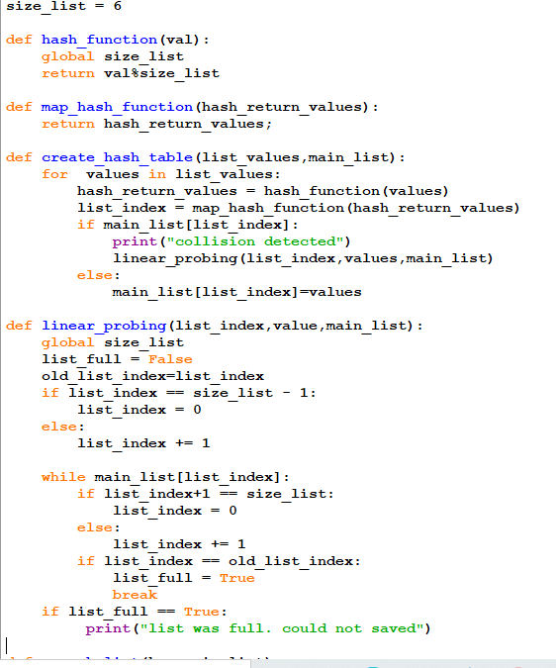

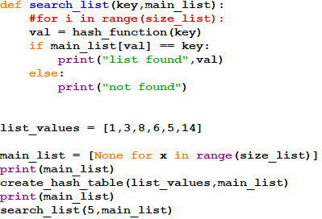
OUTPUT:
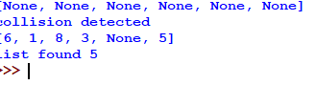

PRACTICAL NO: 8

AIM: Write a program for inorder, postorder and preorder traversal of tree.

GITHUB URL: https://github.com/Bencybaby1234/DSprac
THEORY:

Unlike linear data structures (Array, Linked List, Queues, Stacks, etc) which have only one logical way to traverse them, trees can be traversed in different ways. Following are the generally used ways for traversing trees.

Depth First Traversals:
(a) Inorder (Left, Root, Right)
(b) Preorder (Root, Left, Right)
- Postorder (Left, Right, Root).

CODE :
