Blockly/Scriptcraft for Minecraft

Level 2

Paul Richards 9/4/2020This course will be divided into 3 sessions, each session consisting of 8x1 hour classes.

1. High Level design and game events
   1. Flowcharts
   2. Game initialization on reload event
   3. Player Team selection
   4. Player Career selection
   5. Player Death
   6. Player Command Entered
   7. Player On Ground
   8. Elytra Destruction
2. Game Rules and Game Play
   1. Left click for Fighter
   2. Left click for Bomber
   3. Right Click for Fighter
   4. Right Click for Bomber
   5. Right Click for Infantry
   6. Spawn Protection
   7. Bed Destruction
   8. Bed Creation on reload
3. Game improvements
   1. Exploding snowballs for Bomber
   2. Multiple arrows launched by fighter
   3. Fireworks with Fade and Flicker for Infantry
   4. Slow falling on left click
   5. Splash Potion to protect bed
   6. Purchase potion in game
   7. End Game Detection
   8. Public Server Considerations

1.1 Game Design FlowChart

First we will go over the game design from a high-level perspective.

I have used flowcharts to represent the game design:

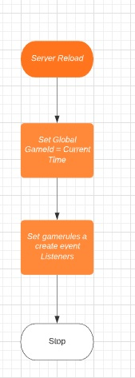

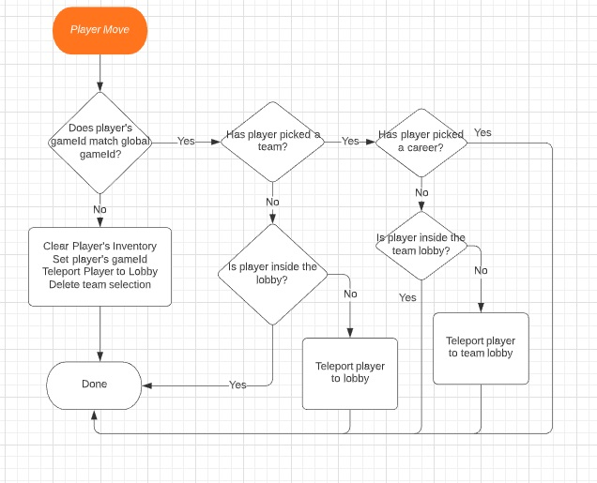

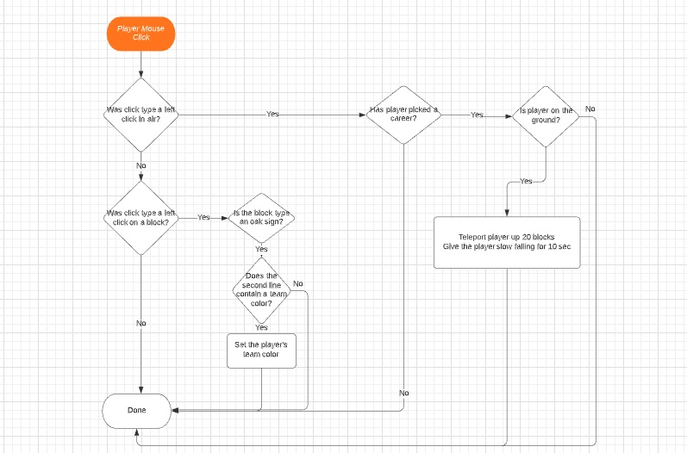

1.2 Game Initialization on Reload

The server reload is the event that drives the game initialization  
Notice the global variable gameId is set to the current time in milliseconds  
When a player joins the server their gameId will be checked, if it does not match this means that they are joining the game for the first time.

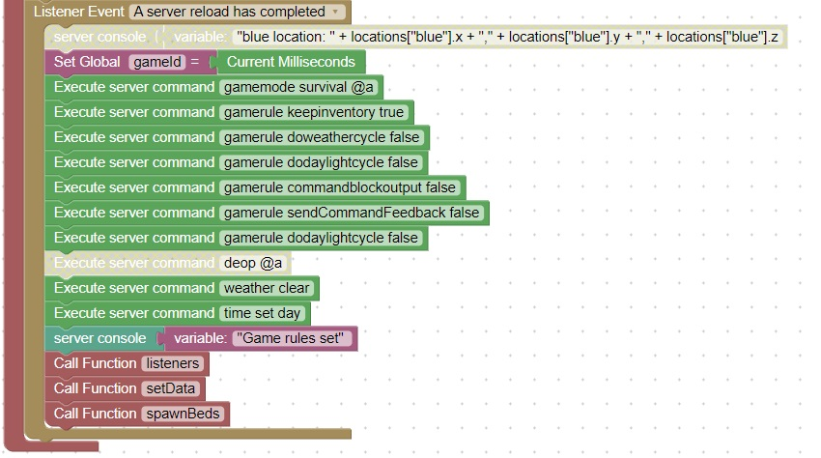

1.3 Player Team Selection

Team selection is the first task that a player must accomplish when joining a server for the first time.  
Team is selected by clicking on an oak sign that contains a "Join Team" message.

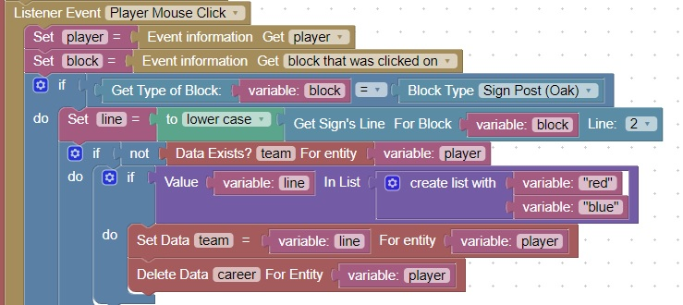

1.4 Player Career Selection

A player must select from the careers:

Fighter

Bomber

When the player's elytra is no longer functioning, both types become infantry

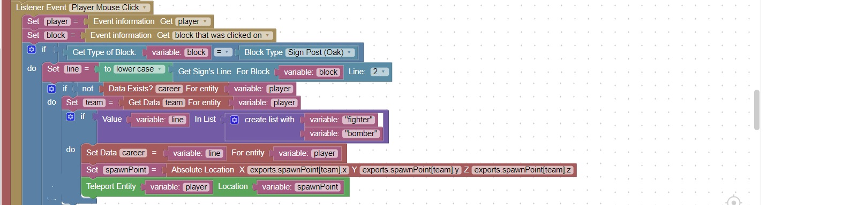

1.5 Player Death  
When a player dies, end of game detection can be run  
You can check how many teams are still active.  
If only 1 team remains, the game is over

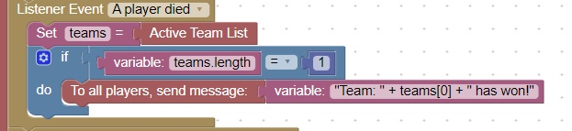

1.6 Player Command Entered  
/t command is similar to the whisper command  
When a user enters a command such as: /t Hello what is up?  
You can use the list from text block with a space as delimeter  
You end up with the list:

/t

Hello

what

is

up?

Then you can use the get and remove block on the first element and your commmand becomes  
/t  
And the list becomes:

Hello

what

is

up?

You can then use text from list block to reform the message :  
Hello what is up?

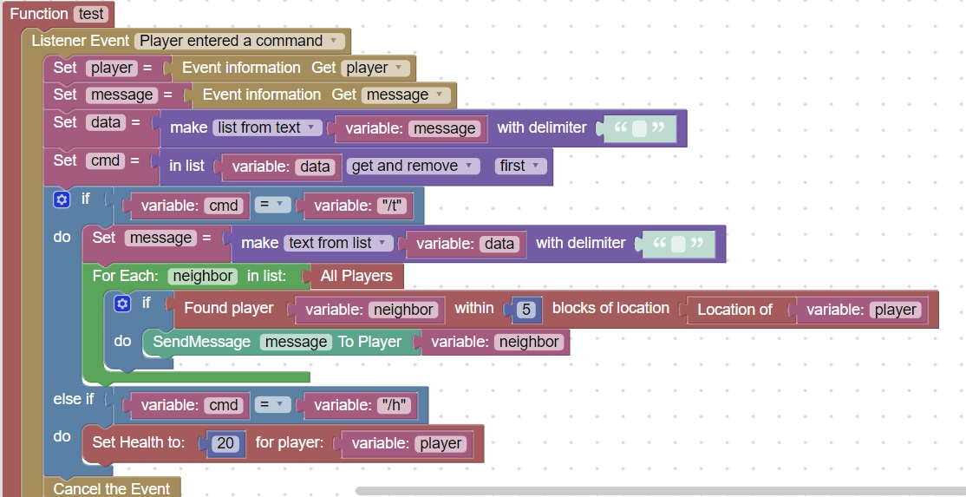

1.7 Player On Ground  
When the block below a player is solid, they are considered on ground.  
This code will output in the server console, whether they are on ground or not

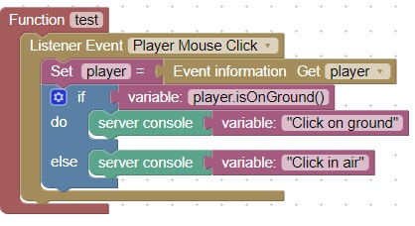

1.8 Elytra Destruction  
As an elytra is used, it wears out, and its durability increases. Also if the player takes damage while flying, the elytra also takes damage.  
This code will check the durability of a worn elytra and notify the user if it is too damaged to fly

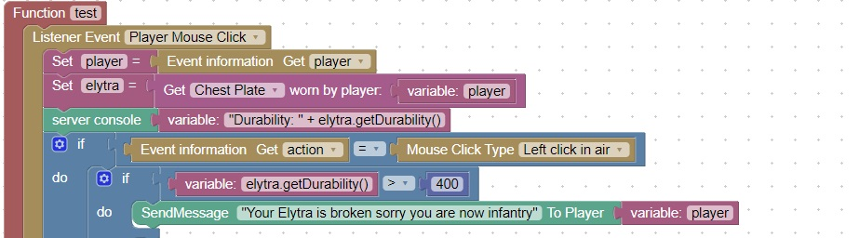

2.1 Left Click for Fighter  
When a player clicks the left mouse button when their career choice is fighter pilot, their vector is multiplied by 2

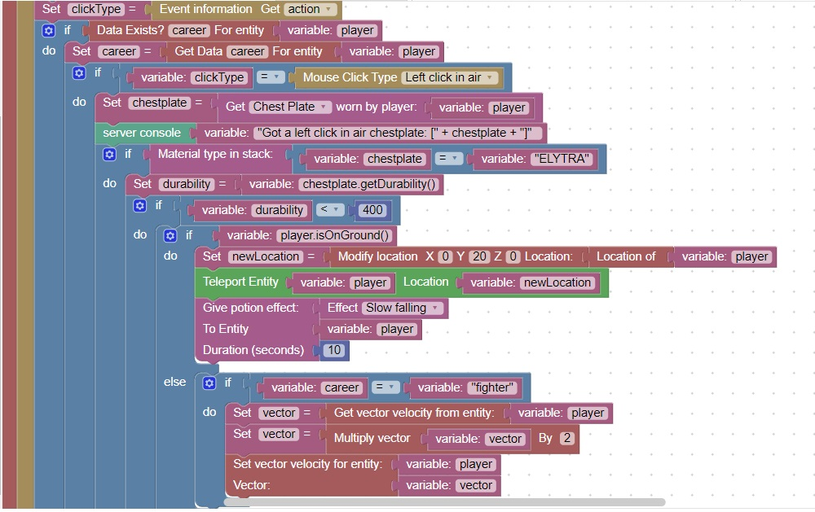

2.2 Left click for Bomber  
When a player clicks the left mouse button and their career choice is a bomber pilot, their altitude (y) will be increased by 20

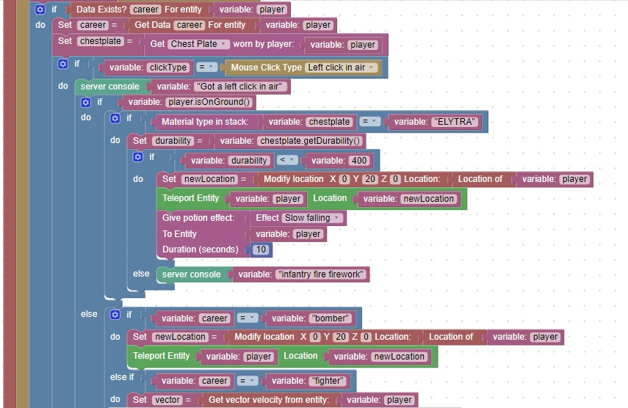

2.3 Right click for fighter

When a player clicks the right mouse button and their career choice is a fighter pilot, arrows are shot.

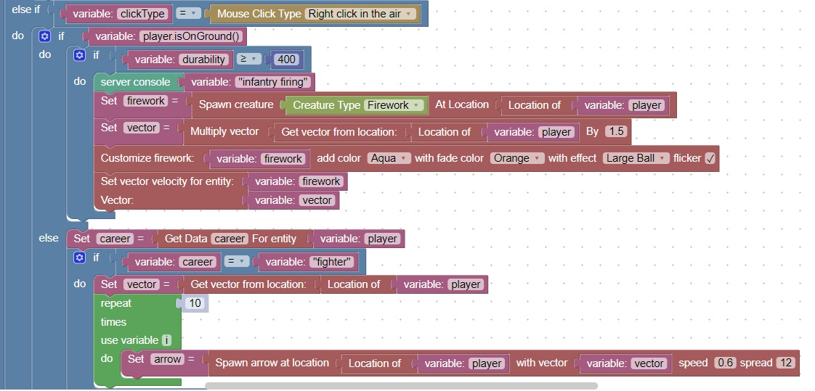

2.4 Right Click for Bomber  
When a player clicks the right mouse button and their career choice is a bomber pilot, snowballs are launched.

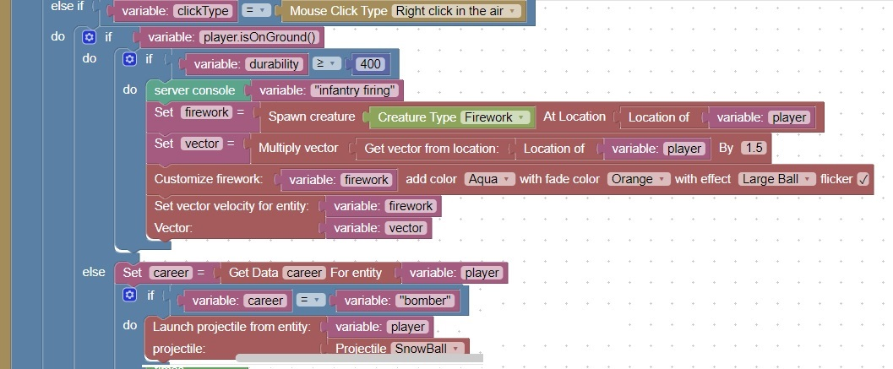

2.5 Right Click for Infantry

When a player clicks the right mouse button and they are on the ground and their Elytra is damaged, they are considered infantry.  
Infantry units fire fireworks on a right click

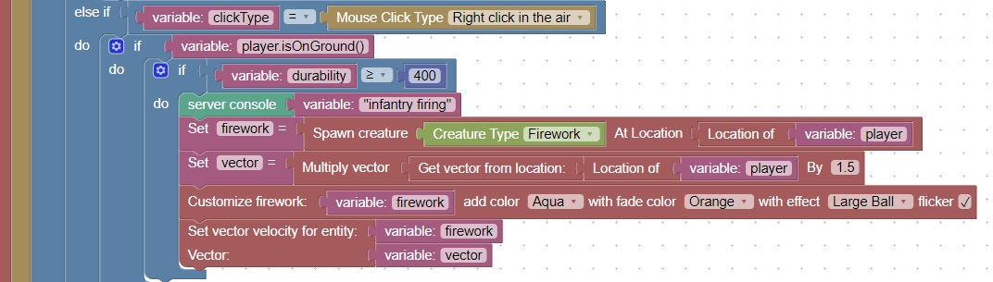

2.6 Spawn Protection  
Players will accidentally try to explode spawn points and signs  
Since an explosion is not considered a block break, another method needs to be used to protect these locations  
This code will check when a projectile hit event occurs, if it occurs near a spawn point

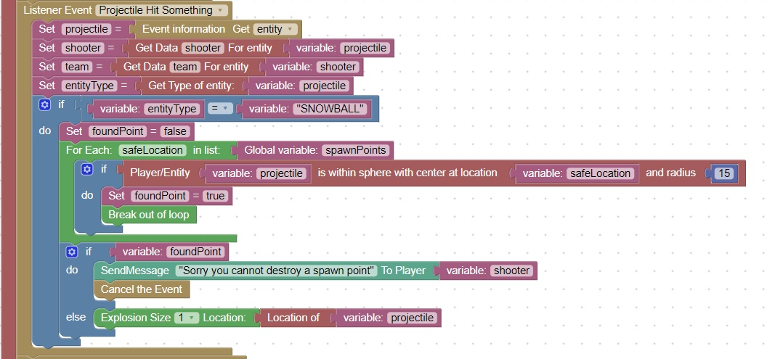

2.7 Bed Destruction  
When a player's bed is destroyed and the player tries to respawn, they are placed into spectator mode

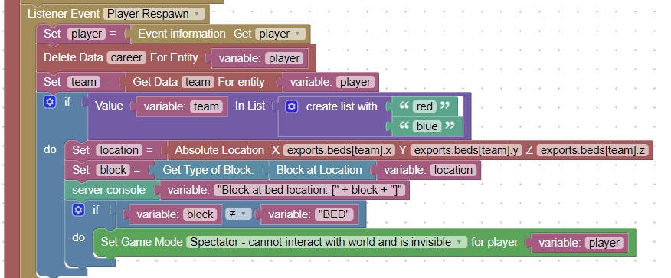

2.8 Bed Creation on Reload  
When the server finishes the reload evcent, it creates beds for all teams.

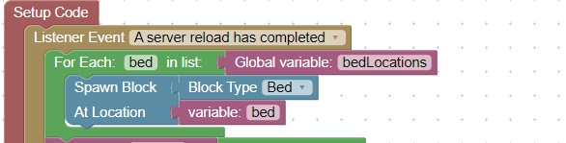

3.1 Exploding Snowballs for Bomber  
When the player performs a right click and their career path is Bomber, an exploding snowball is launched.

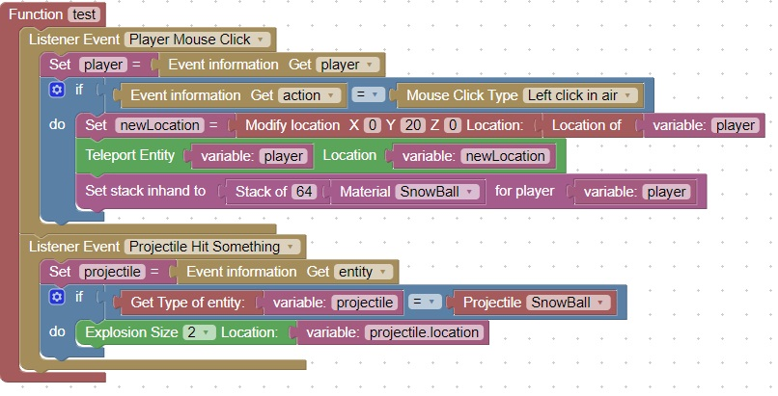

3.2 Multiple arrows launched by fighter  
When the player performs a right click and their career path is fighter pilot, multiple arrows are launched.

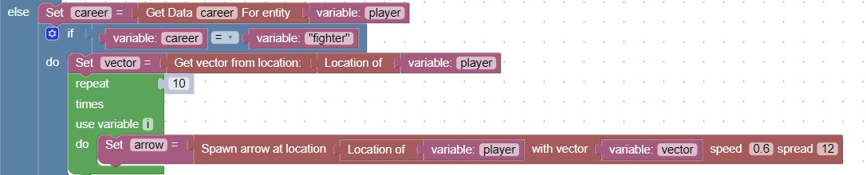

3.3 Firework with fade and flicker for infantry  
When the player performs a right click and they are on the ground and their elytra is damaged. Fireworks are launched.

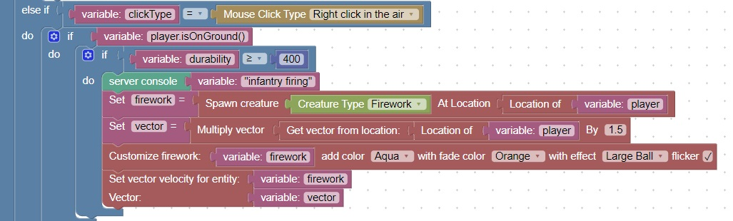

3.4 Slow falling on left click  
When a player performs a left click and their elytra is still functioning, they are propelled into the air and given slow falling so that they have time to deploy the elytra.

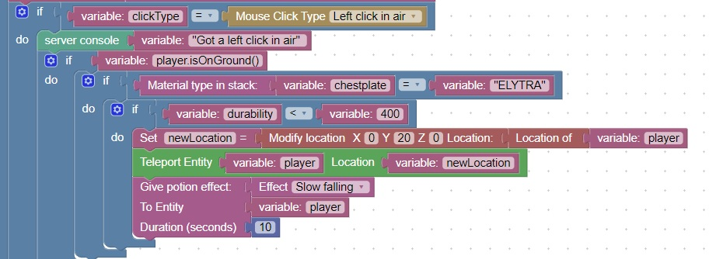

3.5 Splash Potion to protect bed  
When the player selects a career for the first time, a special splash potion is dropped at their location which will help protect their bed.

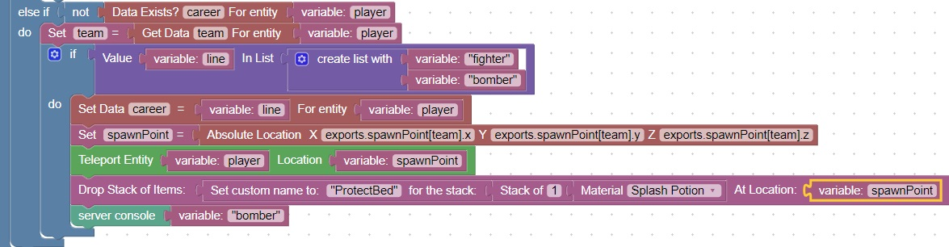

3.6 Purchase Potion in game  
A player can purchase more potions in game using precious metals

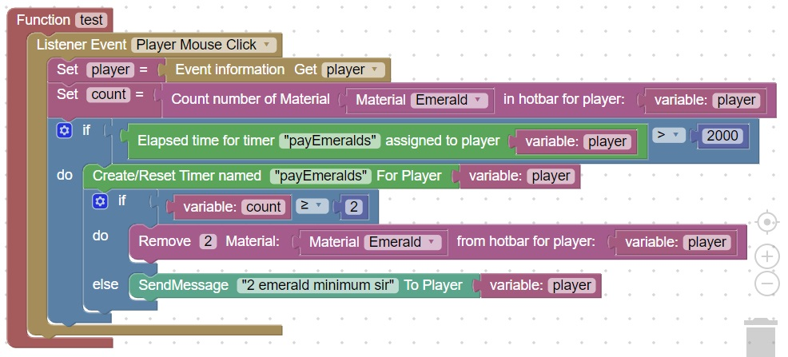

3.7 End game detection  
When a player dies, the number of active teams is determined. When only 1 team is still active they are considered the winner.



3.8 Public server considerations

There are [many public minecraft servers available](https://www.google.com/search?q=minecraft+server+rent&oq=minecraft+server+rent&aqs=chrome..69i57.8933j0j8&sourceid=chrome&ie=UTF-8). Most are very similar.  
It all comes down to cost versus playability  
Here is the price chart for apexminecrafthosting.com:



File transfer protocol is used to move files

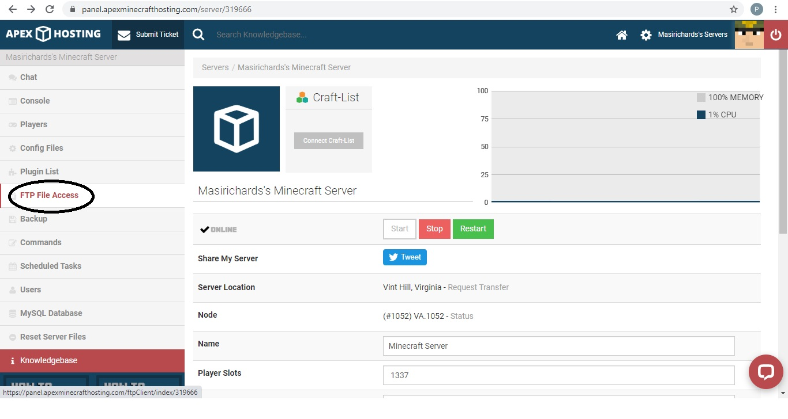

Server console is available from the server screen:

