Introduction

Have you ever wanted to create your own minecraft game and run it on a public server? This class will teach you step-by-step how to do that.

We will create 3 plugins which completely describe the behavior of 3 different games:

Spleef

Bed Wars

Omaha Beach

Plugins are easier to create and more player-friendly than mods. Plugins are also installed only on the server, which makes them easier to manage.  
Typically mods are run off Forge on the client-side and the player needs to install them. The server will kick a player if it doesn't like their list of installed mods:

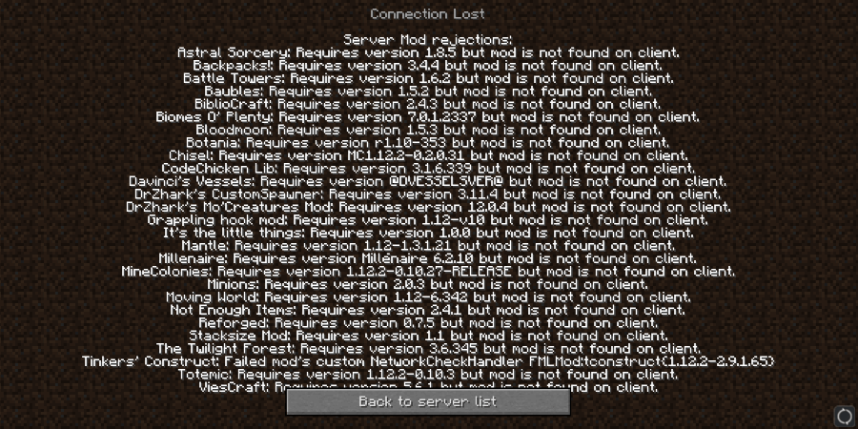  
  
Mods are also more difficult to create as they are written in java and use eclipse. The plugins we make will be created using a scratch program I wrote called **Blockly-Scriptcraft**. It looks like this:

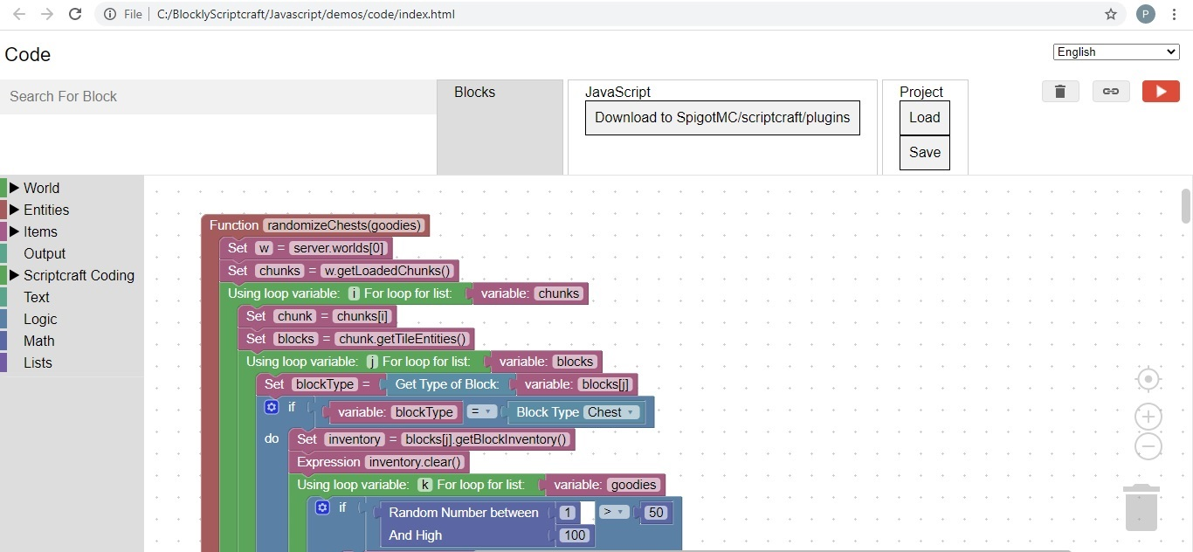

Some popular plugins you may already be aware of are: **Essentials**, **Grief Prevention**, and **World Edit**.  
This course consists of 24: 1 hour classes, 8 classes per game. We will create code in scratch and test the code on your own personal minecraft server.  
We will also discuss how to install your game on a public (paid) server, and at that end of each class you will be given access to a minecraft game on a public server that demonstrates the code we discussed in class.