**Testing (7 day chart) results on GPU 3070**

BTC/UDT 1minute chart 2023-10-15 – 2023-10-21 dataset

data_x_length: 500

data_y_length: 100

epoch: 2

**LSTM:**



Prediction:

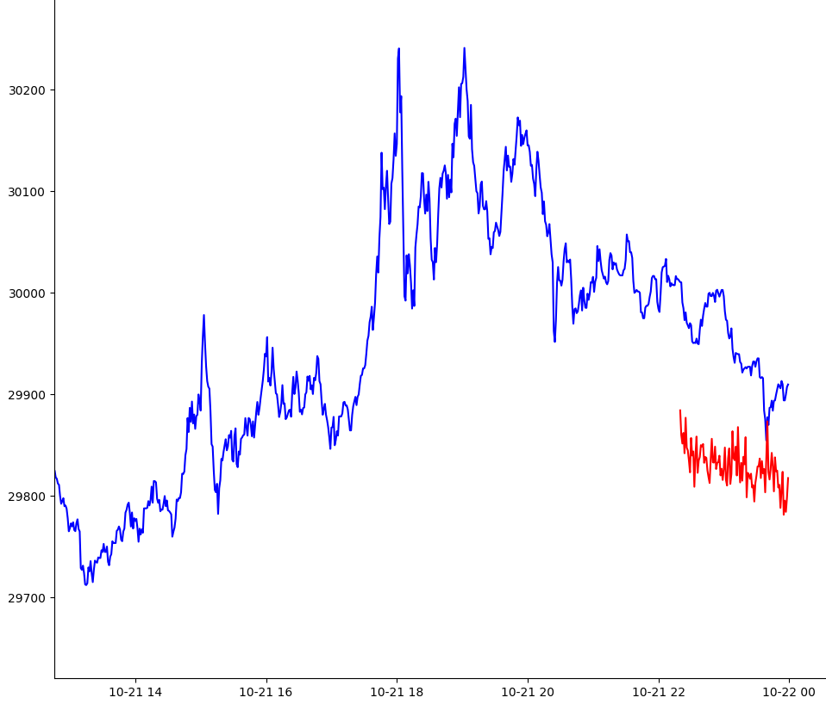

**Transformer:**

Epoch view:

Prediction:

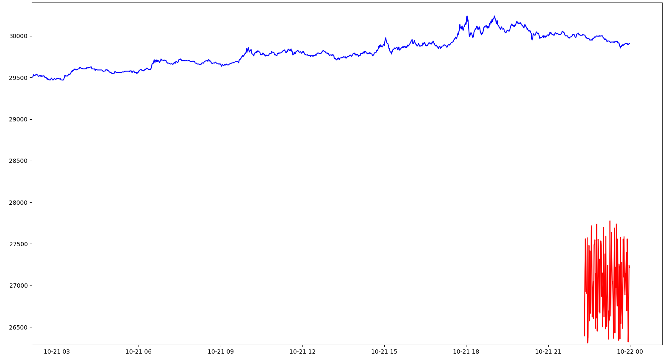

**Testing results on CPU (i7-14700KF 28 core)**

BTC/UDT 1minute chart 2023-10-15 – 2023-10-21 dataset

data_x_length: 500

data_y_length: 100

epoch: 2

**LSTM:**



**Transformer:**

Epoch view:



**Testing (21 day chart) results on GPU 3070**

BTC/UDT 1minute chart 2023-10-01 – 2023-10-21 dataset

data_x_length: 500

data_y_length: 100

epoch: 2

**LSTM:**



Prediction:

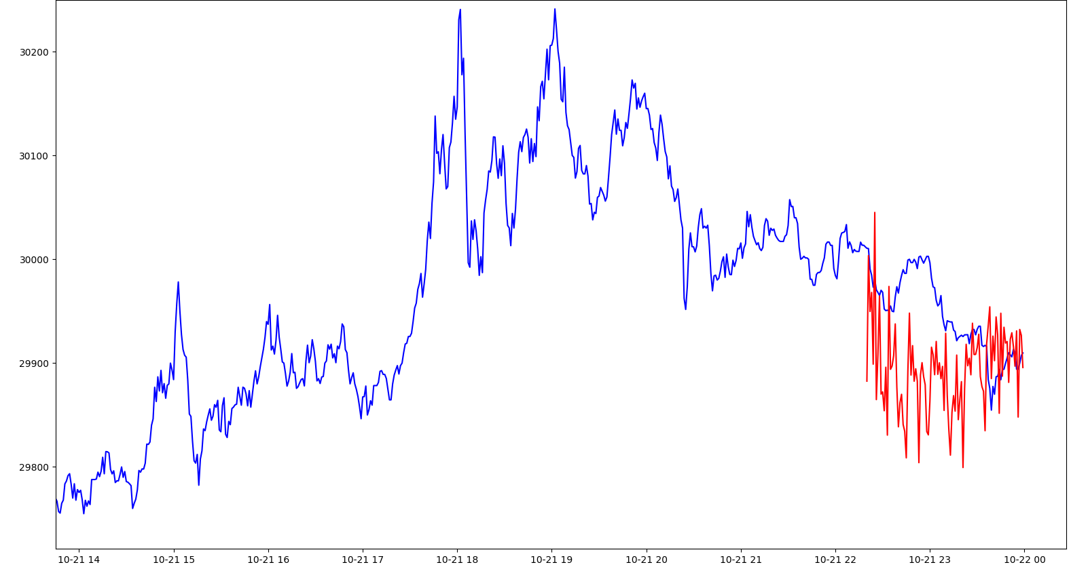

**Transformer:**

Prediction:

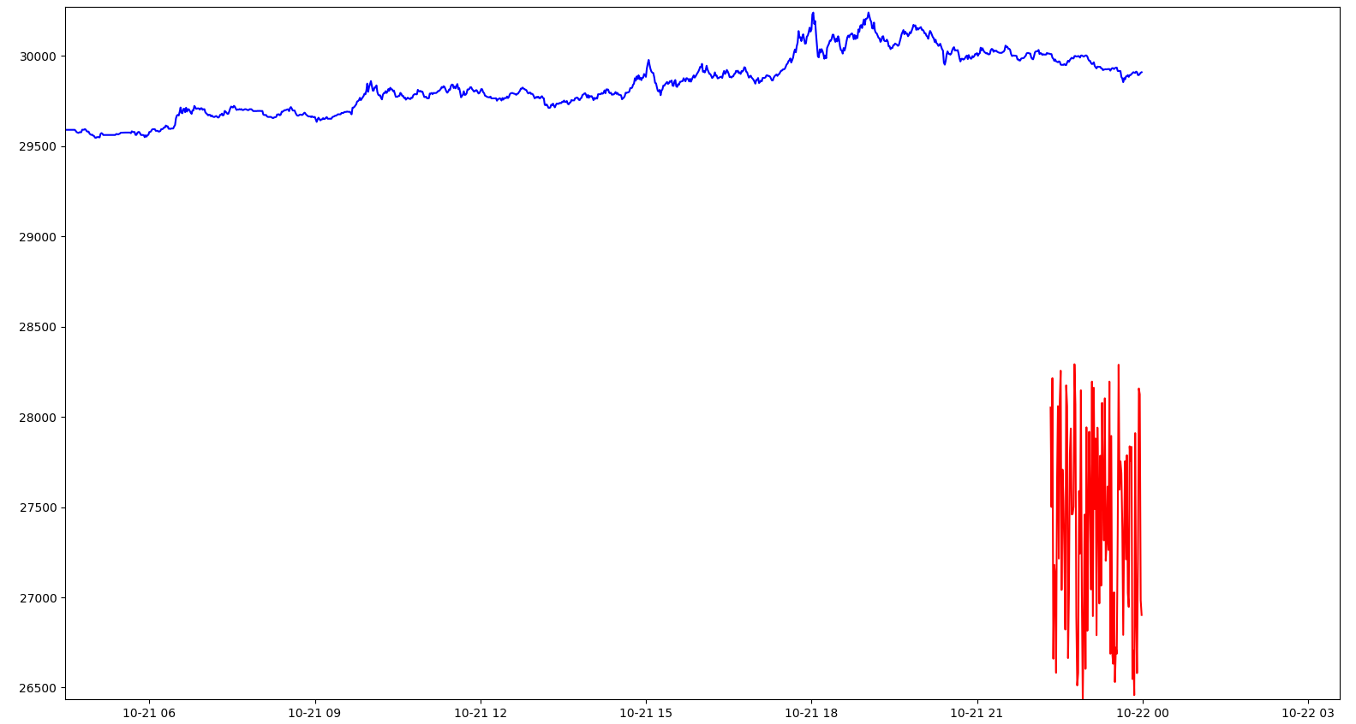

**Testing (21 day chart) results on GPU 3070**

BTC/UDT 1minute chart 2023-10-01 – 2023-10-21 dataset

data_x_length: 500

data_y_length: 100

epoch: 6

**LSTM:**

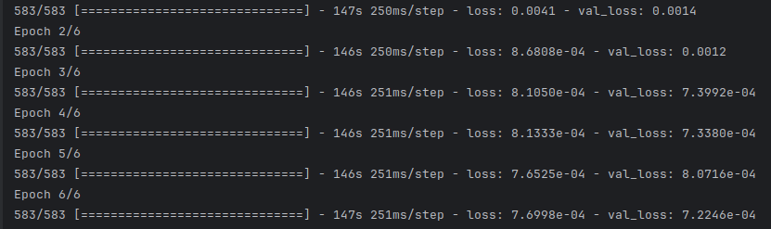

Prediction looks overfitted:

