CampusBoard: An App-Based Online Bulletin Board for Major Clubs in St. Bridget College

A Project
Presented to the College Department
St. Bridget College
Batangas City

In Partial Fulfillment
Of the Requirements for the Degree
Bachelor of Science in Information Technology

By:
Emanuel C. Bautista

To:
Mr. Jerome B. Geli
Ace Zheridan S. Gutierrez
Contents
Introduction 3
Background of the Problem 3
Purpose of the Application 4
Scope of the Application 5
App Overview 6
App Description 6
Stakeholders & Uses 7
Primary Stakeholder 7
Secondary Stakeholders 8
User Roles 8
System Requirements 10
Functional Requirements 10
Non-Functional Requirements 11
App Architecture 12
Selected Type 12
Justification 12
Overall Structure 13
Identification of Data and Structure 14
Data Source: 14
Entities & Attributes: 15
Entity Relationship 15
Relationships 15
Entity Relationship Diagram 16
UML CLASS DIGRAM 17
Key Functionalities 18
Core Features 18
Automation and Workflows 19
Business Logic and Validation 20
Interface & Design 21
Design Principles 21
Navigation Flow 22
References 33

Introduction

Background of the Problem

Staying informed is an essential part of student involvement in school organizations and major clubs at St. Bridget College (SBC). Students participate in various clubs such as academic organizations, leadership groups, technology clubs, and special interest communities, each of which regularly shares announcements about meetings, activities, events, deadlines, and important reminders. However, because information is often posted on physical bulletin boards or scattered across different social media pages, group chats, and online platforms, students may miss important updates or struggle to keep track of announcements from multiple organizations.
This lack of a centralized communication system creates confusion, missed opportunities, and reduced student engagement. Traditional bulletin boards are limited in accessibility, while scattered digital platforms can be disorganized and inconsistent. As a result, students may find it difficult to stay updated with the activities of their clubs, and organization officers may face challenges in efficiently delivering announcements to their members.
To address these issues, CampusBoard was developed as a digital announcement and bulletin board application designed for all major clubs and student organizations within the school. CampusBoard serves as a centralized platform where club officers, administrators, and authorized personnel can post official announcements, event schedules, reminders, and updates for their respective communities. Students can then easily access relevant information by viewing posts based on their joined clubs, categories, or campus-wide announcements.
By replacing traditional bulletin boards and scattered communication channels, CampusBoard enhances communication, organization, and accessibility across all major clubs in the institution. It promotes stronger student participation, improves the delivery of important information, and creates a more connected campus environment. Through this modern digital platform, CampusBoard helps ensure that students remain informed, engaged, and actively involved in school organizations.

Purpose of the Application

The purpose of the CampusBoard application is to provide a centralized, reliable, and organized digital platform for managing and distributing official announcements for all major clubs and student organizations within St. Bridget College (SBC). The application is designed to improve communication between club officers, faculty advisers, organization leaders, and students by ensuring that important updates, schedules, and announcements are accessible, well-organized, and delivered efficiently.
Specifically, the application seeks to:
- Streamline the posting and management of official announcements for all major clubs and campus organizations through one unified platform.
- Ensure that students can easily access important information anytime and anywhere, allowing them to stay updated on meetings, events, deadlines, and organization activities.
- Reduce missed announcements and communication gaps caused by relying solely on physical bulletin boards, scattered social media posts, or multiple messaging platforms.
- Promote better student engagement and participation by making it easier for students to stay informed about the activities of their respective clubs and campus-wide organizations.
- Support organized communication across multiple communities by allowing announcements to be categorized according to clubs, departments, or school-wide notices.
Through this system, CampusBoard enhances communication efficiency, strengthens coordination among school organizations, and fosters a more connected and engaged student community. By modernizing the traditional bulletin board system, CampusBoard supports the digital communication needs of a dynamic campus environment.

Scope of the Application

The CampusBoard application is designed as an internal digital announcement platform for all major clubs and student organizations within St. Bridget College (SBC). Its primary function is to manage and distribute official announcements, updates, and important information to students who are members of various campus organizations. The system allows authorized club officers, administrators, and organization leaders to securely log in and post, edit, delete, approve, and categorize announcements for their respective communities, while students can conveniently view and filter updates based on club, category, or date.
Announcements are organized chronologically to ensure clarity, accessibility, and timely delivery of information across multiple organizations. The application focuses specifically on improving communication, coordination, and information dissemination among campus clubs and student groups. CampusBoard is dedicated solely to serving as a centralized digital bulletin board and does not include unrelated features such as online payments, e-commerce functions, private messaging, social media integration, or external commercial services. Its scope is centered on creating an organized, reliable, and efficient communication system that strengthens student engagement across all major school organizations.

App Overview

App Description

CampusBoard is a digital announcement and bulletin board application designed for all major clubs and student organizations at St. Bridget College (SBC). It serves as a centralized platform where club officers, administrators, and authorized organization leaders can post official announcements, updates, schedules, and important reminders, while students can conveniently access information relevant to their joined clubs or campus-wide communities.
The application is developed as a mobile-based platform, allowing users to view announcements anytime and anywhere through their smartphones. Students can filter updates by club, category, community, or date, making it easier to stay informed about organization activities, meetings, and school events. CampusBoard supports multiple student organizations by providing dedicated spaces for different clubs while also offering general campus-wide announcements in one unified system.
By utilizing modern mobile technology, CampusBoard enhances communication across the entire campus by replacing traditional bulletin boards and scattered online messages with a more organized, accessible, and reliable digital solution. This system promotes better coordination among student organizations, improves student engagement, and ensures that important information is delivered efficiently throughout the school community.

Stakeholders & Uses

Primary Stakeholder

The primary stakeholders of CampusBoard include Club Officers or Administrators and Students from various major clubs and student organizations at St. Bridget College (SBC).
Club Officers / Administrators are responsible for posting, editing, deleting, approving, and managing official announcements within their assigned organizations or communities. They ensure that announcements are accurate, updated, relevant, and properly categorized for their members.
Students serve as the primary recipients of information. They use the application to view announcements, filter updates by club, category, community, or date, and stay informed about meetings, events, deadlines, and activities from their joined organizations as well as campus-wide announcements.

Secondary Stakeholders

Secondary stakeholders include the Faculty Advisers and the School IT Administrator.
Faculty Advisers oversee and monitor organizational announcements to ensure that posted information aligns with school policies, organizational goals, and institutional standards.
School IT Administrators provide technical support, system maintenance, user management assistance, and ensure the security, reliability, and proper functioning of the CampusBoard application.

User Roles

Super Admin
Scope: Global System Control Responsibilities:
- Acts as the ultimate authority over the CampusBoard platform.
- Manages the global user database, including the elevation or removal of administrative privileges.
- Oversees all community settings and ensures the platform’s overall security, stability, and integrity.
Club Officers / Community Admins
Scope: Community-Level Management Responsibilities:
- Maintains the official presence of their assigned clubs or interest groups.
- Curate community content by creating, editing, and approving announcements.
- Ensures that all published information is accurate, organized, and provides value to their specific members.
Students (General User)
Scope: Information Consumption & Engagement Responsibilities:
- Stays updated with campus life by browsing and filtering announcements by category, date, or club.
- Participates in the campus ecosystem by joining relevant communities and following event updates.
- Acts as the primary recipient of all club and school-wide communications.
Faculty Adviser
Scope: Policy Oversight & Quality Control Responsibilities:
- Monitors community activity to ensure all announcements align with school policies and organizational standards.
- Acts as a moderator to maintain professional communication standards.
- Provides guidance to Club Officers regarding the appropriateness and quality of posted content.
School IT Administrator
Scope: Technical Operations & Support Responsibilities:
- Manages the technical infrastructure, including system maintenance and backend performance.
- Provides technical support to all user tiers and handles security management.
- Ensures the CampusBoard application remains reliable, accessible, and bug-free for the entire institution.

System Requirements

Functional Requirements
Table 1
Functional Requirements | Description
FR01 | Admin can log in securely
FR02 | Admin can post announcements
FR03 | Admin can edit or delete announcements
FR04 | Students can view announcements
FR05 | Users can filter announcements by category
FR06 | System displays the date when an announcement was posted

Non-Functional Requirements
Table 2
Non-Functional Requirements | Description
NF01 | Secure authentication and admin access control
NF02 | Fast loading performance for smooth user experience
NF03 | Simple, clean, and user-friendly interface
NF04 | Responsive design compatible with both mobile and web platforms

App Architecture

Selected Type
- Canvas App

Justification
The CampusBoard application is best developed as a Canvas App due to its emphasis on flexible user interface design and efficient presentation of information. As a digital announcement and bulletin board platform for multiple major clubs and student organizations, CampusBoard prioritizes readability, accessibility, and ease of navigation for both students and administrators.
A Canvas App allows developers to fully customize the layout, structure, and visual design of the application, making it suitable for displaying announcements in a clear, organized, and user-friendly manner. This flexibility is important for presenting categorized posts, community-based feeds, and chronological updates in a way that is easy for users to understand and interact with.
In addition, CampusBoard primarily handles straightforward data such as announcement titles, content, categories, dates, user roles, and community assignments. These data types do not require complex relational database structures or highly advanced backend processing. Instead, they focus on simple data entry, retrieval, and filtering, which aligns well with the capabilities of a Canvas App.
Therefore, a Canvas App is the most appropriate development approach for CampusBoard, as it effectively supports the system’s goal of providing an organized, accessible, and visually intuitive communication platform for all major clubs and student organizations within the institution.

Overall Structure

System Architecture
The CampusBoard application follows a client-server architecture designed to ensure efficient announcement management, secure access, and mobile-friendly accessibility across multiple student organizations.
The system is composed of two main components: the client side (users) and the server side (backend system and database). The client side includes the different user roles such as Super Admin, Club Officers or Community Admins, Students, Faculty Advisers, and School IT Administrators. Each user interacts with the system through a mobile or web interface depending on their role and permissions.
Club Officers and Community Admins access the system through secure login credentials, allowing them to create, edit, delete, approve, and categorize announcements. These announcements are then stored in a centralized database containing key information such as title, content, category, date posted, and associated community.

Identification of Data and Structure

Data Source:
Cloud Firestore (Primary Database)
- Dependency: com.google.firebase:firebase-firestore
- Purpose: This is your main NoSQL database. It likely stores the "Notes" or "Board" content mentioned in your code (e.g., in onMessageReceived, you refer to a notification saying "New Note!"). Firestore handles real-time data syncing and persistent storage for your application's content.

Firebase Cloud Messaging (FCM - Push Notifications)
- Dependency: com.google.firebase:firebase-messaging
- File: FCMService.kt
- Purpose: This acts as a "live" data source for incoming events. When a new note is added or an update occurs, the server sends a RemoteMessage to your app. Your code in onMessageReceived extracts title and body data from these messages to trigger local notifications.

Firebase Authentication (User Data)
- Dependencies: com.google.firebase:firebase-auth and androidx.credentials
- Purpose: This handles your user identity data. It manages who is logged in and provides the UID (User ID) used to associate notes in Firestore with specific users. It also integrates with Google Sign-In (via the googleid dependency).

Local State (Memory)
- Context: application as CampusBoardApp
- Purpose: Your FCMService accesses a CampusBoardApp class, which likely holds singleton instances of helpers (like notificationHelper). While not a persistent data source, this serves as your app's internal runtime data management.

Entities & Attributes:
1. Note / Post
Attributes:
- id: String (Unique identifier, likely from Firestore)
- title: String (e.g., "Meeting at 5 PM")
- body: String (The main content of the note)
- authorId: String (Reference to the user who posted it)
- it was posted)
- category: String (Optional, e.g., "Academic", "Social", "Lost & Found")
2. User
Attributes:
- uid: String (Firebase Auth ID)
- displayName: String (Full name)
- email: String
- fcmToken: String (Stored in onNewToken to send targeted notifications to this user)
- role: String (e.g., "Student", "Faculty", or "Admin")
3. Notification
Attributes:
- title: String (Received from remoteMessage.notification or data)
- body: String
- sentAt: Long/Timestamp
- type: String (e.g., "NoteUpdate", "UrgentAlert")

4. CampusBoardApp (Application State)
Attributes/Components:
- notificationHelper: A helper object managing the NotificationManager.
- firestore: (Inferred) The database instance for CRUD operations.

Entity Relationship

Relationships
Admin --(1:N)--> Announcement
- One Admin can create many Announcements.
- Each Announcement is created by one Admin.
- Represented by adminId and adminName in the Announcement document.
Category --(1:N)--> Announcement
- One Category can have many Announcements.
- Each Announcement belongs to one Category.
- Represented by categoryId and categoryName in the Announcement document.
Announcement --(1:N)--> Attachment
- One Announcement can have many Attachments.
- Each Attachment belongs to one Announcement.
- Represented by Attachment being a subcollection under Announcement.
User --(M:N)--> Announcement (via UserAnnouncementView)
- Many Users can view many Announcements.
- Many Announcements can be viewed by many Users.
- This many-to-many relationship is resolved by the UserAnnouncementView collection, which links User and Announcement and holds additional viewData.
- Represented by userId and announcementId in the UserAnnouncementView document.

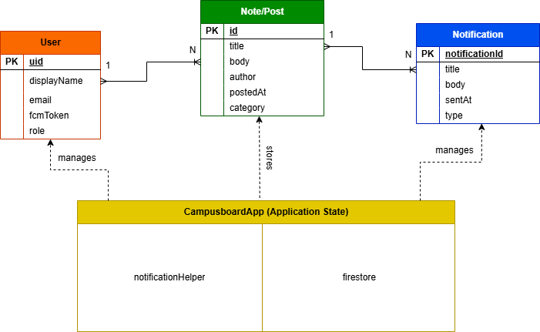
Entity Relationship Diagram

Figure 1. ER DIAGRAM

UML CLASS DIGRAM
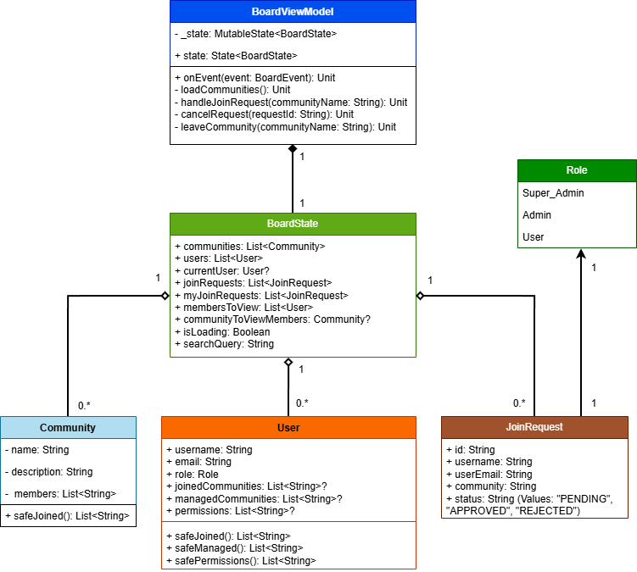

Figure 2. UML CLASS DIAGRAM (LEVEL 3)

Key Functionalities

Core Features

The CampusBoard application includes several core features designed to improve communication and information sharing across all major clubs and student organizations at St. Bridget College (SBC).
Authorized users such as Super Admins and Club Officers can create, post, edit, delete, and manage official announcements, ensuring that important information is distributed accurately and efficiently. These announcements are stored and organized in a centralized system for easy access and management.
Students can view announcements in a clear and organized interface, allowing them to stay updated with the latest activities, events, and reminders from their respective clubs and organizations. The system displays posts in chronological order to ensure that the most recent updates are easily visible.
In addition, CampusBoard supports category-based and community-based filtering, enabling users to quickly find relevant announcements based on their enrolled clubs, departments, or interest groups. This feature improves accessibility and ensures that users can efficiently navigate through different organizational updates without confusion.

Automation and Workflows

The CampusBoard application includes automated processes designed to improve efficiency in posting, organizing, and delivering announcements across all major clubs and student organizations at St. Bridget College (SBC).
When authorized users such as Super Admins or Club Officers create an announcement, the system automatically processes and stores the post in the database. Each announcement is automatically stamped with the correct date and time of posting, ensuring accurate tracking and maintaining a proper chronological order without requiring manual input.
Once published, announcements are instantly made available to students through the system interface. The workflow ensures that updates are delivered in real time, allowing users to immediately access the latest information from their respective clubs and organizations.
In addition, the system automatically organizes announcements into predefined categories and communities. This enables category-based filtering, allowing users to quickly search and view relevant posts based on their interests, enrolled clubs, or organizational groups. This automated workflow reduces manual effort, improves organization, and ensures a smooth and efficient communication process within the CampusBoard system.

Business Logic and Validation

The CampusBoard application incorporates essential business logic and validation rules to ensure data integrity, system security, and proper use of the platform across all major clubs and student organizations.
All required fields such as announcement title, content, category, and date are validated before a post can be submitted. The system prevents incomplete submissions to ensure that all announcements are clear, complete, and properly formatted before being published.
In terms of access control, posting privileges are restricted to authorized users such as Super Admins and Club Officers or Community Administrators. This ensures that only designated personnel can create, edit, or delete official announcements, maintaining the credibility and reliability of the information shared within the platform.
Additionally, the system enforces role-based permissions, ensuring that users can only perform actions allowed by their assigned role. This includes restrictions on managing communities, approving posts, and modifying system data. These validation rules help maintain a secure, organized, and trustworthy communication system within CampusBoard.

Interface & Design

Design Principles

The CampusBoard application functions as a dynamic digital ecosystem designed to bridge the gap between student organizations and the campus community through a tailored interface. By implementing a role-sensitive architecture, the platform shifts its layout and functionality based on whether the user is a general student or an authorized administrator. This ensures that every interaction remains relevant to the user’s specific goals while maintaining a cohesive visual language across the entire application.
For the general student body, the home screen serves as a vibrant discovery hub where updates from various clubs and societies converge into a single organized feed. To prevent information overload, integrated filtering systems allow users to switch between global campus news and content specifically curated from their joined communities. This streamlined approach enables students to quickly identify workshops, social gatherings, or academic deadlines that align with their personal interests without navigating through multiple disjointed pages.
When accessed by club officers or campus administrators, the interface expands into a robust management suite focused on content lifecycle and community growth. A structured creation environment guides editors through the posting process to ensure consistent communication standards across all organizations. Beyond simple broadcasting, administrators utilize a dedicated control center to monitor join requests, moderate member lists, and archive past announcements, providing the tools necessary to maintain an active and healthy digital community.
The system further deepens engagement through its specialized request and approval workflows, which allow for secure and moderated community expansion. Students can explore a directory of available groups and submit access requests, while administrators handle these inquiries through a streamlined tabbed interface that separates membership management from post approvals. This dual-sided functionality ensures that while students enjoy a frictionless browsing experience, the underlying infrastructure remains secure, organized, and easy for student leaders to govern.

Navigation Flow
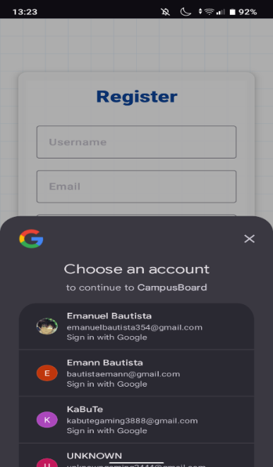
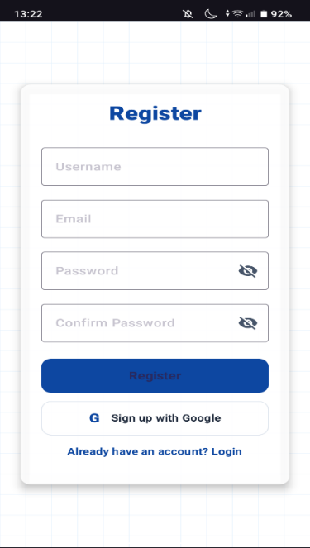
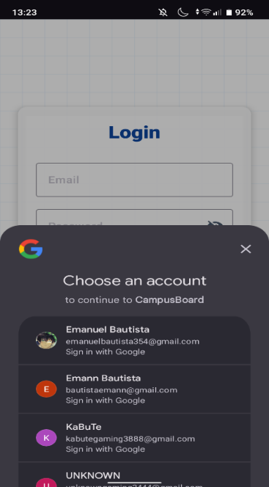
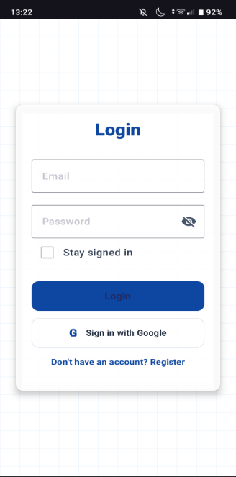

Figure 3.LOGIN & REGISTER
The authentication phase of the CampusBoard application serves as the primary gateway, ensuring that all users are identified before accessing campus communities. The Login Screen provides a clean, centralized interface where returning users can enter their credentials or utilize a "Stay signed in" feature for convenience. For new users, the Registration Screen expands to include fields for a username and password confirmation, ensuring data integrity during account creation. Both screens feature a prominent integration with the Google Identity Services API, allowing users to bypass traditional forms via a "Sign in with Google" button. This triggers a native bottom-sheet account picker, streamlining the onboarding process by leveraging existing verified institutional or personal emails to establish the user's initial profile and role within the system.
How to use:
Account Registration To join CampusBoard, new users must first create an account on the Register screen. This process requires a unique username, a valid email address, and a secure password that must be entered twice to ensure accuracy. For a faster experience, users can click "Sign in with Google," which automatically imports their verified Google profile. Once registered, the system creates a profile for the user, allowing them to start exploring communities and requesting to join campus groups.
Accessing the Account (Login) Returning users use the Login screen to get back into the app. They simply enter their registered email and password into the provided boxes. To save time later, users can check the "Stay signed in" box so they don't have to type their password every time they open the app. If a user originally signed up using Google, they just click the Google button to log in instantly. Once logged in, the app recognizes if the user is a Student or an Admin and immediately shows their specific groups and messages.
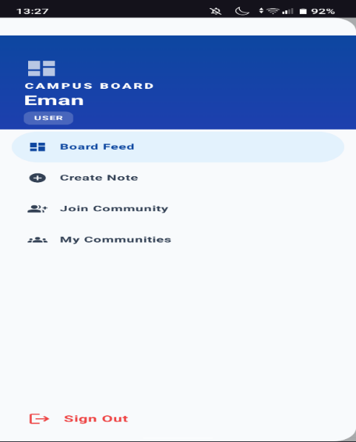
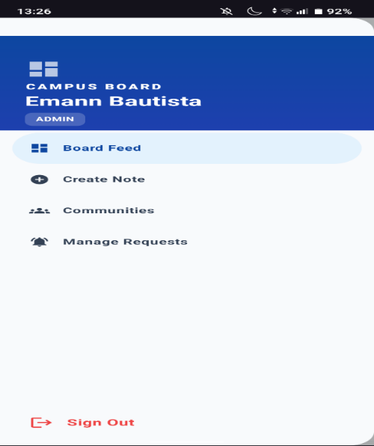
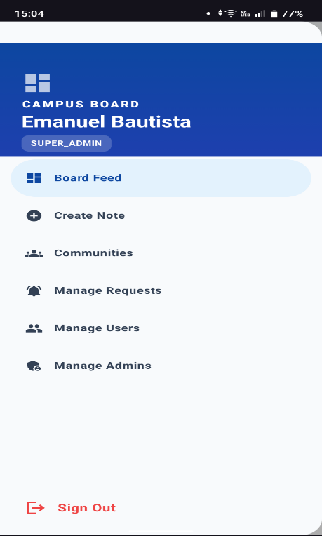
Figure 4. USERS
The navigation within the Board section follows a logic-driven path based on the user’s membership status and permissions. When a student enters the Board, the app first checks if they belong to any communities. If they do not, the navigation automatically directs them to the Join Community screen. Once a user is part of a community, the navigation unlocks the Main Board view, which allows them to toggle between their active groups. For administrators, an additional navigation layer exists through a Management Hub, which uses a tabbed system to switch between "Manage Requests" and "Post Approvals." This structured flow ensures that users only see the tools and information relevant to their current status in the campus ecosystem.

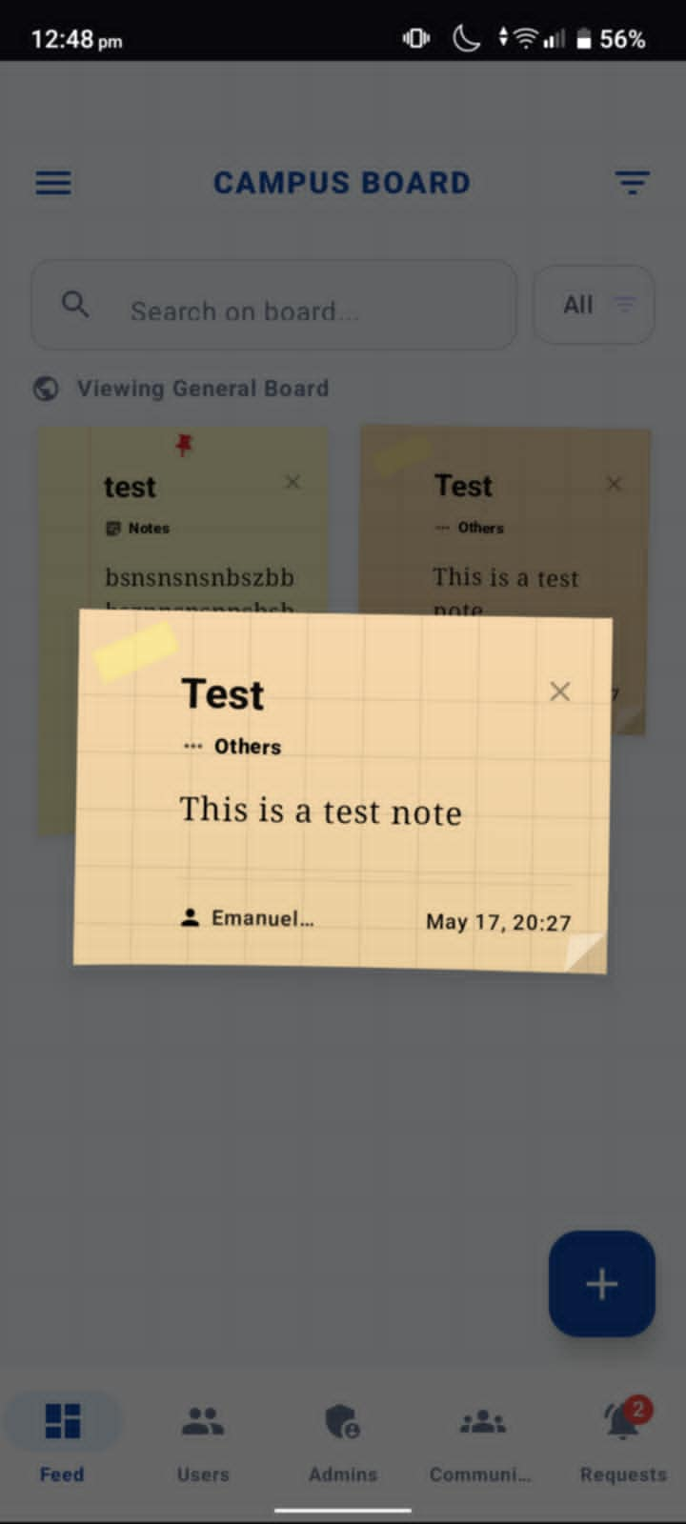
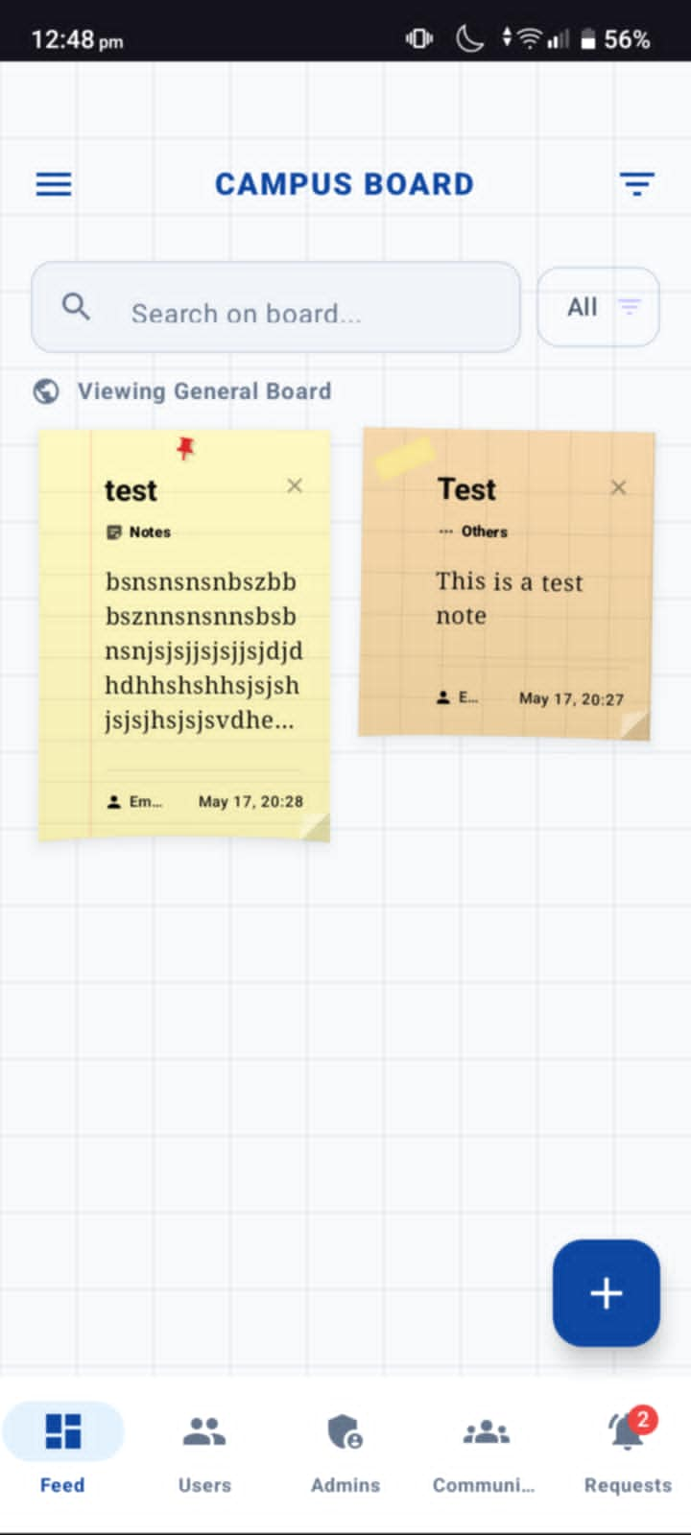

Figure 5. FEEDS
The Campus Board application is a digital bulletin board designed for university communities, allowing users to view and interact with posts styled as virtual sticky notes. The interface features a main feed where students can search and filter posts by category, as well as an expanded "modal" view for reading specific notes in detail. Beyond viewing content, the app includes comprehensive community management features that allow users to discover and request access to interest groups, while administrators can manage member lists, approve join requests, and moderate post submissions through a dedicated tabbed dashboard.
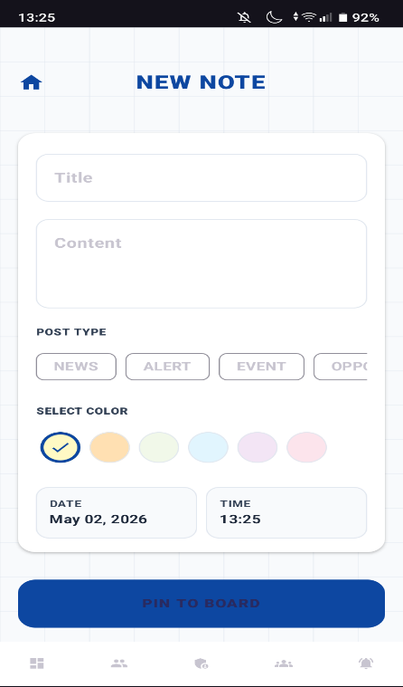
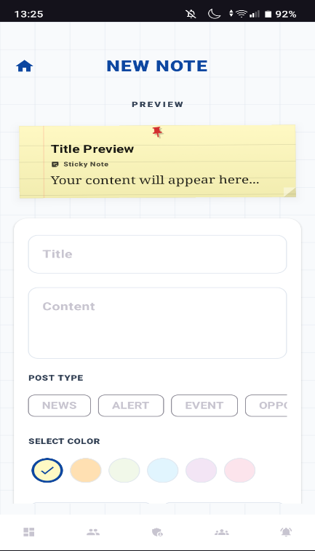

Figure 6. CREATE NOTES
The "New Note" screen is the content creation hub of the Campus Board application, designed to look like a digital stationery shop. It features a real-time "Preview" at the top that mimics a physical sticky note, complete with a red pin and ruled lines. Below the preview is a structured form where users can categorize their messages using specific "Post Type" labels and visual color coding, ensuring that every announcement is both organized and visually distinct on the main community board.
How to use:
To use the "New Note" screen in the Campus Board app, start by entering a catchy headline in the Title field and typing your message into the Content area. Next, categorize your post by selecting a Post Type from the available labels, such as News, Alert, or Event, and pick a background color from the Select Color palette to customize its appearance. You can monitor the real-time Preview at the top of the screen to see exactly how your digital sticky note will look once published. Finally, verify the automatically generated date and time before tapping the Pin to Board button to share your post with the community.
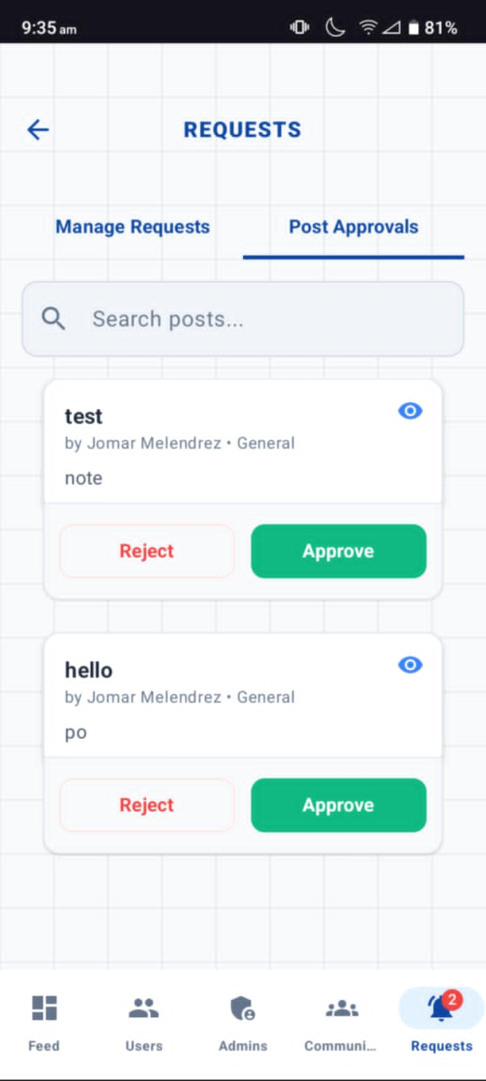
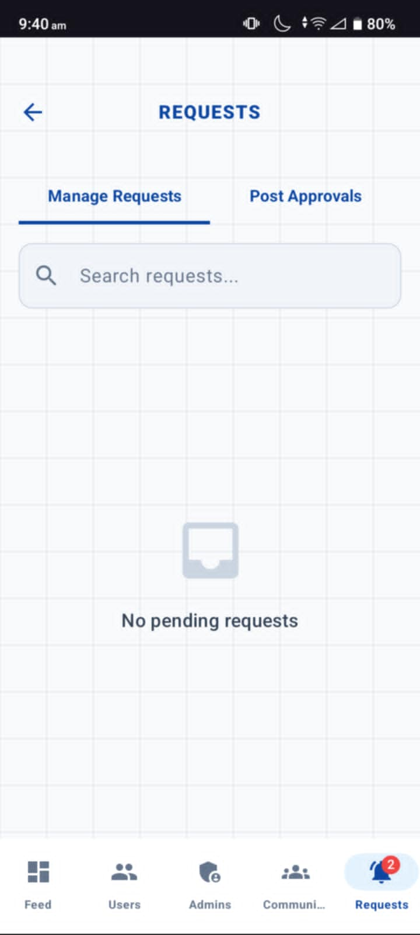

Figure 7. REQUESTS
The Requests screen serves as the administrative control center where community moderators and admins manage membership and content quality. It features a tabbed interface that separates "Manage Requests" from "Post Approvals," allowing for organized oversight. The first tab focuses on community growth by listing users who want to join specific interest groups, while the second tab acts as a content filter, ensuring that every digital sticky note is reviewed for appropriateness and relevance before it is officially published to the community board.
How to use:
To manage the community, navigate to the Requests section by tapping the notification bell icon in the bottom navigation bar. If you are reviewing new members, stay on the Manage Requests tab to see pending applications; read the user's details and the community they wish to join, then tap Accept to add them or Reject to deny the request. To moderate content, switch to the Post Approvals tab, where you can preview the title and text of submitted notes; once reviewed, tap the green Approve button to pin the note to the public board or the red Reject button to dismiss the post.
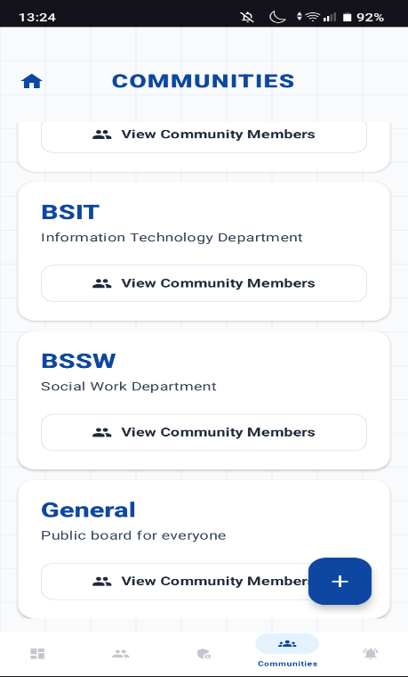
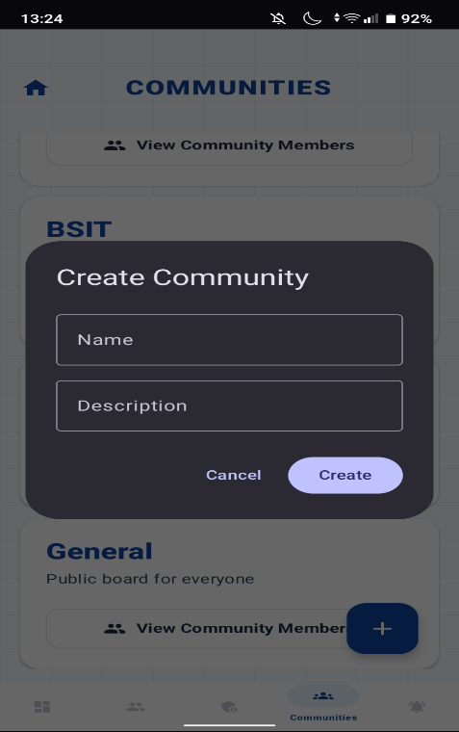

Figue 8. COMMUNITIES
The Communities screen serves as the organizational directory of the Campus Board app, where the student body is divided into specific interest groups, departments, or public boards. Each community card displays its name and a brief description, such as "Information Technology Department" or "Social Work Department," allowing for targeted communication. The interface is designed to facilitate networking through a dedicated member directory for each group and a creation tool for administrators to expand the campus ecosystem by adding new specialized forums.
How to use:
To manage or join groups, navigate to the Communities tab using the icon in the bottom navigation bar. You can browse the list of active groups and tap the View Community Members button on any card to see a list of users currently in that group. If you wish to establish a new group, tap the blue plus (+) floating action button at the bottom right to open the Create Community modal, where you must enter a unique name and a descriptive summary before clicking Create. Additionally, for groups you are already a member of, you can use the management options to view private content or choose to leave the community if you no longer wish to participate.
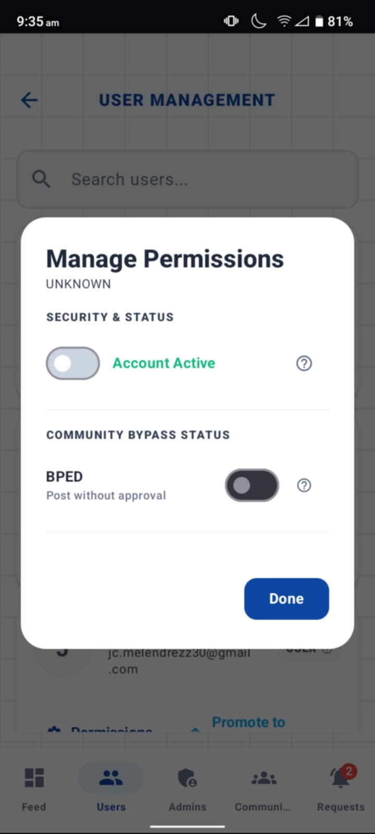
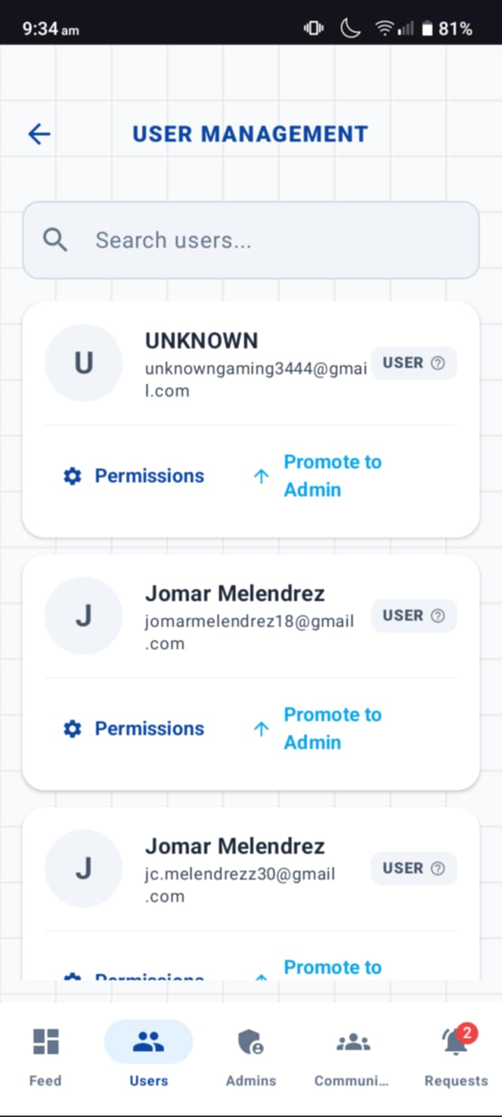

Figure 9. USER PERMISSIONS
The User Management screen is a central dashboard for administrators to monitor and control user access across the Campus Board platform. It provides a searchable list of all registered users, displaying their current roles and contact information while offering quick actions for role elevation and permission adjustments. The "Manage Permissions" overlay allows for precise administrative oversight, including the ability to deactivate accounts for security reasons or grant "bypass" status, which lets trusted members post content instantly without going through the standard moderation queue.
How to use:
To manage users, navigate to the Users tab from the bottom navigation bar and use the search field to locate a specific person by their name or email address. To upgrade a user's authority, tap Promote to Admin on their profile card, or tap the Permissions gear icon to open a detailed settings window. Within this modal, you can toggle the Account Active switch to enable or disable their access to the app, or use the Community Bypass toggles to allow that specific user to publish posts without waiting for admin approval. Once you have finished adjusting these security settings, tap the Done button to save your changes and return to the main list
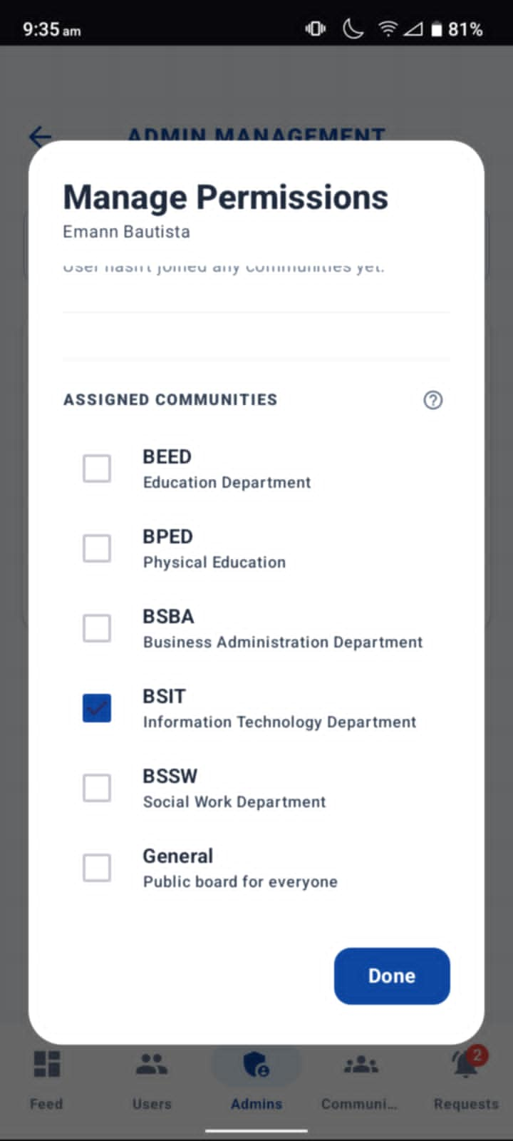
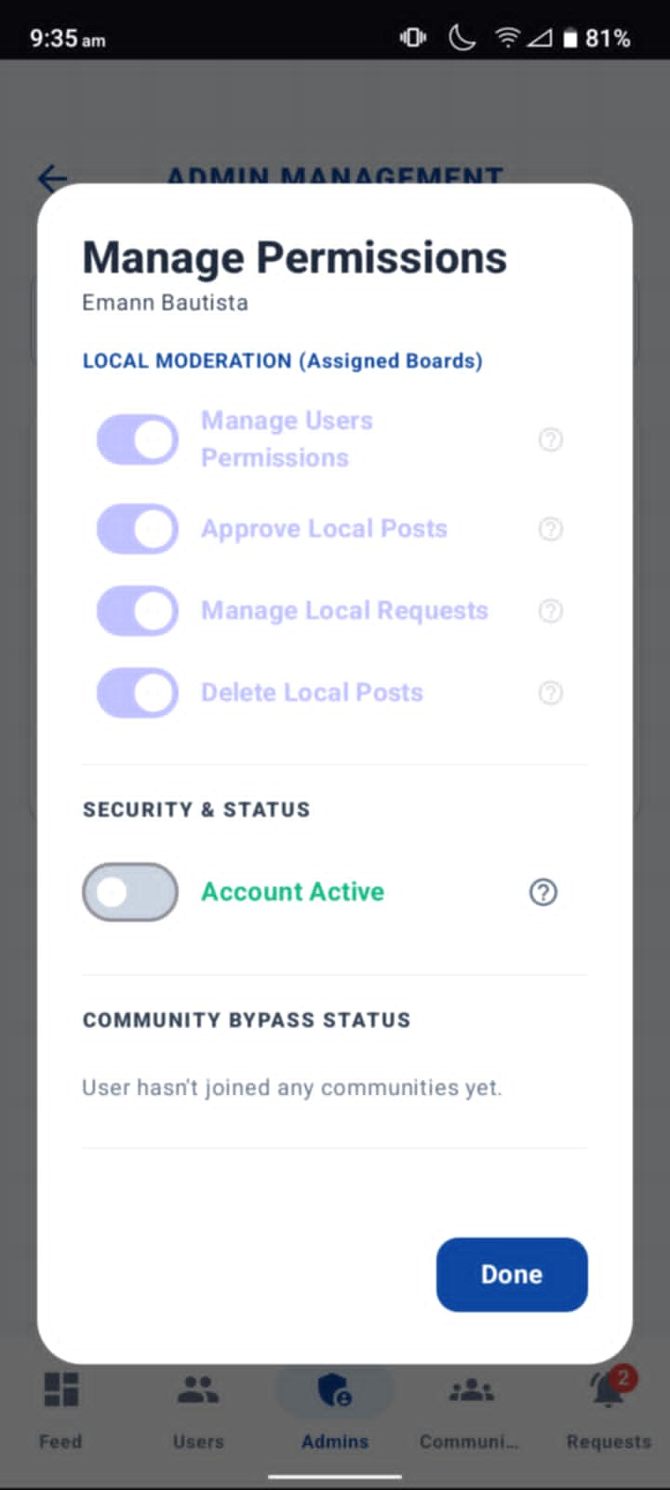
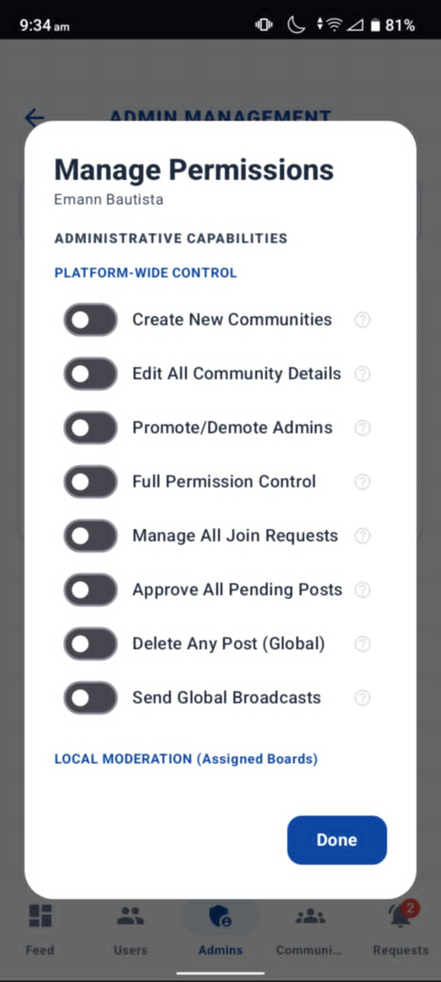
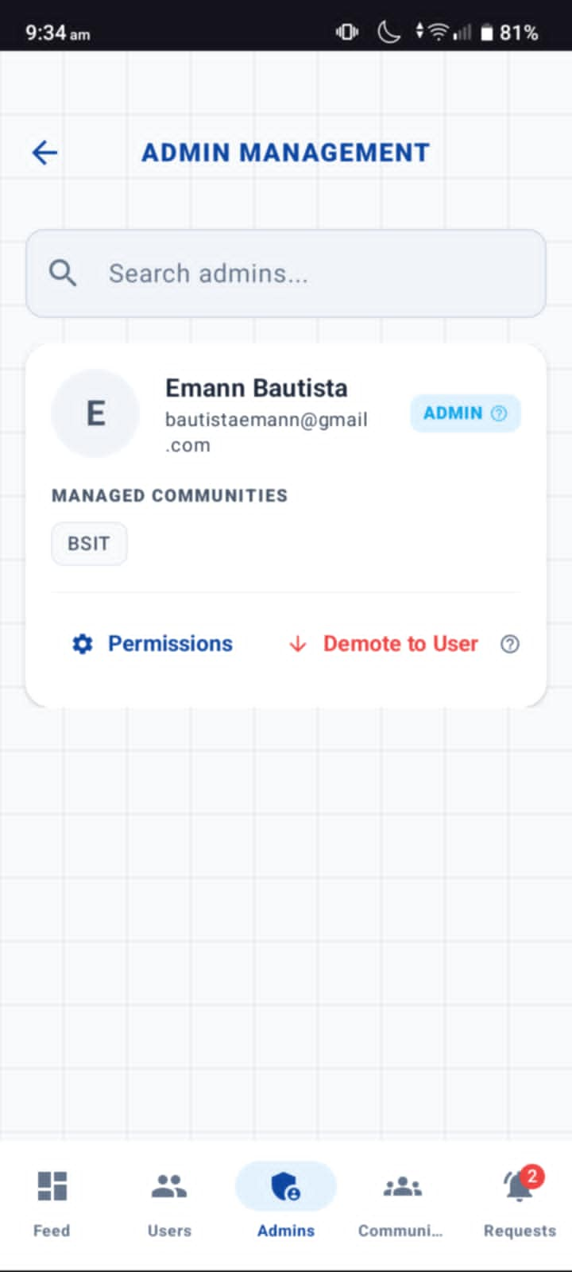
Figure 10. ADMIN PERMISSIONS
The Admin Management screen is the high-level governance module of the Campus Board application, intended for Super Admins to delegate authority. This interface provides a searchable directory of existing administrators, showing their assigned departments and offering the ability to demote them back to standard user status if necessary. The core of this module is a multi-layered permission system that distinguishes between Platform-Wide Control (global powers like creating communities or sending broadcasts) and Local Moderation (restricted powers for specific assigned boards), ensuring that staff members have exactly the level of access required for their specific roles without compromising overall system security.
How to use:
To manage administrative staff, navigate to the Admin tab in the bottom navigation bar and locate the relevant administrator using the search bar. Tap the Permissions gear icon to open the management modal, where you can scroll through three distinct sections: first, toggle Platform-Wide Control settings to grant broad authority like global post deletion; second, adjust Local Moderation and Security & Status to define what the admin can do within their assigned areas or to temporarily deactivate their account; and third, use the Assigned Communities checklist to select specific departments (such as BSIT or BEED) that the admin is responsible for overseeing. Once you have finished configuring their specific access levels, tap the Done button to apply the changes, or use the Demote to User option on the main list if you need to remove their administrative privileges entirely.
Navigation Flow
The CampusBoard application follows a structured and role-based navigation flow to ensure easy access for both students and administrators.
Student Navigation Flow:
Home Screen → Announcement List → Announcement Details
Students begin at the Home Screen where they can view available announcements. They can then proceed to the Announcement List to filter and browse updates by category or community, and finally open Announcement Details to read full information about a specific post.
Admin Navigation Flow:
Admin Login → Dashboard → Create Announcement / Manage Announcements
Administrators start by securely logging into the system through the Admin Login page. After authentication, they are directed to the Dashboard where they can create new announcements or manage existing posts by editing, updating, or deleting content as needed.

References
- Al-Kumaim, N. H., Alhazmi, A. K., Mohammed, F., Gazem, N. A., Shabbir, M. S., & Fazea, Y. (2021). Exploring the impact of digital learning platforms on students’ engagement and communication in higher education. Education and Information Technologies, 26(5), 5671–5698. https://doi.org/10.1007/s10639-021-10507-1

- Bond, M., Bedenlier, S., Marín, V. I., & Händel, M. (2021). Emergency remote teaching in higher education: Mapping the first global online semester. International Journal of Educational Technology in Higher Education, 18(1), 1–24. https://doi.org/10.1186/s41239-021-00282-x

- Google for Education. (2024). Digital collaboration and communication tools for schools and organizations
.
- Microsoft Education. (2024). Improving communication and student engagement through digital platforms.

- UNESCO Digital Education Resources. (2023). Digital education and technology integration in modern learning environments.

