Router Configurations

A Final Project
Presented to the College Department
St. Bridget College
Batangas City

In Partial Fulfillment
of the Requirements for the Networking 2

By
Alegria, Daryl A.
Awitan, Rose Marie Ann L.
Azana, Jhon Benedict A.

December 2025

Router Configurations

A Final Project
Presented to the College Department
St. Bridget College
Batangas City

In Partial Fulfillment
of the Requirements for the Networking 2

By
Awitan, Rose Marie Ann L.
Azana, Jhon Benedict A.
Bautista, Emanuel C.

Submitted to:
Mr. Jerome B. Geli

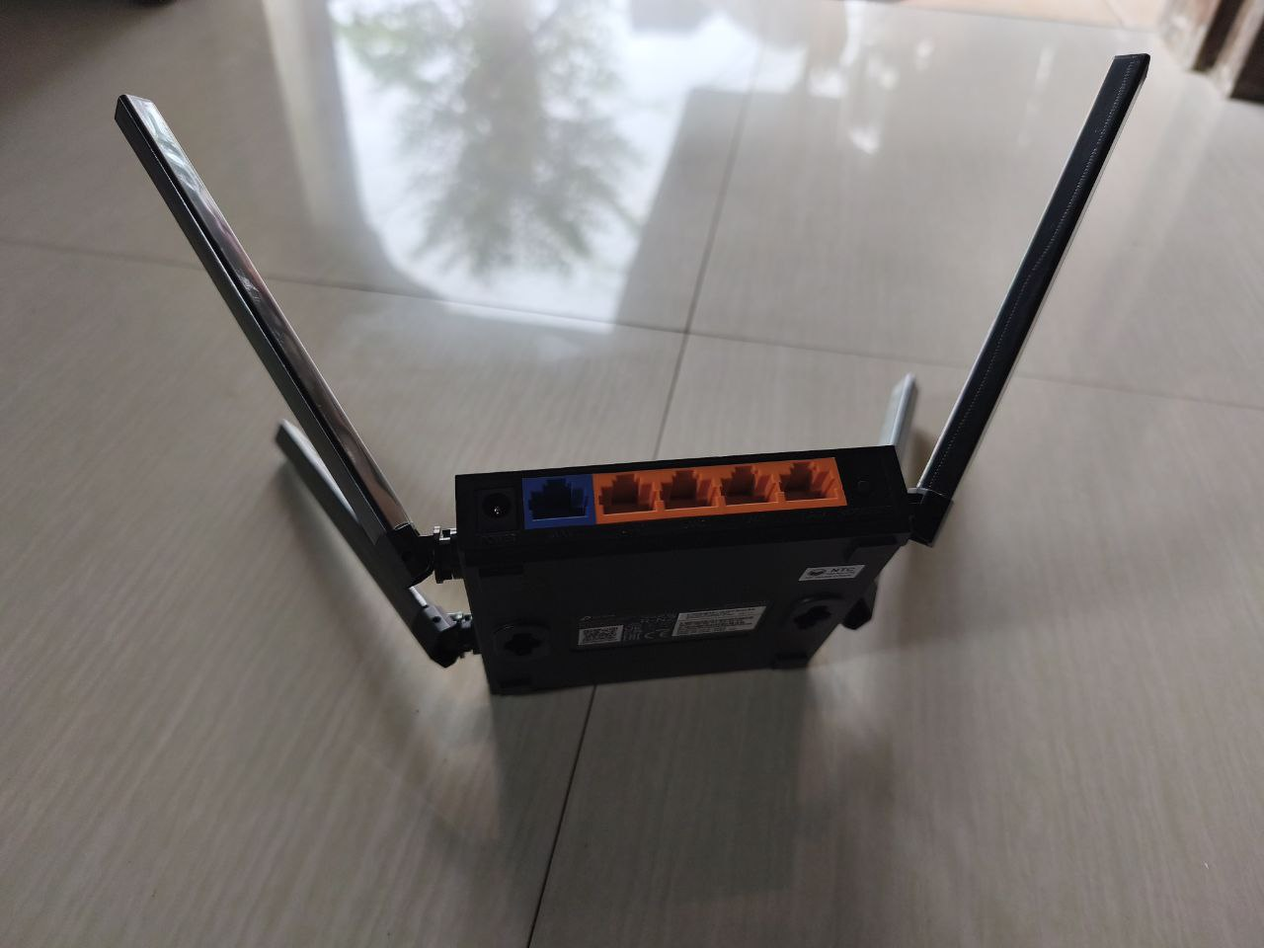
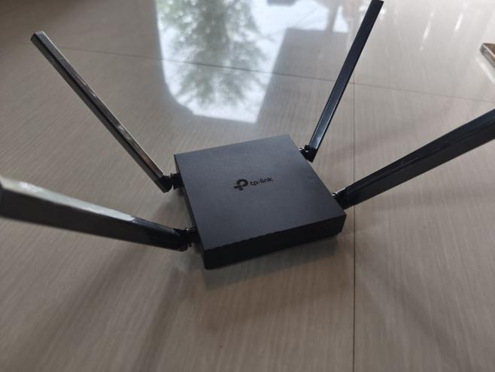
Figure 1: Router’s Specification
Here is the TP-Link Archer C54 AC1200 Dual-Band Wi-Fi Router description rewritten in paragraph form without any links:
The TP-Link Archer C54 is a compact dual-band Wi-Fi 5 router that delivers AC1200 wireless speeds, providing up to 867 Mbps on the 5 GHz band and 300 Mbps on the 2.4 GHz band, making it suitable for HD streaming, online gaming, and general internet use. It supports 802.11ac/n/a standards on 5 GHz and 802.11n/b/g on 2.4 GHz. Equipped with four fixed omni-directional antennas and beamforming technology, the router enhances signal strength and coverage, effectively serving a typical medium-sized home. MU-MIMO technology is also built in, allowing the router to communicate with multiple devices at the same time for improved performance.
For wired connectivity, the Archer C54 includes one 10/100 Mbps WAN port and four 10/100 Mbps LAN ports. It is powered by a 9V/0.85A adapter and has a combined WPS/reset button for quick setup or system reset. In terms of security, it supports WEP, WPA, WPA2, and WPA3 encryption, along with features like IP/MAC binding, access control, and an SPI firewall. The router offers multiple modes of operation such as Router Mode, Access Point Mode, and Range Extender Mode. It also has parental controls, guest networks on both 2.4 GHz and 5 GHz bands, and device-based QoS.
Additional features include IPTV support with IGMP snooping, proxy, and VLAN options, IPv6 compatibility, and easy management via a mobile app or web interface. The design is compact, measuring approximately 115 × 106.7 × 24.3 mm, and the package typically includes the router, a power adapter, an Ethernet cable, and a quick installation guide. It operates within standard temperature and humidity ranges and uses wireless transmission power compliant with international regulations, ensuring stable and reliable performance for everyday home networking needs.
If you want it in a shorter version or more formal format, I can revise it!

