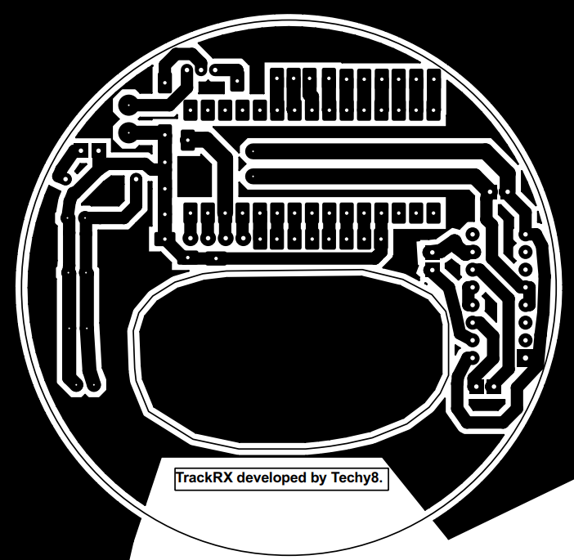  Main controller  Power supply route  Motor/locking control  Sensors and Communication Section (net, gps..)  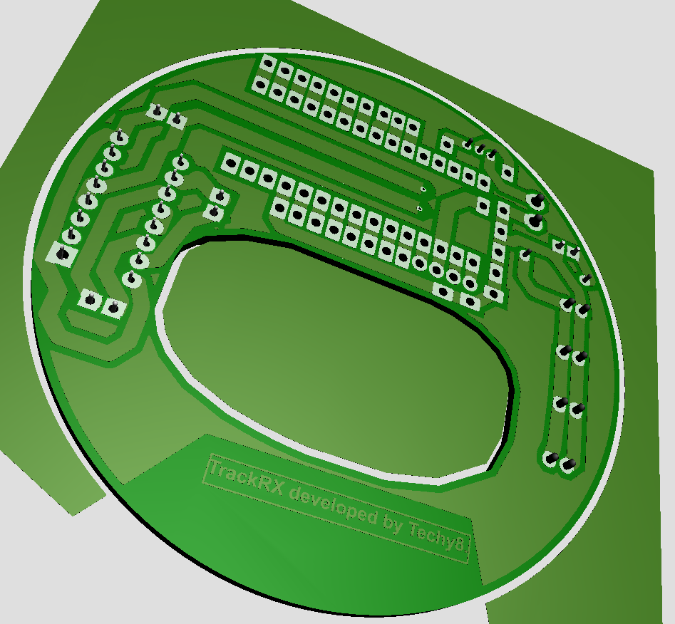 | Printed Circuit Board | This is the main circuit board for the trackRX cap design with different components connected together as shown.
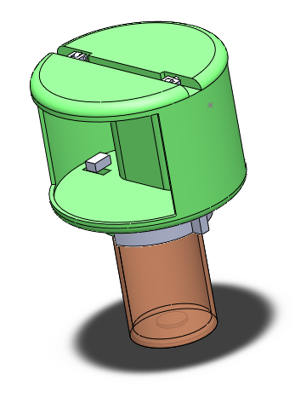 | Cup designs | The current cup design, with the front, back and top.
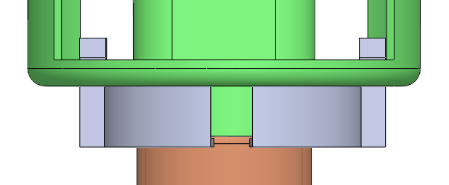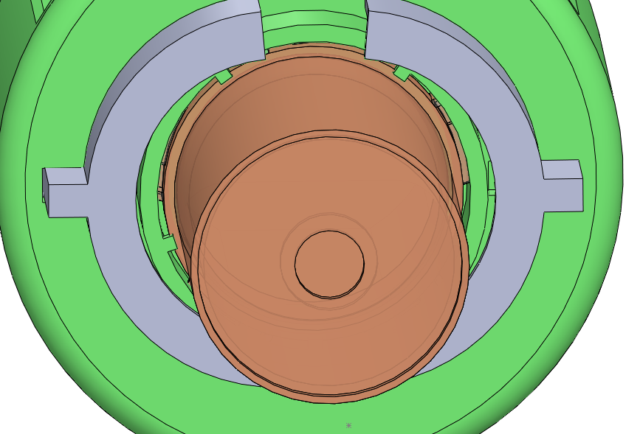  Front  Open  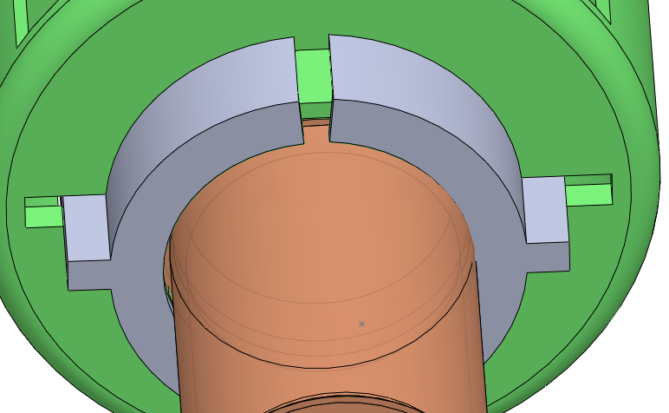  Closed | Bottom lock Mechanism | The current bottom mechanism design. the lock is remotely activated from the dashboard.
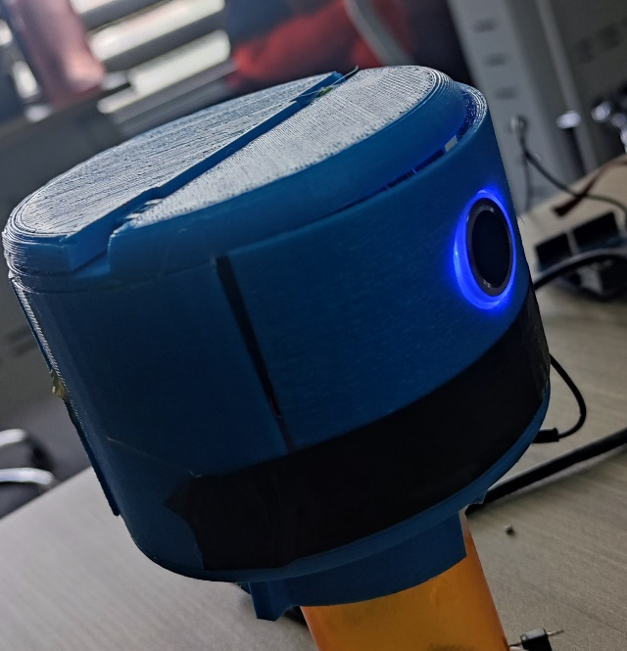 | Device during trial | Smart cap.
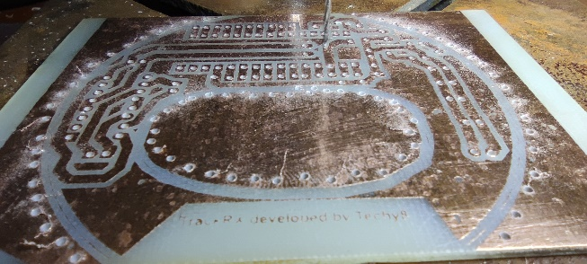 | Drilling of the trackRX pcB | TrackRX pcb.
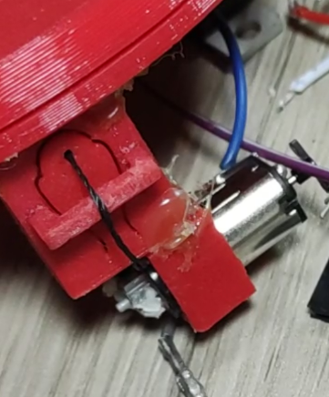 | On device top locking mechanism | Attract and retract based on given command.

