Island Shores Artisans & Tours (PEI)
Intercom Fin AI Agent — Third-Party Risk & AI Governance Assessment
Author: Eliza Benedict | Client: Island Shores Artisans & Tours (PEI) | Date: September 2026
Frameworks: ISO 27001:2022 • ISO 42001 (AI Management) • NIST AI RMF 1.0 • PIPEDA • GDPR

1. Executive Summary & Dashboard
Island Shores Artisans & Tours is a fictional 15-employee retail and guided tour business in Charlottetown, Prince Edward Island (PEI), Canada. To automate customer inquiry response times during peak travel seasons, the business is evaluating the deployment of the Intercom Fin AI Agent (a retrieval-augmented generation support system). This assessment evaluates the security, AI governance, privacy, and third-party vendor risks associated with integrating Fin AI into customer support operations.
EXECUTIVE FINDING: Intercom demonstrates a mature enterprise security baseline (SOC 2 Type II, ISO 27001, ISO 42001) and zero-retention AI inference agreements with LLM subprocessors (OpenAI/Anthropic). However, Island Shores faces 4 critical operational/configuration gaps regarding customer-side chat log retention, cross-border privacy disclosures under PIPEDA, AI hallucination governance, and mandatory AI bot labeling.

Priority Remediation Matrix
Prio | Risk Finding | Recommended Action | Owner | Timeline
01 | Undisclosed Cross-Border Processing | Update website Privacy Policy to explicitly disclose US-based AI subprocessor data flows under PIPEDA. | Legal / Ops | Pre-Launch
02 | Over-Retention of Customer Chat Logs | Configure automated Intercom inbox retention rules to purge chat logs after 12 months; enforce mandatory 2FA/SSO. | IT Admin | Setup
03 | AI Hallucination on Tour Policies | Restrict Fin KB to vetted FAQs; conduct 10 adversarial edge-case simulation tests in Intercom testing environment. | Support Lead | 2 Wks Pre-Launch
04 | Mandatory AI Disclosure | Ensure Intercom's 'Show AI Agent label' remains active and greeting message explicitly identifies AI status. | Support Lead | Pre-Launch

2. Scope, Methodology & Evidence Taxonomy
The assessment followed a structured 5-Stage GRC Assessment Methodology ensuring thorough risk evaluation across vendor architecture and customer operational controls:
- 1. Identify: Defined business use case, tourist PII data categories, subprocessor supply chain (AWS, OpenAI, Anthropic), and legal requirements (PIPEDA / GDPR).
- 2. Assess: Analyzed vendor security documentation, SOC 2 reports, ISO 42001 AI management evidence, DPA terms, and default platform settings.
- 3. Map: Mapped vendor and customer control responsibilities against ISO 27001:2022, ISO 42001, NIST AI RMF 1.0, and PIPEDA/GDPR principles.
- 4. Evaluate: Calculated inherent risk ratings, assessed control mitigation efficacy, and derived residual risk ratings.
- 5. Remediate: Formulated operational Standard Operating Procedures (SOPs), an action tracker, and ongoing monitoring requirements.

Evidence Classification & Assessment Limitations
To preserve analytical transparency, evidence is classified across four distinct tiers: Vendor Documentation (SOC 2, ISO 27001/42001 certs, DPA), Assessment Findings (configuration audits, data flow analysis), Customer Responsibilities (workspace access, MFA, retention settings), and Remediation Artifacts (SOPs, test logs, policy updates).
LIMITATIONS & DISCLAIMER: This document reflects a simulated third-party risk assessment produced for portfolio demonstration purposes using publicly available vendor documentation and a fictional business scenario. It does not constitute formal legal counsel or a regulatory compliance audit.

3. System Architecture & Data-Flow Mapping
Mapping how tourist data moves across systems is essential to evaluating third-party risk. Data flows from website visitors through TLS 1.3 encrypted web widgets to Intercom's VPC gateway. Prompts augmented with approved Knowledge Base articles are dispatched to third-party LLM subprocessors (OpenAI / Anthropic) via zero-retention API calls. Final conversation transcripts and user profiles are stored in AWS encrypted databases (AES-256).

Shared Responsibility Matrix
Control Domain | Intercom (Vendor) Scope | Island Shores (Customer) Scope
Data Encryption | Enforces TLS 1.3 in transit and AES-256 at rest across AWS DBs. | Deploys widget strictly on HTTPS secure website domains.
Access Control | Provides SSO, SCIM, 2FA, and granular RBAC platform capabilities. | Enforces mandatory 2FA/SSO; reviews admin access quarterly.
AI Inference Privacy | Enforces zero-retention DPAs prohibiting LLM model training. | Discloses third-party AI processing in Privacy Policy.
Data Retention | Provides workspace deletion API upon contract termination. | Configures automated chat transcript deletion rules (12 mos).
AI Accuracy & Safety | Provides RAG architecture, confidence thresholds & test tools. | Curates accurate KB content; executes pre-launch edge testing.

4. Control Assessment Matrix (ISO 27001 / ISO 42001 / NIST AI RMF)
Framework Ref | Control Objective | Vendor Implementation | Evidence Source | Status
NIST Govern 1.1  ISO 42001 A.5.1 | AI Governance & Oversight | Intercom maintains formal AI governance validated via ISO 42001 and AIUC-1 certifications. | ISO 42001 Cert | Addressed
NIST Map 3.1  ISO 27001 A.5.21 | Subprocessor Supply Chain | DPAs require zero retention & prohibit LLM model training with OpenAI/Anthropic. | Intercom DPA & Subprocessor List | Addressed
NIST Measure 2.6  ISO 42001 A.8.8 | AI Hallucination & Safety | RAG grounded strictly in KB; confidence thresholds trigger human escalation. | Fin Product Specs | Addressed
NIST Manage 2.1  ISO 27001 A.8.24 | Cryptography & Access | AES-256 at rest, TLS 1.3 in transit, 2FA/SSO/RBAC capabilities. | SOC 2 Type II Report | Addressed
NIST Manage 2.3  ISO 27001 A.8.10 | Information Retention | Workspace data deleted 30 days post-termination. | Privacy Policy | Partially Addressed

5. Privacy & Regulatory Assessment (PIPEDA / GDPR)
Island Shores remains the Data Controller and must actively enforce regulatory compliance under Canadian PIPEDA and EU GDPR across three primary privacy dimensions:
- Cross-Border Data Transfers: Although Intercom offers EU AWS data residency (Dublin), AI inference calls route through US-based LLM APIs (OpenAI/Anthropic). Under PIPEDA Principle 4.1, Island Shores must disclose cross-border processing to users.
- Automated AI Transparency: Canadian OPC guidance and GDPR rules mandate informing consumers when interacting with an AI system. The Messenger 'Show AI Agent' label must remain permanently active.
- Data Minimization & Retention: While zero-retention contracts protect LLM inference, chat transcripts in the Intercom inbox persist indefinitely by default unless automated purging rules are enabled.

6. Risk Register & Scoring Methodology
Inherent and Residual Risks are derived using a standard 5x5 matrix (Inherent Risk = Likelihood x Impact). The visual heat map below illustrates the risk reduction trajectory achieved by implementing customer-side controls and SOP safeguards:
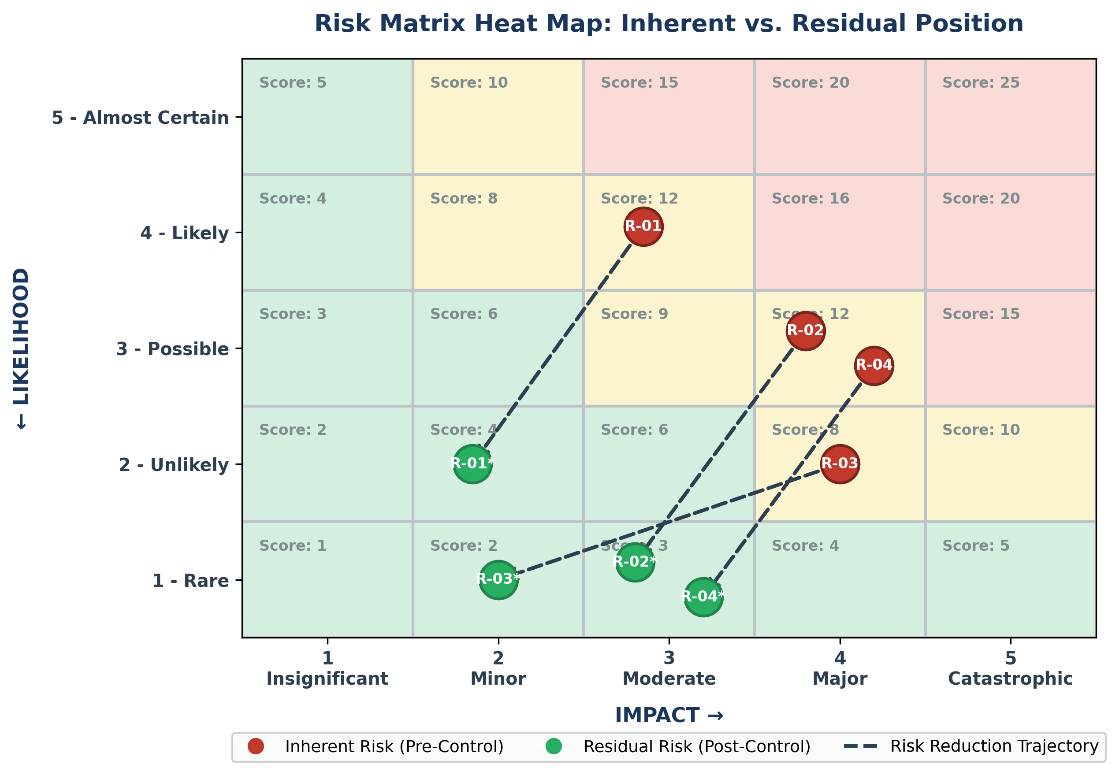
Figure 1: 5x5 Risk Matrix Heat Map displaying Inherent vs. Residual Risk Trajectories
ID | Risk Description | L | I | Inherent | Vendor & Customer Controls | Residual
R-01 | AI Hallucination on Pricing / Tour Rules | 4 | 3 | High (12) | RAG limited to approved KB; confidence threshold triggers human escalation. Customer curates KB strictly. | Low (4)
R-02 | Undisclosed Cross-Border PIPEDA Transfer | 3 | 4 | High (12) | Vendor DPA SCCs. Customer updates website Privacy Policy prior to system launch. | Low (3)
R-03 | PII Exposed to LLM Model Training | 2 | 4 | Med (8) | Zero-retention contractual ban on LLM training. Customer conducts annual TPRM review. | Low (2)
R-04 | Unauthorized Admin Access to Chat Database | 3 | 4 | High (12) | Intercom 2FA/SSO/RBAC. Customer mandates 2FA/SSO on all staff accounts. | Low (3)*

* Residual risk rating is strictly contingent on 2FA/SSO enforcement across all workspace users.

