S.T.F.A. LEE KAM PRIMARY SCHOOL
2025-2026 GENERAL ENGLISH FIRST TERM EXAMINATION
Class : P.3 ( ) Marks :___________
Name : ( ) Parent’s Signature :___________
< Time Allowed：45 minutes >
- Look at the pictures and fill in the blanks with the words from the target vocabulary list. (10%@2%)
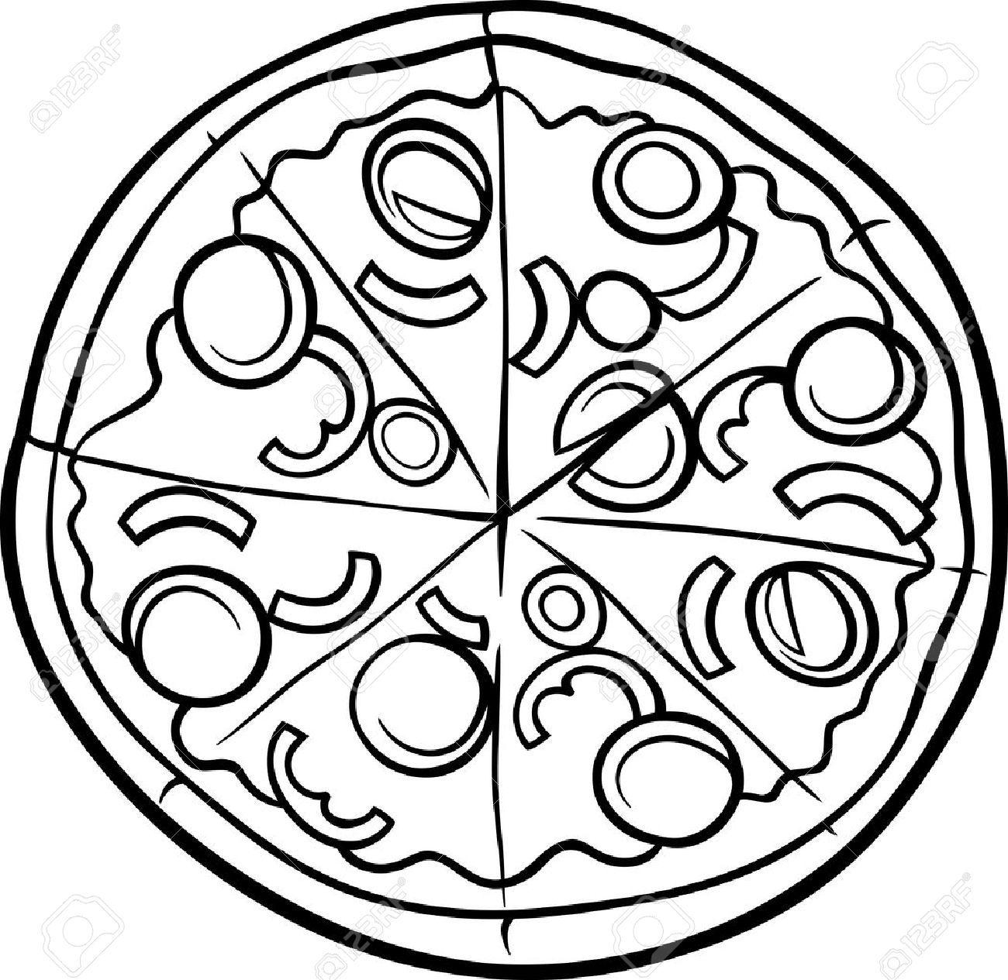 | 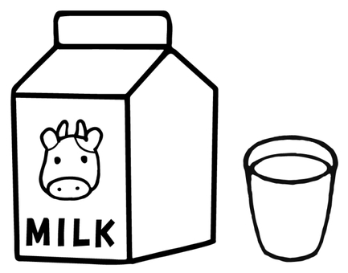  (1) a c____________ of milk
(e.g.) p i z z a
 | 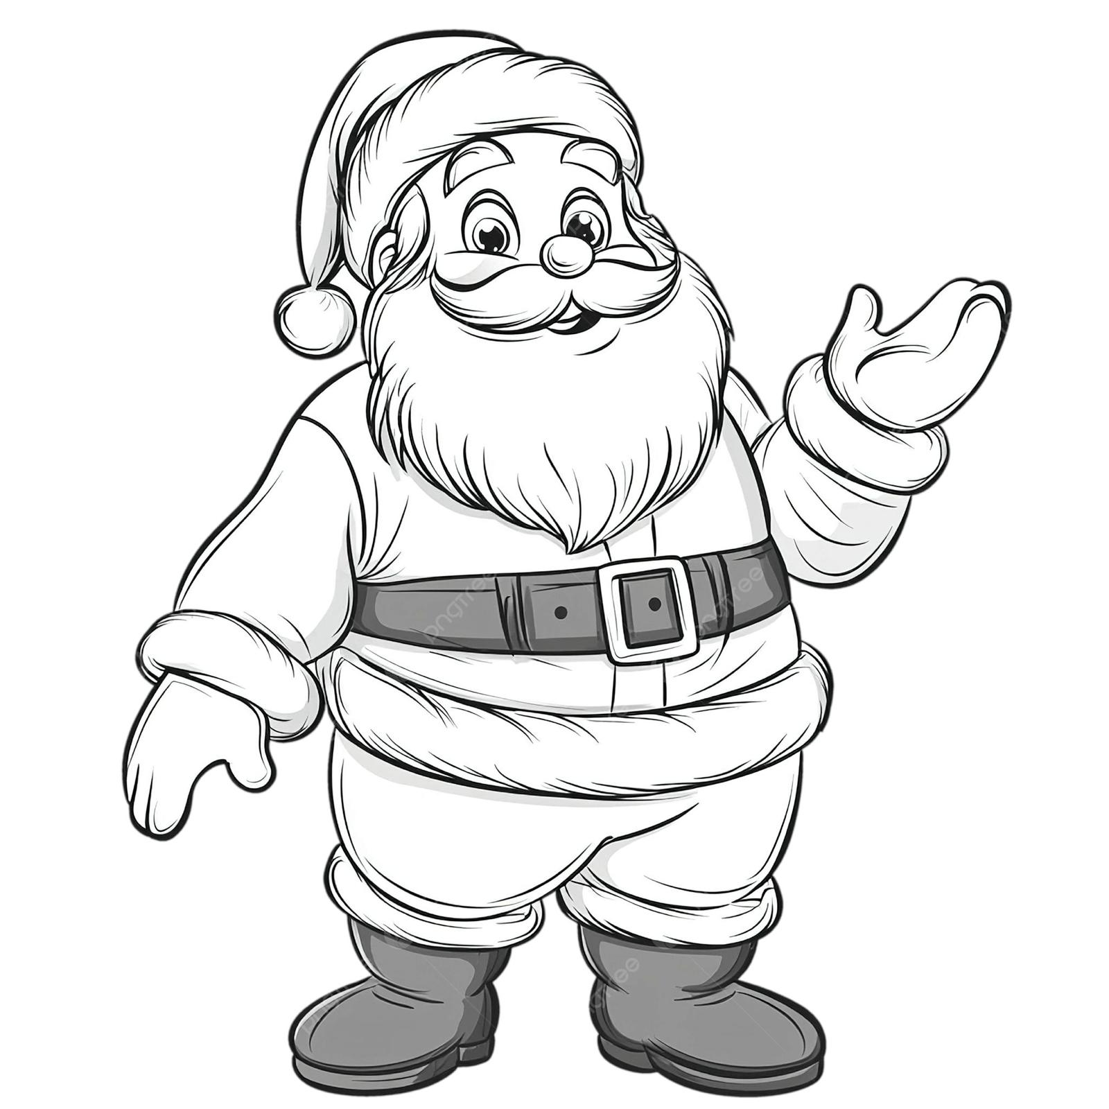
(2) d _______________ | (3) S_________ C_________
 | 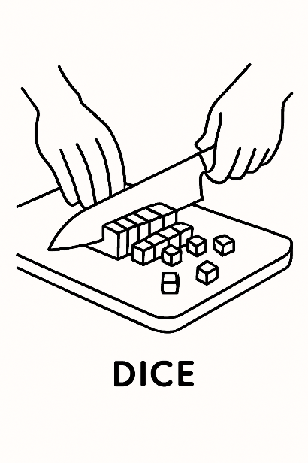
(4) r ____________ | (5) d____________

(B) Circle ONE mistake in each line and write the correct answers. (10%@2%)
(e.g.) A long time ago, there is a hungry cat. | e.g. was
- I celebrate Christmas with my friends three weeks ago. | - _________
(2) Do you like having birthday parties in night? | - _________
(3) She ate a plate for cookies. | - _________
(4) Simon drink milk for breakfast every day. | - _________
(5) Mr Li has three cat at home. | - _________
(C) Read the passage and circle the correct answers. (10%@2%)
I (e.g.) ( has / have / having / had ) an amazing Christmas holiday last year! My family and I had a big feast for our Christmas dinner.
We arrived home from grocery shopping (1) (at / from / in / on) the afternoon. Dad (2) ( roast / roasts / roasted / roasting ) a big turkey and Mum made mashed potatoes. I (3) ( set / sets / setting / setted ) the table with plates and cups. My sister baked cookies and they smelled so good! When everything (4) ( is / are / was / were ) ready, we sat down and ate together. We laughed, talked, and shared stories. After dinner, we exchanged (5) ( person / persons / present / presents ) and played games. It was the best Christmas ever!

- Look at the pictures and fill in the blanks with the given words. Each word can be used ONCE only. (10%@2%)

(e.g.) add | bake | chop | fry | get | peel | pour | put | stir

(e.g.) |  | add the ingredients  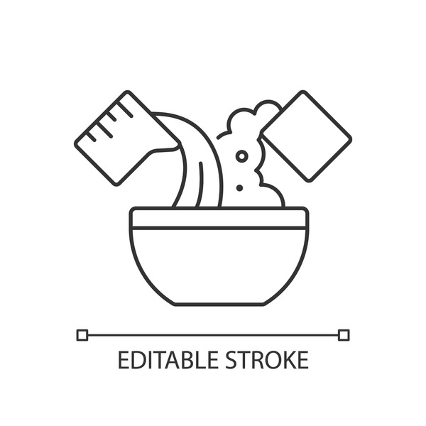 | (3) |  | ________ the drumstick  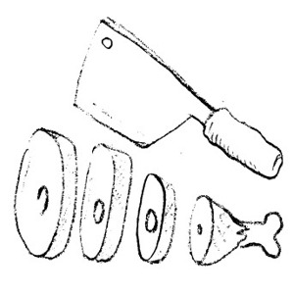
(1) | 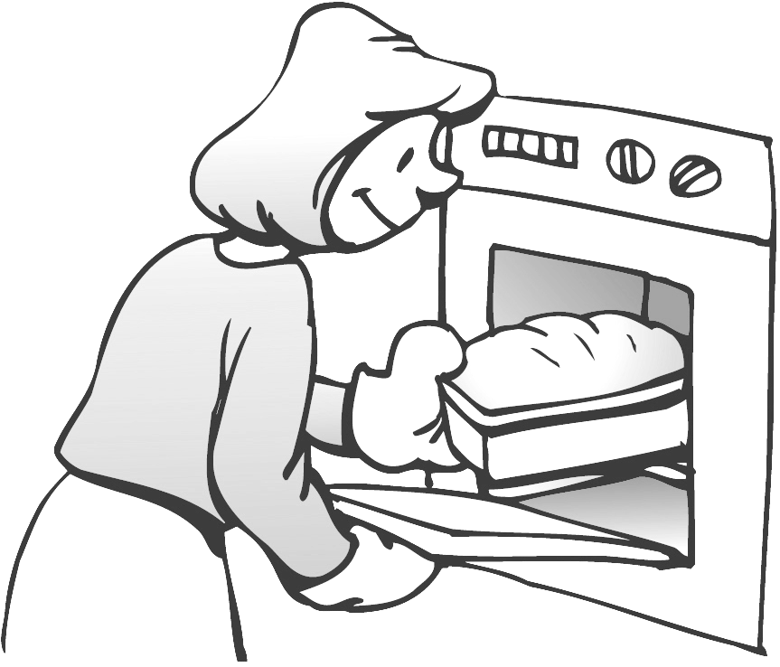 | ________ a cake | (4) |  | ________ the stew  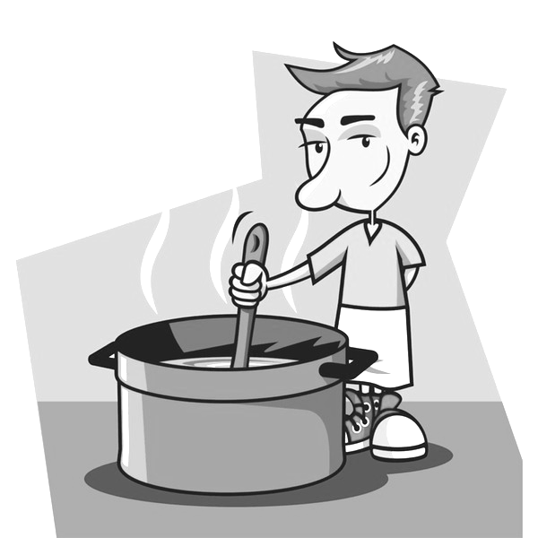
(2) |  | 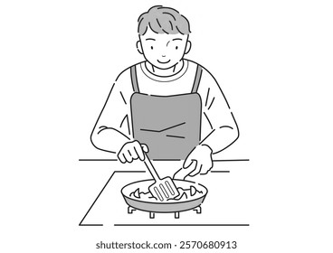  ________ some vegetables | (5) |  | 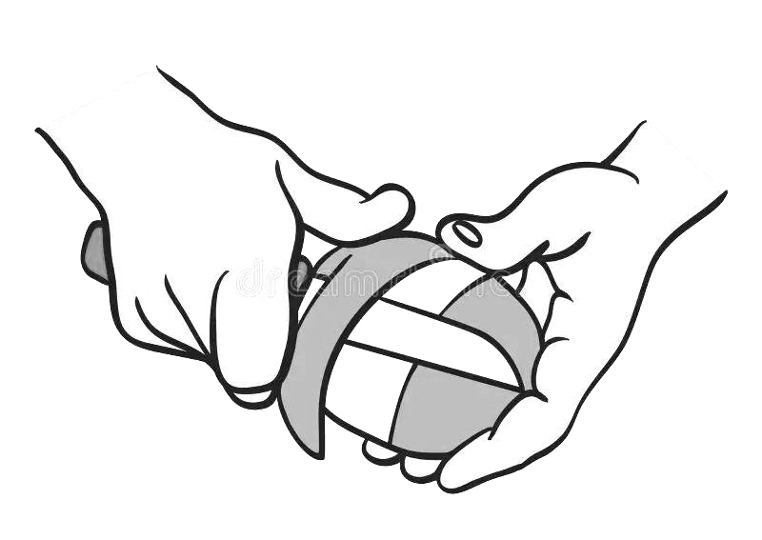  ________ a potato
- Oliver enjoyed his Christmas holiday. Read the table below and check what he did. Complete what Oliver says and use the correct form of the given words. (10%@2%)
 | Yes | No
(e.g.) decorate the Christmas tree
(1) give thanks to my parents
(2) sing Christmas carols
(3) put gifts under the Christmas tree
(e.g.) prepare a Christmas stocking
(4) eat turkey
(5) get candy canes
I enjoyed my Christmas holiday a lot! My family and I did a lot of things during our break. It was a busy yet joyful holiday. I (e.g.) decorated the Christmas tree and Dad did it with me. I (1)__________________________________________________. I (2)__________________________________________________. I (3)__________________________________________________.
However, I (e.g.) did not prepare a Christmas stocking. I (4)__________________________________________________. I (5)__________________________________________________.


- Oliver and Edward went to Haas Cafe for breakfast. Read the order form and fill in the blanks with the correct answers (10%@2%)

Haas Cafe
Open: 8 a.m. – 10 p.m. (Tuesday – Sunday)
Drinks
Breakfast meals
Breakfast meals |  |  |  | Drinks
cereal | $33 |  |  | orange juice | $12
congee | $24 |  |  | apple juice | $12
omelet | $40 |  |  | Fanta lite | $10
dim sum | $26 |  |  | bubble tea | $25
beans | $17 |  |  | hot milk | $15

Special offer: Students get $5 off for hot drinks
(e.g.) Oliver and Edward ordered 3 / three breakfast meals.
(1) The cafe opens _____________________ days a week.
(2) The cafe closes at _____________________ in the evening.
(3) The cafe offers _____________________ kinds of drinks in total.
(4) Oliver had $100. After paying for the breakfast meals they ordered, he had
$_____________________ left.
(5) Edward is a full-time student. He paid $_____________________ for the hot milk.
- Oliver is reading a story to his brother. Read the story and choose the correct answers by blackening the circles. (10%@2%)
5
____________________________
?
Senna the cat was hungry. He sniffed the air and followed the smell to the kitchen. There was a bowl of fish and a plate of chicken on the table. “Dinner time!” thought Senna, but the bowl was too high.
Senna jumped once. Too low! He jumped again. Almost there! On the third try, he reached the bowl and took a bite. “Yum!” he purred. Just then, his owner came in. “Senna! That’s for tomorrow!” yelled his owner. Senna looked up with fish on his whiskers. His owner laughed and gave him a smaller bowl. Senna was happy. He felt full and satisfied. He went to his bed and decided to take a nap. He curled up and fell asleep.
(121 words)

(e.g.) What is Oliver reading to his brother?
A. a card
B. a letter
- a story
D. an email
- Why did Senna go to the kitchen?
- to eat
- to sleep
- to play
- to find his toy

(2) What was on the table?
(You may choose more than one answer.)

A. | B.  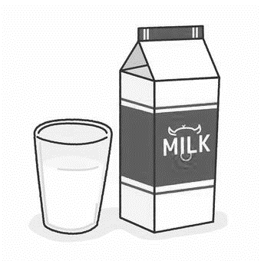 | C.  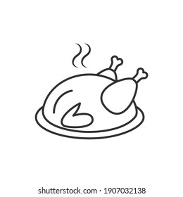 | D.  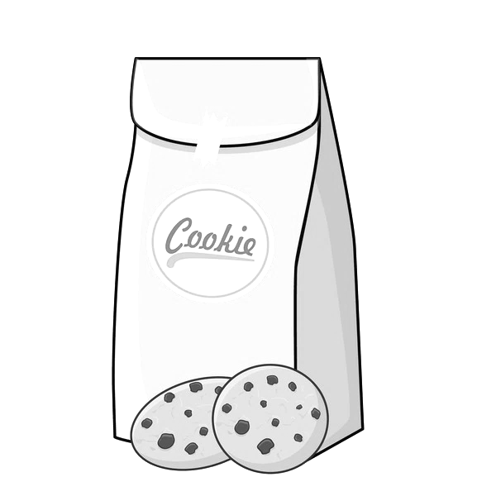
(3) How did Senna’s owner feel when he found out Senna ate the food on the table?
A.   | B.   | C.   | D.  
(4) In line 8, what does the word “him” refer to?
- a smaller bowl
B. Senna
C. Senna’s owner
D. whiskers
(5) What is the title of the story?
- I Love Cats
- Senna’s Angry Owner
- Senna’s Special Dinner
- Yummy Breakfast
- Oliver wants to make a cake for Edward’s birthday. He found a recipe for the cake. Read the recipe and choose the correct answers by blackening the circles. (10%@2%)
by Auntie Helen
Delicious Birthday Cake
What you need:
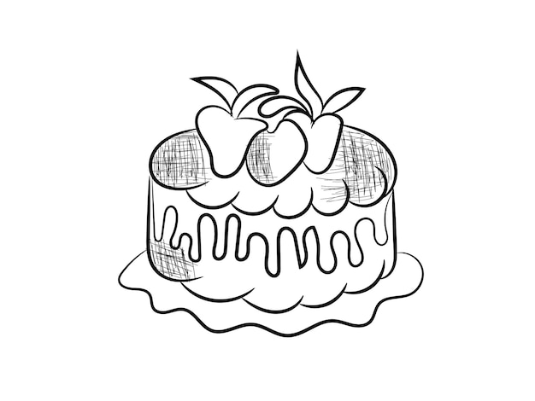
5 large strawberries
150g butter
30g sugar
5 eggs

Steps:
- Preheat the oven to 180°C.
- Chop 2 strawberries.
- Mix the butter and sugar until smooth.
- Fry the chopped strawberries with the butter and sugar mixture.
- Add eggs and stir well.
- Pour the mixture into the cake tin.
- Bake for 30–35 minutes in the oven until golden and firm.
- Put the remaining 3 strawberries on top. Enjoy your fruity treat!

(e.g.) When does Oliver want to make the cake?
- at Chinese New Year
B. at Easter
C. at Halloween
D. on Edward’s birthday
(1) What is Oliver reading?
- a book
B. a poster
C. a recipe
D. a review
(2) Who wrote this text?
- Auntie Helen
- Delicious Birthday Cake
C. Edward
D. Oliver
(3) Which of the following is / are NOT the ingredient(s) for the cake?
(You may choose more than one answer.)
- butter
- large pears
C. sugar
D. milk
(4) How many eggs does Oliver need to make the cake?
A.   | B.   | C.     |   D.    
(5) According to the recipe, how should Oliver set the timer for the oven?
A.  00:00   | B.  11:00   | C.  22:00   | D.    33:00
(I) Edward invited his friend Oliver to come to his birthday party. Read the text messages and answer the questions in complete sentences. (10%@2%)
Edward: Come at 3:00 p.m. and you can stay until 6. We’ll play bingo and read comic books!
Oliver: I will! Thanks for inviting me. I can’t wait!
Edward: Of course! And wear something colourful like your rainbow sweater!
Edward: Hi Oliver! I hope you’re having a great day. I want to tell you something exciting!
Edward: I’m having my birthday party at my house this Saturday afternoon. There will be games, music and some yummy cakes. I really hope you can come!
Oliver: Wow, that sounds amazing! What time should I come?
Oliver: Hey Edward! I’m good, thanks. What’s the exciting news?
Oliver: Can I bring my puppy? He loves parties too!
(e.g.) Who did Edward invite to his party?
He invited Oliver to his party.
- Where is Edward having his birthday party?
__________________________________________________________
- How long does the party last?
__________________________________________________________
- What did Oliver want to bring to the party?
__________________________________________________________
- What should Oliver wear to the party?
__________________________________________________________
- Do you like parties? Why or why not?
__________________________________________________________
__________________________________________________________
(J) Edward is writing his diary. Read his diary and answer the questions in complete sentences. (10%@2%)


1st January, 2026
Last night was amazing! We had a big New Year party at Uncle Sam’s house. The living room was full of balloons and shiny tinsel. Music played loudly, and my cousin Ben danced happily. My friends and I listened to music, played guessing games and laughed a lot.

At midnight, everyone at the party shouted, “Happy New Year!” and we clapped our hands. Uncle Sam brought out a chocolate cake. It was huge. We also shared orange juice and cookies. We ate everything we shared. The fireworks outside lit up the sky with bright colours.

I felt thankful because I had fun with my friends and family. It was the best way to start the New Year!

5

10

(117 words)

(e.g.) What is Edward writing?
He is writing a diary.
- When did Edward write his diary?
_______________________________________________________________
- What decorations were there in the living room?
_______________________________________________________________
- What did Edward eat at the party? Name one thing.
_______________________________________________________________
- In line 9, what does the word “It” refer to?
_______________________________________________________________
- Why did Edward feel thankful after the party?
_______________________________________________________________
~ End of Paper ~

