

**Asia Pacific College**

School of Computer and Information Technology

Magallanes, Makati City



As partial requirement for the fulfillment of the course

SYSADD – Systems Analysis and Design

Term 2, Academic Year 2017 – 2018

by

Ma. Eryel Gianca Cells

Benedict Agno

Christopher Robin Bernardo

Jejomar Politico

to

**Ms. Rhea-Luz Valbuena**

**Date**

November 6, 2017

**Abstract or Executive Summary**

Spot is a mobile application for android devices that works with the help of camera to identify subjects when you point at them. The application will give information like what the subject is, the brand of the subject, what the subject is used for, a brief history of that subject, the subject’s usage and an equivalent translation of the subject in a desired language. Unlike the existing similar applications, Spot has a lot of information to give out and it will be helpful for people because their view of the world around widens and it helps them to avoid being mocked for not knowing what a certain subject is.

Table of Content

1. **List of Figures 3**
2. **Introduction**
   1. Project Context 4
   2. Purpose and Description 5-9
   3. Fishbone Diagram 10
   4. Objective 10

2.5 Scope and Limitations10

1. **Review of Related Literature 11**
2. **Technical Background 12**
3. **Methodology, Results and Discussion 13**

5.1 Gap Analysis / Needs Analysis 13

5.2 Requirements Analysis 13

5.3 Software Requirements and Specification(SRS) 14-15

5.4 Design of Software, Systems, Product, and/or Processes

1. Functional Decomposition Diagram 15
2. Data Flow Diagram 16
3. Entity Relationship Diagram (with Data Dictionary) 17
4. Class Diagram 18
5. Use Case Diagram (fully dressed) 18-21
6. Activity Diagram 21-24
7. Sequence Diagram 25

5.5 Development and Testing 26

5.6 Description of Prototype 27-28

1. **Conclusion and Recommendation 29**
2. **Appendices30-34**
3. **References35**
4. **List of Figures, List of Tables, List of Notations**

Figure 1 – Average National Intelligence Quotient 5

Figure 2 - Updated Average National Intelligence Quotient 7

Figure 3 - Vistor Arrivals to the Philippines 8

Figure 4 - Monthly Visitor Arrivals in the Philippines 8

Figure 5 - Smartphone users in the Philippines 9

Figure 6 - Fishbone Diagram 10

Figure 7 - Functional Decomposition Diagram 16

Figure 8 - Data Flow Diagram 16

Figure 9 - Entity Relationship Diagram 17

Figure 10 - Class Diagram 18

Figure 11 - Analyzing subject characteristics Activity Diagram 21

Figure 12 - Comparing analyzed characteristics Activity Diagram 22

Figure 13 - Gathering subject information Activity Diagram 22

Figure 14 - Saving subject data Activity Diagram 23

Figure 15 - Converting text-to-speech Activity Diagram 23

Figure 16 - Translating subject information Activity Diagram 24

Figure 17 - Sequene Diagram 25

Figure 18 - Splash Screen (Spot logo) Figure 19 - Object Scanned and Percentage display 27

Figure 20 - Subject information 28

Figure 21 - Data Gathering (Interview) 30

Figure 22 - Survey Summary 1 30

Figure 23 - Survey Summary 2 31

Figure 24 - Survey Summary 3 31

Figure 25 - Survey Summary 4 32

Figure 26 - Survey Summary 5 32

Figure 27 - Survey Summary 6 33

Figure 28 - Survey Summary 7 33

Figure 29 - Survey Summary 8 34

Figure 30 - Survey Summary 9 34

Table 1 - Gap analysis 13

Table 2 - Software Requirements Specification 15

Table 3 - Data Dictionary 17

Table 4 - Analyzing subject characteristics Use Case fully dressed 19

Table 5 - Comparing analyzed characteristics Use Case fully dressed 19

Table 6 - Gathering subject information Use Case fully dressed 20

Table 7 - Saving subject data Use Case fully dressed 20

Table 8 - Converting text-to-speech Use Case fully dressed 20

Table 9 - Translating subject information Use Case fully dressed 21

1. **Introduction**

**2.1 Project Context**

Our project is a subject identifier. It contains A.I. or Artificial Intelligence which helps the application identify a subject. It requires Android phone with camera, with wi-fi or 3G / 4G / LTE connection to be able to use the application. All you need to do is to point the camera to any subject you want to identify and what it does is identify what it looks like. It also gives percentage of what the object is mostly looked like. The information will not only focus on the color or visual details but it will also give its brand, what does the subject do, what is it for and a very brief history about it. If the brand can’t be modified, the usual subject’s name will appear. It will also translate the subject’s name and information into any Filipino language you want it to be translated.

The project is inspired by the Imagine Cup Philippines Grand winner Team Opticode, from Lyceum of the Philippines Laguna. Project “Minerva” is a virtual assistant mobile application for visually impaired people. The said application is made to help people suffering from color blindness. The application lets the user point their smartphones at different subjects to hear and tell what these objects are in specific language.

**2.2 Purpose and Description**

Not all things that exist are taught in school, some of these are by-product of curiosity and exploration. The purpose of the application is to bring out or widen a person’s hunger for knowledge and curiosity particularly the tourist in the Philippines.

This knowledge base is often associated with IQ or intelligence quotient, and one thing that affects a person’s IQ is through race and ethnicity which are defined by social conventions and norms to the point that they have been correlated with both genetic traits and cultural traits.

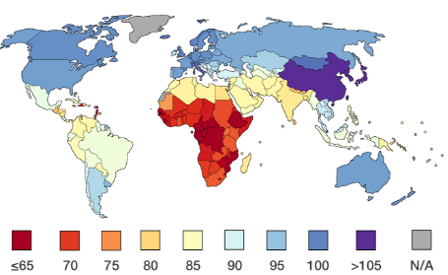

Figure 1 – Average National Intelligence Quotient

<https://iq-research.info/en/page/average-iq-by-country>

The chart above shows the average Intelligence Quotient (IQ) per country way back 2002. Based on the IQ map, the average IQ for the Philippines is 85%. The ranking of this IQ chart was updated last November 3, 2017. The results showed that the Philippines stayed at rank 21since 2006 with the same average of 86% together with Kuwait, Seychelles and Tonga which are from Middle East, East Africa and Oceania.

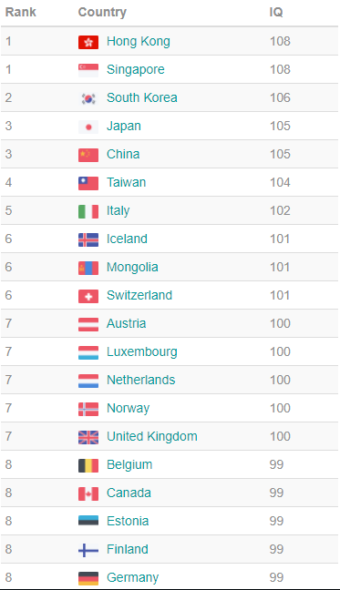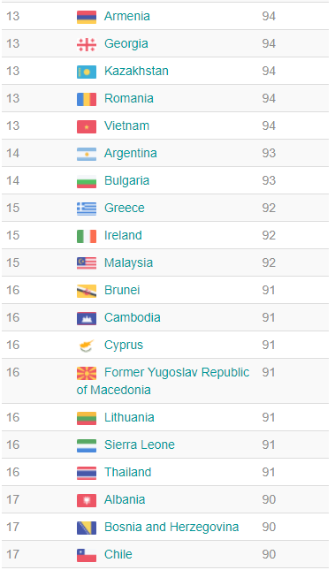

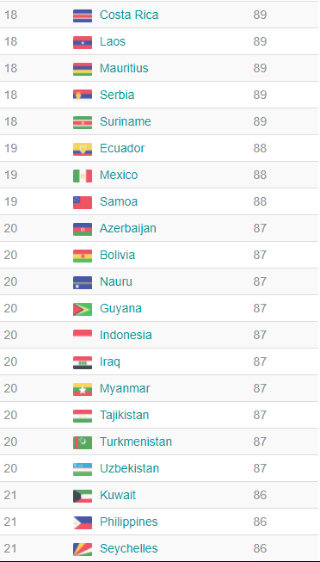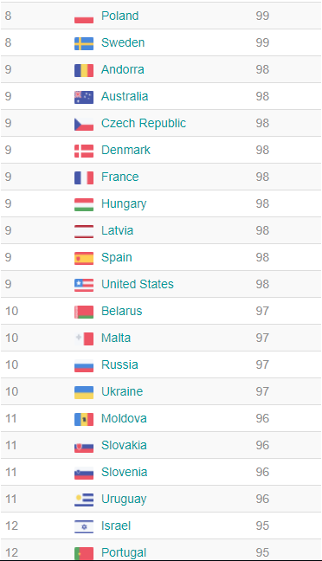

Figure 2 - Updated Average National Intelligence Quotient

<https://iq-research.info/en/page/average-iq-by-country>

“Intelligence is important to academic performance but it’s not the whole story”. Everyone knows an intelligent kid who failed school, or anyone with average intelligence who made it up with hard work, psychological scientists are looking at aspects other than intelligence that make other students do better than others. Sophie von Stumm of the University of Edinburgh in United Kingdom and her coauthors conjectured that curiosity is another important aspect. “Curiosity is basically a hunger for exploration,” von Stumm says. “If you’re intellectually curious, you’ll go home, you’ll read books. If you’re perceptually curious, you might go travelling to foreign countries and try different foods.”.

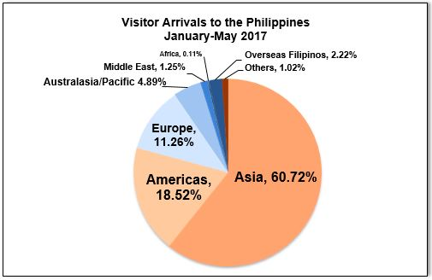Every year, the number of tourist arrivals in the Philippines increases. There are international and local tourist who visit Philippines to explore places, to try foods and adopt cultures of different places. From a feature article in the Philippine Department of Tourism, countries from Asia holds the biggest share by delivering 60.72% of the total visitor arrivals. East Asia filled more than half of the total arrivals with 51.74% while the remaining percentage came from the Association of South East Asian Nations (ASEAN) with 203,400 arrivals (7.06%) and South Asia with 55,543 arrivals. North and South America supplied a total of 534,012 arrivals (18.52%), on the other hand, 11.26% arrivals came from Europe while 4.89% arrivals came from Australasia/Pacific.

Figure - Vistor Arrivals to the Philippines

<http://www.tourism.gov.ph/pages/industryperformance.aspx>

According to a Philippine news article that was posted on July 12, 2017, international tourist arrivals to the Philippines rose more than 14 percent in the same period a year ago to 2.8 million visitors from January to May 2017. It totaled 2,882,737 as of May 2017. Philippines is known as a country with a rich environment. Tourist come and visit Philippines to see some cites, go to beaches, engage in outdoor sports or activities, relax, celebrate and join to different feast and experience Filipino culture.

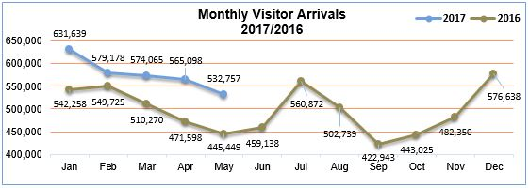

Figure - Monthly Visitor Arrivals in the Philippines

<http://www.tourism.gov.ph/pages/industryperformance.aspx>

Curiosity plays a big role in a person’s intelligence it is one of the factor on how we learn things either being perceptually curious or intellectually curious these adds up to the way we learn things in our environment and the more we learn things around us the more intelligent people become. Well, of course not all things can be taught up in our education system but some things we learn are product of curiosity and that is how our application comes in, where users will be able to know certain things or subjects that piques their interest and as they use the application the higher the chance they learn something new and a chance to share their new knowledge to other people or eventually apply these learnings in their life.

According to Statista there is an increase to mobile phone users from 2015 to 2022. And It is expected that by 2022 mobile phone users will reach 46.04 million. This would be an opportunity for us to provide knowledge, information and convenience to people as they learn and discover more about things.

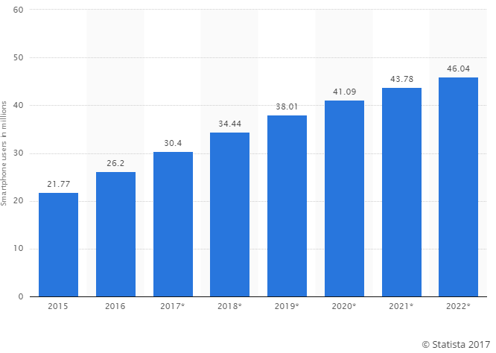

Figure 5 - Smartphone users in the Philippines

Source: <https://www.statista.com/statistics/467186/forecast-of-smartphone-users-in-the-philippines/>

**2.3 Fishbone Diagram**

Nutrition

Education

No enough food to eat

Lack of Educational Instruments

Not all are taught

Poverty

Low Intelligence Quotient

Place lived in

Family

Social Class

Culture

Figure - Fishbone Diagram

**2.4 Objective**

1. To quickly have information after using the application.

2. To increase awareness of things around them.

3. To improve target beneficiaries of the system.

**2.5 Scope and Limitation**

1. English will be the main language used in identifying the subject.

2. Wi-Fi or 3G/LTE is an essential key of the application for optimum results.

1. **Review of Related Literature**

The following are existing systems related to the project:

**Wolfram Language Artificial Intelligence** is a built system that give computers all kinds of intelligence. For a long time, Wolfram Language have been integrating intelligence, up until it discovered and built “Image Identify”. The system lets the user drag a picture to the web page, snap it with your phone or camera, and or load it from a file and see what Image Identify think it is. (Wolfram, 2015)

**Minerva** is a virtual assistant mobile application for visually impaired people. The application was designed and built by the Imagine Cup Philippines champion, Team opticode. The application lets them point their phone at different objects to hear and to tell them what these objects are in specific language. (Reyes, 2017)

**CamFind** is the first mobile visual search engine. It allows the user to search for anything from your mobile phone just by taking a picture. The CamFind is designed to innovate the text-based search powered by CloudSight.ai. The said application is only available for iOS phones. (CamFind, 2016)

The three applications have systems that allows the user give or present an image or subject then lets the system think what the image or subject looks like. Just the same as the project’s system, it modifies or identify what the image might be. The project differs from the three applications as it gives information by determining what the subject or image is in a way of providing or telling the user a brief history of it, its brand name or common name and how will the subject will be use. It also differs from the three applications as the project Spot does not focuses on one subject only, it shows percentage on some subjects that is reached by the camera.

1. **Technical Background**

The application is running with the help of an AI or artificial intelligence from the Microsoft Azure’s cognitive services like custom speech service API where we can let the application “speak”, the translator text API where we can be able to translate the name of the object to a desired language of the user and the computer vision API where we can let the application “see” the object through the camera.

The application also has a search algorithm which analyzes the object being pointed at and it defines how sure the application in defining the subject then it will look how often the object has been pointed by different users of the application and it will rank them according to percentage. Next is the application uses your location and past subjects searched by users nearest to your place to deliver the information accurately and relevantly but before they are stored they will be evaluated if the information that will be projected is coming from sources that are legitimate to avoid spread of false information.

1. **Methodology, Results and Discussion**
   1. **Gap Analysis / Needs Analysis**

|  |  |  |
| --- | --- | --- |
| **User Requirements** | **Current System** | **Proposed Changes** |
| The user need to have an Android phone and the Spot application | Asking a person to identify the subject or translation of a language. | The proposed app will identify  the subject or translate it. |
| The user requires to have an WIFI or data to use the application | Person only used their own idea on the subject | The proposed application will not identify or translate it if the subject or writing are not yet identified in the past. |
| The user requires to point the phone camera to an subject the user wants to identify | A local person helping you on your trip. | The proposed app will identify it and gather more info about the subject being identified |
| The user requires to point the phone camera on a sign or writings to translate it | A person helps you translate it | The proposed app will translate it in your language |

Table - Gap analysis

* 1. **Requirements Analysis**

Spot should provide information for the users regarding on the subject. The simple but efficient flow and processes will make the application more effective and will provide convenience to the users. These requirements will define how smooth the system will work and how will provide convenience for them. When the users scan the subjects, Spot will give out necessary information like name and brief history of that subject. Spot will surely benefit tourist and might as well help people with disabilities and will surely give out information accurate as possible. The subject that has been scanned by Spot will be saved and collected for the application to do its job offline.

* 1. **Software Requirements and Specification (SRS)**

**SOFTWARE REQUIREMENTS SPECIFICATION CHECKLIST**

|  |  |  |  |  |
| --- | --- | --- | --- | --- |
|  | ASSIGNED TO | YES | NO | REMARKS |
| Output  ✓ The mobile application should display necessary details like history, brand, color and what the subject is.  ✓ The mobile application shows a percentage on how accurate the subject looks like.  ✓ The subject details should be translated into any dialect the user wants it to be displayed.  ✓ The mobile application converts subject information’s text to speech. |  |  |  |  |
| Input  ✓ The user should be connected to the internet.  ✓ The user must focus the phone camera to the desired subject that the user wants to identify.  ✓ User must use the tiny box in the middle of the screen to focus on tiny objects. |  |  |  |  |
| Process  ✓ The A.I. scans and analyze the subject’s characteristics to be able to get the subject’s information.  ✓ The A.I. analyzes the subject information before translating it to any dialect the user wants. |  |  |  |  |
| Performance  ✓ The phone must be android and the application’s minimum Operating System(OS) is KitKat.  ✓ Scanning the subject should not take more than 3 minutes.  ✓ The gathering of information after the scan should not be more than 5 minutes.  ✓ The mobile application saves past identified subjects which can be use even without internet.  ✓ The mobile application should display the history, brand, color and what the subject is after verifying the subject by the user.  Control  ✓ The user must allow camera, contacts, cellular data settings and Wi-Fi connection information permissions for the application.  ✓ The user must check play store policies that protect users against potentially harmful software. |  |  |  |  |

Table - Software Requirements Specification

* 1. **Design of Software, Systems, Product, and/or Processes**

1. 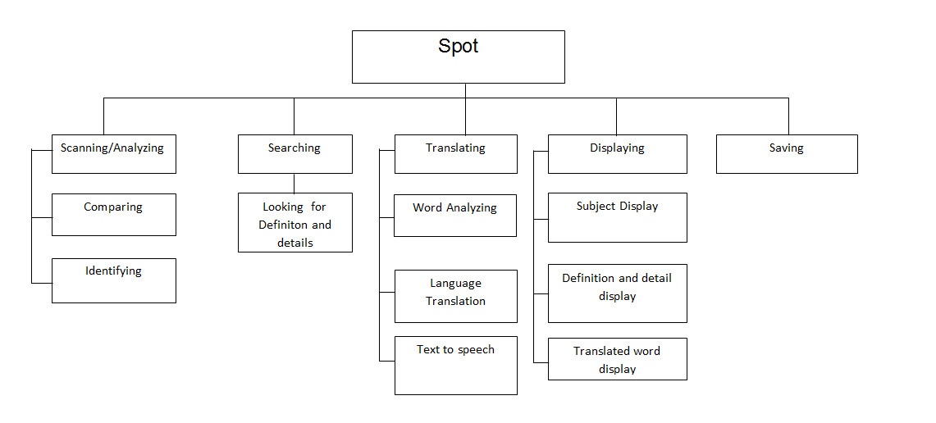**Functional Decomposition Diagram**

Figure - Functional Decomposition Diagram

1. **Data Flow Diagram**

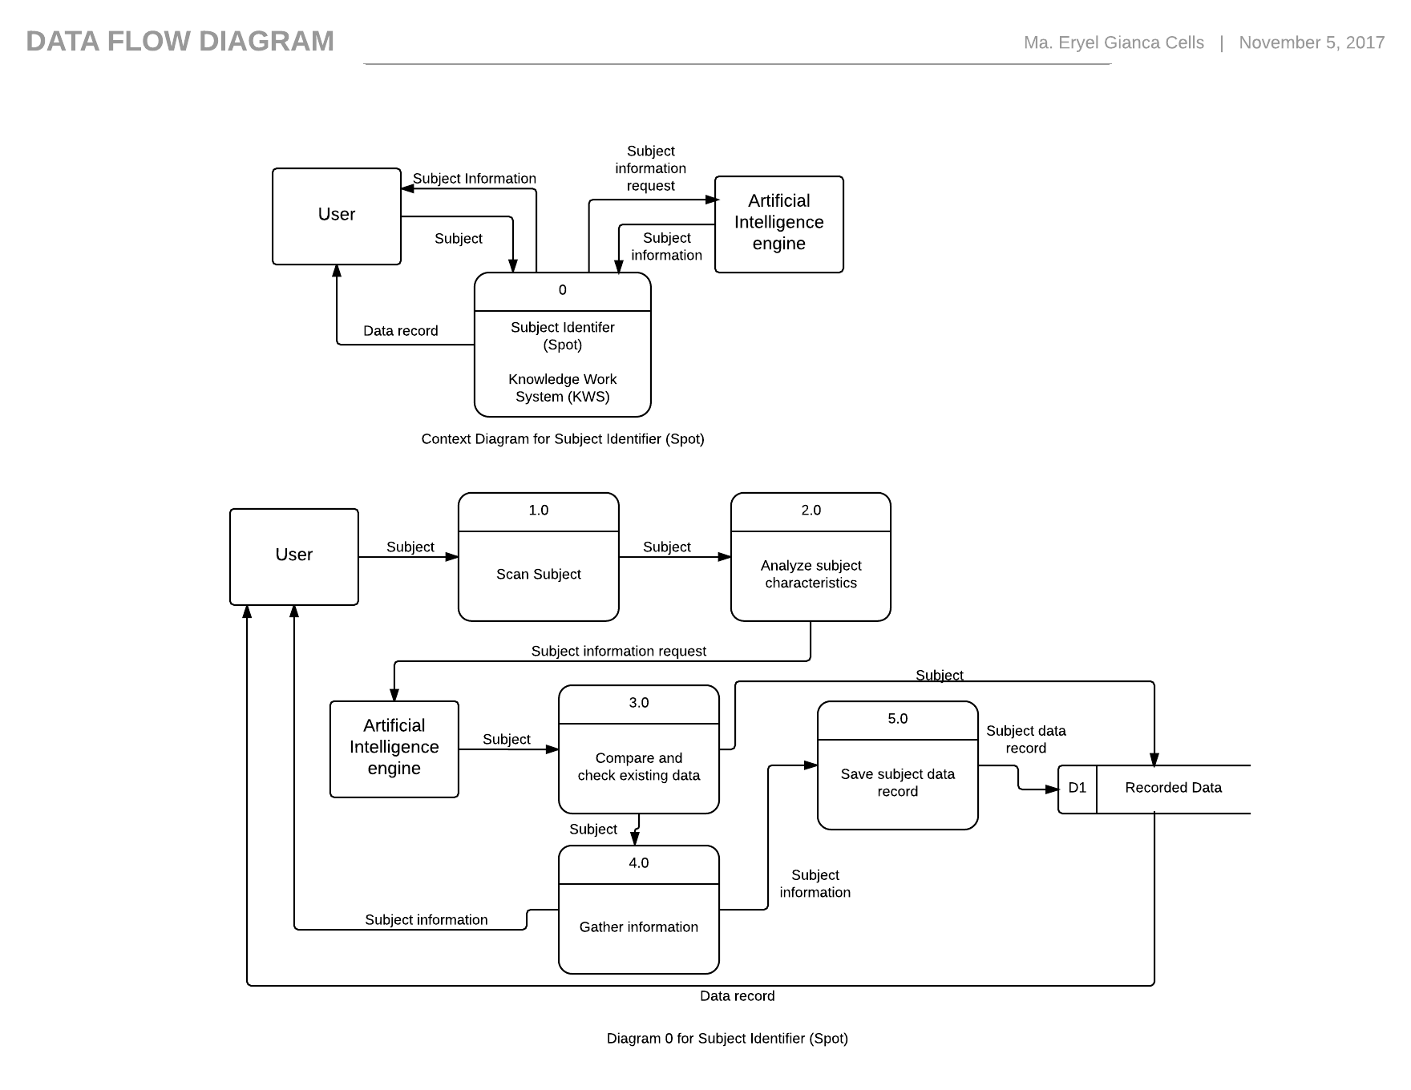

Figure - Data Flow Diagram

1. 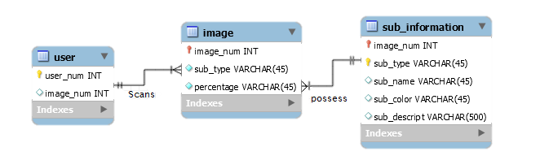**Entity Relationship Diagram (with Data Dictionary)**

Figure - Entity Relationship Diagram

|  |  |  |  |
| --- | --- | --- | --- |
| Attribute | PK/FK | Data Type | Description |

|  |  |  |  |
| --- | --- | --- | --- |
| **User** | | | |
| user_num | PK | INT | User’s primary key |
| image_num |  | INT | User’s presented image |

|  |  |  |  |
| --- | --- | --- | --- |
| **Image** | | | |
| image_num | PK/FK | INT | Image’s |
| sub_type |  | VARCHAR(45) | Image’s subject type |
| percentage |  | VARCHAR(45) | Subject type’s accuracy |

|  |  |  |  |
| --- | --- | --- | --- |
| **Sub_Information** | | | |
| image_num | PK/FK | INT |  |
| sub_type | FK | VARCHAR(45) | Subject type |
| sub_name |  | VARCHAR(45) | Subject name |
| sub_color |  | VARCHAR(45) | Subject color |
| sub_descript |  | VARCHAR(500) | Subject description |

Table - Data Dictionary

1. **Class Diagram**

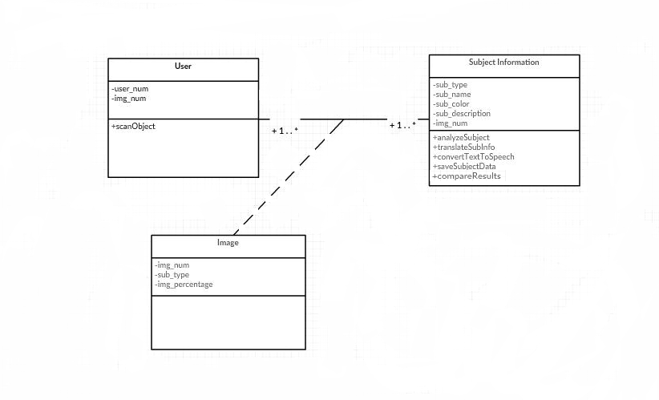

Figure - Class Diagram

1. **Use Case Diagram (fully dressed)**

|  |  |  |
| --- | --- | --- |
| Use Case Name | Analyzing subject characteristics | |
| Scenario | User wants to identify the subject | |
| Triggering Event | Subject verified | |
| Brief Description | User points the camera to a certain subject, the system will scan the subject, verify the subject and gather information. | |
| Actors | User | |
| Related Use Cases | none | |
| Preconditions | User points the mobile phone’s camera to a certain subject. | |
| Postconditions |  | |
| Flow of Activities | Actor | System |
| 1. User presents a subject |  |
|  | 1. Scan subject |
|  | 1. Analyze subject characteristics |
|  | 1. Display Percentage |
| 1. Verify subject |  |
| Exception conditions | User did not point the camera to subject properly. | |

Table - Analyzing subject characteristics Use Case fully dressed

|  |  |  |
| --- | --- | --- |
| Use Case Name | Comparing analyzed characteristics | |
| Scenario | The system wants to check if there is the same existing subject information. | |
| Triggering Event | Subject verified | |
| Brief Description | The system automatically checks and compares the analyzed subject characteristics to existing subject data in the system database. | |
| Actors | System | |
| Related Use Cases | none | |
| Preconditions | Subject must be verified | |
| Postconditions |  | |
| Flow of Activities | Actor | System |
|  | 1. Get subject verified |
|  | 1. Get analyzed subject characteristics |
|  | 1. Check and compare analyze subject characteristics to existing subject data |
| Exception conditions | Subject not yet verified | |

Table - Comparing analyzed characteristics Use Case fully dressed

|  |  |  |
| --- | --- | --- |
| Use Case Name | Gathering subject information | |
| Scenario | The subject has no existing data | |
| Triggering Event |  | |
| Brief Description | There is no existing subject data in system database, create new subject data. | |
| Actors | System | |
| Related Use Cases | none | |
| Preconditions | There must be no existing data. | |
| Postconditions |  | |
| Flow of Activities | Actor | System |
|  | 1. Get subject verified |
|  | 1. Get analyzed subject characteristics |
|  | 1. Gather subject information |
|  | 1. Display subject information |
| Exception conditions | There is existing subject data. | |

Table - Gathering subject information Use Case fully dressed

|  |  |  |
| --- | --- | --- |
| Use Case Name | Saving subject data | |
| Scenario | The system will save the subject information. | |
| Triggering Event | Get subject information | |
| Brief Description | The system will automatically save subject information | |
| Actors | System | |
| Related Use Cases | none | |
| Preconditions | Subject information must be displayed | |
| Postconditions |  | |
| Flow of Activities | Actor | System |
|  | 1. Get subject information |
|  | 1. Save subject data to system database |
| Exception conditions | There is no subject information displayed. | |

Table - Saving subject data Use Case fully dressed

|  |  |  |
| --- | --- | --- |
| Use Case Name | Converting text-to-speech | |
| Scenario | The system will automatically perform text-to-speech. | |
| Triggering Event | Display subject information | |
| Brief Description | The system automatically perform text to speech. | |
| Actors | System | |
| Related Use Cases | none | |
| Preconditions | Subject information must be displayed | |
| Postconditions |  | |
| Flow of Activities | Actor | System |
|  | 1. Get subject information |
|  | 1. Analyze displayed subject information |
|  | 1. Perform text-to-speech |
| Exception conditions | There is no subject information displayed. | |

Table - Converting text-to-speech Use Case fully dressed

|  |  |  |
| --- | --- | --- |
| Use Case Name | Translating subject information | |
| Scenario | User wants to translate the information into another dialect | |
| Triggering Event | Dialect selected | |
| Brief Description | User selected a dialect, then the system will analyze and translate information. | |
| Actors | User | |
| Related Use Cases | none | |
| Preconditions | Dialect selected | |
| Postconditions |  | |
| Flow of Activities | Actor | System |
| 1. Select a dialect |  |
|  | 1. Analyze displayed subject information |
|  | 1. Translate information |
|  | 1. Display translated information |
|  | 1. Perform text-to-speech |
| Exception conditions | There is no subject information displayed. | |

Table - Translating subject information Use Case fully dressed

1. 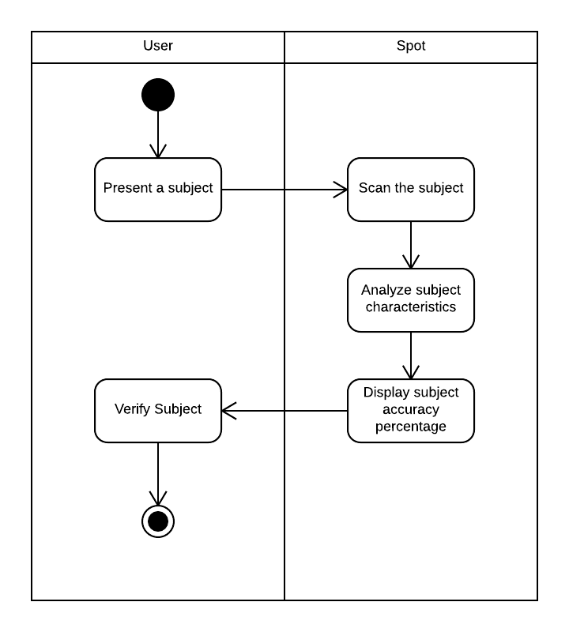**Activity Diagram**

Figure - Analyzing subject characteristics Activity Diagram

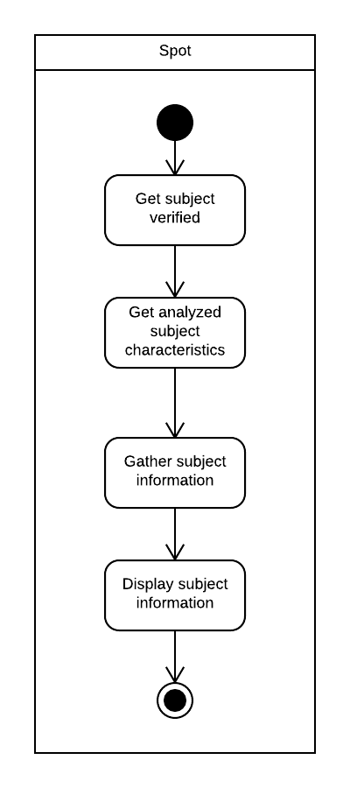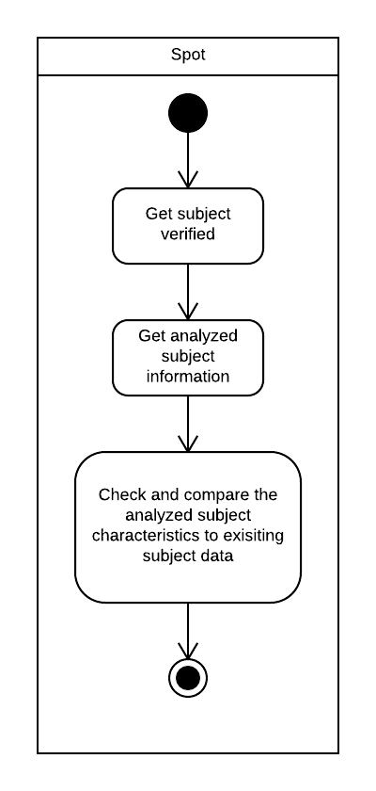Figure - Comparing analyzed characteristics Activity Diagram

Figure - Gathering subject information Activity Diagram

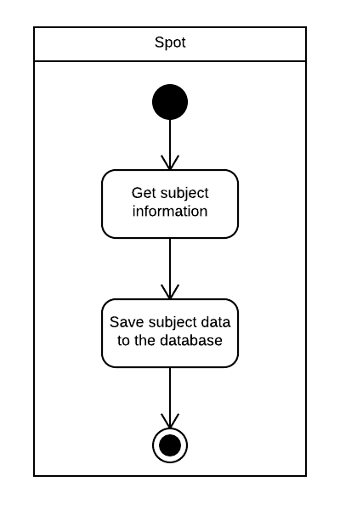

Figure - Saving subject data Activity Diagram

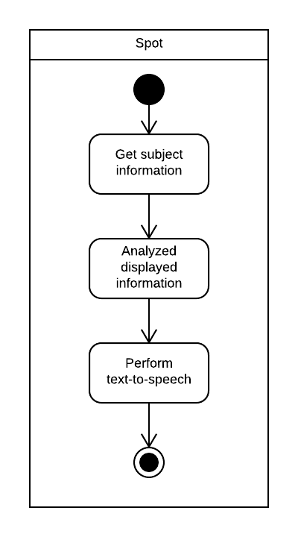

Figure - Converting text-to-speech Activity Diagram

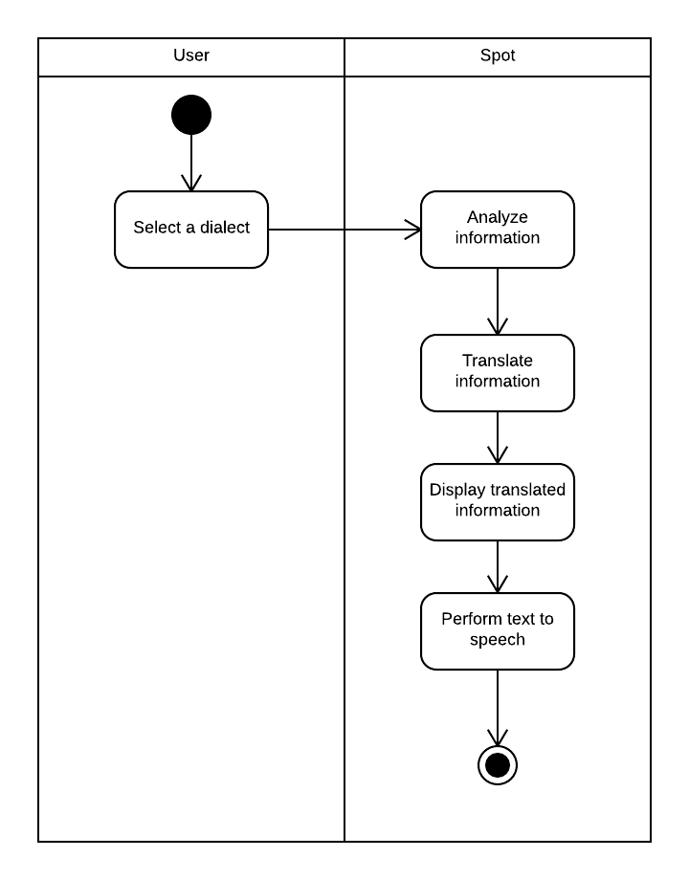Figure - Translating subject information Activity Diagram

1. 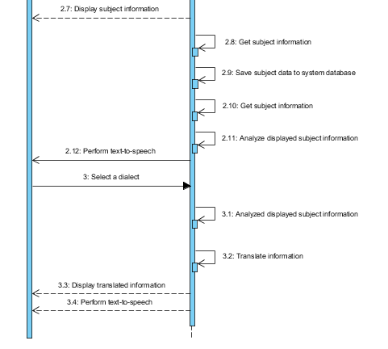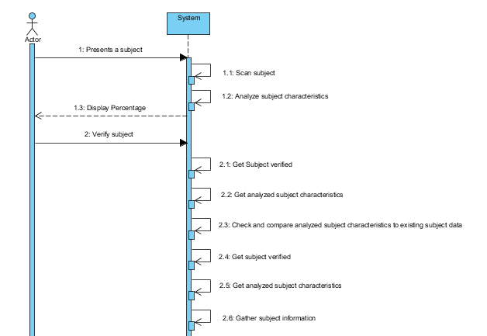**Sequence Diagram**

Figure - Sequene Diagram

* 1. **Development and Testing**

The gathered data through multiple interviews from people that is very vital in connecting the dots between curiosity, knowledge and IQ which has a big impact on the outcome of the project. The design or prototype of the project was made through the Pencil Application and it shows the user interface in which the user will already have an idea how the application will look like and how the application will provide the desired outcomes of the application.

* 1. **Description of Prototype**

Figure - Splash Screen (Spot logo) Figure - Object Scanned and Percentage display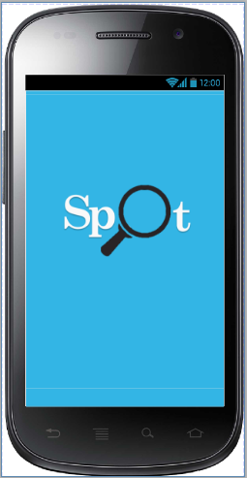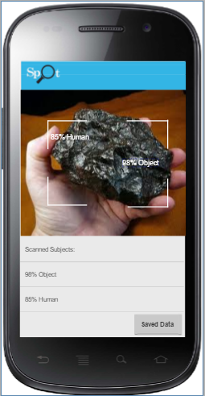

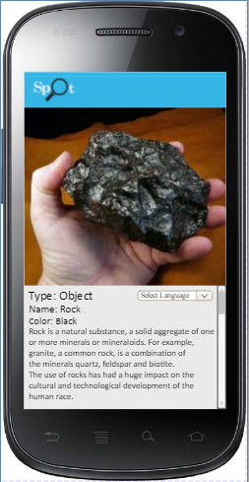

Figure - Subject information

1. **Conclusion and Recommendation**

**Conclusion:**

Most projects that involve AI come from different ranges whether it becomes solutions to problem or even supplements for learning. An application like Spot can have many uses and it varies to the person who is using it, either it can become a supplementary reinforcement of learning or it could be an app that changes a person’s view of the world. These are product of the various researches and integration of technology to each other.

**Recommendation:**

With the evolution of technology, come more opportunities for people to enhance various skills and knowledge. For one to be able to truly understand or widen his/her knowledge that can lead to the rise of IQ one must value learning itself and induce himself/herself in exercise and effort meaning that for the application to have its visible effects one must use it regularly.

1. **Appendices**

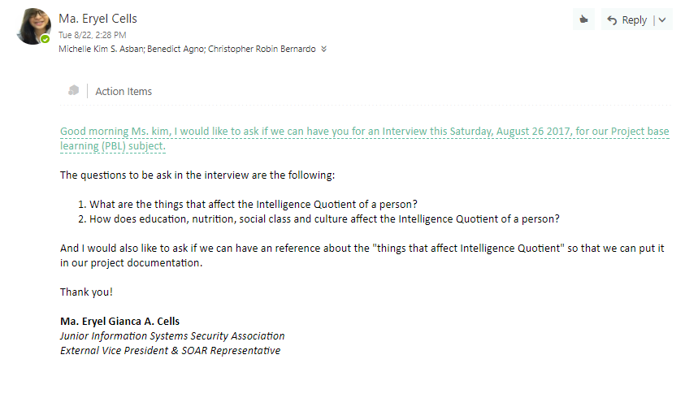

Figure - Data Gathering (Interview)

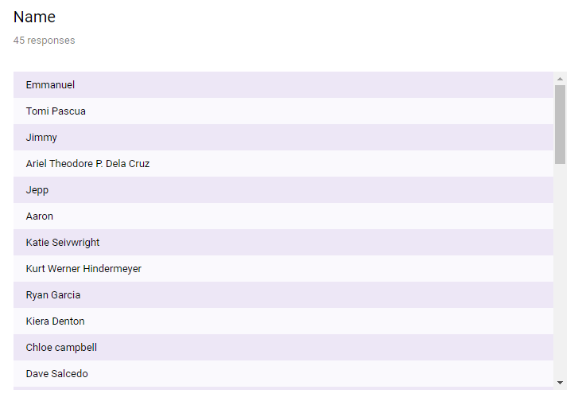

Figure - Survey Summary 1

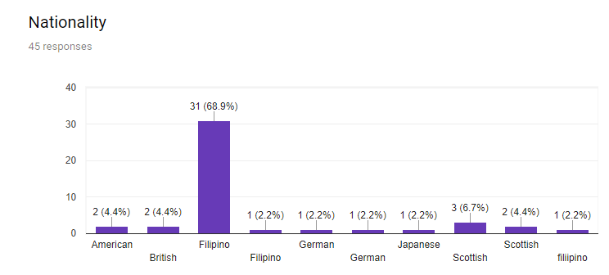

Figure - Survey Summary 2

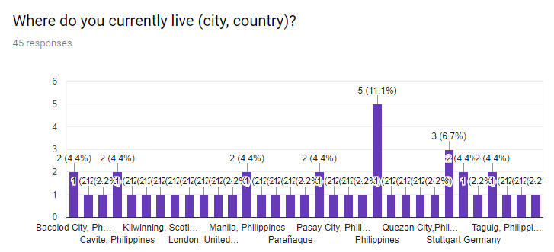

Figure - Survey Summary 3

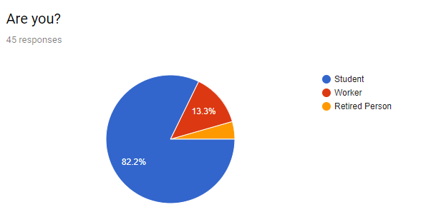

Figure - Survey Summary 4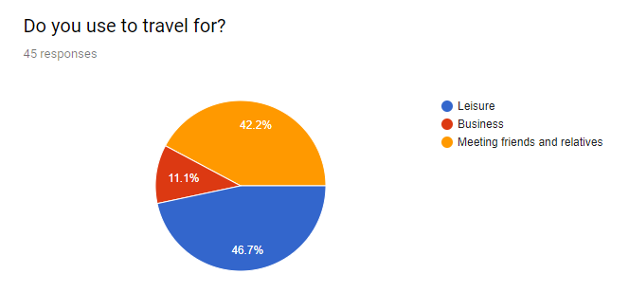

Figure - Survey Summary 5

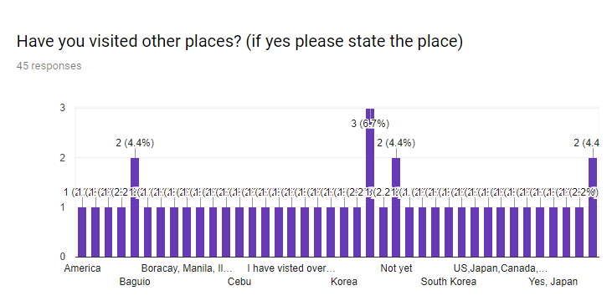

Figure - Survey Summary 6

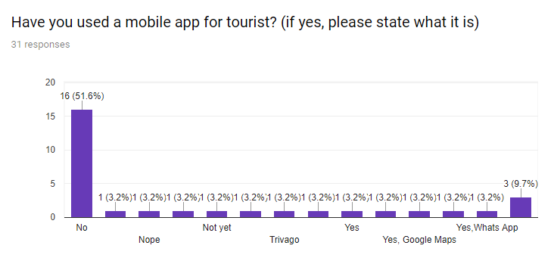

Figure - Survey Summary 7

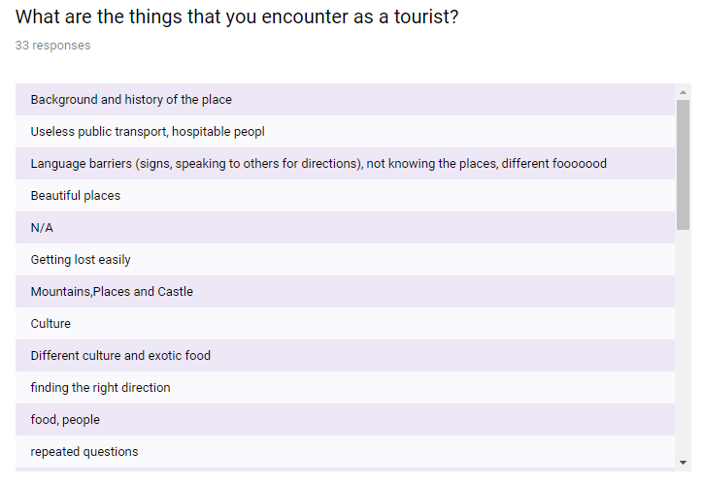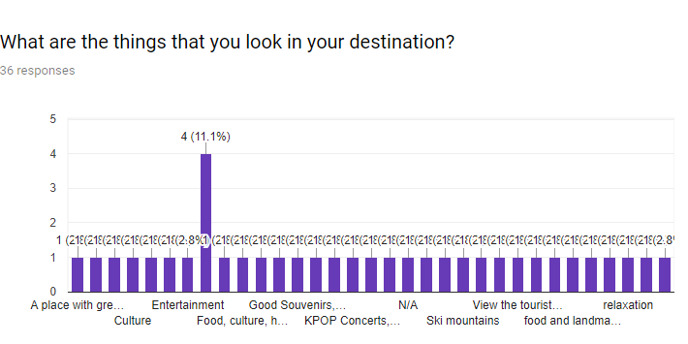

Figure - Survey Summary 8

Figure - Survey Summary 9

# References

(n.d.).

CamFind. (2016, November 30). *CamFind visual search - powered by CloudSight.ai*. Retrieved from Itunes: https://itunes.apple.com/us/app/camfind-visual-search-powered-by-cloudsight-ai/id595857716?mt=8

Editors, M. (n.d.). *Exploring the links between intelligence and curiosity*. Retrieved from Myria: https://myria.com/exploring-the-links-between-intelligence-and-curiosity

Reyes, R. R. (2017, April 22). *Makers of app for the color blind wins top Microsoft award*. Retrieved from Business mirror: http://www.businessmirror.com.ph/makers-of-app-for-the-color-blind-wins-top-microsoft-award/

SEAIMD, O. (2017, July 7). *Industry performance for travel and tourism*. Retrieved from Department of Tourism Philippines: http://www.tourism.gov.ph/pages/industryperformance.aspx

Staff, C. P. (2017, July 12). *Tourist arrivals to Philippines rise 14 percent in first five months of 2017*. Retrieved from CNN Philippines: http://cnnphilippines.com/news/2017/07/12/tourist-arrivals-increase-in-jan-may-2017.html

*Top 10 things to do in the Philippines*. (n.d.). Retrieved from Department of Tourism Philippines: http://www.tourism.gov.ph/sitepages/top10thingstodo.aspx

Wolfram, S. (2015, May 13). *Wolfram Language Artificial Intelligence: The Image Identifier Project*. Retrieved from Stephen Wolfram Blog: http://blog.stephenwolfram.com/2015/05/wolfram-language-artificial-intelligence-the-image-identification-project/

*WORLD RANKING OF COUNTRIES BY THEIR AVERAGE*. (2017, November 4). Retrieved from IQ Research: https://iq-research.info/en/page/average-iq-by-country