1. Introduction and Links
MindTrack is a web-based application developed to help users track their daily wellbeing and lifestyle habits. The system enables users to log in, enter daily records, and manage information about mood, sleep, exercise, and work/study activities. The purpose of the application is to provide a simple and practical platform for monitoring personal daily habits and related wellbeing data.
The project was implemented using Django and Python for the back end, together with HTML, CSS, and JavaScript for the front end. While the original design idea was kept, some parts of the implementation were adjusted during development in order to improve the structure of the system, the user experience, and the overall quality of the final web application.
Repository URL: https://github.com/Benedicttirkey/MindTrack
Deployed Application URL: [Insert Render deployment link here]
2. Updated Design Specification
2.1 Design Overview
The overall concept of MindTrack remained consistent with the original design specification. The application was designed as a health and wellbeing tracking system that allows users to record important aspects of their daily life through a simple web interface. The main functional scope of the system includes user authentication, profile management, daily record creation, and the storage of lifestyle-related data such as mood, sleep, exercise, and work/study information.
During development, the team kept the core purpose of the original design but refined some implementation details to better match the final system. These refinements mainly involved improvements to the data structure, interface organisation, and the practical integration of front-end and back-end components. The updated design specification presented below reflects the final implemented structure of the MindTrack application.
2.2 User Stories
The main requirements of MindTrack were described as user stories and prioritised using the MoSCoW method. This helped the team identify which features were essential for the final system and which features were desirable but not required for the first implemented version.
The main “Must” requirements focused on secure account access, personal profile settings, daily mood recording, lifestyle data input, and daily note-taking. These requirements formed the core functionality of the final system.
M1 (Must): As a student, I want to create an account and log in securely so that only I can access my personal records.
M2 (Must): As a logged-in user, I want to update my profile with nickname, age, and sleep preference so that the system can personalise my experience.
M3 (Must): As a user, I want to record my daily mood, stress, and anxiety scores on the daily record page so that I can track my mental state over time.
M4 (Must): As a user, I want to record my daily lifestyle data, including sleep, exercise, and work/study duration, on the same page so that I can see how my habits relate to my mood.
M5 (Must): As a user, I want to add a short text note to each day’s record so that I can remember important events that might explain changes in my mood.
The “Should” requirements focused on weekly summaries and visual feedback. These features were intended to improve user engagement and make the application more useful over time.
S1 (Should): As a user, I want the system to show a weekly dashboard with charts of my mood, sleep, and exercise so that I can easily see patterns for the last 7 days.
S2 (Should): As a user, I want the system to count how many days this week I completed a record and show my current streak so that I feel motivated to keep tracking consistently.
The “Could” requirement identified an additional convenience feature related to logout access.
C1 (Could): As a user, I would like to log out from my account from the profile page so that I can securely end my session on shared devices.
The “Won’t” requirement clarified a feature that was considered but intentionally kept out of scope for the current version.
W1 (Won’t): As a user, I would like the app to automatically sync data from external devices such as fitness trackers or smartwatches, but this is out of scope for the current version, which will focus on manual daily input only.
These user stories guided the implementation priorities of the final system and ensured that the most important functions were completed first.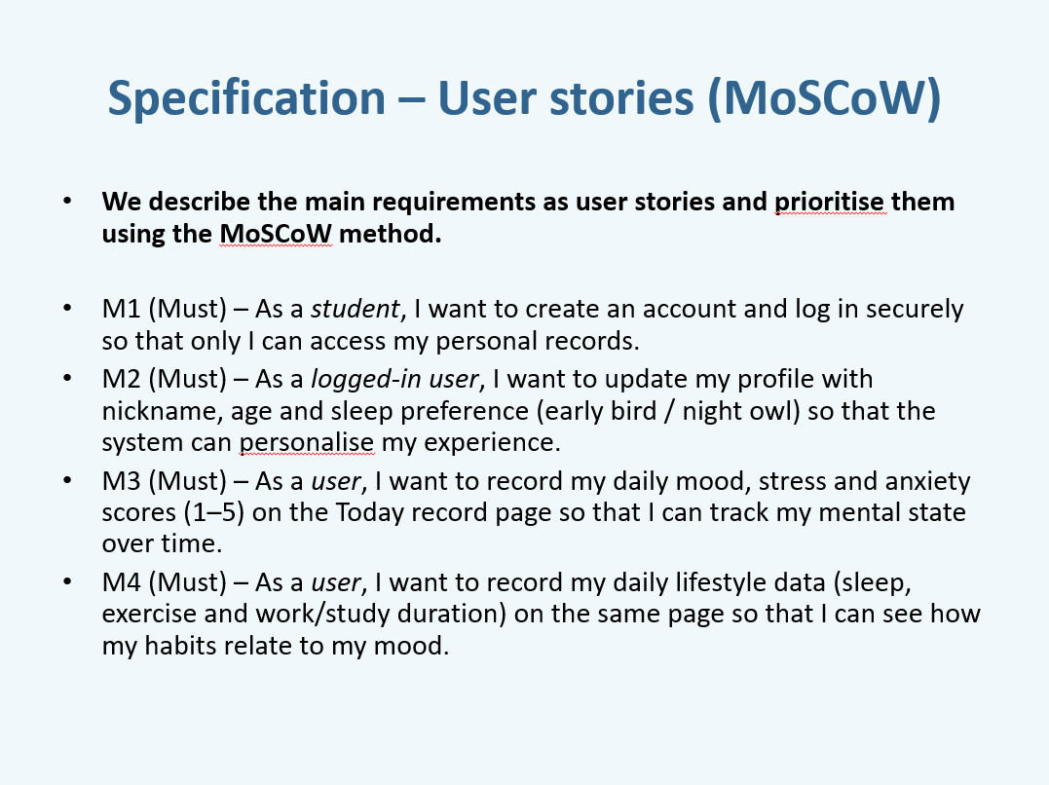
Figure 1. User stories for the MindTrack application, prioritised using the MoSCoW method (Part 1).
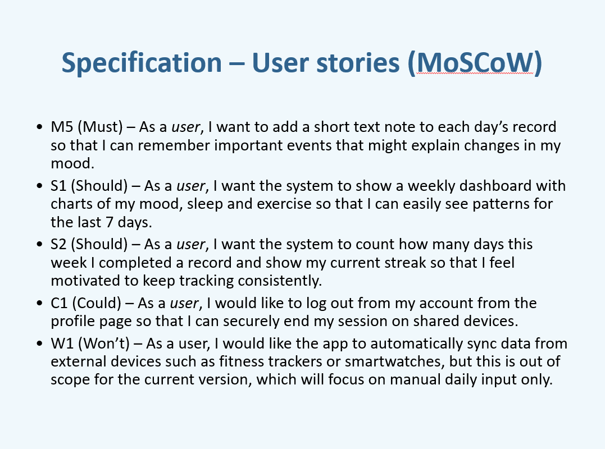
Figure 2. User stories for the MindTrack application, prioritised using the MoSCoW method (Part 2).
2.3 System Architecture Diagram
The system architecture of MindTrack follows a standard three-layer web application structure consisting of the client layer, middleware/application layer, and database layer.
At the client layer, users access the system through a web browser such as Chrome, Edge, or Firefox. This layer provides the user interface, where users can log in, submit daily records, and interact with the application using HTML, CSS, and JavaScript.
At the middleware layer, Django was used as the main application framework. This layer is responsible for handling the core application logic, including user authentication, processing daily record data, managing requests and responses, and supporting application functions such as record submission and data-related features. It acts as the bridge between the front-end interface and the database.
At the database layer, MySQL was used to store persistent application data. This includes user information, daily records, mood records, sleep records, exercise records, and work/study records. The database layer supports structured storage and retrieval of the information entered by users through the system.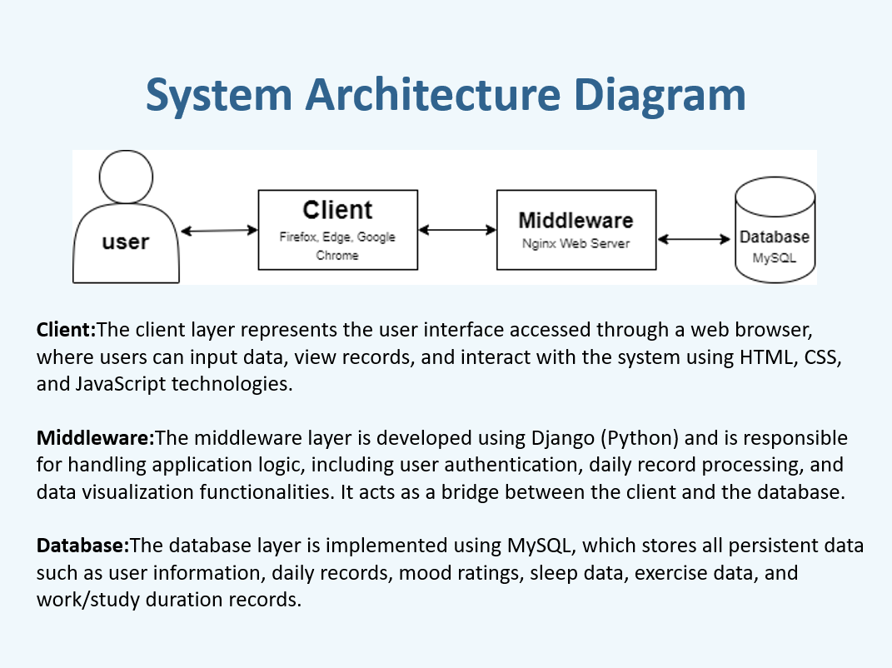
Figure 3. Final system architecture diagram of the MindTrack application.
2.4 ER Diagram
The final ER design of MindTrack is centred around the relationship between the User entity and the Daily Record entity. A user can have multiple daily records, and each daily record stores the data entered for a specific date.
The User entity contains the main account-related attributes, including user_id, username, email, password, age, gender, and sleep preference. This information supports authentication and basic user profile management within the system.
The Daily Record entity is linked to a specific user and includes attributes such as record_id and record_date. It acts as the parent record for the daily information entered by the user.
Each Daily Record can contain several related sub-records. These include Mood Record, Sleep Record, Exercise Record, and WorkStudy Record. The Mood Record stores values such as mood rating, stress rating, anxiety rating, and note text. The Sleep Record stores sleep time, wake time, sleep duration, and sleep status. The Exercise Record stores information such as exercise type, exercise duration, and whether exercise was completed. The WorkStudy Record stores work/study duration information linked to the daily record.
This structure allows the application to organise user wellbeing data in a modular way while keeping all daily information connected to a single daily record. The updated ER diagram reflects the final implementation more accurately and provides a clearer representation of the relationships between the core entities of the system.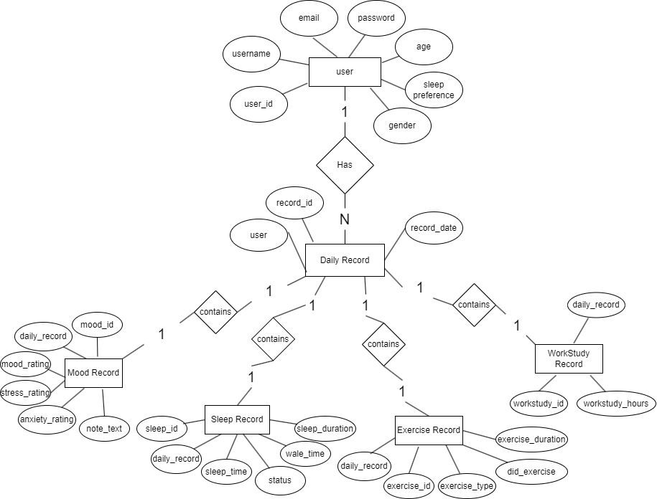
Figure 4. Updated ER diagram of the MindTrack application.
2.5 Sitemap
The sitemap shows the main navigation structure of the MindTrack application. At the top level, users begin from the landing page and can move to either the register page or the login page. After authentication, users are directed to the dashboard/home page, from which they can navigate to the main functions of the system.
The second level of the sitemap includes the key system pages: Daily Record, Data Visualization, Profile, and Logout. These pages represent the main features available after login.
At a deeper level, the Daily Record function is divided into lifestyle and mood-related modules. The mood-related section includes mood rating, stress rating, anxiety rating, and mood note fields. The lifestyle-related section includes sleep, exercise, and work/study inputs. The Data Visualization section allows users to view recorded information in a more structured and visual way, including mood, sleep, exercise, and weekly check-in related outputs.
The sitemap demonstrates that the final system was designed with a simple and task-oriented navigation structure, allowing users to move efficiently between account access, daily input, profile management, and record visualisation.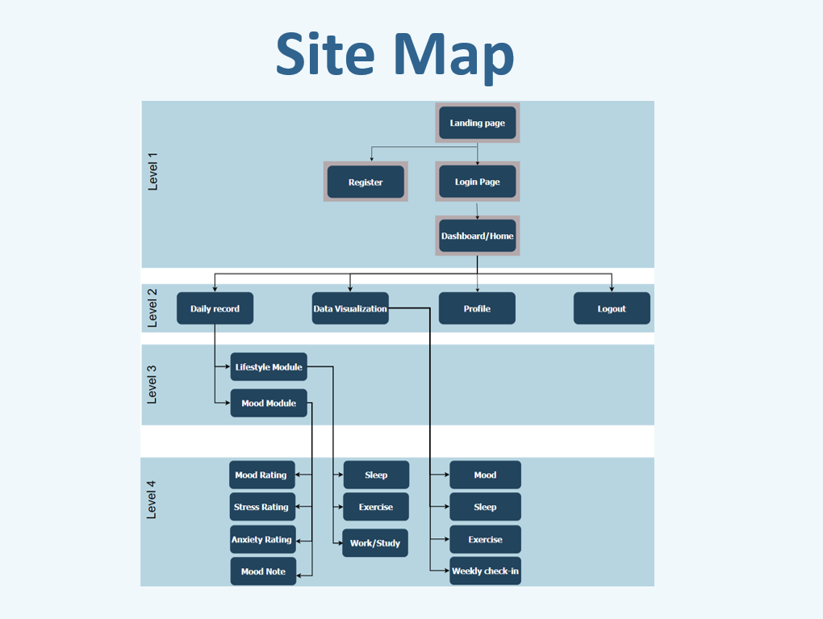
Figure 5. Sitemap showing the navigation structure of the MindTrack application.
2.6 Wireframes
Wireframes were created during the design stage to guide the layout and structure of the final user interface. These wireframes helped the team plan the arrangement of interface components, page hierarchy, and the overall user journey before implementation began.
The login wireframe shows a split layout with a logo area on one side and a login panel on the other. The login panel includes username and password input fields, a log in button, and a register link for new users. This reflects the intended focus on simplicity, clarity, and easy access to the main authentication features of the system.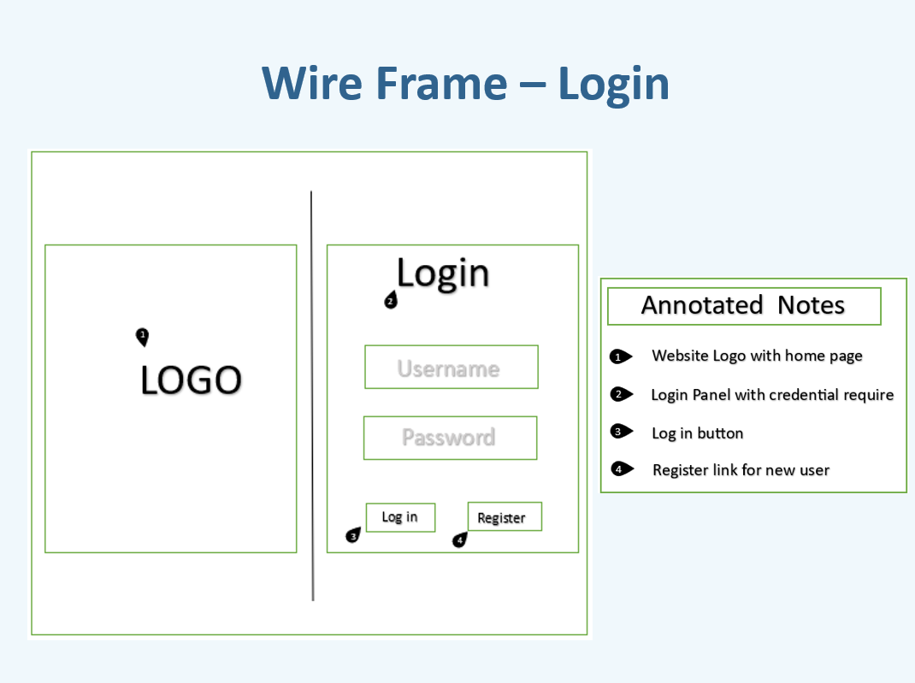
Figure 6. Login page wireframe used during the design stage of the MindTrack application.
The mood page wireframe shows the design of the mood module, including mood rating, stress rating, anxiety rating, and mood note input areas. It also includes a top navigation bar linking to the home page, daily record page, data visualization page, and personal center. This layout supports the user story of recording daily emotional data in a structured way.
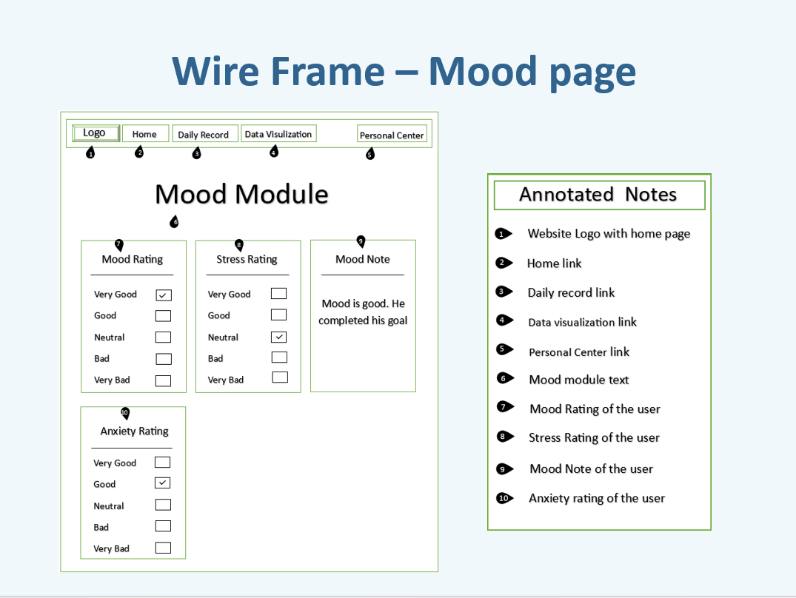
Figure 7. Mood page wireframe showing the structure of the daily mood input module.
The data visualization wireframe shows how charts and summaries were intended to be displayed to the user. The page includes visual sections for mood, sleep, weekly check-in, and exercise, helping users identify patterns in their recent records. This wireframe directly supports the “Should” user story related to a weekly dashboard with charts.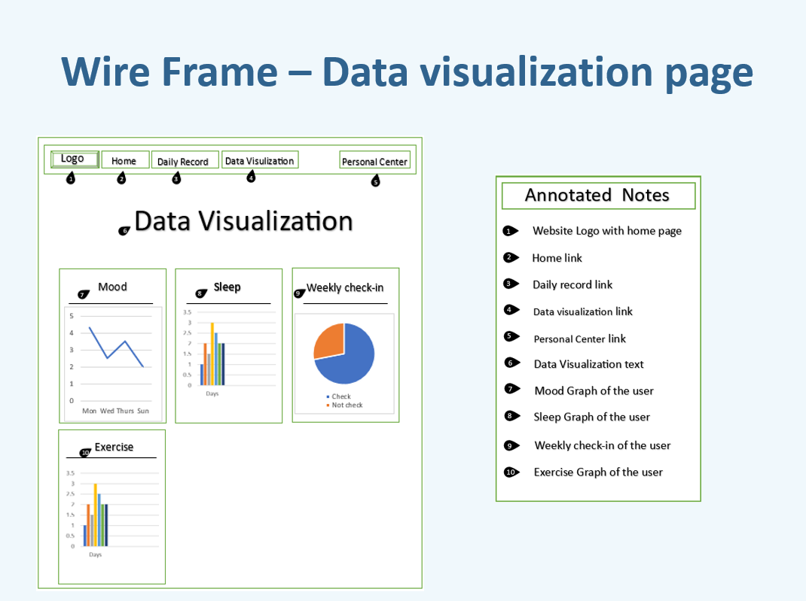
Figure 8. Data visualization page wireframe showing the planned chart-based summary interface.
The personal center wireframe shows the structure of the profile page, including user information such as username, email, age, gender, and sleep preference, together with navigation and logout controls. This layout supports profile management and secure session control.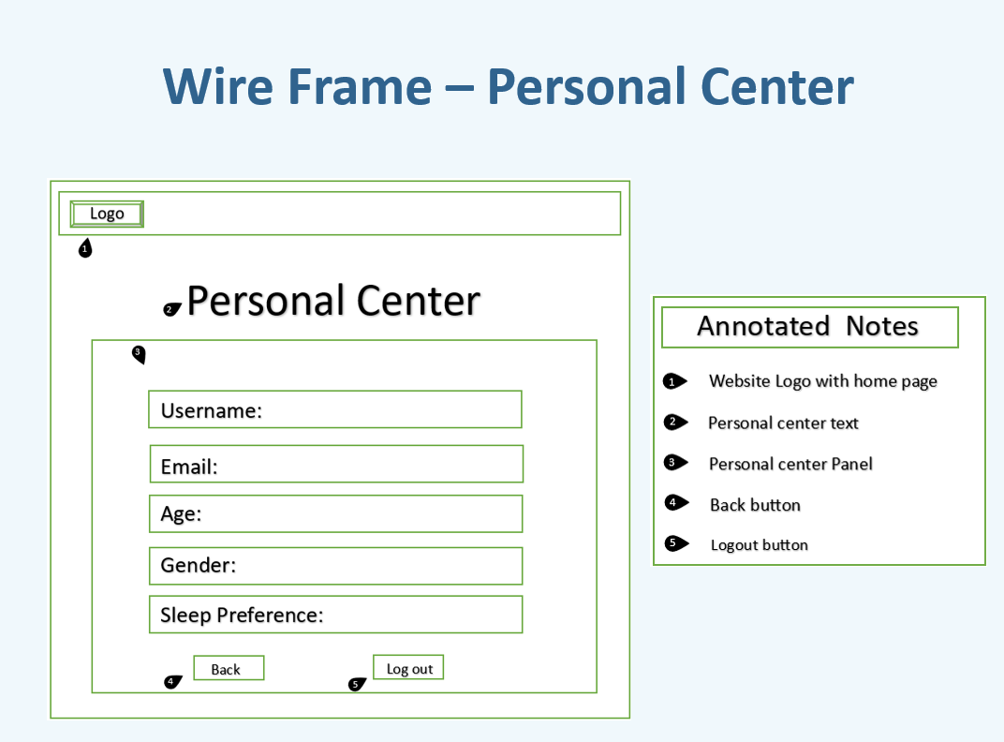
Figure 9. Personal center wireframe showing the planned profile and account interface.
Although some visual details were refined during development, the wireframes remained useful references for the final page structure and helped maintain consistency between the original design and the implemented interface.
2.7 Changes from the Original Design
Although the overall purpose of the system remained unchanged, some practical revisions were made during implementation. These changes were introduced in order to improve usability, simplify development, and ensure that the final web application aligned with the project requirements.
One of the main changes was the refinement of the final data model to better support the structure of daily wellbeing records. The updated ER diagram more clearly represents the relationship between users, daily records, and the related sub-records for mood, sleep, exercise, and work/study data.
In addition, the final navigation structure became more clearly organised around a landing page, authentication pages, a dashboard/home page, and several task-specific pages such as Daily Record, Data Visualization, and Profile. This helped make the system easier to use and better aligned the design with the actual implemented features.
The wireframe stage also informed the final interface layout across several core pages, including the login page, mood page, data visualization page, and personal center. While some visual and structural refinements were introduced during coding, the core page structure remained consistent with the original design direction.
Overall, the final implemented design remained faithful to the original project idea, while the updated design specification reflects the more accurate and practical version of the system that was actually built.
3. Implementation Highlights
3.1 Main Components and Technology Stack
MindTrack was implemented as a Django-based web application. The back end was developed using Python and Django, while the front end was built using HTML, CSS, and JavaScript. MySQL was used as the database to store persistent user data and daily records.
The system was organised into several main components. Django models were used to represent core entities such as User, Daily Record, Mood Record, Sleep Record, Exercise Record, and WorkStudy Record. Views and templates were used to handle page rendering and user interaction, while static files were used for styling and front-end behaviour. This structure helped keep the project organised and made it easier to connect the front-end pages with the back-end logic and database.
3.2 Core Functionality
The final implementation achieved the main functionality described in the design specification. First, the system supports user authentication, allowing users to register, log in securely, and access their own records. This ensures that personal data is only available to the correct user.
Second, the application supports the creation and storage of daily records. Users can submit mood-related data, including mood rating, stress rating, anxiety rating, and a short mood note. They can also enter lifestyle-related data such as sleep, exercise, and work/study duration. This information is stored in the database and linked to the corresponding daily record for that user.
Third, the system includes a profile or personal centre page where user information such as age, gender, and sleep preference can be managed. This supports a more personalised experience and reflects one of the key user stories from the design stage.
Finally, the application includes a data visualisation function that allows users to view patterns in their submitted data more clearly. This extends the system beyond simple data entry and supports reflection on daily habits and wellbeing trends.
3.3 Front-end Interactivity
The application was not implemented as a purely static Django website. Front-end interactivity was supported through the use of HTML, CSS, and JavaScript in the user interface.
Interactive functionality is reflected in the way users move through the system, submit daily records, access profile information, and view data visualisations. The system provides a more dynamic experience than basic static page rendering because user input is processed and then displayed in structured and meaningful ways. The data visualisation page is an especially important example of this, as it presents user data in a more interactive and visually interpretable form.
In addition, the navigation structure of the application supports smooth movement between the main pages, including the home/dashboard page, daily record page, data visualisation page, and personal centre page. This helps create a connected and usable web application rather than a collection of unrelated pages.
3.4 Look and Feel and Responsiveness
The implementation aimed to provide a consistent and user-friendly interface across the main parts of the system. The page structure, navigation style, and visual layout were designed to make the application clear and easy to use.
A consistent design approach was used across key pages such as login, home/dashboard, daily record, data visualisation, and personal centre. This helped give the application a more polished overall appearance and made it easier for users to understand how to move between different functions.
The final interface also reflected the earlier wireframe designs while allowing practical refinements during implementation. In particular, the system focused on keeping the main actions clear, grouping related inputs together, and presenting information in a readable way. This supported both usability and the overall presentation quality of the web application.
3.5 Code Quality and Structure
The final codebase was organised to support readability and maintainability. Django’s project structure helped separate models, templates, views, and static resources into different areas of the application, reducing confusion and making the project easier to manage.
The data model was structured so that daily wellbeing information could be separated into linked records for mood, sleep, exercise, and work/study data. This avoided storing unrelated information in a single large structure and made the system design clearer and easier to extend.
The project also included unit tests for important parts of the application, including model behaviour and selected views. This helped verify that core business logic and page behaviour worked as expected. Overall, the implementation highlights show that the final system achieved the main functional goals of the project while also meeting the requirements for structure, interactivity, and usability.
4. Testing
Testing was carried out to verify the reliability of the MindTrack web application. The system was tested using Django’s built-in testing framework, which allowed both model-level and view-level functionality to be checked in a structured way.
At the model level, the tests focused on the core data structures of the application. These included checks that a user could be created correctly, that the system automatically generated a unique 6-digit user_id, and that password hashing and verification worked as expected. The tests also verified that a Daily Record could be created successfully and that duplicate daily records for the same user on the same date were prevented by the database constraint. In addition, related models such as MoodRecord, SleepRecord, ExerciseRecord, and WorkStudyRecord were tested to ensure that they were linked correctly to the corresponding daily record.
At the view level, tests were written for the login page and selected protected pages. These tests checked whether the login page loaded successfully, whether valid login details redirected the user correctly, whether invalid login details produced the expected behaviour, and whether mood and lifestyle data could be submitted and stored successfully.
After implementation, all tests were executed using Django’s test runner. A total of 17 tests were run and completed successfully. This indicates that the core business logic, selected views, and record relationships in the system were functioning as expected at the time of testing.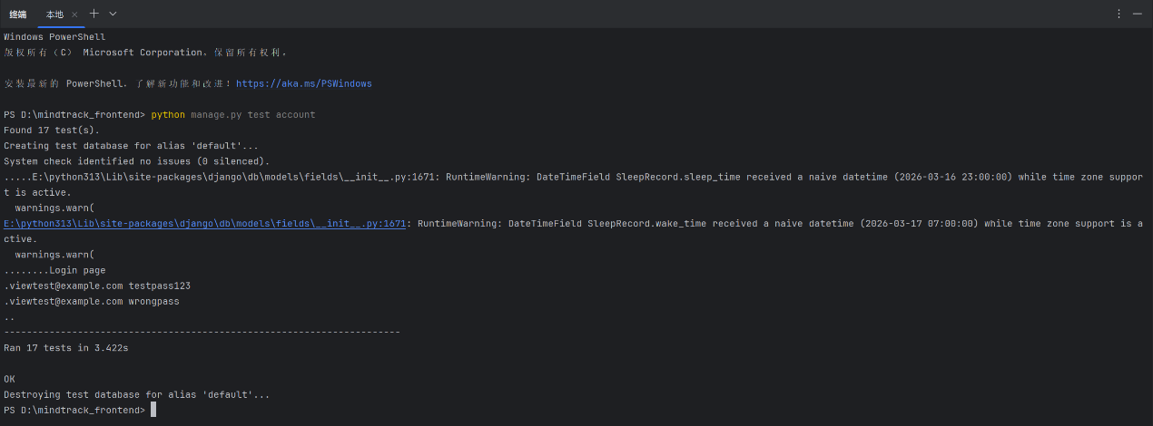
Figure 13. Output of Django’s test runner confirming successful execution of 17 tests.
5. Accessibility Report
Accessibility was evaluated using Google Lighthouse on two key pages of the MindTrack application: the home page and the login page. Both pages achieved an accessibility score of 100, showing that the implemented accessibility measures were effective.
Three main accessibility improvements were reflected in the final system. First, form controls were clearly labelled so that screen readers could correctly identify input fields, especially on the login page. Second, colour contrast and text visibility were kept at an accessible level, improving readability for users with low vision. Third, the structure of the pages was improved through the use of semantic elements and clear navigation features, including logical heading order, meaningful link names, and main landmark regions.
Additional accessibility support was also evident in the final pages. The login page supported accessibility through labelled form elements, distinguishable links, sufficient touch target size, keyboard-friendly structure, and a skip link. The home page also demonstrated accessible design through descriptive image alt text, clear heading structure, sufficient colour contrast, discernible link names, and a main landmark. The login page did not require major accessibility redesign because Lighthouse testing already showed an accessibility score of 100.
Overall, the accessibility work focused on practical improvements rather than unnecessary redesign. The final Lighthouse results suggest that the main pages of the application were accessible in terms of form usability, readability, page structure, and assistive-technology support.
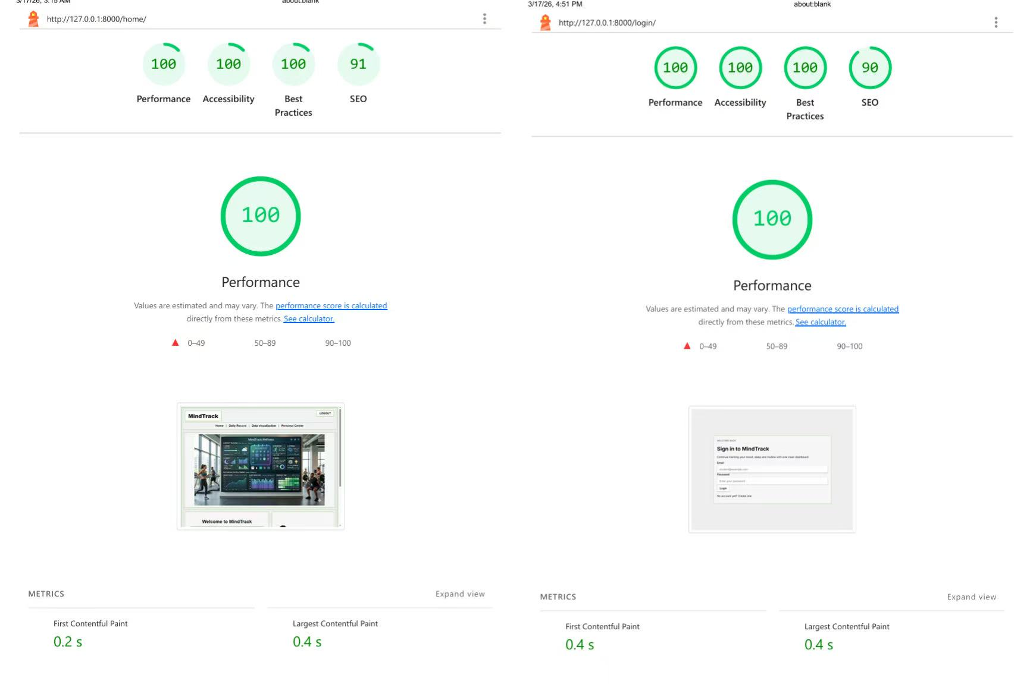
Figure 14. Lighthouse accessibility results for the MindTrack login page and home page after implementation.
6. Sustainability Report
Sustainability-related performance was evaluated using Google Lighthouse. Two pages were tested: the home page and the login page. The login page already showed strong results, while the home page was identified as the main page requiring optimisation. Because the login page already achieved a performance score of 100, no substantial optimisation changes were required for that page, and improvement work was therefore focused on the home page.
The baseline Lighthouse results showed that the home page had a performance score of 84, while accessibility, best practices, and SEO were already strong. Based on these results, improvement work was focused on the home page in order to reduce unnecessary front-end overhead and improve overall page efficiency.
After optimisation, the home page performance score improved from 84 to 100, while accessibility and best practices remained at 100 and SEO remained stable at 91. The login page also achieved strong results, with performance, accessibility, and best practices all reaching 100. This showed that the system was performing efficiently on key pages after implementation.
The Lighthouse results suggest that the final version of the application uses front-end resources more effectively and loads more efficiently than before. Overall, the sustainability evaluation showed measurable improvement, especially on the home page, and confirmed that the final implementation was more resource-efficient and technically polished.
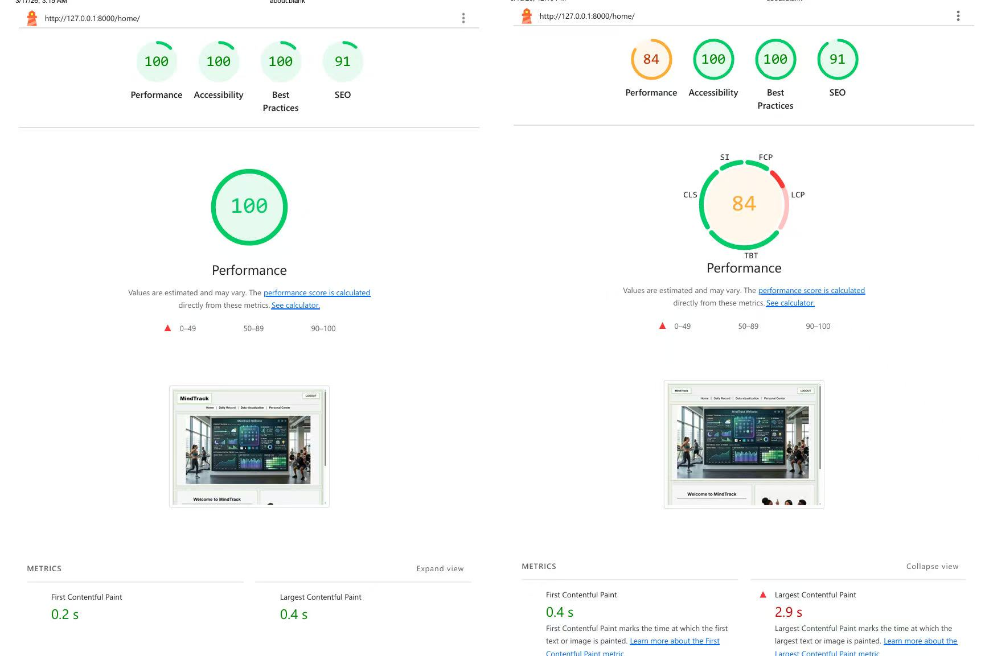
Figure 15. Google Lighthouse sustainability-related results for the MindTrack home page before and after optimisation.
7. Appendix
7.1 Team Contributions
The project was completed as a team effort, with responsibilities divided across implementation, testing, and documentation. The main contributions were as follows:
[Member 1 Name]: [main responsibilities]
[Member 2 Name]: [main responsibilities]
[Member 3 Name]: [main responsibilities]
All members contributed to discussion, review, and refinement of the final system and report.
7.2 AI Use Statement
We declare that we have used GenAI for debugging support, code-quality suggestions, accessibility implementation guidance, sustainability/performance improvement guidance, and limited copy-editing of the report.
The main tool used was ChatGPT. GenAI support affected parts of the code, tests, accessibility-related improvements, sustainability analysis, and report wording. All suggestions were reviewed, adapted to the project, and checked by the team before inclusion in the final submission.

