|  |  |  |  |
| --- | --- | --- | --- |
| Universität Konstanz · Postfach 714 · 78457 Konstanz |  | Prof. Dr. Helmut Cölfen  Fachbereich Chemie · Physikalische Chemie  Universitätsstraße 10  D-78464 Konstanz  +49 7531 88-4063  Fax +49 7531 88-3139  Helmut.Coelfen@uni-konstanz.de  <http://cms.uni-konstanz.de/coelfen> | |
| **Editor Journal of Chromatography A** |
|  | | |
| **27.09.2020** | | | | |
| Revision on our submission of the research paper on the calibration experiment in Asymmetrical-flow field flow fractionation | | |
|  | | |

Dear Editor,

Hereby, we would like submit a revised version of our manuscript with changes which were made due to the helpful comments of the referees. A detailed reply to all is attached separately. We addressed all comments and reevaluated the data after including some necessary changes into our presented algorithms. The corrections suggested by thee reviewers could contribute to show our findings even more clearly.

Some of the critics turned our indeed to support our main hypothesis with some additional explanations. We hope that after making these changes our paper is now in an acceptable condition.

Best Regards

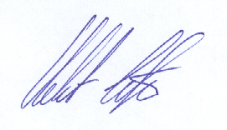

Prof. Dr. Helmut Cölfen (corresponding author)