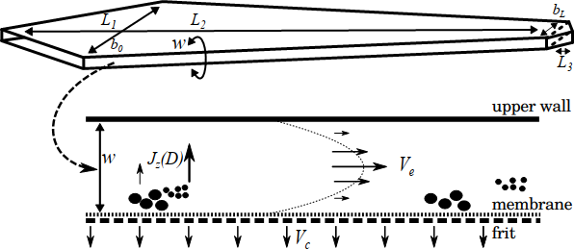

Figure 1. Top view of an AF4 channel (top) and its cross-sectional area (bottom).

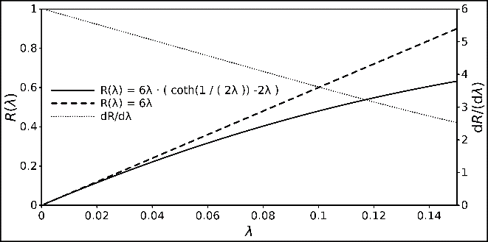

Figure 2: Relationship between *R* and *λ*, displayed with the classical FFF retention and its linear approximation. The derivative of the retention equation is also displayed to demonstrate its strict monotony.

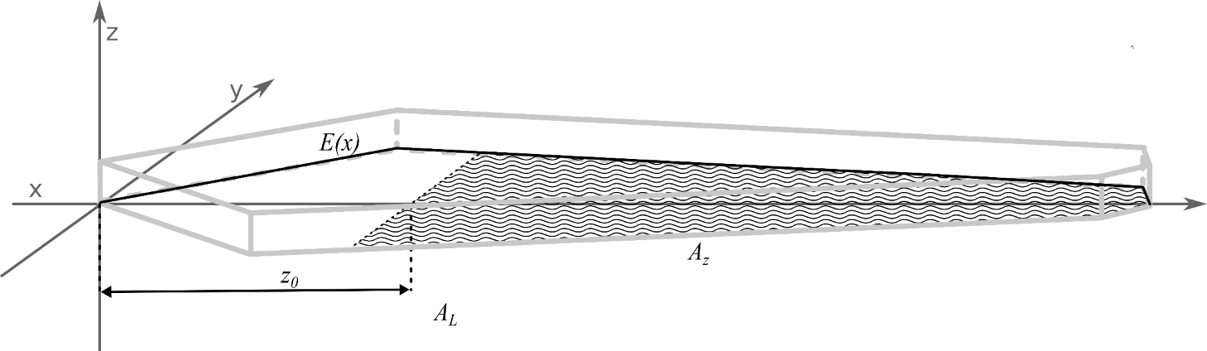

Figure 3. Coordinate system with the shape description function *E*(*x*), the focus position *z*0 the plain of the effective separation volume (hatched area *A*z), the complete area of all sections *AL* (hatched and non-hatched surface in the *x*,*y* plain) and the light grey edges of the generated channel shape.

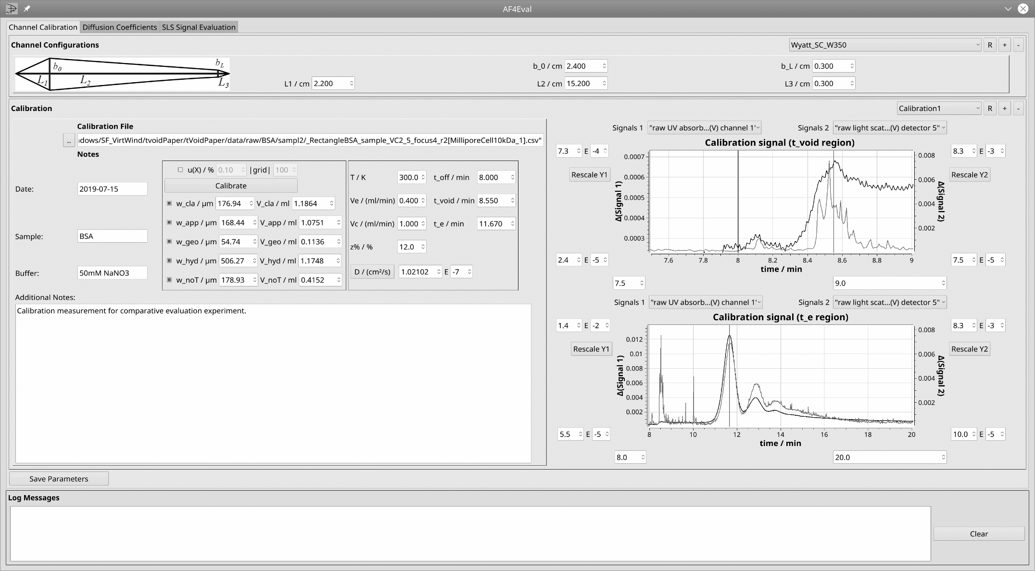

Figure 4. User interface for the manual read-out of *t*void and *t*e. The bars are controlled via the respective spin boxes and allow a direct transfer of the value from the fractogram to the calculation.

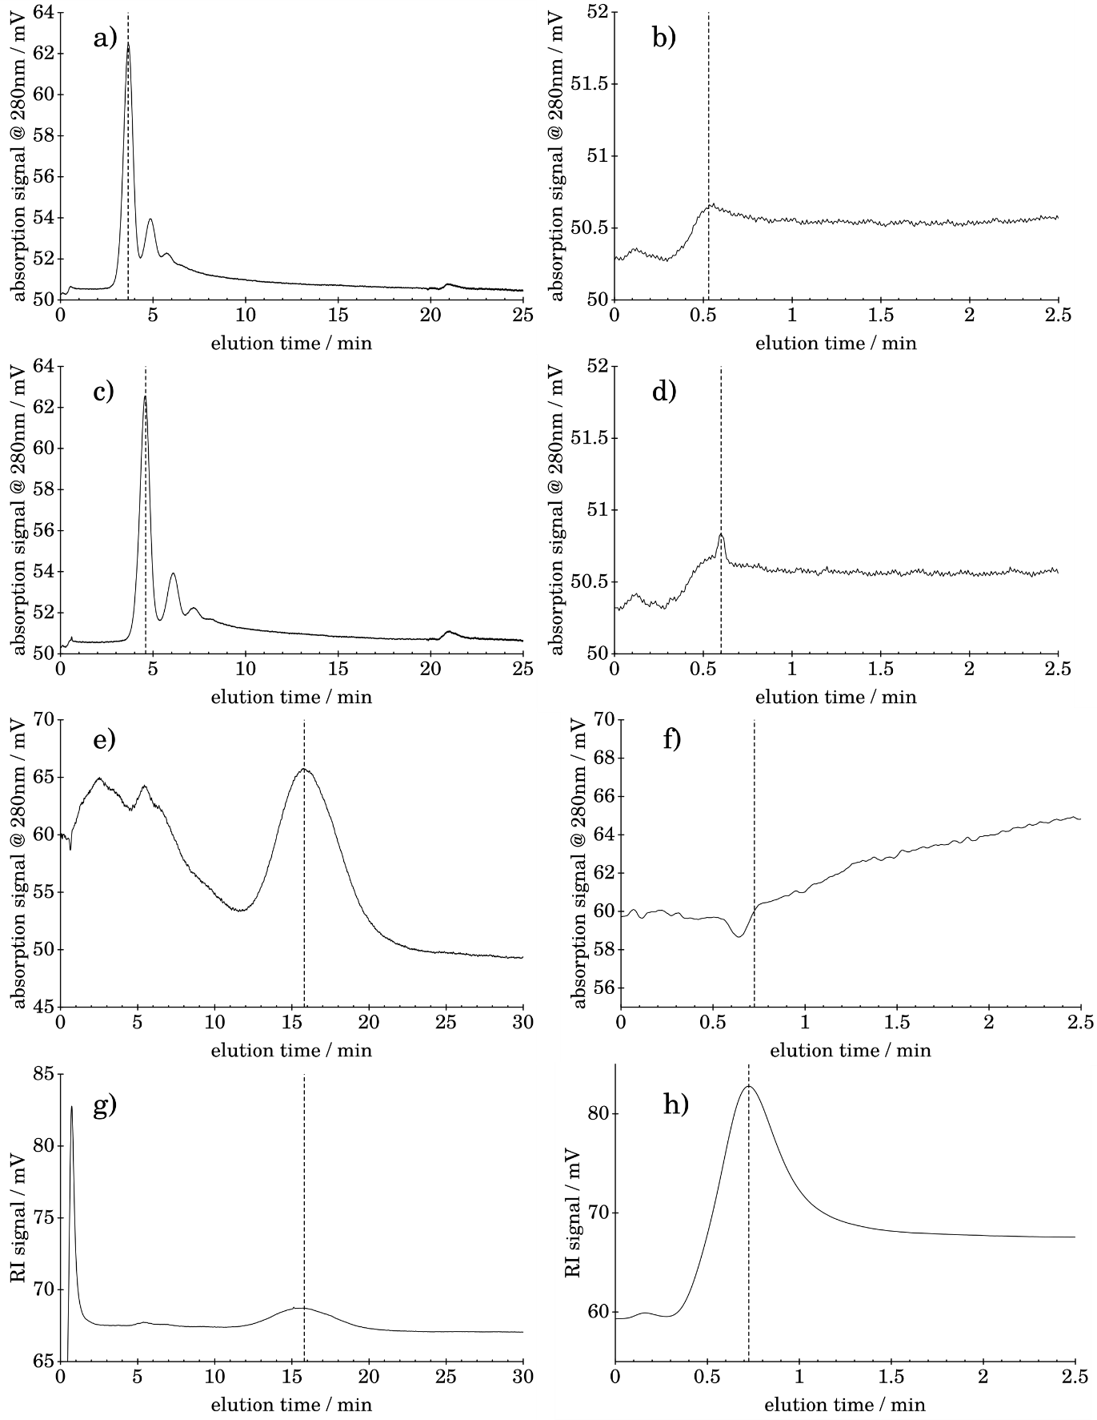

Figure 5. Raw fractograms, each data set is shown completely on the left (dashed line marks the position of *t*e) and a zoomed detail of void peak region (dashed line marks the position of *t*void) on the right: a) BSA_Vc2_5_r1, *t*e b) BSA_Vc2_5_r1, *t*void c) BSA_Vc3_5_r1, *t*e d) BSA_Vc3_5_r1, *t*void e) PS_Vc0_5_r1, UV, *t*e f) PS_Vc0_5_r1, UV, *t*void g) PS_Vc0_5_r1, RI, *t*e h) PS_Vc0_5_r1, RI, *t*void.

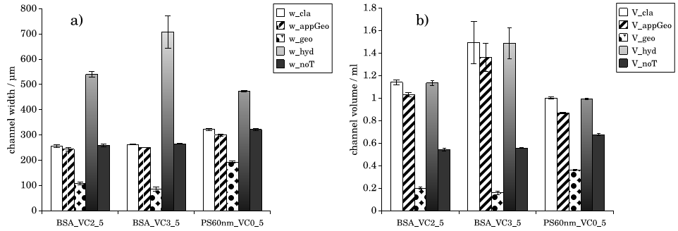

Figure 6. Results of calibration algorithms with test measurements, a) channel width b) channel volume.

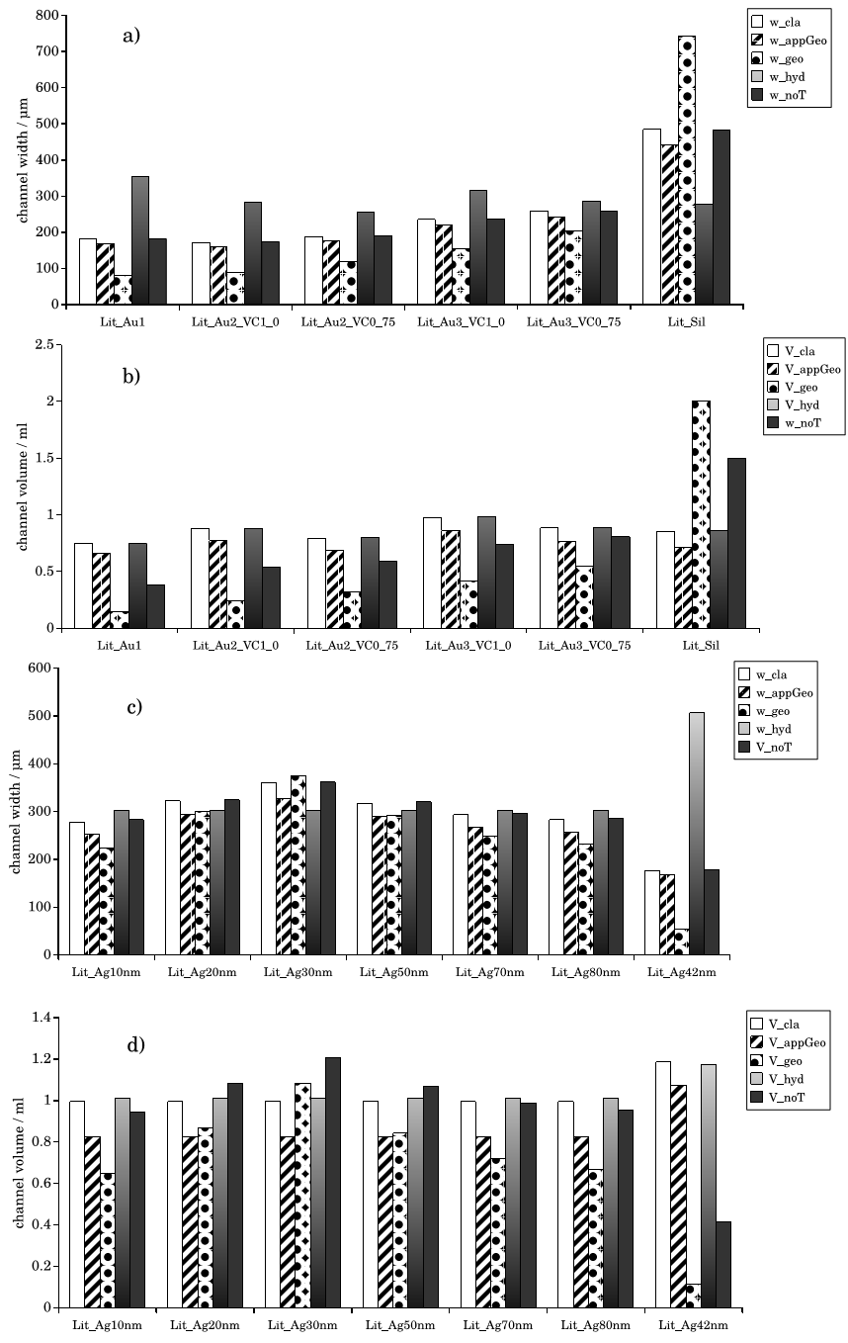

Figure 7. Results of calibration algorithms with literature data, a) *w* for data from Table 3 b) *w* channel volume Table 3 c) *w* for data from Table 4 d) *V* for data from Table 4.

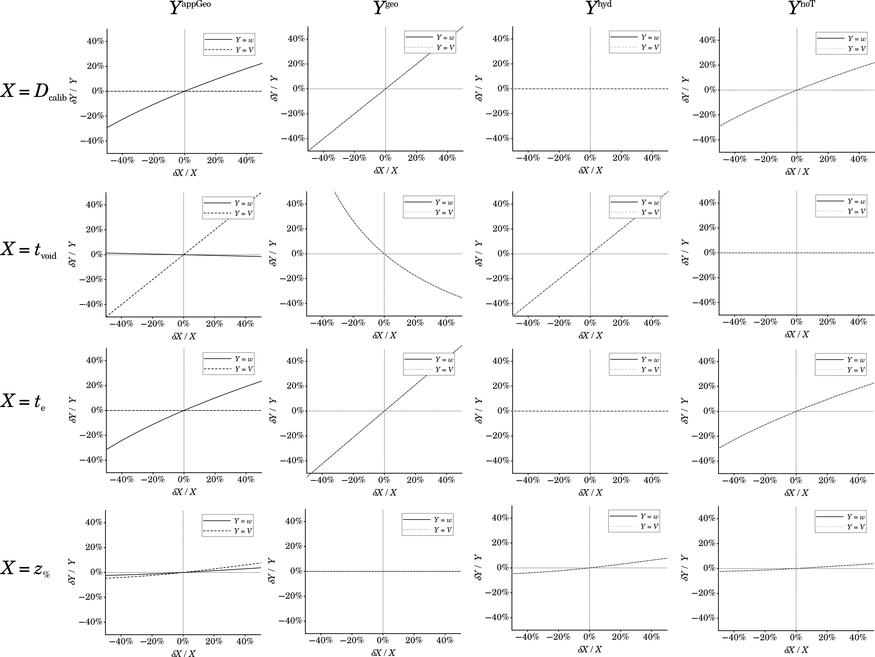

Figure 8. Selected results from the deviation analysis.

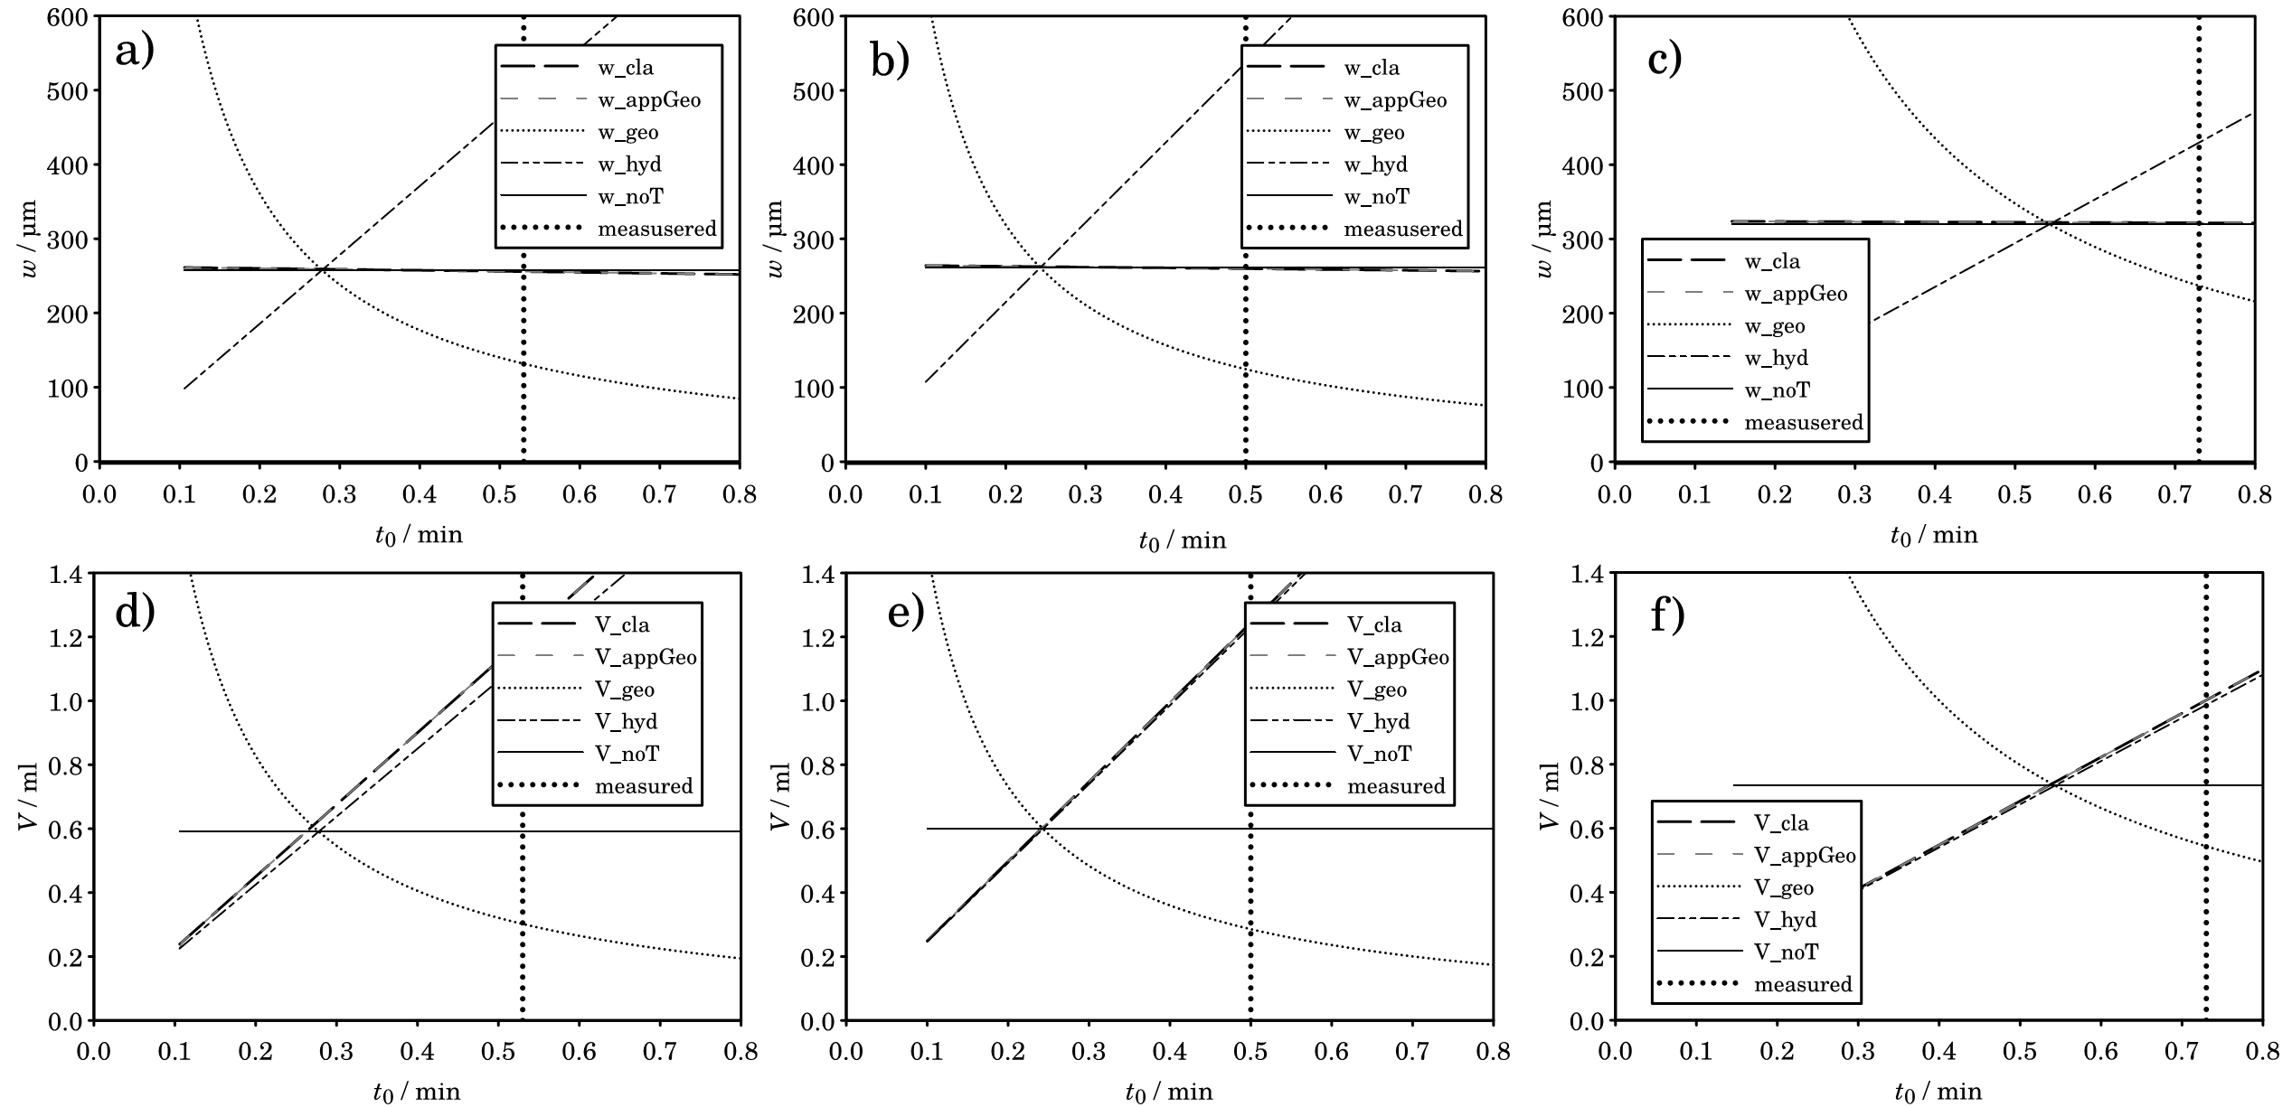

Figure 9. Overlay of the simulated calibration results for all central data and varying *t*void.*­*a) *w* for BSA_Vc2_5 b) *V* for BSA_Vc2_5 c) *w* for BSA_Vc3_5 d) *V* for BSA_Vc3_5 e) *w* for PS_Vc0_5 f) *V* for PS _Vc0_5.

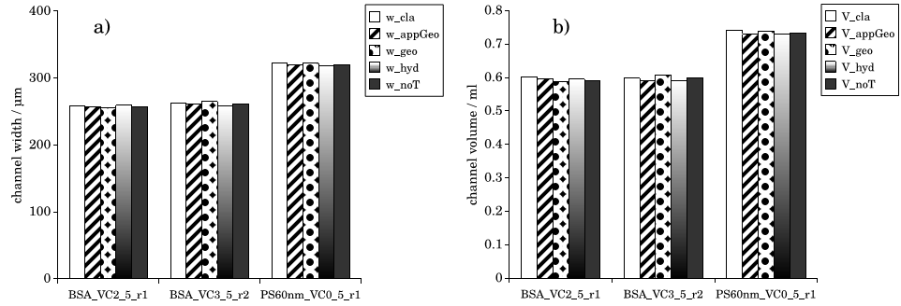

Figure 10. Results of calibration algorithms with selected test measurements and adjusted *t*void as determined by the intersection of the lines from Fig. 9, a) channel width b) channel volume.

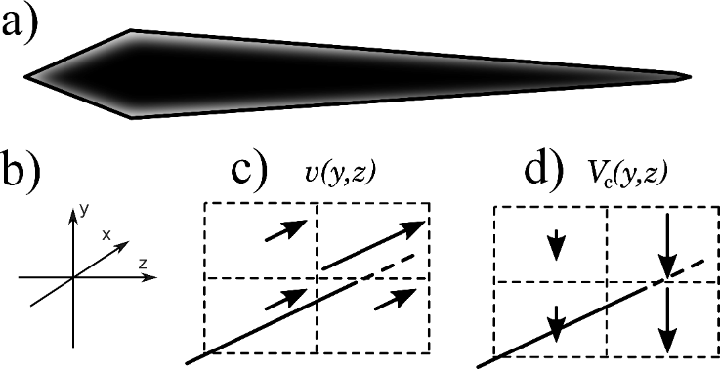

Figure 11. a) Schematic view of the expected distribution of crossflow b) Rotated coordinates for c) expected distribution of elution velocities and d) expected crossflow distribution along the channel border.