3000 words / 5 figures / (max. 6 printed pages)

Determination of Diffusion coefficients from Flow Field-Flow Fractionation data without calibration and automatable batch evaluation of via void peak determination

Benedikt Häusele1, Maxim Benjamin Gindele1, Helmut Cölfen1*

1 Physical Chemistry, Department of Chemistry, University of Konstanz, Universitätsstr. 10, 78457 Konstanz, Germany

benedikt.haeusele@uni-konstanz.de  
helmut.coelfen@uni-konstanz.de

*Correspondence:

helmut.coelfen@uni-konstanz.de  
Tel.: +49 7531 88-4063  
Fax: +49 7531 88-3139

Abstract:

Asymmetrical field-flow fractionation is a versatile chromatographic fractionation method. In combination it is used for size-based separation of colloids, biomolecules and polymers. Although used often as pure separation method, a well-elaborated theory is available that allows precise quantification of the analysis results. A conversion from the time domain to the domain of hydrodynamic radius is then possible directly without. Up to now, this is an error-prone procedure requiring some effort as the fractrograms have to be pre-processed manually to gain all information required for the conversion. In this work, we present a software-based evaluation workflow which circumvents these pitfalls allowing to calculate reliable distributions. Providing a small graphical user interface minimizes the manual effort of evaluation which turns out to be useful especially for method development, extensive parameter studies and multi-detection methods.

Keywords:

Asymmetrical Flow Field-flow fractionation, void peak determination, size determination, calibration

**Introduction**

AF4 (Asymmetrical flow field-flow fractionation) is a chromatographic technique that can be used to separate samples due to their diffusion coefficient (Wahlund1987). It is a member of the field-flow fractionation techniques invented by J. Calvin Giddings (Giddings1977). Compared to more commonly applied separation methods like SEC and HPLC (Coelfen2000) FFF techniques are based on the interaction of the analyte with a physical field which separates the sample to a corresponding physical size (Giddings1993). In principle, the method is applicable to a huge variety of samples, including small biomolecules, nanoparticles and polymers (Giddings1993 Cölfen2000 Litzen1989) up to big agglomerates like protein aggregates(Yohannes2010), virus-like particles (Pease2009), drug carrier systems (Fraunhofer2004). Nowadays, AF4 is the most commonly used flow FFF method, where the separation channel is formed of a solid wall and a frit covered by a membrane.

Though, the development of dedicated measurement protocols can be complicated as the high number of adjustable parameters. (Giddings2013) This includes instrumental specifications like the channel length *L*, channel width *w* and the choice of membrane material. Three typical variable experimental conditions are elution flow *Ve*, applied cross flow *Vc* and the sample focusing period *tf*. FFF has to be combined with at least one detection technique, typically MALLS, Uv/Vis and/or RI, but also on-line NMR (cite Hiller 2013), mass spectrometry (Yohannes2011) and SAXS (Thünemannn2009a).

Although AF4 theory has been elaborated and well documented in literature, the application transfer to quantitative evaluation software is still behind to comparable methods like AUC, where several software solution and a couple of evaluation methods are available and usable even without in-depth knowledge of the underlying algorithmic considerations (cite Schuck2000, cite Demeler2005). Therefore, we try to fill this gap with implementation of the known procedure. According to some example measurements we validate underlying assumptions according to suitable data sets. s

**Theory**

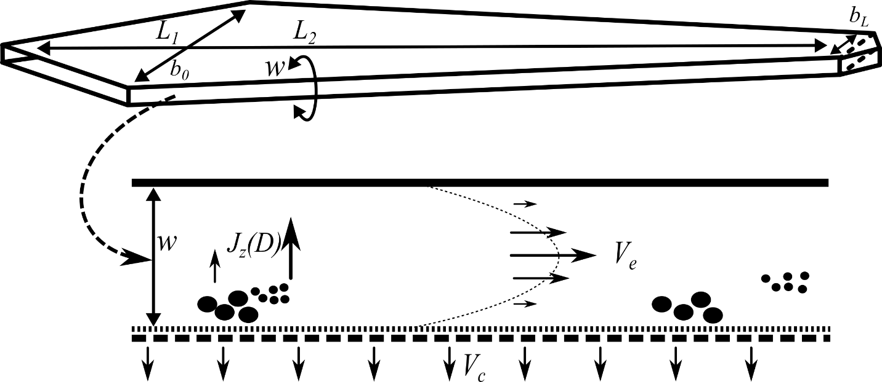

Figure . Top view of an AF4 channel (top) and its cross-sectional area (bottom)

The sample is injected into a flat channel with a solid upper wall and a lower wall that allows the streaming solvent to pass partially (Figure 1). In current devices this wall is made of a frit covered by an ultrafiltration membrane. The inlet flow *V*in is, thereby, split to a crossflow *V*c(which is distributed uniformly over the horizontal section of the channel) and an elution flow *V*e forming parabolic flow profile typical for all FFF variants. The “broadness” of the parable representing the velocity gradient depends on the plate distance *w*.

*V*c transports the particles to the membrane. As a consequence, the opposed translational diffusion *J*z determines the average velocity zone and hence the time of elution. The mathematical description of AF4 experiments and its derivation has been described extensively in literature (Wahlund2013, Haakasson2012, Magnusson2012, Wahlund1987). Thereby, we only state a short description of those formulas that are used in our evaluation approach which is essentially built up existing theory. While the physical relationships are widely known and well documented, this is not always the case for their translations into an evaluation procedure. This might seem to be a trivial step as the physical content is well elaborated, however, when the underlying physics are already known. However, considering the number different approaches which exist for calibration (Wahlund2013, Bolinsson2018) and their variations in detail, the implementation affects not only the evaluation but also the required measurement setup and, of course, the final measurement result. The lack of such standardized evaluation procedures impairs the reproducibility of measurements and may be one of the reasons why the analytical characterization potential is not exhausted to its potential up to now (Cölfen2000). We give a detailed pseudocode description of our implemented method - considered as the most convenient evaluation procedure recently (Borlinsson2108) - in the supplementary information for this reason. The retention ratio *R,* defined as

$R=\frac{t_{0}}{t_{\text{e}}}$ (1)

with the time of the void peak *t*0 (the time which is required for a particle to travel if no retention occurs) and any possible point of time during the evaluation).

This is connected to the relative mean layer distance *λ* by the classical FFF retention equation:

$R=6λ⋅(\text{coth}\left(\frac{1}{2λ}\right)-2λ)$, (2)

which is often simplified by

$R_{\text{approx}}=6λ$, (3)

For AF4, the relevant correlation of *λ* and *D* has been elaborated (Wahlund1987) as

$λ=\frac{D⋅V^{0}}{V_{\text{c}}⋅w^{2}}$. (4)

For a typical AF4 measurement the channel volume *V*­0­ and the channel height *w* are critical sizes for the evaluation. Recently, we used a calibration method (Schmid2018) that makes use of the volume calculation as reported by Wahlund (1987) and then adjusts *w* by a simple bisection accordingly to eq. (3) and (4). A similar method was reported indepently (Hakansson, Magnusson). Fig. 2 shows that the bisection is applicable due to the strict monotony of the retention equation within the relevant scope.

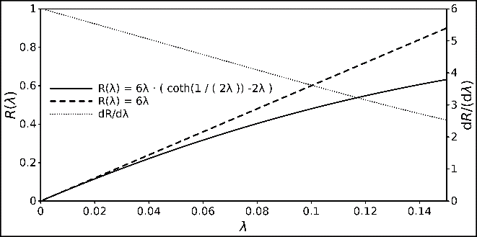

Figure : Relationship between R and λ,, displayed with the classical FFF retention and its linear approximation. The derivative of the retention equation is also displayed to demonstrate its strict monotony.

This approach reveals as disadvantageous as it does not make use of the simple fact that the V0 has to be a product of the surface and height of the channel. Thereby, it leads to the intuitive observation that variations of any parameters don’t affect the calculated volume and the channel height linearly equally. This implies independence of these magnitudes from each other which would violate fundamental geometrical principles.

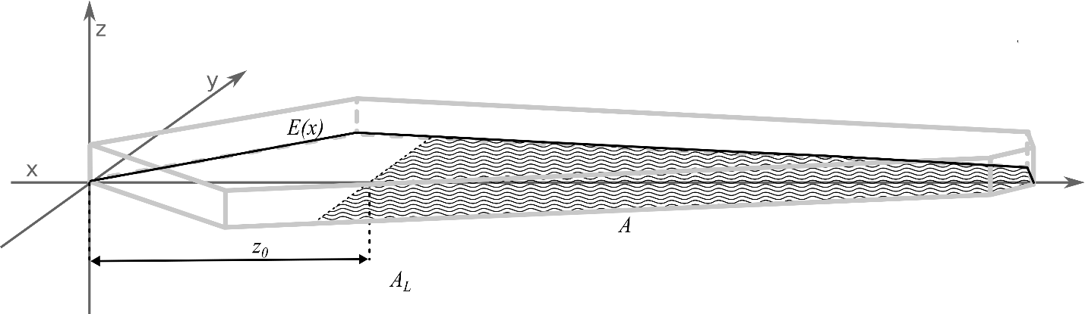

Figure 3. Coordinate system with the shape description function *E*(*x*), the focus position *z*0 the plain of the effective separation volume (hatched area A), the complete area of all sections *AL* (hatched and non-hatched surface in the *x*,*y* plain) and the light grey edges of the generated channel shape.

Making use of the simple relationship

$V^{0}=A⋅w$ (5)

, we show a second way here to perform the calibration. It is conducted by substituting the term

$\frac{V^{0}}{w^{2}} :=S$ (6)

in eq. (4) and determine *S* analogously to *w* as in the classical approach. In a second step, inserting eq. 5

with the used channel plane *A* (Fig. 3) that was used for the separation gives a solution for *w* as

$w=\frac{A}{S}$ (7)

With eq. (6) now the Volume can be calculated. Dedicated derivations of the channel plane calculation is given in the supplementary information. As has already been stated, in this approach, all hydrodynamic information is already used to calculate *S,* the remaining considerations are only dependent on the channel geometry, therefore we refer to the volume calculated this way as *V*geo and the resulting channel height *w*geo.

A third way of calculating the height and the volume is based considerations concerning the flow velocities and hydrodynamic properties exhibited in the channel based based on a refinement for variable channel heights *b*(*x*) (Litzén1991). However, the same rigorous equations for the description of the channel shape were used as for the calculation of *V*geo. This leads to a direct linear relationship of *t*0 and *w*:

(8)

The “conversion factor” *C*F is determined via the hydrodynamic and geometric properties of the measurement. It obtained by solving the integral:

$C_{\text{F}}= \int_{z_{0}}^{L}{\frac{E(ξ)}{V_{\text{in}}-V_{c}⋅\frac{2⋅\int_{0}^{ξ}{E(x)dx}}{A_{L}} }}dξ$ (9)

Here *E*(*x*) describes the shape of the channel in dependence of a longitudinal position *x* and *A*L is the complete surface of the channel. *V*in is Then, using eq. 5, *V*hyd can be calculated. The values obtained by this method are denoted as *V*hyd in the following. A detailed derivation for the factor *C*Fand *V*hyd is given in the supporting information.

Inserting of eq. 5 and 8 into the “basic AF4” eq. 4 now gives

$λ=\frac{D⋅A}{{2⋅V}_{\text{c}}⋅t_{0}⋅C_{F}}$ (10)

As *λ* is accessible via eq. 3, and all other parameters are known from this is a universal expression that enables the calculation of *D* without previous calibration measurement.

**Materials and methods**

AF4Eval is our first published version of evaluation software of AF4 data which is now available. The user can create profiles for channel shapes and corresponding calibrations for a measurement set. The data have to be provided in a standard csv-file format with the measurement time as first column and an arbitrary number. The software can process an arbitrary amount of signal channels to make it flexible for the evaluation with different coupled detection techniques. As *t*0 and *t*e have to be determined manually, we integrated a simple graphical element (Fig. 4) with movable bars to the user interface to enable the user to perform this task.

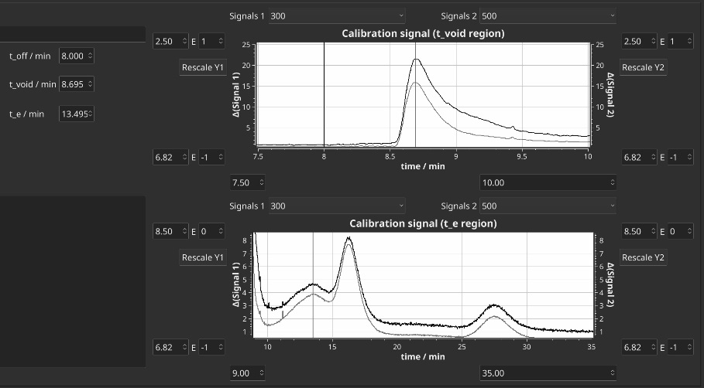

Figure . User interface for the manual read-out of *t*0 and *t*e. Offset of

In addition, a basic module for the processing of MALLS data is already integrated in the current development state. However, as comparable software is already available for the unprocessed AF4 data, these functions are not discussed here further. The current software as published in this work was implemented in C++14 using the well-known cross-platform framework Qt 5.7.1 and the graphical plotting library Qwt 6.1.2 (Rathman2014). The source code of the project can be obtained at github: <https://github.com/biocrystal777/AF4Eval>. Data shown in this report where obtained with a version compiled with g++ 6.3 under Debian Gnu/Linux 9.5.

Based on the theory above we implemented 7 smaller algorithms: 3 ways of calibration (“classical”, “geometrical” and “hydrodynamic”), 2 corresponding methods to gain distributions of diffusion coefficients and a direct conversion without calibration, i.e. without the need of an external *D* from a second measurement. The calibration-dependent three methods enable an estimation of the void peak time from the geometrical properties of the calibrated channel. Thus, manual readout of the void peak is avoided entirely and the methods can be integrated in an entirely automated procedure. The direct conversion turns out to be useful if no appropriated standard is available. These algorithms vary in their specific required input magnitudes (Tab. 1).

Table 1: Used Spacer dimensions, index *j* indicates a distribution of the magnitude

|  |  |  |  |  |  |  |
| --- | --- | --- | --- | --- | --- | --- |
|  | Classical Calibration | Calibration via *V*geo | Calibration via *V*hyd | Classical Conversion | Conversion via *V*hyd | Direct Convesion |
|  | *D*calib | *D*calib |  |  |  |  |
|  | *t*0 | *t*0 | *t*0 |  |  | *t*0 |
|  | *t*e | *t*e |  |  |  |  |
|  |  |  |  | *tj* | *tj* | *tj* |
|  | *V*e |  | *V*e |  | *V*e | *V*e |
| Inputs | *V*c | *V*c | *V*c | *V*c | *V*c | *V*c |
|  | *z*% | (*z*%) | (*z*%) | *z*% | (*z*%) | (*z*%) |
|  |  | *L*1, *L*2, *L*3 | *L*1, *L*2, *L*3 |  | *L*1, *L*2, *L*3 | *L*1, *L*2, *L*3 |
|  |  | *b*0, *b*L | *b*0, *b*L |  | *b*0, *b*L | *b*0, *b*L |
|  |  |  |  | *w* | *w* |  |
|  |  |  |  | *V*0 | *V*0 |  |
|  | *w* | *w (w*geo*)* | *w (w*hyd*)* |  |  |  |
| Outputs | *V*0 | *V*0 (*V*geo) | *V*0 (*V*hyd) |  |  |  |
|  |  |  |  | *Dj* | *Dj* | *Dj* |

In addition, an error analysis option was implemented that allows to estimate the uncertainties of the methods. The error analysis allows to define a range *R* of the estimated uncertainty *u*(*Xi*) from 1 to 100% for the input quantity *Xi* and a grid resolution parameter. The method then iterates over arrays *u*(*Xi*) of *R* while conducting the assigned algorithm and gives the deviation of the output quantitiy *Y*j. This gives a rough overview, how the deviation of one quantity affects the result under while the other quantities are kept constant. This way, the individual impact of the uncertainty of each variable can be easily quantified for each experimental condition.

**Experiments**

Table 2: Used Spacer dimensions

|  |  |  |  |  |  |  |
| --- | --- | --- | --- | --- | --- | --- |
| Spacer | *L*1 / mm | *L*2 / mm | *L*3 / mm | *b*0 / mm | *b*L / mm | *w*Spacer / µm |
| S1 | 20 | 150 | 4 | 11 | 4 | 250 |
| S2 | 20 | 150 | 4 | 11 | 4 | 350 |
| S3 | 20 | 150 | 4 | 11 | 4 | 460 |
| S4 | 20 | 150 | 4 | 21 | 4 | 250 |
| S5 | 20 | 150 | 4 | 21 | 4 | 350 |
| S6 | 20 | 150 | 4 | 21 | 4 | 460 |

The experiments were conducted with a Wyatt Eclipse DualTec Separation system. The setup was coupled with a degassing unit (G1322A), an isocratic pump (G1310B) and an autosampler (G1328C), all from the Agilent 1260 series. Signals were recorded using Astra 6.1.7.17 with a sample rate of 0.5 Hz. The experiments were conducted with the following spacer measurements. A Dawn Heleos 8+ MALLS detector (wavelength = 663 nm) and a UV/DAD detector (G1315C, Agilent series 1100) were used for detection. Spacer with 6 different dimensions were used, dimensions given in Table 1. The eluent was 50 mM NaNo3. Measurement samples were BSA (and Thyroglobulin). The injected sample amount was 20 µl at a sample concentration of 4 mg/ml. For each spacer a new 5 kDa Millipore regenerated Cellulose membrane was used. Detailed measurement program and sequence setup is given in the supplementary information.

**Results**

Determined channel widths and volumes.

Example of the automation of the whole measurement sequence.

Example of result n varying z

**Discussion**

Comparison of the four discussed methods.

Text………..

**Conclusions**

We have shown that a dedicated software for the evaluation has the potential to greatly improve the practical handling of AF4 data and further development. As already known, expected the information about channel volume and channel height are the critical quantities for contemporary machines. The early substitution of an expression of variables with known values shows up to be very useful when translating the physical relationships into a precisely defined evaluation algorithm. The development of the software will be continued, considering the following list of features only as an example for numerous possible extensions:

* Alternative calibration methods as have been investigated recently (Bolinsson2018). Also

distance measurement has improved continuously (Berkovic2012) up to , therefore we think that further calibration methods based on combination of the channel with such a device might be an additional orthogonal tool for the calibration.

* Crossflow gradients (Litzen1989, Kirkland1992, Williams2001), steric effects and decays (cite Wahlund Håkansson2012, cite Magnusson2012). Our final goal will be to provide an open and extensible reference implementation of which gathers all these state-of-the-art evaluation methods
* advanced handling of light scattering data.
* AF4 related deconvolution techniques (Schmid2018, if accepted)
* improved focus point determination as recently presented (Wang2018).
* generation of plotting language scripts based on the given data set

As distance measurement by optical methods has improved continuously over the last decades up to submicrometer precision a direct measurement of *w* will be an additional improvement. It was stated by Wahlund(2013) that, unfortunately, these calculations were not available in commercial software. Instead, we suggest that a software implementation is much more suited to fit the needs of the coming developments in progress of evaluation procedures. I t allows a much more flexible adaption according upcoming new developments and integration of subsequent data processing than a proprietary approach. To allow further automation it would be rather helpful if all important parameters from a measurement were directly available in an easily parsable format to reduce. We encourage users of AF4 get in contact to discuss possible extensions for their specific needs.

**Acknowledgements**

This work was generously supported by the DFG (Deutsche Forschungsgemeinschaft) within the SFB 1214, project B6. We also thank Emre Brookes for hosting the version control repository for the development steps before publication.

**References**

Müssen noch ergänzt werden zum Text

Rathmann, U. *Qwt - Qt Widgets for Technical Applications*, 2014.