3000 words / 5 figures / (max. 6 printed pages)

Revision of the AF4 calibration experiment

Benedikt Häusele1, Maxim Benjamin Gindele1, Helmut Cölfen1*

1 Physical Chemistry, Department of Chemistry, University of Konstanz, Universitätsstr. 10, 78457 Konstanz, Germany

benedikt.haeusele@uni-konstanz.de  
helmut.coelfen@uni-konstanz.de

*Correspondence:

helmut.coelfen@uni-konstanz.de  
Tel.: +49 7531 88-4063  
Fax: +49 7531 88-3139

Abstract:

Asymmetrical field-flow fractionation is a versatile chromatographic fractionation method. In combination it is used for size-based separation of colloids, biomolecules and polymers. Although used often as pure separation method, a well-elaborated theory is available that allows precise quantification of the translational diffusion coefficient *D*. Still, current literature suggests different ways to transform this theory into applicable experimental procedures and no “gold standard ” for correct data processing exists. While some sources report a direct way to extract diffusion information from the fractogram, others suggest the necessity of an external calibration measurement. In this work, we compare the different approaches and calibration algorithms based on original and literature data using our own open-source AF4 evaluation software. Based on the results, we conclude that available AF4 setups do not fulfill the requirements for absolute measurements of *D* yet and direct meaurements of *w*.

Keywords:

Asymmetrical Flow Field-flow fractionation, void peak determination, size determination, calibration

**Introduction**

AF4 (Asymmetrical flow field-flow fractionation) is a chromatographic technique that can be used to separate samples due to their diffusion coefficient (Wahlund1987). It is a member of the field-flow fractionation techniques invented by J. Calvin Giddings (Giddings1977). Compared to more commonly applied separation methods like SEC and HPLC (Coelfen2000) FFF techniques are based on the interaction of the analyte with a physical field which separates the sample to a corresponding physical size (Giddings1993). In principle, the method is applicable to a huge variety of samples, including small biomolecules, nanoparticles and polymers (Giddings1993 Cölfen2000 Litzen1989) up to big agglomerates like protein aggregates(Yohannes2010), virus-like particles (Pease2009), drug carrier systems (Fraunhofer2004). Nowadays, AF4 is the most commonly used flow FFF method, where the separation channel is formed of a solid wall and a frit covered by a membrane.

Though, the development of dedicated measurement protocols can be complicated as the high number of adjustable parameters. (Giddings2013) This includes instrumental specifications like the channel length *L*, channel width *w* and the choice of membrane material. Three typical variable experimental conditions are elution flow *Ve*, applied cross flow *Vc* and the sample focusing period *tf*. FFF has to be combined with at least one detection technique, typically MALLS, Uv/Vis and/or RI, but also on-line NMR (cite Hiller 2013), mass spectrometry (Yohannes2011) and SAXS (Thünemannn2009a).

Although AF4 theory has been elaborated and well documented in literature, the application transfer to quantitative evaluation software is still behind to comparable methods like AUC, where several software solutions and a couple of evaluation methods are available and usable even without in-depth knowledge of the underlying algorithmic considerations (cite Schuck2000, cite Demeler2005). Therefore, we fill this gap with implementation of the known procedure.

In addition we want to compare the different approaches reported up to now in literature. In the past, the validity of the no-field method in AF4 has been disproved successfully (Martin2011). For the remaining

**Theory**

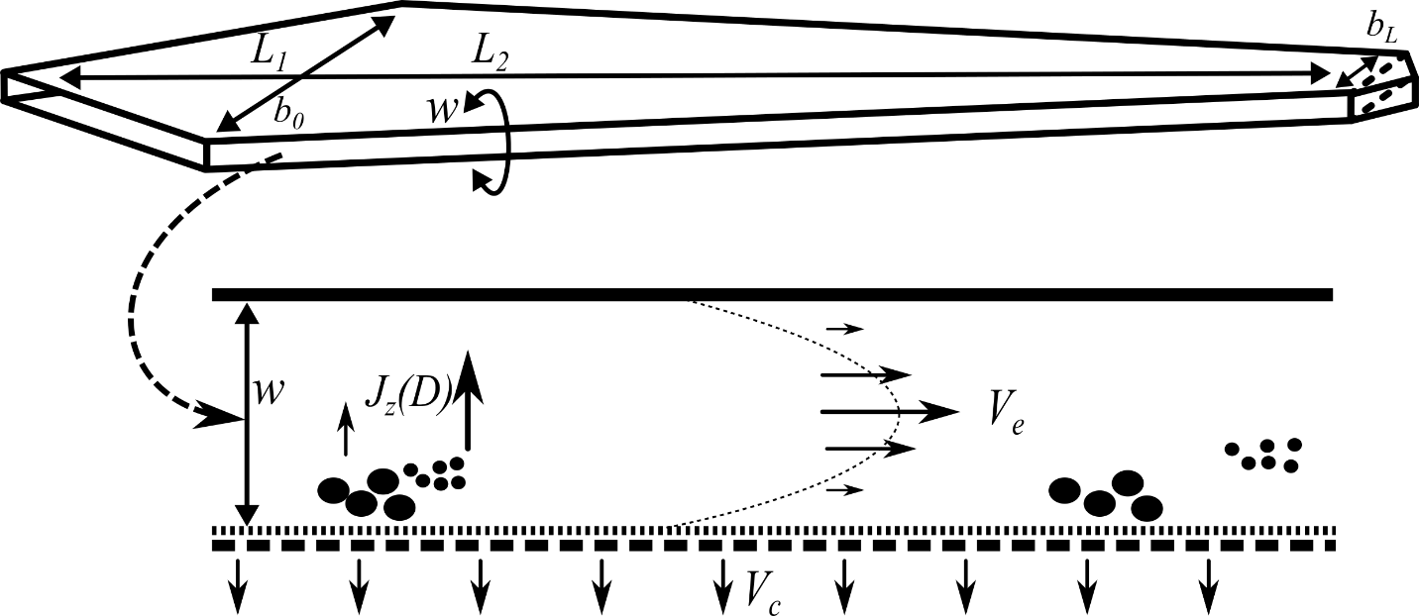

Figure . Top view of an AF4 channel (top) and its cross-sectional area (bottom)

The sample is injected into a flat channel with a solid upper wall and a lower wall that allows the streaming solvent to pass partially (Figure 1). In current devices this wall is made of a frit covered by an ultrafiltration membrane. The inlet flow *V*in is, thereby, split to a crossflow *V*c(which is distributed uniformly over the horizontal section of the channel) and an elution flow *V*e forming parabolic flow profile typical for all FFF variants:

$V_{in}= V_{e}+ V_{c}$ (1)

The “broadness” of the parable representing the velocity gradient depends on the plate distance *w*, also designated as channel height. L1, L2, b0 and bL describe the channel dimensions as shownr in Figure 1.

*V*c transports the particles to the membrane. As a consequence, the opposed translational diffusion *J*z determines the average velocity zone and hence the time of elution. The mathematical description of AF4 experiments and its derivation has been described extensively in literature (Wahlund2013, Haakasson2012, Magnusson2012, Wahlund1987). Thereby, we only state a short description of those formulas that are used in our evaluation approach which is essentially built up existing theory. While the physical relationships are widely known and well documented, this is not always the case for their translations into an evaluation procedure. This might seem to be a trivial step as the physical content is well elaborated, however, when the underlying physics are already known. However, considering the number different approaches which exist for calibration (Wahlund2013, Bolinsson2018) and their variations in detail, the implementation affects not only the evaluation but also the required measurement setup and, of course, the final measurement result. The lack of such standardized evaluation procedures impairs the reproducibility of measurements and may be one of the reasons why the analytical characterization potential is not exhausted to its potential up to now (Cölfen2000).

In total, 5 different calibration ways are described here briefly. The explicit derivation of the underlying formalisms and algorithmic considerations are stated in the supporting information.

The retention ratio *R,* defined as

$R=\frac{t_{0}}{t_{\text{e}}}$ (2)

with the time of the void peak *t*0 (the time which is required for a particle to travel if no retention occurs) and any possible point of time during the evaluation).

This is connected to the relative mean layer distance *λ* by the classical FFF retention equation:

$R=6λ⋅(\text{coth}\left(\frac{1}{2λ}\right)-2λ)$, (3)

which is often simplified by

$R_{\text{approx}}=6λ$. (4)

For AF4, the relevant correlation of *λ* and *D* has been elaborated (Wahlund1987) as

$λ=\frac{D⋅V^{0}}{V_{\text{c}}⋅w^{2}}$. (5)

For a typical AF4 measurement the channel volume *V*­0­ and the channel height *w* are critical sizes for the evaluation. Recently, we used a calibration method (Schmid2018) that makes use of the volume calculation as reported by Wahlund (1987) and then adjusts *w* by a simple bisection accordingly to eq. (3) and (4),. A similar method was reported independently (Hakansson, Magnusson).

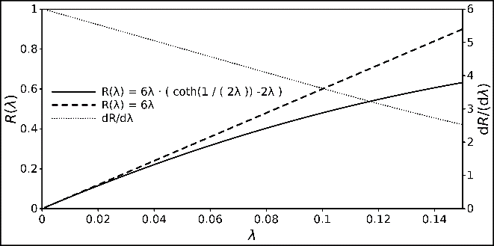

Figure : Relationship between R and λ, displayed with the classical FFF retention and its linear approximation. The derivative of the retention equation is also displayed to demonstrate its strict monotony.

Fig. 2 shows that bisection is easily applicable due to the strict monotony of the retention equation within the relevant scope and sufficient for being used on modern CPU. It can be replaced by an even more efficient conversion if required (Schure1987). Here, the separation volume *V*0 is estimated according to (Wahlund1987)

$λ=\frac{V^{0}}{V_{\text{c}}⋅w^{2}}$ (6)

In the following, we refer to this method as “classical” calibration method with the calculated separation volume *V*cla and channel height *w*cla.

(7)

The formalism for relevant method has been adjusted for narrowing trapezoidal channel shapes as follows (Litzén1991) and is used as such for the second method (*Y* is a correction term for approximating the correct channel surface):

$t_{0}=\frac{V^{app}}{V_{c}}\ln\left( 1+\frac{V_{c}}{V_{e}}\left(1-\frac{b_{0}z-\frac{\left(z^{2}\right)\left(b_{0}-b_{L}\right)}{2L}-Y}{A_{L}}\right)\right)$ (8)

It has to be a product of the surface and height of the channel. For this, reason we introduce a third calibration method Vgeo and *w*geo. Making use of

$V^{geo}=A⋅w^{geo}$ (9)

Thereby, leads to the intuitive observation that variations of any parameters don’t affect the calculated volume and the channel height linearly equally.

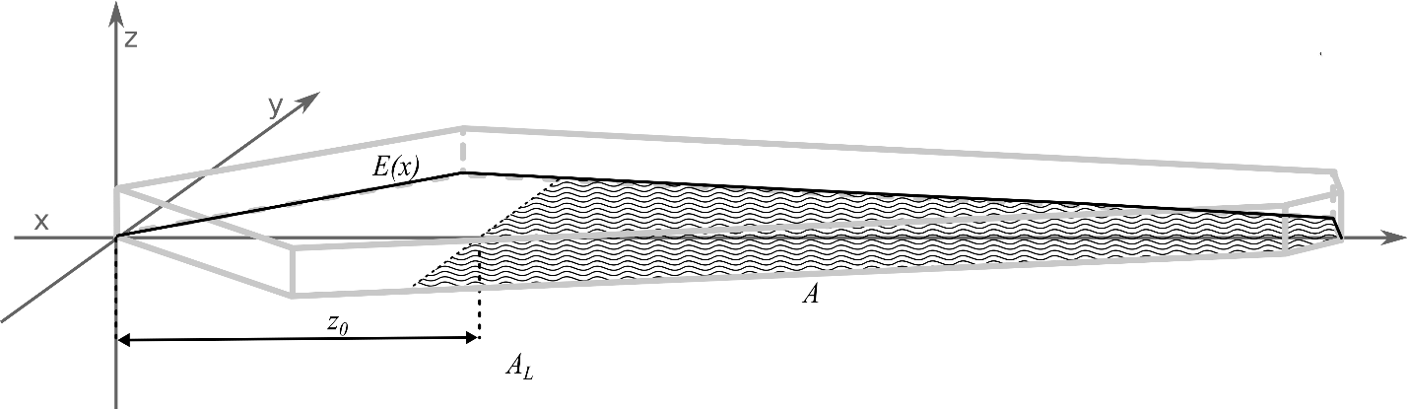

Figure . Coordinate system with the shape description function *E*(*x*), the focus position *z*0 the plain of the effective separation volume (hatched area A), the complete area of all sections *AL* (hatched and non-hatched surface in the *x*,*y* plain) and the light grey edges of the generated channel shape.

, we show a second way here to perform the calibration. It is conducted by substituting the term

$\frac{Vgeo}{w^{2}} :=S$ (10)

in eq. (4) and determine *S* analogously to *w* as in the classical approach. In a second step, inserting eq. 5

with the passed channel area *Az* (Fig. 3) that was used for the separation gives a solution for *w* as

$w=\frac{A_{z}}{S}$ (11)

With eq. (6), now the Volume can be calculated. Dedicated derivations of the channel plane calculation is given in the supplementary information. As has already been stated, in this approach, all hydrodynamic information is already used to calculate *S,* the remaining considerations are only dependent on the channel geometry.

A fourth way of calculating the height and the volume is based on considerations concerning the flow velocities and hydrodynamic processes in the channel. The same rigorous equations for the description of the channel shape were used as for the calculation of *V*geo. This leads to a direct linear relationship of *t*0 and *w*:

(12)

The “conversion factor” *C*F is determined via the hydrodynamic and geometric properties of the measurement. It can be obtained by solving the integral:

$C_{\text{F}}= \int_{z_{0}}^{L}{\frac{E(ξ)}{V_{\text{in}}-V_{c}⋅\frac{2⋅\int_{0}^{ξ}{E(x)dx}}{A_{L}} }}dξ$ (13)

This expression is derived based on a known approach (Litzen1991), but independent from the shape and more suited to relate w and t0 directly. The function *E*(*x*) describes the shape of the channel in dependence of its longitudinal position *x*. *A*L is the complete surface of the channel, i.e.

$A_{\text{L}}= 2\int_{0}^{L}{E(x)dx}$ (14)

Then, using eq. 5, *V*hyd can be calculated. The values obtained by this method are denoted as *V*hyd in the following. A detailed derivation for the factor *C*Fand *V*hyd is given in the supporting information. The obvious advantage of this method is the independence from an external diffusion coefficient i.e. no calibration measurement has to be involved in this procedure. This is a formalized method which is equivalent to calibration free conversion approaches (Zattoni2009, Eskelin2019, deCarsalade2019).

The fifth algorithm also makes use of this conversion factor. Here, it is used to substitute the void time t0. This way, Equation 2 can be written as

$R=\frac{2C_{F}w^{noT}}{t_{e}}$ (15)

By reformulating Eq. 8, λ can be calculated written as:

$λ(w)=\frac{{DA}_{z}}{V_{c}w}$ (16)

Now Eq. 5 can be merged with *(14)*.

$\frac{2C_{F}w}{t_{e}}= 6λ(w)⋅(\text{coth}\left(\frac{1}{2λ(w)}\right)-2λ(w))$ (17)

*w* can now be determined numerically from Eq. 16. This calibration procedure is advantageous as t0 does not have to be determined experimentally and be read from the fractogram but requires a calibration measurement for the determination of *t*e and a known *D*.

**Materials and methods**

AF4Eval is our first published version of hydrodynamic evaluation software for AF4 data which is now available. The user can create profiles for channel shapes and corresponding calibrations for a measurement set. Data are provided in a standardized csv-file format. As *t*0 and *t*e have to be determined manually, we integrated a simple graphical element (Fig. 4) with movable bars to the user interface to enable the user to perform this task.

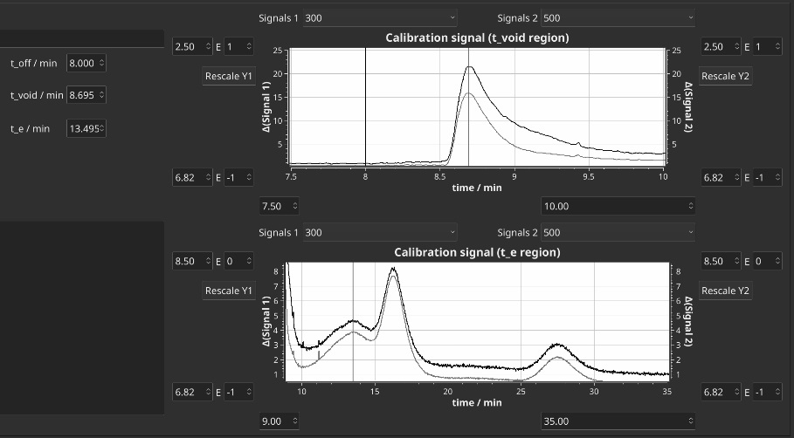

Figure . User interface for the manual read-out of *t*0 and *t*e. Offset of

AF4Eval is written in C++14 and its source code obtainable via github: <https://github.com/biocrystal777/AF4Eval>. Data shown in this report where obtained with a version compiled with g++ 6.3 under Debian Gnu/Linux 9.5, using the framework Qt 5.7 and the plotting library Qwt 6.1.2(Rathmann).

Based on the theory above we implemented 5 calibration algorithms. The calibration-dependent three methods enable an estimation of the void peak time from the geometrical properties of the calibrated channel. Thus, manual readout of the void peak is avoided entirely and the methods can be integrated in an entirely automated procedure. The direct conversion turns out to be useful if no appropriated standard is available. These algorithms vary in their specific required input magnitudes (Tab. 1).

Table 1: Required input parameters for the described calibration algorithms

|  |  |  |  |  |  |
| --- | --- | --- | --- | --- | --- |
|  | Classical Calibration | Calibration with approximated Volume | Calibration via *V*geo | Calibration via *V*hyd | Calibration *V*noT |
|  | *D*calib | *D*calib | *D*calib | *D*calib | *D*calib |
|  | *t*0 | *t*0 | *t*0 | *t*0 |  |
|  | *t*e | *t*e | *t*e | *t*e | *t*e |
|  |  |  |  |  |  |
|  | *V*e |  |  | *V*e | *V*e |
| Inputs | *V*c | *V*c | *V*c | *V*c | *V*c |
|  | *z*% | (*z*%) | (*z*%) | (*z*%) | (*z*%) |
|  |  | *L*1, *L*2 | *L*1, *L*2, *L*3 | *L*1, *L*2, *L*3 | *L*1, *L*2, *L*3 |
|  |  | *b*0, *b*L | *b*0, *b*L | *b*0, *b*L | *b*0, *b*L |
|  |  |  |  |  |  |
|  |  |  |  |  |  |
|  | *w* | *w (w*geo*)* | *w (w*geo*)* | *w (w*hyd*)* | *w (w*noT*)* |
| Outputs | *V*0 | *V*0 (*V*geo) | *V*0 (*V*geo) | *V*0 (*V*hyd) | *V*0 (*V*noT) |
|  |  |  |  |  |  |

In addition, an error analysis function was implemented that allows to estimate the uncertainties of the methods. The error analysis allows to define a range *R* of the estimated uncertainty *u*(*Xi*) from 1 to 100% for the input quantity *Xi* and a grid resolution parameter. The method then iterates over arrays *u*(*Xi*) of *R* while conducting the assigned algorithm and gives the deviation of the output quantitiy *Y*j. This gives a rough overview, how the deviation of one quantity affects the result under while the other quantities are kept constant. This way, the individual impact of the uncertainty of each variable can be easily quantified for each experimental condition. Further functionalities are the evaluation of MALLS data and the

**Experiments**

The experiments were conducted with a Wyatt Eclipse DualTec Separation system. The setup was coupled with a degassing unit (G1322A), an isocratic pump (G1310B) and an autosampler (G1328C), all from the Agilent 1260 series. Signals were recorded using Astra 6.1.7.17 with a sample rate of 0.5 Hz. The experiments were conducted with the following spacer measurements. A Dawn Heleos 8+ MALLS detector (wavelength = 663 nm) and a UV/DAD detector (G1315C, Agilent series 1100) were used for detection. Spacer with 6 different dimensions were used, dimensions given in Table 1. The eluent was 50 mM NaNo3. Measurement samples were. The injected sample amount was 20 µl at a sample concentration of 4 mg/ml. For each spacer a new 5 kDa Millipore regenerated Cellulose membrane was used. Detailed measurement program and sequence setup is given in the supplementary information.

**Results**

Own measurements, results with different algorithms

BSA(3.5, 2.5), PS Vc = 0.5, 3 images here, all 9 in appendix

Table 3: Parameters used for calibration experiments

|  |  |  |  |  |  |  |
| --- | --- | --- | --- | --- | --- | --- |
| Parameter | BSA1 | BSA2 | PS |  |  |  |
| t0 | 20 | 150 | 4 |  |  |  |
| te | 20 | 150 | 4 |  |  |  |
| Vc | 20 | 150 | 4 |  |  |  |
| Ve | 20 | 150 | 4 |  |  |  |
| Dcalib |  |  |  |  |  |  |
| z |  |  |  |  |  |  |
| b0 |  |  |  |  |  |  |
| bl |  |  |  |  |  |  |
| L1 | 20 | 150 | 4 |  |  |  |
| L2 | 20 | 150 | 4 |  |  |  |

Table 4: Results from calibration experiments

|  |  |  |  |  |  |  |
| --- | --- | --- | --- | --- | --- | --- |
| Parameter | BSA1 |  | BSA2 |  | PS |  |
|  | w | V | w | V | w | V |
| Algo1 | 20 | 150 | 4 | 11 | 4 | 350 |
| Algo2 | 20 | 150 | 4 | 11 | 4 | 460 |
| … | 20 | 150 | 4 | 21 | 4 | 250 |
|  | 20 | 150 | 4 | 21 | 4 | 350 |
|  | 20 | 150 | 4 | 21 | 4 | 460 |

Reproduction with literature data

Table 4: Parameters used for calibration calculations with literature data

|  |  |  |  |  |  |  |
| --- | --- | --- | --- | --- | --- | --- |
| Parameter | Gold1 [Jochem] | Gold 2 [Zattoni] | Gold 3  [Zattoni] | QD 1 [Zattoni] | QD 2 [Zattoni] | QD 3 [Zattoni] |
| t0 | 20 | 150 | 4 | 11 | 4 | 250 |
| Te | 20 | 150 | 4 | 11 | 4 | 350 |
| Vc | 20 | 150 | 4 | 11 | 4 | 460 |
| Ve | 20 | 150 | 4 | 21 | 4 | 250 |
| Dcalib | 20 | 150 | 4 | 21 | 4 | 350 |
| Z | 20 | 150 | 4 | 21 | 4 | 460 |
| B0 |  |  |  |  |  |  |
| Bl |  |  |  |  |  |  |
| L1 |  |  |  |  |  |  |
| L2 |  |  |  |  |  |  |

Table 4: Results for calibration experiments with literature data

|  |  |  |  |  |  |  |
| --- | --- | --- | --- | --- | --- | --- |
| Parameter | Gold1 [Jochem] | | Gold 2 [Zattoni] | | Gold 3 [Zattoni] | |
|  | *w* | *V* | *w* | *V* | *w* | *V* |
| Algo1 | 20 | 150 | 4 | 11 | 4 | 350 |
| Algo2 | 20 | 150 | 4 | 11 | 4 | 460 |
| … | 20 | 150 | 4 | 21 | 4 | 250 |
|  | 20 | 150 | 4 | 21 | 4 | 350 |
|  | 20 | 150 | 4 | 21 | 4 | 460 |

Table 5: Results for calibration experiments with literature data

|  |  |  |  |  |  |  |
| --- | --- | --- | --- | --- | --- | --- |
| Parameter | QD 1 [Zattoni] | | QD 2 [Zattoni] | | QD 3 [Zattoni] | |
|  | *w* | *V* | *w* | *V* | *w* | *V* |
| Algo1 | 20 | 150 | 4 | 11 | 4 | 350 |
| Algo2 | 20 | 150 | 4 | 11 | 4 | 460 |
| … | 20 | 150 | 4 | 21 | 4 | 250 |
|  | 20 | 150 | 4 | 21 | 4 | 350 |
|  | 20 | 150 | 4 | 21 | 4 | 460 |

Convergence for varying t0:

Variations of t0 for each algorithm V0(t0), w(t0) for BSA1, BSA2, Ps own samples

Iterative Deltat parameter analysis (error consideration):

Each parameter for each algorithm -> 5 x 8 curves BSA1

**Discussion**

Comparison of the five discussed methods.

Alternative hypothesis for the occurrence of the “void peak”.

**Conclusions**

We have shown that a dedicated software for the evaluation has the potential to greatly improve the practical handling of AF4 data and further development. As already known, expected the information about channel volume and channel height are the critical quantities for contemporary machines. The early substitution of an expression of variables with known values shows up to be very useful when translating the physical relationships into a precisely defined evaluation algorithm. The development of the software will be continued, considering the following list of features only as an example for numerous possible extensions:

* Alternative calibration methods as have been investigated recently (Bolinsson2018). Also

distance measurement has improved continuously (Berkovic2012) up to xxx, therefore we think that further calibration methods based on combination of the channel with such a device might be an additional orthogonal tool for the calibration.

* Crossflow gradients (Litzen1989, Kirkland1992, Williams2001), steric effects and decays (cite Wahlund2013, Håkansson2012, cite Magnusson2012). Our final goal will be to provide an open and extensible reference implementation of which gathers all these state-of-the-art evaluation methods
* advanced handling of light scattering data.
* AF4 related deconvolution techniques (Schmid201, Schure1989)
* improved focus point determination as recently presented (Wang2018).
* generation of plotting language scripts based on the given data set

As distance measurement by optical methods has improved continuously over the last decades up to submicrometer precision a direct measurement of *w* will be an additional improvement. It was stated by Wahlund(2013) that, unfortunately, these calculations were not available in commercial software. Instead, we suggest that a software implementation is much more suited to fit the needs of the coming developments in progress of evaluation procedures. It allows a much more flexible adaption according upcoming new developments and integration of subsequent data processing than a proprietary approach. To allow further automation it would be rather helpful if all important parameters from a measurement were directly available in an easily parsable format to reduce. We encourage users of AF4 get in contact to discuss possible extensions for their specific needs.

**Acknowledgements**

This work was generously supported by the DFG (Deutsche Forschungsgemeinschaft) within the SFB 1214, project B6. We also thank Emre Brookes for hosting the version control repository for the development steps before publication.

**References**

Müssen noch ergänzt werden zum Text

Rathmann, U. *Qwt - Qt Widgets for Technical Applications*, 2014.