3000 words / 5 figures / (max. 6 printed pages)

Revision of the AF4 calibration experiment

Benedikt Häusele1, Maxim Benjamin Gindele1, Helmut Cölfen1*

1 Physical Chemistry, Department of Chemistry, University of Konstanz, Universitätsstr. 10, 78457 Konstanz, Germany

benedikt.haeusele@uni-konstanz.de  
helmut.coelfen@uni-konstanz.de

*Correspondence:

helmut.coelfen@uni-konstanz.de  
Tel.: +49 7531 88-4063  
Fax: +49 7531 88-3139

Abstract:

Asymmetrical field-flow fractionation is a versatile chromatographic fractionation method. In combination it is used for size-based separation of colloids, biomolecules and polymers. Although used often as pure separation method, a well-elaborated theory is available that allows precise quantification of the translational diffusion coefficient *D*. Still, current literature suggests different ways to transform this theory into applicable experimental procedures and no “gold standard ” for correct data processing exists. While some sources report a direct way to extract diffusion information from the fractogram, others suggest the necessity of an external calibration measurement. In this work, we compare the different approaches and calibration algorithms based on original and literature data using our own open-source AF4 evaluation software. Based on the results, we conclude that available AF4 setups do not fulfill the requirements for absolute measurements of *D* yet and direct meaurements of *w* and an analytical evaluation cannot for measurements without an external standard.

Keywords:

Asymmetrical Flow Field-flow fractionation, void peak determination, size determination, calibration

**Introduction**

AF4 (asymmetrical flow field-flow fractionation) is a chromatographic technique that can be used to separate samples due to their diffusion coefficient (Wahlund1987). It is a member of the FFF (field-flow fractionation) family invented by J. Calvin Giddings (Giddings1977). Compared to more commonly applied separation methods like SEC and HPLC (Coelfen2000) FFF techniques are based on the interaction of the analyte with a physical field which separates the sample to a corresponding physical size (Giddings1993). In principle, the method is applicable to a huge variety of samples, including small biomolecules, nanoparticles and polymers (Giddings1993 Cölfen2000 Litzen1989) up to big agglomerates like protein aggregates(Yohannes2010), virus-like particles (Pease2009), drug carrier systems (Fraunhofer2004). Nowadays, AF4 is the most commonly used flow FFF method, where the separation channel is formed of a solid wall and a frit covered by a membrane.

Though, the development of dedicated measurement protocols can be complicated as the high number of adjustable parameters. (Giddings2013) This includes instrumental specifications like the channel shape, its related parameters length *L*, the channel width b0 and bL, the choice of the membrane material. The three typical variable experimental conditions are elution flow *Ve*, applied cross flow *Vc* and the focusing flow and period. AF4 has to be combined with at least one detection technique, typically MALLS (multi-angle laser light), Uv/Vis and/or RI (refractive index) detection. Also on-line NMR (cite Hiller 2013), mass spectrometry (Yohannes2011) and SAXS (Small-angle X-ray scattering) (Thünemannn2009a) has been applied as detection technique.

In addition to the parameters listed above, the channel thickness *w* and the separation volume *V* have to be known precisely in order to allow a correct determination of the diffusion coefficient, and, thereby, the size of a measured sample (Wahlund1987, Wahlund2013). However, due to dwelling of the applied membrane in the channel, these magnitudes are not directly accessible with current devices, which reasons the necessity of suitable calibration methods.

Although AF4 theory has been elaborated and well documented in literature, the application transfer to quantitative evaluation software is still behind to comparable methods like analytical ultracentrifugration AUC. Here, several software solutions and a couple of evaluation methods are already available and can be used even without in-depth knowledge of the underlying algorithmic considerations (cite Schuck2000, cite Demeler2005). This may be also a reason, why the practical handling of AF4 data evaluation is handled very inconsistently by different authors. While some authors suggest a direct conversion from measurement data is directly possible from a measurement (Zattoni2009), others suggest an external measurement using a calibrant with a known diffusion coefficient (Litzen1993,Wahlund2013) or an external size measurement via coupled MALLS (Bolinsson).

Therefore, we fill this gap with implementation of the known procedures and compare them to each other.

In this, we want to compare some of the different approaches reported up to now in literature. In the past, the validity of the no-field method in AF4 has already been disproved successfully (Martin2011). A reported, which aims to measure the thickness of the membrane directly by a micrometre (Litzen1989, Litzen1993, Wahlund2014,) has to be questioned as it is cannot be not conducted *in situ*.

For some remaining methods

**Theory**

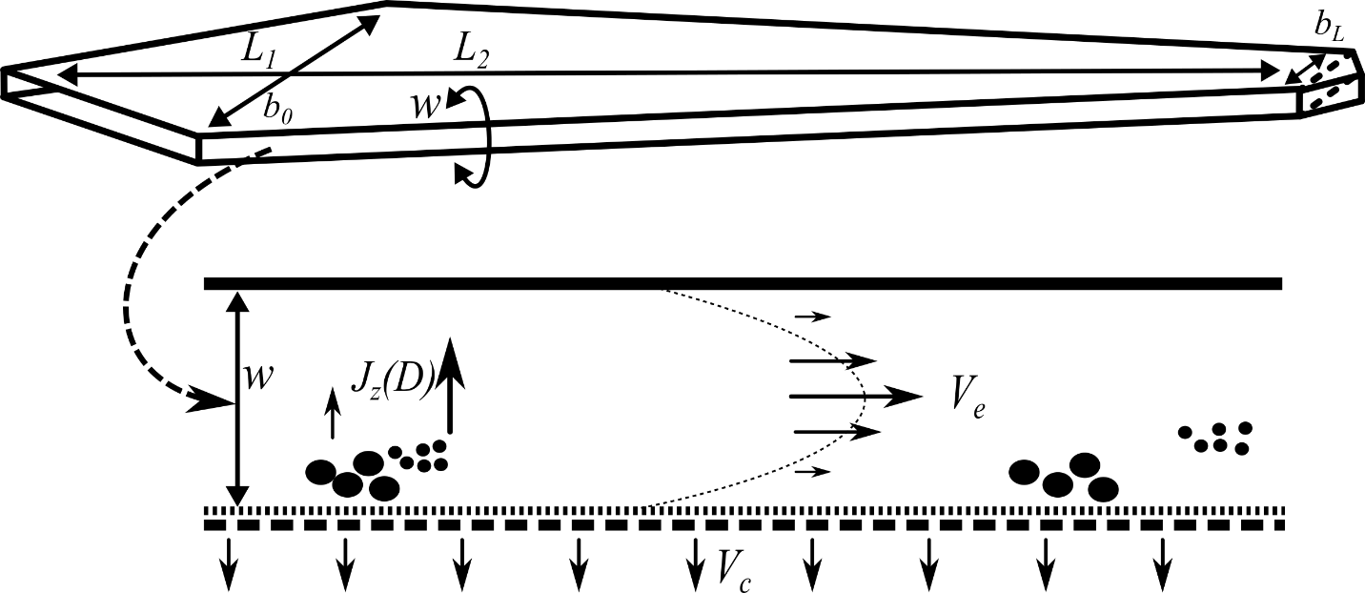

Figure . Top view of an AF4 channel (top) and its cross-sectional area (bottom)

The sample is injected into a flat channel with a solid upper wall and a lower wall that allows the streaming solvent to pass partially (Figure 1). In current devices this wall is made of a frit covered by an ultrafiltration membrane. The inlet flow *V*in is, thereby, split to a crossflow *V*c(which is distributed uniformly over the horizontal section of the channel) and an elution flow *V*e forming parabolic flow profile typical for all FFF variants:

(1)

The “broadness” of the parable representing the velocity gradient depends on the plate distance *w*, also designated as channel height. L1, L2, b0 and bL describe the channel dimensions as shown in Figure 1.

*V*c transports the particles to the membrane. As a consequence, the opposed translational diffusion *J*z determines the average velocity zone and hence the time of elution. Mathematical descriptions of AF4 experiments and derivation have been described in literature (Wahlund2013, Haakasson2012, Magnusson2012, Wahlund1987). They describe phenomenons by physical and geometric approaches. As shown in the supportings, rigorously applying a coordinate system to the channel shape allows to express these formula for random channel shapes as well.

Thereby, we only state a short description of those formulas that are used in our evaluation approach which is essentially built up existing theory. While the physical relationships are widely known and well documented, this is not always the case for their translations into an evaluation procedure. This might seem to be a trivial step as the physical content is well elaborated, however, when the underlying physics are already known. However, considering the number of different approaches which exist for calibration (Wahlund2013, Bolinsson2018) and their variations in detail, the implementation affects not only the evaluation but also the required measurement setup and, of course, the final measurement result. The lack of such standardized evaluation procedures impairs the reproducibility of measurements and may be one of the reasons why the analytical characterization potential is not exhausted to its potential up to now (Cölfen2000).

In total, 5 different calibration ways are described here briefly. The explicit derivation of the underlying formalisms and algorithmic considerations are stated in the supporting information.

The retention ratio *R,* defined as

(2)

with the time of the void peak *t*0 (the time which is required for a particle to travel if no retention occurs) and any possible point of time during the evaluation).

This is connected to the relative mean layer distance *λ* by the classical FFF retention equation:

, (3)

which is often simplified by

. (4)

For AF4, the relevant correlation of *λ* and *D* has been elaborated (Wahlund1987) as

. (5)

For a typical AF4 measurement the channel volume *V*­0­ and the channel height *w* are critical sizes for the evaluation. Recently, we used a calibration method (Schmid2018) that makes use of the volume calculation as reported by Wahlund (1987) and then adjusts *w* by a simple bisection accordingly to eq. (3) and (4),. A similar method was reported independently (Hakansson, Magnusson).

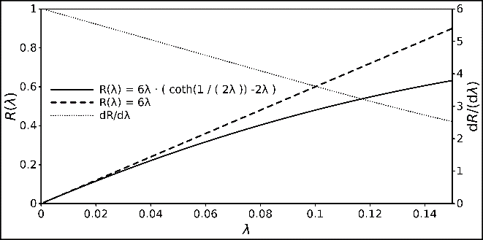

Figure : Relationship between R and λ, displayed with the classical FFF retention and its linear approximation. The derivative of the retention equation is also displayed to demonstrate its strict monotony.

Fig. 2 shows that bisection is easily applicable due to the strict monotony of the retention equation within the relevant scope and sufficient for being used on modern CPU. It can be replaced by an even more efficient conversion if required (Schure1987). Here, the separation volume *V*0 is estimated according to (Wahlund1987)

(6)

In the following, we refer to this method as “classical” calibration method with the calculated separation volume *V*cla and channel height *w*cla.

(7)

The formalism for relevant method has been adjusted for narrowing trapezoidal channel shapes as follows (Litzén1991) and is used as such for the second method (*Y* is a correction term for approximating the correct channel surface):

(8)

It has to be a product of the surface and height of the channel. For this, reason we introduce a third calibration method Vgeo and *w*geo. Making use of

(9)

Thereby, leads to the intuitive observation that variations of any parameters don’t affect the calculated volume and the channel height linearly equally.

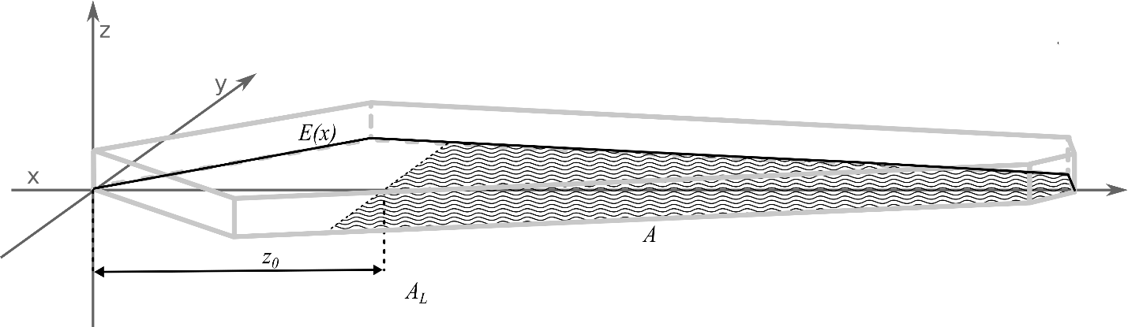

Figure . Coordinate system with the shape description function *E*(*x*), the focus position *z*0 the plain of the effective separation volume (hatched area A), the complete area of all sections *AL* (hatched and non-hatched surface in the *x*,*y* plain) and the light grey edges of the generated channel shape.

, we show a second way here to perform the calibration. It is conducted by substituting the term

(10)

in eq. (4) and determine *S* analogously to *w* as in the classical approach. In a second step, inserting eq. 5

with the passed channel area *Az* (Fig. 3) that was used for the separation gives a solution for *w* as

(11)

With eq. (6), now the Volume can be calculated. Dedicated derivations of the channel plane calculation is given in the supplementary information. As has already been stated, in this approach, all hydrodynamic information is already used to calculate *S*. By this approach it is ensured, that volume, height and the channel area fit together geometrically.

A fourth way of calculating the height and the volume is based on considerations concerning the flow velocities and hydrodynamic processes in the channel. The same rigorous equations for the description of the channel shape were used as for the calculation of *V*geo. This leads to a direct linear relationship of *t*0 and *w*:

(12)

The “conversion factor” *C*F is determined via the hydrodynamic and geometric properties of the measurement. It can be obtained by solving the integral:

(13)

This expression is derived based on a known approach (Litzen1991), but independent from the shape and more suited to relate w and t0 directly. The function *E*(*x*) describes the shape of the channel in dependence of its longitudinal position *x*. *A*L is the complete surface of the channel, i.e.

(14)

Then, using eq. 5, *V*hyd can be calculated. The values obtained by this method are denoted as *V*hyd in the following. A detailed derivation for the factor *C*Fand *V*hyd is given in the supporting information. The obvious advantage of this method is the independence from an external diffusion coefficient i.e. no calibration measurement has to be involved in this procedure. This is a formalized method which is equivalent to calibration free conversion approaches (Zattoni2009, Eskelin2019, deCarsalade2019).

The fifth algorithm also makes use of this conversion factor. Here, it is used to substitute the void time t0. This way, Equation 2 can be written as

(15)

By reformulating Eq. 8, λ can be calculated written as:

(16)

Now Eq. 5 can be merged with *(14)*.

(17)

*w* can now be easily determined numerically from Eq. 16 and Eq. 17. This calibration calculation procedure is advantageous as *t*0 does not have to be determined experimentally and be read from the fractogram. However, it requires a calibration measurement for the determination of *t*e and a known *D*.

**Materials and methods**

AF4Eval is our current published version of hydrodynamic evaluation software for AF4 data. The user can create profiles for channel shapes and corresponding calibrations for a measurement set. Data are provided in a standardized csv-file format. Further input formats such as AniML (Schäfer2004,Davies2007) are planned to be added. As *t*0 and *t*e have to be determined manually for some calibration methods, we integrated a simple graphical element (Fig. 4) with movable bars to the user interface to enable the user to pick the peak position manually without transferring the chosen value as it would be required in a spreadsheet application.

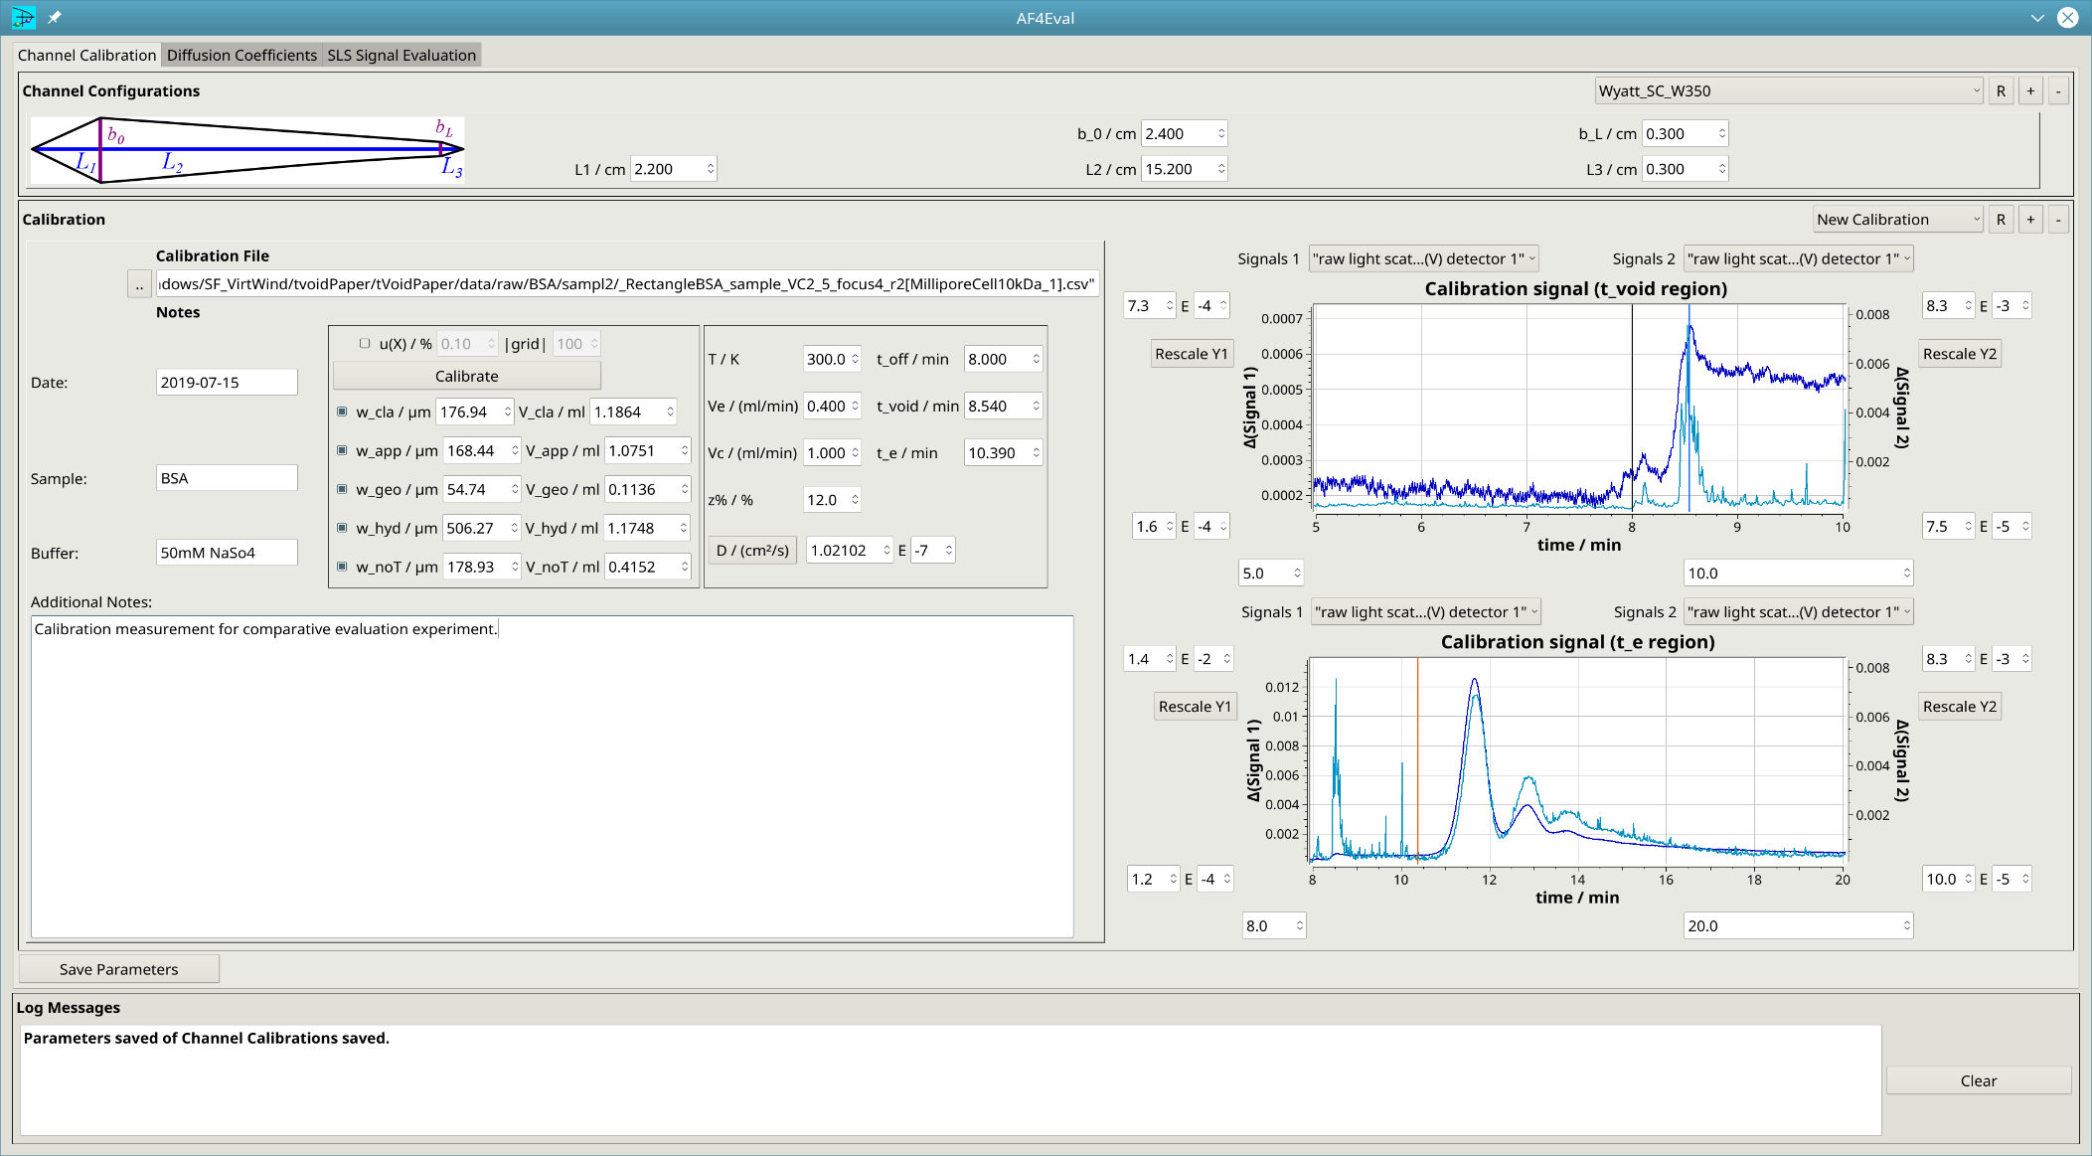

Figure . User interface for the manual read-out of *t*0 and *t*e. The bars are controlled via the respective spin boxes and allow a direct transfer of the value from the fractogram to the calculation.

AF4Eval is written in C++14 and its source code obtainable via github and can be used without charge for academic purposes: <https://github.com/biocrystal777/AF4Eval>. Data shown in this report where obtained with a version compiled with g++ 6.3 under Debian Gnu/Linux 9.5, using the framework Qt 5.7 and the plotting library Qwt 6.1.2(Rathmann).

Table 1: Required input parameters for the described calibration algorithms

|  |  |  |  |  |  |
| --- | --- | --- | --- | --- | --- |
|  | Classical | Approximated Volume | Geometrical | Hydrodyamic | Without *t*0 |
|  | *D*calib | *D*calib | *D*calib |  | *D*calib |
|  | *t*0 | *t*0 | *t*0 | *t*0 |  |
|  | *t*e | *t*e | *t*e |  | *t*e |
|  |  |  |  |  |  |
|  | *V*e | *V*e |  | *V*e | *V*e |
| Inputs | *V*c | *V*c | *V*c | *V*c | *V*c |
|  | *z*% | *z*% | *z*% | *z*% | *z*% |
|  |  | *L*1, *L*2 | *L*1, *L*2, *L*3 | *L*1, *L*2, *L*3 | *L*1, *L*2, *L*3 |
|  |  | *b*0, *b*L | *b*0, *b*L | *b*0, *b*L | *b*0, *b*L |
|  |  |  |  |  |  |
| Side condition | - | - | Eq. 9 | Eq. 9 | Eq. 9 |
|  | *w* | *w (w*appgeo*)* | *w (w*geo*)* | *w (w*hyd*)* | *w (w*noT*)* |
| Outputs | *V*0 | *V*0 (*V*appgeo) | *V*0 (*V*geo) | *V*0 (*V*hyd) | *V*0 (*V*noT) |
|  |  |  |  |  |  |

Based on the theory above we implemented 5 calibration algorithms. The calibration-dependent three methods enable an estimation of the void peak time from the geometrical properties of the calibrated channel. Thus, manual readout of the void peak is avoided entirely and the methods can be integrated in an entirely automated procedure. The direct conversion turns out to be useful if no appropriated standard is available. These algorithms vary in their specific required input magnitudes (Tab. 1). A pseudocode of the applied calculations representation is given in the supporting information.

In addition, an error analysis function was implemented that allows to estimate the uncertainties of the methods. The error analysis allows to define a range *R* of the estimated uncertainty *u*(*Xi*) from 1 to 100% for the input quantity *Xi* and a grid resolution parameter. The method then iterates over arrays *u*(*Xi*) of *R* while conducting the assigned algorithm and gives the deviation of the output quantity *Y*j. This gives a rough overview, how the deviation of one quantity affects the result under while the other quantities are kept constant. This way, the individual impact of the uncertainty of each variable can be easily quantified for each experimental condition. Further functionalities are the evaluation of MALLS data. and the

**Experiments**

The experiments were conducted with a Wyatt Eclipse DualTec Separation system. The setup was coupled with a degassing unit (G1322A), an isocratic pump (G1310B) and an autosampler (G1328C), all from the Agilent 1260 series. Signals were recorded using the software Astra 6.1.7.17 with a sample rate of 0.5 Hz. A detector chain, consisting of a Dawn Heleos 8+ MALLS detector (wavelength = 663 nm) a UV/VisDAD detector (G1315C, Agilent series 1100) and an RI detector. Before usage, an interdetector distance correction was conducted according to the elution peak of a BSA measurement using the respective function in Wyatt. Only signals with a decent signal-to-noise ratio were considered.

In the channel, an SC W350 spacer from Wyatt was used. The detailed dimensions are given in Table 3, together with the measurement conditions and related input parameters for the algorithms. Two samples were used: BSA and Nanospheres. 3 replicates for each condition were measured. The eluent was 50 mM NaNo3 for measurements with BSA. The injected sample amount was 20 µl. For the measurement with PS (Polystyrene) nanospheres, a 0.1 % w/v of SDS (sodium dodecyl sulfate) was used. Measurements were conducted at 293 K. For each spacer a new 5 kDa Millipore regenerated Cellulose membrane was used. Detailed measurement program and sequence setup is given in the supplementary information.

**Results**

*Comparison of algorithms with own test measurements*

First of all, we tested the algorithms with data acquired from our own field-flow fractionation. Standard protocols with a constant crossflow. Before elution, the sample was focused at 12 % of the total channel length. The details of the measurement protocols are given in the supportings (Table XXX). BSA was measured at *V*c=2.5 mlmin-1 and *V*c=3.5 mlmin-1. To provide an example for a lower crossflow, additional measurements with PS nanospheres were conducted at *V*c=0.5 mlmin-1. For BSA, the signals of the UV-Vis detector were chosen, for the PS measurements, UV and RI were considered.

Table 3: Parameters used for calibration experiments

|  |  |  |  |  |  |  |  |  |  |  |  |  |
| --- | --- | --- | --- | --- | --- | --- | --- | --- | --- | --- | --- | --- |
| Parameter | unit | BSA_Vc2_5 | | | | BSA_Vc3_5 | | | | PS_Vc0_5 | | |
|  |  | r1 | r2 | r3 | r1 | | r2 | r3 | r1 | | r2 | r3 |
| *t*0 | min | 0.53 | 0.55 | 0.54 | 0.6 | | 0.5 | 0.51 | 0.73 | | 0.72 | 0.72 |
| *t*e | min | 3.65 | 3.65 | 3.35 | 4.6 | | 4.5 | 4.5 | 15.8 | | 15 | 15.1 |
| *V*c | mlmin-1 | 2.5 | | | 3.5 | | | | 0.5 | | | |
| *V*e | mlmin-1 | 1.0 | | | 1.0 | | | | 1.0 | | | |
| *D*calib | cm²s-1 | 6.1*10-7 | | | 6.1*10-7 | | | | 6.74*10-8 | | | |
| *z*% | % | 12 | | | 12 | | | | 12 | | | |
| *b*0 | mm | 22 | | | 22 | | | | 22 | | | |
| *b*L | mm | 3 | | | 3 | | | | 3 | | | |
| *L*1 | mm | 20 | | | 20 | | | | 20 | | | |
| *L*2 | mm | 150 | | | 150 | | | | 150 | | | |
| *L*3 | mm | 3 | | | 3 | | | | 3 | | | |

The plotted signals of the fractograms were used to pick positions of *t*0 and *t*e for the BSA monomer peak, as shown exemplarily in Fig. 5. The fractograms have been corrected in time by its offset due to the focusing-related steps. I.e. “0” on the time axis displays the actual time of elution from the focusing position *z*%.

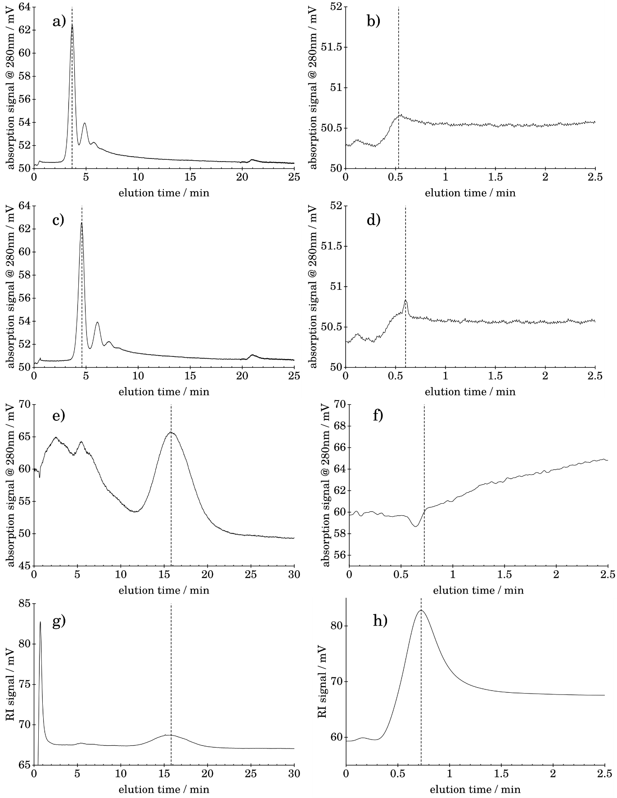

Figure . User interface for the manual read-out of *t*0 and *t*e. Offset of

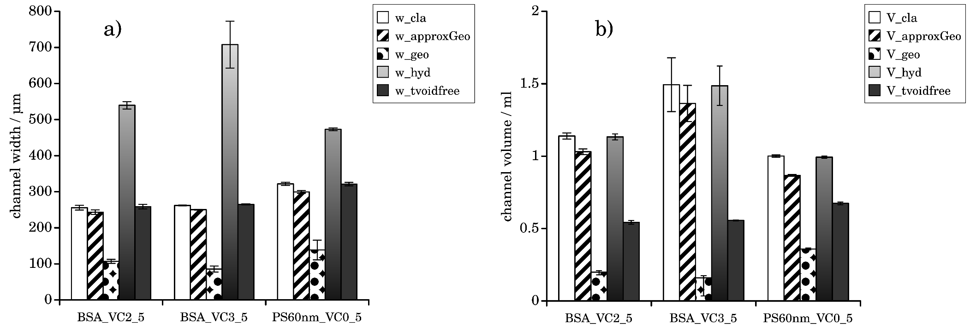

Figure . User interface for the manual read-out of *t*0 and *t*e. Offset of

The complete fractograms and extracted peak positions of all 9 measurements are given in the supporting information (Fig.xxx-xxx). All information were collected (Table 3) and processed by the 5 calibration algorithms of AF4eval. The calculated channel heights and volumes are displayed in Fig. 6. The acquired retention times were typical for our AF4 setup and comparable to a lot of other measurements with similar conditions. In all three cases, *V*appgeois smaller than the calculated *V*cla. This is simply reasoned by the smaller surface, when the trapezoidal tapering is considered in the calculation.

Consequently, the same observation is made for the relation of *w*appgeo and *w*cla­. As each of our calibration calculations was deduced from essentially the same established AF4 theroy, we would have expected each of the calculations to lead to yield a very result. Instead, introducing the ensurance of the geometrical side condition of Eq. 9 (*w*geoand *V*geo) made the calculated channel volume and related height shrink dramatically compared to the other calibration results. Whereas removing the dependence on the known *D*calib (for determination of *w*hyd) led to dramatically increased calculated channel widths, which are highly unrealistic as the spacer thickness of 350 µm represents the maximal possible distance between membrane and upper wall. Interestingly, the related separation volume *V*hydwas nearly the same as for the established first two variants as they uses a very similar assumption for the derivation of the respective volume. This indicates that the formalism is indeed correct. Finally, removing *t*0 from the list input parameters by making use of Eq. 12 led to a result, which preserves the correct geometric relation, and resulted in a channel thickness within the expected range.

In order to exclude potential errors in our own experimental setups, we applied the algorithms on published fractogram data.

*Comparison of algorithms using published data in literature*

For the reevaluation we screened the respective AF4-related literature for data sets which provided fractograms and required information on the applied measurement conditions as possible. Especially the focus position z% was not always indicated. For our investigations, we decided, to assume a value which is typically used for channels without frit-inlet. The implication of possible deviations of this real value are discussed below separately. We chose to work with measurements made with spherical gold nanoparticles[Jochem, Zattoni], Silica particles[Zattoni] and silver nanospheres[Koopmans, Loeschner]. Measurements in the used literature had been conducted using trapezoidal channel geometries with different channel dimensions and AF4 devices from different vendors. The Diffusion coefficient was respective diffusion coefficient was calculated according to the specifactions made in the respective publication and the expected shell thickness for polymer coatings[Duplatre1996,Bockstahl2000]. All used parameters are displayed in Table 4 and Table 5. We applied the algorithms in the same way as we did for our own measured data.

Table `74: Parameters used for calibration calculation with literature data [1]

|  |  |  |  |  |  |  |  |  |  |  |  |  |  |
| --- | --- | --- | --- | --- | --- | --- | --- | --- | --- | --- | --- | --- | --- |
| Parameter | unit | Lit_Au1[Joch] | Lit_Au2[Zat] | | | | LitAu3[Zat] | | | | | Lit_Sil[Zat] | |
|  |  |  | | Vc1_0 | Vc0_75 | | | Vc1_0 | | Vc0_75 | |  | |
| *t*0 | min | 0.593 | | 0.89 | | 0.89 | | | 0.992 | 0.992 | | | 0.96 |
| *t*e | min | 4.42 | | 4.55 | | 0.992 | | | 9.45 | 9.45 | | | 13.3 |
| *V*c | mlmin-1 | 0.8 | | 1.0 | | 0.75 | | | 1.0 | | 0.75 | 0.2 | |
| *V*e | mlmin-1 | 0.5 | | 1.0 | | | | | 1.0 | | | | 0.2 |
| *D*calib | cm²s-1 | 6.1*10-7 | | 6.1*10-7 | | | | | 6.74*10-8 | | | | 1.13*10-7 |
| *z*% | % | 12 | | 12 | | | | | 12 | | | | 12 |
| *b*0 | mm | 22 | | 22 | | | | | 22 | | | | 22 |
| *b*L | mm | 3 | | 3 | | | | | 3 | | | | 5 |
| *L*1 | mm | 20 | | 20 | | | | | 20 | | | | 22 |
| *L*2 | mm | 150 | | 150 | | | | | 150 | | | | 213 |
| *L*3 | mm | 3 | | 3 | | | | | 3 | | | | 5 |

Table 5: Parameters used for calibration calculation with literature data

|  |  |  |  |  |  |  |  |  |  |  |  |  |  |  |  |  |  |  |  |
| --- | --- | --- | --- | --- | --- | --- | --- | --- | --- | --- | --- | --- | --- | --- | --- | --- | --- | --- | --- |
| Parameter | unit | LitAG[Koopmans] | | | | | | | | | | | | | | | | Lit_Ag_42nm[Loe] | |
|  |  | 10nm | 20nm | | | | | 30nm | 50nm | | 70nm | | | 90nm | | | |  | |
| *t*0 | min | 0.75 | | 0.75 | | 0.75 | | | 0.75 | | | 0.75 | | | 0.75 | | | 0.75  10.39 | |
| *t*e | min | 1.81 | | 4.32 | | 7.85 | | | 10.11 | | | 12.02 | | | 14.32 | | |
| *V*c | mlmin-1 | 0.4 | | | | | | | | | | | | | | | 1 | | |
| *V*e | mlmin-1 | 1.0 | | | | | | | | | | | | | | | 0.4 | | |
| *D*calib | cm²s-1 | 4.29*10-7 | | | 2.14*10-7 | | 1.43*10-7 | | | 8.58*10-8 | | | 6.13*10-8 | | | 4.76*10-8 | | | 1.02*10-7 |
| *z*% | % | 12 | | | | | | | | | | | | | | | 12 | | |
| *b*0 | mm | 20 | | | | | | | | | | | | | | | 24 | | |
| *b*L | mm | 5 | | | | | | | | | | | | | | | 3 | | |
| *L*1 | mm | 20 | | | | | | | | | | | | | | | 22 | | |
| *L*2 | mm | 250 | | | | | | | | | | | | | | | 152 | | |
| *L*3 | mm | 5 | | | | | | | | | | | | | | | 3 | | |

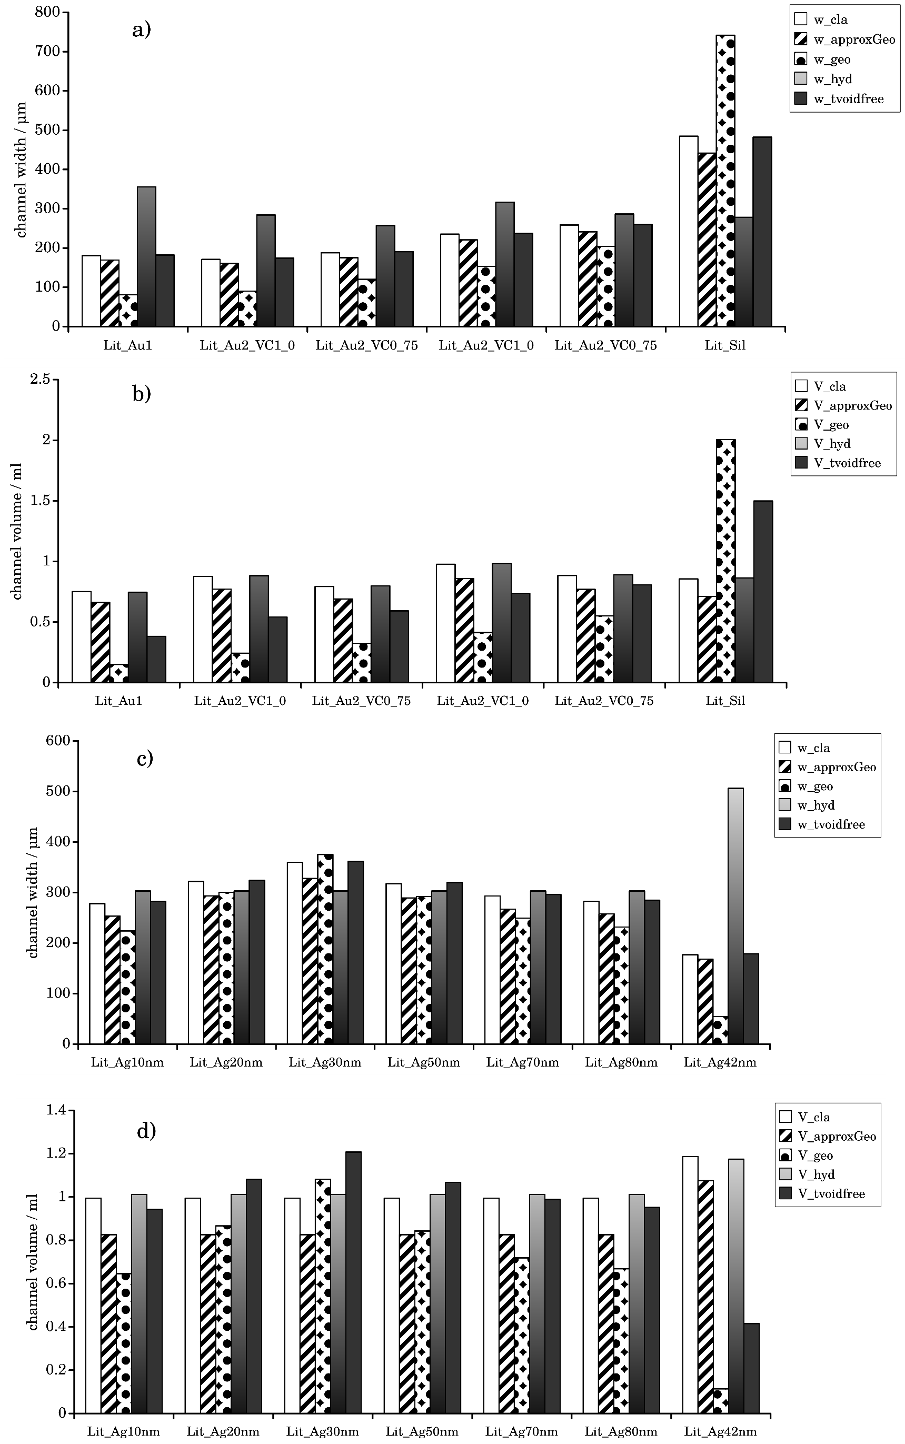

Figure . User interface for the manual read-out of *t*0 and *t*e. Offset of

The results of our evaluations are displayed in Fig.6. For the data set Lit_Au1, we could confirm all effects of previous findings: *w*geowas significantly smaller than the other calculated channel distances, while *w*hyd.

Tt can be summarized that applying AF4 theory blindly leads to conspicuously inconsistent results. As we counterchecked the derivation of our formulas and implementation into the software multiple times, we speculated this behavior to be reasoned by a systematic measurement error. For this reason, we continued and investigated the influence of measurement uncertainties on the resulting sizes.

*Influence of measurement uncertainties on the calibration result*

In the following, we implemented an additional feature which displays the effect of deviations to the final results. The task was implemented by a generic preprocessor macro, which keeps all but one parameters constant and iterates over a grid of the remaining parameter to be investigated. Thereby, we plot the impact of a deviation *δX* of a parameter *X* to the relative deviations of the resulting volume and channel widths (*δY*). This analysis is useful as due to the included numeric procedures and the relationship between the two output variables and its inputs is not obvious, especially when an input variable is used multiple times. In addition this analysis can be used as a base for an estimation of the total propagation of uncertainty. Here, we show the result of this analysis, where the central parameters *δX*=0 are taken from the parameter set BSA_Vc2_5_r1.

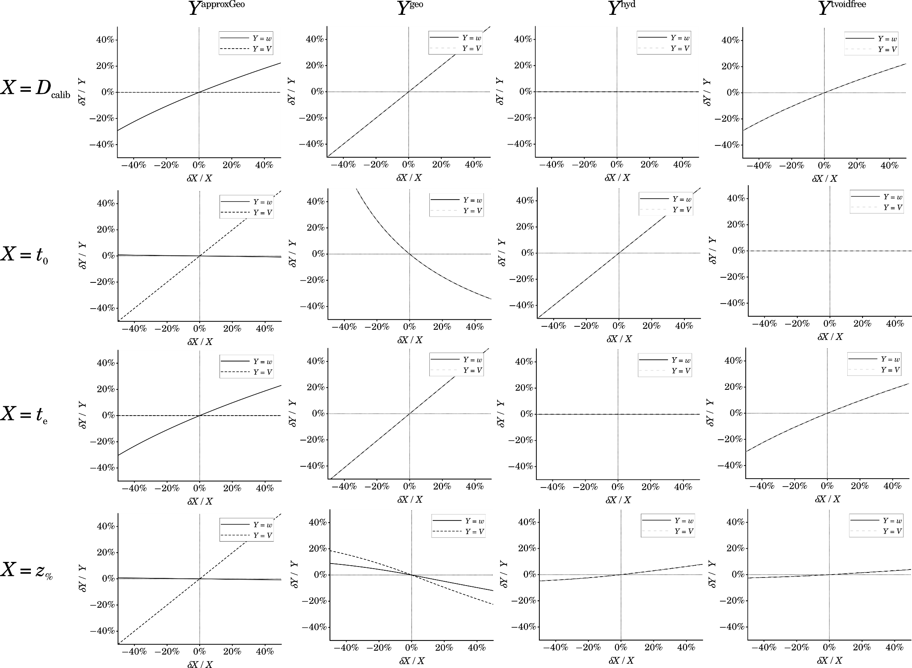

Figure . User interface for the manual read-out of *t*0 and *t*e. Offset of

Fig. 8 shows the influence of deviations to 4 of the parameters, we expected to exhibit the highest possible uncertainty. *t*0 and *t*e have to be considered as they are the primary raw measured results. The physical dimensions of the channel area and the applied flow volumes are assumed to be measured and with high accuracy, thereby, we don’t discuss them further them here in detail. Also, we skip the discussion on the first algorithm due to its similarity to the second one. However, the resulting data of full analysis of all 5 algorithms and 10 parameter sets is shown in the supportings. (including the results for BSA_Vc2_5_r1 and PS_Vc3_5_r1)??? The externally acquired Diffusion coefficient has to be considered here, as for many samples, different numerical values have been (Raj1974, Lanew1987, Stelezer1984, Fuh1992, Liu1993) published. Also, side conditions like temperature and the temperature-dependent viscosity can influence the effective Diffusion coefficient[Wahlund2013], where the latter one is often not known exactly in practice. The analysis shows that all procedures but the fourth (where *D* is not used) scale with *D*. However, the dependence significantly was strongerfor the third procedure, while the volume is completely neglected for the second. The same relationships are shown for the input variable *t*e. Interestingly, a deviation of the focus position seems only to contribute significantly if the actual position is strongly displaced from its designated position. The relation of the deviations of *t*0 were remarkable. While the linear relationship of the calculated volume was obvious, there was almost no impact on *w*appGeo. For the third and fourth procedures, we found a proportional and a nearly inverse proportional relationship. As logical consequence a deviation of *t*0 leads to a divergence of the results in these procedures as it could be seen in the experimental results. This consideration lead to a closer consideration of an impact of the void peak time.

*Convergence of the calibration calculations via the adjustment of* *t*0

Variations of t0 for each algorithm V0(t0), w(t0).

**Discussion**

Invalidity of measured void peak

Error source : channel outlet- to-detector distance

Alternate hypothesis for the occurrence of the “void peak”.

Image crossflow near border

**Conclusions**

We have shown that a dedicated software for the evaluation has the potential to greatly improve the practical handling of AF4 data and further development. As already known, expected the information about channel volume and channel height are the critical quantities for contemporary machines. The early substitution of an expression of variables with known values shows up to be very useful when translating the physical relationships into a precisely defined evaluation algorithm. The development of the software will be continued, considering the following list of features only as an example for numerous possible extensions:

* Alternative calibration methods as have been investigated recently (Bolinsson2018). Also

distance measurement has improved continuously (Berkovic2012) up to xxx, therefore we think that further calibration methods based on combination of the channel with such a device might be an additional orthogonal tool for the calibration.

* Crossflow gradients (Litzen1989, Kirkland1992, Williams2001), steric effects and decays (cite Wahlund2013, Håkansson2012, cite Magnusson2012). Our final goal will be to provide an open and extensible reference implementation of which gathers all these state-of-the-art evaluation methods
* advanced handling of light scattering data.
* AF4 related deconvolution techniques (Schmid201, Schure1989)
* improved focus point determination as recently presented (Wang2018).
* generation of plotting language scripts based on the given data set

As distance measurement by optical methods has improved continuously over the last decades up to submicrometer precision a direct measurement of *w* will be an additional improvement. It was stated by Wahlund(2013) that, unfortunately, these calculations were not available in commercial software. Instead, we suggest that a software implementation is much more suited to fit the needs of the coming developments in progress of evaluation procedures. It allows a much more flexible adaption according upcoming new developments and integration of subsequent data processing than a proprietary approach. To allow further automation it would be rather helpful if all important parameters from a measurement were directly available in an easily parsable format to reduce. We encourage users of AF4 get in contact to discuss possible extensions for their specific needs.

**Acknowledgements**

This work was generously supported by the DFG (Deutsche Forschungsgemeinschaft) within the SFB 1214, project B6. We also thank Emre Brookes for hosting a derepository for the development steps prior publication.

**References**

Müssen noch ergänzt werden zum Text

Rathmann, U. *Qwt - Qt Widgets for Technical Applications*, 2014.