Revision of the AF4 calibration experiment

Benedikt Häusele1, Maxim Benjamin Gindele12, Helmut Cölfen1*

1 Physical Chemistry, Department of Chemistry, University of Konstanz, Universitätsstr. 10, 78457 Konstanz, Germany

2 Institute of Inorganic Chemistry, Leibniz University Hannover, Callinstr. 9, 30167 Hannover, Germany

benedikt.haeusele@uni-konstanz.de  
gindele@acc.uni-hannover.de  
helmut.coelfen@uni-konstanz.de

*Correspondence:

helmut.coelfen@uni-konstanz.de  
Tel.: +49 7531 88-4063  
Fax: +49 7531 88-3139

Abstract:

Asymmetrical flow field-flow fractionation is a versatile chromatographic fractionation method. It is used for size-based separation of colloids, biomolecules and polymers in combination with at least one detection technique. Although used often as pure separation method, a well-elaborated theory is available that allows precise quantification of the translational diffusion coefficient *D*. Still, current literature suggests different ways to transform this theory into applicable experimental procedures and no “gold standard” for correct data processing exists. While some sources report a direct way to extract diffusion information from the fractogram, others suggest the necessity of an external calibration measurement to obtain the channel width *w*. In this work, we compare the different approaches and calibration algorithms based on original and literature data using our own open-source AF4 evaluation software. Based on the results, we conclude that available AF4 setups do not fulfill the requirements for absolute measurements of *D*. We show that the best way to conduct is to consider the area of the channel and *D* of the calibrant while neglecting the small peak which occurs in the void peak region.

Highlights:

Keywords:

Asymmetrical flow field-flow fractionation, void peak determination, size determination, calibration

**Introduction**

AF4 (asymmetrical flow field-flow fractionation) is a chromatographic technique that can be used to separate samples due to their diffusion coefficient[1]. It is a member of the FFF (field-flow fractionation) family invented by J. Calvin Giddings [2]. Compared to more commonly applied separation methods like SEC and HPLC[3], FFF techniques are based on the interaction of the analyte with a physical field which separates the sample to a corresponding physical size[4]. In principle, the method is applicable to a huge variety of samples, including small biomolecules[5,6], nanoparticles and polymers [3,4] up to big agglomerates like protein aggregates[7], virus-like particles [8] and drug carrier systems [9]. Nowadays, AF4 is the most commonly used flow FFF method, where the separation channel is formed of a solid wall and a frit covered by a membrane.

The development of dedicated measurement protocols can be complicated due to the high number of adjustable parameters, though[10]. This includes instrumental specifications like the channel shape, its related parameters length *L*, the channel width *b*0 and *b*L and the choice of the membrane material. The three typical variable experimental conditions are elution flow *Ve*, applied cross flow *Vc* and the focusing flow and period. AF4 has to be combined with at least one detection technique, typically MALLS (multi-angle laser light scattering), UV/Vis and/or RI (refractive index) detection. Also, on-line NMR [11], mass spectrometry [12] and SAXS (Small-angle X-ray scattering) [13] have been applied as detection techniques.

In addition to the parameters listed above, the channel thickness *w* and the separation volume *V* have to be known precisely in order to allow a correct determination of the diffusion coefficient, and, thereby, the size of a measured sample [1,10]. However, due to dwelling of the applied membrane in the channel, these magnitudes are not directly accessible with current devices, which reasons the necessity of suitable calibration methods.

Although AF4 theory has been elaborated and well documented in literature, the transfer to its application quantitative evaluation software lacks still behind compared to methods like AUC (analytical ultracentrifugation). Here, several software solutions and a couple of evaluation methods are already available and can be used even without in-depth knowledge of the underlying algorithmic considerations [14,15]. This may be also a reason, why the practical handling of AF4 data evaluation is handled very inconsistently by different authors. While some authors suggest a direct conversion from measurement data is directly possible from a measurement [16], others suggest an external measurement using a calibrant with a known diffusion coefficient [10,17] or an external size measurement via coupled MALLS [18].

Therefore, we fill this gap with an implementation of the known procedures and compare them to each other.

In this, we want to compare some of the different approaches reported up to now in literature. In the past, the validity of the no-field method in AF4 has already been disproved successfully [19]. A reported approach, which aims to measure the thickness of the membrane directly by a micrometer [5,10,17] has to be questioned as the measurement cannot be not conducted *in situ*.

**Theory**

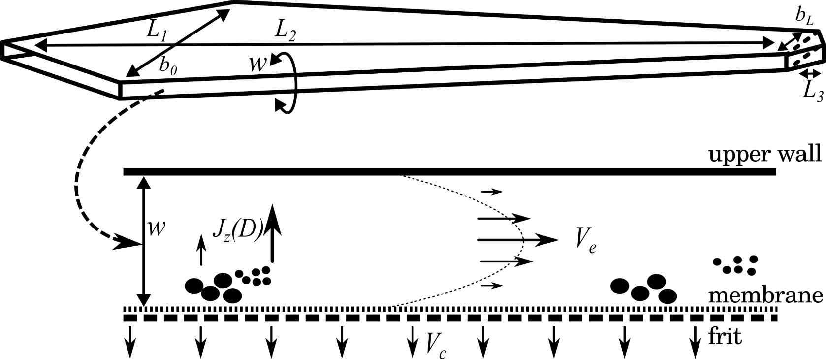

Figure 1. Top view of an AF4 channel (top) and its cross-sectional area (bottom)

The sample is injected into a flat channel with a solid upper wall and a lower wall that allows the streaming solvent to pass partially (Fig. 1). In current devices this wall is made of a frit covered by an ultrafiltration membrane. The inlet flow *V*in is, thereby, split to a crossflow *V*c(which is distributed uniformly over the horizontal section of the channel) and an elution flow *V*e forming parabolic flow profile typical for all FFF variants:

(1)

The “broadness” of the parable representing the velocity gradient depends on the plate distance *w*, also designated as channel width. *L*1, *L*2, *b*0 and *b*L describe the channel dimensions as shown in Fig. 1.

*V*c transports the particles to the membrane. As a consequence, the opposed translational diffusion *J*z determines the average velocity zone and hence the time of elution. Mathematical descriptions of AF4 experiments and derivation have been described in literature [1,10,20,21]. They describe phenomena by physical and geometric approaches. As shown in the supporting information, rigorously applying a coordinate system to the channel shape allows to express these formulas for random channel shapes as well.

Thereby, we only state a short description of those formulas that are used in our evaluation approach which is essentially built up on existing theory. While the physical relationships are widely known and well documented, this is not always the case for their translations into an evaluation procedure. This might seem to be a trivial step as the physical content is well elaborated. However, having a closer look to the physical formalism, it turns out that the overdetermined nature of the system

Considering the number of different approaches which exist for calibration [10,18] and their variations in detail, the implementation affects not only the evaluation but also the required measurement setup and, of course, the final measurement result. The lack of such standardized evaluation procedures impairs the reproducibility of measurements and may be one of the reasons why the analytical characterization potential is not exhausted to its potential up to now [3].

In total, 5 different calibration ways are described here briefly. The explicit derivation of the underlying formalisms and algorithmic considerations are stated in the supporting information.

The retention ratio *R,* defined as

(2)

with the time of the void peak *t*0 (the time which is required for a particle to travel if no retention occurs) and any possible point of time during the evaluation).

This is connected to the relative mean layer distance *λ* by the classical FFF retention equation:

, (3)

which is often simplified to

. (4)

For AF4, the relevant correlation of *λ* and *D* has been elaborated [1] as

. (5)

For a typical AF4 measurement the channel volume *V*­0­ and the channel width *w* are critical sizes for the evaluation. Recently, we used a calibration method (Schmid2018) that makes use of the volume calculation as reported by Wahlund (1987) and then adjusts *w* by a simple bisection accordingly to Eq. (3) and (4). A similar method was reported independently[20,2].

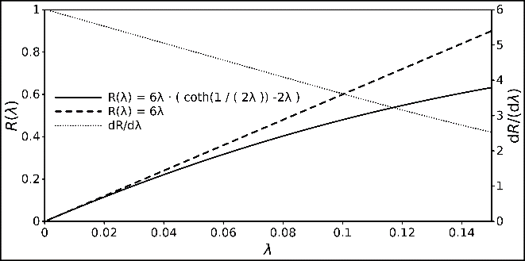

Figure 2: Relationship between R and λ, displayed with the classical FFF retention and its linear approximation. The derivative of the retention equation is also displayed to demonstrate its strict monotony.

Fig. 2 shows that bisection is easily applicable due to the strict monotony of the retention equation within the relevant scope and sufficient for being used on modern CPU. It can be replaced by an even more efficient conversion if required[22]. Here, the separation volume *V*0 is estimated according to [1]

(6)

In the following, we refer to this method as “classical” calibration method with the calculated separation volume *V*cla and channel height *w*cla.

(7)

The formalism for relevant method has been adjusted for narrowing trapezoidal channel shapes as follows [23] and is used as such for the second method (*Y* is a correction term for approximating the correct channel surface):

(8)

The separation volume of the channel can also be a product of the surface and height of the channel. For this reason, we introduce a third calibration method which yields the corresponding volumes *V*geo and *w*geo. Making use of

(9)

Thereby, leads to the intuitive observation that variations of any parameters don’t affect the calculated volume and the channel width linearly equally.

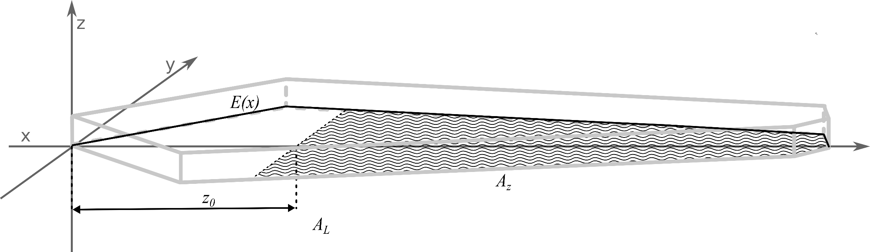

Figure 3. Coordinate system with the shape description function *E*(*x*), the focus position *z*0 the plain of the effective separation volume (hatched area *A*z), the complete area of all sections *AL* (hatched and non-hatched surface in the *x*,*y* plain) and the light grey edges of the generated channel shape.

, we show a second way here to perform the calibration. It is conducted by substituting the term

(10)

in Eq. (4) and determine *S* analogously to *w* as in the classical approach. In a second step, inserting Eq. 5

with the passed channel area *Az* (Fig. 3) that was used for the separation gives a solution for *w* as

(11)

Using Eq. (6), now the volume can be calculated. Dedicated derivations of the channel plane calculation is given in the supplementary information. As already stated, in this approach, all hydrodynamic information is already used to calculate *S*. By this approach it is ensured, that volume, width and the channel area fit together geometrically.

A fourth way of calculating the width and the volume is based on considerations concerning the flow velocities and hydrodynamic processes in the channel. The same rigorous equations for the description of the channel shape were used as for the calculation of *V*geo. This leads to a direct linear relationship of *t*0 and *w*:

(12)

The “conversion factor” *C*F is determined via the hydrodynamic and geometric properties of the measurement. It can be obtained by solving the integral:

(13)

This expression is derived based on a known approach [23], but independent from the shape and more suited to relate w and t0 directly. The function *E*(*x*) describes the shape of the channel in dependence of its longitudinal position *x*. *A*L is the complete surface of the channel, i.e.

(14)

Then, using Eq. 5, *V*hyd can be calculated. The values obtained by this method are denoted as *V*hyd in the following. A detailed derivation for the factor *C*Fand *V*hyd is given in the supporting information. The obvious advantage of this method is the independence from an external diffusion coefficient i.e. no calibration measurement is involved in this procedure. This is a formalized method which is equivalent to calibration free conversion approaches [16,24,25].

The fifth algorithm also makes use of this conversion factor. Here, it is used to substitute the void time t0. This way, Eq. 2 can be written as

(15)

By reformulating Eq. 8, λ can be calculated written as:

(16)

Now Eq. 5 can be merged with *(14)*.

(17)

*w* can now be easily determined numerically from Eq. 16 and Eq. 17. This calibration calculation procedure is advantageous as *t*0 does not have to be determined experimentally and be read from the fractogram. However, it requires a calibration measurement for the determination of *t*e and a known *D*.

**Materials and methods**

AF4Eval is our current published version of hydrodynamic evaluation software for AF4 data. The user can create profiles for channel shapes and corresponding calibrations for a measurement set. Data are provided in a standardized csv-file format. Further input formats such as AniML[26,27,28] are planned to be added. As *t*0 and *t*e have to be determined manually for some calibration methods, we in8tegrated a simple graphical element (Fig. 4) with movable bars to the user interface to enable the user to pick the peak position manually without transferring the chosen value as it would be required in a spreadsheet application.

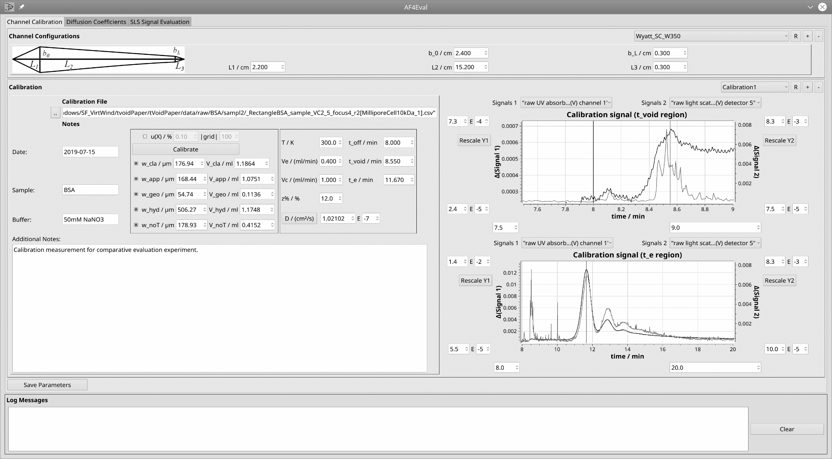

Figure 4. User interface for the manual read-out of *t*0 and *t*e. The bars are controlled via the respective spin boxes and allow a direct transfer of the value from the fractogram to the calculation.

AF4Eval is written in C++14. Its source code obtainable via github and can be used without charge for academic purposes: https://github.com/biocrystal777/AF4Eval. Data shown in this report where obtained with a version compiled with g++ 6.3 under Debian Gnu/Linux 9.5, using the framework Qt 5.7 and the plotting library Qwt 6.1.2[29].

Table 1: Required input parameters for the described calibration algorithms

|  |  |  |  |  |  |
| --- | --- | --- | --- | --- | --- |
|  | Classical | Approximated Volume | Geometrical | Hydrodyamic | Without *t*0 |
|  | *D*calib | *D*calib | *D*calib |  | *D*calib |
|  | *t*0 | *t*0 | *t*0 | *t*0 |  |
|  | *t*e | *t*e | *t*e |  | *t*e |
|  |  |  |  |  |  |
|  | *V*e | *V*e |  | *V*e | *V*e |
| Inputs | *V*c | *V*c | *V*c | *V*c | *V*c |
|  | *z*% | *z*% | *z*% | *z*% | *z*% |
|  |  | *L*1, *L*2 | *L*1, *L*2, *L*3 | *L*1, *L*2, *L*3 | *L*1, *L*2, *L*3 |
|  |  | *b*0, *b*L | *b*0, *b*L | *b*0, *b*L | *b*0, *b*L |
|  |  |  |  |  |  |
| Side condition | - | - | Eq. 9 | Eq. 9 | Eq. 9 |
|  | *w* | *w (w*appgeo*)* | *w (w*geo*)* | *w (w*hyd*)* | *w (w*noT*)* |
| Outputs | *V*0 | *V*0 (*V*appgeo) | *V*0 (*V*geo) | *V*0 (*V*hyd) | *V*0 (*V*noT) |
|  |  |  |  |  |  |

Based on the theory above we implemented 5 calibration algorithms. The calibration-dependent three methods enable an estimation of the void peak time from the geometrical properties of the calibrated channel. Thus, manual readout of the void peak is avoided entirely and the methods can be integrated in an entirely automated procedure. The direct conversion turns out to be useful if no appropriated standard is available. These algorithms vary in their specific required input magnitudes (Tab. 1). A pseudocode of the applied calculations representation is given in the supporting information.

In addition, an error analysis function was implemented that allows to estimate the uncertainties of the methods. The error analysis allows to define a range *R* of the estimated uncertainty *δX* from -100% to 100% for the input quantity *Xi* and a grid resolution parameter. The method then iterates over *X*+*δX* of *R* while conducting the assigned algorithm and gives the deviation of the output quantity *Y*j. The method seems trivial from a mathematical perspective, however, it gives a good overview, how the deviation of one quantity affects the result under while the other quantities are kept constant. This is especially useful if the impact cannot be foreseen due to the involvement in several numerical procedures. This way, the individual impact of the uncertainty of each variable can be easily quantified for each experimental condition. Other functionalities, such as the evaluation of size distributions based on the calibration, are not discussed in this publication.

**Experiments**

The experiments were conducted with a Wyatt Eclipse DualTec Separation system. The setup was coupled with a degassing unit (G1322A), an isocratic pump (G1310B) and an autosampler (G1328C), all from the Agilent 1260 series. Signals were recorded using the software Astra 6.1.7.17 with a sample rate of 0.5 Hz. A detector chain, consisting of a Dawn Heleos 8+ MALLS detector (wavelength = 663 nm) a UV/VisDAD detector (G1315C, Agilent series 1100) and an RI detector. Before usage, an interdetector distance correction was conducted according to the elution peak of a BSA measurement using the respective function in Wyatt. Only signals with a decent signal-to-noise ratio were considered.

In the channel, an SC W350 spacer from Wyatt was used. The detailed dimensions are given in Table 3, together with the measurement conditions and related input parameters for the algorithms. Two samples were used: BSA and Nanospheres. 3 replicates for each condition were measured. The eluent was 50 mM NaNO3 for measurements with BSA. The injected sample amount was 20 µl. For the measurement with PS (Polystyrene) nanospheres, a 0.1 % w/v of SDS (sodium dodecyl sulfate) was used. Measurements were conducted at 293 K. For each spacer a new 5 kDa Millipore regenerated Cellulose membrane was used. Detailed measurement program and sequence setup is given in the supplementary information.

**Results**

*Comparison of algorithms with test measurements*

First, we tested the algorithms with data acquired from our own field-flow fractionation. Standard protocols with a constant crossflow. Before elution, the sample was focused at 12 % of the total channel length. The details of the measurement protocols are given in the supporting information (Table S.1-S.3). BSA was measured at *V*c=2.5 mlmin-1 and *V*c=3.5 mlmin-1. To provide an example for a lower crossflow, additional measurements with PS nanospheres were conducted at *V*c=0.5 mlmin-1. For BSA, the signals of the UV-Vis detector were chosen, for the PS measurements, UV and RI were considered.

Table 2: Parameters used for calibration experiments with test measurements

|  |  |  |  |  |  |  |  |  |  |  |  |  |
| --- | --- | --- | --- | --- | --- | --- | --- | --- | --- | --- | --- | --- |
| Parameter | unit | BSA_Vc2_5 | | | | BSA_Vc3_5 | | | | PS_Vc0_5 | | |
|  |  | r1 | r2 | r3 | r1 | | r2 | r3 | r1 | | r2 | r3 |
| *t*0 | min | 0.53 | 0.55 | 0.54 | 0.6 | | 0.5 | 0.51 | 0.73 | | 0.72 | 0.72 |
| *t*e | min | 3.65 | 3.65 | 3.35 | 4.6 | | 4.5 | 4.5 | 15.8 | | 15 | 15.1 |
| *V*c | mlmin-1 | 2.5 | | | 3.5 | | | | 0.5 | | | |
| *V*e | mlmin-1 | 1.0 | | | 1.0 | | | | 1.0 | | | |
| *D*calib | cm²s-1 | 6.1*10-7 | | | 6.1*10-7 | | | | 6.74*10-8 | | | |
| *z*% | % | 12 | | | 12 | | | | 12 | | | |
| *b*0 | mm | 22 | | | 22 | | | | 22 | | | |
| *b*L | mm | 3 | | | 3 | | | | 3 | | | |
| *L*1 | mm | 20 | | | 20 | | | | 20 | | | |
| *L*2 | mm | 150 | | | 150 | | | | 150 | | | |
| *L*3 | mm | 3 | | | 3 | | | | 3 | | | |

The plotted signals of the fractograms were used to pick positions of *t*0 and *t*e for the BSA monomer peak, as shown exemplarily in Fig. 5. The fractograms have been corrected in time by its offset due to the focusing-related steps. I.e. “0” on the time axis displays the actual time of elution from the focusing position *z*%.

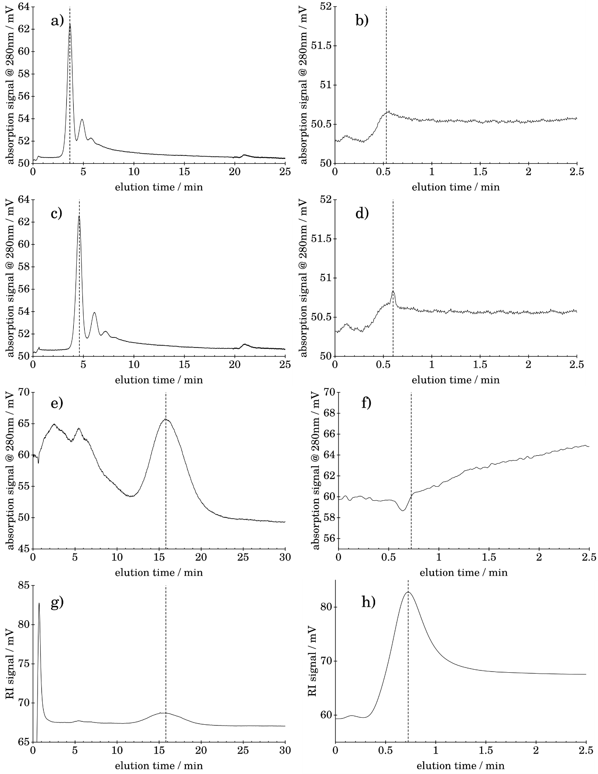

Figure 5. Raw fractograms, each data set is shown completely on the left (dashed line marks the position of *t*e) and a zoomed detail of void peak region (dashed line marks the position of *t*0) on the right: a) BSA_Vc2_5_r1, *t*e b) BSA_Vc2_5_r1, *t*0 c) BSA_Vc3_5_r1, *t*e d) BSA_Vc3_5_r1, *t*0 e) PS_Vc0_5_r1, UV, *t*e f) PS_Vc0_5_r1, UV, *t*0 g) PS_Vc0_5_r1, RI, *t*e h) PS_Vc0_5_r1, RI, *t*0

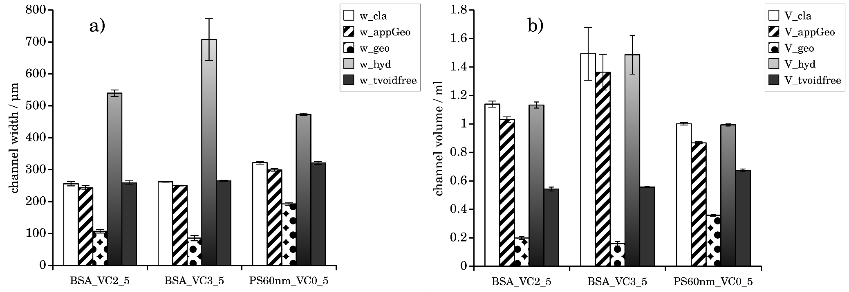

Figure 6. Results of calibration algorithms with test measurements, a) channel width b) channel volume

The complete fractograms and extracted peak positions of all 9 measurements are given in the supporting information (Fig. S.9-S.13). All information was collected (Table 2) and processed by the 5 calibration algorithms of AF4eval. The calculated channel widths and volumes are displayed in Fig. 6. The acquired retention times were typical for our AF4 setup and comparable to a lot of other measurements with similar conditions. In all three cases, *V*appgeois smaller than the calculated *V*cla. This is simply reasoned by the smaller surface, when the trapezoidal tapering is considered in the calculation.

Consequently, the same observation is made for the relation of *w*appgeo and *w*cla­. As each of our calibration calculations was deduced from essentially the same established AF4 theroy, we would have expected each of the calculations to lead to yield a very result. Instead, introducing the ensurance of the geometrical side condition of Eq. 9 (*w*geoand *V*geo) made the calculated channel volume and related width shrink dramatically compared to the other calibration results. Whereas removing the dependence on the known *D*calib (for determination of *w*hyd) led to dramatically increased calculated channel widths, which are highly unrealistic as the spacer thickness of 350 µm represents the maximal possible distance between membrane and upper wall. Interestingly, the related separation volume *V*hydwas nearly the same as for the established first two variants as they use a very similar assumption for the derivation of the respective volume. This indicates that the formalism is indeed correct. Finally, removing *t*0 from the list input parameters by making use of Eq. 12 led to a result, which preserves the correct geometric relation, and resulted in a channel thickness within the expected range.

In order to exclude potential errors in our own experimental setups, we applied the algorithms on published fractogram data.

*Comparison of algorithms using published data in literature*

For the reevaluation we screened the respective AF4-related literature for data sets which provided fractograms and required information on the applied measurement conditions as possible. Especially the focus position z% was not always indicated. For our investigations, we decided, to assume a value which is typically used for channels without frit-inlet. The implication of possible deviations of this real value are discussed below separately. We chose to work with measurements made with spherical gold nanoparticles [16,30], Silica particles[16] and silver nanospheres[31,32]. Measurements in the used literature had been conducted using trapezoidal channel geometries with different channel dimensions and AF4 devices from different vendors. The respective diffusion coefficient was calculated according to the specifications made in the respective publication and the expected shell thickness for polymer coatings[33,34]. All used parameters are displayed in Table 3 and Table 4. We applied the algorithms in the same way as we did for our own measured data.

Table 3: Parameters used for calibration calculation with literature data

|  |  |  |  |  |  |  |  |  |  |  |  |  |  |
| --- | --- | --- | --- | --- | --- | --- | --- | --- | --- | --- | --- | --- | --- |
| Parameter | unit | Lit_Au1[Joch] | Lit_Au2[Zat] | | | | LitAu3[Zat] | | | | | Lit_Sil[Zat] | |
|  |  |  | | Vc1_0 | Vc0_75 | | | Vc1_0 | | Vc0_75 | |  | |
| *t*0 | min | 0.593 | | 0.89 | | 0.89 | | | 0.992 | 0.992 | | | 0.96 |
| *t*e | min | 4.42 | | 4.55 | | 0.992 | | | 9.45 | 9.45 | | | 13.3 |
| *V*c | mlmin-1 | 0.8 | | 1.0 | | 0.75 | | | 1.0 | | 0.75 | 0.2 | |
| *V*e | mlmin-1 | 0.5 | | 1.0 | | | | | 1.0 | | | | 0.2 |
| *D*calib | cm²s-1 | 6.1*10-7 | | 6.1*10-7 | | | | | 6.74*10-8 | | | | 1.13*10-7 |
| *z*% | % | 12 | | 12 | | | | | 12 | | | | 12 |
| *b*0 | mm | 22 | | 22 | | | | | 22 | | | | 22 |
| *b*L | mm | 3 | | 3 | | | | | 3 | | | | 5 |
| *L*1 | mm | 20 | | 20 | | | | | 20 | | | | 22 |
| *L*2 | mm | 150 | | 150 | | | | | 150 | | | | 213 |
| *L*3 | mm | 3 | | 3 | | | | | 3 | | | | 5 |

Table 4: Parameters used for calibration calculation with literature data

|  |  |  |  |  |  |  |  |  |  |  |  |  |  |  |  |  |  |  |  |
| --- | --- | --- | --- | --- | --- | --- | --- | --- | --- | --- | --- | --- | --- | --- | --- | --- | --- | --- | --- |
| Parameter | unit | LitAG[Koopmans] | | | | | | | | | | | | | | | | Lit_Ag_42nm[Loe] | |
|  |  | 10nm | 20nm | | | | | 30nm | 50nm | | 70nm | | | 90nm | | | |  | |
| *t*0 | min | 0.75 | | 0.75 | | 0.75 | | | 0.75 | | | 0.75 | | | 0.75 | | | 0.75  10.39 | |
| *t*e | min | 1.81 | | 4.32 | | 7.85 | | | 10.11 | | | 12.02 | | | 14.32 | | |
| *V*c | mlmin-1 | 0.4 | | | | | | | | | | | | | | | 1 | | |
| *V*e | mlmin-1 | 1.0 | | | | | | | | | | | | | | | 0.4 | | |
| *D*calib | cm²s-1 | 4.29*10-7 | | | 2.14*10-7 | | 1.43*10-7 | | | 8.58*10-8 | | | 6.13*10-8 | | | 4.76*10-8 | | | 1.02*10-7 |
| *z*% | % | 12 | | | | | | | | | | | | | | | 12 | | |
| *b*0 | mm | 20 | | | | | | | | | | | | | | | 24 | | |
| *b*L | mm | 5 | | | | | | | | | | | | | | | 3 | | |
| *L*1 | mm | 20 | | | | | | | | | | | | | | | 22 | | |
| *L*2 | mm | 250 | | | | | | | | | | | | | | | 152 | | |
| *L*3 | mm | 5 | | | | | | | | | | | | | | | 3 | | |

The results of our evaluations are displayed in Fig.7. For the data set Lit_Au1, we could confirm all effects of previous findings: *w*geowas significantly smaller than the other calculated channel distances, while *w*hyd.

Tt can be summarized that applying AF4 theory blindly leads to conspicuously inconsistent results. As we counterchecked the derivation of our formulas and implementation into the software multiple times, we speculated this behavior to be reasoned by a systematic measurement error. For this reason, we continued and investigated the influence of measurement uncertainties on the resulting sizes.

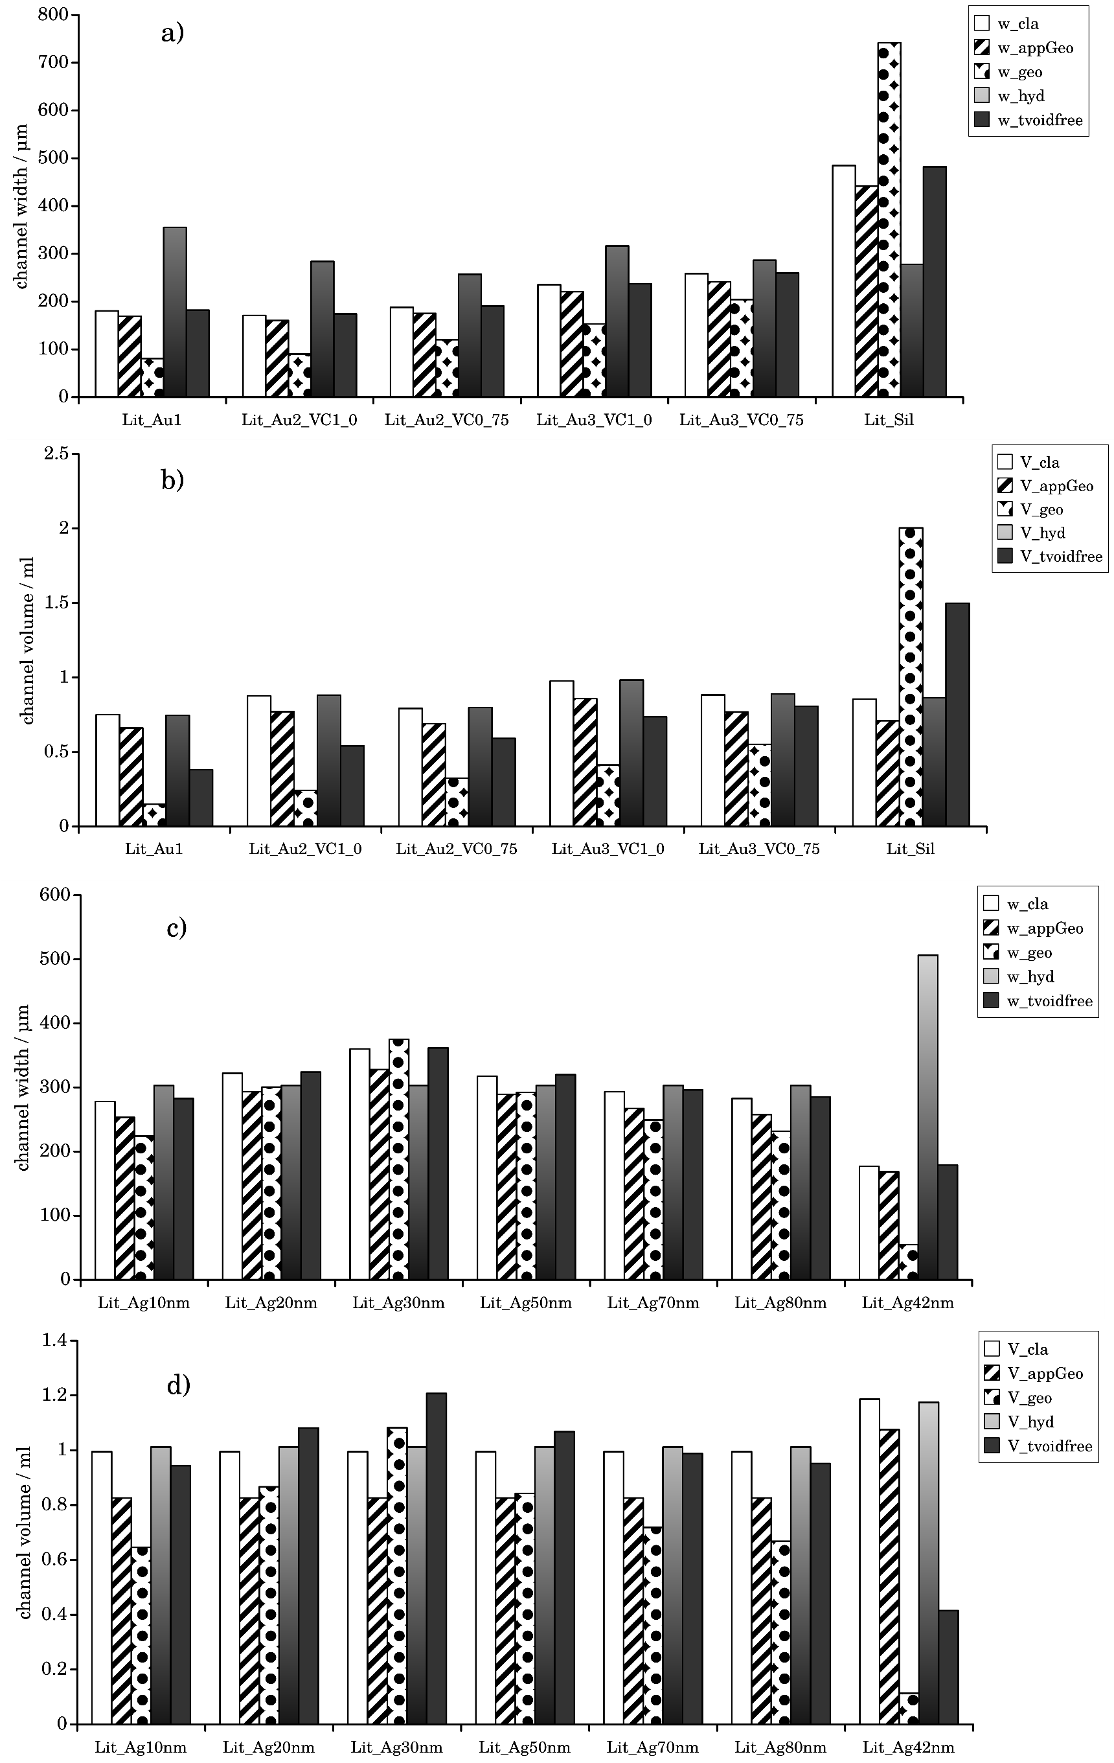

Figure 7. Results of calibration algorithms with literature data, a) *w* for data from Table 3 b) *w* channel volume Table 3 c) *w* for data from Table 4 d) *V* for data from Table 4

*Influence of measurement uncertainties on the calibration result*

In the following, we implemented an additional feature which displays the effect of deviations to the final results. The task was implemented by a generic preprocessor macro, which keeps all but one parameter constant and iterates over a grid of the remaining parameters to be investigated. Thereby, we plot the impact of a deviation *δX* of a parameter *X* to the relative deviations of the resulting volume and channel widths (*δY*). This analysis is useful as due to the included numeric procedures and the relationship between the two output variables and its inputs is not obvious, especially when an input variable is used multiple times. In addition, this analysis can be used as a base for an estimation of the total propagation of uncertainty. Here, we show the result of this analysis, where the central parameters *δX*=0 are taken from the parameter set BSA_Vc2_5_r1.

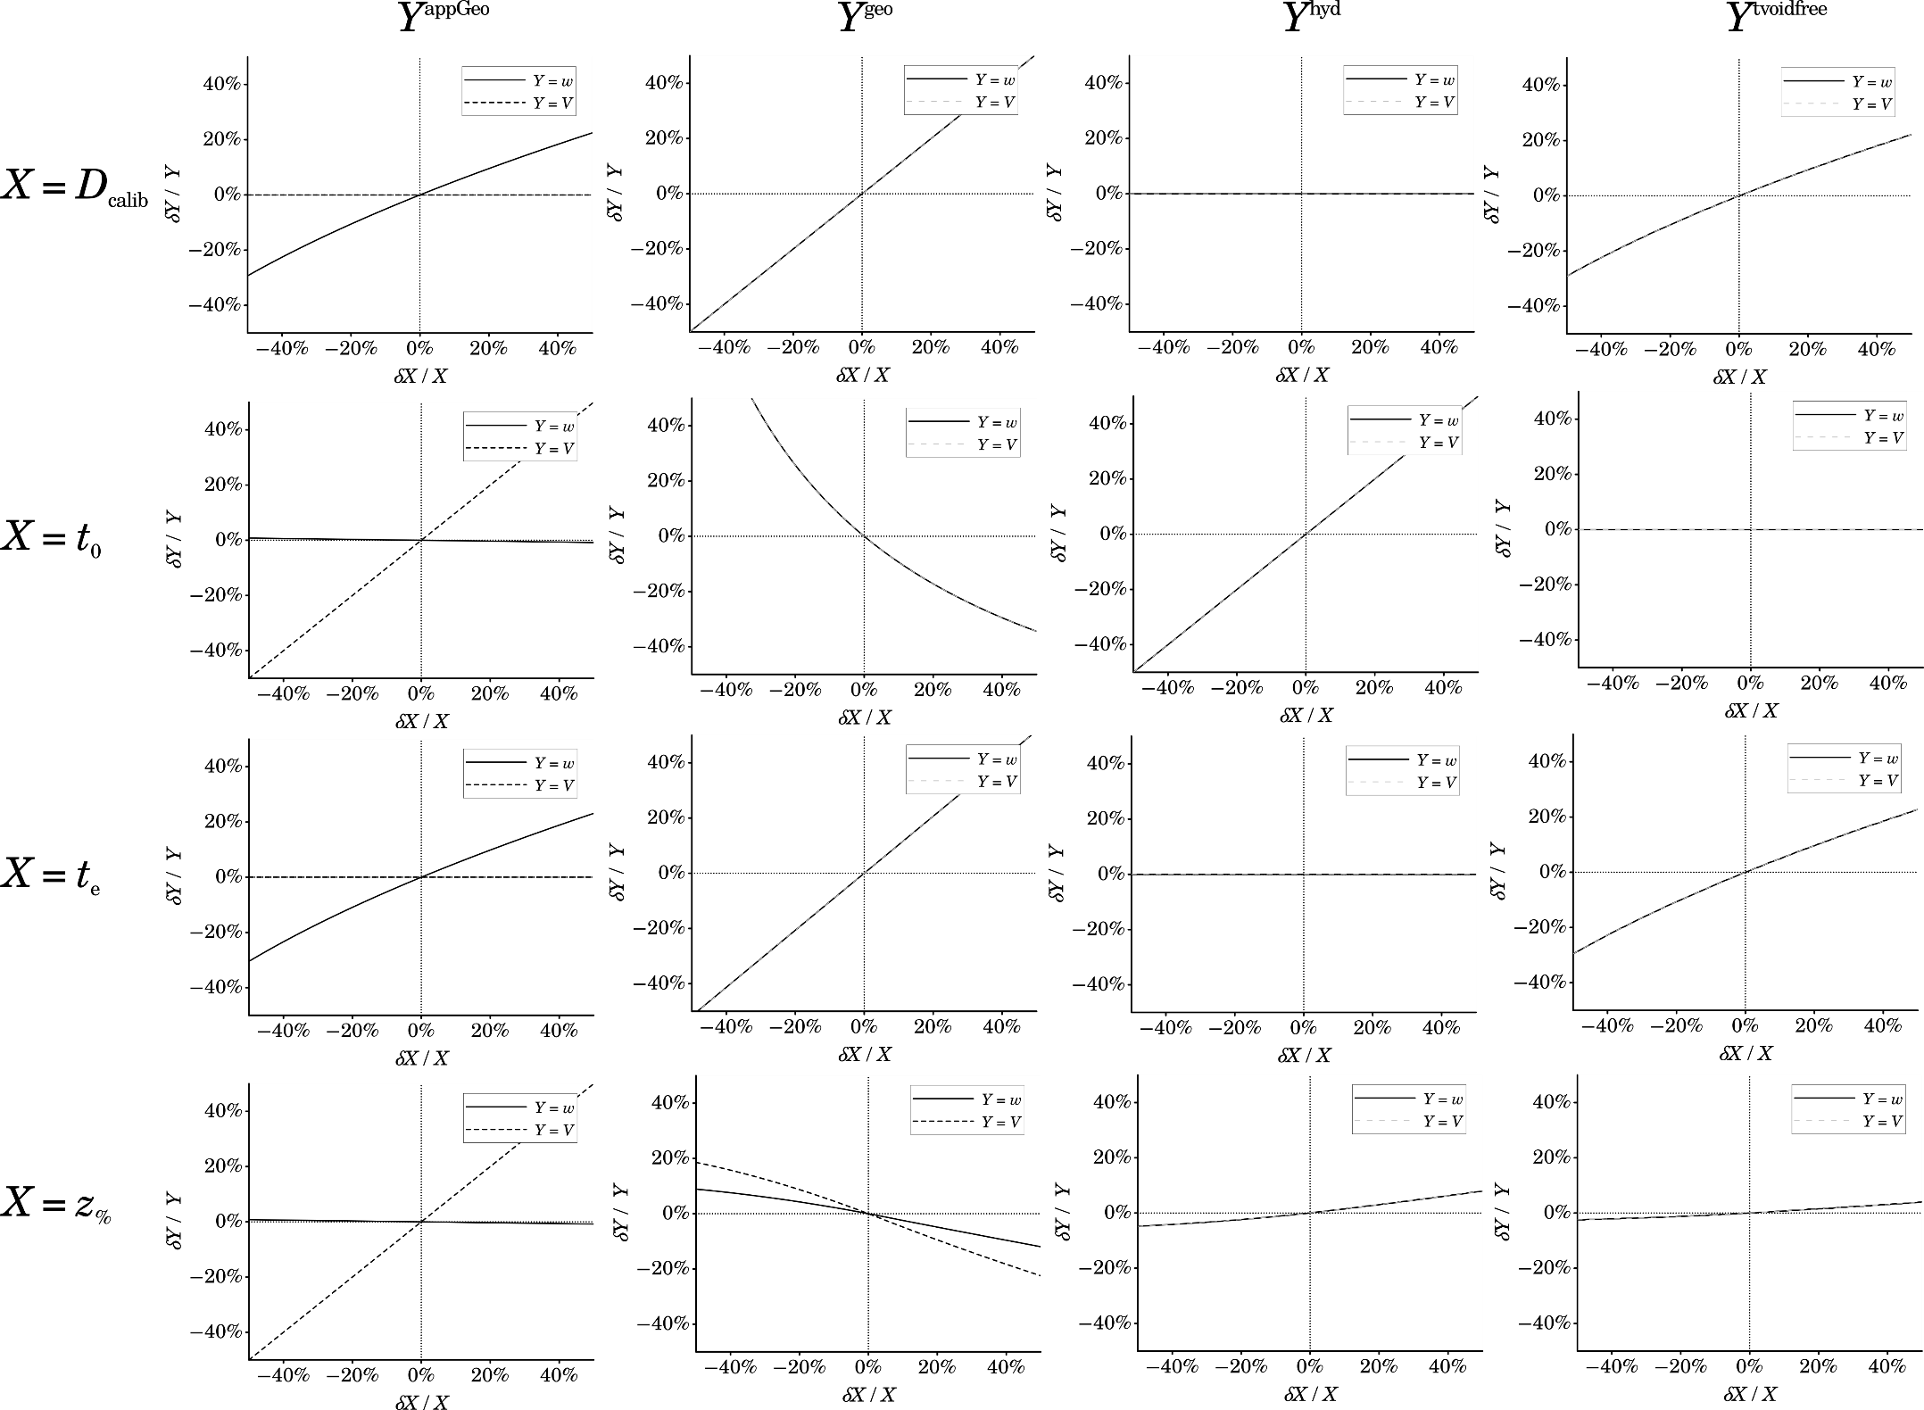

Figure 8. Selected results from the deviation analysis

Fig. 8 shows the influence of deviations to 4 of the parameters, we expected to exhibit the highest possible uncertainty. *t*0 and *t*e have to be considered as they are the primary raw measured results. The physical dimensions of the channel area and the applied flow volumes are assumed to be measured and with high accuracy, thereby, we don’t discuss them further here in detail. Also, we skip the discussion on the first algorithm due to its similarity to the second one. However, the resulting data of full analysis of all 5 algorithms and 10 parameter sets is shown in the supportings. The diffusion coefficient externally acquired has to be considered here, as for many samples, different numerical values have been published[35,36,37,38,39]. Also, side conditions like temperature and the temperature-dependent viscosity can influence the effective diffusion coefficient[10], where the latter one is often not known exactly in practice. The analysis shows that all procedures but the fourth (where *D* is not used) scale with *D*. However, the dependence was significantly strongerfor the third procedure, while the volume is completely neglected for the second. The same relationships are shown for the input variable *t*e. Interestingly, a deviation of the focus position seems only to contribute significantly if the actual position is strongly displaced from its designated position. The relation of the deviations of *t*0 were remarkable. While the linear relationship of the calculated volume was obvious, there was almost no impact on *w*appGeo. For the third and fourth procedures, we found a proportional and a nearly inverse proportional relationship. As logical consequence a deviation of *t*0 leads to a divergence of the results in these procedures as it could be seen in the experimental results. This consideration lead to a closer consideration of an impact of the void peak time.

*Convergence of the calibration calculations via the adjustment of* *t*0

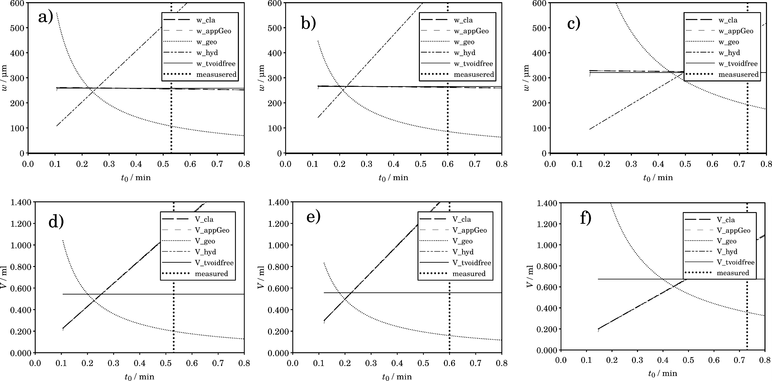

Figure 9. Overlay of the simulated calibration results for all central data and varying *t*0.*­*a) *w* for BSA_Vc2_5 b) *V* for BSA_Vc2_5 c) *w* for BSA_Vc3_5 d) *V* for BSA_Vc3_5 e) *w* for PS_Vc0_5 f) *V* for PS _Vc0_5

Similarly, to the analysis above,*t*­0 was varied for all 5 algorithms and the resulting channel widths. The analysis was conducted for one measurement per triplicate. The results, shown in Fig. 9, indicate a convergence of all algorithms for *w* and *V* in a range of *t*0 near which is significantly dislocated from the respective measured value. This confirms prior observations that the measured void peak might yield wrong results [1,10]. Similar results could be obtained for the evaluation of the given literature data (Supporting information). Consequently, only a much smaller value can be considered as the “true” void peak position by its definition (the time used of passing the channel with the average migration velocity, starting from the focus position).

**Discussion**

*Invalidity of measured void peak*

Our results show several implications towards working out best practices in AF4 calibration. As it could be demonstrated, the measured void Peaks are not suited to reproduce calibration results which are consistent with the elaborated AF4 theory. An obvious potential error might be a bad correction of the offset volume in our measurement setup. However, the error has been shown to occur abundantly in literature data as well. As a consequence, *t*0 would be a very unreliable source of information just because of this pitfall. Moreover, we even believe the observed small peak in AF4 should not be related to this magnitude at all.

*Alternate hypothesis for the occurrence of the “void peak”*

Finally, we want to give another possible explanation for the reason behind the occurrence of the little observable peak, which has been considered as the void peak. To the best of our knowledge this explanation has not been reported elsewhere up to now. FFF is fundamentally based on the friction between the solvent and the channel wall. This friction is responsible for forming the parabolic flow profile. However, the friction to the side walls is usually not considered at all. Still, it should be assumed that a similar velocity gradient is present immediately at these side channel walls. While we assume the cross flow to be uniformly distributed over the channel area and the migration velocity to be dependent solely on x- and z position referring to Fig. 3, this is probably not true at these border regions. A more sophisticated hypothetical flow distribution is shown in Fig. 10.

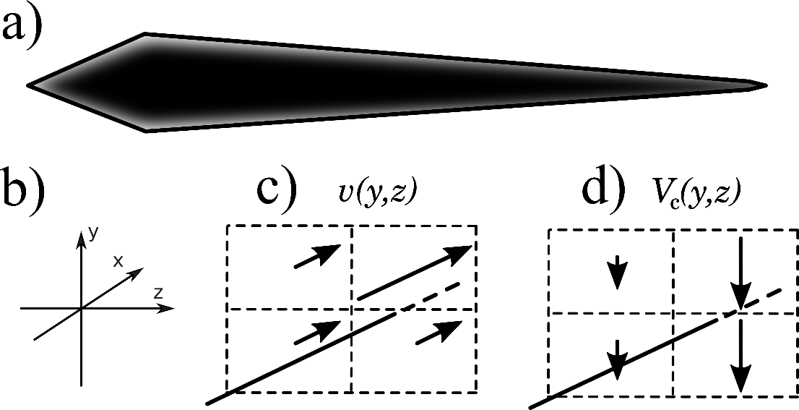

Figure 10. a) Schematic view of the expected distribution of crossflow b) Rotated coordinates for c) expected distribution of elution velocities and d) expected crossflow distribution along the channel border

Because of the friction of solvent and channel side wall, 4 regions with different flow are present in this model. Due to diffusion, a sample particle can easily migrate from one of these zones into another. By this effect, a small amount of the sample partially eludes the retention effect of the crossflow. This portion is then detected much earlier than the retained sample. However, it does not accompany a ”solvent front”, a term used for the description other chromatography techniques, but which has no actual correspondent in Field-Flow-Fractionation: Due to the parabolic flow distribution, the single laminar layers of the solvent flow are permanently displaced against each other. As a result, no common elution speed for all layers should exist. It has been reported that the observed peak intensity increases with decreasing *V*c [24,40]. This might be reasoned by an increase of the permeable (i.e. unaffected from crossflow) area in the presented model.

To give experimental evidence, dedicated mathematical models will have to be developed in the future. Therefore, the physical nature of *t*0 ­has to be considered as a theoretical auxiliary construct (i.e. “the time needed to flush the separation volume if there was no flow gradient along the diameter” as it was the case for very big wall distance). One should not rely on an experimental value for this parameter consequently. Approaches already exist, which substitute its value by the information on the channel shape and the external calibration measurement using a calibrant known Diffusion coefficient. Our fifth algorithm belongs to this group as well as some simplified versions in literature [10,41,42] or the replacement of the known *D* with a related property of the calibrant [18]. According to our study, this groups remains the only valid approach to conduct the calibration properly.

**Conclusions**

We have shown that the measured void peak is not a reliable value for the evaluation of field-flow-fractionation data. Based on this observation, we could confirm this hypothesis by Wahlund and give strong evidence how a gold standard calibration for the evaluation of AF4 data with current instruments. Our dedicated software for the evaluation has the potential to greatly improve the practical handling of AF4 data. As already known, expected the information about channel volume and channel width are the critical quantities for contemporary machines. Avoiding *t*0 as an error-prone calibration input is likely to improve accuracy of AF4 measurements. The development of our software will be continued, considering a list of features for numerous possible extensions:

* Alternative calibration methods as have been investigated recently [18]. Also

distance measurement has improved continuously [43] methods, therefore we think that further calibration methods based on combination of the channel with such a device might be an additional orthogonal tool for the calibration.

* Crossflow gradients [5,44,45], steric effects and decays [10,20,21]. Our final goal will be to provide an open and extensible reference implementation of which gathers all these state-of-the-art evaluation methods
* Advanced handling of light scattering data.
* AF4 related deconvolution techniques [46,47]
* Improved focus point determination as recently presented [42].
* An API for scripting languages.

As distance measurement by optical methods has improved continuously over the last decades up to submicrometer precision a direct measurement of *w* will be an additional improvement. If the width could be provided directly, the presented formalism could be applied easily to determine *D* without prior calibration. It was stated by Wahlund[10] that, unfortunately, hydrodynamic calculations were not available in commercial software. Our platform-independent and vendor-agnostic implementation is designed to fill this gap, relying on a state-of-the-art technology stack. We encourage users of AF4 get in contact to discuss possible extensions for their specific needs.

**Acknowledgements**

This work was generously supported by the DFG (Deutsche Forschungsgemeinschaft) within the SFB 1214, project B6. We also thank Emre Brookes for hosting a repository for the development steps prior publication.

**References**

[1] K.-G. Wahlund, J. C. Giddings, Properties of an asymmetrical flow field-flow fractionation channel having one permeable wall, Anal. Chem. 1987, 59(9), 1332-1339; https://doi.org/10.1021/ac00136a016

[2] J. C. Giddings, F. J. Yang, M. N. Myers, Flow field-flow fractionation: new method for separating, purifying, and characterizing the diffusivity of viruses, J. Virol .1977, 21(1), 131-138;

[3] H. Cölfen, M. Antonietti, Field-flow fractionation techniques for polymer and colloid analysis, in: New Developments in Polymer Analytics I, Editor: Manfred Schmidt, Adv. Pol. Sci., 150, 67-187

[4] J. C. Giddings, Field-Flow Fractionation: Analysis of Macromolecular, Colloidal, and Particulate Materials, Science 1993, 260, 1456-1465; https://doi.org/10.1126/science.8502990

[5] A. Litzén, K. G. Wahlund, Improved separation speed and efficiency for proteins, nucleic acids and viruses in asymmetrical flow field flow fractionation, J. Chromatogr. A 1989, 476, 413-42 https://doi.org/10.1016/S0021-9673(01)93885-3

[6] A. Litzén, J.K. Walter, H. Krischollek, K.-G. Wahlund, Separation and quantitation of monoclonal antibody aggregates by asymmetrical flow field-flow fractionation and comparison to gel permeation chromatography, Anal. Biochem., 1993, 212(2), 469-480; https://doi.org/10.1006/abio.1993.1356

[7] G.Yohannes, S. K. Wiedmer, M. Elomaa, M. Jussilal, V. Aseyev, M.-L. Riekkola, Thermal aggregation of bovine serum albumin studied by asymmetrical flow field-flow fractionation, Anal. Chim. Acta 2010, 675, 191-198; https://doi.org/10.1016/j.aca.2010.07.016

[8] L. F. Pease, D. I. Lipin, D.-H. Tsai, M. R. Zachariah, L. H. L. Lua, M. J. Tarlov, A. P. J. Middelberg, Quantitative characterization of virus-like particles by asymmetrical flow field flow fractionation, electrospray differential mobility analysis, and transmission electron microscopy, Biotechnol. Bioeng. 2008, 102(3), 845-855; http://dx.doi.org/10.1002/bit.22085

[9] W. Fraunhofer, G. Winter, C. Coester, Asymmetrical flow field-flow fractionation and multiangle light scattering for analysis of gelatin nanoparticle drug carrier systems, Anal. Chem. 2004, 76(7), 1909-1920; http://dx.doi.org/10.1021/ac0353031

[10] K.-G. Wahlund, Flow field-flow fractionation: critical overview, J. Chromatogr. A 2013, 1287, 97-112; https://doi.org/10.1016/j.chroma.2013.02.028

[11] W. Hiller, W. van Aswegen, M. Hehn, H. Pasch, Online ThFFF-NMR: A Novel Tool for Molar Mass and Chemical Composition Analysis of Complex Macromolecule, Macromolecules 2013, 46(7), 2544-2552, https://doi.org/10.1021/ma400350y

[12] G.Yohannes, M. Jussila, K. Hartonen, M-L Riekkola, Asymmetrical flow field-flow fractionation technique for separation and characterization of biopolymers and bioparticles, J Chromatogr A 2011, 1218, 4104-4116; https://doi.org/10.1016/j.chroma.2010.12.110

[13] A. F. Thünemann, P. Knappe, R. Bienert and S. Weidner, Online coupling of field-flow fractionation with SAXS and DLS for polymer analysis, Anal. Methods 2009, 1(3), 153-228, https://doi.org/10.1039/B9AY00107G

[14] P. Schuck, Size-distribution analysis of macromolecules by sedimentation velocity ultracentrifugation and lamm equation modeling, Biophys. J. 2000, 78(3), 1606-1619, https://doi.org/10.1016/S0006-3495(00)76713-0

[15] B. Demeler, UltraScan – A Comprehensive Data Analysis Software Package for Analytical Ultracentrifugation Experiments, in: Analytical Ultracentrifugation: Techniques and Methods, 2005, Editor: D. J. Scott, S. E. Harding and A. J. Rowe

[16] A. Zattoni, D. C. Rambaldi, P. Reschiglian, M. Melucci, S. Krol, A. M. Coto-Garcia, A. Sanz-Medel, D. Roessner, C. Johann, Asymmetrical flow field-flow fractionation with multi-angle light scattering detection for the analysis of structured nanoparticles, J. Chromatogr. A 2009, 1216, 9106-9112; https://doi.org/10.1016/j.chroma.2009.06.037

[17] A. Litzén, Separation Speed, Retention, and Dispersion in Asymmetrical Flow Field-Flow Fractionation as Functions of Channel Dimensions and Flow Rates, Anal. Chem. 1993, 65(4), https://doi.org/10.1021/ac00052a025

[18] H. Bolinsson, Y. Lu, S. Hall, L. Nilsson, A. Håkannsson, An alternative method for calibration of flow-field-flow fractionation channels for hydrodrnamic radius determination: The nanoemulsion method, J. Chromatogr. A 2018, 1553, 155-163, https://doi.org/10.1016/j.chroma.2017.12.026

[19] M. Martin, M. Hoyos, On the no-fied method for void time determination in flow field-flow fractionation

J. Chromatogr. A, 1218, 4711-4125, https://doi.org/10.1016/j.chroma.2011.01.010

[20] A. Håkansson, E. Magnusson, B. Bergenståhl, L. Nilsson, Hydrodynamic radius determination with asymmetrical flow field-flow fractionation using decaying cross-flows. Part I. A theoretical approach J. Chromatogr. A 2012, 1253, 120-126, https://doi.org/10.1016/j.chroma.2012.07.029

[21] E. Magnusson, A. Håkansson, J. Janiak, B. Bergenståhl, L. Nilsson, Hydrodynamic radius determination with asymmetrical flow field-flow fractionation using decaying cross-flows. Part II. Experimental evaluation,

J. Chromatogr. A 2012, 1253, 127-153, https://doi.org/10.1016/j.chroma.2012.07.005

[22] M. R. Schure, Fast Algorithm for the Conversion of R to Lambda Values in Field-Flow Fractionation, Separation Science and Technology 1987, 22(12), 2403-2411,

[23] A. Litzén, K.-G. Wahlund, Zone Broadening and Dilution in Rectangular and Trapezoidal -- Asymmetrical Flow Field-Flow Fractionation Channels, J. Chromatogr. A 1991, Analytical Chemistry, 63, 1001-1007

[24] Katri Eskelin, Minna M. Poranen, Hanna M. Oksanen, Asymmetrical Flow Field-Flow Fractionation on Virus and Virus-Like Particle Applications, Microorganisms 2019, 7(11), 1-20; https://doi.org/10.3390/microorganisms7110555

[25] V. de Carsalade du pont, E. Alasonati, S. Vaslin-Reimann, M, Martin, M. Hoyos, P. Fisicaro ,

Asymmetric field flow fractionation applied to the nanoparticles characterization: Study of the parameters governing the retention in the channel: 19th International Congress of Metrology 2019,

https://doi.org/10.1051/metrology/201923001

[26] B. A. Schäfer, D. Poetz, G. W. Kramer, Documenting Laboratory Workflows Using the Analytical Information Markup Language, J. Lab. Autom. 2004, 9, 375-381; https://doi.org/10.1016/j.jala.2004.10.003

[27] A. Roth, R. Jopp, R. Schäfer, G. W. Kramer, Automated Generation of AnIML Documents by Analytical Instruments, J. Lab. Autom. 2006, 11, 247-253, https://doi.org/10.1016/j.jala.2006.05.013

[28] T. Davies, Herding AnIMLs, Chemistry International, 29(6), 21-23, http://publications.iupac.org/ci/2007/2906/pp1_animls.html

[29] U. Rathmann U. Qwt - Qt Widgets for Technical Applications, 2014

[30] A.-R. Jochem, G. N. Ankah, L.-A. Meyer, S. Elsenberg, C. Johann and T. Kraus, Colloidal Mechanisms of Gold Nanoparticle Loss in Asymmetric Flow Field-Flow Fractionation, Anal. Chem. 2016, 88, 10065-10073, https://doi.org/10.1021/acs.analchem.6b02397

[31] G.F. Koopmans, T. Hiemstra, I.C. Regelink, B. Molleman, R.N.J. Comans, Asymmetric flow field-flow fractionation of manufactured silver nanoparticles spiked into soil solution, J. Chromatogr. A 2015, 1392, 100-109; https://doi.org/10.1016/j.chroma.2015.02.073

[32] K. Loeschner, J. Navratilova, C. Købler, K. Mølhave, S. Wagner, F. von der Kammer, E. H. Larsen, Detection and characterization of silver nanoparticles in chicken meat by asymmetric flow field flow fractionation with detection by conventional or single particle ICP-MS, Anal. Bioanal. Chem. 2013, 405, 8185-8195; https://doi.org/10.1007/s00216-013-7228-z

[33] G. Duplâtre, M. F. Ferreira Marques, M. da Graça Miguel, Size of Sodium Dodecyl Sulfate Micelles in Aqueous Solutions as Studied by Positron Annihilation Lifetime Spectroscopy, J. Phys. Chem. 1996; https://doi.org/10.1021/jp960644m

[34] F. Bockstahl, E. Pachoud, G. Duplâtre, I. Billard, Size of sodium dodecyl sulphate micelles in aqueous NaCl solutions as studied by positron annihilation lifetime spectroscopy, Chem. Phys. 2000, 256, 307-313,

https://doi.org/10.1016/S0301-0104(00)00126-9

[35] T. Raj, W. H. Flygare, Diffusion Studies of Bovine Serum Albumin by Quasielastic Light Scattering, Biochemistry 1974, 13(16), 3336-3340; https://doi.org/10.1021/bi00713a024

[36] L. A. Larew R. R. Walter, A Kinetic, Chromatographic Method for Studying Protein Hydrodynamic Behavior, Anal. Biochem. 1987, 164, 537-546, https://doi.org/10.1016/0003-2697(87)90530-6

[37] K. J. Stelzer D. F. Hastings M. A. Gordon, Treatment of Mobile Phase Particulate Matter in Low-Angle Quasi-elastic Light Scattering, Anal. Biochem. 1984, 136, 251-257; https://doi.org/10.1016/0003-2697(84)90332-4

[38] C. B. Fuh, S. Levin, J. C. Giddings, Rapid Diffusion Coefficient Measurements Using Analytical SPLITT Fractionaction: Application to Proteins, Anal. Biochem. 1993, 208, 80-87; <https://doi.org/10.1006/abio.1993.1011>

[39] M.-K. Liu, P. Li, J. C. Giddings, Rapid protein separation and diffusion coefficient measurement by frit inlet flow field-flow fractionations, Protein Sci. 1993, 2, 1520-153; https://doi.org/10.1002/pro.5560020917

[40] Wim T. Kok, Rashid. N.Qureshi, Optimization of Asymmetrical Flow Field-Flow Fractionation (AF4), LG GC Eur. 2010, 23(1), 18-25

[41] B. Wittgren, K.-G. Wahlund, H. Dérand, B. Wesslén, Aggregation Behavior of an Amphiphilic Graft Copolymer in Aqueous Medium Studied by Asymmetrical Flow Field-Flow Fractionation, Macromolecules 1996, 29, 268-276; https://doi.org/10.1021/ma950837s

[42] J.-L. Wang and E. Alasonati, P. Fisicaro, M. F. Benedetti, M. Martin, Theoretical and experimental investigation of the focusing position in asymmetrical flow field-flow fractionation (AF4), J. Chromatogr. A 2018, 1561, 67-75; https://doi.org/10.1016/j.chroma.2018.04.056

[43] G. Berkovic, E. Shafir, Optical methods for distance and displacement measurements, Adv. Opt. Photonics, 2012, 441-471 https://doi.org/10.1364/AOP.4.000441

[44] J. J. Kirkland, E. I. DuPont de Nemours, C. H. Dilks Jr., S. W. Rementer, W. W. Yau, Asymmetric-channel flow field-flow fractionation with exponential force-field programming, J. Chromatogr. A 1992, 339-355; https://doi.org/10.1016/0021-9673(92)80303-C

[45] P.S. Williams, M. C. Giddings, J.C. Giddings, A data analysis algorithm for programmed field-flow fractionation, Anal. Chem. 2001, 73(17), 4202-4211; https://doi.org/10.1021/ac010305b

[46] M. Schmid, B. Häusele, M. Junk, E. Brookes, J. Frank, H. Cölfen, High-Resolution Asymmetrical Flow Field-Flow Fractionation Data Evaluation via Richardson-Lucy-Based Fractogram Correction, Anal. Chem. 2018, 90, 13978-13986

[47] M. R. Schure, B. N. Barman, J. C. Giddings, Deconvolution of Nonequilibrium Band Broadening Effects for Accurate Particle Size Distributions by Sedimentation Field-Flow Fractionation, Anal. Chem. 1989, 61(24), 2735-2743, https://doi.org/ 10.1021/ac00199a011