Guided Practice - Monstrous Adaptability Lab Report
Use this template to document your work as you complete your assignment.

Your Information
Your Name: Joshua Farr
Assignment Title: 2.3 Monstrous Adaptability
GitHub Repository: https://github.com/Benelisn/2.3-Monstrous-Adaptability

Development Summary
Briefly describe the work you completed. In your response, mention the creature cards you added, how you used image files and alt text, how you linked the external CSS file, and how Flexbox changed the page layout.
I wrote the code form the GP instructions downloaded some images edited the code so it matched up with the images, created a “shadow” type monster then added vampires banshees, and a wraith with pictures of each monster and the alt text of their names. The flexbox changes I talk more about in the reflection.

Code Evidence
Insert screenshots that show the completed code for this assignment. Make sure your screenshots are readable and show the relevant completed step sections.

Screenshot 1: Completed HTML code
Paste your screenshot below this line:

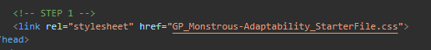

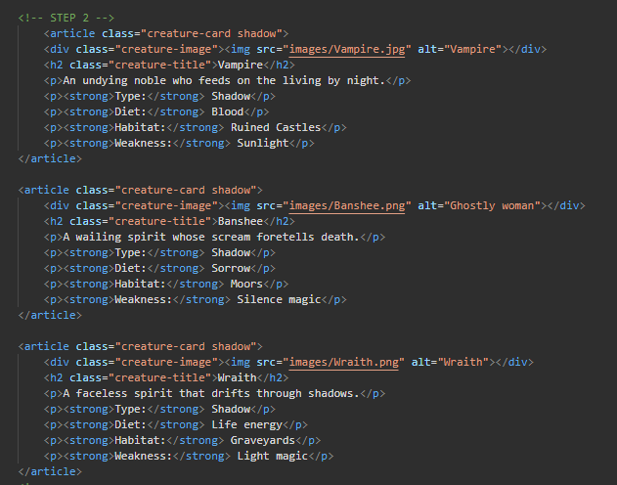

Screenshot 2: Completed CSS Code
Paste your screenshot below this line:
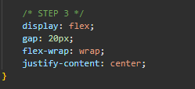
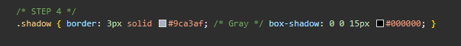

Image File Evidence
List the image files you added to the images folder. The file names listed here should match the file names used in your HTML image paths.
Creature Name | Image File Name | Alt Text Summary
Vampire | images/Vampire.jpg | Vampire
Wraith | images/Banshee.png | Wraith
Banshee | images/Wraith.png | Banshee

Rendered Web Page Evidence
Insert a screenshot of the completed web page as it appears in your browser. The bestiary should show the new creature cards, visible images, and a flexible layout that wraps or centers appropriately.

Screenshot 3: Rendered Web Page
Paste your screenshot below this line:
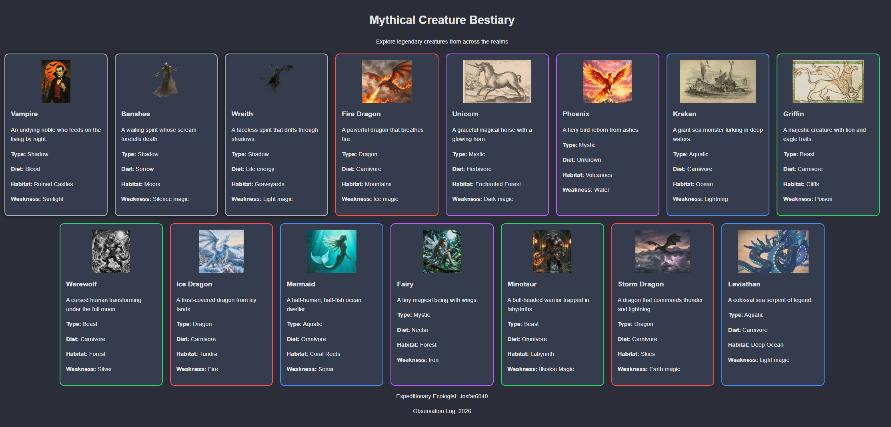

Reflection
1. How did Flexbox properties such as gap, flex-wrap, and justify-content help organize the bestiary layout?
Display: flex lined the cards up, gap added an even spacing between them, flex-wrap moved the cards into a new row once one filled up, justify-content: center centered each row

2. Why is it important for each creature image to have an accurate file path and meaningful alt text?
In case the images don’t render at least something will display and if the site doesn’t know where to get the image how would it show anything at all.

