Guided Practice - Legendary Layouts Lab Report
Use this template to document your work as you complete your assignment.

Your Information
Your Name: Joshua Farr
Assignment Title: Legendary Layouts
GitHub Repository: https://github.com/Benelisn/2.4-Legendary-Layouts/upload

Development Summary
Briefly describe the work you completed. In your response, mention the quest listings you added, how you linked the external CSS file, how CSS Grid changed the job board layout, and how the media query changed the layout on smaller screens.
I added 3 new quests Find Cat, Troll Dispute, Gather Herbs, each uses the same structure job-card. I linked the style sheet, CSS Grid was used to create 3 equal columns with a 25px gap making 9 cards into 3 rows of 3, Media query switches the gird to 1 column when using a screen with a max with of 768px.

Quest Listing Evidence
List the three new quests you added to the job board.
Quest Title | Quest Description Summary | Reward | Difficulty
Lost Cat | Find the runaway cat | 75 | Easy
Troll Bridge Toll Dispute | Convince the troll under the bridge to stop charging travelers | 150 | Medium
Gather Herbs | Gather 10 bloomberries from the woods to the south | 60 | Easy

Code Evidence
Insert screenshots that show the completed code for this assignment. Make sure your screenshots are readable and show the relevant completed step sections.

Screenshot 1: Completed HTML code
Paste your screenshot below this line:

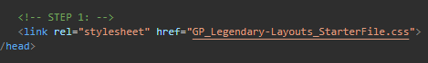

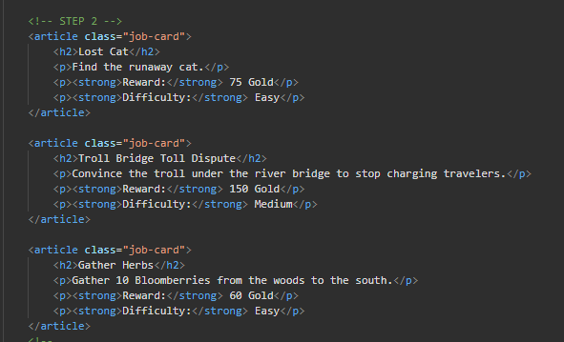

Screenshot 2: Completed CSS GridCode
Paste your screenshot below this line:
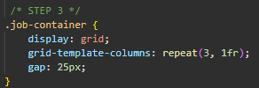

Screenshot 3: Completed Media Query Code
Paste your screenshot below this line:
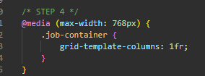

Rendered Web Page Evidence
Insert screenshots of the completed web page as it appears in your browser. Include one screenshot at a wider desktop size and one screenshot after resizing the browser window to a smaller/mobile width.

Screenshot 4: Desktop/Wide Layout
Paste your screenshot below this line:
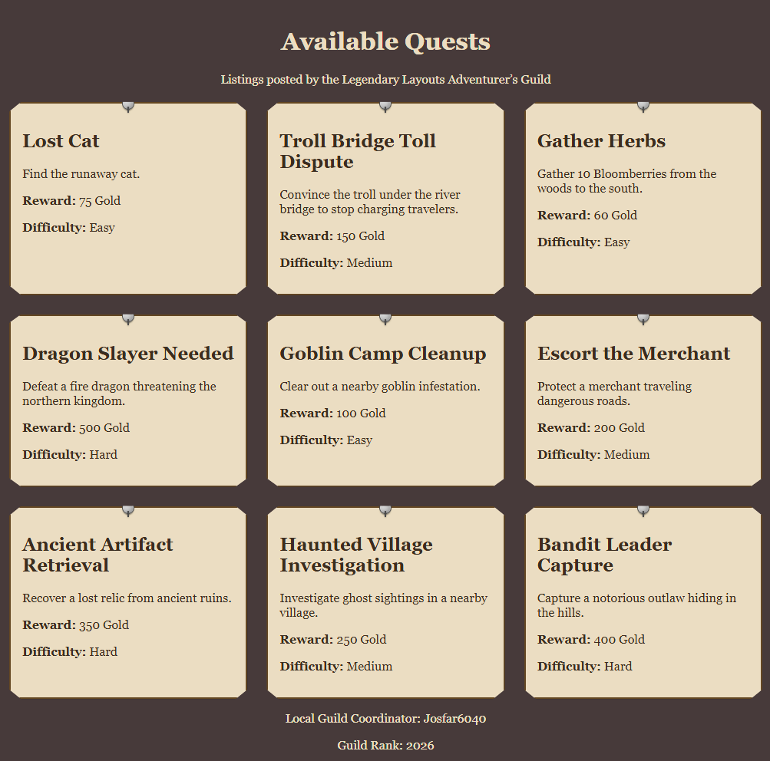

Screenshot 5: Mobile/Narrow Layout
Paste your screenshot below this line:
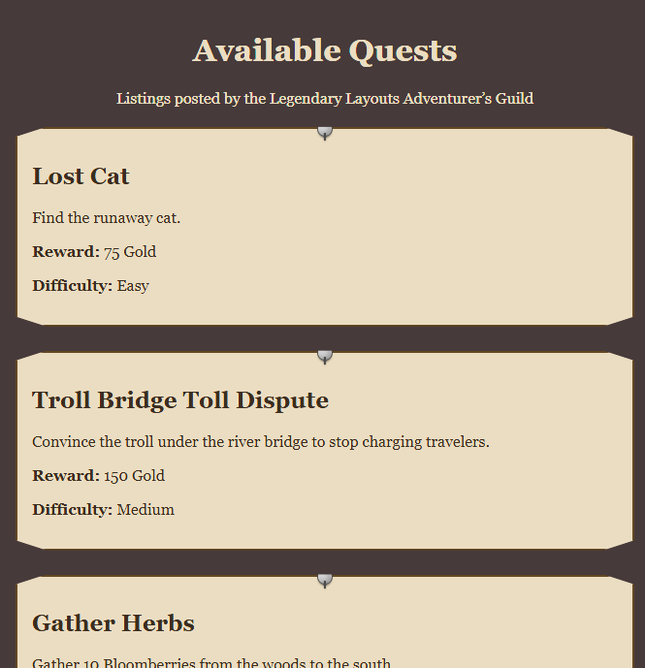

Responsive Design Check
1. What changed when you resize the browser window below the media query breakpoint?
The layout goes from 3 columns to 1 column
2. Why does changing grid-template-columns to 1fr improve readability on smaller screens?
Each card is stretched across the screen and stacked from top to bottom making it easy to see

Reflection
1. How did CSS Grid help organize the quest listings on the job board?
It placed the cards in even rows automatically repeat(3, 1fr) made columns equal width, so the cards line up well. Gap added consistent spacing between them, so it all looked organized.
2. How did the media query make the job board more responsive for smaller screens?
It checks the screen width and applies different rules based on it in this case if the max width was 768px or less. The same html works on phones and pcs so its convenient, and only overrides one property grid-tempalte-column

