Assessment – Responsive Recipes Lab Report
Use this template to document your work as you complete your assignment.

Your Information
Your Name: Joshua Farr
Assignment Title: Reponsive Recipes
GitHub Repository: https://github.com/Benelisn/2.5-Responsive-Recipes

Development Summary
Briefly describe the work you completed. In your response, mention the potion recipes you added, how you linked the external CSS file, whether you used Flexbox or CSS Grid, and how your media queries changed the layout for tablet and desktop screen sizes.

Potion Recipe Evidence
List the three additional potion recipes you added to the webpage. Each recipe should include a unique name, a brief effect description, and an ingredient table with quantities.
Potion Name | Effect Description Summary | Ingredients Included | Quantity Details Included?
Regeneration | Restores Health over time | Trolls Blood, Green moss, Phoenix Ash | 3 drops, 1 clump, 1 pinch
Mana | Restores Mana | Blue lotus petals, Moonwell water, Crushed Sapphire | 5 petals, 1 vial, 1 pinch
Stamina | Restores Stamina | Golden Wheat Grain, Wild Honey, Giant’s Toe Root | 1 handful, 2 spoonfuls, 1 sliced root

Layout and Responsiveness Evidence
- Did you use Flexbox or CSS Grid for the main layout? Explain why that layout method was appropriate for this recipe page.
CSS Grid works well because all these potions are the same type of content so even rows and columns works.
- What layout or spacing changes occur at the 768px breakpoint?
The layout goes from 1 column to 2.
- What layout or spacing changes occur at the 1024px breakpoint?
The layout goes from 2 columns to 3
- How did you confirm that the page remained readable across mobile, tablet, and desktop screen sizes?
  - I opened the html in a web browser then pressed F12 then ctrl+shift m to check how it would look on a phone

Code Evidence
Insert screenshots that show the completed code for this assignment. Make sure your screenshots are readable and show the relevant HTML and CSS requirements.

Screenshot 1: Completed HTML Code
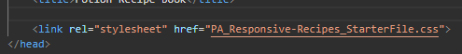
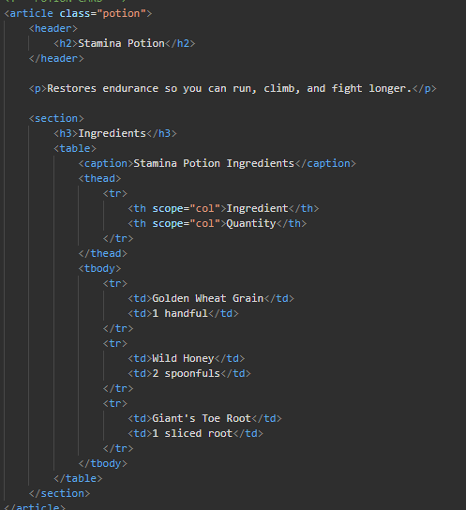
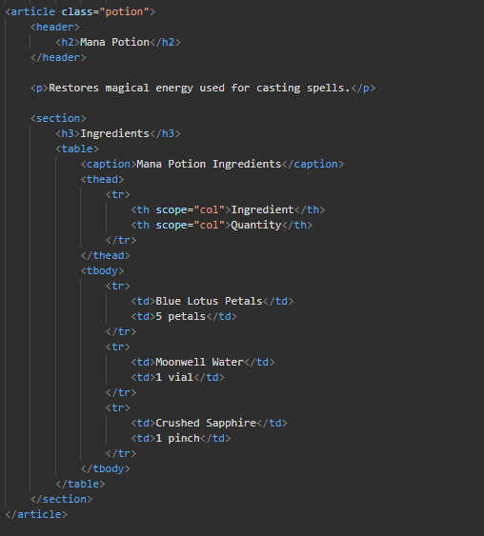
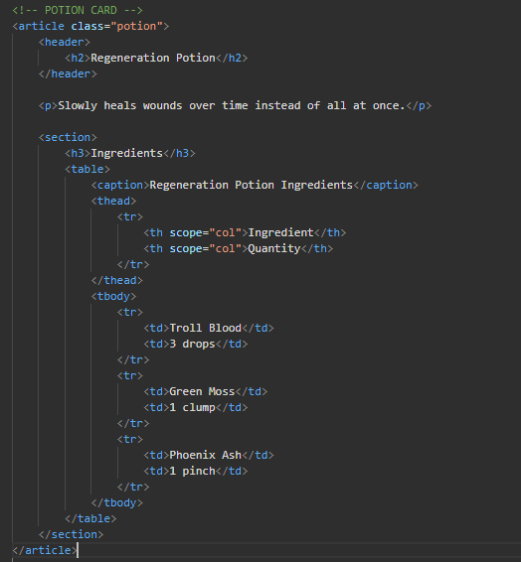

Screenshot 2 - Completed CSS Layout Code
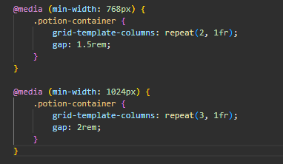

Screenshot 3 – Completed Media Query Code
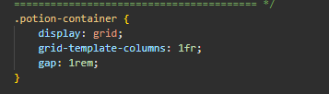

Rendered Web Page Evidence
Insert screenshots of the completed web page as it appears in your browser. Include evidence that the page adjusts for mobile, tablet, and desktop screen sizes.

Screenshot 4: Mobile/Narrow Layout
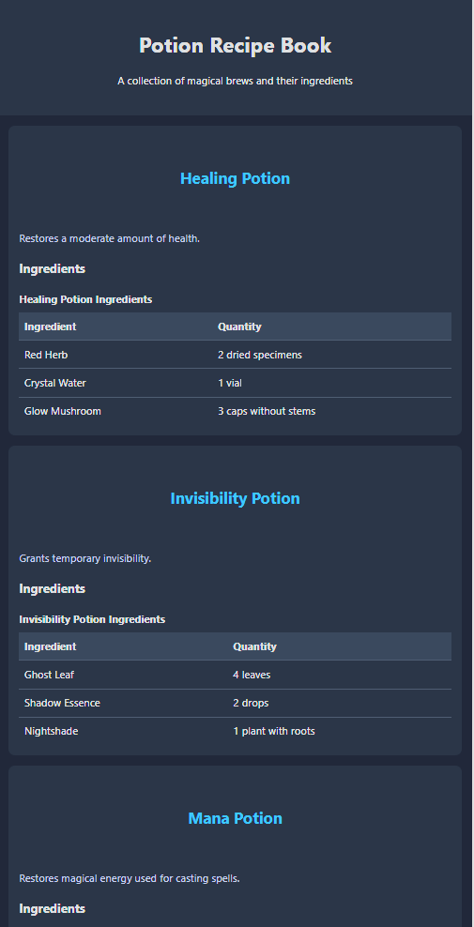

Screenshot 5 – Tablet Layout
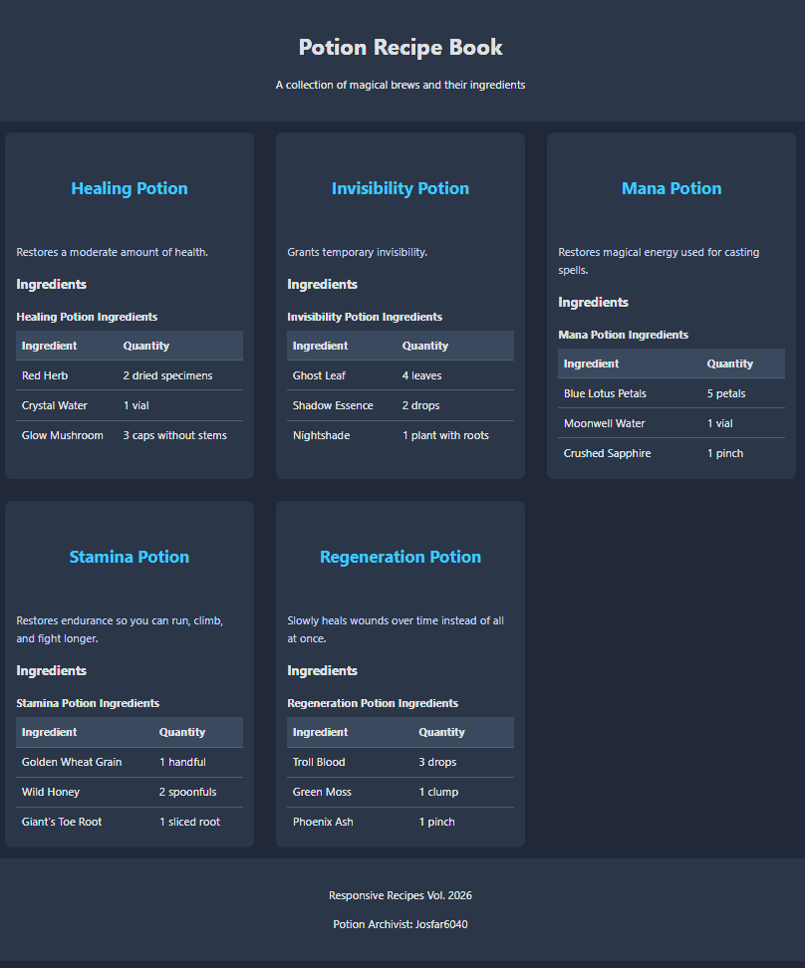

Screenshot 6 – Desktop/Wide Layout
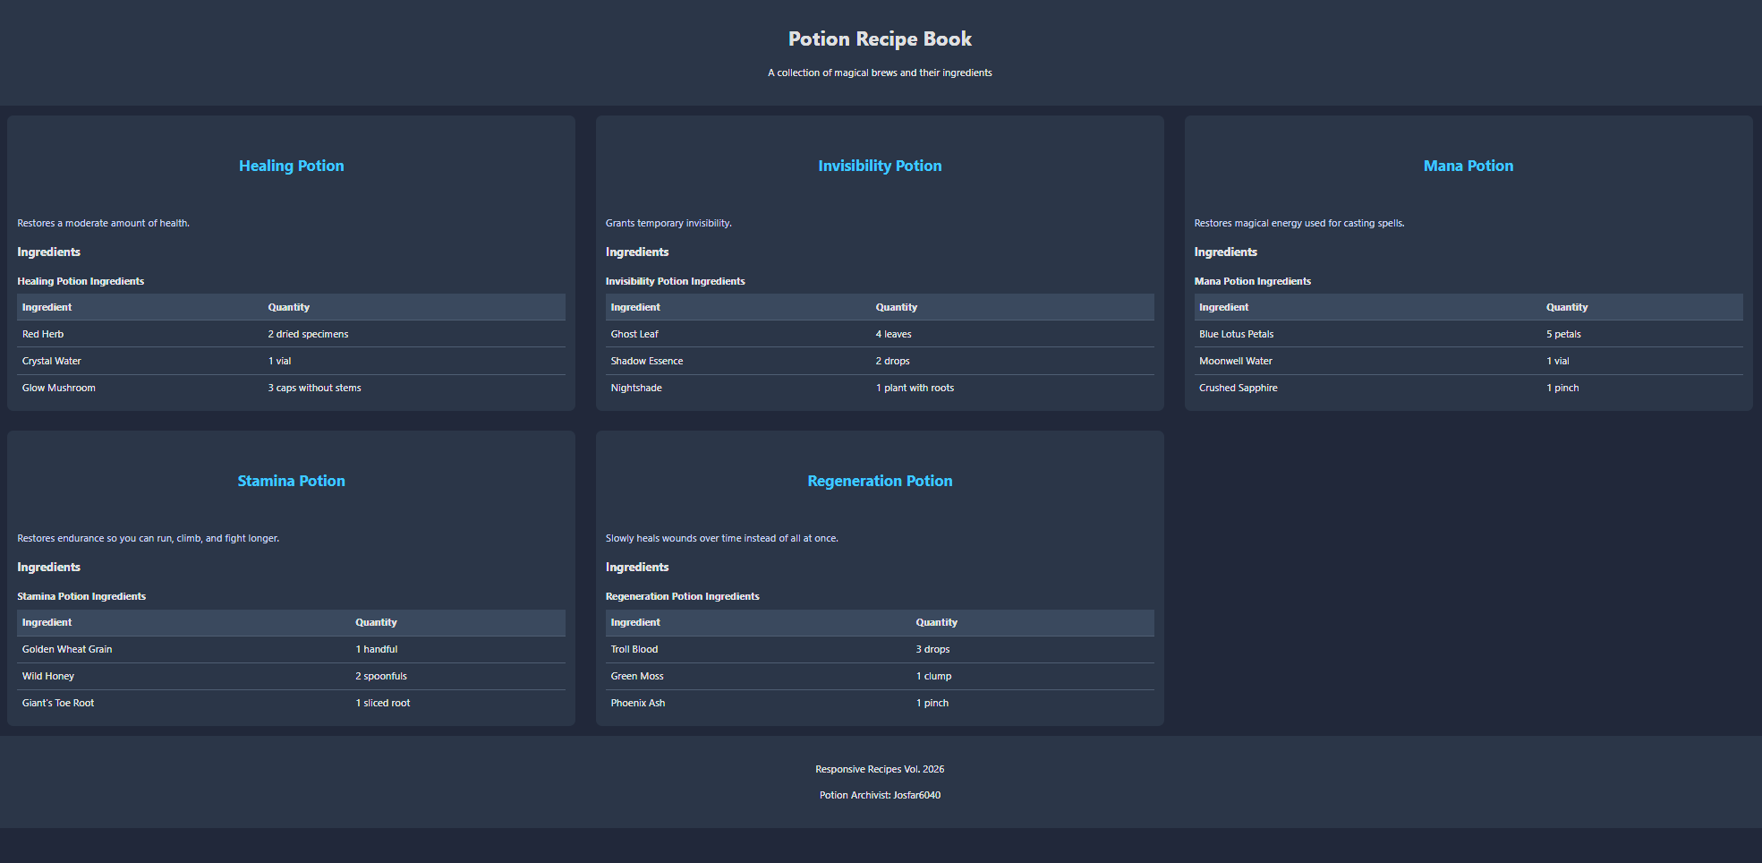

Reflection
Answer the reflection questions below in complete sentences.
1. What was the most challenging part of making the recipe page responsive?
I put the potion card inside another potion card which gave me just like 1 card with 4 potions, so I fixed that. That was the only issue I really ran into was just some basic syntax and sitting here looking at me screen thinking that’s not right. It was an easy enough fix though. I guess the only other thing I had to keep in mind was making sure the mobile (768px) rule came first so the 1024px rule can override it after, which is also simple but that means it can be easy to forget.
2. How did Flexbox or CSS Grid help organize the recipe content?
Grid placed the potions in even columns with equal width (1fr), gap kept consistent spacing
3. What would you improve about the page if you had more time?
I think the first and most meaningful thing I could change would be to simple add some pictures of each of the potions, after that I could maybe give them an accent color that would match the potion, but now that I think about it the most important thing I would add would be a search bar/ filter, when creating lists like this it’s easy to overwhelm the user I find and its annoying to have to scroll through everything just to find what I’m looking for.

