## Part A:

C语言标程用y86-64code翻译

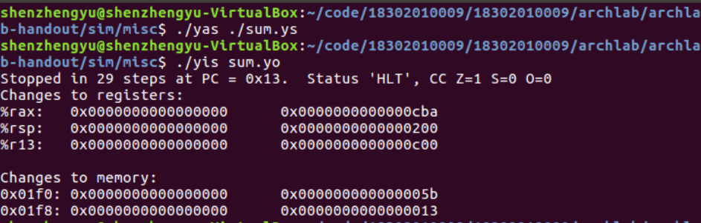

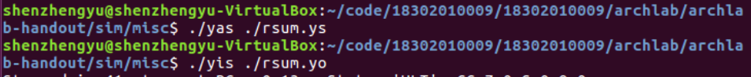

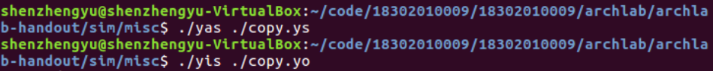

## Part B：

unix> ./ssim -t ../y86-code/asumi.yo



unix> (cd ../y86-code; make testssim)



unix> (cd ../ptest; make SIM=../seq/ssim) 

To test your implementation of iaddq:

unix> (cd ../ptest; make SIM=../seq/ssim TFLAGS=-i)



## PartC

