##Problem Statement:

A technology solution to enhance the training practice for the ‘on the job’ training level modules.

The modules focus on entering details into an online form from a physical or scanned document.

##Statistics:

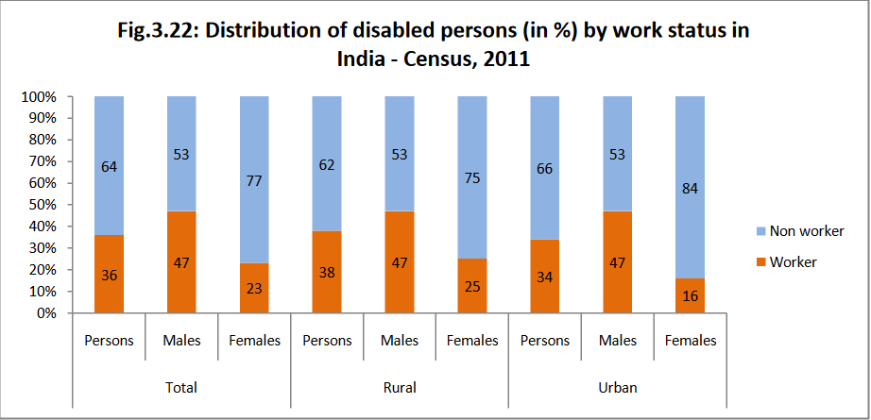

-In general, only a minority of disabled get the opportunity to work.

-Hence, training becomes an essential part of bridging this gap.

##Proposed Methodology:

Slide 1:

-Modular Approach.

-Increasing level-wise difficulty.

-Visual cue based questions

-Positive reinforcement through smilies(and possibly sound) and badges.

Slide 2:

-Intensive guided practice of different formats.

-Monitoring capability through admin panel(just mention)

Admin panel will help the instructor in getting the overview of(No need)

Strengths & weaknesses.

-Screenshots of admin panel.

##Future prospects:

-Introduction of avatar.

-Catering learning needs of other kinds of disability.

-Better analytics for focused and effective teaching.

##Quotes:

There is a plan and a purpose, a value to every life, no matter what its location, age, gender or disability. Sharron Angle

[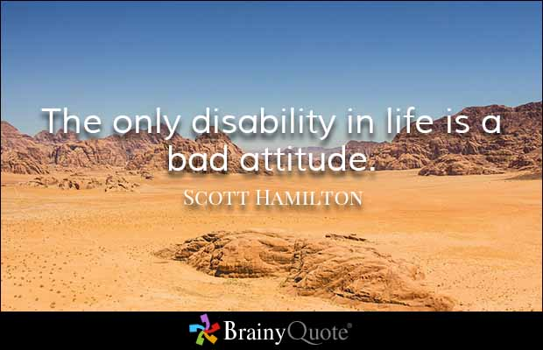](https://www.brainyquote.com/quotes/authors/s/scott_hamilton.html)

The only disability in life is a bad attitude.

##Team details.