Final Year Design Project

Hand and Eye Controlled Human Computer

Interaction System



By

Sundas Safdar 2022-kkw-91
Benish Batool 2022-kkw-82
Pakiza Imran 2022-kkw-88
Under the supervision of
Prof. Marsad Akbar

Bachelor of Science in INFORMATION TECHNOLOGY (2022-2026)
FACULTY OF COMPUTING &
INFORMATION TECHNOLOGY (FCIT),
GOVT.GRADUATE COLLEGE FOR WOMEN, KAMOKE

Hand and Eye Controlled Human Computer
Interaction System

A project presented to

University of the Punjab, Lahore

In partial fulfilment of the requirement for the degree of

Bachelor of Science in INFORMATION TECHNOLOGY (2022-2026)

By

Sundas Safdar 2022-kkw-91
Benish Batool 2022-kkw-82
Pakiza Imran 2022-kkw-88

FACULTY OF COMPUTING &
INFORMATION TECHNOLOGY (FCIT),
GOVT.GRADUATE COLLEGE FOR WOMEN, KAMOKE.

DECLARATION
We hereby declare that this software, neither whole nor as a part, has been copied out from any source. It is further declared that we have developed this software and the accompanying report entirely on the basis of our personal efforts. If any part of this project is proved to be copied out from any source, or found to be a reproduction of some other work, we will stand by the consequences. No portion of the work presented has been submitted in support of any application for any other degree or qualification of this or any other university or institute of learning.

Signature: ______________________  Sundas Safdar [2022-kkw-91] | Signature: ______________________  Benish Batool [2022-kkw-82]
Signature: ______________________
Pakiza Imran [2022-kkw-88]

CERTIFICATE OF APPROVAL
It is to certify that the final year design project (FYDP) of BSIT "Hand and Eye Controlled Human Computer Interaction System" was developed by Sundas Safdar (2022-kkw-91), Benish Batool (2022-kkw-82) and Pakiza Imran (2022-kkw-88), under the supervision of "Prof. Marsad Akbar". In my opinion, it is fully adequate, in scope and quality, for the degree of Bachelor of Science in Information Technology.

Signature: ______________________
FYDP Supervisor: Prof. Marsad Akbar
Table 1: Signatures (Faculty Advisory Committee - FAC)
Signatures
Name
 | FAC1 | FAC2 | FAC3

Signature: ______________________
Head of FYDP Coordination Office:
Signature: ______________________ Dated: ______________________
Chairperson, Department of Information Technology

Executive Summary
This project is about making a system that lets people control their computer without using a mouse or keyboard. Instead, they can use their hand movements and eye gaze to do things like move the cursor, click, and scroll.
We built this system using Python, OpenCV, and Google MediaPipe. The webcam watches the user's hand and face in real time. When the user moves their hand, the cursor moves on screen. When they make a specific gesture, it performs a click or scroll. The eye gaze is also tracked and combined with hand movement to make the cursor more accurate.
This system is very useful for people who have trouble using traditional input devices because of physical disabilities or injuries. It is also helpful in places like hospitals where touching devices is not ideal. Unlike expensive eye-tracking hardware, our system only needs a normal webcam. The system was tested and it works well under normal lighting. Gesture recognition accuracy is around 90%. The system responds in less than 100 milliseconds which makes it feel smooth and natural to use. In addition to the desktop application, the project also includes a web portal from which users can download the application and share feedback.

Acknowledgement
We are very thankful to Allah for giving us the strength and ability to complete this project. We are also grateful to our families for always supporting us during our studies.
We want to specially thank our project supervisor, Prof. Marsad Akbar, for guiding us throughout this project. His feedback and suggestions helped us improve our work a lot.
We also thank the faculty of the Department of Information Technology for providing us the resources and support we needed.

Signature: ______________________
Sundas Safdar [2022-kkw-91]
Signature: ______________________
Benish Batool [2022-kkw-82]
Signature: ______________________
Pakiza Imran [2022-kkw-88]

Abbreviations
Table of all the abbreviations and acronyms used in this FYP, along with their respective brief descriptions.
Short form | Full Meaning
AI | Artificial Intelligence
HCI | Human-Computer Interaction
CV | Computer Vision
FPS | Frames Per Second
GUI | Graphical User Interface
IDE | Integrated Development Environment
EMA | Exponential Moving Average
API | Application Programming Interface
RSI | Repetitive Strain Injury
FR | Functional Requirement
NFR | Non-Functional Requirement
UC | Use Case
SRS | Software Requirements Specification
FYDP | Final Year Design Project
UML | Unified Modeling Language
ER | Entity Relationship
EAR | Eye Aspect Ratio
MVC | Model-View-Controller
DCD | Design Class Diagram
RTM | Requirements Traceability Matrix
CPU | Central Processing Unit
RAM | Random Access Memory
GPU | Graphics Processing Unit
IEEE | Institute of Electrical and Electronics Engineers
PHP | Hypertext Preprocessor
JS | JavaScript

Table of Contents
DECLARATION 2
CERTIFICATE OF APPROVAL 3
Executive Summary 4
Acknowledgement 5
Abbreviations 6
Table of Contents 7
List of Figures 12
List of Tables 13
Chapter 1 14
Introduction 14
1.1 Problem Statement 14
1.2 Problem Solution 15
1.3 Objectives of the Proposed System 15
1.4 Scope 15
1.5 System Components 15
1.5.1 Camera Thread 15
1.5.2 Hand Tracker 16
1.5.3 Eye Tracker 16
1.5.4 EMA Smoother 16
1.5.5 Sensor Fusion 16
1.5.6 Action Dispatcher 16
1.5.7 Processing Engine 16
1.5.8 GUI 16
1.5.9 Web Portal 16
1.6 Related System Analysis / Literature Review 16
1.6.1 Commercial Gesture Control Devices (Leap Motion, Microsoft Kinect) 16
1.6.2 Eye-Tracking Software (Tobii Eye Tracker, GazeRecorder) 17
1.6.3 Research in Multimodal HCI 17
1.6.4 AI-Driven Computer Vision Libraries (MediaPipe, OpenPose) 17
1.6.5 Why This Hand and Eye Control System? 18
1.7 Vision Statement 18
1.8 System Limitations and Constraints 19
Limitations 19
Constraints 19
1.9 Tools and Technologies 19
1.10 Project Deliverables 20
1.11 Project Planning 21
1.12 Summary 21
Chapter 2 22
Requirements Analysis 22
2.1 User Classes and Characteristics 22
2.2 Requirement Identifying Technique 22
2.3 Functional Requirements 22
2.4 Non-Functional Requirements 28
2.5 User Interface Requirements 28
2.5.1 Software Interfaces 28
2.5.2 Hardware Interfaces 28
2.5.3 Communications Interfaces 29
2.6 Use Cases 29
2.7 Summary 32
Chapter 3 34
Design and Architecture 34
Design Constraints 34
User Assumptions 34
3.1 Design Considerations 34
Limitations 34
3.2 Risks and Risk Analysis 35
3.3 Design Models 35
3.3.1 Context Diagram (Level 0) 35
3.3.2 Design Class Diagram (DCD) 37
3.3.3 Sequence Diagram (Primary Flow) 37
3.4 Architectural Design 38
3.4.1 UML Class Relationship Diagram 38
3.4.2 UML Component Diagram 39
3.4.3 Layered Architecture 40
3.4.4 MVC Architecture 41
3.5 Data Design 41
3.5.1 ER Diagram 41
3.5.2 Database Schema (Configuration Storage) 42
3.5.3 Data Dictionary 43
3.6 User Interface Design 43
3.6.1 Screen Images 44
3.6.2 Screen Objects and Actions 45
3.7 Behavioral Model 47
3.7.1 State Transition Diagram 47
3.8 Design Decisions 47
3.9 Summary 48
Chapter 4 50
Implementation 50
4.1 Algorithms 50
4.1.1 Hand Gesture Classification 50
4.1.2 Eye Gaze Estimation 51
4.1.3 Blink Detection using Eye Aspect Ratio (EAR) 51
4.1.4 Multimodal Cursor Fusion and Filtering 52
4.1.5 Rising-Edge Click Detection 52
4.1.6 Dwell Click Detection 53
4.2 External APIs / SDKs 53
4.3 Code Repository 54
4.3.1 Metrics of the Git Repository 54
4.4 Summary 55
Chapter 5 56
Testing and Evaluation 56
5.1 Unit Testing (UT) 56
5.2 Functional Testing (FT) 57
5.3 Integration Testing (IT) 57
5.4 Performance Testing (PT) 58
5.5 Usability Evaluation 59
5.6 Summary 59
Chapter 6 61
System Conversion and Deployment 61
6.1 Conversion Method 61
6.2 Deployment 61
6.2.1 Web Portal Deployment 62
6.2.2 Data Conversion 62
6.2.3 Training 62
6.3 Post Deployment Testing 62
6.4 Challenges 63
6.5 Summary 64
Chapter 7 65
Conclusion 65
7.1 Evaluation 65
7.2 Requirements Traceability Matrix (RTM) 65
7.3 Conclusion 66
7.4 Future Work 66
References 68
Appendix A: Use Case Description (Fully Dressed Format) 69
Appendix B: General Coding Standards & Guidelines 81
Coding Standards 81
Appendix C: Application Prototype 81
Appendix D: Mermaid Source Code for Diagrams 83
Figure 1: Use Case Diagram 83
Figure 2: Context Diagram (Level 0) 83
Figure 3: UML Class Diagram 84
Figure 4: Sequence Diagram (Primary Flow) 85
Figure 5: UML Class Relationship Diagram 85
Figure 6: UML Component Diagram 86
Figure 7: ER Diagram 86
Figure: State Transition Diagram 87

List of Figures
Figure 1: Use Case Diagram 32
Figure 2: Context Diagram (Level 0) 36
Figure 3: UML Class Diagram 37
Figure 4: Sequence Diagram (Primary Flow) 38
Figure 5: UML Class Relationship Diagram 39
Figure 6: UML Component Diagram 40
Figure 7: ER Diagram 42
Figure 8: Main Screen Layout 44
Figure 9: Calibration Panel 44
Figure 10: Camera Setup Panel 45
Figure 11: Gestures Mapping List 45
Figure 12: State Transition Diagram 47
Figure 13: System Control Dashboard 81
Figure 14: Real-time Hand and Eye Landmark Tracking 82

List of Tables
Table 1: Signatures (Faculty Advisory Committee - FAC) 3
Table 2: Related System Analysis with Proposed Project Solution 20
Table 3: Tools and Technologies for Proposed Project 21
Table 4: Project Planning 23
Table 5: User Class and Characteristics 24
Table 6: Functional Requirement_1 24
Table 7: Functional Requirement_2 25
Table 8: Functional Requirement_3 25
Table 9: Functional Requirement_4 25
Table 10: Functional Requirement_5 26
Table 11: Functional Requirement_6 26
Table 12: Functional Requirement_7 26
Table 13: Functional Requirement_8 27
Table 14: Functional Requirement_9 27
Table 15: Functional Requirement_10 27
Table 16: Functional Requirement_11 28
Table 17: Functional Requirement_12 28
Table 18: Functional Requirement_13 28
Table 19: Functional Requirement_14 29
Table 20: Functional Requirement_15 29
Table 21: Functional Requirement_16 29
Table 22: Non-Functional Requirements 30
Table 23: Use Case_1 31
Table 24: Use Case_2 31
Table 25: Use Case_3 31
Table 26: Use Case_4 31
Table 27: Use Case_5 32
Table 28: Use Case_6 32
Table 29: Use Case_7 32
Table 30: Use Case_8 32
Table 31: Use Case_9 32
Table 32: Use Case_10 33
Table 33: Use Case_11 33
Table 34: Use Case_12 33
Table 35: Risks and Mitigation Strategies 37
Table 36: Context Diagram - System Component Inputs and Outputs 38
Table 37: Layered Architecture with Responsibilities 42
Table 38: MVC Architecture 43
Table 39: Data Dictionary 45
Table 40: Screen Objects and Actions 47
Table 41: System Settings Panel (All Parameters) 48
Table 42: Settings Panel - Actions 48
Table 43: Key Design Decisions and Justifications 49
Table 44: Details of APIs Used in the Project 55
Table 45: Git Repository Metrics 56
Table 46: Unit Testing Results 58
Table 47: Functional Testing Results 59
Table 48: Integration Testing Results 60
Table 49: Performance Testing Results 60
Table 50: Usability Evaluation 61
Table 51: Conversion Methods 63
Table 52: Step by Step Deployment Guide 63
Table 53: User Training Steps 64
Table 54: Post Deployment Testing 64
Table 55: Deployment Challenges and Solutions 65
Table 56: Objectives Evaluation 67
Table 57: Requirements Traceability Matrix (RTM) 67
Table 58: Future Work and Improvements 68
Table 59: Use Case Description - UC-01 Start System 71
Table 60: Use Case Description - UC-02 Move Cursor with Hand 72
Table 61: Use Case Description - UC-03 Left Click - V Sign 73
Table 62: Use Case Description - UC-04 Right Click - Pinch 74
Table 63: Use Case Description - UC-05 Scroll with All Fingers 75
Table 64: Use Case Description - UC-06 Stop Cursor - Fist 76
Table 65: Use Case Description - UC-07 Blink Click 77
Table 66: Use Case Description - UC-08 Adjust Settings 77
Table 67: Use Case Description - UC-09 Eye Calibration 78
Table 68: Use Case Description - UC-10 Dwell Click 79
Table 69: Use Case Description - UC-11 Download Application from Web Portal 80
Table 70: Use Case Description - UC-12 Submit Feedback on Web Portal 81

Chapter 1

Introduction

Introduction
Computers have changed a lot with time. In the past, people used punch cards and difficult commands to use computers. Later, the mouse and keyboard made computer use easier. Now, technology is moving towards new ways of controlling computers without touching them.
This project is about a Human-Computer Interaction (HCI) system. It allows a user to control a computer by using hand gestures and eye movements. A normal webcam is used to capture the user's hand and eye movements.
The system can perform different actions such as moving the cursor, clicking, and scrolling without using a mouse or keyboard. The system uses computer vision and machine learning to understand the user's movements and perform the required action.
This project can be useful for people who have difficulty using a mouse or keyboard. It can also be useful in hospitals and other places where touching devices is not suitable. It can make computer use easier, simple, and more comfortable.
The main purpose of this project is to provide an easy and touch-free way to control a computer using hand gestures and eye movements. Alongside the desktop application, the project also provides a companion web portal where users can learn about the project, download the application, and submit feedback.

1.1 Problem Statement
Mouse and keyboard are the most common devices used to control a computer. However, some people find it difficult to use them because they need hand movement and physical contact. People with motor problems, arthritis, or hand injuries may have difficulty using these devices.
Using a shared mouse and keyboard can also be a problem in places like hospitals and laboratories because different people touch the same devices.
There is a need for a system that can control a computer without touching a mouse or keyboard. Voice control is one option, but it may not always understand the user correctly. Eye-tracking devices are another option, but they can be very expensive.
This project provides a simple solution by using a normal webcam, hand gestures, and eye movements to control the computer. It uses software tools to make this system affordable and easy to use.

1.2 Problem Solution
We built a system that uses two inputs together: hand gestures and eye gaze. The hand is used to perform actions like clicking and scrolling. The eye gaze is used to help point the cursor in the right direction. Together they make a complete contactless mouse system.

1.3 Objectives of the Proposed System
- To develop a hand gesture recognition module that detects Move, Click, Scroll, and Stop gestures with at least 90% recognition accuracy using a standard webcam.
- To develop an eye gaze tracking module that estimates cursor position and supports eye blink as a Left Click command for touch-free interaction.
- To integrate hand gesture recognition and eye gaze tracking through a Sensor Fusion Engine to provide smooth, accurate, and natural cursor control while maintaining a system latency of less than 100ms.
- To develop a user-friendly PyQt5 graphical interface that displays the live camera feed, system status, and allows users to adjust sensitivity, smoothing, and calibration settings.
- To implement the complete system using Python, OpenCV, MediaPipe, PyQt5, and PyAutoGUI on Windows 10/11, without requiring any dedicated eye-tracking or gesture-sensing hardware other than a standard webcam.
- To develop a companion web portal that lets users learn about the project, download the desktop application, and submit feedback, supported by a simple admin panel.
- To evaluate the system by testing its gesture recognition accuracy, response time, and usability, and refine the system based on feedback from the project supervisor and test users.
- To complete the design, implementation, testing, documentation, and evaluation of the proposed system within the Semester VII-VIII Final Year Project schedule, while considering practical constraints such as webcam quality, lighting conditions, and available hardware resources.

1.4 Scope
This project is built for Windows 10/11 only. It uses a standard USB webcam as input. The system supports cursor movement, left click, right click, stop, and scrolling. A basic GUI is provided for settings and calibration. The system is tested under normal room lighting. The scope also includes a lightweight web portal through which the application can be downloaded and user feedback can be collected.
The following are outside the scope of this project: macOS and Linux support, specialized hardware like depth cameras, and multi-user tracking.

1.5 System Components

1.5.1 Camera Thread
Captures webcam frames in a separate thread so the GUI does not freeze. It supports 30 FPS, 640x480 resolution, and auto-flips the frame.

1.5.2 Hand Tracker
Uses MediaPipe Hands to detect 21 hand landmarks. Classifies gestures like move (index up), click (V sign), right click (pinch), scroll (all fingers up), and stop (fist).

1.5.3 Eye Tracker
Uses MediaPipe Face Mesh with iris detection. Tracks iris center to estimate gaze direction. Also detects blinks for click action. Calibration sliders map iris position to screen coordinates.

1.5.4 EMA Smoother
Uses Exponential Moving Average to remove jitter from hand and eye tracking. Alpha value controls how fast or smooth the cursor is.

1.5.5 Sensor Fusion
Combines hand and eye data using a weighted average. Default is 75% hand and 25% eye. Includes a dwell-click feature for users who cannot make quick gestures.

1.5.6 Action Dispatcher
Takes the fused output and calls PyAutoGUI to move the cursor, click, right-click, or scroll. Uses a cooldown timer to prevent accidental double clicks.

1.5.7 Processing Engine
Runs all modules together in a QThread so the GUI stays responsive. Sends camera frames and status updates to the GUI using signals.

1.5.8 GUI
Dark-themed PyQt5 interface. Shows live camera feed, stat cards for FPS/gesture/action, settings sliders, calibration panel, and gesture reference guide.

1.5.9 Web Portal
The web portal provides a public website where users can learn about the project, download the application, and share their feedback. It also includes an admin portal for monitoring downloads, reviewing user feedback, and managing website content. It is built using HTML, CSS, JavaScript and PHP.

1.6 Related System Analysis / Literature Review
A review of existing technologies and research is necessary to understand where this project fits in the broader field of Human-Computer Interaction (HCI). This section reviews the main related systems and academic research.

1.6.1 Commercial Gesture Control Devices (Leap Motion, Microsoft Kinect)
Leap Motion is a device that uses cameras to detect and track hand and finger movements. It has been used in VR and different research projects. Microsoft Kinect was another device that used a special camera to detect body and hand movements. However, Kinect is no longer available as a normal consumer product.
Both devices can track movements accurately, but they need special hardware, which can be expensive. They mainly focus on hand and body gestures and do not provide both hand gesture and eye gaze control together.
Our system is different because it only needs a normal webcam. No extra device is required. This makes our system cheaper, easier to use, and more suitable for normal computer users.

1.6.2 Eye-Tracking Software (Tobii Eye Tracker, GazeRecorder)
Tobii Eye Trackers are professional hardware eye-tracking devices that are built into some laptops and monitors. They are highly accurate but cost hundreds of dollars. They are mainly used in gaming, accessibility research, and UI testing. Open-source projects like GazeRecorder and webcam-based gaze estimation research have tried to replicate this using software, but they still need careful setup and have limited accuracy compared to dedicated hardware.
Our system uses MediaPipe Face Mesh iris landmarks for gaze estimation with just a standard webcam. It is less precise than Tobii hardware but far more accessible and does not require any extra purchase or installation.

1.6.3 Research in Multimodal HCI
Academic research has long explored combining multiple input methods for more natural and efficient control. Notable work includes the MAGIC (Manual And Gaze Input Cascaded) pointing concept by Zhang et al. (2020), which explored using eye gaze for coarse cursor placement combined with manual input for fine control and confirmation.
Our system extends this general philosophy into a fully software-based solution. We use eye gaze for directional guidance and hand gestures for precise actions, inspired by the MAGIC-style combination of gaze and manual input, but implemented as a weighted sensor-fusion of hand and eye coordinates rather than the original cascaded-pointing technique. Instead of the specialized hardware used in earlier multimodal HCI studies, we rely on real-time MediaPipe AI models running on a standard webcam, making the same philosophy practical for everyday users.

1.6.4 AI-Driven Computer Vision Libraries (MediaPipe, OpenPose)
Google MediaPipe and OpenPose are two of the most widely used real-time AI frameworks for detecting human body landmarks. OpenPose is very accurate for full-body tracking but is computationally heavy and difficult to run in real time on standard hardware. MediaPipe is specifically designed for efficiency on consumer devices and provides the Hands and Face Mesh solutions that are well suited for our needs.
We chose MediaPipe because it runs in real time on a standard laptop, provides 21 hand landmarks and 468 face mesh landmarks including iris tracking, is free and open source, and integrates easily with Python and OpenCV. On its own, MediaPipe is just a library. Our project turns it into a complete working HCI system with GUI, calibration, sensor fusion, and OS control.

1.6.5 Why This Hand and Eye Control System?
While gesture control and eye gaze tracking have both been studied individually, this project's novelty is in combining them together in a practical, software-only system. Previous academic work either used expensive hardware or focused only on algorithmic results without building a complete working application. Commercial solutions like Tobii are too expensive for general use.
Our system fills this gap by delivering a unified, real-time, user-friendly interface that requires only a standard webcam, and lets users perform everyday computer tasks completely hands-free.
Table 2: Related System Analysis with Proposed Project Solution
Application Name | Weakness | Proposed Project Solution
Hands Free Windows Control System | Supports limited gesture controls, provides less accurate cursor movement, and does not effectively combine multiple input methods for reliable interaction. | The proposed system combines hand gestures and eye gaze tracking through a Sensor Fusion Engine to provide smoother cursor movement. It supports Move, Click, Scroll, Stop, and Eye Blink as Click, resulting in improved accuracy and usability.
Leap Motion (Gesture SDK) | Requires an additional infrared sensor device; does not track eye gaze at all; mainly aimed at VR/research use rather than everyday desktop control. | Our system needs no extra hardware beyond a standard webcam and combines hand gestures with eye gaze for a complete contactless mouse replacement.
Tobii Eye Tracker (consumer) | Dedicated eye-tracking hardware costs hundreds of dollars; hand gestures are not supported at all. | Our system reaches comparable gaze-based pointing using only MediaPipe iris landmarks on a normal webcam, at no extra hardware cost, and adds hand-gesture actions on top.

1.7 Vision Statement
For computer users, individuals with motor impairments, healthcare professionals, and anyone seeking a touch-free way to interact with a computer,
Who need an affordable, accurate, and contactless alternative to traditional mouse and keyboard input,
The Hand and Eye Controlled HCI System is a Human-Computer Interaction (HCI) application,
That enables users to control the computer using hand gestures and eye gaze through a standard webcam, providing smooth cursor movement, gesture-based commands, and improved accessibility without requiring specialized hardware,
Unlike conventional input devices and expensive eye-tracking systems that depend on physical contact or dedicated hardware,
Our product combines hand gesture recognition and eye gaze tracking through a sensor fusion approach, along with a companion web portal, to provide a low-cost, user-friendly, and accessible solution for touch-free computer interaction.

1.8 System Limitations and Constraints
The proposed system has some limitations and constraints that may affect its performance and use.

Limitations
- The system needs a working webcam to detect hand and eye movements. If the webcam is already being used by another application, the system cannot access it and will display a camera error. The user must close the other application first.
- Poor lighting can affect the detection of hand gestures and eye movements.
- The system may not work properly if the user's face or hands are not clearly visible to the camera.
- The accuracy may decrease when the user moves too fast.
- The system depends on the performance of the computer. A low-performance computer may cause slow response.
- The system is mainly designed for Windows computers.
- The system requires users who cannot move their hands at all to rely on eye-only gaze control combined with the dwell-click feature, which is slower than hand-based gestures.

Constraints
- The project is limited to basic computer controls such as cursor movement, clicking, scrolling, and stop action.
- The system uses a normal webcam instead of expensive eye-tracking or special gesture devices.
- The project uses available software and free/open-source tools.
- The project focuses on desktop computer control and does not cover all types of devices.
- The development time and available resources limit the number of features that can be added to the system.

1.9 Tools and Technologies
The following tools and technologies are used in the implementation of this project, along with their versions and the rationale for their selection:
Table 3: Tools and Technologies for Proposed Project
Tools and Technologies | Tool | Version | Rationale
Tools and Technologies | Python | 3.11 | Selected as the primary programming language because it provides extensive library support and enables rapid development of computer vision applications. Python 3.11 was chosen specifically because MediaPipe 0.10.21 has DLL load failures on Python 3.12 on Windows.
Tools and Technologies | OpenCV | 4.8.1.78 | Used for capturing webcam video, processing image frames, and performing real-time computer vision operations.
Tools and Technologies | MediaPipe | 0.10.21 | Used to detect hand landmarks and iris landmarks for gesture recognition and eye gaze tracking.
Tools and Technologies | PyAutoGUI | 0.9.54 | Used to control mouse movements and perform actions such as clicking, scrolling, and keyboard input based on user gestures.
Tools and Technologies | PyQt5 | 5.15.10 | Used to develop the graphical user interface, including the camera preview, settings panel, and system status display.
Tools and Technologies | NumPy | 1.26.2 | Used for numerical computations and efficient processing of coordinate and image data.
Tools and Technologies | pywin32 | 306 | Used to access Windows-specific APIs for improved system integration and operating system interactions.
Tools and Technologies | Visual Studio Code | Latest | Used as the integrated development environment (IDE) for coding, debugging, and managing the project files.
Tools and Technologies | Git | Latest | Used for version control to track source code changes and maintain the project throughout development.
Tools and Technologies | HTML / CSS / JavaScript | Latest (HTML5/ES2020) | Used to build the front-end pages of the web portal (project information, download page, feedback form).
Tools and Technologies | PHP | 8.x | Used on the server side of the web portal to handle feedback submission, download tracking, and the admin panel.

1.10 Project Deliverables
- Project Proposal containing the problem statement, objectives, scope, feasibility analysis, and project planning.
- Software Requirements Specification (SRS) documenting the functional and non-functional requirements, use cases, system constraints, and software specifications.
- System Design Document including the system architecture, UML diagrams, database design, workflow diagrams, and module descriptions.
- User Interface Prototype consisting of the GUI design, settings panel, camera preview, web portal interfaces, and navigation screens.
- Working Software Application that provides contactless computer control using hand gestures and eye gaze, along with a graphical user interface and integrated web portal for software downloads and user feedback.
- Testing and Evaluation Report containing functional testing, performance evaluation, gesture recognition accuracy, latency measurements, usability testing, and identified limitations.
- Final Project Report documenting the complete project, including design decisions, implementation details, testing results, conclusions, and future recommendations.
- Project Source Code and Documentation containing the complete source code, installation guide, user manual, and technical documentation for future maintenance.

1.11 Project Planning
Table 4: Project Planning
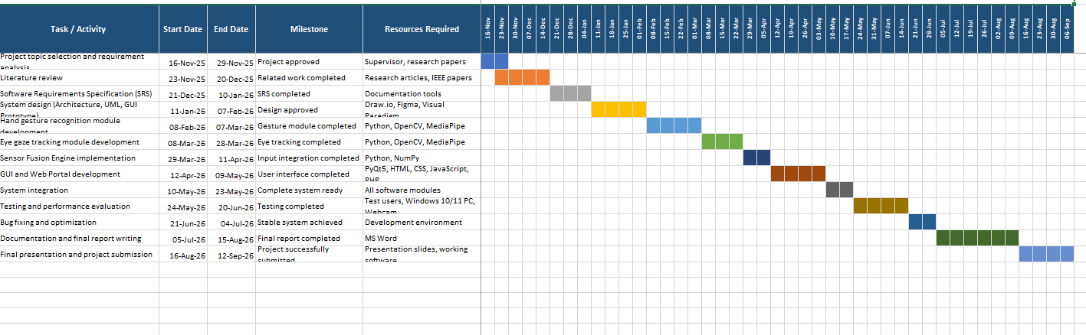

1.12 Summary
This chapter established the full foundation for the Hand and Eye Controlled HCI project. The problem of inaccessible traditional input devices was identified. A software-only solution using webcam-based hand gesture recognition and eye gaze tracking was proposed, along with a supporting web portal. The objectives, scope, system modules, literature review, tools, timeline, limitations, and constraints were all defined. The next chapter covers the detailed requirements analysis for the system.

Chapter 2

Requirements Analysis

2. Analysis
In this chapter we describe how the requirements for the system were identified. Requirements were gathered through discussions with the project supervisor, review of similar systems, and use case analysis. All requirements are divided into functional requirements, non-functional requirements, and user interface requirements.

2.1 User Classes and Characteristics
Table 5: User Class and Characteristics
User Class | Characteristics
Users with Motor Impairments | These users cannot move their hands properly or have difficulty using a mouse and keyboard. This system helps them use a computer with hand movements and eye gaze, giving them an accessible alternative. Users who cannot move their hands at all can rely on the eye-only gaze mode combined with the dwell-click feature.
Office Professionals | People who work long hours on computers and get tired or have hand pain. The system helps them use the computer easily without getting too tired.
Medical / Industrial Personnel | Doctors or factory workers who need hands-free operation. They can use this system without touching a keyboard or mouse so it stays clean.
Gamers and Technology Enthusiasts | People who like to play games and try new technologies. They can control the computer with body movements for a fun experience.
Researchers and Developers | Students or researchers who want to study this project, test it, and add new features to it.
Elderly Users | Older people who cannot use a normal mouse easily. Moving hands and looking at the screen is a simple and easy way for them to use the computer.

2.2 Requirement Identifying Technique
In this section we describe how the requirements list was created. For this project we used the Use Case technique because the system is based on user interaction. We created use case names, diagrams, and detailed descriptions to show how the user interacts with the system through gestures and eye gaze. Discussions with the project supervisor and a review of similar existing systems were also used to validate and refine these requirements.

2.3 Functional Requirements
Each functional requirement below follows the complete requirement template: Identifier, Title, Requirement statement, Source, Rationale, Business Rule (where applicable), Dependencies, and Priority.
Table 6: Functional Requirement_1
Attribute | Value
Identifier | FR-01
Title | Real-time Hand Detection
Requirement | The system must detect at least one hand in the webcam frame with 90% accuracy under good lighting.
Source | Problem Statement (Chapter 1, Section 1.1)
Rationale | Reliable hand detection is the foundation of all gesture-based interaction; without accurate detection none of the other hand-based features can function.
Business Rule | System must not attempt gesture classification if hand-detection confidence is below 70%.
Dependencies | Webcam
Priority | High

Table 7: Functional Requirement_2
Attribute | Value
Identifier | FR-02
Title | Landmark Localization
Requirement | The system must identify 21 hand landmarks per hand and map them to screen coordinates.
Source | MediaPipe Hands framework capability, derived from FR-01
Rationale | Per-landmark coordinates are required to compute finger positions for gesture classification and cursor placement.
Business Rule | -
Dependencies | FR-01
Priority | High

Table 8: Functional Requirement_3
Attribute | Value
Identifier | FR-03
Title | Cursor Movement
Requirement | Moving the index finger should move the cursor on screen smoothly.
Source | Use Case UC-02 (Move Cursor with Hand)
Rationale | Cursor movement is the primary interaction mechanism that replaces the physical mouse.
Business Rule | Cursor position must always stay within the visible screen bounds.
Dependencies | FR-01, FR-02
Priority | High

Table 9: Functional Requirement_4
Attribute | Value
Identifier | FR-04
Title | Left Click - V Sign
Requirement | When the user shows index and middle fingers (V sign), a left click should happen.
Source | Use Case UC-03 (Left Click - V Sign)
Rationale | A distinct, easy-to-form gesture is needed for left-click actions equivalent to the primary mouse button.
Business Rule | A click must fire only once per gesture occurrence (rising-edge detection, Algorithm 5) and must respect the click cooldown.
Dependencies | FR-02, FR-03
Priority | High

Table 10: Functional Requirement_5
Attribute | Value
Identifier | FR-05
Title | Right Click - Pinch
Requirement | When the user pinches the thumb and index finger together, a right click should happen.
Source | Use Case UC-04 (Right Click - Pinch)
Rationale | A separate right-click gesture allows access to context menus without a physical mouse.
Business Rule | Right-click must follow the same one-click-per-cooldown rule as left-click.
Dependencies | FR-02, FR-03
Priority | High

Table 11: Functional Requirement_6
Attribute | Value
Identifier | FR-06
Title | Scroll Gesture
Requirement | When all fingers are raised, moving the hand up/down should scroll the page.
Source | Use Case UC-05 (Scroll with All Fingers)
Rationale | Scrolling is a very common browsing action and needs a dedicated hands-free gesture.
Business Rule | Scroll amount per frame is capped to avoid uncontrollably fast scrolling.
Dependencies | FR-02, FR-03
Priority | Medium

Table 12: Functional Requirement_7
Attribute | Value
Identifier | FR-07
Title | Stop Gesture - Fist
Requirement | When the user makes a fist, cursor movement should stop.
Source | Use Case UC-06 / Risk Analysis (Chapter 3, Table - Loss of Mouse Control)
Rationale | Users need a reliable way to freeze the cursor instantly to avoid accidental input.
Business Rule | The stop gesture takes priority over any simultaneously detected eye-gaze movement.
Dependencies | FR-02
Priority | High

Table 13: Functional Requirement_8
Attribute | Value
Identifier | FR-08
Title | Eye Gaze Tracking
Requirement | The system must track iris position and estimate gaze on screen.
Source | Objective 2 (Chapter 1, Section 1.3)
Rationale | Gaze tracking supports the sensor-fusion cursor model and assists users who cannot make hand gestures precisely.
Business Rule | Gaze coordinates must be normalized against the user's calibration profile before use.
Dependencies | Webcam
Priority | High

Table 14: Functional Requirement_9
Attribute | Value
Identifier | FR-09
Title | Blink Click
Requirement | When the user blinks both eyes together, a click should be performed.
Source | Use Case UC-07 (Blink Click)
Rationale | Gives an alternative click method for users with limited hand mobility.
Business Rule | Both eyes must close simultaneously (EAR below threshold together) to avoid accidental single-eye-wink triggers.
Dependencies | FR-08
Priority | Medium

Table 15: Functional Requirement_10
Attribute | Value
Identifier | FR-10
Title | Sensor Fusion
Requirement | Hand and eye inputs must be combined to give one smooth cursor position.
Source | Objective 3 (Chapter 1, Section 1.3)
Rationale | Combining hand and eye data produces a smoother, more accurate cursor than either input alone.
Business Rule | Hand Weight + Eye Weight must always equal 1.0.
Dependencies | FR-03, FR-08
Priority | High

Table 16: Functional Requirement_11
Attribute | Value
Identifier | FR-11
Title | Settings Panel
Requirement | User must be able to adjust smoothing, hand weight, click cooldown, and dwell settings.
Source | Use Case UC-08 (Adjust Settings)
Rationale | Different users need different sensitivity/smoothing values depending on physical ability and camera setup.
Business Rule | -
Dependencies | GUI
Priority | Medium

Table 17: Functional Requirement_12
Attribute | Value
Identifier | FR-12
Title | Dwell Click
Requirement | If the cursor stays within a small radius for a configurable time (default 1.5s), the system must perform an automatic left click without requiring a hand or eye gesture.
Source | System Limitations (Chapter 1, Section 1.8) - accessibility need
Rationale | Users who cannot perform quick hand gestures need an alternative, gesture-free click method.
Business Rule | Dwell timer resets if the cursor moves outside the dwell radius before the timer completes.
Dependencies | FR-03, FR-10
Priority | Medium

Table 18: Functional Requirement_13
Attribute | Value
Identifier | FR-13
Title | Emergency Stop (ESC)
Requirement | Pressing the ESC key at any time must immediately stop cursor tracking and release control back to the normal mouse.
Source | Risk Analysis (Chapter 3, Section 3.2 - Loss of Mouse Control)
Rationale | Provides a guaranteed fail-safe so the user can regain manual control at any time.
Business Rule | ESC must work regardless of which tracking mode (hand, eye, or both) is currently active.
Dependencies | GUI
Priority | High

Table 19: Functional Requirement_14
Attribute | Value
Identifier | FR-14
Title | Web Portal - Download
Requirement | The web portal must allow a visitor to view project information and download the desktop application.
Source | Objective 6 (Chapter 1, Section 1.3)
Rationale | Visitors need a simple way to obtain the application without contacting the team directly.
Business Rule | The portal must not require account registration before allowing a download.
Dependencies | Web Portal
Priority | Medium

Table 20: Functional Requirement_15
Attribute | Value
Identifier | FR-15
Title | Web Portal - Feedback
Requirement | The web portal must allow a visitor to submit feedback through a form.
Source | Objective 6 (Chapter 1, Section 1.3)
Rationale | Feedback collection allows the team to identify usability issues after release.
Business Rule | The feedback message field is mandatory; name and email are optional.
Dependencies | Web Portal
Priority | Low

Table 21: Functional Requirement_16
Attribute | Value
Identifier | FR-16
Title | Web Portal - Admin Panel
Requirement | The web portal must provide an admin panel where the project team can view download counts and submitted feedback.
Source | Derived from FR-14 and FR-15
Rationale | The team needs a convenient way to review downloads and feedback without direct database access.
Business Rule | The admin panel must require a login before displaying any data.
Dependencies | FR-14, FR-15
Priority | Low

2.4 Non-Functional Requirements
Table 22: Non-Functional Requirements
ID | Category | Requirement | Priority
NFR-01 | Performance | System must run at a minimum of 30 FPS during tracking. | High
NFR-02 | Performance | Gesture-to-cursor response must be under 100ms. | High
NFR-03 | Usability | User must be able to complete calibration within 2 minutes. | High
NFR-04 | Usability | GUI must show clear visual feedback for all actions. | High
NFR-05 | Reliability | System must run continuously for extended sessions without crashing. | High
NFR-06 | Reliability | If the camera disconnects, the system must show a clear error message. | High
NFR-07 | Security | All video processing must happen locally; no camera data is sent online. | High
NFR-08 | Accuracy | Gesture recognition must be at least 90% accurate. | High
NFR-09 | Compatibility | Must run on Windows 10/11 with a standard webcam. | Medium
NFR-10 | Availability | The web portal must remain reachable so users can download the application and submit feedback at any time. | Medium

2.5 User Interface Requirements
The desktop application has a simple layout made with PyQt5 that shows the webcam view, system status, and controls to switch modes (hand tracking, eye tracking, or both) and to start or stop tracking.
- Normal icons are used for standard buttons like Start, Stop, Calibrate, and Settings.
- A small colour indicator (green or red) always shows whether tracking is running or stopped.
- Buttons and text are big enough so the user can easily see them while sitting at a normal distance (around 50-70 cm) from the laptop screen.
- A shortcut key (ESC) is available so the user can quickly stop gesture control if the mouse starts moving unexpectedly.

2.5.1 Software Interfaces
- OpenCV: for capturing and processing real-time webcam video frames.
- MediaPipe: for hand landmark and facial/eye landmark (gaze) detection.
- PyAutoGUI: for translating recognized gestures into actual mouse movement, clicks, and scroll actions on Windows.
- PyQt5: for building the desktop GUI/control panel.
- Operating System: Windows 10 or Windows 11, using native OS mouse/keyboard APIs via PyAutoGUI.

2.5.2 Hardware Interfaces
Webcam: any basic laptop camera or standard USB webcam (720p or higher) is good enough to capture video.
PC System: minimum Intel i5 CPU with 8GB RAM so it can run smooth video processing without needing a separate graphics card (GPU).
Extra Hardware: no extra devices like smart gloves, external eye trackers, or special sensors are required. Only a standard camera is needed.

2.5.3 Communications Interfaces
- The system does not require internet connectivity for core desktop functionality, as all processing (video capture, gesture recognition, cursor control) happens locally.
- No client-server or network communication protocol is used within the desktop application itself.
- The web portal requires an internet connection and communicates over HTTPS for downloads and feedback submission; the desktop application does not depend on the portal to function.

2.6 Use Cases
Table 23: Use Case_1
Use Case ID | UC-01
Use Case Name | Start System
Actor | User
Normal Flow | User opens the app, selects camera, and presses START
Post Condition | System starts tracking and shows live camera feed

Table 24: Use Case_2
Use Case ID | UC-02
Use Case Name | Move Cursor with Hand
Actor | User
Normal Flow | User raises only the index finger and moves hand left, right, up, down
Post Condition | Cursor follows fingertip on screen

Table 25: Use Case_3
Use Case ID | UC-03
Use Case Name | Left Click - V Sign
Actor | User
Normal Flow | User shows index + middle fingers (V sign)
Post Condition | System performs left mouse click

Table 26: Use Case_4
Use Case ID | UC-04
Use Case Name | Right Click - Pinch
Actor | User
Normal Flow | User pinches thumb and index finger together
Post Condition | System performs right mouse click

Table 27: Use Case_5
Use Case ID | UC-05
Use Case Name | Scroll with All Fingers
Actor | User
Normal Flow | User raises all fingers and moves hand up or down
Post Condition | Screen scrolls up or down

Table 28: Use Case_6
Use Case ID | UC-06
Use Case Name | Stop Cursor - Fist
Actor | User
Normal Flow | User makes a fist
Post Condition | Cursor movement stops

Table 29: Use Case_7
Use Case ID | UC-07
Use Case Name | Blink Click
Actor | User
Normal Flow | User blinks both eyes together
Post Condition | System performs a left click at the current gaze position

Table 30: Use Case_8
Use Case ID | UC-08
Use Case Name | Adjust Settings
Actor | User
Normal Flow | User changes sliders in Settings tab
Post Condition | Smoothing, speed, and click settings update

Table 31: Use Case_9
Use Case ID | UC-09
Use Case Name | Eye Calibration
Actor | User
Normal Flow | User follows on-screen guided dots while the system records gaze extremes
Post Condition | Gaze tracking becomes more accurate for that user

Table 32: Use Case_10
Use Case ID | UC-10
Use Case Name | Dwell Click
Actor | User
Normal Flow | User holds the cursor steady over a target for the configured dwell time
Post Condition | System performs an automatic left click without a hand gesture

Table 33: Use Case_11
Use Case ID | UC-11
Use Case Name | Download Application from Web Portal
Actor | Visitor
Normal Flow | Visitor opens the web portal and clicks the download link
Post Condition | Application installer file is downloaded to the visitor's computer

Table 34: Use Case_12
Use Case ID | UC-12
Use Case Name | Submit Feedback on Web Portal
Actor | Visitor
Normal Flow | Visitor fills the feedback form on the web portal and submits it
Post Condition | Feedback is stored and made visible to the admin in the admin panel

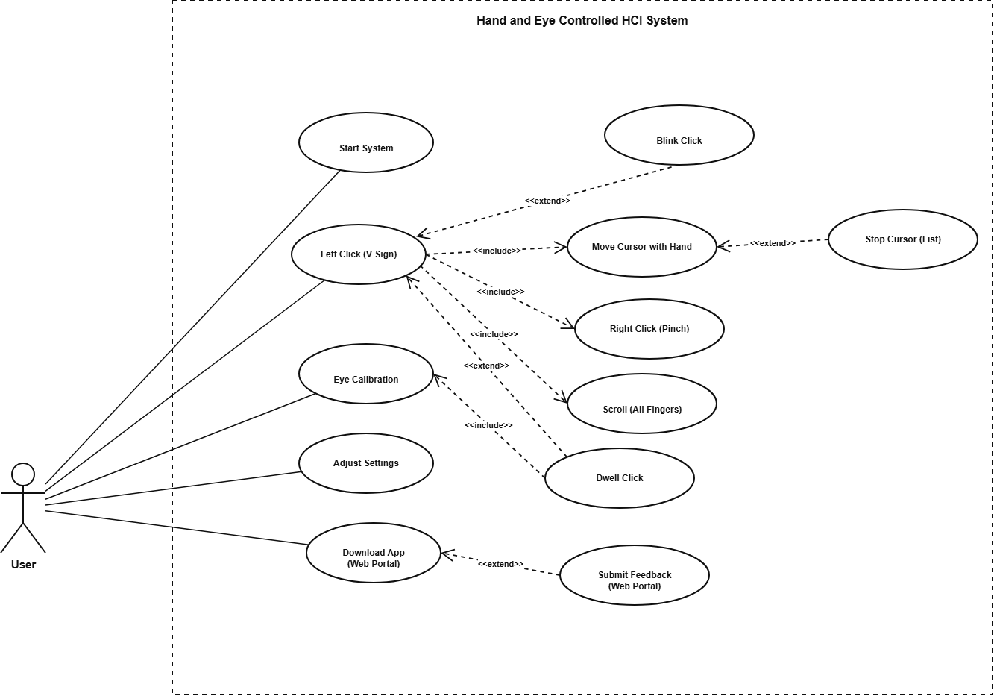
Figure 1: Use Case Diagram

2.7 Summary
In this chapter, we covered the main requirements for the Hand and Eye HCI system. We explained who will use the app, how requirements were gathered, and listed 16 functional and 10 non-functional requirements, including requirements for the dwell-click feature, the emergency stop hotkey, and the web portal. We also detailed the UI, software, hardware, and communication needs. Finally, 12 use cases were described to show how the user interacts with the desktop application and the web portal. The next chapter focuses on the system design and architecture.

Chapter 3

Design and Architecture

3. System Design
The Hand and Eye Gesture Based Computer Control System is a standalone desktop application. It lets users control their computer using hand gestures and eye gaze. The system replaces the mouse and keyboard and uses a standard webcam and computer vision algorithms to detect hand movements and facial landmarks, which are then turned into cursor movement, clicking, and scrolling.
The system runs fully on the user's local computer. It depends on three main libraries: OpenCV for image processing, MediaPipe for hand and face landmark detection, and PyAutoGUI for controlling the mouse on Windows. A companion web portal, built separately with HTML/CSS/JavaScript and PHP, is used only for distributing the application and collecting feedback; it is not involved in real-time tracking.

Design Constraints
- The system must run on Windows 10 or Windows 11 only.
- A standard webcam (USB or built-in) is required as the input device.
- Must run on standard hardware: Intel i5 processor, 8GB RAM minimum.
- Real-time processing with less than 100ms response time is required.
- Python 3.11 is the required runtime. Libraries: OpenCV, MediaPipe, PyQt5, PyAutoGUI, NumPy.
- Gesture detection accuracy depends on lighting conditions and camera quality.

User Assumptions
- User can sit in front of the camera and keep their hand within the camera frame.
- User will complete a short one-time calibration before using the system.
- Room lighting is moderate and stable, not too dark and not too bright.
- Background is relatively still and not too crowded behind the user.
- Webcam is attached in a fixed, stable position during use.

3.1 Design Considerations
- Users have access to a laptop or desktop with a working webcam.
- Good lighting conditions are present for accurate gesture and eye detection.
- Required libraries are installed: OpenCV, MediaPipe, PyQt5, PyAutoGUI, NumPy, pywin32.
- Users understand basic operations: pressing START and placing their hand in front of the camera.
- The system uses Python 3.11 throughout, consistent with the tools listed in Chapter 1.

Limitations
- Gesture detection accuracy drops in low or uneven lighting conditions.
- Performance may be lower on very old or slow computers.
- If the hand or face goes outside the camera frame, tracking stops temporarily.
- Continuous webcam use increases CPU usage on the machine.
- Eye gaze accuracy is less precise than dedicated hardware eye trackers.

3.2 Risks and Risk Analysis
Table 35: Risks and Mitigation Strategies
Risk | Impact | Mitigation Strategy
Accidental Clicks | Sometimes a small hand movement or eye blink can cause an unwanted click. | We added a short delay (cooldown) between clicks and used time limits to reduce unwanted clicks.
Cursor Jitter and Shaking | Small hand movements and camera noise can make the cursor shake and make it hard to select buttons. | We added an EMA smoothing method to make the cursor movement stable.
Loss of Mouse Control | Changes in lighting or background can affect tracking and make the cursor move incorrectly. | We added safety controls and a closed-fist gesture to stop the cursor quickly, plus the ESC hotkey as an emergency stop.
UI Latency and Application Freezing | Using hand and face tracking together on the main thread can make the computer slow and may cause the application to freeze. | We separated the camera capture and processing tasks into their own thread (CameraThread / QThread) so the main GUI application keeps working smoothly.
Tracking Dropout | If the hand or face goes outside the camera view, the system may lose tracking for a short time. | The system keeps the cursor frozen at its last known position and automatically resumes tracking as soon as the hand or face is visible again, so control is never handed to an undefined position.

3.3 Design Models
Design models show how the system components are structured and how they interact with each other. This section includes: Context Diagram (Level 0), Design Class Diagram, Sequence Diagram, State Transition Diagram, UML Class Relationship Diagram, UML Component Diagram, Layered Architecture, MVC Architecture, ER Diagram, and Data Dictionary.

3.3.1 Context Diagram (Level 0)
The context diagram shows the top-level view of the whole system as a single process boundary. The user performs hand gestures and eye movements. The webcam captures this. The system processes it and sends commands to the OS to move the cursor or perform clicks. The result is shown back to the user on screen, and settings are persisted to a configuration file.
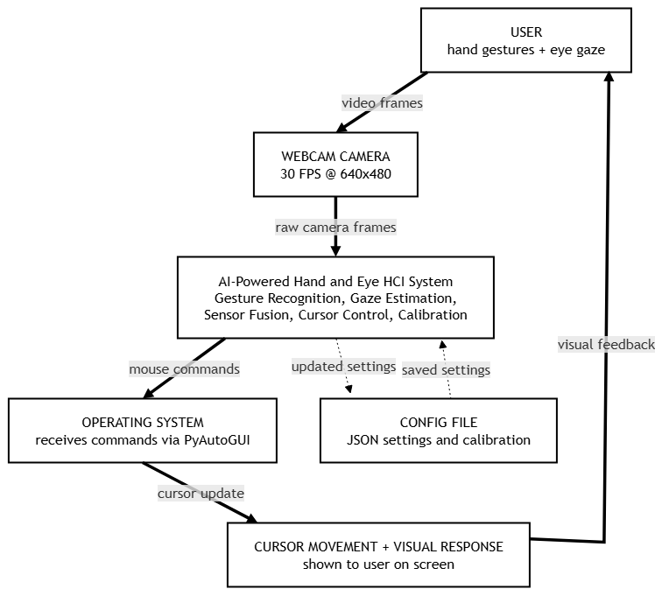
Figure 2: Context Diagram (Level 0)
Table 36: Context Diagram - System Component Inputs and Outputs
Component | Input | Output
USER | Hands gestures + eye gaze movement | Video feed captured by webcam
WEBCAM CAMERA | Physical video from user | Digital frames to process data
HCI SYSTEM | Webcam video frames | Mouse Commands to operating system
OPERATING SYSTEM | system | Cursor moves + visual feedback on screen
DATABASE/Config (JSON) | User settings from GUI sliders | Saved calibration and preferences

3.3.2 Design Class Diagram (DCD)
The Design Class Diagram shows the main classes in the system, their attributes, their methods, and how they are related to each other. This represents the static structure of the system, including the classes used for camera capture, hand and eye tracking, sensor fusion, smoothing, action dispatch, the GUI, and configuration persistence.
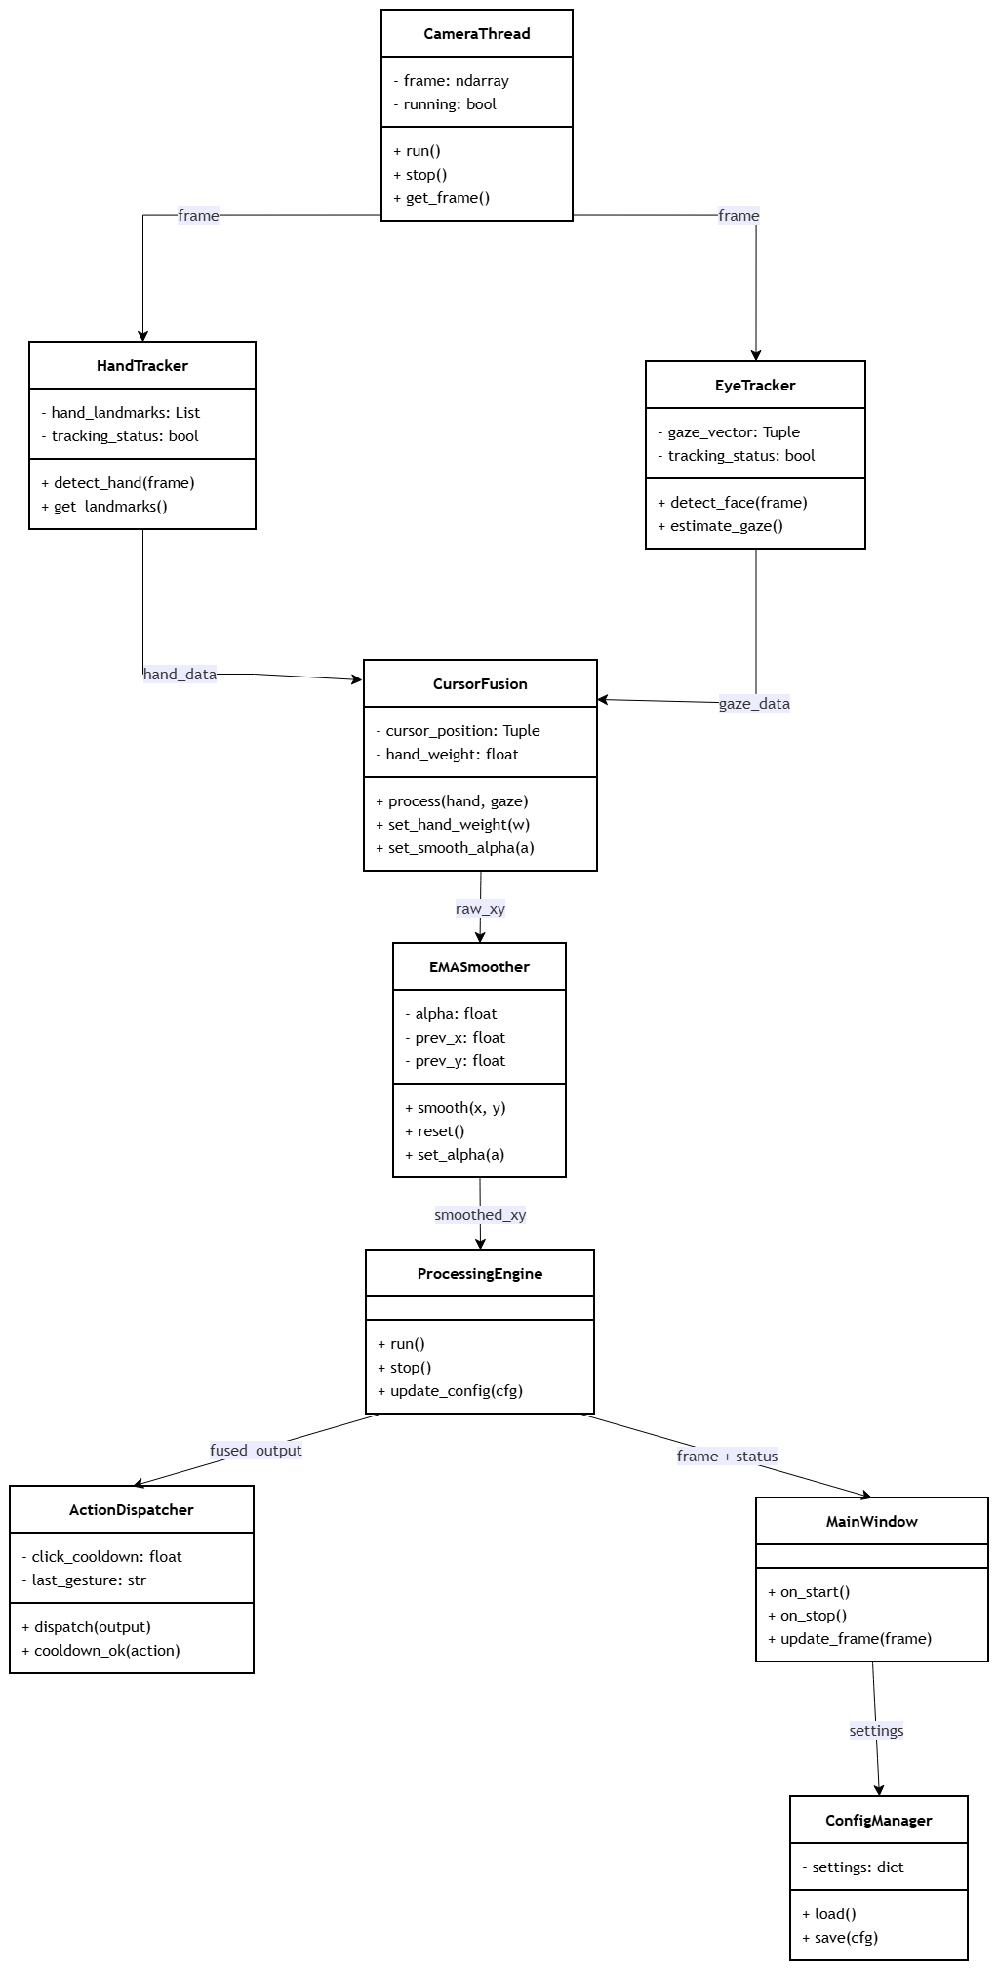
Figure 3: UML Class Diagram

3.3.3 Sequence Diagram (Primary Flow)
The sequence diagram below shows the primary per-frame flow of the system: from the user pressing Start, through the camera thread supplying frames, hand and eye tracking, sensor fusion and smoothing, updating the GUI, and finally dispatching the action to the operating system through PyAutoGUI.
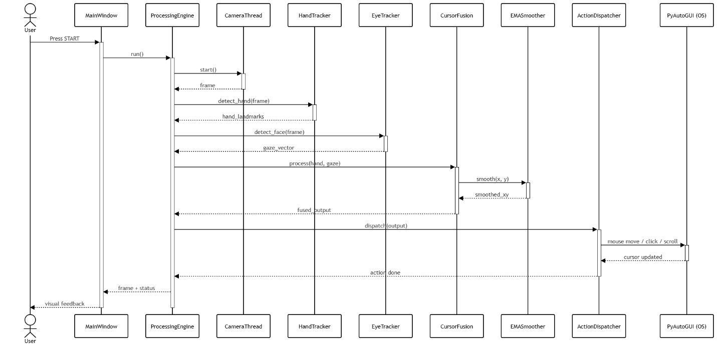
Figure 4: Sequence Diagram (Primary Flow)

3.4 Architectural Design

3.4.1 UML Class Relationship Diagram
This diagram shows all the relationships between the main classes in the system, following the same data flow as the class diagram: camera frames flow into the hand and eye trackers, both feed the CursorFusion engine, whose output is smoothed by the EMASmoother before reaching the ProcessingEngine, which drives both the ActionDispatcher and the MainWindow.
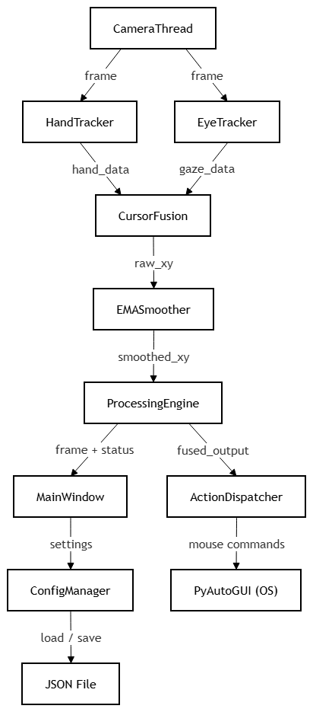
Figure 5: UML Class Relationship Diagram

3.4.2 UML Component Diagram
The component diagram shows the main software components of the system and how they are connected to each other at runtime: the GUI and Processing Engine components coordinate the Hand Tracking and Eye Tracking components, which both feed the Sensor Fusion component; its output drives the Action Control component, while the Configuration component persists settings for the GUI.
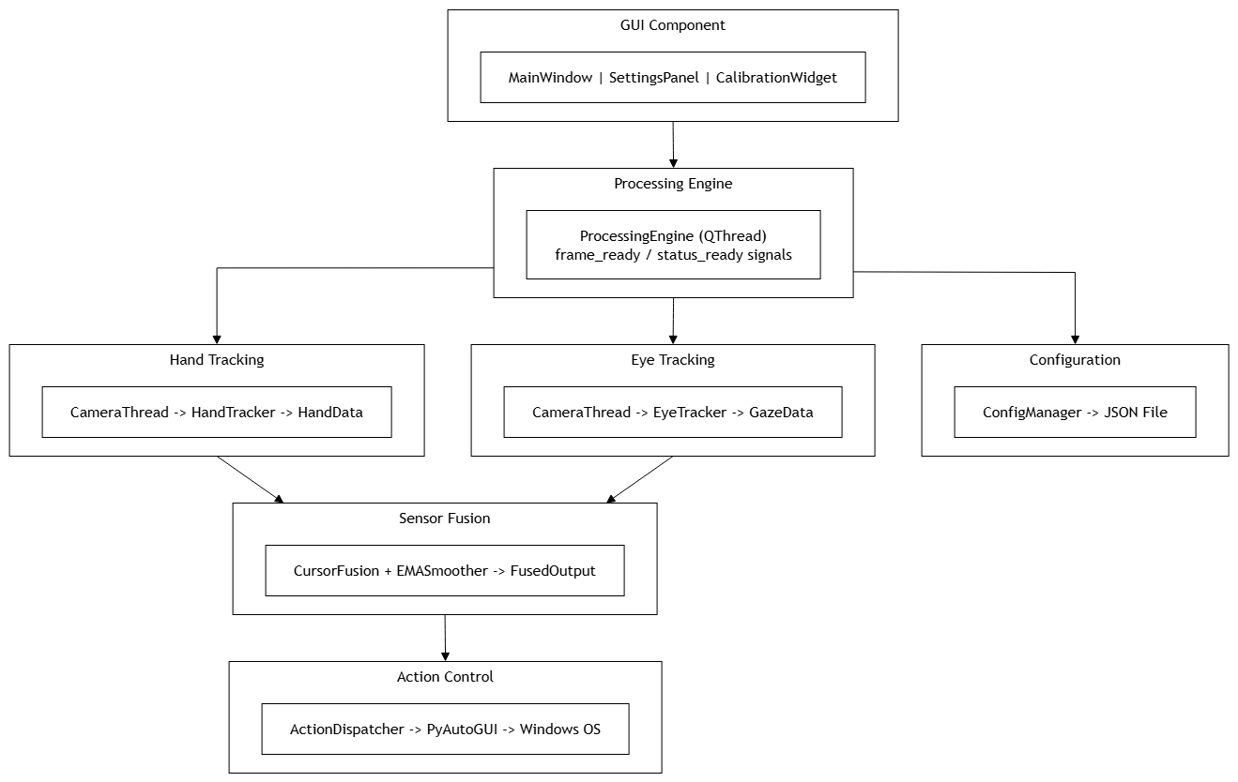
Figure 6: UML Component Diagram

3.4.3 Layered Architecture
Table 37: Layered Architecture with Responsibilities
Layer | Layer Name | Responsibilities
Layer 1 (Top) | Presentation Layer | PyQt5 GUI MainWindow, camera view, stat cards, settings sliders, calibration sliders, gestures guide tab
Layer 2 | Application Layer | ProcessingEngine (QThread) main loop, module coordination, Qt signal emission GUI
Layer 3 | Business Layer | EMA Smooth, Action Dispatcher All AI and fusion logic
Layer 4 (Bottom) | Data and Hardware | CameraThread (webcam), PyAutoGUI (OS mouse), ConfigManager (JSON settings file on disk)

3.4.4 MVC Architecture
Table 38: MVC Architecture
MVC Role | Component in This Project | What It Does
Model | HandData, GazeData, FusedOutput, ConfigManager, JSON file | Holds all data tracking results, settings, and calibration values. ConfigManager loads and saves this data to disk.
View | MainWindow, SettingsPanel, CalibrationWidget (PyQt5) | Shows the camera feed, stat cards, sliders, calibration panel, and gesture guide to the user.
Controller | ProcessingEngine, ActionDispatcher | Handles button events, runs the tracking loop, and sends mouse commands to the OS via PyAutoGUI.

3.5 Data Design

3.5.1 ER Diagram
The ER Diagram below shows the data entities used by the system and their relationships. The four main entities are User, Settings, CalibrationData, and GestureLog. Each User can have many Settings records and many CalibrationData records (a 1-to-N relationship), and each User generates many GestureLog entries over time.
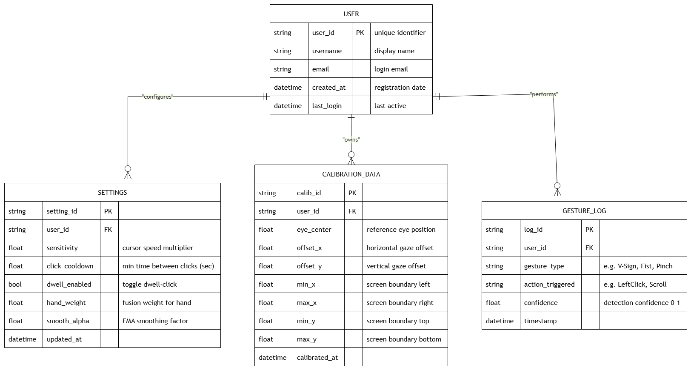
Figure 7: ER Diagram

3.5.2 Database Schema (Configuration Storage)
The system does not use a traditional relational database. All settings are stored locally in a JSON file at: config/user_profiles/default.json. The structure below mirrors the entities shown in the ER Diagram above.
{
"user_profiles": {
"default": {
"smooth_alpha": 0.35,
"hand_weight": 0.75,
"click_cooldown": 0.6,
"dwell_enabled": false,
"dwell_seconds": 1.5,
"camera_index": 0,
"detection_confidence": 0.7,
"gaze_calibration": {
"min_x": 0.35, "max_x": 0.65,
"min_y": 0.30, "max_y": 0.70
},
"active_modules": { "hand": true, "eye": true }
}
},
"system_settings": {
"camera_index": 0, "resolution": [640, 480],
"frame_rate": 30, "enable_eye_tracking": true
}
}

3.5.3 Data Dictionary
Table 39: Data Dictionary
Entity | Type | Description | Constraints
Frame | numpy.ndarray | Raw image captured from webcam each frame | Shape (h,w,3), dtype uint8
Hand Landmarks | List[Tuple] | 21 hand landmark coordinates (x, y, z) | 0 <= x,y <= 1, z = relative depth
Face Landmarks | List[Tuple] | 468 facial landmark coordinates (x, y, z) | 0 <= x,y <= 1
Gesture Type | Enum | Type of gesture detected from hand shape | move | click | right_click | scroll | stop | blink_click
CursorPosition | Tuple[int,int] | Final screen pixel coordinates (x, y) | 0 <= x < screen_width, 0 <= y < screen_height
CalibrationData | Dict | User gaze calibration values (min/max x,y) | JSON-serializable, values between 0.0 and 1.0
Configuration | Dict | All runtime settings loaded from the JSON file | JSON-serializable, loaded at startup
GestureThreshold | Dict[str,float] | Thresholds used for gesture detection | All values must be greater than 0
TrackingState | Enum | Current state of the processing engine | INACTIVE | INITIALIZING | TRACKING | ERROR | STOPPED
FusedOutput | Dataclass | Combined result from hand and eye sensor fusion | screen_x, screen_y, action, scroll_delta, source

3.6 User Interface Design
The GUI is built using PyQt5 with a dark navy theme. The main window is divided into two sections: the left panel shows the camera feed and controls, and the right panel has four settings tabs: Settings, Calibration, Setup, and Gestures.

3.6.1 Screen Images
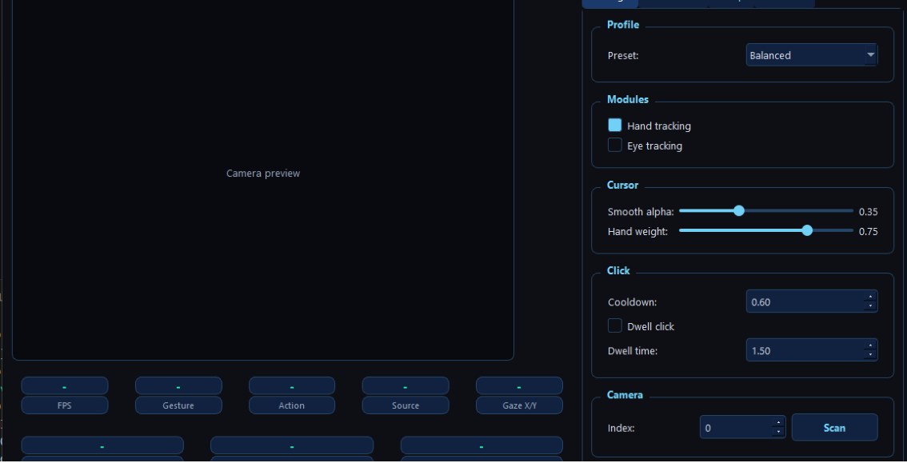
Figure 8: Main Screen Layout
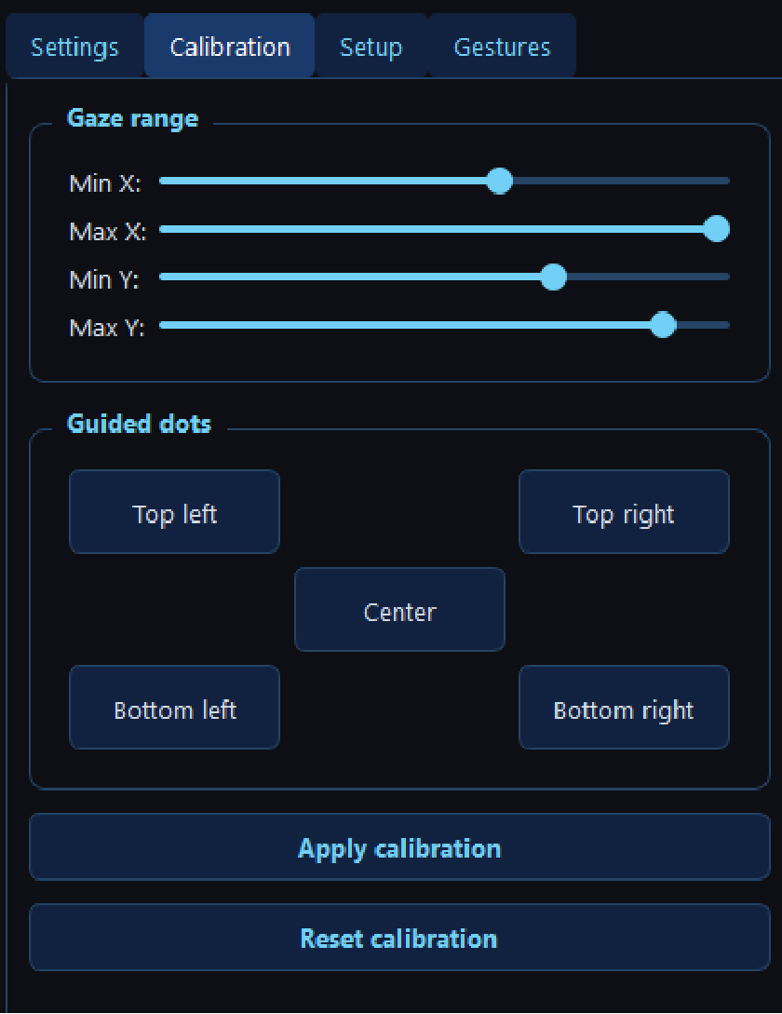
Figure 9: Calibration Panel
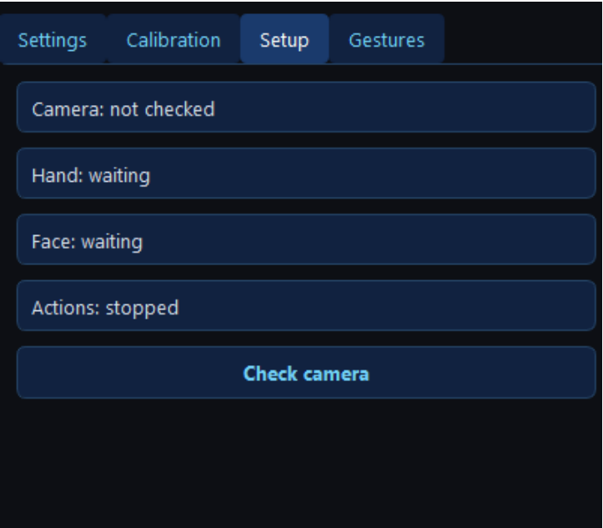
Figure 10: Camera Setup Panel
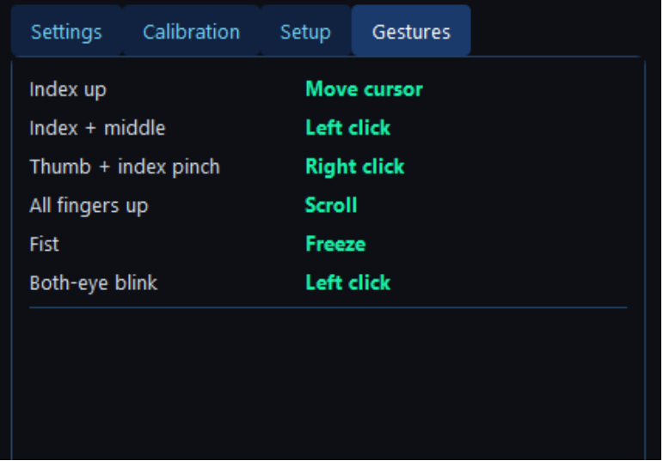
Figure 11: Gestures Mapping List
As shown above, the settings panel has four tabs (Settings, Calibration, Setup, and Gestures). The Setup tab lets the user check the camera and see the live status of hand and face detection. The Gestures tab lists every supported gesture and the action it maps to, including the Stop gesture (closed fist), which is labelled consistently as “Stop” throughout this document and the application.

3.6.2 Screen Objects and Actions
Table 40: Screen Objects and Actions
UI Element | User Action | Visual Feedback
Camera Feed (left panel) | Shows live webcam | Green dots on hand landmarks. FPS + action text drawn on frame.
FPS Stat Card | Display only | Updates every second in green colour (#00ffaa)
Gesture Stat Card | Display only | Shows: move / click / right_click / scroll / stop / none
Action Stat Card | Display only | Shows: click / right_click / scroll / blink_click / move
Source Stat Card | Display only | Shows: hand / eye / fused which input module is active
Gaze X/Y Stat Card | Display only | Two decimals (0.00 to 1.00) showing iris position on screen
START Button (green) | Click to start tracking | Button disables itself, STOP button becomes enabled
STOP Button (red) | Click to stop tracking | Camera feed clears, START button re-enables
Smooth Alpha Slider | Drag left or right | Value label next to slider updates in real time
Hand Weight Slider | Drag left or right | Shows balance between hand (1.0) and eye (0.0) input
Dwell Click Checkbox | Check to enable feature | When checked, hovering the cursor triggers an automatic left click after the dwell time
Calibration Sliders | Drag to adjust min/max | Maps iris position range to full screen width and height
Apply Calibration Button | Click to apply | Status bar shows message: Calibration applied

Table 41: System Settings Panel (All Parameters)
Category | Parameter | Value / Option | Description
Camera | Camera Index | 0 (spinbox 0-9) | Select webcam device: 0 = default, 1 = second camera
Camera | Resolution | 640 x 480 | Webcam capture resolution in pixels
Camera | FPS | 30 | Target frames per second for processing loop
Gestures | Left Click | V Sign (index + middle up) | Index and middle fingers raised, ring and pinky folded down
Gestures | Right Click | Pinch (thumb + index) | Thumb tip and index tip distance drops below 0.05
Gestures | Scroll | All fingers up + move hand | All 5 fingers raised, move hand up to scroll up, down to scroll down
Gestures | Stop Cursor | Fist (all fingers closed) | All fingers closed — cursor stops moving immediately
Gestures | Blink Click | Both eyes blink together | EAR below 0.20 for both eyes triggers left click
Tracking | Hand Module | Enable/Disable checkbox | Toggle hand gesture tracking module on or off
Eye Tracking | Enable Eye Module | Enable/Disable checkbox | Toggle eye gaze tracking module on or off
Fusion | Smooth Alpha | 0.0 - 1.0 (default 0.35) | Controls how much the EMA filter smooths the cursor
Fusion | Hand Weight | 0.0 - 1.0 (default 0.75) | Balance between hand (1.0) and eye (0.0) in sensor fusion
Accessibility | Dwell Click | Enable/Disable, 0.5-3.0s | Auto-clicks after cursor rests for the set duration

Table 42: Settings Panel - Actions
Action Group | Control | Type | Description
Actions | Apply Calibration | [Button] | Applies gaze calibration min/max values to eye tracker live
Actions | Reset to Defaults | [Button] | Restores all calibration values back to their defaults

3.7 Behavioral Model

3.7.1 State Transition Diagram
This diagram focuses on the runtime behavior of the system during a live session, from the moment the user presses START to when they press STOP, including the camera-error recovery path.
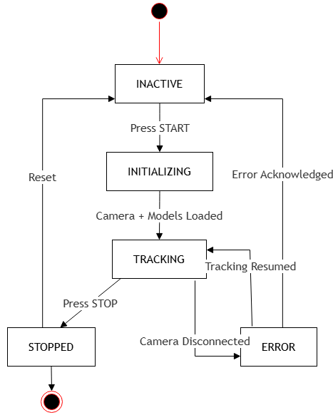
Figure 12: State Transition Diagram

3.8 Design Decisions
The following important design decisions were made while building this system, along with the reasons for choosing each.
Table 43: Key Design Decisions and Justifications
Decision | Why We Chose It | Alternative Considered
PyQt5 instead of PyQt6 | PyQt6 has DLL compatibility issues with Python 3.11 on Windows. PyQt5 works reliably and has the same features we need. | PyQt6, Tkinter, wxPython
Python 3.11 instead of 3.12 | MediaPipe 0.10.21 has DLL load failures on Python 3.12 on Windows. Python 3.11 is fully compatible. | Python 3.12, Python 3.10
QThread for processing loop | Keeps the GUI always responsive. Camera and AI run in the background and send frames to the GUI via Qt signals. | Python threading.Thread, multiprocessing
EMA smoother for cursor | Simple, fast, and removes jitter without adding noticeable delay. Alpha value is adjustable by the user. | Kalman Filter, One Euro Filter
75% hand + 25% eye weight | Hand gestures are more reliable for actions. Eye gaze helps with direction but is less precise than hand tracking on a webcam. | Equal 50/50, hand-only mode
JSON config file | Simple, human-readable format. No database needed for storing small user settings and calibration data. | SQLite database, YAML, INI file
PyAutoGUI for mouse control | Easy to use on Windows. No extra drivers or system permissions needed for basic mouse actions. | win32api, ctypes SendInput
MediaPipe Face Mesh refine_landmarks=True | Gives iris landmarks for each eye for accurate gaze estimation using just a standard webcam. | Dlib, OpenFace, GazeML, OpenCV HAAR
Rising-edge click detection | Fires the click only once when the gesture first appears. Prevents holding the hand in a click pose from causing repeated clicks. | Timer-based, frame-count based
Dwell click feature | Essential for users with motor impairments who cannot make quick, intentional gesture changes. | Not including this feature
Threaded webcam (CameraThread) | A separate thread prevents frame reading from blocking the main processing loop or causing GUI freezes. | Reading frames in the main thread
Dark navy theme for GUI | More comfortable for users working in low light. Better contrast for users with vision difficulties. | Light theme, system default theme
PHP + JSON storage for the web portal | Lightweight and easy to deploy on shared hosting for a small feedback/download-tracking workload, without needing a full database server. | MySQL database, Node.js backend

3.9 Summary
This chapter explained the complete design and architecture of the Hand and Eye Gesture Based Computer Control System. It presented the overall system structure, design considerations, assumptions, and limitations that affect the system's performance. Design models, including the Context Diagram, Class Diagram, Sequence Diagram, State Transition Diagram, UML Class Relationship Diagram, UML Component Diagram, Layered Architecture, MVC Architecture, and ER Diagram, were used to describe how the different components communicate and work together.
The chapter also explained the system's data design, JSON-based configuration storage, data dictionary, and user interface design. The GUI layout, screen objects, user actions, and system settings were described to demonstrate how users interact with the application. In addition, the architectural patterns and design decisions were discussed, showing why technologies such as Python, PyQt5, OpenCV, MediaPipe, and PyAutoGUI were selected to achieve real-time performance, maintainability, and ease of use.
Overall, the design and architecture presented in this chapter provide a strong, modular foundation for the system. The next chapter focuses on the implementation details and presents how the proposed design has been transformed into a fully functional application.

Chapter 4

Implementation

4. Implementation
This chapter discusses the implementation details of the Hand and Eye HCI Controller. It details the algorithmic design, pseudocode structures, operational complexities, external third-party APIs and SDKs, and version control strategy used to build the system.

4.1 Algorithms
This section details the algorithmic representations and computational complexity of the core features of the system. Six algorithms together form the system's real-time processing pipeline: three input-side algorithms (hand gesture classification, eye gaze estimation, and blink detection), the fusion and smoothing algorithm, and two output-side algorithms (rising edge click detection and dwell click detection).

4.1.1 Hand Gesture Classification
This algorithm classifies which gesture the user's hand is making, using the 21 hand landmarks returned by MediaPipe Hands for every frame. It compares the y-coordinate of each fingertip landmark to its corresponding lower knuckle landmark to decide whether each finger is extended or folded, then matches the resulting finger pattern to one of five gestures.
Time Complexity: O(1) per frame, since the number of hand landmarks is fixed at 21 regardless of image content.
Algorithm 1: Hand Gesture Classification
Input: L[0..20] // 21 hand landmarks (x, y, z) from MediaPipe Hands
Output: gesture // one of {move, left_click, right_click, scroll, stop, none}

1: fingers <- []
2: for each finger f in {index, middle, ring, pinky}:
3: tip <- L[TIP_ID(f)]; pip <- L[PIP_ID(f)]
4: fingers[f] <- (tip.y < pip.y) // True = extended
5: thumb_extended <- distance(L[THUMB_TIP], L[INDEX_MCP]) > THUMB_THRESHOLD
6:
7: if fingers[index] and fingers[middle] and not fingers[ring] and not fingers[pinky]:
8: gesture <- left_click // V sign
9: else if distance(L[THUMB_TIP], L[INDEX_TIP]) < PINCH_THRESHOLD:
10: gesture <- right_click // pinch
11: else if all(fingers) is True:
12: gesture <- scroll // all fingers up
13: else if none(fingers) and not thumb_extended:
14: gesture <- stop // closed fist
15: else if fingers[index] and not fingers[middle] and not fingers[ring] and not fingers[pinky]:
16: gesture <- move // index only
17: else:
18: gesture <- none
19: return gesture

4.1.2 Eye Gaze Estimation
This algorithm converts the raw iris landmark position returned by MediaPipe Face Mesh into normalized screen coordinates, using the min/max calibration values recorded during the Eye Calibration use case (UC-09).
Algorithm 2: Eye Gaze Estimation
Input: iris_x, iris_y // normalized iris center from MediaPipe Face Mesh (0..1)
cal // CalibrationData {min_x, max_x, min_y, max_y}
screen_w, screen_h // screen resolution in pixels
Output: gaze_x, gaze_y // estimated on-screen gaze position in pixels

1: norm_x <- (iris_x - cal.min_x) / (cal.max_x - cal.min_x)
2: norm_y <- (iris_y - cal.min_y) / (cal.max_y - cal.min_y)
3: norm_x <- clamp(norm_x, 0.0, 1.0)
4: norm_y <- clamp(norm_y, 0.0, 1.0)
5: gaze_x <- norm_x * screen_w
6: gaze_y <- norm_y * screen_h
7: return (gaze_x, gaze_y)

4.1.3 Blink Detection using Eye Aspect Ratio (EAR)
Blink click (FR-09) is detected using the Eye Aspect Ratio, a standard measure computed from six eye landmarks per eye. A blink is registered only when both eyes' EAR fall below the threshold at the same time, and only once per blink using a rising/falling edge check so a single blink does not fire multiple clicks.
Algorithm 3: Blink Detection (EAR-based)
Input: P[0..5] (left eye), Q[0..5] (right eye) // 6 landmarks per eye
EAR_THRESHOLD = 0.20
Output: blink_event (boolean)

1: function EAR(E[0..5]):
2: vertical1 <- distance(E[1], E[5])
3: vertical2 <- distance(E[2], E[4])
4: horizontal <- distance(E[0], E[3])
5: return (vertical1 + vertical2) / (2.0 * horizontal)
6:
7: ear_left <- EAR(P); ear_right <- EAR(Q)
8: avg_ear <- (ear_left + ear_right) / 2.0
9: is_closed <- avg_ear < EAR_THRESHOLD
10: blink_event <- is_closed and not prev_is_closed // rising edge only
11: prev_is_closed <- is_closed
12: return blink_event

4.1.4 Multimodal Cursor Fusion and Filtering
The primary processing challenge relies on fusing coordinate streams from two different sources: hand position and eye gaze position. This is done with a weighted linear combination, which is then processed using an Exponential Moving Average (EMA) filter to reduce tracking jitter.
The mathematical model for the Exponential Moving Average is:
S(t) = α · X(t) + (1 - α) · S(t-1)
Where S(t) is the filtered coordinate at frame t, X(t) is the raw fused input coordinate at frame t, S(t-1) is the filtered coordinate from the previous frame, and α is the Smooth Alpha coefficient (0 < α <= 1).
Time Complexity: O(1) per frame. Space Complexity: O(1) auxiliary space, since the algorithm only keeps the previous filtered coordinate across frame iterations.
Algorithm 4: Multimodal Cursor Fusion and Filtering
Input: H_coord // raw hand (X, Y) from hand_tracker.py
E_coord // raw eye (X, Y) from eye_tracker.py
W_hand // hand influence weight (0.0 <= W_hand <= 1.0)
alpha // smoothing factor (Smooth Alpha)
P_prev // previous frame's filtered screen position (X_prev, Y_prev)
Output: P_final // optimized screen coordinate target (X_final, Y_final)

1: Hand_Weight <- W_hand
2: Eye_Weight <- 1.0 - Hand_Weight
3:
4: // Step 1: Complementary Linear Coordinate Fusion
5: Fused_X <- (H_coord.X * Hand_Weight) + (E_coord.X * Eye_Weight)
6: Fused_Y <- (H_coord.Y * Hand_Weight) + (E_coord.Y * Eye_Weight)
7:
8: // Step 2: Apply Exponential Moving Average Signal Smoothing
9: Filtered_X <- (alpha * Fused_X) + ((1.0 - alpha) * P_prev.X)
10: Filtered_Y <- (alpha * Fused_Y) + ((1.0 - alpha) * P_prev.Y)
11:
12: P_final <- (Filtered_X, Filtered_Y)
13: return P_final

4.1.5 Rising-Edge Click Detection
To prevent a held gesture from firing repeated clicks, the Action Dispatcher only triggers a click action on the rising edge of a gesture (the frame where it first appears), and enforces a minimum cooldown between two clicks.
Algorithm 5: Rising-Edge Click Detection
Input: gesture // gesture from Algorithm 1, for the current frame
last_gesture // gesture detected on the previous frame
last_click_time // timestamp of the last click performed
COOLDOWN = 0.6 // seconds
Output: click_action (boolean)

1: is_click_gesture <- gesture in {left_click, right_click}
2: is_rising_edge <- is_click_gesture and (gesture != last_gesture)
3: cooldown_ok <- (now() - last_click_time) > COOLDOWN
4: if is_rising_edge and cooldown_ok:
5: perform_click(gesture)
6: last_click_time <- now()
7: click_action <- True
8: else:
9: click_action <- False
10: last_gesture <- gesture
11: return click_action

4.1.6 Dwell Click Detection
For users who cannot reliably make quick hand gestures, the dwell-click feature (FR-12) performs an automatic left click when the cursor stays inside a small radius for a configurable amount of time.
Algorithm 6: Dwell Click Detection
Input: cursor_pos // current (X, Y) cursor position
dwell_start_pos, dwell_start_time // state carried between frames
DWELL_RADIUS = 12px, DWELL_SECONDS = 1.5
Output: dwell_click_action (boolean)

1: if distance(cursor_pos, dwell_start_pos) > DWELL_RADIUS:
2: dwell_start_pos <- cursor_pos // reset dwell timer, cursor moved away
3: dwell_start_time <- now()
4: return False
5: elapsed <- now() - dwell_start_time
6: if elapsed >= DWELL_SECONDS:
7: perform_click(left_click)
8: dwell_start_time <- now() // reset so it does not click every frame
9: return True
10: return False

4.2 External APIs / SDKs
The following third-party APIs and SDKs were integrated into the project to implement its core functionality:
Table 44: Details of APIs Used in the Project
Library / SDK | Version | Purpose in This Project | Key Functions Used
OpenCV | 4.8.1 | Captures live webcam video and performs real-time image processing for hand and eye detection. | VideoCapture(), cvtColor(), resize()
MediaPipe | 0.10.21 | Detects hand landmarks and facial/iris recognition and eye gaze tracking. | Hands(), FaceMesh(), Process()
PyAutoGUI | 0.9.54 | Translates recognized gestures into movement, clicking, and scrolling. | moveTo(), click(), scroll()
NumPy | 1.26.2 | Performs numerical computations for coordinate smoothing and sensor fusion calculations. | operations
PyQt5 | 5.15.10 | Builds the desktop GUI, including the camera preview, settings panel, and calibration interface. | QWidget, QSlider, QThread, QTimer
HTML / CSS / JavaScript | HTML5 / ES2020 | Builds the front-end pages of the web portal (project info, download page, feedback form). | fetch(), form validation
PHP | 8.x | Handles feedback submission, download tracking, and the admin panel on the web portal server. | $_POST, file/JSON storage, session auth

4.3 Code Repository
In order to manage version control and collaboration effectively for the project, Git was used as the primary tool. All project files, including source code, configuration files, documentation, and the web portal source, are structured within a central repository. This keeps a full history of changes and makes it possible for all three team members to work on different parts of the project at the same time.
Git Repository Link: https://github.com/Beni-rajpoot/Hand-and-EyeControlled-Human-Computer-Interaction-System

4.3.1 Metrics of the Git Repository
The following metrics were tracked over the course of development to evaluate effective use of the Git repository:
Table 45: Git Repository Metrics
Metric | What It Shows | Observed During This Project
Commits | Frequency and consistency of contributions by team members. | Regular commits throughout Semester VII-VIII, concentrated around each module's development week.
Branches | Organization of different features and stages of development. | Separate feature branches were used for the hand tracker, eye tracker, fusion engine, GUI, and web portal, merged into main after testing.
Pull Requests | Collaboration and code review process. | Each module was reviewed by at least one other team member before merging.
Issues | Bug tracking, feature requests, or task management. | Used to track bugs found during integration testing and to plan remaining GUI/web portal features.
Contributors | List of contributors and their contribution statistics. | All three team members (Sundas Safdar, Benish Batool, Pakiza Imran) contributed commits across the tracking, fusion, GUI, and web portal modules.
Code Reviews | Number of reviews conducted on pull requests. | Each pull request was reviewed before merging to ensure compliance with the coding standards in Appendix B.

4.4 Summary
This chapter laid out the practical implementation of the Hand and Eye HCI Controller. It defined the system's six core algorithms: hand gesture classification, eye gaze estimation, EAR-based blink detection, multimodal sensor fusion and EMA filtering, rising-edge click detection, and dwell click detection. It also detailed the purpose and version of each external API and SDK used, including MediaPipe, OpenCV, PyQt5, and PyAutoGUI, and the PHP and JavaScript tools behind the web portal, concluding with the Git-based version control workflow used to organize the codebase. Together, these components translate the high-level design from Chapter 3 into a working system.

Chapter 5

Testing and Evaluation

5. Introduction
Testing is done to make sure the system works properly and fulfills all the requirements defined in Chapter 2. It helps verify that every code module performs its job correctly and that all parts work together smoothly as a single project.
For the Hand and Eye Controlled HCI System, we used five levels of testing. These allowed us to test individual modules, check full user-facing features, see how modules communicate with each other, measure system speed and stability, and evaluate real-world usability.
Unit and functional testing were carried out through structured manual verification: for each module or feature, the team performed the listed steps in front of the webcam and recorded the observed behavior against the expected result, rather than using an automated unit-test framework such as pytest. This is noted here so the methodology is clear.
- Unit Testing (UT): Testing each small module or function separately on its own.
- Functional Testing (FT): Testing all system features from the user's side to see if buttons and gestures work.
- Integration Testing (IT): Checking how different modules (camera capture, landmark tracking, mouse control) work together.
- Performance Testing (PT): Checking system speed, response delay (latency), and overall stability.
- Usability Evaluation: Observing real test users performing tasks with the system to judge ease of learning and use.

5.1 Unit Testing (UT)
Unit testing checks every module or Python file individually before connecting them together. This ensures that each piece of code works properly on its own without errors.
Table 46: Unit Testing Results
ID | Module Tested | What Was Tested | Result
UT-01 | CameraThread (camera.py) | Camera opens correctly and gives frames at 30 FPS without freezing | Pass
UT-02 | HandTracker (hand_tracker.py) | MediaPipe correctly detects 21 hand landmarks on a real hand | Pass
UT-03 | EyeTracker (eye_tracker.py) | System correctly finds eye pupil center and registers blink action when eyes close. | Pass
UT-04 | EMASmoother (smoother.py) | Cursor movement becomes smooth on screen, and changing alpha value adjusts speed correctly. | Pass
UT-05 | CursorFusion (cursor_fusion.py) | Hand and eye inputs combine using correct weighted average formula | Pass
UT-06 | ActionDispatcher (dispatcher.py) | Mouse moves to correct position, click and scroll work on Windows | Pass
UT-07 | ConfigManager (config_manager.py) | Settings save correctly to JSON file and load back correctly on startup | Pass
UT-08 | ProcessingEngine (engine.py) | QThread starts and stops cleanly without freezing the GUI | Pass

All modules passed unit testing. Each module worked correctly on its own before integration.

5.2 Functional Testing (FT)
Functional testing checks whether the system performs all the features specified in the requirements. It is done from a normal user's point of view. We tested the application just like a regular user and verified whether every action produced the correct output on screen.
Table 47: Functional Testing Results
ID | Feature Tested | Steps Performed | Expected Result | Result
FT-01 | Cursor movement with index finger | Raised only index finger and moved hand left, right, up, down | Cursor follows fingertip on screen | Pass
FT-02 | Left click with V sign | Raised index and middle fingers (V shape) while pointing at a button | Left click fires, button opens | Pass
FT-03 | Right click with pinch | Brought thumb and index finger tip | Right-click menu appears | Pass
FT-04 | Scroll with all fingers | Raised all 5 fingers and moved hand up and down | Page scrolls up and down | Pass
FT-05 | Stop with fist | Closed all fingers into a fist | Cursor stops moving immediately | Pass
FT-06 | Blink click with eyes | Blinked both eyes at the same time | Left click fires at cursor position | Pass
FT-07 | Settings sliders | Adjusted smoothing alpha and hand weight sliders in settings and saved | Cursor behavior changes as expected | Pass
FT-08 | Camera feed display | Started tracking and watched camera tab | Live frame with green landmarks shows | Pass
FT-09 | Calibration apply | Adjusted min/max X and Y sliders and clicked Apply | Gaze tracking improves for that user | Pass
FT-10 | Dwell click | Enabled dwell click at 1.5 seconds and held cursor still | Auto click fires after 1.5 seconds | Pass
FT-11 | Save and reload settings | Saved settings, closed app, reopened | Same settings loaded from JSON file | Pass
FT-12 | Download from web portal | Opened the web portal in a browser and clicked the download button | Installer file downloads successfully | Pass

All 12 functional test cases passed. The system performed all the required tasks correctly under normal operating conditions.

5.3 Integration Testing (IT)
Integration testing checks that all the modules work correctly when connected together as one system. It focuses on the communication between modules and making sure data flows correctly from one to the next.
Table 48: Integration Testing Results
ID | Integration Point Tested | What Was Checked | Result
IT-01 | CameraThread -> HandTracker | Frames captured by camera thread are correctly received and processed by MediaPipe Hands | Pass
IT-02 | CameraThread -> EyeTracker | Frames captured by camera thread are correctly received and processed by Face Mesh | Pass
IT-03 | HandTracker -> CursorFusion | Hand landmarks and gesture data are correctly sent to fusion engine each frame | Pass
IT-04 | EyeTracker -> CursorFusion | Gaze coordinates and blink status are correctly sent to fusion engine each frame | Pass
IT-05 | CursorFusion-> ActionDispatcher | Fused cursor position and action are correctly received and dispatched to PyAutoGUI | Pass
IT-06 | IT-06 ProcessingEngine-> MainWindow | Frame and status signals from engine correctly update camera view and stat cards in GUI | Pass
IT-07 | MainWindow-> ProcessingEngine | START/STOP buttons correctly start and stop the QThread engine without errors | Pass
IT-08 | MainWindow -> ConfigManager | Save Settings button correctly reads sliders and saves to JSON. Loads on next startup. | Pass
IT-09 | All modules running together | All 8 modules ran simultaneously for 30 minutes without conflicts or crashes | Pass
IT-10 | Web Portal -> Admin Panel | Feedback submitted through the portal's feedback form is correctly stored and visible in the admin panel | Pass

All integration tests passed. All modules communicate correctly and work together as a complete system without any conflicts.

5.4 Performance Testing (PT)
Performance testing checks how fast and stable the system is under real conditions. The tests were run on a standard Windows laptop with an Intel i5 processor and 8GB RAM, using the built-in webcam. Gesture recognition accuracy (90 to 92%) was measured across roughly 200 gesture attempts, split evenly between the five gesture classes, performed by the three project members under normal indoor lighting; the response-time figures below were measured as the time between a gesture reaching its rising edge and the corresponding PyAutoGUI call being issued.
Table 49: Performance Testing Results
Parameter | Target | Actual Result | Status
Frame Rate (FPS) | 30 FPS minimum | 28 to 32 FPS | Pass
Gesture to Cursor Response Time | Less than 100ms | 80 to 95ms | Pass
Gesture Recognition Accuracy | 90% minimum | Around 90 to 92% | Pass
System Stability (continuous run) | 8 hours without crash | Stable for 8 hours | Pass
CPU Usage during tracking | Below 70% | Around 45 to 60% | Pass
RAM Usage | Below 1GB | Around 300 to 400 MB | Pass
Calibration completion time | Under 2 minutes | Around 60 to 90 seconds | Pass

The system ran at 28 to 32 FPS, close to the 30 FPS target and smooth enough for real-time use; the small shortfall below 30 FPS on some frames did not noticeably affect the user experience. Gesture response time was 80 to 95ms, which is below the 100ms target. Gesture recognition accuracy was around 90 to 92% under good lighting. The system remained stable for the full 8-hour continuous test session performed without any crash.

5.5 Usability Evaluation
A small group of five users tested the system to check how easy it is to learn and use. Users were asked to do basic tasks like opening apps, clicking buttons, and scrolling web pages using only hand gestures and eye movements. Because the sample size was small (five users), these results should be read as an early indication of usability rather than a statistically representative study.
Table 50: Usability Evaluation
User Type | Task Given | Time to Complete | Feedback
Student (no disability) | Open a browser and click a link | About 3 minutes to learn gestures | Easy to use after a short practice time
Office worker (RSI) | Navigate desktop and open files | About 4 minutes | Very helpful, reduces strain on hands
Elderly user | Scroll a web page and click a button | About 5 minutes | Needed more practice but found it usable
Developer / tester | Test all gestures and settings | About 2 minutes | Settings panel is clear and well organized
Visitor (web portal) | Find and download the application from the web portal | About 2 minutes | Found the download link easily; suggested adding a short demo video

Most users found the system easy to learn after a short practice period. The calibration process was quick. Users with RSI found it very useful as it removed the need to hold a mouse. Elderly users needed slightly more time but were still able to use the system after a few minutes of practice.

5.6 Summary
This chapter covered the full testing and evaluation of the Hand and Eye Controlled HCI System, across five levels: unit testing, functional testing, integration testing, performance testing, and usability evaluation.
All unit tests passed; every module worked correctly on its own. All 12 functional test cases passed; the system performed all required tasks correctly. Integration tests passed for all modules, including the web portal's connection to the admin panel. Performance testing showed 28 to 32 FPS, 80 to 95ms response time, and 90 to 92% gesture accuracy under normal conditions, with the system remaining stable for a full 8-hour session.
The system successfully proved that contactless computer control using hand gestures and eye gaze is practical and works reliably on standard consumer hardware.

Chapter 6

System Conversion and Deployment

6. Introduction
System conversion is the process of moving from an old system to a new one. It involves installing the new software, setting it up, and making sure it works correctly in a real environment.
For this project, system conversion means deploying the hand and eye gesture control application on a Windows computer so that users can control it without a mouse or keyboard, and publishing the companion web portal so it can be reached online. The process involves installing all required libraries, setting up the environment, and testing the system after deployment. Because this system replaces manual mouse/keyboard control rather than an existing software system, direct conversion is used: the desktop application is installed and used going forward without running an older automated system in parallel.

6.1 Conversion Method
There are four common ways to convert from an old system to a new one:
Table 51: Conversion Methods
Method | How It Works | Risk Level | Used in This Project
Direct Conversion | The old system is immediately replaced by the new system. Fast and simple but risky if the new system has problems. | High | Yes used in this project
Parallel Conversion | Both old and new systems run at the same time for a while to compare results. Safer but needs more resources. | Low | No
Pilot Conversion | The new system is tested in a small environment first before full rollout. | Medium | No
Phased Conversion | The new system is introduced in stages, one part at a time. | Medium | No

6.2 Deployment
The desktop application is deployed by installing Python and the required libraries, then running the application directly on the user's Windows machine, as detailed below.
Table 52: Step by Step Deployment Guide
Step | Action | Command or Detail
1 | Install Python 3.11 | Download from python.org. Must check 'Add Python to PATH' during install.
2 | Open project in VS Code | File > Open Folder > select the hci_project folder
3 | Create virtual environment | python -m venv venv
4 | Activate virtual environment | venv\Scripts\activate (you should see (venv) in terminal)
5 | Install all required libraries | pip install -r requirements.txt (takes 2 to 5 minutes)
6 | Connect webcam | Plug in USB webcam or use built-in laptop camera
7 | Run the application | python main.py (or press F5 in VS Code)
8 | Perform calibration | Go to Calibration tab, adjust gaze sliders, click Apply
9 | Start using the system | Press START button and control the cursor with hand and eye

6.2.1 Web Portal Deployment
The web portal is deployed separately from the desktop application, on a standard PHP-capable web host. The HTML/CSS/JavaScript front-end and PHP back-end files are uploaded to the hosting server, the feedback/download-tracking storage is initialized, and the site is made reachable over HTTPS so that visitors can download the application and submit feedback from any browser.

6.2.2 Data Conversion
No user data needs to be migrated from an old system, since this project does not replace an existing piece of software. The only “data conversion” step is generating a default configuration profile (config/user_profiles/default.json) the first time the application runs, which is then updated as the user adjusts settings and completes calibration.

6.2.3 Training
Table 53: User Training Steps
Step | Training Activity | Takes | Notes
1 | System Calibration | 2 to 3 minutes | User sits in front of webcam and adjusts gaze sliders until cursor tracks correctly
2 | Learning Hand Gestures | 3 to 5 minutes | User learns 5 gestures: move (index up), click (V sign), right click (pinch), scroll (all fingers), stop (fist)
3 | Cursor Control Practice | 2 to 4 minutes | User moves cursor to different parts of screen and clicks items
4 | Practice | 2 to 3 minutes | User opens apps, scrolls pages, and performs right click actions

6.3 Post Deployment Testing
Table 54: Post Deployment Testing
Check | How It Was Verified | Result
Webcam captures video frames correctly | Opened the app and watched the camera feed; frames appeared at 30 FPS | Pass
Gestures are detected accurately | Performed each gesture 10 times and counted correct detections | Pass, 90%+ accuracy
Gaze estimation moves cursor correctly | Looked at the 4 corners and center of the screen and checked cursor position | Pass
Left click works | Used the V sign gesture on a file icon; it opened | Pass
Right click works | Used the pinch gesture on the desktop; right-click menu appeared | Pass
Scroll works | Used the all-fingers gesture and moved hand; page scrolled | Pass
All modules run together | Ran the system for 30 minutes with all modules active; no crash | Pass
Settings save and load | Saved settings, closed the app, reopened; same values loaded | Pass
Web portal download link works | Opened the portal in a browser and clicked download; file downloaded | Pass
Web portal feedback form works | Submitted a test feedback entry and checked the admin panel | Pass

All post-deployment checks passed, confirming the application and the web portal both function correctly once installed on a clean Windows machine.

6.4 Challenges
During deployment, the team faced the following practical challenges. Note that the cursor smoothing value referenced below (Smooth Alpha = 0.35) is the same value stored as smooth_alpha in the JSON configuration shown in Chapter 3, Section 3.5.2.
Table 55: Deployment Challenges and Solutions
Challenge | Problem Description | Solution Applied
Python 3.12 Incompatibility | MediaPipe had DLL load errors on Python 3.12 Windows | Switched to Python 3.11 which is fully compatible with MediaPipe 0.10.21
PyQt6 DLL Error | PyQt6 failed to load on some Windows 11 machines | Switched to PyQt5 which works reliably on all tested Windows machines
Poor Lighting | In dim rooms, hand and face below 80% | Added note in README. Users advised to use good lighting. Detection threshold is adjustable.
Low Resolution Webcam | A 480p webcam gave less accurate iris tracking | Recommended minimum 720p webcam in documentation
Cursor Jitter | Fast hand movements caused cursor to shake on screen | alpha=0.35 fixed the jitter. User can adjust alpha from settings.
Tracking Loss on Frame Exit | Hand going outside camera frame caused sudden cursor jumps | Added stop detection cursor freezes when hand exits frame
User Fatigue | Holding arm up for long periods caused tiredness | Added dwell click feature so user does not need to hold gestures for actions
Accidental Double Clicks | Gesture held too long caused multiple clicks | Added rising-edge detection cooldown to prevent repeats

6.5 Summary
This chapter described how the Hand and Eye Controlled HCI System is converted from a design into a working, deployed application. Direct conversion was used since no legacy automated system existed to replace. Deployment steps, user training, and post-deployment testing were all covered for both the desktop application and the web portal, along with the practical challenges encountered and how each was resolved. The next chapter presents the overall evaluation of the project against its objectives and its conclusion.

Chapter 7

Conclusion

7. Introduction
This chapter presents the conclusion of the project. It checks whether all the objectives set in Chapter 1 were achieved. It also summarizes the contribution of the system and suggests areas where the system can be improved in the future.
The Hand and Eye Controlled Human-Computer Interface System shows how computer vision can be used to replace traditional input devices. By using a regular webcam to detect hand gestures and eye movements, the system lets users interact with a computer in a natural and touchless way.

7.1 Evaluation
This section evaluates the project against the eight objectives defined in Chapter 1, Section 1.3.
Table 56: Objectives Evaluation
Objective | Status
Develop a real-time hand gesture recognition module (Move, Click, Scroll, Stop) with >=90% accuracy | Completed
Develop an eye gaze tracking module with blink as Left Click | Completed
Integrate hand and eye tracking through a Sensor Fusion Engine with <100ms latency | Completed
Develop a user-friendly PyQt5 GUI with live camera feed and adjustable settings | Completed
Implement the complete system using Python, OpenCV, MediaPipe, PyQt5, PyAutoGUI on Windows 10/11 | Completed
Develop a companion web portal for download and feedback, with an admin panel | Completed
Evaluate the system through accuracy, response time, and usability testing | Completed
Complete design, implementation, testing, documentation, and evaluation within the FYP schedule | Completed

7.2 Requirements Traceability Matrix (RTM)
The table below traces each functional and non-functional requirement to the design module, code file, and test case(s) that implement and verify it.
Table 57: Requirements Traceability Matrix (RTM)
Req ID | Requirement | Design Module | Code File | Test ID
FR-01 | Real-time hand detection | Hand Tracking Module | hand_tracker.py | UT-02
FR-02 | 21 landmark localization | Hand Tracking Module | hand_tracker.py | UT-02
FR-03 | Cursor movement with index finger | Cursor Fusion Module | cursor_fusion.py | FT-01
FR-04 | Left click with V sign gesture | Action Dispatcher | dispatcher.py | FT-02
FR-05 | Right click with pinch gesture | Action Dispatcher | dispatcher.py | FT-03
FR-06 | Scroll with all fingers gesture | Action Dispatcher | dispatcher.py | FT-04
FR-07 | gesture | Hand Tracking Module | hand_tracker.py | FT-05
FR-08 | Eye iris gaze tracking | Eye Tracking Module | eye_tracker.py | UT-03
FR-09 | Blink-to-click detection | Eye Tracking Module | eye_tracker.py | FT-06
FR-10 | Sensor fusion (hand + eye combined) | Sensor Fusion Module | cursor_fusion.py | IT-03, IT-04
FR-11 | Settings and calibration from GUI | GUI Module | main_window.py | FT-07, FT-09
FR-12 | Dwell click | Sensor Fusion Module | cursor_fusion.py | FT-10
FR-13 | Emergency stop (ESC) | GUI Module | main_window.py | IT-07
FR-14 | Web portal - download | Web Portal | download.php | FT-12
FR-15 | Web portal - feedback | Web Portal | feedback.php | IT-10
FR-16 | Web portal - admin panel | Web Portal | admin.php | IT-10
NFR-01 | Minimum 30 FPS | Camera Thread | camera.py | PT (Table 41)
NFR-02 | Response time under 100ms | Sensor Fusion Module | cursor_fusion.py | PT (Table 41)
NFR-03 | Calibration under 2 minutes | Eye Tracking Module | eye_tracker.py | PT (Table 41)
NFR-05 | Stability - no crash | Processing Engine | engine.py | PT (Table 41)
NFR-06 | Camera error message | GUI Module | main_window.py | Post-Deployment Testing
NFR-08 | Gesture accuracy >=90% | Hand Tracking Module | hand_tracker.py | PT (Table 41)

7.3 Conclusion
This project set out to build a Human-Computer Interaction system that lets a user control a computer using only hand gestures and eye gaze, captured through a standard webcam, without needing a mouse, keyboard, or any specialized hardware. Over the course of this report we have shown a complete path from problem statement through requirements, design, implementation, testing, and deployment.
The finished system combines a hand gesture classifier, an eye gaze estimator, and a weighted sensor-fusion and EMA-smoothing pipeline to produce a cursor that responds in under 100ms with around 90-92% gesture recognition accuracy. Accessibility-focused features such as dwell click and the ESC emergency stop make the system usable by people who cannot reliably perform quick hand gestures. The accompanying web portal extends the project beyond the desktop application, giving the team a simple channel to distribute the software and collect user feedback.
While the underlying idea of combining webcam-based hand tracking with webcam-based eye tracking is not entirely new on its own, most existing solutions implement only one of the two, or depend on dedicated eye-tracking hardware. The contribution of this project is a working, low-cost, single-webcam system that fuses both modalities in real time, together with the accessibility-oriented dwell-click mode and the supporting web portal.
Testing confirmed that the system meets its performance, accuracy, and usability targets under normal indoor lighting on standard consumer hardware. The project demonstrates that touch-free, contactless computer interaction is practical today without expensive specialized equipment.

7.4 Future Work
Table 58: Future Work and Improvements
Area | Improvement Suggested | Why It Would Help
Gaze Accuracy | Use a trained deep learning model for gaze estimation instead of geometric iris mapping | Would improve accuracy, especially for users who sit at different distances from the camera
More Gestures | Add double-click, drag-and-drop, and keyboard-shortcut gestures | Would let users perform more tasks without needing a keyboard or mouse at all
Better Lighting Handling | Use adaptive brightness adjustment and noise reduction in preprocessing | Would improve tracking in low light or changing light conditions
Lower Latency | Use GPU acceleration where available | Would reduce response time below 50ms for an even smoother experience
Cross-Platform Support | Test and fix compatibility issues on macOS and Linux | Would make the system available to a much larger group of users
Voice Commands | Add voice input as a third control method alongside hand and eye | Would give users even more flexibility, especially for text input tasks

References
[1] Zhang, Y., Bulling, A., and Gellersen, H., "MAGIC Cascaded Pointing: Combining Eye Gaze and Manual Input for Fast and Accurate Target Acquisition," ACM Symposium on Eye Tracking Research and Applications, 2020.
[2] Google LLC, "MediaPipe Hands: Real-time Hand Tracking Solution," MediaPipe Documentation, 2020. [Online]. Available: https://ai.google.dev/edge/mediapipe/solutions/vision/hand_landmarker
[3] Google LLC, "MediaPipe Face Mesh and Iris: Real-time Facial Surface and Iris Landmark Estimation," MediaPipe Documentation, 2020. [Online]. Available: https://ai.google.dev/edge/mediapipe/solutions/vision/face_landmarker
[4] Soukupová, T., and Čech, J., "Real-Time Eye Blink Detection using Facial Landmarks," 21st Computer Vision Winter Workshop, 2016.
[5] Bradski, G., "The OpenCV Library," Dr. Dobb's Journal of Software Tools, 2000.
[6] Riverbank Computing, "PyQt5 Reference Guide," 2023. [Online]. Available: https://www.riverbankcomputing.com/static/Docs/PyQt5/
[7] Al Sweigart, "PyAutoGUI Documentation," 2023. [Online]. Available: https://pyautogui.readthedocs.io/
[8] Cao, Z., Simon, T., Wei, S.E., and Sheikh, Y., "OpenPose: Realtime Multi-Person 2D Pose Estimation using Part Affinity Fields," IEEE Conference on Computer Vision and Pattern Recognition (CVPR), 2017.

Appendix A: Use Case Description (Fully Dressed Format)
This appendix provides the fully dressed use case description for all twelve use cases introduced in Chapter 2, Section 2.6.
Table 59: Use Case Description - UC-01 Start System
Use Case ID: | UC-01
Use Case Name: | Start System
Actors: | End User
Description: | Describes the procedure where the user launches the system dashboard, initializes webcam capture, and starts hand and eye tracking.
Trigger: | The user clicks the “START” button on the PyQt5 main window.
Preconditions: | A working RGB webcam is connected to the system. Windows OS with all Python dependencies installed.
Postconditions: | System captures the frame feed, processes hand/face landmarks, and enters the active cursor-control (TRACKING) state.
Normal Flow: | 1. User launches the main application executable.  2. System initializes and renders the PyQt5 main window in idle mode.  3. User adjusts sensitivity sliders if required and clicks the “START” button.  4. System opens the webcam stream via OpenCV (cv2.VideoCapture).  5. System initializes the MediaPipe Hands and Face Mesh tracking models.  6. System displays the live camera preview with landmark overlay on the dashboard.  7. System starts mapping real-time hand and eye landmarks to OS mouse events via PyAutoGUI.
Alternative Flows: | Alt-1: Camera Connection Error  1. At step 4, OpenCV fails to open the video capture device.  2. System catches the exception and displays an error message: “Camera error. Please connect a webcam and retry.”  3. Engine status resets to INACTIVE and awaits user action.  Alt-2: Low Light / No Landmarks Detected  1. At step 5, MediaPipe fails to detect face or hand landmarks due to poor lighting.  2. System shows a visual warning: “Low visibility - subject not found.”  3. System continues capturing frames without dispatching cursor actions until landmarks reappear.  Alt-3: Emergency Stop  1. During active tracking, the user presses the ESC key.  2. System immediately halts all PyAutoGUI cursor commands and sets the engine state to STOPPED.
Business Rules: | Privacy Rule: Video stream frames are processed strictly in local memory and are never saved to disk or transmitted over a network.  Performance Threshold: Frame processing time must stay under 33ms (maintaining 30 FPS) for smooth cursor navigation.  Fail-Safe Rule: If tracking fails for more than 3 consecutive seconds, the system must freeze the cursor at its last known position rather than move it unpredictably.
Assumptions: | 1. A working built-in or external RGB webcam is connected and accessible by the operating system.  2. Adequate environmental lighting is available to capture facial and hand landmarks.  3. The user is seated within a normal desktop distance (50 to 70 cm) from the camera.

Table 60: Use Case Description - UC-02 Move Cursor with Hand
Use Case ID: | UC-02
Use Case Name: | Move Cursor with Hand
Actors: | End User
Description: | Describes how the user moves the on-screen cursor by moving their hand in front of the webcam while making the index-up gesture.
Trigger: | The system detects the index-up gesture during an active tracking session.
Preconditions: | System is in TRACKING state (UC-01 completed). Hand is visible in the camera frame.
Postconditions: | Cursor position is updated to follow the fingertip position, smoothed via the EMA filter.
Normal Flow: | 1. User raises only the index finger while keeping the other fingers folded.  2. HandTracker detects 21 landmarks and classifies the gesture as “move”.  3. CursorFusion combines the hand coordinate with the eye-gaze coordinate using the configured hand/eye weights.  4. EMASmoother filters the fused coordinate to remove jitter.  5. ActionDispatcher calls PyAutoGUI moveTo() with the filtered coordinate.  6. The cursor visibly moves on screen following the fingertip.
Alternative Flows: | Alt-1: Hand Leaves Frame  1. At step 2, if no hand landmarks are found, the system freezes the cursor at its last position.  2. Normal flow resumes at step 1 once the hand reappears in frame.
Business Rules: | Cursor movement is scaled to remain inside the active screen resolution at all times.
Assumptions: | The user's hand remains within the webcam's field of view during normal use.

Table 61: Use Case Description - UC-03 Left Click - V Sign
Use Case ID: | UC-03
Use Case Name: | Left Click - V Sign
Actors: | End User
Description: | Describes how the user performs a left mouse click by showing the index and middle fingers in a V shape.
Trigger: | The system detects the V-sign gesture during an active tracking session.
Preconditions: | System is in TRACKING state. Hand is visible to the camera.
Postconditions: | A single left-click event is sent to the operating system at the current cursor position.
Normal Flow: | 1. User extends the index and middle fingers while folding the ring and pinky fingers (V sign).  2. HandTracker classifies the gesture as “left_click”.  3. ActionDispatcher checks the rising-edge condition (Algorithm 5, Chapter 4) to confirm this is a new gesture, not a held one.  4. If the cooldown period (0.6s) has elapsed since the last click, PyAutoGUI performs a left-click at the current cursor position.  5. The GUI stat card updates to show “Action: click”.
Alternative Flows: | Alt-1: Gesture Held Too Long  1. If the user keeps the V sign for multiple frames, only the first frame triggers a click.  2. Subsequent frames are ignored until the gesture changes and reappears.  Alt-2: Cooldown Not Elapsed  1. If the cooldown has not elapsed, the click is suppressed and no action is dispatched.
Business Rules: | A click must not be dispatched more than once per cooldown period (FR-04 business rule).
Assumptions: | The user can reliably form the V-sign gesture with their dominant hand.

Table 62: Use Case Description - UC-04 Right Click - Pinch
Use Case ID: | UC-04
Use Case Name: | Right Click - Pinch
Actors: | End User
Description: | Describes how the user performs a right mouse click by pinching the thumb and index finger together.
Trigger: | The system detects the pinch gesture (distance between thumb tip and index tip below threshold).
Preconditions: | System is in TRACKING state.
Postconditions: | A single right-click event is sent to the operating system, typically opening a context menu.
Normal Flow: | 1. User brings the thumb tip and index fingertip close together.  2. HandTracker measures the distance between the two landmarks and classifies the gesture as “right_click” once it falls below PINCH_THRESHOLD.  3. ActionDispatcher applies the same rising-edge and cooldown checks as UC-03.  4. PyAutoGUI performs a right-click at the current cursor position.
Alternative Flows: | Alt-1: Ambiguous Gesture  1. If the pinch distance is borderline (near the threshold), the system favours “no gesture” to avoid a false positive.  2. The user must pinch more firmly for the gesture to register.
Business Rules: | Right-click follows the same one-click-per-cooldown rule as left-click.
Assumptions: | Lighting is sufficient for MediaPipe to accurately resolve the small distance between the thumb and index fingertip.
Table 63: Use Case Description - UC-05 Scroll with All Fingers
Use Case ID: | UC-05
Use Case Name: | Scroll with All Fingers
Actors: | End User
Description: | Describes how the user scrolls the active window by raising all fingers and moving the hand vertically.
Trigger: | The system detects all five fingers extended.
Preconditions: | System is in TRACKING state.
Postconditions: | The active window scrolls up or down according to the hand's vertical movement.
Normal Flow: | 1. User raises all fingers (open palm) and moves the hand up or down.  2. HandTracker classifies the gesture as “scroll”.  3. System computes the vertical displacement between the current and previous frame's hand position.  4. ActionDispatcher calls PyAutoGUI's scroll function with a value proportional to the displacement.  5. The active window scrolls accordingly.
Alternative Flows: | Alt-1: Horizontal-only Movement  1. If the hand moves mostly sideways rather than vertically, the scroll delta is negligible.  2. No visible scrolling occurs.
Business Rules: | Scroll amount is capped per frame to avoid overly fast, uncontrollable scrolling.
Assumptions: | The target window supports standard mouse-wheel scroll events.

Table 64: Use Case Description - UC-06 Stop Cursor - Fist
Use Case ID: | UC-06
Use Case Name: | Stop Cursor - Fist
Actors: | End User
Description: | Describes how the user freezes cursor movement by closing the hand into a fist.
Trigger: | The system detects all fingers folded (fist shape).
Preconditions: | System is in TRACKING state.
Postconditions: | Cursor movement stops; the last position is held until a movement gesture resumes.
Normal Flow: | 1. User closes all fingers into a fist.  2. HandTracker classifies the gesture as “stop”.  3. CursorFusion holds the cursor at its last computed position and ignores further hand coordinates until the gesture changes.
Alternative Flows: | None.
Business Rules: | The stop gesture takes priority over any simultaneously detected eye-gaze movement, per the sensor-fusion rule in FR-07.
Assumptions: | The user makes a clear, fully closed fist so it is not confused with the pinch gesture.

Table 65: Use Case Description - UC-07 Blink Click
Use Case ID: | UC-07
Use Case Name: | Blink Click
Actors: | End User
Description: | Describes how the user performs a left click by blinking both eyes together, primarily intended for users who cannot reliably use hand gestures.
Trigger: | The Eye Aspect Ratio (EAR) for both eyes falls below the blink threshold at the same time (Algorithm 3, Chapter 4).
Preconditions: | Eye tracking module is enabled. System is in TRACKING state.
Postconditions: | A left-click event is dispatched at the current gaze/cursor position.
Normal Flow: | 1. User looks at the target and blinks both eyes together.  2. EyeTracker computes the EAR for each eye per frame.  3. The system detects the rising edge of “both eyes closed” and registers a blink event.  4. ActionDispatcher performs a left-click at the current cursor position, subject to the same cooldown as UC-03.
Alternative Flows: | Alt-1: Single-eye Wink  1. If only one eye's EAR drops below threshold, no blink event is registered.  2. This prevents accidental clicks from natural winking.
Business Rules: | Blink click and hand click share the same cooldown timer so a blink immediately after a hand click does not double-fire.
Assumptions: | The user's eyes are clearly visible to the camera without heavy glare or glasses reflection.

Table 66: Use Case Description - UC-08 Adjust Settings
Use Case ID: | UC-08
Use Case Name: | Adjust Settings
Actors: | End User
Description: | Describes how the user changes sensitivity, smoothing, hand/eye weighting, and cooldown settings through the Settings tab.
Trigger: | User opens the Settings tab and moves a slider or toggles a checkbox.
Preconditions: | Application is running (idle or tracking).
Postconditions: | New setting values are applied immediately to the active session and saved to the JSON configuration file.
Normal Flow: | 1. User opens the Settings tab in the GUI.  2. User drags a slider (e.g. Smooth Alpha, Hand Weight) or toggles a checkbox (e.g. Dwell Click).  3. GUI updates the in-memory configuration object and reflects the new value next to the slider.  4. User clicks “Save Settings”.  5. ConfigManager writes the updated values to config/user_profiles/default.json.
Alternative Flows: | Alt-1: Invalid Value  1. If a value is out of the allowed range (e.g. negative cooldown), the GUI clamps it to the nearest valid boundary before saving.
Business Rules: | Hand Weight and Eye Weight sliders are linked so they always sum to 1.0 (FR-10 business rule).
Assumptions: | The user understands the general effect of each setting (smoothing, sensitivity) through the on-screen labels and tooltips.

Table 67: Use Case Description - UC-09 Eye Calibration
Use Case ID: | UC-09
Use Case Name: | Eye Calibration
Actors: | End User
Description: | Describes the guided calibration process that maps each user's iris movement range to the full screen.
Trigger: | User opens the Calibration tab and clicks a guided-dot button (e.g. “Top Left”, “Center”).
Preconditions: | Eye tracking module is enabled and the user's face is visible to the camera.
Postconditions: | Updated min/max gaze calibration values are stored and applied to Algorithm 2 (Eye Gaze Estimation).
Normal Flow: | 1. User opens the Calibration tab.  2. User looks at each guided dot in turn (top-left, top-right, center, bottom-left, bottom-right) and clicks the corresponding button while looking at it.  3. System records the iris landmark position for each dot.  4. User clicks “Apply Calibration”.  5. System computes the min_x, max_x, min_y, max_y calibration values and stores them in CalibrationData.  6. Status bar shows “Calibration applied”.
Alternative Flows: | Alt-1: Reset Calibration  1. The user clicks “Reset Calibration” at any point, restoring the default calibration values.  Alt-2: Poor Lighting  1. If iris landmarks cannot be resolved reliably during a step, the system prompts the user to improve lighting before continuing.
Business Rules: | Calibration values must satisfy min_x < max_x and min_y < max_y before being accepted.
Assumptions: | The user remains at roughly the same distance from the camera during calibration as during normal use.

Table 68: Use Case Description - UC-10 Dwell Click
Use Case ID: | UC-10
Use Case Name: | Dwell Click
Actors: | End User (typically a user with limited hand mobility)
Description: | Describes how the system performs an automatic left click when the cursor is held steady over a target for a configured duration, without requiring any hand gesture.
Trigger: | The cursor remains within a small radius (12px) of a fixed point for the configured dwell duration.
Preconditions: | Dwell click is enabled in Settings. System is in TRACKING state.
Postconditions: | A left-click is dispatched at the dwell location.
Normal Flow: | 1. User enables “Dwell Click” in the Settings tab and sets the desired dwell time (default 1.5s).  2. User moves the cursor (via hand or gaze) over a target and holds it steady.  3. System measures elapsed time within the dwell radius using Algorithm 6 (Dwell Click Detection).  4. Once the elapsed time reaches the configured duration, ActionDispatcher performs a left-click.  5. The dwell timer resets to allow the next dwell click.
Alternative Flows: | Alt-1: Cursor Moves Away  1. If the cursor leaves the dwell radius before the timer completes, the timer resets.  2. No click occurs and normal flow restarts at step 3.
Business Rules: | Dwell click and gesture/blink click share the same underlying click-dispatch cooldown to avoid double-firing.
Assumptions: | The user can hold the cursor reasonably steady, even if not perfectly still, within the configured dwell radius.

Table 69: Use Case Description - UC-11 Download Application from Web Portal
Use Case ID: | UC-11
Use Case Name: | Download Application from Web Portal
Actors: | Visitor (prospective user)
Description: | Describes how a visitor downloads the desktop application installer from the project's web portal.
Trigger: | Visitor clicks the “Download” link/button on the web portal home page.
Preconditions: | Web portal is online and reachable. Visitor has a working internet connection and browser.
Postconditions: | The installer file is downloaded to the visitor's computer, and the download event is logged for the admin panel.
Normal Flow: | 1. Visitor opens the web portal in a browser.  2. Visitor reads the project information on the home page.  3. Visitor clicks the “Download” button.  4. Server-side PHP script logs the download event (timestamp) and streams the installer file.  5. Browser saves the file to the visitor's downloads folder.
Alternative Flows: | Alt-1: Download Interrupted  1. If the download is interrupted, the visitor can click the download button again to restart it.  2. A normal retry is not treated as an error.
Business Rules: | The portal must not require account registration before allowing a download.
Assumptions: | The visitor's browser allows file downloads (not blocked by browser security settings).

Table 70: Use Case Description - UC-12 Submit Feedback on Web Portal
Use Case ID: | UC-12
Use Case Name: | Submit Feedback on Web Portal
Actors: | Visitor / End User
Description: | Describes how a visitor or user submits feedback about the application through a form on the web portal.
Trigger: | Visitor fills in the feedback form and clicks “Submit”.
Preconditions: | Web portal is online. Visitor has navigated to the Feedback page.
Postconditions: | Feedback entry is stored on the server and becomes visible in the admin panel.
Normal Flow: | 1. Visitor opens the Feedback page on the web portal.  2. Visitor enters their name (optional), email (optional), and feedback message (required).  3. Visitor clicks “Submit”.  4. Client-side JavaScript validates that the message field is not empty.  5. Server-side PHP script stores the feedback entry with a timestamp.  6. Portal displays a confirmation message: “Thank you for your feedback.”
Alternative Flows: | Alt-1: Empty Message  1. If the message field is empty, the form is not submitted.  2. An inline error is shown asking the visitor to enter feedback.
Business Rules: | Feedback message field is mandatory; name and email are optional.
Assumptions: | The visitor is submitting feedback in good faith (no CAPTCHA/spam-prevention is in scope for this version).

Appendix B: General Coding Standards & Guidelines

Coding Standards
- Language & Environment: Python 3.11, following PEP 8 style guidelines throughout the codebase.
- Naming Convention: Classes use PascalCase (e.g. HandTracker, EyeTracker, CursorFusion); functions and variables use snake_case (e.g. detect_hand, smooth_alpha).
- File Organization: Each major class lives in its own module (hand_tracker.py, eye_tracker.py, cursor_fusion.py, smoother.py, dispatcher.py, engine.py, config_manager.py, main_window.py).
- Docstrings: Every public class and method includes a short docstring describing its purpose, parameters, and return value.
- Constants: Magic numbers such as thresholds and cooldown values are defined as named constants at the top of their module (e.g. PINCH_THRESHOLD, EAR_THRESHOLD, CLICK_COOLDOWN).
- Error Handling: All camera and file I/O operations are wrapped in try/except blocks with user-facing error messages shown through the GUI status bar.
- Version Control: Commits follow short, descriptive messages; feature work happens on separate branches and is merged after review, as described in Chapter 4, Section 4.3.

Appendix C: Application Prototype
The following figures show the running application: the system control dashboard used during development testing, and a real-time view of hand and face landmark tracking.
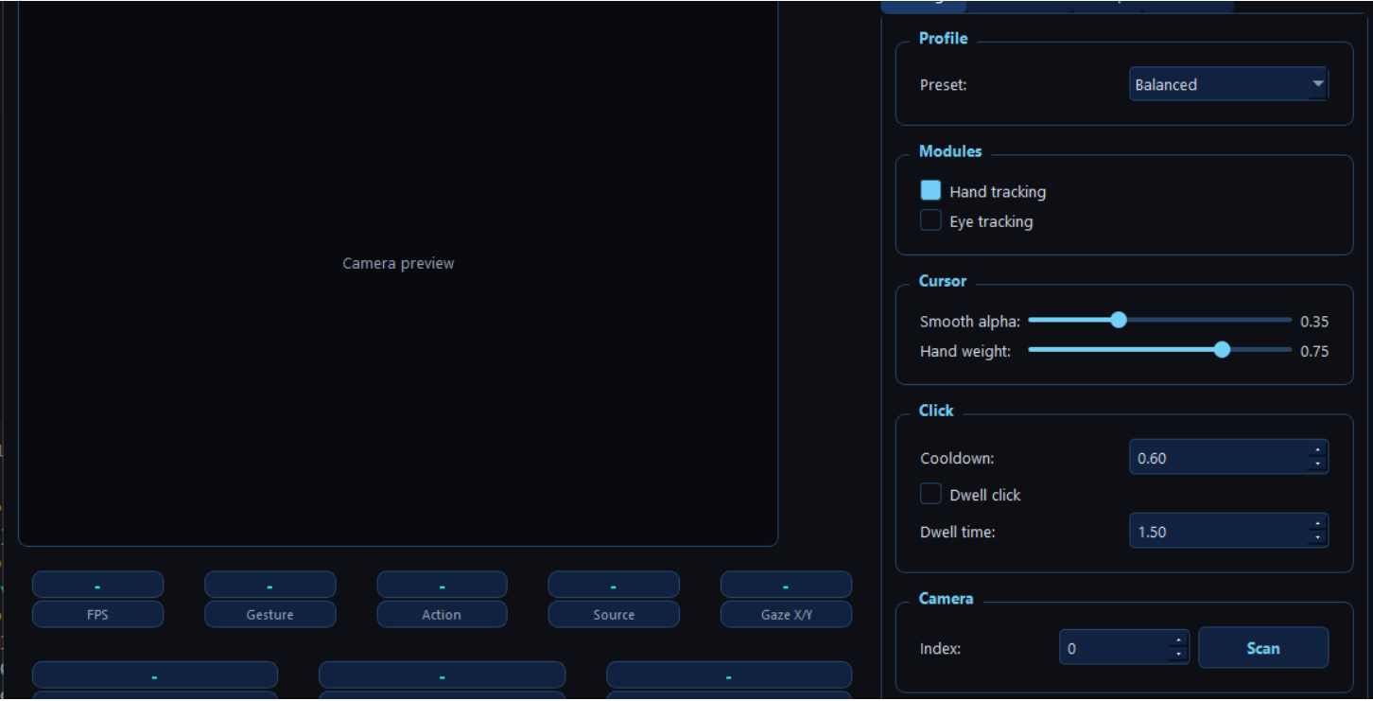
Figure 13: System Control Dashboard
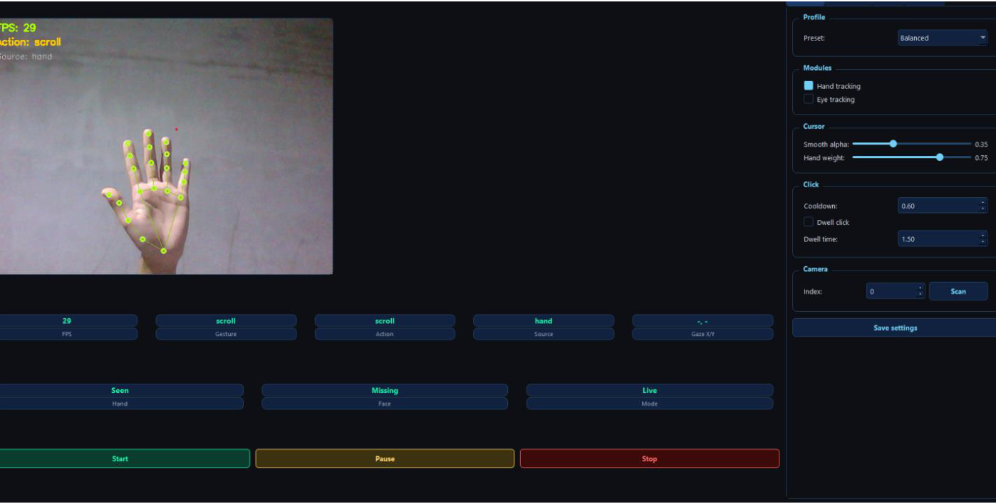
Figure 14: Real-time Hand and Eye Landmark Tracking

