**Feasibility Study**

**Project: Tutor-App**

Authors: Beniamin Rekala, Marvin Keiblinger, Vratislav Doronenko, Mahdi Mahmody, Hasan Kizilirmak

Abteilung für Informatik – Software Engineering, 5EHIF

Schuljahr 2021/22

Abstract

The following document will provide a general overview of our project. In the following pages the market analysis (target group, competitors, comparison) of our project and the technologies and variants we want to use in the project are determined. We then describe our available application capabilities and the challenges and strategies we face. Finally, we explain the feasibility of the project and specify in a few words our decision.

Table of Contents

Abstract 2

Table of Contents 3

1 Introduction 4

1.1 Project Background 4

1.2 Project Proposal 4

2 Project/Product Variants 5

2.1 Product Options 5

2.2 Product Scope 5

3 Technical and Architectural Options 6

3.1 Architectural Decisions 6

3.2 Frontend Technologies 6

3.3 Backend Technologies 6

3.4 Database Technologies 6

3.5 Architectural Overview 6

4 Available Skills 7

5 Risk & Mitigation 8

6 Summary and Feasibility Assesment 9

# Introduction

## Project Background

The existing tutor system at our school is very complicated and time-consuming. There is no precise plan on how to sign up for it. Communication via e-mail is also very poor and usually leads to nothing. It is rarely advertised by teachers and not at all by students. Furthermore, it is difficult for students to arrange a meetup and build study groups, because of the different schedules and subjects. For these reasons, we want to create an uncomplicated way of getting to know other students and learning together.

## Project Proposal

We want to create a mobile application and web application with a clear overview that is easy to use and to understand. Tutors can declare their schedule, costs, contact details and the subject they want to teach. Location options such as remote or present can be freely selected. If you chose “remote” you can share your screen with your tutor/student, so that u can work better together. Ratings will also be possible, for both students and tutors. There is also going to be a chat function to contact each other. For students that just have a small question, there will also be a Q&A section to ask and answers the questions. It is also possible to create study groups, where u can meet up with more people and study together.

# Market Study

## User Profile

The target audience are students from our school htl-donaustadt, that need tutoring or want to tutor. For the tutors it is beneficial, because they revise their knowledge and may earn some money on the side. For students that need tutoring it helps them learn and improve their grades. They also have the opportunity to ask questions in the Q&A section.

## Existing Products

|  |  |  |  |  |  |  |  |
| --- | --- | --- | --- | --- | --- | --- | --- |
|  | **NetSupportSchoolTutor** | **StudySmarter** | **OTOO TUTOR** | **tutorhunt.com** | **wyzant.com** | **tutor.id** | **Tutor App** |
| Rating | 4.2 ⭐ | 4.4 ⭐ | 3.4 ⭐ | 4.1 ⭐ | 4.1 ⭐ | 4.6 ⭐ | - |
| Price | Free In app payment Tutor payment | Free In app payment Tutor payment | Free In app payment Tutor payment | Free Tutor payment (ca. $ 40) | Free Tutor payment | Free Tutor payment (ca. $ 20) | Free Tutor payment |
| Chat | **✓** | **✓** | **✓** | **✓** | **✓** | **✓** | **✓** |
| Study groups | **X** | **✓** | **✓** | **✓** | **X** | **X** | **✓** |
| Online Lessons | **✓** | **✓** | **X** | **✓** | **✓** | **✓** | **✓** |
| Feedback  system | **✓** | **X** | **X** | **✓** | **✓** | **✓** | **✓** |
| Advanced  Whiteboard | **X** | **X** | **X** | **✓** | **X** | **X** | **X** |
| Q&A | **X** | **X** | **X** | **X** | **✓** | **X** | **✓** |
| Manage  lessons | **✓** | **X** | **X** | **✓** | **X** | **X** | **✓** |
| Individual teacher | **X** | **X** | **X** | **X** | **✓** | **X** | **X** |
| Free  Discovery  Lesson | **X** | **X** | **X** | **X** | **X** | **✓** | **X** |

If we compare the existing products with each other, we see that there is a very high demand. You can also see from the reviews that customers consider it is useful to use a tutor app. As you can see from the table, we want to implement many other features that make the other products so special, so that our product will stand out as the one with the most features.

We think that our project can hold its own in the market relatively well, since it has a lot more features than the existing ones as well as it will be cross-platform so it will appeal to a wider audience.

# Project/Product Variants

## Product Options

We have a mobile app and a web app. The mobile app is faster and easier to use, and you always have your mobile phone on you and can therefore access the mobile app at any time.

The web app has the advantage that it can be used on a laptop/computer. It also has more features such as streaming your screen and share your work with your student/tutor. It is also helpful when studying remote.

|  |  |  |
| --- | --- | --- |
|  | PRO | CON |
| Mobile app | Everyone has a mobile phone  Easier accessible | Application could be too big  An Android app won’t work on iOS |
| Website | You don’t need to download anything as a user  Web apps provide access to users on a wide range of devices | Website could go down (DDOS) |

We choose both, because with the mobile app you can arrange a meeting time uncomplicated. And it is easier to keep in touch with your tutor/student. It is also a lot more accessible.

The web app is helpful if you want to study remote, so you can share your screen and work together in subjects such as programming. The web app is usable for a wider range of devices therefore people without android phones will be able to benefit from our app.

## Product Scope

* We want to implement a chat function so that the tutor can communicate with the student.
* We want to let our users create a profile to use the mobile/web app. They will be able to choose between student or tutor.
* We want to implement a Q&A section where students can ask questions and others can answer it.
* We want the tutors to be able to declare their schedule, costs, contact details and the subject they want to teach.
* We want to have a list of tutors, from where the students can choose from. There will also be a filter to find a fitting tutor. Students will be able to request a tutor and the tutor can accept or reject it.
* The students can rate the tutor based on his teaching, vice versa.
* We want to implement a function to share your screen with the tutor/student.
* We want to implement the possibility to create study groups.

# Technical and Architectural Options

## Architectural Decisions

We want to use Java/XML for our mobile app, because we already have experience with it, because we used it in our last project.

We selected React for our web app because it is fast and not very complex. And it is also easy to learn and understand. And we already have some knowledge in JavaScript.

We want to use NodeJS as our backend, because we had JavaScript in our first semester and have basic knowledge in JavaScript.

We choose MySQL because we had MySQL in our second semester and will use it in our last year too, so we will get more knowledge over time.

## Frontend Technologies

|  |  |  |  |
| --- | --- | --- | --- |
| **Mobile App** | Compatibility | Documentation | Our knowledge |
| Xamarin | --------------------  Business logic in C# | --------------------  Sufficient documentation is available | --------------------  Little to non-existent |
| Flutter | ~~~~~~~~~~~~  Business logic in Dart | --------------------  Sufficient documentation is available | --------------------  Little to non-existent |
| **Java/XML** | --------------------  Business logic in Java | ~~~~~~~~~~~~  Documentation old | --------------------  Basic knowledge in Java |
| React Native | ~~~~~~~~~~~~  Business logic in JavaScript | --------------------  Sufficient documentation is available | --------------------  Little to non-existent |

We want to use Java/XML for our mobile app, because we already have experience with it, because we used it in our last project.

|  |  |  |  |
| --- | --- | --- | --- |
| **Web App** | Compatibility | Documentation | Our knowledge |
| HTML/CSS | --------------------  Basic HTML and CSS | --------------------  Sufficient documentation is available | --------------------  Good knowledge |
| **React** | ~~~~~~~~~~~~  Business logic in JavaScript | --------------------  Sufficient documentation is available | --------------------  Little to non-existent |
| Angular | ~~~~~~~~~~~~  Business logic in JavaScript | --------------------  Sufficient documentation is available | --------------------  Little to non-existent |

We want to use React for our web app, because the documentation is good and it is easier to learn, even though we do not have any experience with it. To create a dynamic web application specifically with HTML strings is tricky because it requires a complex coding, but React JS solved that issue and makes it easier. We also have knowledge in JavaScript.

## Backend Technologies

|  |  |  |  |
| --- | --- | --- | --- |
| **Server** | Compatibility | Documentation | Our knowledge |
| C#  ASP.NET | --------------------  Business logic in C# | --------------------  Sufficient documentation is available | --------------------  No experience with the Framework |
| Java  Spring | --------------------  Business logic in Java | ~~~~~~~~~~~~  Documentation old | --------------------  No experience with the Framework |
| **Node.js** | ~~~~~~~~~~~~  Business logic in JavaScript | --------------------  Sufficient documentation is available | --------------------  Good knowledge |

We want to use Node.js as our backend, because we had JavaScript in our first semester and have good knowledge in JavaScript.

## Database Technologies

|  |  |  |  |
| --- | --- | --- | --- |
| **Database** | Compatibility | Documentation | Our knowledge |
| MongoDB | --------------------  Fast and can store any format | --------------------  Sufficient documentation is available | --------------------  Little to non-existent |
| Redis | ~~~~~~~~~~~~  Saving JSON files is supported, but it is very complex | --------------------  Sufficient documentation is available | --------------------  Little to non-existent |
| Oracle | ~~~~~~~~~~~~  Saving JSON files is supported, but it is very complex | --------------------  Sufficient documentation is available | --------------------  One-year experience in Oracle |
| **MySQL** | --------------------  Fast and can store any format | ~~~~~~~~~~~  Limited documentation is available | --------------------  Good knowledge |

We choose MySQL because we had MySQL in our second semester and will use it in our last year too, so we will get more knowledge over time.

## Architectural Overview

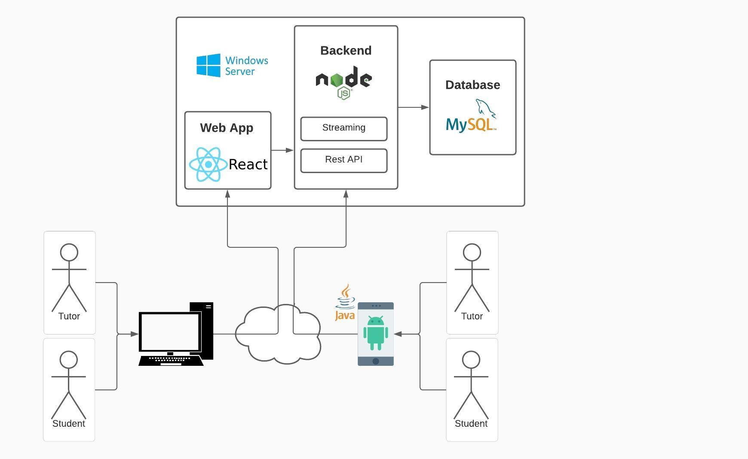

# Available Skills

|  |  |  |  |  |  |  |  |  |
| --- | --- | --- | --- | --- | --- | --- | --- | --- |
|  | C# | Java | NodeJS | MySQL | Oracle | HTML5  CSS | Firebase | JavaScript |
| Hasan | + | + | ~ | + | + | + | ~ | + |
| Mahdi | + | ~ | + | ~ | + | + | - | + |
| Beni | + | ~ | ~ | + | ~ | + | + | + |
| Vratislav | - | ~ | - | ~ | ~ | ~ | - | - |
| Marvin | + | + | ~ | + | + | ~ | ~ | ~ |

# Risk & Mitigation

**Web App:**

Our team does not really have a lot of experience with React, so we are going to fill that void by reading through documentation or watch tutorials.

**Division of work:**

Working together on different parts of the program is a challenge. The division should be fair and should not clash between the frontend and backend. Especially since everyone has different skills in the team, everyone should be assigned to their strengths individually, but this does not rule out working on the team's weaknesses.

**Database:**

Another challenge that the team will have to overcome will be to connect the application to the database and to write or read data from the program into the database. Nevertheless, we are hopefully positive, as our team consists of relatively good programmers and there is enough material, such as books and tutorials, to learn.

**Lockdown:**

Another problem we have is that there could be another lockdown. In this case the communication would be more difficult because we would not see each other. But since we have experience working in lockdown, the problem is easy to solve.

**Missing Manpower:**

One of the biggest problems we face as a team is that one team member might not be in the fifth grade. In this case we were understaffed, and the responsibilities would be mixed up. To prevent this, we gave people from our team who we know they will be in the next grade a second responsibility.

# Summary and Feasibility Assesment

**SUMMARY:**

We made the decision that we are going to use Java/XML for our mobile app, because we have experience with.

We selected React for our web app because it is fast and not very complex. And it is also easy to learn and understand. And we already have some knowledge in JavaScript.

We want to use Node.js as our backend, because we had JavaScript in our first semester and have good knowledge in JavaScript.

We choose MySQL because we had MySQL in our second semester and will use it in our last year too, so we will get more knowledge over time.

**Evaluation of our feasibility:**

We are sure that we can master the challenges which are going to approach us in the future because our team has significant good skills in many programming languages and we also want to learn new technologies. If we are going to experience any difficulties, then we will inform the experienced teaching staff from our school and ask for help.