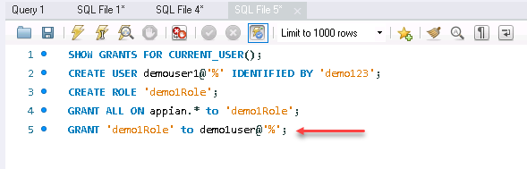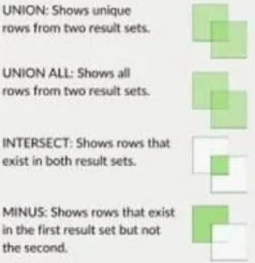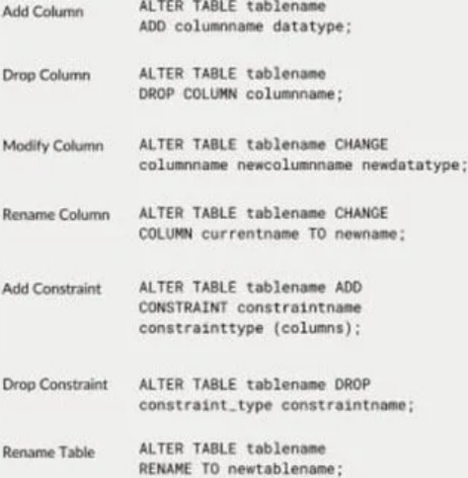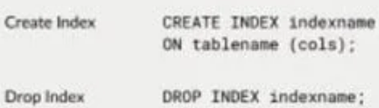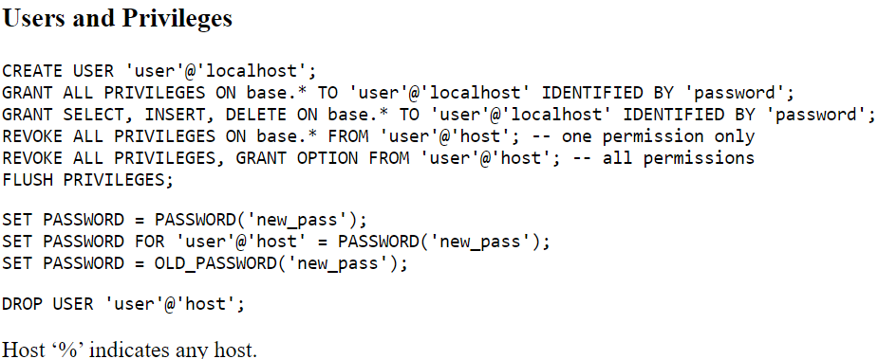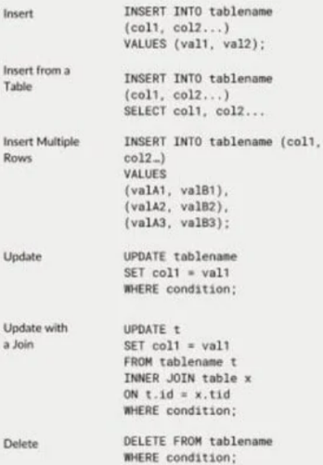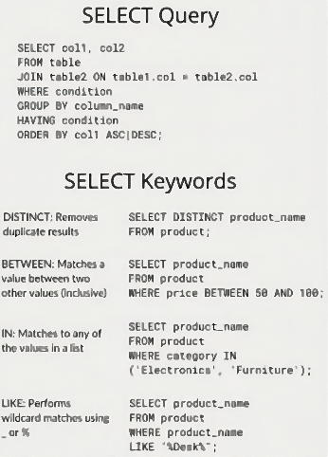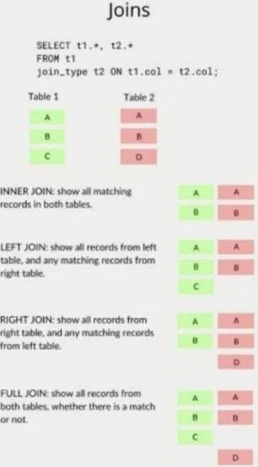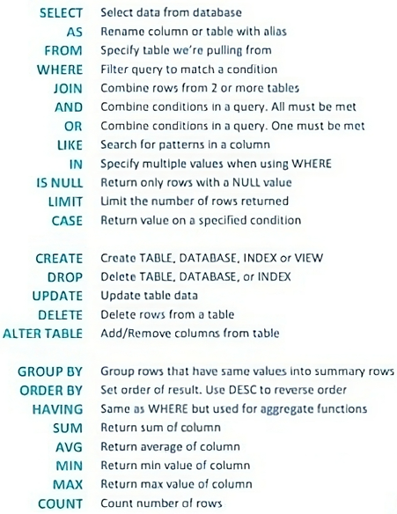V

