**Frontend Development with React.js**

1. **Introduction**
   * **Project Title**: Fit Flex
   * **Team Members**:
     + 1. **BENISHWAR S (Leader)**
       2. **RAHIM USHAMADEEN K**
       3. **RAM DINESH S**
       4. **SANTHOSH S**
2. **Project Overview**

Fit Flex aims to help users achieve their fitness goals by suggesting structured exercise routines based on their body metrics and exercise preferences. The website serves as a comprehensive fitness guide and shopping portal that promotes health and wellness.

1. **Architecture**
   * **Component Structure**: Outline the structure of major React components and how they interact.
   * **State Management**: Describe the state management approach used (e.g., Context API, Redux).
   * **Routing**: Explain the routing structure if using react-router or another routing library.
2. **Setup Instructions**
   * **Prerequisites**: List software dependencies (e.g., Node.js).
   * **Installation**: Provide a step-by-step guide to clone the repository, install dependencies, and configure environment variables.
3. **Folder Structure**
   * **Client**: Describe the organization of the React application, including folders like components, pages, assets, etc.
   * **Utilities**: Explain any helper functions, utility classes, or custom hooks used in the project.
4. **Running the Application**
   * Visual Studio Code
   * **Frontend**: npm start in the client directory.
5. **State Management**
   * **Global State**: Describe global state management and how state flows across the application.
   * **Local State**: Explain the handling of local states within components.
6. **User Interface**

.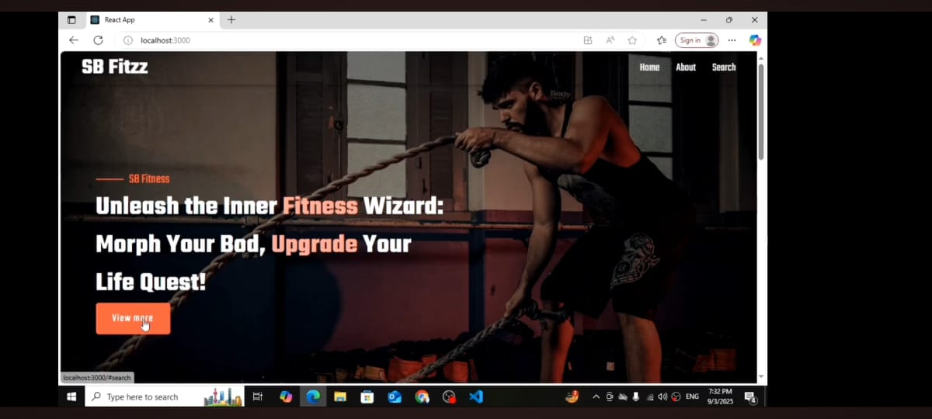

1. **Styling**

* **CSS Frameworks/Libraries**: Describe any CSS frameworks, libraries, or pre-processors (e.g., Sass, Styled-Components) used.
* **Theming**: Explain if theming or custom design systems are implemented.

1. **Testing**

* A website testing strategy ensures quality by checking functionality, usability, compatibility, performance, and security before launch. It involves testing features, user experience, browser/device support, speed, and vulnerabilities, followed by regression and user acceptance testing

.

1. **Screenshots or Demo**

<https://drive.google.com/file/d/19ARysqR113xfnuF5-HJ4Dzj0kzCRh30K/view?usp=drivesdk>

1. **Known Issues**

* Lack of live chat or immediate assistance may frustrate users seeking quick help or guidance
* Current exercise plans may not fully account for all individual health conditions or fitness levels, leading to less precise recommendations.

1. **Future Enhancements**

* Incorporate AI-driven fitness assessments and adaptive workout plans that evolve based on user progress and feedback.
* Create dedicated mobile apps for ios and Android to provide users with fitness guidance on the go.