**Section 1: Application Installation**

The application installation process has one stage, The application installation. This installs the database upon the application running

**Step 1:**

* **Locate the installer**

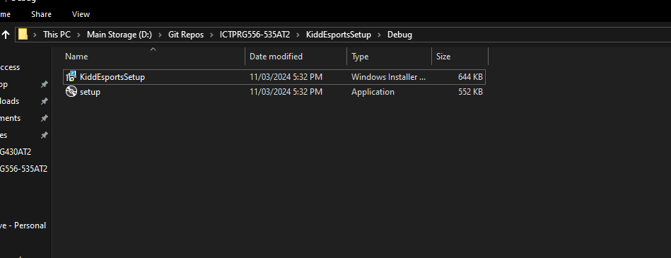

Go to the directory that the installer was downloaded to and double-click on the KiddEsportsSetup application installer

**Step 2**

* **Follow installation setup and select the download directory**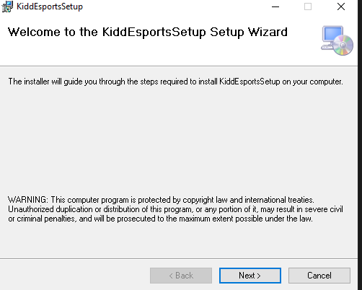

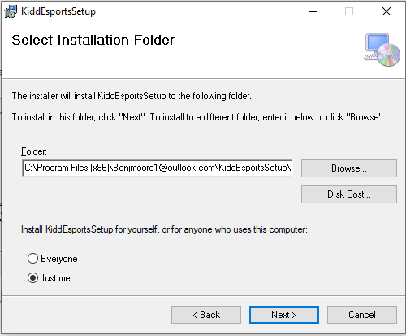

**Step 3**

* **Locate the installation folder**
  + Navigate to the installation folder chosen in the installation setup

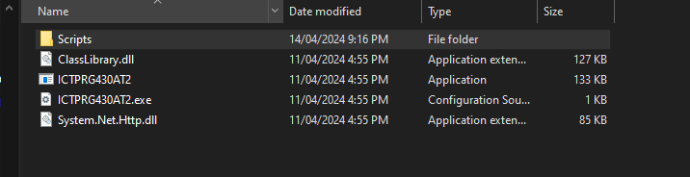

**Step 4**

* **Run the application**

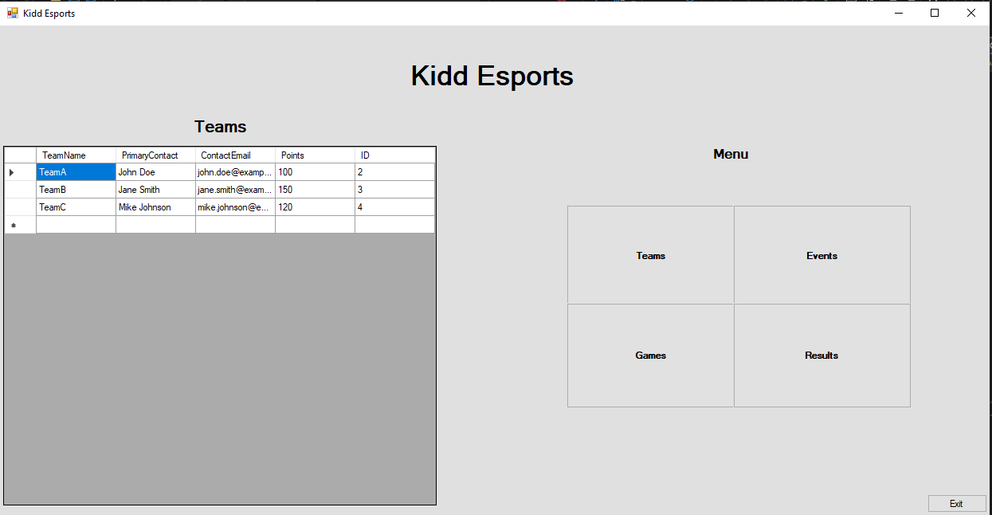

**Note: If there are any issue with creating the sql tables or database, please use the scripts folder as follows:**

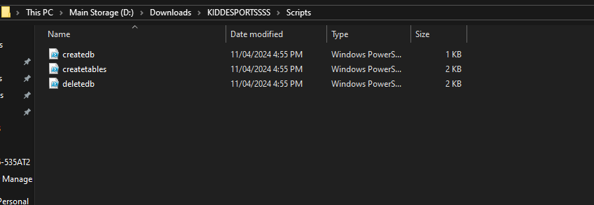

* **Open the folder**
* **Left-click on the createdb file**
* **Select run with powershell**
* **Left-click on the createtables file**
* **Select run with powershell**
* **Restart the application**

**Section 2: Application unistallation**

The Application uninstallation process has two stages, the application uninstallation and the database uninstallation.

* *Step 1: Locate installer*
  + To locate the installer, either go to the folder this was downloaded to initially or through the control panel >> Uninstall

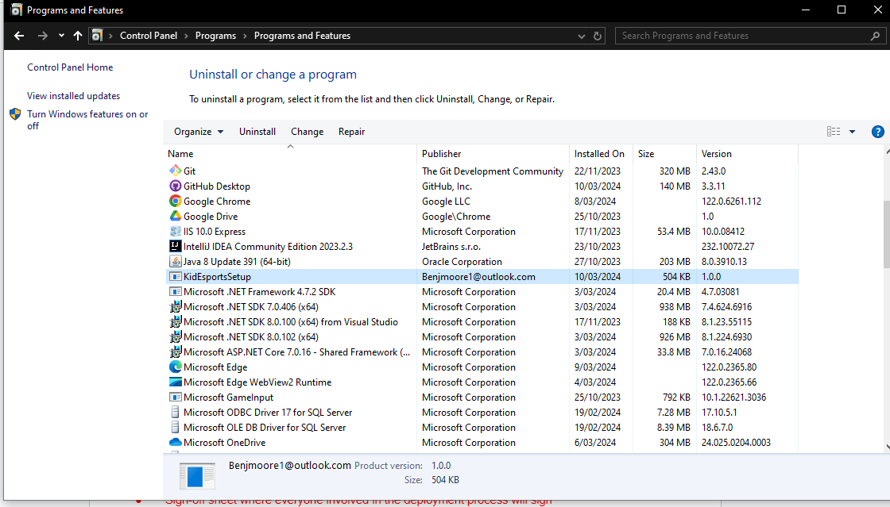

* Step 2: Select Uninstall
  + Either open the installer and select remove or select uninstall on the control panel to remove the application

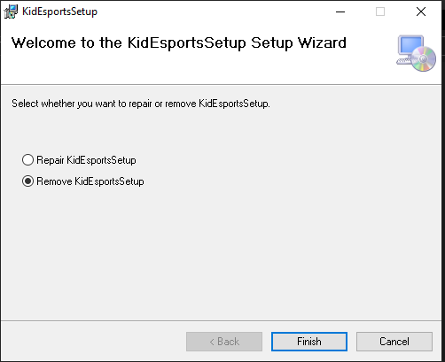

*This will complete the uninstallation of the user application*

* Database uninstallation
  + To uninstall the database the DeleteDB PowerShell file needs to be run
    - Select the Scripts folder in the download directory

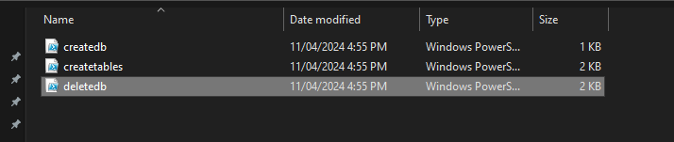

* + - Left click on the deletedb file
    - Select run with PowerShell
    - The database is now uninstalled