|  |
| --- |

| **Software Installation Plan** |
| --- |
| KiddEsports Data Management |
|  |
|  |
|  |
| **Benjamin Moore** |
| **ICTPRG543** |

**Table of Contents**

Introduction 2

Objectives 2

Installation Method 2

Checklist – Server System Requirements 2

Checklist – Client System Requirements 3

Checklist – Security and Organisational Requirements 3

Checklist – Pre-installation Tasks and Resource Requirements 3

Data Requirements 3

Installation Procedure – Application and Database 4

Post-Installation Tasks 4

Uninstallation Procedure 4

Sign-Off 4

# Introduction

An efficient application is required for Kidd Esports, a junior Esports organisation, to effectively track event results. After the creation of the application is finished, it is imperative to deploy it onto Mark's laptop for preliminary testing and assessment. This document offers a thorough installation strategy designed to satisfy Kidd Esports' unique needs, guaranteeing a seamless and effective deployment procedure

# Objectives

* Assist Mark in installing the application on his laptop by providing step-by-step instructions to guarantee setup simplicity.
* Ensure that the application can be uninstalled, making it easy to remove if needed.
* Create the database empty, meaning that it will contain no data at all. Additionally, provide a SQL script so that the database can be created.
* Establish strong security protocols by limiting application permissions in SQL Server with a dedicated user account.

# Installation Method

The Kidd Esports application will be installed using a Windows Installer (MSI) package. This option was selected to provide a smooth setup process for Mark's laptop due to its guided installation processes and ease of deployment.

We will be present during the installation to facilitate user engagement and configuration as needed. This method guarantees that any particular needs or desires can be met while the installation is being done. An attended installation also guarantees correct setup and lowers the possibility of problems. Additionally, the installation will be made to support silent installation in case it needs to be deployed in the future across several systems. This will simplify the procedure for larger-scale deployments by enabling automated installs without the need for human participation. When it comes to dependability and ease of maintenance, the MSI package outperforms other installation techniques like scripts or third-party tools. It offers a uniform format for the application's packaging and guarantees Windows operating system compatibility.

All things considered, the MSI installation method offers a reliable and effective way to install the Kidd Esports application on Mark's laptop and makes future deployments easier.

# Checklist – Server System Requirements

* Disk space: Make sure there is enough space on the drive to hold the SQL Server databases, application files, and any temporary files created during setup and use. It is advised to have at least 100 GB of free disc space to handle future development.
* Processor and RAM: To manage the workload of running SQL Server and providing the application, the server needs to have a powerful processor and enough RAM. For best results, a quad-core processor with at least 8 GB of RAM is advised.
* Software:
  + Operating system: To host SQL Server and give the program a reliable environment, Windows Server 2016 or later is advised.
  + Database management system: To meet the database requirements of the application, SQL Server 2017 Express Edition or above is needed.
  + Make sure SQL Server licensing is up to date to meet legal obligations.
* Configuration files: Ensure that SQL Server and the application have all the required configuration files installed and available. These files might contain database connections, security setups, and network protocol settings.
* Dynamic Link Libraries (DLL): Verify that all DLL files necessary for the program and SQL Server are installed and set up properly. These libraries contain parts for database connectivity or other features that the application needs.
* System Environment Variables: For the programme or SQL Server to function properly, make sure that all necessary system environment variables are checked and set up. Paths to executable files, temporary directories, and configuration files are examples of these variables.

We can offer a dependable and stable hosting environment for the Kidd Esports software and its related database, guaranteeing seamless functioning and peak performance, by making sure the server satisfies these prerequisites.

Checklist – Client System Requirements

The client machine must meet certain software and hardware requirements to access the deployed application. The following is a list of topics that are pertinent to the deployment project and methodology:

* Disk space: Make sure the client machine has enough disc space to hold the application files and any extra data produced while using it. For optimal performance, a minimum of 10 GB of free disc space should be available.
* Processor and RAM: For the client system to operate the application effectively, it must have a powerful processor and enough RAM. For best results, a dual-core processor with at least 4 GB of RAM is advised.
* Software
  + Operating system: For the application to function, the client system must be running a compatible operating system. To ensure Kidd Esports application compatibility, Windows 10 Home or above is advised.
  + Database management system: If the application requires it, the client system should have compatible database management system components installed, even though it might not host the database directly.
  + Verify the licences required for database connectivity.
  + Configuration files: Check that the client machine has the necessary configuration files installed for the program. User preferences, network connectivity, and programme behaviour settings could be contained in these files.
* Dynamic Link Libraries (DLL): Verify that the client system has all necessary DLL files installed and configured appropriately for the program. These libraries might have graphical user interface components, database connectivity components, or other application-specific features.
* System Environment Variables: For the program to function properly, make sure that all necessary system environment variables are checked and set up. Paths to executable files, temporary directories, and configuration files are examples of these variables.

Through the fulfilment of these prerequisites by the client system, users will be able to access and make use of the Kidd Esports application with maximum efficiency and usefulness.

# Checklist – Security and Organisational Requirements

* **Database Security:**
* It's important to include database security features like encryption and access limits in order to ensure the security and privacy of the application's data.
* Regular updating of database credentials, including passwords and access permissions, mitigates the risk of unauthorised access or data breaches.
* **Patch Management:**
* One way to keep the application secure is to patch it frequently or whenever the user requests it.
* Finding application vulnerabilities that hackers may exploit is made easier with the development of security monitoring technologies.
* **User Training and Awareness:**
* Provide comprehensive training and awareness programs to educate users about security best practices, such as password management, data protection, and phishing awareness.
* Encourage users to report any security incidents or suspicious activities promptly to the appropriate authorities.
* **Incident Response Plan:**
* Develop and maintain an incident response plan outlining procedures for detecting, analyzing, and responding to security incidents or breaches.
* Establish clear communication channels and escalation paths to facilitate rapid response and resolution of security incidents.

# 

# 

# Checklist – Pre-installation Tasks and Resource Requirements

**Compile the application in release mode**

* Ensuring that the application code is properly compiled in release mode ensures optimal performance and minimizes the file size.
* Verifying that all the dependencies and the libraries are properly included in the compiled app.

**Complete the installation file/script**

* Using a proper installer tool to create the installation package, making sure to include a setup wizard for client-friendly installation.
* Including different options for the configuration of the installation directories, the database settings and any other preferences.

**Test the install program**

* Performing thorough testing of the installation program, ensuring it installs the application as expected and correctly.
* Testing multiple installation situations, including (but not limited to) different operating systems and different configurations.
* Verifying that the installation process is as simple and error/bug-free as possible, with clear and understandable instructions for the client.

**Verify Folder permissions**

* Ensuring that the installation directories and folders needed for the app have the correct access permissions.
* Verifying that the client has access to the correct and necessary permissions for the installation program to append to the installation directory.

**Verify Server permissions**

* Verifying that the SQL Server instance has the correct and necessary permissions to create any databases and manage client accounts and information.
* Ensuring that the client account and information used by the application has the necessary permissions to not only access the database but also perform the required operations.

# Data Requirements

* **Data Requirements**
  + The application requires a database to store event results, including information about participants, teams, matches, and scores.
  + Tables such as ‘Participants’, ‘Teams’, ‘Matches’, and ‘Scores’ are likely needed to store relevant information about the events and participants.
* **Pre-populated default values**
  + Given the application requirements, all of the tables require their own base values to ensure an easy and seamless operation and provide a consistent user experience. However, the application can also function as intended without the previously mentioned base values.
  + For example, tables like Events and Teams may benefit from having initial values for attributes such as event names and team names.
  + declaring initial values also helps ensure a streamlined user experience as it reduces the need for manual data entry and that the essential data is available.
* **Data Migration**
  + Handwritten information and Excel documents are provided but will not be migrated over the installation.

# Installation Procedure – Application and Database

Refer to section one of the Installation Guide

# Post-Installation Tasks

* Upon installation, the ClassLibrary User is created and has readwrite permissions.
* A database backup should be made regularly, it is recommended to back up the database to either a secondary physical or cloud location.
* Future updates can be installed using the new installer according to their version
* Once installed the user can add security to the application by creating a user account to access the database, This can be done through the Scripts folder as shown

Locate your scripts folder in the installation folder of your application

* + 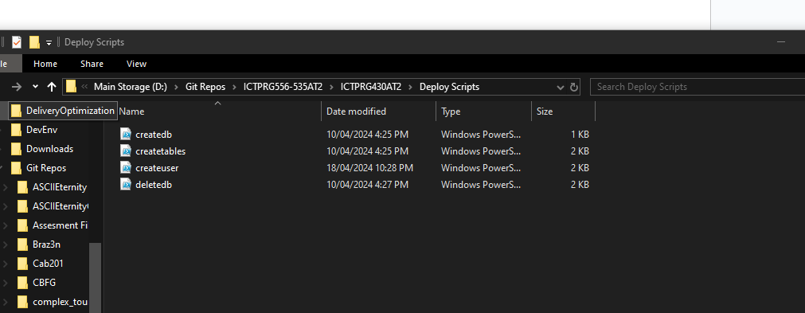
  + Select the createuser file and right-click
  + Select open in Notepad (or any text editor other than Word)
  + 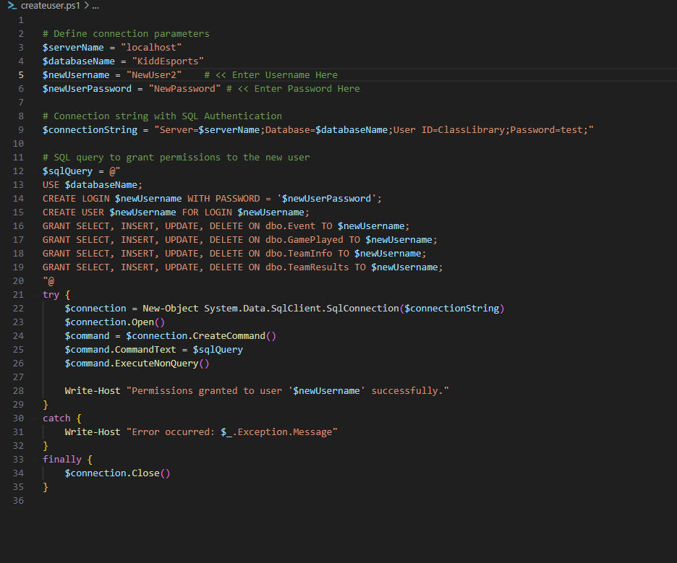
  + Change the username and password as shown in the file
  + Save
  + Go to the file again and right click >> run with powershell
  + You can now use MySQL browser or any console browser to access the local database. Since the application creates an account on installation, this is not necessary but will allow you to change the password of the ClassLibrary account or monitor any access permissions.

# Uninstallation Procedure

The Application uninstallation process has two stages, the application uninstallation and the database uninstallation.

**Application unistallation**

* *Step 1: Locate installer*
  + To locate the installer, either go to the folder this was downloaded to initially or through the control panel >> Uninstall

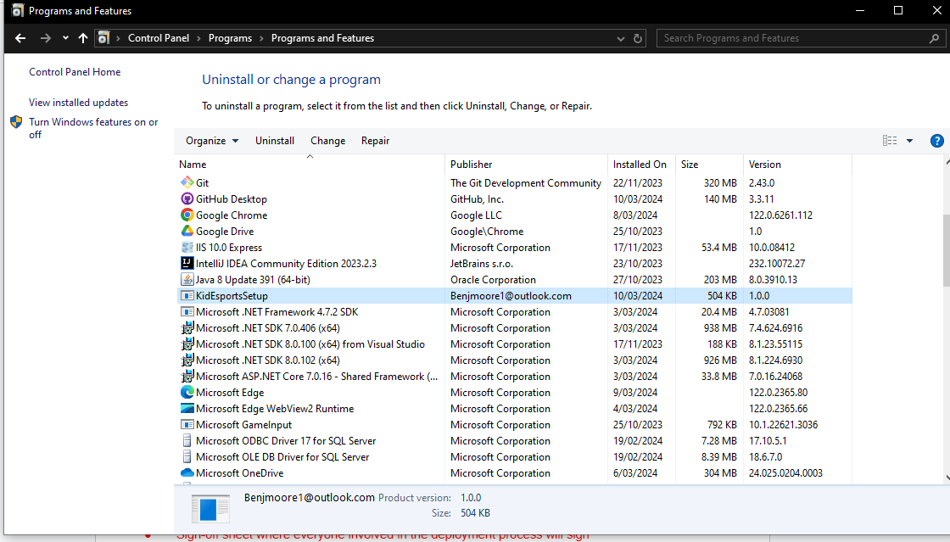

* Step 2: Select Uninstall
  + Either open the installer and select remove or select uninstall on the control panel to remove the application

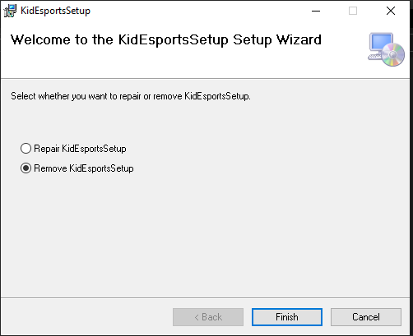

*This will complete the uninstallation of the user application*

* Database uninstallation
  + To uninstall the database the DeleteDB PowerShell file needs to be run
    - Select the Scripts folder in the download directory

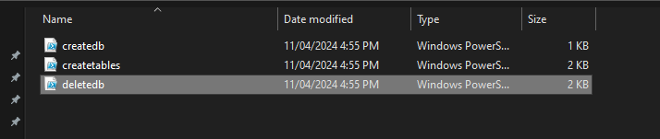

* + - Left click on the deletedb file
    - Select run with PowerShell
    - The database is now uninstalled

# Sign-Off

| **Project Name:** | Kidd Esports Data | | |
| --- | --- | --- | --- |
| **Project Manager:** | Benjamin Moore | | |
| **Start Date:** | 01/03/24 | | |
| **Completion Date:** | 11/03/24 | | |
| **Project Deliverables:** | | | |
| Installation package for user interface and class library | | | |
| Uninstallation functionality in the installer package | | | |
| Application functionality to create a database | | | |
| Script to uninstall the database | | | |
| Installation plan for application installation and uninstallation | | | |
|  | | | |
|  | | | |
|  | | | |
|  | | | |
|  | | | |
|  | | | |
|  | | | |
| ***I acknowledge that I have ran the install package in the Production Environment and submitted the installation guide as per your instructions.*** | | | |
| Benjamin Moore | |  | 10/03/24 |
| **Programmer’s Name** | | **Signature** | **Date** |
| Benjamin moore | |  | 10/03/24 |
| **Project Manager** | | **Signature** | **Date** |