|  |
| --- |





| **Technical Report** |
| --- |
| ICTPRG534 – Deploy applications to production environments |
|  |
|  |
|  |
| **Benjamin Moore** |
| **10/05/2023** |
|  |

**Table of Contents**

Task 1 - Email 2

Task 2 – Software Installation Plan 2

Task 3 – Email 2

Task 4 – Installation and Uninstall Package 2

Task 5 – Installation 2

Task 6 – Un-Installation 2

Task 7 – Install/Uninstall Review 3

Task 8 – Production Installation 3

Task 9 – Installation Sign-Off 3

Task 10 – Post Deployment Report Email 4

Task 11 – Deployment Sign-Off 4

# Task 1 - Email

* Screenshot of the hypothetical email to the Project Manager Reviewing the provided business case scenario and program specifications

To: Project Manager / Manager

From:

CC:

BCC:

Date: 11/03/24

Subject: Request for Program Specifications and Standards

-------------------------------------------------------------

Hi Project Manager,

Regarding the Program Specifications and the Organisation’s Programming and Documentation Standards

The program has been determined that it needs to have the ability to save, edit, add and search through a list of birthdays and personal information in order for the application to function properly. this will be implemented through a saved array and a read/write method. The specifications of the project will be followed. Please specify your organisation's programming and documentation standards before development proceeds to ensure that they are in line with other softwares that your company has developed.

If you have any queries please reach out.

Regards,

Benjamin Moore

----------------------------------------------

Benjamin Moore

Lead Developer@UptownIT.com.au

-----------------------------------------------

# Task 2 – Software Installation Plan

* Prepare a Software Installation Plan, include a reference to the completed Installation plan here.

Included in submission

# Task 3 – Email

* Screenshot of the hypothetical email to the Project Manager to verify that the client and server system meet the system and security requirements for the installation of the application.

To: Project Manager / Manager

From:

CC:

BCC:

Date: 11/03/24

Subject: Verification of server system requirements

-------------------------------------------------------------

Hi Project Manager,

Regarding the Verification of server system requirements

The program has been determined that it needs to have the ability to save, edit, add and search through a list of birthdays and personal information for the application to function properly. this will be implemented through a saved array and a read/write method. The specifications of the project will be followed. Please specify your organisation's programming and documentation standards before development proceeds to ensure that they are in line with other software that your company has developed.

If you have any queries please reach out.

Regards,

Benjamin Moore

----------------------------------------------

Benjamin Moore

Lead Developer@UptownIT.com.au

-----------------------------------------------

# Task 4 – Installation and Uninstall Package

* Provide a screenshot of the developed Installation package

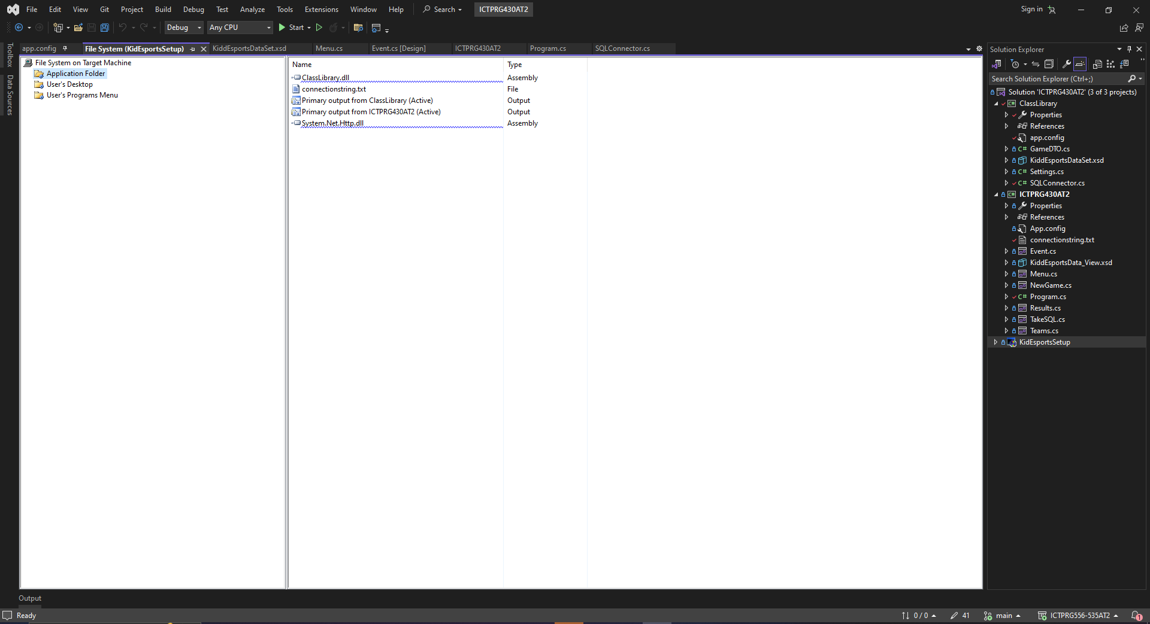

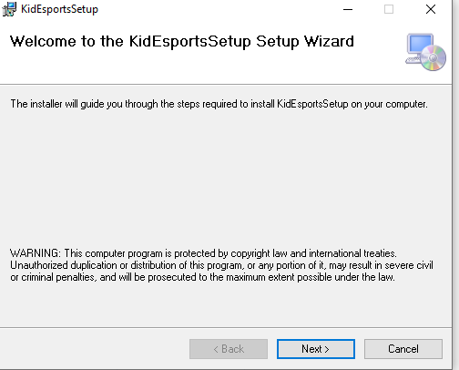

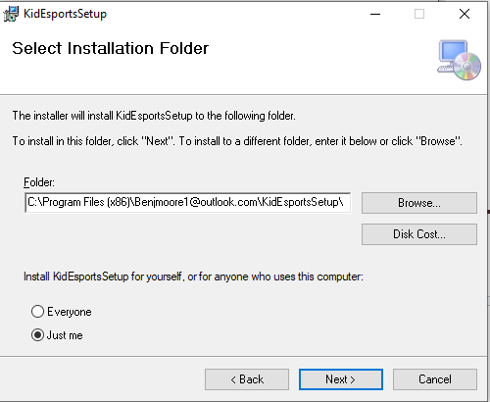

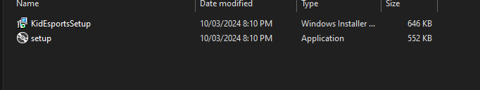

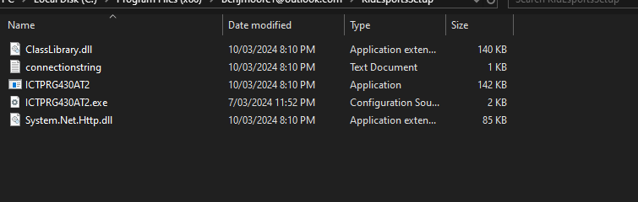

* Provide a screenshot of the developed Uninstallation packaged

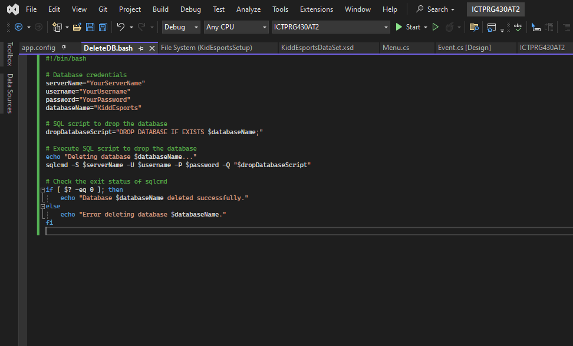

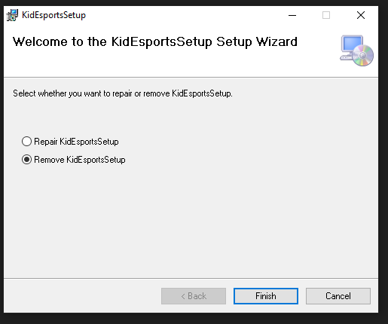

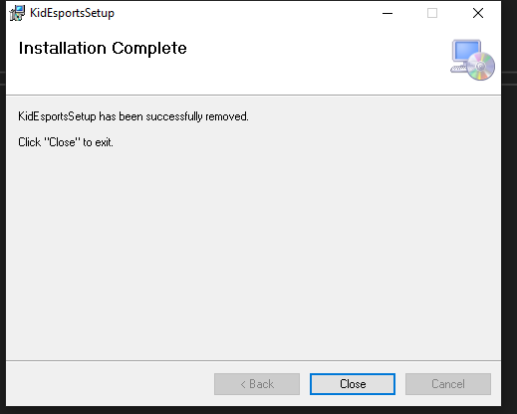

# Task 5 – Installation

* Provided in the installation guide

# Task 6 – Un-Installation

* Provided in the installation guide

# 

# Task 7 – Install/Uninstall Review

There were a few issues throughout the creation of the install and uninstall application package. The main issue faced was ensuring that connection strings were correctly parsed into the application, the initial idea was to use a file reader and a text file to input the connection string into the application properties. This was ineffective and did not work correctly, However, using the executable properties once the application has been built proves to be effective on the machine.

# Task 8 – Production Installation

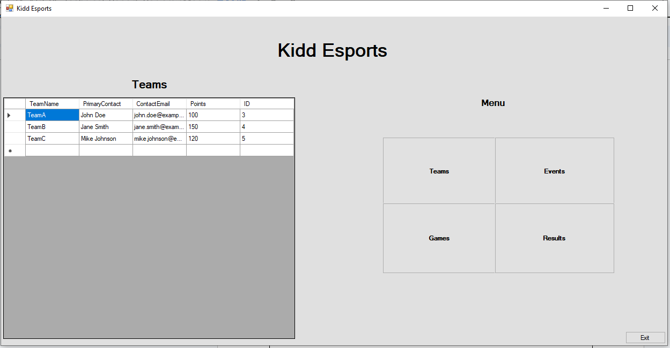

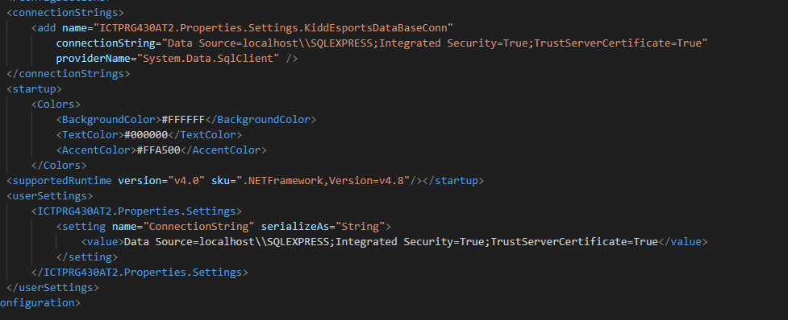

# 

# Task 9 – Installation Sign-Off

# 

| **Project Name:** | Kidd Esports Data | | |
| --- | --- | --- | --- |
| **Project Manager:** | Benjamin Moore | | |
| **Start Date:** | 01/03/24 | | |
| **Completion Date:** | 11/03/24 | | |
| **Project Deliverables:** | | | |
| Installation package for user interface and class library | | | |
| Uninstallation functionality in the installer package | | | |
| Application functionality to create a database | | | |
| Script to uninstall the database | | | |
| Installation plan for application installation and uninstallation | | | |
|  | | | |
|  | | | |
|  | | | |
|  | | | |
|  | | | |
|  | | | |
|  | | | |
| ***I acknowledge that I have ran the install package in the Production Environment and submitted the installation guide as per your instructions.*** | | | |
| Benjamin Moore | |  | 10/03/24 |
| **Programmer’s Name** | | **Signature** | **Date** |
| Benjamin moore | |  | 10/03/24 |
| **Project Manager** | | **Signature** | **Date** |

# 

# Task 10 – Post Deployment Report Email

* Screenshot of the hypothetical email to the Project Manager to verify the deployment of the database and tasks performed post-installation such as changing the Connection String or the URL or End-Point of the backend.
* Ensure the Email contains at least 1 screenshot of each point below, alongside a description of the screenshot or process demonstrated in the screenshot.

To: Project Manager / Manager

From:

CC:

BCC:

Date: 11/03/24

Subject: Deployment Report

-------------------------------------------------------------

Hi Project Manager,

Regarding the deployment of the production application and database packages,

I'm writing this email to inform you that the post-installation tasks worked accordingly. The Connection string was changed to the production connection string, the database has also been populated with the correct rows and tables for the data to be transferred. Please see the screenshots attached for the validation of the production application;

If you have any queries please reach out.

Regards,

Benjamin Moore

----------------------------------------------

Benjamin Moore

Lead Developer@UptownIT.com.au

-----------------------------------------------

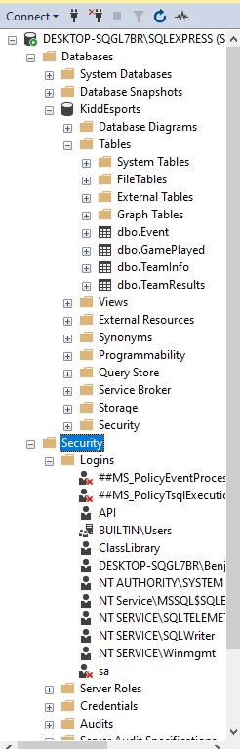

* + The deployment of the database.
  + A configuration file that shows any configured parameters, variables, and connection strings of the database that are valid for the production environment.

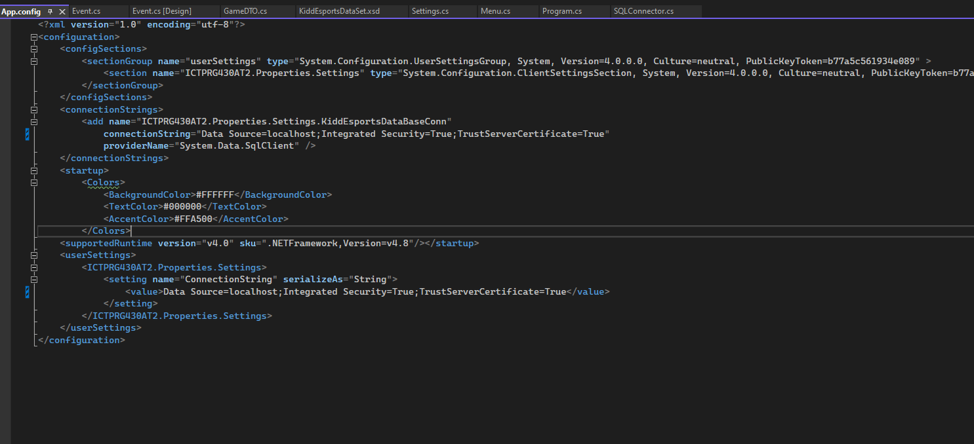

* + Configured security features of the application or database such as user role, privilege or permissions parameters.

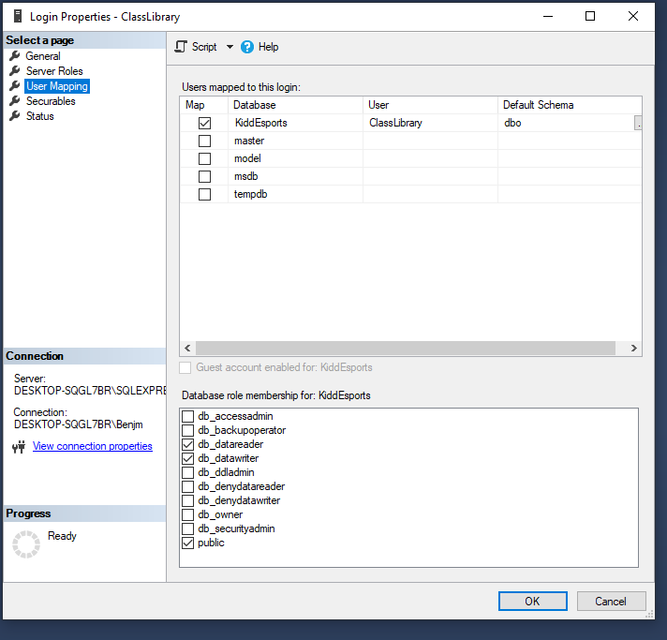

* + The deployed application returning data from the deployed database

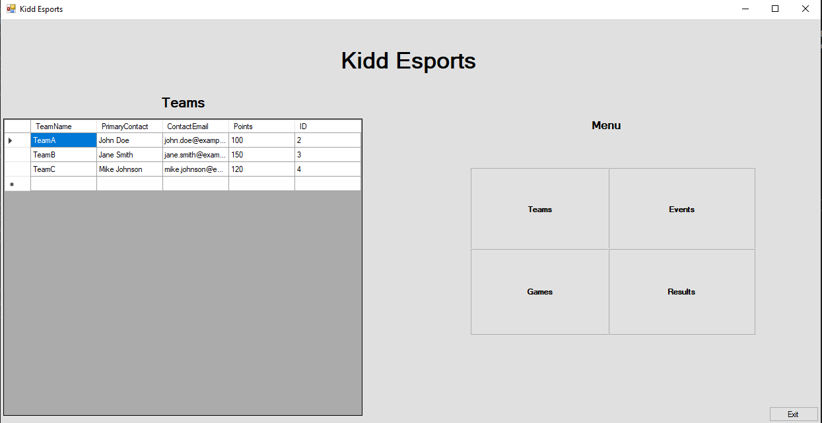

# Task 11 – Deployment Sign-Off

| **Project Name:** | Kidd Esports Data Management | | |
| --- | --- | --- | --- |
| **Project Manager:** | Benjamin Moore | | |
| **Start Date:** | 04/03/24 | | |
| **Completion Date:** | 11/03/24 | | |
| **Project Deliverables:** | | | |
| Frontend KiddEsports Data Management Application | | | |
| KiddEsports Database Creation and population scripts | | | |
| KiddEsports Installation and Uninstallation packages | | | |
| KiddEsports Installation Guide | | | |
| KiddEsports Installation Plan | | | |
| KiddEsports Technical Report | | | |
|  | | | |
|  | | | |
|  | | | |
|  | | | |
|  | | | |
|  | | | |
| ***I acknowledge that I have deployed the application as per the Installation plan and have completed and provided all required documentation*** | | | |
| Benjamin Moore | |  | 11/03/24 |
| **Programmer’s Name** | | **Signature** | **Date** |
|  | |  |  |
| **Project Manager** | | **Signature** | **Date** |