欢迎使用

英雄联盟预测系统
  - 使用Python3.9构建的简单胜率计算系统

系统介绍
本系统由Python3.9构建，通过收集并统计韩服在2021.12.10-2021.12.20超凡大师及以上段位的5000+场排位赛数据，计算用户所给BP后阵容胜方胜率。预测结果通过PyQt5实现可视化。

使用准备
在使用之前，请确保您的电脑已正确安装Python，并已加入到Path，且Python版本大于等于3.9。本程序在Windows 11 X64系统下构建，不保证在其他平台(Linux,MacOS等)上能正确运行。请确保您使用的系统推荐显示缩放，且显示分辨率大于1280×720，否则可能会出现显示错误。
Prediction.zip为压缩后的程序主体。请先将整个压缩包内的文件夹解压到您可以找到的目录，并打开Prediction文件夹。
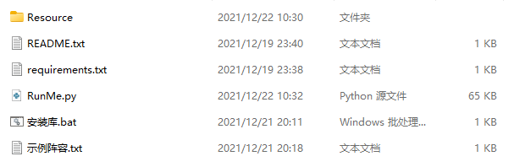
请首先双击安装库.bat，安装运行必需的库文件。请确保您的Python已加入Path。双击后，该批处理文件会自动安装所需库。

您可以通过阅读README.txt获取帮助。
开始使用
使用Python或Python IDLE或其他编译器运行RunMe.py。
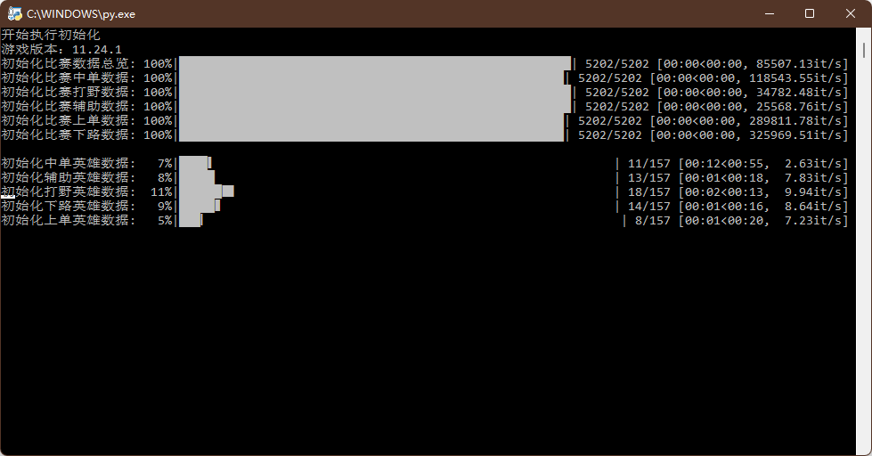
每次使用前，程序会自动进行初始化，总耗时应在2分钟之内。您可以在终端界面上查看初始化进度。
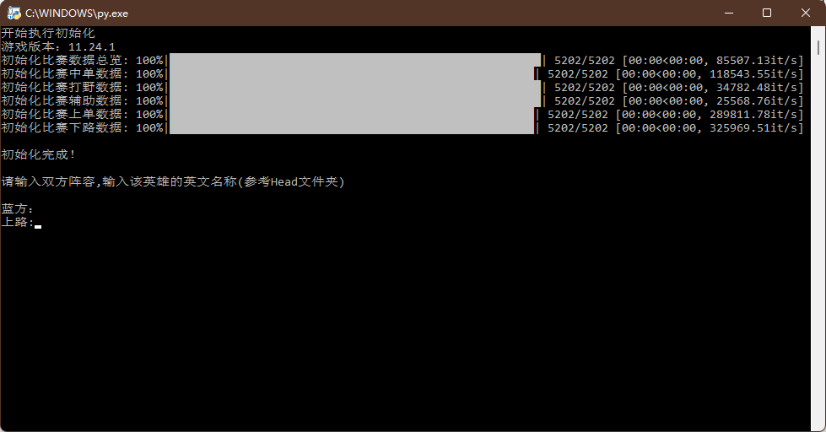
初始化完成后，请您按提示分别输入红蓝方的上路、打野、中路、下路和辅助所用英雄。每次输入完一个分路后请轻敲回车。
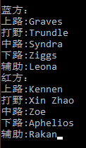

这样即为正确的输入方式。

预测结果读取
在您正确地输入双方阵容后，终端上会展示蓝方的预测胜率.
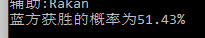
同时会生成一个用于展示预测数据的窗口。
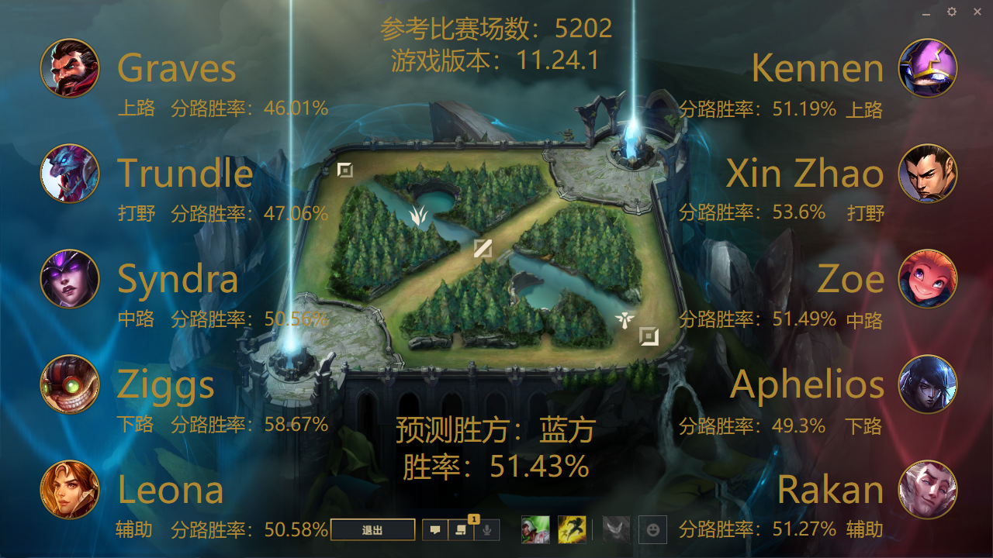
该界面展示双方所选英雄在该分路的胜率，预测胜率通过双方对位胜率计算。该界面可通过单击右上角的“X”和下方的“退出”关闭，单击右上角“-”最小化。
使用实例
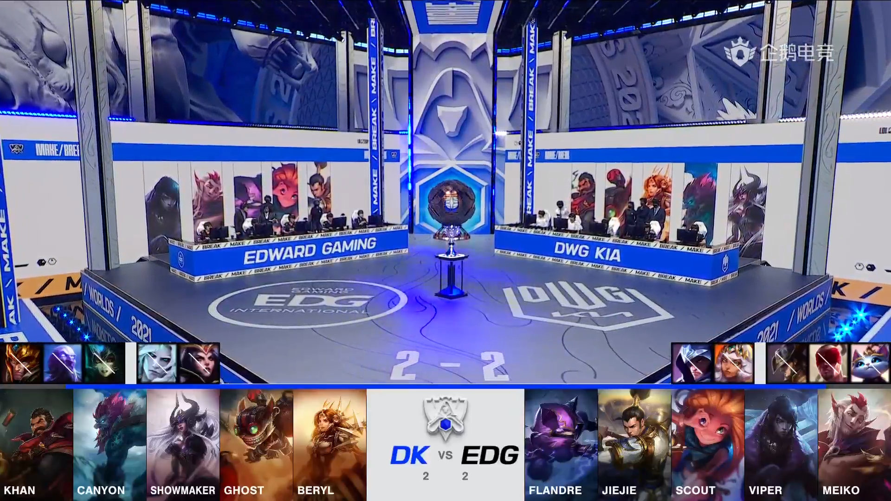
2021年11月7日凌晨，EDG完成了与DK的第五场比赛，拿下了2021年英雄联盟全球总决赛的冠军。在第五场比赛BP结束后，大家都为EDG的输赢而担忧。接下来，我们使用该系统预测该场比赛EDG的胜率。
我们先获取比赛双方的阵容：
DK（蓝方）：Graves，Trundle，Syndra，Ziggs，Leona
EDG（红方）：Kennen，Xin Zhao，Zoe，Aphelios，Rakan
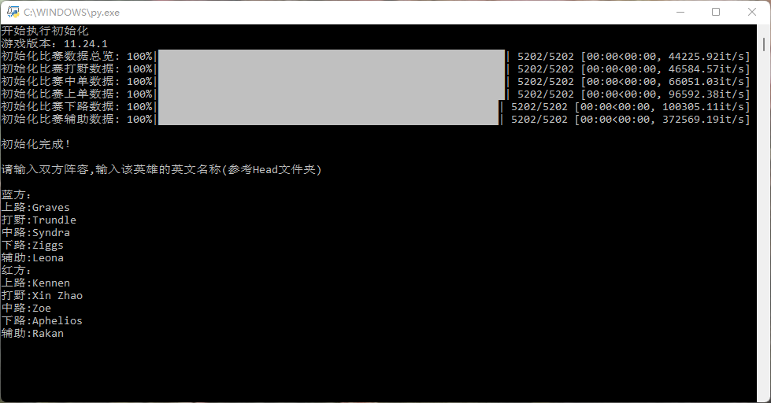
我们运行程序，将双方阵容输入到终端中：
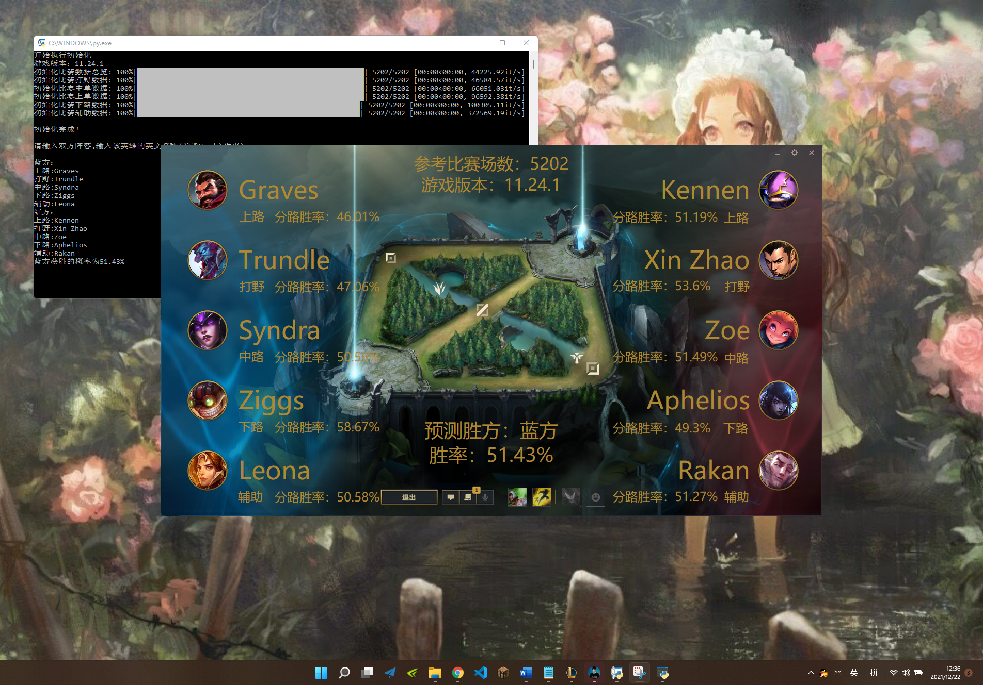
获得以下数据：
可以看出，从阵容来看的话，DK的获胜概率是略高的。这样的预测结果与网络上主流的预测结果是相似的。但由于EDG出战人员基础扎实，合作共赢，最终赢得了这场比赛。

注意事项
若RunMe.py运行失败，请仔细阅读报错内容，查看是否有文件未解压或文件位置错误。一般情况下，直接将压缩包解压是最好的方法
请不要尝试修改Resource文件夹中的任何文件及文件夹（除非询问过开发者）
请不要尝试修改RunMe.py代码中注释的部分（除非询问过开发者）
若双击安装库.bat后报错，请首先检查python是否添加到Path（环境变量），方法请自行百度；若已添加但仍然报错，请报告开发者
大作业说明

代码
- # coding = utf-8
- import riotwatcher
- from PyQt5 import QtCore, QtGui, QtWidgets
- from PyQt5.QtWidgets import QApplication, QMainWindow
- import sys
- import os
- from tqdm import tqdm
- import threading

- # reload(sys)
- # sys.setdefaultencoding("utf8")

- b, r = [0 for i in range(5)], [0 for i in range(5)]
- 胜方 = ''
- 胜率 = 0.00

- postn = ['上路', '打野', '中路', '下路', '辅助'] # 分路预存列表

- def resource_path(relative_path): # 获取当前目录以获取资源文件
- if getattr(sys, 'frozen', False):
- base_path = sys._MEIPASS
- else:
- base_path = os.path.abspath(".")
- return os.path.join(base_path, relative_path)

- class Ui_MainWindow(object): # PyQt5 数据可视化封装
- def setupUi(self, MainWindow): # MainWindow窗口定义
- MainWindow.setObjectName("比赛预测可视化")
- MainWindow.setEnabled(True)
- MainWindow.resize(1287, 787)
- MainWindow.setAnimated(True)
- self.centralwidget = QtWidgets.QWidget(MainWindow) # QWidgets定义
- self.centralwidget.setObjectName("centralwidget")
- self.label = QtWidgets.QLabel(self.centralwidget)
- self.label.setEnabled(True)
- self.label.setGeometry(QtCore.QRect(0, 0, 1280, 720))
- sizePolicy = QtWidgets.QSizePolicy(QtWidgets.QSizePolicy.Preferred,
- QtWidgets.QSizePolicy.Preferred)
- sizePolicy.setHorizontalStretch(0)
- sizePolicy.setVerticalStretch(0)
- sizePolicy.setHeightForWidth(
- self.label.sizePolicy().hasHeightForWidth())
- self.label.setSizePolicy(sizePolicy)
- self.label.setText("")
- self.label.setPixmap(
- QtGui.QPixmap(os.path.join(sys.path[0]+"\\Resource", "background.png")))
- self.label.setObjectName("label")
- self.label_2 = QtWidgets.QLabel(self.centralwidget)
- self.label_2.setGeometry(QtCore.QRect(54, 52, 72, 72))
- sizePolicy = QtWidgets.QSizePolicy(QtWidgets.QSizePolicy.Preferred,
- QtWidgets.QSizePolicy.Preferred)
- sizePolicy.setHorizontalStretch(0)
- sizePolicy.setVerticalStretch(0)
- sizePolicy.setHeightForWidth(
- self.label_2.sizePolicy().hasHeightForWidth())
- self.label_2.setSizePolicy(sizePolicy)
- self.label_2.setBaseSize(QtCore.QSize(0, 0))
- self.label_2.setFocusPolicy(QtCore.Qt.NoFocus)
- self.label_2.setLayoutDirection(QtCore.Qt.LeftToRight)
- self.label_2.setAutoFillBackground(False)
- self.label_2.setStyleSheet("min-width: 72px;\n"
- "max-width: 72px;\n"
- "min-height: 72px;\n"
- "max-height: 72px;\n"
- "border-radius: 36px;\n"
- "border-width: 0 0 0 0;\n"
- "border-image: url(" +
- os.path.join(sys.path[0]+"\\Resource", "Head/" +
- str(b[0]) +
- ".png").replace("\\", '/') +
- ") 8 8 8 8 stretch strectch;")
- self.label_2.setMidLineWidth(0)
- self.label_2.setText("")
- self.label_2.setTextFormat(QtCore.Qt.AutoText)
- self.label_2.setScaledContents(True)
- self.label_2.setAlignment(QtCore.Qt.AlignCenter)
- self.label_2.setWordWrap(False)
- self.label_2.setOpenExternalLinks(False)
- self.label_2.setObjectName("label_2")
- self.label_3 = QtWidgets.QLabel(self.centralwidget)
- self.label_3.setGeometry(QtCore.QRect(54, 188, 72, 72))
- sizePolicy = QtWidgets.QSizePolicy(QtWidgets.QSizePolicy.Preferred,
- QtWidgets.QSizePolicy.Preferred)
- sizePolicy.setHorizontalStretch(0)
- sizePolicy.setVerticalStretch(0)
- sizePolicy.setHeightForWidth(
- self.label_3.sizePolicy().hasHeightForWidth())
- self.label_3.setSizePolicy(sizePolicy)
- self.label_3.setBaseSize(QtCore.QSize(0, 0))
- self.label_3.setFocusPolicy(QtCore.Qt.NoFocus)
- self.label_3.setLayoutDirection(QtCore.Qt.LeftToRight)
- self.label_3.setAutoFillBackground(False)
- self.label_3.setStyleSheet("min-width: 72px;\n"
- "max-width: 72px;\n"
- "min-height: 72px;\n"
- "max-height: 72px;\n"
- "border-radius: 36px;\n"
- "border-width: 0 0 0 0;\n"
- "border-image: url(" +
- os.path.join(sys.path[0]+"\\Resource", "Head/" +
- str(b[1]) +
- ".png").replace("\\", '/') +
- ") 8 8 8 8 stretch strectch;")
- self.label_3.setMidLineWidth(0)
- self.label_3.setText("")
- self.label_3.setTextFormat(QtCore.Qt.AutoText)
- self.label_3.setScaledContents(True)
- self.label_3.setAlignment(QtCore.Qt.AlignCenter)
- self.label_3.setWordWrap(False)
- self.label_3.setOpenExternalLinks(False)
- self.label_3.setObjectName("label_3")
- self.label_4 = QtWidgets.QLabel(self.centralwidget)
- self.label_4.setGeometry(QtCore.QRect(54, 324, 72, 72))
- sizePolicy = QtWidgets.QSizePolicy(QtWidgets.QSizePolicy.Preferred,
- QtWidgets.QSizePolicy.Preferred)
- sizePolicy.setHorizontalStretch(0)
- sizePolicy.setVerticalStretch(0)
- sizePolicy.setHeightForWidth(
- self.label_4.sizePolicy().hasHeightForWidth())
- self.label_4.setSizePolicy(sizePolicy)
- self.label_4.setBaseSize(QtCore.QSize(0, 0))
- self.label_4.setFocusPolicy(QtCore.Qt.NoFocus)
- self.label_4.setLayoutDirection(QtCore.Qt.LeftToRight)
- self.label_4.setAutoFillBackground(False)
- self.label_4.setStyleSheet("min-width: 72px;\n"
- "max-width: 72px;\n"
- "min-height: 72px;\n"
- "max-height: 72px;\n"
- "border-radius: 36px;\n"
- "border-width: 0 0 0 0;\n"
- "border-image: url(" +
- os.path.join(sys.path[0]+"\\Resource", "Head/" +
- str(b[2]) +
- ".png").replace("\\", '/') +
- ") 8 8 8 8 stretch strectch;")
- self.label_4.setMidLineWidth(0)
- self.label_4.setText("")
- self.label_4.setTextFormat(QtCore.Qt.AutoText)
- self.label_4.setScaledContents(True)
- self.label_4.setAlignment(QtCore.Qt.AlignCenter)
- self.label_4.setWordWrap(False)
- self.label_4.setOpenExternalLinks(False)
- self.label_4.setObjectName("label_4")
- self.label_5 = QtWidgets.QLabel(self.centralwidget)
- self.label_5.setGeometry(QtCore.QRect(54, 460, 72, 72))
- sizePolicy = QtWidgets.QSizePolicy(QtWidgets.QSizePolicy.Preferred,
- QtWidgets.QSizePolicy.Preferred)
- sizePolicy.setHorizontalStretch(0)
- sizePolicy.setVerticalStretch(0)
- sizePolicy.setHeightForWidth(
- self.label_5.sizePolicy().hasHeightForWidth())
- self.label_5.setSizePolicy(sizePolicy)
- self.label_5.setBaseSize(QtCore.QSize(0, 0))
- self.label_5.setFocusPolicy(QtCore.Qt.NoFocus)
- self.label_5.setLayoutDirection(QtCore.Qt.LeftToRight)
- self.label_5.setAutoFillBackground(False)
- self.label_5.setStyleSheet("min-width: 72px;\n"
- "max-width: 72px;\n"
- "min-height: 72px;\n"
- "max-height: 72px;\n"
- "border-radius: 36px;\n"
- "border-width: 0 0 0 0;\n"
- "border-image: url(" +
- os.path.join(sys.path[0]+"\\Resource", "Head/" +
- str(b[3]) +
- ".png").replace("\\", '/') +
- ") 8 8 8 8 stretch strectch;")
- self.label_5.setMidLineWidth(0)
- self.label_5.setText("")
- self.label_5.setTextFormat(QtCore.Qt.AutoText)
- self.label_5.setScaledContents(True)
- self.label_5.setAlignment(QtCore.Qt.AlignCenter)
- self.label_5.setWordWrap(False)
- self.label_5.setOpenExternalLinks(False)
- self.label_5.setObjectName("label_5")
- self.label_6 = QtWidgets.QLabel(self.centralwidget)
- self.label_6.setGeometry(QtCore.QRect(54, 596, 72, 72))
- sizePolicy = QtWidgets.QSizePolicy(QtWidgets.QSizePolicy.Preferred,
- QtWidgets.QSizePolicy.Preferred)
- sizePolicy.setHorizontalStretch(0)
- sizePolicy.setVerticalStretch(0)
- sizePolicy.setHeightForWidth(
- self.label_6.sizePolicy().hasHeightForWidth())
- self.label_6.setSizePolicy(sizePolicy)
- self.label_6.setBaseSize(QtCore.QSize(0, 0))
- self.label_6.setFocusPolicy(QtCore.Qt.NoFocus)
- self.label_6.setLayoutDirection(QtCore.Qt.LeftToRight)
- self.label_6.setAutoFillBackground(False)
- self.label_6.setStyleSheet("min-width: 72px;\n"
- "max-width: 72px;\n"
- "min-height: 72px;\n"
- "max-height: 72px;\n"
- "border-radius: 36px;\n"
- "border-width: 0 0 0 0;\n"
- "border-image: url(" +
- os.path.join(sys.path[0]+"\\Resource", "Head/" +
- str(b[4]) +
- ".png").replace("\\", '/') +
- ") 8 8 8 8 stretch strectch;")
- self.label_6.setMidLineWidth(0)
- self.label_6.setText("")
- self.label_6.setTextFormat(QtCore.Qt.AutoText)
- self.label_6.setScaledContents(True)
- self.label_6.setAlignment(QtCore.Qt.AlignCenter)
- self.label_6.setWordWrap(False)
- self.label_6.setOpenExternalLinks(False)
- self.label_6.setObjectName("label_6")
- self.label_7 = QtWidgets.QLabel(self.centralwidget)
- self.label_7.setGeometry(QtCore.QRect(1160, 52, 72, 72))
- sizePolicy = QtWidgets.QSizePolicy(QtWidgets.QSizePolicy.Preferred,
- QtWidgets.QSizePolicy.Preferred)
- sizePolicy.setHorizontalStretch(0)
- sizePolicy.setVerticalStretch(0)
- sizePolicy.setHeightForWidth(
- self.label_7.sizePolicy().hasHeightForWidth())
- self.label_7.setSizePolicy(sizePolicy)
- self.label_7.setBaseSize(QtCore.QSize(0, 0))
- self.label_7.setFocusPolicy(QtCore.Qt.NoFocus)
- self.label_7.setLayoutDirection(QtCore.Qt.LeftToRight)
- self.label_7.setAutoFillBackground(False)
- self.label_7.setStyleSheet("min-width: 72px;\n"
- "max-width: 72px;\n"
- "min-height: 72px;\n"
- "max-height: 72px;\n"
- "border-radius: 36px;\n"
- "border-width: 0 0 0 0;\n"
- "border-image: url(" +
- os.path.join(sys.path[0]+"\\Resource", "Head/" +
- str(r[0]) +
- ".png").replace("\\", '/') +
- ") 8 8 8 8 stretch strectch;")
- self.label_7.setMidLineWidth(0)
- self.label_7.setText("")
- self.label_7.setTextFormat(QtCore.Qt.AutoText)
- self.label_7.setScaledContents(True)
- self.label_7.setAlignment(QtCore.Qt.AlignCenter)
- self.label_7.setWordWrap(False)
- self.label_7.setOpenExternalLinks(False)
- self.label_7.setObjectName("label_7")
- self.label_8 = QtWidgets.QLabel(self.centralwidget)
- self.label_8.setGeometry(QtCore.QRect(1160, 188, 72, 72))
- sizePolicy = QtWidgets.QSizePolicy(QtWidgets.QSizePolicy.Preferred,
- QtWidgets.QSizePolicy.Preferred)
- sizePolicy.setHorizontalStretch(0)
- sizePolicy.setVerticalStretch(0)
- sizePolicy.setHeightForWidth(
- self.label_8.sizePolicy().hasHeightForWidth())
- self.label_8.setSizePolicy(sizePolicy)
- self.label_8.setBaseSize(QtCore.QSize(0, 0))
- self.label_8.setFocusPolicy(QtCore.Qt.NoFocus)
- self.label_8.setLayoutDirection(QtCore.Qt.LeftToRight)
- self.label_8.setAutoFillBackground(False)
- self.label_8.setStyleSheet("min-width: 72px;\n"
- "max-width: 72px;\n"
- "min-height: 72px;\n"
- "max-height: 72px;\n"
- "border-radius: 36px;\n"
- "border-width: 0 0 0 0;\n"
- "border-image: url(" +
- os.path.join(sys.path[0]+"\\Resource", "Head/" +
- str(r[1]) +
- ".png").replace("\\", '/') +
- ") 8 8 8 8 stretch strectch;")
- self.label_8.setMidLineWidth(0)
- self.label_8.setText("")
- self.label_8.setTextFormat(QtCore.Qt.AutoText)
- self.label_8.setScaledContents(True)
- self.label_8.setAlignment(QtCore.Qt.AlignCenter)
- self.label_8.setWordWrap(False)
- self.label_8.setOpenExternalLinks(False)
- self.label_8.setObjectName("label_8")
- self.label_9 = QtWidgets.QLabel(self.centralwidget)
- self.label_9.setGeometry(QtCore.QRect(1160, 324, 72, 72))
- sizePolicy = QtWidgets.QSizePolicy(QtWidgets.QSizePolicy.Preferred,
- QtWidgets.QSizePolicy.Preferred)
- sizePolicy.setHorizontalStretch(0)
- sizePolicy.setVerticalStretch(0)
- sizePolicy.setHeightForWidth(
- self.label_9.sizePolicy().hasHeightForWidth())
- self.label_9.setSizePolicy(sizePolicy)
- self.label_9.setBaseSize(QtCore.QSize(0, 0))
- self.label_9.setFocusPolicy(QtCore.Qt.NoFocus)
- self.label_9.setLayoutDirection(QtCore.Qt.LeftToRight)
- self.label_9.setAutoFillBackground(False)
- self.label_9.setStyleSheet("min-width: 72px;\n"
- "max-width: 72px;\n"
- "min-height: 72px;\n"
- "max-height: 72px;\n"
- "border-radius: 36px;\n"
- "border-width: 0 0 0 0;\n"
- "border-image: url(" +
- os.path.join(sys.path[0]+"\\Resource", "Head/" +
- str(r[2]) +
- ".png").replace("\\", '/') +
- ") 8 8 8 8 stretch strectch;")
- self.label_9.setMidLineWidth(0)
- self.label_9.setText("")
- self.label_9.setTextFormat(QtCore.Qt.AutoText)
- self.label_9.setScaledContents(True)
- self.label_9.setAlignment(QtCore.Qt.AlignCenter)
- self.label_9.setWordWrap(False)
- self.label_9.setOpenExternalLinks(False)
- self.label_9.setObjectName("label_9")
- self.label_10 = QtWidgets.QLabel(self.centralwidget)
- self.label_10.setGeometry(QtCore.QRect(1160, 460, 72, 72))
- sizePolicy = QtWidgets.QSizePolicy(QtWidgets.QSizePolicy.Preferred,
- QtWidgets.QSizePolicy.Preferred)
- sizePolicy.setHorizontalStretch(0)
- sizePolicy.setVerticalStretch(0)
- sizePolicy.setHeightForWidth(
- self.label_10.sizePolicy().hasHeightForWidth())
- self.label_10.setSizePolicy(sizePolicy)
- self.label_10.setBaseSize(QtCore.QSize(0, 0))
- self.label_10.setFocusPolicy(QtCore.Qt.NoFocus)
- self.label_10.setLayoutDirection(QtCore.Qt.LeftToRight)
- self.label_10.setAutoFillBackground(False)
- self.label_10.setStyleSheet("min-width: 72px;\n"
- "max-width: 72px;\n"
- "min-height: 72px;\n"
- "max-height: 72px;\n"
- "border-radius: 36px;\n"
- "border-width: 0 0 0 0;\n"
- "border-image: url(" +
- os.path.join(sys.path[0]+"\\Resource", "Head/" +
- str(r[3]) +
- ".png").replace("\\", '/') +
- ") 8 8 8 8 stretch strectch;")
- self.label_10.setMidLineWidth(0)
- self.label_10.setText("")
- self.label_10.setTextFormat(QtCore.Qt.AutoText)
- self.label_10.setScaledContents(True)
- self.label_10.setAlignment(QtCore.Qt.AlignCenter)
- self.label_10.setWordWrap(False)
- self.label_10.setOpenExternalLinks(False)
- self.label_10.setObjectName("label_10")
- self.label_11 = QtWidgets.QLabel(self.centralwidget)
- self.label_11.setGeometry(QtCore.QRect(1160, 596, 72, 72))
- sizePolicy = QtWidgets.QSizePolicy(QtWidgets.QSizePolicy.Preferred,
- QtWidgets.QSizePolicy.Preferred)
- sizePolicy.setHorizontalStretch(0)
- sizePolicy.setVerticalStretch(0)
- sizePolicy.setHeightForWidth(
- self.label_11.sizePolicy().hasHeightForWidth())
- self.label_11.setSizePolicy(sizePolicy)
- self.label_11.setBaseSize(QtCore.QSize(0, 0))
- self.label_11.setFocusPolicy(QtCore.Qt.NoFocus)
- self.label_11.setLayoutDirection(QtCore.Qt.LeftToRight)
- self.label_11.setAutoFillBackground(False)
- self.label_11.setStyleSheet("min-width: 72px;\n"
- "max-width: 72px;\n"
- "min-height: 72px;\n"
- "max-height: 72px;\n"
- "border-radius: 36px;\n"
- "border-width: 0 0 0 0;\n"
- "border-image: url(" +
- os.path.join(sys.path[0]+"\\Resource", "Head/" +
- str(r[4]) +
- ".png").replace("\\", '/') +
- ") 8 8 8 8 stretch strectch;")
- self.label_11.setMidLineWidth(0)
- self.label_11.setText("")
- self.label_11.setTextFormat(QtCore.Qt.AutoText)
- self.label_11.setScaledContents(True)
- self.label_11.setAlignment(QtCore.Qt.AlignCenter)
- self.label_11.setWordWrap(False)
- self.label_11.setOpenExternalLinks(False)
- self.label_11.setObjectName("label_11")
- self.label_12 = QtWidgets.QLabel(self.centralwidget)
- self.label_12.setGeometry(QtCore.QRect(150, 40, 461, 91))
- palette = QtGui.QPalette()
- brush = QtGui.QBrush(QtGui.QColor(177, 136, 50))
- brush.setStyle(QtCore.Qt.SolidPattern)
- palette.setBrush(QtGui.QPalette.Active, QtGui.QPalette.WindowText,
- brush)
- brush = QtGui.QBrush(QtGui.QColor(177, 136, 50))
- brush.setStyle(QtCore.Qt.SolidPattern)
- palette.setBrush(QtGui.QPalette.Inactive, QtGui.QPalette.WindowText,
- brush)
- brush = QtGui.QBrush(QtGui.QColor(120, 120, 120))
- brush.setStyle(QtCore.Qt.SolidPattern)
- palette.setBrush(QtGui.QPalette.Disabled, QtGui.QPalette.WindowText,
- brush)
- self.label_12.setPalette(palette)
- font = QtGui.QFont()
- font.setFamily("Microsoft YaHei")
- font.setPointSize(36)
- self.label_12.setFont(font)
- self.label_12.setText(b[0])
- self.label_12.setScaledContents(False)
- self.label_12.setObjectName("label_12")
- self.label_13 = QtWidgets.QLabel(self.centralwidget)
- self.label_13.setGeometry(QtCore.QRect(150, 176, 461, 91))
- palette = QtGui.QPalette()
- brush = QtGui.QBrush(QtGui.QColor(177, 136, 50))
- brush.setStyle(QtCore.Qt.SolidPattern)
- palette.setBrush(QtGui.QPalette.Active, QtGui.QPalette.WindowText,
- brush)
- brush = QtGui.QBrush(QtGui.QColor(177, 136, 50))
- brush.setStyle(QtCore.Qt.SolidPattern)
- palette.setBrush(QtGui.QPalette.Inactive, QtGui.QPalette.WindowText,
- brush)
- brush = QtGui.QBrush(QtGui.QColor(120, 120, 120))
- brush.setStyle(QtCore.Qt.SolidPattern)
- palette.setBrush(QtGui.QPalette.Disabled, QtGui.QPalette.WindowText,
- brush)
- self.label_13.setPalette(palette)
- font = QtGui.QFont()
- font.setFamily("Microsoft YaHei")
- font.setPointSize(36)
- self.label_13.setFont(font)
- self.label_13.setText(b[1])
- self.label_13.setScaledContents(False)
- self.label_13.setObjectName("label_13")
- self.label_14 = QtWidgets.QLabel(self.centralwidget)
- self.label_14.setGeometry(QtCore.QRect(150, 312, 471, 91))
- palette = QtGui.QPalette()
- brush = QtGui.QBrush(QtGui.QColor(177, 136, 50))
- brush.setStyle(QtCore.Qt.SolidPattern)
- palette.setBrush(QtGui.QPalette.Active, QtGui.QPalette.WindowText,
- brush)
- brush = QtGui.QBrush(QtGui.QColor(177, 136, 50))
- brush.setStyle(QtCore.Qt.SolidPattern)
- palette.setBrush(QtGui.QPalette.Inactive, QtGui.QPalette.WindowText,
- brush)
- brush = QtGui.QBrush(QtGui.QColor(120, 120, 120))
- brush.setStyle(QtCore.Qt.SolidPattern)
- palette.setBrush(QtGui.QPalette.Disabled, QtGui.QPalette.WindowText,
- brush)
- self.label_14.setPalette(palette)
- font = QtGui.QFont()
- font.setFamily("Microsoft YaHei")
- font.setPointSize(36)
- self.label_14.setFont(font)
- self.label_14.setText(b[2])
- self.label_14.setScaledContents(False)
- self.label_14.setObjectName("label_14")
- self.label_15 = QtWidgets.QLabel(self.centralwidget)
- self.label_15.setGeometry(QtCore.QRect(150, 448, 431, 91))
- palette = QtGui.QPalette()
- brush = QtGui.QBrush(QtGui.QColor(177, 136, 50))
- brush.setStyle(QtCore.Qt.SolidPattern)
- palette.setBrush(QtGui.QPalette.Active, QtGui.QPalette.WindowText,
- brush)
- brush = QtGui.QBrush(QtGui.QColor(177, 136, 50))
- brush.setStyle(QtCore.Qt.SolidPattern)
- palette.setBrush(QtGui.QPalette.Inactive, QtGui.QPalette.WindowText,
- brush)
- brush = QtGui.QBrush(QtGui.QColor(120, 120, 120))
- brush.setStyle(QtCore.Qt.SolidPattern)
- palette.setBrush(QtGui.QPalette.Disabled, QtGui.QPalette.WindowText,
- brush)
- self.label_15.setPalette(palette)
- font = QtGui.QFont()
- font.setFamily("Microsoft YaHei")
- font.setPointSize(36)
- self.label_15.setFont(font)
- self.label_15.setText(b[3])
- self.label_15.setScaledContents(False)
- self.label_15.setObjectName("label_15")
- self.label_16 = QtWidgets.QLabel(self.centralwidget)
- self.label_16.setGeometry(QtCore.QRect(150, 584, 481, 91))
- palette = QtGui.QPalette()
- brush = QtGui.QBrush(QtGui.QColor(177, 136, 50))
- brush.setStyle(QtCore.Qt.SolidPattern)
- palette.setBrush(QtGui.QPalette.Active, QtGui.QPalette.WindowText,
- brush)
- brush = QtGui.QBrush(QtGui.QColor(177, 136, 50))
- brush.setStyle(QtCore.Qt.SolidPattern)
- palette.setBrush(QtGui.QPalette.Inactive, QtGui.QPalette.WindowText,
- brush)
- brush = QtGui.QBrush(QtGui.QColor(120, 120, 120))
- brush.setStyle(QtCore.Qt.SolidPattern)
- palette.setBrush(QtGui.QPalette.Disabled, QtGui.QPalette.WindowText,
- brush)
- self.label_16.setPalette(palette)
- font = QtGui.QFont()
- font.setFamily("Microsoft YaHei")
- font.setPointSize(36)
- self.label_16.setFont(font)
- self.label_16.setText(b[4])
- self.label_16.setScaledContents(False)
- self.label_16.setObjectName("label_16")
- self.label_18 = QtWidgets.QLabel(self.centralwidget)
- self.label_18.setGeometry(QtCore.QRect(660, 176, 481, 91))
- palette = QtGui.QPalette()
- brush = QtGui.QBrush(QtGui.QColor(177, 136, 50))
- brush.setStyle(QtCore.Qt.SolidPattern)
- palette.setBrush(QtGui.QPalette.Active, QtGui.QPalette.WindowText,
- brush)
- brush = QtGui.QBrush(QtGui.QColor(177, 136, 50))
- brush.setStyle(QtCore.Qt.SolidPattern)
- palette.setBrush(QtGui.QPalette.Inactive, QtGui.QPalette.WindowText,
- brush)
- brush = QtGui.QBrush(QtGui.QColor(120, 120, 120))
- brush.setStyle(QtCore.Qt.SolidPattern)
- palette.setBrush(QtGui.QPalette.Disabled, QtGui.QPalette.WindowText,
- brush)
- self.label_18.setPalette(palette)
- font = QtGui.QFont()
- font.setFamily("Microsoft YaHei")
- font.setPointSize(36)
- self.label_18.setFont(font)
- self.label_18.setText(r[1])
- self.label_18.setScaledContents(False)
- self.label_18.setAlignment(QtCore.Qt.AlignRight
- | QtCore.Qt.AlignTrailing
- | QtCore.Qt.AlignVCenter)
- self.label_18.setObjectName("label_18")
- self.label_22 = QtWidgets.QLabel(self.centralwidget)
- self.label_22.setGeometry(QtCore.QRect(650, 40, 491, 91))
- palette = QtGui.QPalette()
- brush = QtGui.QBrush(QtGui.QColor(177, 136, 50))
- brush.setStyle(QtCore.Qt.SolidPattern)
- palette.setBrush(QtGui.QPalette.Active, QtGui.QPalette.WindowText,
- brush)
- brush = QtGui.QBrush(QtGui.QColor(177, 136, 50))
- brush.setStyle(QtCore.Qt.SolidPattern)
- palette.setBrush(QtGui.QPalette.Inactive, QtGui.QPalette.WindowText,
- brush)
- brush = QtGui.QBrush(QtGui.QColor(120, 120, 120))
- brush.setStyle(QtCore.Qt.SolidPattern)
- palette.setBrush(QtGui.QPalette.Disabled, QtGui.QPalette.WindowText,
- brush)
- self.label_22.setPalette(palette)
- font = QtGui.QFont()
- font.setFamily("Microsoft YaHei")
- font.setPointSize(36)
- self.label_22.setFont(font)
- self.label_22.setText(r[0])
- self.label_22.setScaledContents(False)
- self.label_22.setAlignment(QtCore.Qt.AlignRight
- | QtCore.Qt.AlignTrailing
- | QtCore.Qt.AlignVCenter)
- self.label_22.setObjectName("label_22")
- self.label_23 = QtWidgets.QLabel(self.centralwidget)
- self.label_23.setGeometry(QtCore.QRect(710, 312, 431, 91))
- palette = QtGui.QPalette()
- brush = QtGui.QBrush(QtGui.QColor(177, 136, 50))
- brush.setStyle(QtCore.Qt.SolidPattern)
- palette.setBrush(QtGui.QPalette.Active, QtGui.QPalette.WindowText,
- brush)
- brush = QtGui.QBrush(QtGui.QColor(177, 136, 50))
- brush.setStyle(QtCore.Qt.SolidPattern)
- palette.setBrush(QtGui.QPalette.Inactive, QtGui.QPalette.WindowText,
- brush)
- brush = QtGui.QBrush(QtGui.QColor(120, 120, 120))
- brush.setStyle(QtCore.Qt.SolidPattern)
- palette.setBrush(QtGui.QPalette.Disabled, QtGui.QPalette.WindowText,
- brush)
- self.label_23.setPalette(palette)
- font = QtGui.QFont()
- font.setFamily("Microsoft YaHei")
- font.setPointSize(36)
- self.label_23.setFont(font)
- self.label_23.setText(r[2])
- self.label_23.setScaledContents(False)
- self.label_23.setAlignment(QtCore.Qt.AlignRight
- | QtCore.Qt.AlignTrailing
- | QtCore.Qt.AlignVCenter)
- self.label_23.setObjectName("label_23")
- self.label_24 = QtWidgets.QLabel(self.centralwidget)
- self.label_24.setGeometry(QtCore.QRect(690, 448, 451, 91))
- palette = QtGui.QPalette()
- brush = QtGui.QBrush(QtGui.QColor(177, 136, 50))
- brush.setStyle(QtCore.Qt.SolidPattern)
- palette.setBrush(QtGui.QPalette.Active, QtGui.QPalette.WindowText,
- brush)
- brush = QtGui.QBrush(QtGui.QColor(177, 136, 50))
- brush.setStyle(QtCore.Qt.SolidPattern)
- palette.setBrush(QtGui.QPalette.Inactive, QtGui.QPalette.WindowText,
- brush)
- brush = QtGui.QBrush(QtGui.QColor(120, 120, 120))
- brush.setStyle(QtCore.Qt.SolidPattern)
- palette.setBrush(QtGui.QPalette.Disabled, QtGui.QPalette.WindowText,
- brush)
- self.label_24.setPalette(palette)
- font = QtGui.QFont()
- font.setFamily("Microsoft YaHei")
- font.setPointSize(36)
- self.label_24.setFont(font)
- self.label_24.setText(r[3])
- self.label_24.setScaledContents(False)
- self.label_24.setAlignment(QtCore.Qt.AlignRight
- | QtCore.Qt.AlignTrailing
- | QtCore.Qt.AlignVCenter)
- self.label_24.setObjectName("label_24")
- self.label_25 = QtWidgets.QLabel(self.centralwidget)
- self.label_25.setGeometry(QtCore.QRect(700, 584, 441, 91))
- palette = QtGui.QPalette()
- brush = QtGui.QBrush(QtGui.QColor(177, 136, 50))
- brush.setStyle(QtCore.Qt.SolidPattern)
- palette.setBrush(QtGui.QPalette.Active, QtGui.QPalette.WindowText,
- brush)
- brush = QtGui.QBrush(QtGui.QColor(177, 136, 50))
- brush.setStyle(QtCore.Qt.SolidPattern)
- palette.setBrush(QtGui.QPalette.Inactive, QtGui.QPalette.WindowText,
- brush)
- brush = QtGui.QBrush(QtGui.QColor(120, 120, 120))
- brush.setStyle(QtCore.Qt.SolidPattern)
- palette.setBrush(QtGui.QPalette.Disabled, QtGui.QPalette.WindowText,
- brush)
- self.label_25.setPalette(palette)
- font = QtGui.QFont()
- font.setFamily("Microsoft YaHei")
- font.setPointSize(36)
- self.label_25.setFont(font)
- self.label_25.setText(r[4])
- self.label_25.setScaledContents(False)
- self.label_25.setAlignment(QtCore.Qt.AlignRight
- | QtCore.Qt.AlignTrailing
- | QtCore.Qt.AlignVCenter)
- self.label_25.setObjectName("label_25")
- self.label_19 = QtWidgets.QLabel(self.centralwidget)
- self.label_19.setGeometry(QtCore.QRect(220, 123, 221, 31))
- palette = QtGui.QPalette()
- brush = QtGui.QBrush(QtGui.QColor(177, 136, 50))
- brush.setStyle(QtCore.Qt.SolidPattern)
- palette.setBrush(QtGui.QPalette.Active, QtGui.QPalette.WindowText,
- brush)
- brush = QtGui.QBrush(QtGui.QColor(177, 136, 50))
- brush.setStyle(QtCore.Qt.SolidPattern)
- palette.setBrush(QtGui.QPalette.Inactive, QtGui.QPalette.WindowText,
- brush)
- brush = QtGui.QBrush(QtGui.QColor(120, 120, 120))
- brush.setStyle(QtCore.Qt.SolidPattern)
- palette.setBrush(QtGui.QPalette.Disabled, QtGui.QPalette.WindowText,
- brush)
- self.label_19.setPalette(palette)
- font = QtGui.QFont()
- font.setFamily("Microsoft YaHei")
- font.setPointSize(18)
- self.label_19.setFont(font)
- self.label_19.setText(
- "分路胜率：" + str(round(pos_win_rate[heroname[b[0]]][0] * 100, 2)) +
- '%')
- self.label_19.setScaledContents(False)
- self.label_19.setObjectName("label_19")
- self.label_20 = QtWidgets.QLabel(self.centralwidget)
- self.label_20.setGeometry(QtCore.QRect(220, 259, 221, 31))
- palette = QtGui.QPalette()
- brush = QtGui.QBrush(QtGui.QColor(177, 136, 50))
- brush.setStyle(QtCore.Qt.SolidPattern)
- palette.setBrush(QtGui.QPalette.Active, QtGui.QPalette.WindowText,
- brush)
- brush = QtGui.QBrush(QtGui.QColor(177, 136, 50))
- brush.setStyle(QtCore.Qt.SolidPattern)
- palette.setBrush(QtGui.QPalette.Inactive, QtGui.QPalette.WindowText,
- brush)
- brush = QtGui.QBrush(QtGui.QColor(120, 120, 120))
- brush.setStyle(QtCore.Qt.SolidPattern)
- palette.setBrush(QtGui.QPalette.Disabled, QtGui.QPalette.WindowText,
- brush)
- self.label_20.setPalette(palette)
- font = QtGui.QFont()
- font.setFamily("Microsoft YaHei")
- font.setPointSize(18)
- self.label_20.setFont(font)
- self.label_20.setText(
- "分路胜率：" + str(round(pos_win_rate[heroname[b[1]]][1] * 100, 2)) +
- '%')
- self.label_20.setScaledContents(False)
- self.label_20.setObjectName("label_20")
- self.label_21 = QtWidgets.QLabel(self.centralwidget)
- self.label_21.setGeometry(QtCore.QRect(220, 395, 221, 31))
- palette = QtGui.QPalette()
- brush = QtGui.QBrush(QtGui.QColor(177, 136, 50))
- brush.setStyle(QtCore.Qt.SolidPattern)
- palette.setBrush(QtGui.QPalette.Active, QtGui.QPalette.WindowText,
- brush)
- brush = QtGui.QBrush(QtGui.QColor(177, 136, 50))
- brush.setStyle(QtCore.Qt.SolidPattern)
- palette.setBrush(QtGui.QPalette.Inactive, QtGui.QPalette.WindowText,
- brush)
- brush = QtGui.QBrush(QtGui.QColor(120, 120, 120))
- brush.setStyle(QtCore.Qt.SolidPattern)
- palette.setBrush(QtGui.QPalette.Disabled, QtGui.QPalette.WindowText,
- brush)
- self.label_21.setPalette(palette)
- font = QtGui.QFont()
- font.setFamily("Microsoft YaHei")
- font.setPointSize(18)
- self.label_21.setFont(font)
- self.label_21.setText(
- "分路胜率：" + str(round(pos_win_rate[heroname[b[2]]][2] * 100, 2)) +
- '%')
- self.label_21.setScaledContents(False)
- self.label_21.setObjectName("label_21")
- self.label_26 = QtWidgets.QLabel(self.centralwidget)
- self.label_26.setGeometry(QtCore.QRect(220, 531, 221, 31))
- palette = QtGui.QPalette()
- brush = QtGui.QBrush(QtGui.QColor(177, 136, 50))
- brush.setStyle(QtCore.Qt.SolidPattern)
- palette.setBrush(QtGui.QPalette.Active, QtGui.QPalette.WindowText,
- brush)
- brush = QtGui.QBrush(QtGui.QColor(177, 136, 50))
- brush.setStyle(QtCore.Qt.SolidPattern)
- palette.setBrush(QtGui.QPalette.Inactive, QtGui.QPalette.WindowText,
- brush)
- brush = QtGui.QBrush(QtGui.QColor(120, 120, 120))
- brush.setStyle(QtCore.Qt.SolidPattern)
- palette.setBrush(QtGui.QPalette.Disabled, QtGui.QPalette.WindowText,
- brush)
- self.label_26.setPalette(palette)
- font = QtGui.QFont()
- font.setFamily("Microsoft YaHei")
- font.setPointSize(18)
- self.label_26.setFont(font)
- self.label_26.setText(
- "分路胜率：" + str(round(pos_win_rate[heroname[b[3]]][3] * 100, 2)) +
- '%')
- self.label_26.setScaledContents(False)
- self.label_26.setObjectName("label_26")
- self.label_27 = QtWidgets.QLabel(self.centralwidget)
- self.label_27.setGeometry(QtCore.QRect(220, 667, 221, 31))
- palette = QtGui.QPalette()
- brush = QtGui.QBrush(QtGui.QColor(177, 136, 50))
- brush.setStyle(QtCore.Qt.SolidPattern)
- palette.setBrush(QtGui.QPalette.Active, QtGui.QPalette.WindowText,
- brush)
- brush = QtGui.QBrush(QtGui.QColor(177, 136, 50))
- brush.setStyle(QtCore.Qt.SolidPattern)
- palette.setBrush(QtGui.QPalette.Inactive, QtGui.QPalette.WindowText,
- brush)
- brush = QtGui.QBrush(QtGui.QColor(120, 120, 120))
- brush.setStyle(QtCore.Qt.SolidPattern)
- palette.setBrush(QtGui.QPalette.Disabled, QtGui.QPalette.WindowText,
- brush)
- self.label_27.setPalette(palette)
- font = QtGui.QFont()
- font.setFamily("Microsoft YaHei")
- font.setPointSize(18)
- self.label_27.setFont(font)
- self.label_27.setText(
- "分路胜率：" + str(round(pos_win_rate[heroname[b[4]]][4] * 100, 2)) +
- '%')
- self.label_27.setScaledContents(False)
- self.label_27.setObjectName("label_27")
- self.label_28 = QtWidgets.QLabel(self.centralwidget)
- self.label_28.setGeometry(QtCore.QRect(875, 124, 221, 31))
- palette = QtGui.QPalette()
- brush = QtGui.QBrush(QtGui.QColor(177, 136, 50))
- brush.setStyle(QtCore.Qt.SolidPattern)
- palette.setBrush(QtGui.QPalette.Active, QtGui.QPalette.WindowText,
- brush)
- brush = QtGui.QBrush(QtGui.QColor(177, 136, 50))
- brush.setStyle(QtCore.Qt.SolidPattern)
- palette.setBrush(QtGui.QPalette.Inactive, QtGui.QPalette.WindowText,
- brush)
- brush = QtGui.QBrush(QtGui.QColor(120, 120, 120))
- brush.setStyle(QtCore.Qt.SolidPattern)
- palette.setBrush(QtGui.QPalette.Disabled, QtGui.QPalette.WindowText,
- brush)
- self.label_28.setPalette(palette)
- font = QtGui.QFont()
- font.setFamily("Microsoft YaHei")
- font.setPointSize(18)
- self.label_28.setFont(font)
- self.label_28.setLayoutDirection(QtCore.Qt.RightToLeft)
- self.label_28.setText(
- "分路胜率：" + str(round(pos_win_rate[heroname[r[0]]][0] * 100, 2)) +
- '%')
- self.label_28.setScaledContents(False)
- self.label_28.setAlignment(QtCore.Qt.AlignLeading | QtCore.Qt.AlignLeft
- | QtCore.Qt.AlignVCenter)
- self.label_28.setObjectName("label_28")
- self.label_29 = QtWidgets.QLabel(self.centralwidget)
- self.label_29.setGeometry(QtCore.QRect(875, 257, 221, 31))
- palette = QtGui.QPalette()
- brush = QtGui.QBrush(QtGui.QColor(177, 136, 50))
- brush.setStyle(QtCore.Qt.SolidPattern)
- palette.setBrush(QtGui.QPalette.Active, QtGui.QPalette.WindowText,
- brush)
- brush = QtGui.QBrush(QtGui.QColor(177, 136, 50))
- brush.setStyle(QtCore.Qt.SolidPattern)
- palette.setBrush(QtGui.QPalette.Inactive, QtGui.QPalette.WindowText,
- brush)
- brush = QtGui.QBrush(QtGui.QColor(120, 120, 120))
- brush.setStyle(QtCore.Qt.SolidPattern)
- palette.setBrush(QtGui.QPalette.Disabled, QtGui.QPalette.WindowText,
- brush)
- self.label_29.setPalette(palette)
- font = QtGui.QFont()
- font.setFamily("Microsoft YaHei")
- font.setPointSize(18)
- self.label_29.setFont(font)
- self.label_29.setLayoutDirection(QtCore.Qt.RightToLeft)
- self.label_29.setText(
- "分路胜率：" + str(round(pos_win_rate[heroname[r[1]]][1] * 100, 2)) +
- '%')
- self.label_29.setScaledContents(False)
- self.label_29.setAlignment(QtCore.Qt.AlignLeading | QtCore.Qt.AlignLeft
- | QtCore.Qt.AlignVCenter)
- self.label_29.setObjectName("label_29")
- self.label_30 = QtWidgets.QLabel(self.centralwidget)
- self.label_30.setGeometry(QtCore.QRect(875, 395, 221, 31))
- palette = QtGui.QPalette()
- brush = QtGui.QBrush(QtGui.QColor(177, 136, 50))
- brush.setStyle(QtCore.Qt.SolidPattern)
- palette.setBrush(QtGui.QPalette.Active, QtGui.QPalette.WindowText,
- brush)
- brush = QtGui.QBrush(QtGui.QColor(177, 136, 50))
- brush.setStyle(QtCore.Qt.SolidPattern)
- palette.setBrush(QtGui.QPalette.Inactive, QtGui.QPalette.WindowText,
- brush)
- brush = QtGui.QBrush(QtGui.QColor(120, 120, 120))
- brush.setStyle(QtCore.Qt.SolidPattern)
- palette.setBrush(QtGui.QPalette.Disabled, QtGui.QPalette.WindowText,
- brush)
- self.label_30.setPalette(palette)
- font = QtGui.QFont()
- font.setFamily("Microsoft YaHei")
- font.setPointSize(18)
- self.label_30.setFont(font)
- self.label_30.setLayoutDirection(QtCore.Qt.RightToLeft)
- self.label_30.setText(
- "分路胜率：" + str(round(pos_win_rate[heroname[r[2]]][2] * 100, 2)) +
- '%')
- self.label_30.setScaledContents(False)
- self.label_30.setAlignment(QtCore.Qt.AlignLeading | QtCore.Qt.AlignLeft
- | QtCore.Qt.AlignVCenter)
- self.label_30.setObjectName("label_30")
- self.label_31 = QtWidgets.QLabel(self.centralwidget)
- self.label_31.setGeometry(QtCore.QRect(875, 533, 221, 31))
- palette = QtGui.QPalette()
- brush = QtGui.QBrush(QtGui.QColor(177, 136, 50))
- brush.setStyle(QtCore.Qt.SolidPattern)
- palette.setBrush(QtGui.QPalette.Active, QtGui.QPalette.WindowText,
- brush)
- brush = QtGui.QBrush(QtGui.QColor(177, 136, 50))
- brush.setStyle(QtCore.Qt.SolidPattern)
- palette.setBrush(QtGui.QPalette.Inactive, QtGui.QPalette.WindowText,
- brush)
- brush = QtGui.QBrush(QtGui.QColor(120, 120, 120))
- brush.setStyle(QtCore.Qt.SolidPattern)
- palette.setBrush(QtGui.QPalette.Disabled, QtGui.QPalette.WindowText,
- brush)
- self.label_31.setPalette(palette)
- font = QtGui.QFont()
- font.setFamily("Microsoft YaHei")
- font.setPointSize(18)
- self.label_31.setFont(font)
- self.label_31.setLayoutDirection(QtCore.Qt.RightToLeft)
- self.label_31.setText(
- "分路胜率：" + str(round(pos_win_rate[heroname[r[3]]][3] * 100, 2)) +
- '%')
- self.label_31.setScaledContents(False)
- self.label_31.setAlignment(QtCore.Qt.AlignLeading | QtCore.Qt.AlignLeft
- | QtCore.Qt.AlignVCenter)
- self.label_31.setObjectName("label_31")
- self.label_32 = QtWidgets.QLabel(self.centralwidget)
- self.label_32.setGeometry(QtCore.QRect(875, 666, 221, 31))
- palette = QtGui.QPalette()
- brush = QtGui.QBrush(QtGui.QColor(177, 136, 50))
- brush.setStyle(QtCore.Qt.SolidPattern)
- palette.setBrush(QtGui.QPalette.Active, QtGui.QPalette.WindowText,
- brush)
- brush = QtGui.QBrush(QtGui.QColor(177, 136, 50))
- brush.setStyle(QtCore.Qt.SolidPattern)
- palette.setBrush(QtGui.QPalette.Inactive, QtGui.QPalette.WindowText,
- brush)
- brush = QtGui.QBrush(QtGui.QColor(120, 120, 120))
- brush.setStyle(QtCore.Qt.SolidPattern)
- palette.setBrush(QtGui.QPalette.Disabled, QtGui.QPalette.WindowText,
- brush)
- self.label_32.setPalette(palette)
- font = QtGui.QFont()
- font.setFamily("Microsoft YaHei")
- font.setPointSize(18)
- self.label_32.setFont(font)
- self.label_32.setLayoutDirection(QtCore.Qt.RightToLeft)
- self.label_32.setText(
- "分路胜率：" + str(round(pos_win_rate[heroname[r[4]]][4] * 100, 2)) +
- '%')
- self.label_32.setScaledContents(False)
- self.label_32.setAlignment(QtCore.Qt.AlignLeading | QtCore.Qt.AlignLeft
- | QtCore.Qt.AlignVCenter)
- self.label_32.setObjectName("label_32")

- self.label_17 = QtWidgets.QLabel(self.centralwidget)
- self.label_17.setGeometry(QtCore.QRect(490, 510, 300, 131))
- palette = QtGui.QPalette()
- brush = QtGui.QBrush(QtGui.QColor(177, 136, 50))
- brush.setStyle(QtCore.Qt.SolidPattern)
- palette.setBrush(QtGui.QPalette.Active, QtGui.QPalette.WindowText,
- brush)
- brush = QtGui.QBrush(QtGui.QColor(177, 136, 50))
- brush.setStyle(QtCore.Qt.SolidPattern)
- palette.setBrush(QtGui.QPalette.Inactive, QtGui.QPalette.WindowText,
- brush)
- brush = QtGui.QBrush(QtGui.QColor(120, 120, 120))
- brush.setStyle(QtCore.Qt.SolidPattern)
- palette.setBrush(QtGui.QPalette.Disabled, QtGui.QPalette.WindowText,
- brush)
- self.label_17.setPalette(palette)
- font = QtGui.QFont()
- font.setFamily("Microsoft YaHei")
- font.setPointSize(28)
- self.label_17.setFont(font)
- self.label_17.setText("预测胜方：" + str(胜方) + "\n胜率：" +
- str(round(胜率 * 100, 2)) + "%")
- self.label_17.setScaledContents(False)
- self.label_17.setAlignment(QtCore.Qt.AlignCenter)
- self.label_17.setObjectName("label_17")
- self.label_33 = QtWidgets.QLabel(self.centralwidget)
- self.label_33.setGeometry(QtCore.QRect(400, 10, 480, 91))
- palette = QtGui.QPalette()
- brush = QtGui.QBrush(QtGui.QColor(177, 136, 50))
- brush.setStyle(QtCore.Qt.SolidPattern)
- palette.setBrush(QtGui.QPalette.Active, QtGui.QPalette.WindowText,
- brush)
- brush = QtGui.QBrush(QtGui.QColor(177, 136, 50))
- brush.setStyle(QtCore.Qt.SolidPattern)
- palette.setBrush(QtGui.QPalette.Inactive, QtGui.QPalette.WindowText,
- brush)
- brush = QtGui.QBrush(QtGui.QColor(120, 120, 120))
- brush.setStyle(QtCore.Qt.SolidPattern)
- palette.setBrush(QtGui.QPalette.Disabled, QtGui.QPalette.WindowText,
- brush)
- self.label_33.setPalette(palette)
- font = QtGui.QFont()
- font.setFamily("Microsoft YaHei")
- font.setPointSize(24)
- self.label_33.setFont(font)
- self.label_33.setText("参考比赛场数：" + str(len(matchdata)) + "\n游戏版本：" +
- str(versions['v']))
- self.label_33.setScaledContents(False)
- self.label_33.setAlignment(QtCore.Qt.AlignCenter)
- self.label_33.setObjectName("label_33")

- self.shut = QtWidgets.QPushButton(self.centralwidget)
- self.shut.setGeometry(QtCore.QRect(1240, 0, 41, 31))
- self.shut.setText("")
- self.shut.setShortcut("")
- self.shut.setCheckable(False)
- self.shut.setAutoDefault(False)
- self.shut.setFlat(True)
- self.shut.setObjectName("shut")
- self.shut_2 = QtWidgets.QPushButton(self.centralwidget)
- self.shut_2.setGeometry(QtCore.QRect(1172, 2, 41, 31))
- self.shut_2.setText("")
- self.shut_2.setShortcut("")
- self.shut_2.setCheckable(False)
- self.shut_2.setAutoDefault(False)
- self.shut_2.setFlat(True)
- self.shut_2.setObjectName("shut_2")
- self.shut_3 = QtWidgets.QPushButton(self.centralwidget)
- self.shut_3.setGeometry(QtCore.QRect(429, 670, 104, 31))
- self.shut_3.setText("")
- self.shut_3.setShortcut("")
- self.shut_3.setCheckable(False)
- self.shut_3.setAutoDefault(False)
- self.shut_3.setFlat(True)
- self.shut_3.setObjectName("shut_3")
- self.shut_3.setToolTip("退出")

- self.shut.clicked.connect(MainWindow.close)
- self.shut_3.clicked.connect(MainWindow.close)
- self.shut_2.clicked.connect(MainWindow.showMinimized)

- MainWindow.setCentralWidget(self.centralwidget)
- self.menubar = QtWidgets.QMenuBar(MainWindow)
- self.menubar.setGeometry(QtCore.QRect(0, 0, 0, 0))
- self.menubar.setDefaultUp(False)
- self.menubar.setNativeMenuBar(False)
- self.menubar.setObjectName("menubar")
- MainWindow.setMenuBar(self.menubar)
- self.statusbar = QtWidgets.QStatusBar(MainWindow)
- self.statusbar.setObjectName("statusbar")
- self.statusbar.setEnabled(False)
- self.statusbar.setMaximumSize(QtCore.QSize(0, 0))
- self.statusbar.setSizeGripEnabled(False)
- self.statusbar.setObjectName("statusbar")
- MainWindow.setStatusBar(self.statusbar)

- self.retranslateUi(MainWindow)
- QtCore.QMetaObject.connectSlotsByName(MainWindow)

- def retranslateUi(self, MainWindow):
- _translate = QtCore.QCoreApplication.translate
- MainWindow.setWindowTitle(
- _translate(u"Visual Prediction Data", u"Visual Prediction Data"))
- MainWindow.resize(1280, 720)
- MainWindow.setFixedSize(MainWindow.width(), MainWindow.height())
- MainWindow.setWindowFlags(QtCore.Qt.FramelessWindowHint)

- def disp(): # 可视化函数
- if __name__ == '__main__':
- QApplication.setAttribute(QtCore.Qt.AA_EnableHighDpiScaling) # 高清屏适配
- # app = QApplication(sys.argv)
- # font = QtGui.QFont("Microsoft YaHei")
- # pointsize = font.pointSize()
- # font.setPixelSize(pointsize * 90 / 72)
- # app.setFont(font)
- app = QApplication(sys.argv) # QApplication Contribution
- MainWindow = QMainWindow() # QMainWindow Contribution
- ui = Ui_MainWindow()
- ui.setupUi(MainWindow)
- MainWindow.show() # 显示窗口
- sys.exit(app.exec_()) # 循环窗口

- my_api = 'There is no need for this unless u wanna retrieve new data, but I do not advise u do so' # Riot开发者数据获取Api

- lol_watcher = riotwatcher.LolWatcher(my_api) # LOlWatcher调用
- region = 'kr' # 国服数据不被拳头官方收录，韩服数据一定程度上代表全球数据
- Region = 'asia' # 区域
- herodata = {} # 英雄ID——名称字典初始化
- heroes = {} # 英雄数据字典初始化
- heroname = {} # 英雄名称——ID字典初始化
- match4rec = [] # 用于记录的比赛数据
- summoner4srch = [] # 用于搜索的召唤师

- if False: # 已有离线数据，在线数据获取关闭
- versions = lol_watcher.data_dragon.versions_for_region(region) # 获取游戏版本
- champions_version = versions['n']['champion'] # 获取英雄版本
- heroes = lol_watcher.data_dragon.champions(champions_version) # 获取英雄数据
- for i in tqdm(heroes['data']): # 遍历英雄数据
- herodata[heroes['data'][i]['key']] = {
- 'name': heroes['data'][i]['name'],
- 'position': ''
- } # 更新英雄ID——名称
- for i in herodata:
- heroname[herodata[i]['name']] = eval(i) # 更新英雄名称——ID
- # open("./heronames.txt",'w+').write(str(heroname))
- summoner_name = 'Hide on bush' # 初始召唤师名称
- summoner_faker = lol_watcher.summoner.by_name(
- region, summoner_name) # 初始召唤师数据
- matchlist_faker = lol_watcher.match.matchlist_by_puuid(
- 'asia', summoner_faker['puuid'], 0, 10) # 初始召唤师比赛记录
- # print(match_faker)
- match_1 = lol_watcher.match.by_id(
- 'asia', matchlist_faker[0]) # 获取初始召唤师最近的第一场比赛

- match4rec.append(matchlist_faker[0]) # 进入记录比赛列表

- # 将该局比赛所有召唤师放入搜索用召唤师列表
- summoner4srch += match_1['metadata']['participants']
- else:
- herodata = eval(
- open(os.path.join(sys.path[0]+"\\Resource", "herodata.txt"), 'r').read()) # 从文件获取英雄ID——名称字典
- heroname = eval(
- open(os.path.join(sys.path[0]+"\\Resource", "heroname.txt"), "r").read()) # 从文件获取英雄名称——ID字典
- versions = eval(
- open(os.path.join(sys.path[0]+"\\Resource", "versions.txt"), 'r').read()) # 从文件获取游戏版本

- # print(summoner4srch, '\n')
- while False: # len(summoner4srch) <= 10:
- for temp in range(len(summoner4srch)): # 遍历搜索用召唤师列表
- tempmatchlist = lol_watcher.match.matchlist_by_puuid(
- Region, summoner4srch[temp], 0, 10) # 获取该召唤师最近比赛列表
- tempmatchid = tempmatchlist[9] # 获取每个召唤师的最近第九场比赛，以保证随机性
- tempmatch = lol_watcher.match.by_id(Region, tempmatchid) # 获取该场比赛数据
- for i in tempmatch['metadata']['participants']: # 遍历参与该场比赛的召唤师
- if i is not summoner4srch[temp]: # 排除已在列表中的召唤师
- summoner4srch.append(i) # 将新召唤师加入搜索用召唤师列表
- # summoner4srch = eval(open("./userdata.txt", 'r').read())
- # print(summoner4srch, '\n')
- if False: # 已有离线数据，在线数据获取关闭
- jsq = 0 # 初始化计数器
- for i in range(100):
- jsq += 1
- jsq %= 10
- tempmatchlist = lol_watcher.match.matchlist_by_puuid(
- Region, summoner4srch[i], jsq, 1)
- match4rec.append(tempmatchlist[0])
- # print(tempmatchlist[0], ',', end='')
- # match4rec = eval(open("./matchid.txt", 'r').read())
- # print(match4rec)

- matchdata = {}
- if False: # 已有离线数据，在线数据获取关闭
- for i in match4rec: # 遍历记录比赛列表
- tempmatch = lol_watcher.match.by_id(Region, i) # 获取该场比赛数据
- B = [] # 初始化蓝方列表
- R = [] # 初始化红方列表
- for j in range(5): # 获取蓝方英雄数据
- B.append(tempmatch['info']['participants']
- [j]['championId']) # 加入蓝方列表
- for j in range(5, 10): # 获取红方英雄数据
- R.append(tempmatch['info']['participants']
- [j]['championId']) # 加入红方列表
- WL = '' # 初始化胜利方
- if tempmatch['info']['participants'][0]['win']: # 如果蓝方获胜
- WL = 'B' # 胜利方赋值为B
- else:
- WL = 'R' # 胜利方赋值为R
- tempmatchdata = {} # 初始化临时比赛数据字典
- tempmatchdata['B'] = B # 记录蓝方英雄数据
- tempmatchdata['R'] = R # 记录红方英雄数据
- tempmatchdata['res'] = WL # 记录胜方
- matchdata[i] = tempmatchdata # 将临时数据字典加入总比赛字典
- matchdata = eval(
- open(os.path.join(sys.path[0]+"\\Resource", "matchdata.txt"), 'r').read()) # 从文件获取比赛数据字典
- # print(matchdata)

- def counterpoint_analyse(pos): # 对位胜率分析
- if pos == 0:
- cpos = '上单'
- if pos == 1:
- cpos = '打野'
- if pos == 2:
- cpos = '中单'
- if pos == 3:
- cpos = '下路'
- if pos == 4:
- cpos = '辅助' # 确定分路
- current_position_sumup = {} # 初始化当前分路英雄总比赛场数字典
- current_position_win_sumup = {} # 初始化当前分路英雄总胜场字典
- # 初始化两英雄在该分路对位总比赛场数列表
- counterpoint_sumup = [[0 for i in range(10000)] for i in range(10000)]
- counterpoint_win_sumup = [
- [0 for i in range(10000)] for i in range(10000)] # 初始化两英雄在该分路对位总胜场列表
- for matchnum in tqdm(list(matchdata.keys()),
- desc="初始化比赛" + cpos + "数据",
- file=sys.stdout): # 遍历比赛数据字典
- current_position_sumup[matchdata[matchnum]['B']
- [pos]] = current_position_sumup.setdefault(
- matchdata[matchnum]['B'][pos], 0) + 1 # 蓝方该分路所用英雄比赛场数+1
- current_position_sumup[matchdata[matchnum]['R']
- [pos]] = current_position_sumup.setdefault(
- matchdata[matchnum]['R'][pos], 0) + 1 # 红方该分路所用英雄比赛场数+1
- if matchdata[matchnum]['res'] == 'B': # 如果胜利方为蓝方
- current_position_win_sumup[matchdata[matchnum]['B'][
- pos]] = current_position_win_sumup.setdefault(
- matchdata[matchnum]['B'][pos], 0) + 1 # 蓝方该分路所用英雄胜场+1
- else: # 否则
- current_position_win_sumup[matchdata[matchnum]['R'][
- pos]] = current_position_win_sumup.setdefault(
- matchdata[matchnum]['R'][pos], 0) + 1 # 红方该分路所用英雄胜场+1
- try:
- counterpoint_sumup[matchdata[matchnum]['B'][pos]][
- matchdata[matchnum]['R'][pos]] += 1
- counterpoint_sumup[matchdata[matchnum]['R'][pos]][
- matchdata[matchnum]['B'][pos]] += 1 # 该分路英雄对位总场数+1
- counterpoint_win_sumup[matchdata[matchnum]['B'][pos]][
- matchdata[matchnum]['R'][pos]] += (
- matchdata[matchnum]['res'] == 'B')
- counterpoint_win_sumup[matchdata[matchnum]['R'][pos]][
- matchdata[matchnum]['B'][pos]] += (
- matchdata[matchnum]['res'] == 'R') # 该分路胜利方英雄对位胜场+1
- except: # debug
- print(matchdata[matchnum]['B'][pos], matchdata[matchnum]['R'][pos])
- matchdata.pop(matchnum)
- # print("current_position_sumup:", current_position_sumup, '\n')
- # print("current_position_win_sumup", current_position_win_sumup)
- for i in tqdm(herodata.keys(),
- desc="初始化" + cpos + "英雄数据",
- file=sys.stdout,
- leave=False): # 输出分路英雄对位数据
- temp = current_position_sumup.setdefault(eval(i), 0)
- if temp: # 判断是否有该英雄比赛记录
- print(herodata[i]['name'],
- '的',
- cpos,
- '胜率：',
- current_position_win_sumup.setdefault(eval(i), 0) / temp *
- 100,
- '%',
- sep='',
- file=open(os.path.join(
- sys.path[0]+"\\Resource", "data.txt"), 'a+'),
- end='') # 输出该英雄在该分路的胜率，并输出到同目录下data.txt文件中
- pos_win_rate[eval(i)][pos] = current_position_win_sumup.setdefault(
- eval(i), 0) / temp # 输出该英雄在该分路的胜率
- for j in herodata.keys():
- temp = counterpoint_sumup[eval(i)][eval(j)]
- if temp: # 判断是否有该英雄比赛记录
- counter_win_rate[eval(i)][eval(
- j)] = counterpoint_win_sumup[eval(i)][eval(j)] / temp # 记录该英雄在该分路对位过的所有英雄的胜率
- print(herodata[i]['name'],
- '与',
- herodata[j]['name'],
- '对位的胜率：',
- counterpoint_win_sumup[eval(i)][eval(j)] / temp * 100,
- '%',
- sep='',
- file=open(os.path.join(sys.path[0]+"\\Resource", "counterdata.txt"),
- 'a+'),
- end='') # 记录该英雄在该分路对位过的所有英雄的胜率，并输出到同目录下counterdata.txt中
- # print('\n')

- def All_data_analyse():
- for matchnum in tqdm(list(matchdata), desc="初始化比赛数据总览", file=sys.stdout): # 遍历比赛数据
- for i in range(2): # 遍历红蓝方
- temp = 'B'
- if i:
- temp = 'R'
- for j in range(5): # 遍历该方英雄
- for_all_match_count[matchdata[matchnum]
- [temp][j]] += 1 # 记录英雄总场次
- if temp == matchdata[matchnum]['res']:
- # 记录英雄胜场
- for_all_match_win_count[matchdata[matchnum][temp][j]] += 1
- for i in tqdm(list(herodata.keys()),
- desc="初始化英雄数据总览",
- file=sys.stdout,
- leave=False): # 遍历英雄数据
- if for_all_match_count[eval(i)]: # 判断是否存在数据
- print(herodata[i]['name'],
- '的总胜率为',
- for_all_match_win_count[eval(i)] /
- for_all_match_count[eval(i)] * 100,
- '%',
- sep='',
- file=open(os.path.join(
- sys.path[0]+"\\Resource", "data.txt"), 'a+'),
- end='') # 记录该英雄总比赛胜率，并输出到同目录下data.txt文件夹中
- all_pos_win_rate[eval(i)] = for_all_match_win_count[eval(
- i)] / for_all_match_count[eval(i)] # 记录该英雄总比赛胜率

- if __name__ == "__main__":
- # multiprocessing.freeze_support()

- # counter_win_rate = multiprocessing.Manager().list()
- # pos_win_rate = multiprocessing.Manager().list()
- # all_pos_win_rate = multiprocessing.Manager().list()
- # for_all_match_count = multiprocessing.Manager().list()
- # for_all_match_win_count = multiprocessing.Manager().list()
- print("开始执行初始化")
- counter_win_rate = [[0 for i in range(1000)] for i in range(1000)]
- pos_win_rate = [[0.00 for i in range(5)] for i in range(1000)] # 初始化胜率列表
- open(os.path.join(sys.path[0]+"\\Resource",
- "counterdata.txt"), 'w+').write('')
- open(os.path.join(sys.path[0]+"\\Resource",
- "data.txt"), 'w+').write('') # 初始化输出文件

- for_all_match_count = [0 for i in range(1000)]
- for_all_match_win_count = [0 for i in range(1000)]
- all_pos_win_rate = [0.00 for i in range(1000)] # 初始化胜率列表

- print("游戏版本：" + str(versions['v'])) # 输出游戏版本

- threadlist = [] # 初始化线程列表
- for i in range(5): # 多线程
- t = threading.Thread(target=counterpoint_analyse,
- args=(i, )) # 新建线程，分析各分路数据
- # t.setDaemon(True)
- t.start() # 启动线程
- threadlist.append(t) # 记录该线程
- t = threading.Thread(target=All_data_analyse) # 新建线程，分析英雄总胜率
- # t.setDaemon(True)
- t.start() # 启动线程
- threadlist.append(t) # 记录该线程
- for i in threadlist:
- i.join() # 阻塞线程，等待线程执行完毕

- # os.system("cls")
- print("初始化完成！\n")
- if True:
- print("请输入双方阵容,输入该英雄的英文名称(参考Head文件夹)\n")
- for i in range(2):
- if not i:
- print("蓝方：")
- else:
- print("红方：")
- for j in range(5):
- tempinput = input(postn[j] + ':') # 获取各方各分路英雄
- while not heroname.__contains__(tempinput):
- tempinput = input("不存在此英雄，请重新输入:")
- if not i:
- b[j] = tempinput
- else:
- r[j] = tempinput
- bt = 0
- for i in range(5):
- temp = 0.00
- if not counter_win_rate[heroname[b[i]]][heroname[r[i]]]:
- temp = pos_win_rate[heroname[b[i]]][i]
- if not temp:
- temp = all_pos_win_rate[heroname[b[i]]]
- bt += temp # 胜率累加
- bt /= 5
- print('蓝方获胜的概率为', round(bt * 100, 2), '%', sep='')
- if bt >= 0.5:
- 胜方 = '蓝方'
- else:
- 胜方 = '红方'
- bt = 1 - bt
- 胜率 = bt # 记录胜率
- disp() # 可视化

思路与程序结构

思路
- 所谓胜率预测，就是根据双方战胜对方的可能性的汇总结果。
- 只有获取足够大的样本，才能获取更接近于真实情况的结果。
- 所以我通过申请成为Riot拳头公司开发者，以获取英雄联盟比赛数据api，通过获取大量的英雄对位数据、英雄分路数据，在本地进行胜率的计算与预测，并通过PyQt5实现数据可视化。

程序结构
- 构建MainWindow，绘制结果展示窗口，并封装
- 构建MainWindow调用函数
- 初始化所用字典、列表与变量
- 读取Resource文件夹中的资源文件，为变量赋值
- 构建分路英雄分析函数，将结果输出到资源文件夹中
- 构建英雄所有场次分析函数，将结果输出到资源文件夹中
- 获取用户所要预测的阵容，调用分析函数分析胜率
- 输出胜率，并展示窗口

第三方库
- Riotwatcher：该库通过构建函数来使得调用拳头开发者Api变得更加简便。该库目前仍在更新，将在拳头更新Api列表后加入新的函数。官网：https://pypi.org/project/riotwatcher/
- PyQt5：这是QT5应用在Python中实现的库，包含600+个类和6000+个函数和方法，同时也是一个跨平台的工具包，可运行在Linux、Windows、MacOS上。PyQt5被广泛地用于构建动态（Dynamic）或静态（Static）窗口。官网：https://pypi.org/project/PyQt5/
- Tqdm：用于展示进度条。该库包含的函数可轻易地绘制美观的进度条，并可与代码执行进度与循环执行次数相绑定，便于使用者和开发者了解代码的执行进度。官网：https://pypi.org/project/tqdm/

运行过程与结果截图


总结
因能力和时间有限，只能实现基本的功能。在线更新数据、相同数据缓存等暂未实现。
在编写的过程中，常常运用到字典与列表的深度赋值与查询，以及其他的行为；库和类的调用，外部文件的读取等。代码的总量也是偏大。总之，在此次大作业过程中，我学到了许多。

