Department of Electrical and Computer Engineering
University of Victoria
ECE 356: Engineering System Software
Section A01
____________________________________________________

Project Report: Autonomous Ocean Mapping Technology

Hailey Gascoigne
Benjamin Philipenko
Jairus Abad

September 25, 2023

Acknowledgements

Our team would like to acknowledge our mentor, Andrew Polanyi, for his input and support as we begin this project. We would also like to acknowledge Professor Navneet Popli for setting up this design opportunity and the team at CCIC for their financial contributions to the project.

Table of Contents
Index iii
1. Team Composition and Division of Work 1
2. Objectives 1
3. Project Scope 1
4. Methodology 2
5. Project Timeline 3
6. Budget 3
7. Expected Outcomes 4
8. Project Description 5
9. Feasibility Analysis 5
9.1. Technical Analysis 6
9.2. Economical Analysis 7
10. Hardware Specifications 9
10.1. Onboard Computer 9
10.2. Waterproof Distance Sensor 9
10.3. Motors and ESC Kit 9
10.4. Protective Enclosure 9
11. Software Specifications 10
11.1. Data Acquisition 10
11.2. Data Processing 10
11.3. 3D Topographical Map Generation 10
11.4. Display 10
12. Safety, Security, and Privacy Considerations 11
13. Business Requirement Document 11
13.1. Requirement Elicitation Techniques 11
13.2. BRD 12
13.3. Requirements and User Stories 13
13.4. Story Points, User Story Priorities, and Sprint Allocation 14
13.5. Project Responsibility Distribution 16
13.6. Project Planning 17
14. Design 17
14.1. Use Case UML Model 17
14.2. Misuse Case UML Model 18
14.3. Specifications and Sequence Diagrams 19
14.3.1. Powering on the Device 20
14.3.2. Connecting the Device to the Web Server 21
14.3.3. Initiating Ocean Floor Mapping 22
14.3.4. Transmitting Sensor Data to the Web Server 23
14.3.5. Processing Sensor and GPS Data 24
14.3.6. Displaying Topographical Maps to User Interface 26
15. Test Case Document 27
16. Implementation 31
16.1. Project Box Diagram 31
16.2. Component Specification and Functionality 31
16.2.1. Microcontroller 31
16.2.2. GPS Module 32
16.2.3. Ultrasonic Distance Sensor 32
16.3. Industry Standard & Compliance - Software Implementation 32
16.4. Industry Standard & Compliance - Hardware Implementation 33
16.5. Safety & Privacy Practices 33
16.6. Final Implementation 33
References 36

Index

Electronic Speed Controller (ESC): device designed to control the speed of an electric motor.

Front-end Application: the layer or element that the user has the ability to use, see, and interact with through buttons, images, interactive elements, navigational menus, and text.

Ultrasonic Sensor: a sensor that measures distance by using ultrasonic waves.

User Interface (UI): the point of human-computer interaction and communication in a device.

3D Topographical Representation: a 3D model that shows the contour lines which represent relative positions and elevations of a region.

1. Team Composition and Division of Work
Our team is made up of three members: Ben, Jairus, and Hailey. To ensure that the design and construction of the prototype meets the required timeline requirements, we will divide the workload between the team members in a way that optimizes efficiency. Ben will be focusing primarily on the ocean mapping software and finding a method to convert the raw sensor data into a parsable data file that can create the 3D maps of the ocean floor. Jairus will be working on the hardware of the drone, connecting and testing the sensors, GPS module, and motors to the microprocessor. Hailey will build the buoyant, waterproof chassis of the drone and work on the automation of the navigational system. There will be some gaps in the timeline between the software, hardware, and construction of the drone, so any idle time that any team member has can be used to help the other team members with their assigned work.

2. Objectives
Our project aims to develop a prototype autonomous ocean floor mapping technology that can efficiently and cost-effectively map the topography of the ocean floor. The primary goal is to create a device that floats on the water's surface, collects depth data, and transmits this information to a software system that will generate detailed 3D topographical maps of the ocean floor. This technology will enhance naval operations, marine research, and maritime security by providing a valuable tool for safe navigation, exploration, and scientific understanding of the ocean environment.

3. Project Scope
The scope of this project includes creating a device which maps the ocean floor using an ultrasonic distance sensor. Due to the limited time and budget of the project, the prototype will accurately measure the depth of the ocean floor up to 1m underwater. Scaling up this distance to deeper water should be considered for future improvements to the design but is not within the scope of this project. The drone will operate autonomously within a given scanning pattern, but machine learning algorithms for full automation are beyond the scope of this project and will not be employed. The prototype will have a GPS module onboard so that the location of the maps are included in the data collection and processing. Future improvements should include upgrading the GPS to a more accurate sensor, but for the purpose of this project’s scope, the GPS will record the location to within 100m of accuracy.

4. Methodology
Our team has chosen to implement the Agile team management strategy for our ocean floor mapping project. This methodology aligns with our project's dynamic nature and objectives. A flow chart outlining our method for creating the prototype is shown in Figure 1.

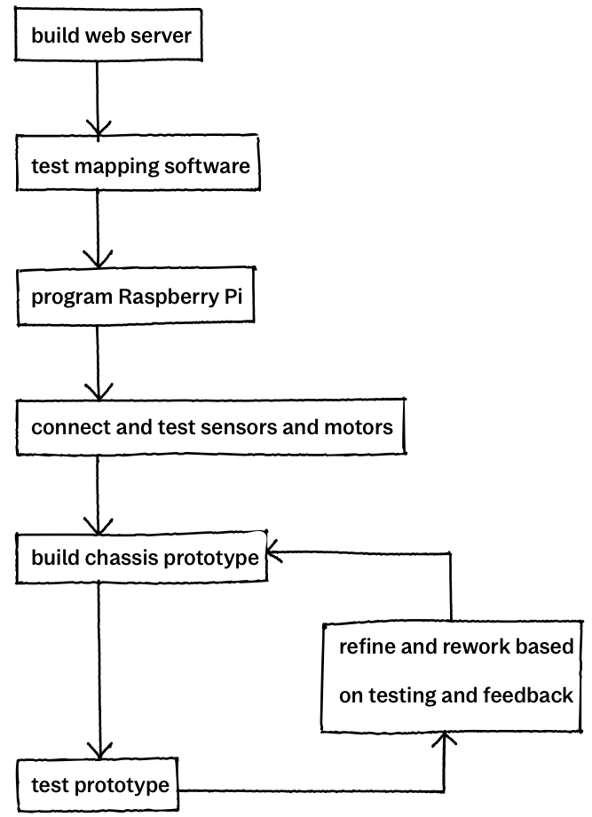
Figure 1. Proposed method of building autonomous ocean mapping prototype

5. Project Timeline
The final prototype must be completed by Nov. 30, 2023 so that it can be presented in the UVic Ocean Challenge on Dec. 1, 2023. The detailed timeline of our project is shown in the Gantt chart in Figure 2.

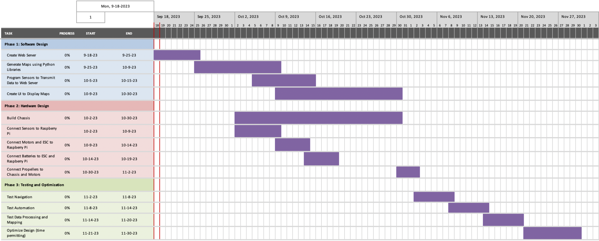
Figure 2. Timeline for project deliverables

6. Budget
The required materials to build our prototype and their associated costs are detailed in Table 1. Our total proposed budget is $1,295.00. Some of these values are rough estimates since the actual cost will not be known until the time of purchase, so a line item for incidental costs is included in case of any additional incurred costs during the construction of the prototype.

Table 1. Total cost of materials to build autonomous ocean mapping prototype
Material | Cost Per Unit ($) | Number of Units | Total Cost ($)
Microprocessor with microSD card | $150.00 | 1 | $150.00
Waterproof distance sensor [1] | $20.00 | 4 | $80.00
Motors and ESC kit (5pc) [2] | $25.00 | 1 | $25.00
Waterproof motor and ESC [3] | $40.00 | 4 | $160.00
Propellers | $15.00 | 4 | $60.00
Protective enclosure (3D printed) | $200.00 | 1 | $200.00
Raspberry Pi GPS module [4] | $40.00 | 1 | $40.00
GSM/GPS Module [5] | $80.00 | 1 | $80.00
Incidental Costs | – | – | $500.00
Total Cost |  |  | $1,295.00

7. Expected Outcomes
The goal of this prototype is to provide an accurate, small-scale method of mapping the ocean floor with the ability to scale up the project given more time and additional funding. Since we are limited in design time and budget, our goal is to have a prototype that accurately estimates the depth of the ocean floor up to 1m below the surface.

The prototype should be able to autonomously move in a 3m x 3m square in the water and scan the ocean floor in that area. The navigational system will be GPS dependent to account for additional movement of the drone due to waves. The data collected by the ultrasonic sensor will be transmitted to a web server where it will be converted into a 3D topographical map. The GPS module onboard the prototype will ensure that the location of the mapping is also recorded.

8. Project Description
The proposed prototype is an autonomous drone that floats on the surface of the water and maps the ocean floor using an ultrasonic distance sensor. This distance data will be transmitted to a web server where Python libraries will be used to convert the raw data into a 3D topographical map of the ocean floor. A diagram that illustrates our planned work sequence for the project is shown in Figure 3.

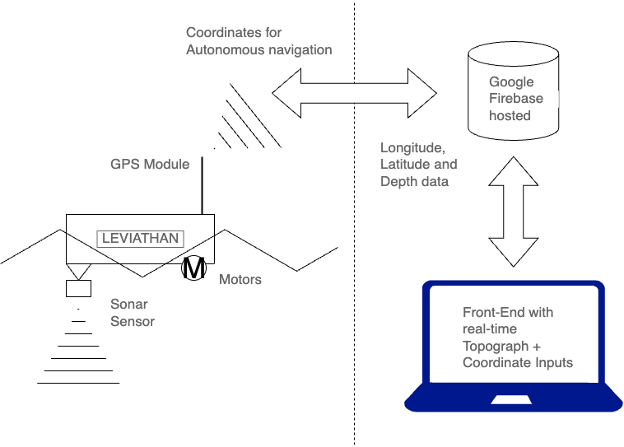

Figure 3. Diagram for autonomous ocean mapping project

9. Feasibility Analysis
To ensure that the proposed prototype was the best solution to the challenge of creating an autonomous ocean mapping technology, two feasibility analyses were performed. The technical feasibility analysis includes a risk assessment of the prototype, and investigates other possible solutions. The economical feasibility analysis uses cost/benefit analysis to ensure that the project is worthwhile.

9.1. Technical Analysis
A simple risk assessment was performed on our prototype design to ensure that the design is feasible and that identified hazards related to the design are minimized. The details of the risk assessment are shown in Table 2.

Table 2. Risk assessment of proposed ocean mapping drone design
Hazard | Technical Failure of Drone | Data Transmission Interruptions | Environmental Hazards and Damage to Drone
Affected Parties and Impact of Hazard | - Project team  - Operators  - Technical failure of drone can lead to project delays | - Project team  - Operators  - Data transmission interruptions can lead to incomplete mapping data | - Project team  - Ocean environment  - Environmental hazards can lead to damage to the drone
Existing Risk Management Measures | - Quality control processes and testing  - Regular maintenance | - Routine monitoring of data transmission systems | - Durable materials used during device construction  - Monitoring of weather conditions
Recommended Steps to Further Mitigate Risk | - Stress testing | - Implement alternative communication channels & protocols | - Regular maintenance to identify damage from use
Responsible Parties for Implementation | - Project team | - Project team | - Project team
Timeline for Implementation | - Stress testing will be performed during the development phase | - Alternative communication channels will be implemented during development phase | - Inspections and maintenance will be conducted regularly after deployment

Throughout the brainstorming process of this project, we came up with some other solutions and adapted these ideas into the final prototype which best fits the desired outcomes. Some of our initial ideas and the reason that we chose a different approach in the final design are outlined below.

The first choice that had to be made was whether the drone would be submersible or buoyant. Initial designs incorporated a submersible drone, but the final prototype floats on the surface of the water. This change was made because our team determined that a submersible drone would require a significant amount of stabilization technology to ensure that the distance measurement was accurate. The device would also need a pressure-rated casing to withstand deep water pressure. In contrast, the floating model would require much less hardware. The main problem with choosing a buoyant design is the wave movement which will lead to inaccuracy in the measurements. While there is a tradeoff between both designs, it was determined that the buoyant model was more feasible given the budget and timeline constraints for this project. Additionally, it was determined that the chosen design would be much simpler to scale up in the future.

In the initial brainstorming of our design, we considered using a tethered connection between the drone and the base station to facilitate power and data transmission. However, we decided to use wireless data transmission instead of a tethered connection, which improved the technical aspects of our design. By using wireless communication in our design, our drone will have increased mobility and flexibility without being constrained by the length of the tether. Wireless communication also offers faster data transmission speeds, which enhances our data collection and analysis capabilities. It also eliminates the risk of entanglement, ensuring the safety of our drone in various environments. In summary, the decision to shift from a tethered connection to wireless data transmission significantly improved the technical aspects of our project by enhancing mobility, adaptability, data transmission speed, and safety.

9.2. Economical Analysis
To determine if the project is economically feasible, a benefit-cost analysis was completed. It should be noted that some of the benefits are monetary estimates based on utility value of implementing the prototype. Due to the small scale of the prototype, the benefit value is scaled down to an estimate which matches the capabilities of the design. The benefits and costs are recorded in dollars per year, and assume that only one prototype is built. The benefit-cost analysis is detailed in Table 3.

Table 3. Benefit-cost analysis of implementing the proposed ocean mapping prototype
Item | Benefit ($ per year) | Cost ($ per year)
Reduced labour costs (operates without human control) | 2,470.00 | -
Reduced safety costs (no human divers, manned submersibles required) | 1,710.00 | -
Fuel savings (drone operates on battery power) | 380.00 | -
Research and development costs (for one drone) | - | 1,295.00
Operating costs | - | 87.60
Unforeseen expenses due to accidents or technical problems | - | 1,295.00
Total | 4,560.00 | 2,677.60

These numbers are based on the assumption that our prototype can map approximately 1 square kilometer per year. Based on research of current ocean mapping technologies, this would be equivalent to paying a geoscientist for 38 hours of work at approximately $65.00 per hour [6]. For simplicity, we assume the safety costs are equivalent to 38 hours of a submarine operator’s wage, which is approximately $45.00 per hour. Fuel savings assume that alternate options require a boat that consumes 2.5 gallons per hour and runs for 38 hours, where marine fuel is $4.00 per gallon.

The research and development costs are based on the estimated cost of building one prototype. For simplicity, the unforeseen expenses due to damage was set to be the cost to build an entirely new boat. The operating costs are based on the cost to recharge the prototype 8 times a day for a year at $0.03 per charge. The battery pack onboard is estimated to last 2 hours between charges.

Based on the total benefits and costs, we can determine the benefit-cost ratio by dividing the total benefit by the total cost. Using this formula, we find the benefit-cost ratio to be 1.7. Since this is greater than 1, the project is deemed economically feasible and worthwhile.

10. Hardware Specifications
The hardware components that will be implemented into our system are vital to our ocean floor mapping project’s success. The Raspberry Pi serves as the central control unit, managing data from sensors like depth sensors and GPS modules. The HC-SR04 Waterproof Ultrasonic Distance Measuring Module provides accurate depth measurements, while HiLetgo 5pcs ULN2003 28BYJ-48 4-Phase Stepper Motors enables precise drone maneuverability. Additionally, a 3D printed waterproof enclosure protects our onboard electronics from water and environmental elements. Together, these components form the design for our system’s hardware specifications to achieve reliable ocean floor mapping.

10.1. Onboard Computer
The microprocessor that will be implemented in our system is a RaspberryPi and will serve as the central control unit. It will receive data from sensors like depth sensors and GPS modules and facilitate real-time data transmission to collect data that can be analyzed and stored.

10.2. Waterproof Distance Sensor
The ultrasonic sensor that will be implemented in our system is the HC-SR04 Waterproof Ultrasonic Distance Measuring Module, which will provide depth measurements through ultrasonic pulses. Its waterproof design ensures reliable operation underwater, and also integrates with the Raspberry Pi. Designed for underwater operation, it withstands water exposure and pressure changes, making it an ideal choice for our system.

10.3. Motors and ESC Kit
The motors that will be implemented to provide precise maneuverability to our drone are the HiLetgo 5pcs ULN2003 28BYJ-48 4-Phase Stepper Motors. These stepper motors will control the propellers of our drone to ensure accurate movement.

10.4. Protective Enclosure
The protective enclosure that will be used in our system will be a 3D printed waterproof enclosure. Its primary role is to protect the onboard electronics from water. It will securely house the microcontrollers, sensors, and power sources, with a customized fit to prevent internal damage. Built with waterproof materials, it will ensure electronics remain dry.

11. Software Specifications
The software development component of this project will be critical in the data acquisition and processing to achieve our objective of efficiently mapping the ocean floor. Python will be used for backend development to handle data acquisition and processing. JavaScript will be used to develop the frontend for visualizing and analyzing the data in a functional UI.. Using this software design, our system will be able to generate meaningful data visualizations of ocean floor information for navigation, research, and security.

11.1. Data Acquisition
The software must be capable of receiving real-time data from the ultrasonic sensor. The software library that will be implemented is Apache Kafka, which is a data streaming platform that can receive, process, and distribute real-time data.

11.2. Data Processing
The software must be capable of performing analysis and parsing the data into a format that can be processed by our mapping software. The software library that will be implemented to achieve this is TensorFlow, which is a library for high-performance numerical computations.

11.3. 3D Topographical Map Generation
The software must be capable of processing the parsed stored location and depth data and generate a 3D topographical representation. The software library that will be implemented to achieve this is Plotly. This library can be used to produce interactive graphs that can be embedded on websites, and provides a wide variety of complex plotting options.

11.4. Display
All the data collected must be displayed in a visualization platform that can be used to perform meaningful functions such as enhancing naval operations, marine research, and maritime security. The software library that will be implemented to build a functional UI is React.js. React is a JavaScript library for building user interfaces. This can be used to create a web-based frontend application that will display data and enable users to interact meaningfully with it.

12. Safety, Security, and Privacy Considerations
In the development of our autonomous ocean floor mapping technology, our team is focused on safety, security, and environmental responsibility in the design process. We are committed to minimizing the environmental impact of our technology by designing our drone to operate in the ocean without any disturbance to the natural environment. Our device will operate with minimal interference to other maritime operations and navigation systems, enhancing safety in shared waters. This ensures the safety of our device and its seamless integration with existing maritime operations. Secure data transmission is ensured through encryption protocols, which will safeguard the data integrity and security during transmission from the drone to our software system.

Finally, we will prioritize continuous monitoring and improvement of our technology's safety, security, and privacy features. Ongoing assessments will ensure that we promptly address emerging challenges and concerns, further underlining our commitment to responsible ocean floor mapping.

13. Business Requirement Document

13.1. Requirement Elicitation Techniques
Minimal communication was established with the mentor at this point; therefore, our elicitation techniques included brainstorming, literature reviews, and documentation analysis. Literature reviews were used in order to evaluate current methods and constraints faced by ocean floor mapping, and documentation analysis was used to review existing libraries for data processing. Brainstorming was utilized to develop communication protocol techniques, UI design, data collection methodology, and mechanical design.

13.2. BRD
A description of the functional and non-functional requirements for this project are detailed in Table 4.

Table 4. Business requirements table, including the requirement description and need, and the sprint number
Type | ID | Requirement Description | Sprint No. | Requirement Need
FUNCTIONAL | AOM-1 | The Leviathan must be able to detect depths of up to 4 meters from the HC-SR04 Sonar Sensor | 1 | To acquire reasonable quality data in order to produce a more in-depth topographical map
FUNCTIONAL | AOM-2 | The depth data from the HC-SR04 sonar sensor must have a depth error of at most +/- 5 cm. | 1 | To minimize depth error for a more accurate and precise topographical map
FUNCTIONAL | AOM-3 | Leviathan's frame must be able to have a water rating of IPX7 | 4 | Waterproofing is required to protect the electronics inside the Buoy
FUNCTIONAL | AOM-4 | The Raspberry Pi must be able to communicate through SSH | 2 | Communication protocol is needed to send data to the database for data analysis and visualization
FUNCTIONAL | AOM-5 | The Leviathan must have a horizontal position error from the NEO-6M GPS module of at most +/- 3m | 2 | GPS data must have minimal error to produce a more accurate and precise topographical map
FUNCTIONAL | AOM-6 | The Web Server UI must be display a 3D graph with respect to depth, longitude and latitude | 1 | To display an accurate, intuitive, and readable map of the ocean depth
FUNCTIONAL | AOM-7 | The Raspberry Pi must host a Node.js server | 1 | In order to serve the client which is our locally hosted website
NON-FUNCTIONAL | AOM-78 | The Leviathan must incorporate a lighting system using LEDs with a total brightness of 100 Lumens | 3 | To ensure that the device is easily visible to other vessels in the ocean
NON-FUNCTIONAL | AOM-9 | Leviathan must be able to withstand waves of upto 5 ft | 4 | To continue collecting and processing accurate data in extreme ocean conditions
NON-FUNCTIONAL | AOM-10 | All information send to the Node.js Raspberry Pi hosted server must have a latency of less than 2s | 3 | For real-time data visualization to be smooth and reasonably practical
NON-FUNCTIONAL | AOM-11 | The battery life of the Leviathan must be at least 2 hours | 3 | To make sure the device can operate for a reasonable amount of time. minimizing maintenance
NON-FUNCTIONAL | AOM-12 | The Leviathan must be locally networked through a fiber optic cable | 2 | To enable local communication between the Raspberry Pi and the locally hosted website
NON-FUNCTIONAL | AOM-13 | The Leviathan's local network must be secure from any attempted infiltration | 2 | Security ensures that the device is protected from malicious users

13.3. Requirements and User Stories
The functional requirements of the project were divided using a hierarchical structure of themes, features, epics, user stories, tasks, and acceptance criteria. This process is outlined in Table 5.

Table 5. Hierarchy of themes, features, epics, user stories, tasks, and acceptance criteria
Themes | Features | Epics | User Stories | Tasks | Acceptance Criteria
System Performance | Environmental Data Collection | Water Depth Sensor Integration | As a marine scientist, I want to detect objects at a reasonable distance in order to generate a topographical map | Develop object detection algorithms to accurately identify objects at the desired distance range for topographical map generation. | Given a water depth sensor, when a reading is taken, then the sensor should accurately read the distance to a depth of 4m below surface level
System Performance | Environmental Data Collection | Water Depth Sensor Data Retrieval | As a marine scientist, I want to minimize distance error so I can generate an accurate and precise graph | Optimize distance measurement algorithms, apply error correction, calibration, testing, and integration for reduced distance error and improved accuracy in graph generation. | Given a distance measurement from the sensor, when the sensor reads the data, then take an average of ten readings to ensure that the collected data is accurate
System Performance | Environmental Data Collection | GPS Data Retrieval | As a marine scientist, I want the device to minimize horizontal position error so it can generate an accurate and precise graph | Enhance positioning algorithms, implement error correction methods, data filtering, sensor calibration, testing, and integration with graphing for improved data accuracy. | Given a GPS coordinate from the GPS module, when the sensor reads the device location, then it takes an average of ten readings to ensure that the collected data is accurate
System Performance | Real Time Data Processing and Visualization | Sensor Data Processing | As a marine scientist, I want the device to have minimal latency for more accurate real-time data processing | Optimize data processing algorithms and reduce communication latency for improved real-time data accuracy. | Given a sensor reading, when the data is transmitted from the sensor, then the data should be received to be processed within 10 seconds
System Performance | Real Time Data Processing and Visualization | Topographical Map Generation | As a marine scientist, I want the system to display a 3D graph for Data Visualization | Integrate a 3D graphing library, develop data parsing, graph generation, user interface integration, user controls, testing, and documentation for marine data visualization | Given water depth sensor data, when the data is transmitted from the sensor, then the system generates a real-time topographical map of the water depth at the specific GPS location
System Performance | Real Time Data Processing and Visualization | Data Communication | As a marine scientist, I want the device to be able to communicate through SSH so I can relay marine data to the Backend | Enable SSH communication on the device to establish a secure connection for relaying marine data to the Backend | Given a sensor reading, when the data is transmitted from the sensor, then it communicates via SSH to relay the data to the system's backend
System Performance | Real Time Data Processing and Visualization | Data Communication | As a marine scientist, I want the device to host a Node.js server so it can serve personal laptop client | Install and configure a Node.js server on the device, set up port configurations, integrate client-side scripts, and implement security measures for serving personal laptop clients. | Given water depth sensor data, when the data is processed and graphs are generated, then Node.js is used to display data in a user-friendly way
System Reliability | Environmental Resiliency | Waterproof Case Design | As a marine scientist, I want the device to be water resistant in order to protect the electrical components | Incorporate waterproof seals, select appropriate enclosures, and conduct testing to safeguard electrical components from water exposure. | Given a system that measures water depth, when the device is in the water, then the system stays dry
System Reliability | Environmental Resiliency | Enhance Durability for Big Waves | As a marine scientist, I want the device to be able to withstand big waves so it can operate accurately in the ocean | Reinforce device structure with saltwater-resistant materials, based on structural analysis and testing, to enhance its ability to withstand big waves for accurate ocean operation. | Given a system that measures water depth, when the device encounters large waves, then it still remains able to read depth data accurately
System Reliability | Environmental Resiliency | Power Management | As a marine scientist, I want the device to have a reasonable continuous operation time to minimize maintenance | Develop and implement power-saving algorithms to reduce energy consumption during device operation. | Given a system that measures water depth, when the device is operational, it can continuously operate for at least 2 hours between battery charges
System Reliability | Security and Safety | Data Security | As the developer, I want the system to be secure in order to avoid malicious users | Implement user authentication and authorization mechanisms for system security | Given a system that measures water depth. when malicious users attempt to infiltrate the system, then the system should prevent such users from obtaining any data
System Reliability | Security and Safety | Data Security | As the developer, I want the device to be locally networked to eliminate public network complexities | Configure local network hardware, IP addressing, network protocols, security measures, and testing procedures to simplify device integration with local networks | Given a system that measures water depth, when the device is connected to the internet, then it should be connected locally rather than through public networks
System Reliability | Security and Safety | LED Light Beacon Design | As a marine scientist, I want the device to emit flashing light so it can easily be spotted in the ocean | Implement a flashing light feature for enhanced ocean visibility by developing control circuitry, ensuring underwater durability, managing power consumption and meeting all regulatory requirements that comply with regulations | Given a system that measures water depth, when the device is at sea, then it should emit a flashing LED light to make other vessels aware of its proximity

13.4. Story Points, User Story Priorities, and Sprint Allocation
Story points were assigned to each user story (see Table 5) using the Planning Poker Method. Each team member assigned a Fibonacci sequence number to each user story, based on complexity and importance, until a consensus was reached. Priority was also assigned to each user story. Given these two metrics, each user story was assigned to a sprint. The results of this procedure are shown in Table 6.

Table 6. Story points, priorities, and sprint allocation for project user stories
User Stories | Story Points | Priority | Sprint No.
As a marine scientist, I want to detect objects at a reasonable distance in order to generate a topographical map | 5 | Mid | 1
As a marine scientist, I want to minimize distance error so I can generate an accurate and precise graph | 3 | Low | 1
As a marine scientist, I want the device to minimize horizontal position error so it can generate an accurate and precise graph | 3 | Low | 2
As a marine scientist, I want the device to have minimal latency for more accurate real-time data processing | 1 | Low | 2
As a marine scientist, I want the system to display a 3D graph for Data Visualization | 13 | High | 3
As a marine scientist, I want the device to be able to communicate through SSH so I can relay marine data to the Backend | 8 | High | 2
As a marine scientist, I want the device to host a Node.js server so it can serve personal laptop client | 2 | Low | 4
As a marine scientist, I want the device to be water resistant in order to protect the electrical components | 3 | Low | 4
As a marine scientist, I want the device to be able to withstand big waves so it can operate accurately in the ocean | 5 | Mid | 4
As a marine scientist, I want the device to have a reasonable continuous operation time to minimize maintenance | 5 | Mid | 2
As the developer, I want the system to be secure in order to avoid malicious users | 3 | Low | 4
As the developer, I want the device to be locally networked to eliminate public network complexities | 5 | High | 3
As a marine scientist, I want the device to emit flashing light so it can easily be spotted in the ocean | 2 | Low | 4

13.5. Project Responsibility Distribution
A RACI Matrix was created to allocate responsibility, accountability, consulting, and informing roles to each team member for each main task requirement in the project (see Table 7).

Table 7. RACI Matrix for main project task completion
Task/Activity | Jairus | Hailey | Benjamin | Mentor
Define Sensor Requirements | R | I | I | I
U/I Design | C | R | A | I
Conduct Testing and Validation | R | A | R | I
Supply Necessary Equipment | R | R | R | R
Data Analysis and Error Correction | A | R | R | I
Design Enclosure | I | I | I | R
Establish Data Communication Protocol | R | C | C | I

13.6. Project Planning
The sprints that were determined in section 13.4 were then divided into a Gantt Chart to plan the project timeline. This chart is shown in Figure 4.
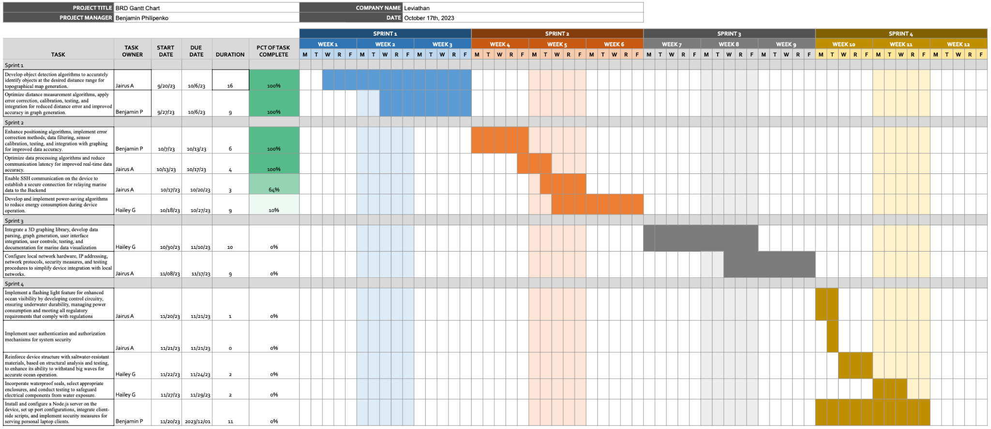

Figure 4. Gantt Chart with allocated sprints for each user story

14. Design
High level use case UML model was used to model the application. A misuse case UML model and sequence diagrams for the project were also created. The specifications for there are detailed in the following sections.

14.1. Use Case UML Model
A use case UML model, which is shown in Figure 5, was used to model the project application. The primary actor is the user of the application, and the secondary actors are the sensing system and web server, which are integral to the successful operation of the device.

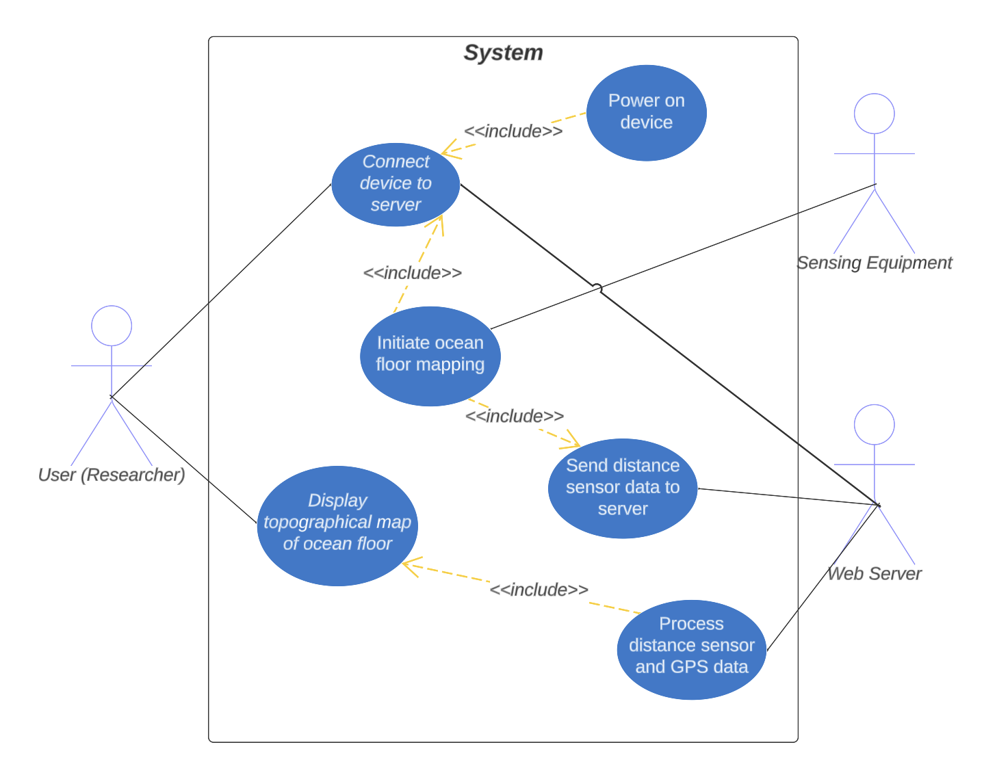
Figure 5. High level UML model use case diagram

14.2. Misuse Case UML Model
A misuse case UML model was also created to illustrate a sequence of actions wherein the system interacts with misusers, potentially resulting in harm to specific stakeholders if the sequence is allowed to proceed. This misuse case model is shown in Figure 6.

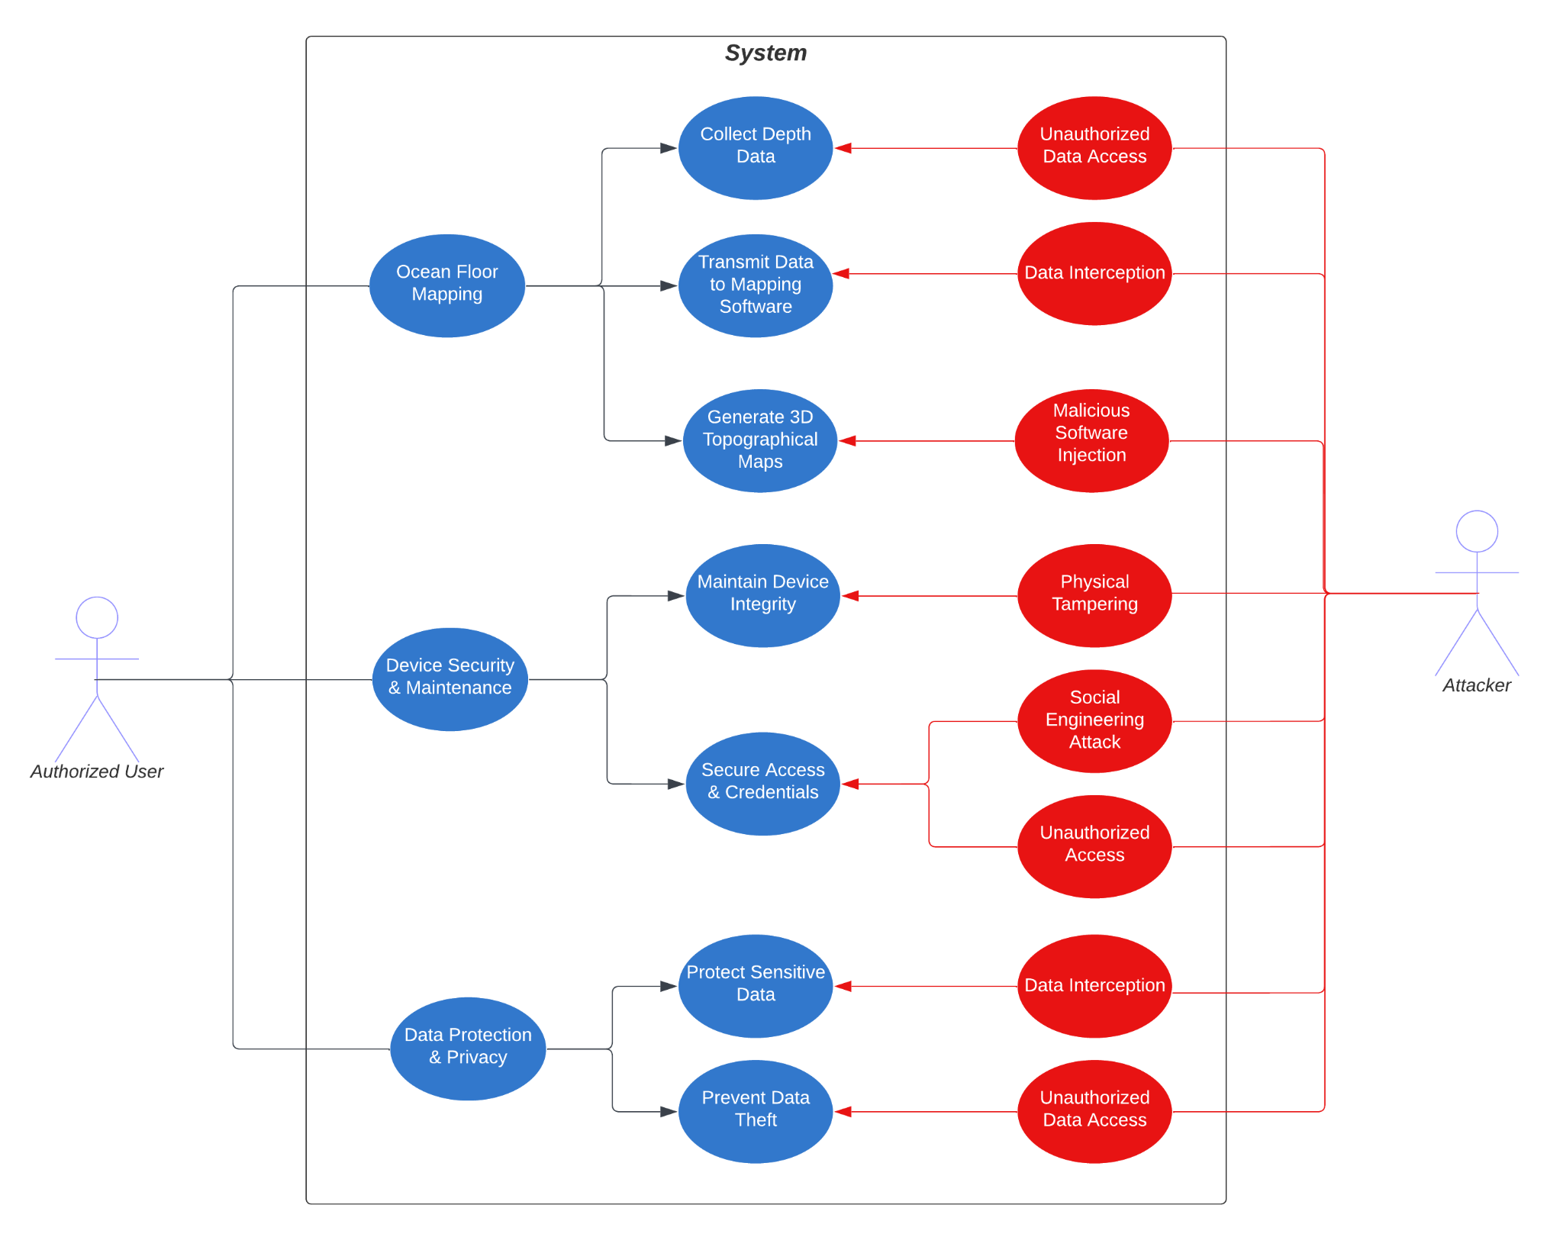
Figure 6. Misuse case UML model

14.3. Specifications and Sequence Diagrams
Specifications and sequence diagrams for each of the identified use cases are shown in the following sections.

14.3.1. Powering on the Device

ID | UC-01
Description | The user powers on the device so it can be utilized.
Actors | User
Secondary Use Cases | N/A
Preconditions | N/A
Main Flow | - The user powers on the device  - If Leviathan turns on properly  - The LP is prompted to login  - The LP connects the ethernet cable to the Leviathan
Postconditions | The device can connect to the web server and begin transmitting data
Alternative Flow(s) | N/A

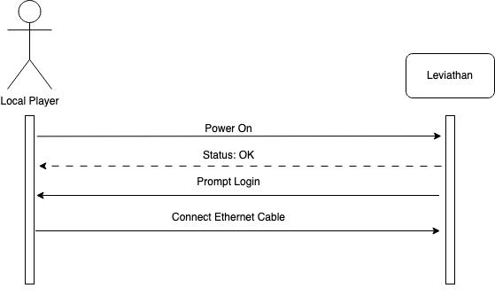

14.3.2. Connecting the Device to the Web Server

ID | UC-02
Description | The device connects to the web server in preparation for data transfer
Actors | User, Web Server
Secondary Use Cases | UC-01
Preconditions | Device is powered on.
Main Flow | - The LP sends SSH command to connect to RPi terminal  - The LP sends startup command in the personal laptop terminal  - The RPi sends server state and the LP connects to IP in the browser
Postconditions | System is informed of the web server connection and begins transmitting sensor data.
Alternative Flow(s) | 2b. The device does not connect successfully  - The system sends an error message prompting user to try powering up the device again

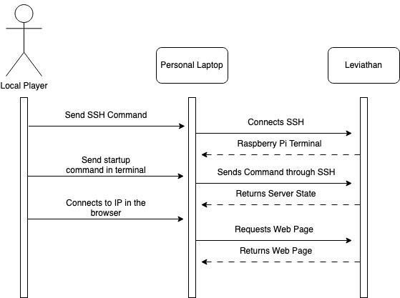

14.3.3. Initiating Ocean Floor Mapping

ID | UC-03
Description | The sensors begin measuring the distance to the ocean floor
Actors | Sensor Equipment, Web Server
Secondary Use Cases | UC-01, UC-02
Preconditions | Device is connected to the web server and the personal laptop is displaying the web page
Main Flow | - The front-end shows a blank topographical map under the website heading “Ocean Map”  - Device attempts to begin reading data from the sensors  - If it successfully connects to the sensors  - Sensors begin transmitting data to the device
Postconditions | Sensor data is transmitted and stored in the onboard microcontroller.
Alternative Flow(s) | 2b. If the device cannot connect to the sensors  - The device displays sensor connection errors, in the web server so the problem can be resolved by the user

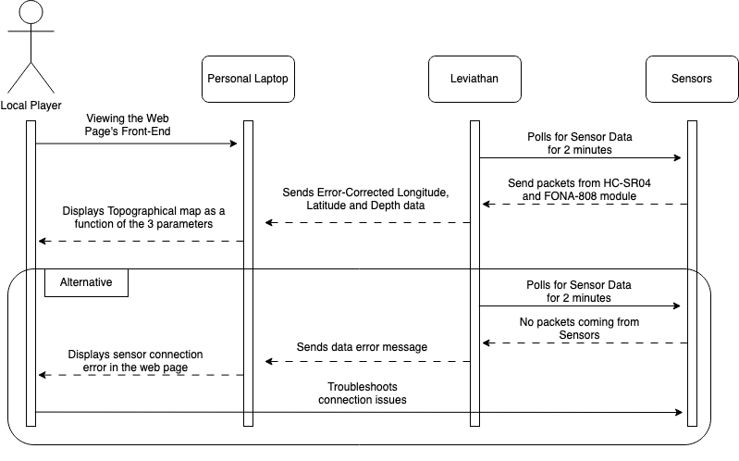

14.3.4. Transmitting Sensor Data to the Web Server

ID | UC-04
Description | The sensor data is transmitted to the web server.
Actors | Web Server
Secondary Use Cases | UC-01, UC-02, UC-03
Preconditions | Device is connected to the web server and sensor data is being collected.
Main Flow | - Leviathan hosts the Node.js server  - The Leviathan sends distance and GPS data to the locally hosted server
Postconditions | The server must contain data from both the GPS and sensor modules for data processing.
Alternative Flow(s) | 2b. If the device does not transmit the data  - Error message is generated so the problem can be resolved by the user

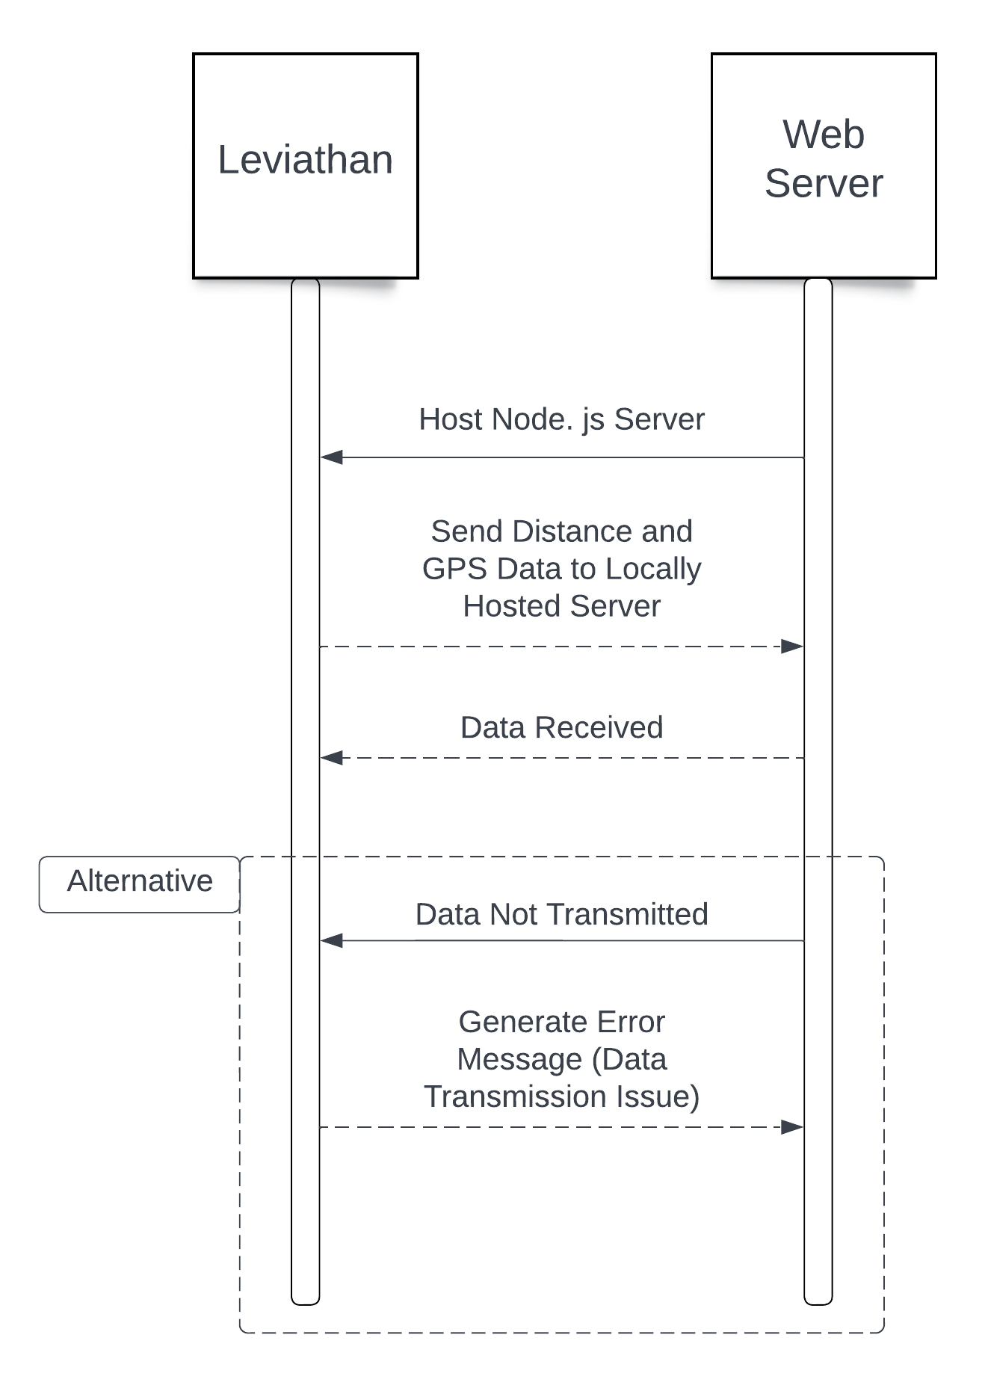

14.3.5. Processing Sensor and GPS Data

ID | UC-05
Description | The device takes the collected sensor data and processes it into a usable format for creating maps.
Actors | Web Server
Secondary Use Cases | UC-03, UC-04
Preconditions | Sensor data is in the locally hosted server, available for processing.
Main Flow | - The program pulls the data from the hosted server  - The program parses the data and calculates for error corrections and accounts for location data duplicates  - The data is then displayed on the front-end of the website in the form of a topographical map.
Postconditions | The data must be in the proper format in order for the mapping software to display the maps to the UI.
Alternative Flow(s) | 1b. If the data cannot pull the data from the server  - Generate and display error message so the problem can be resolved by the user

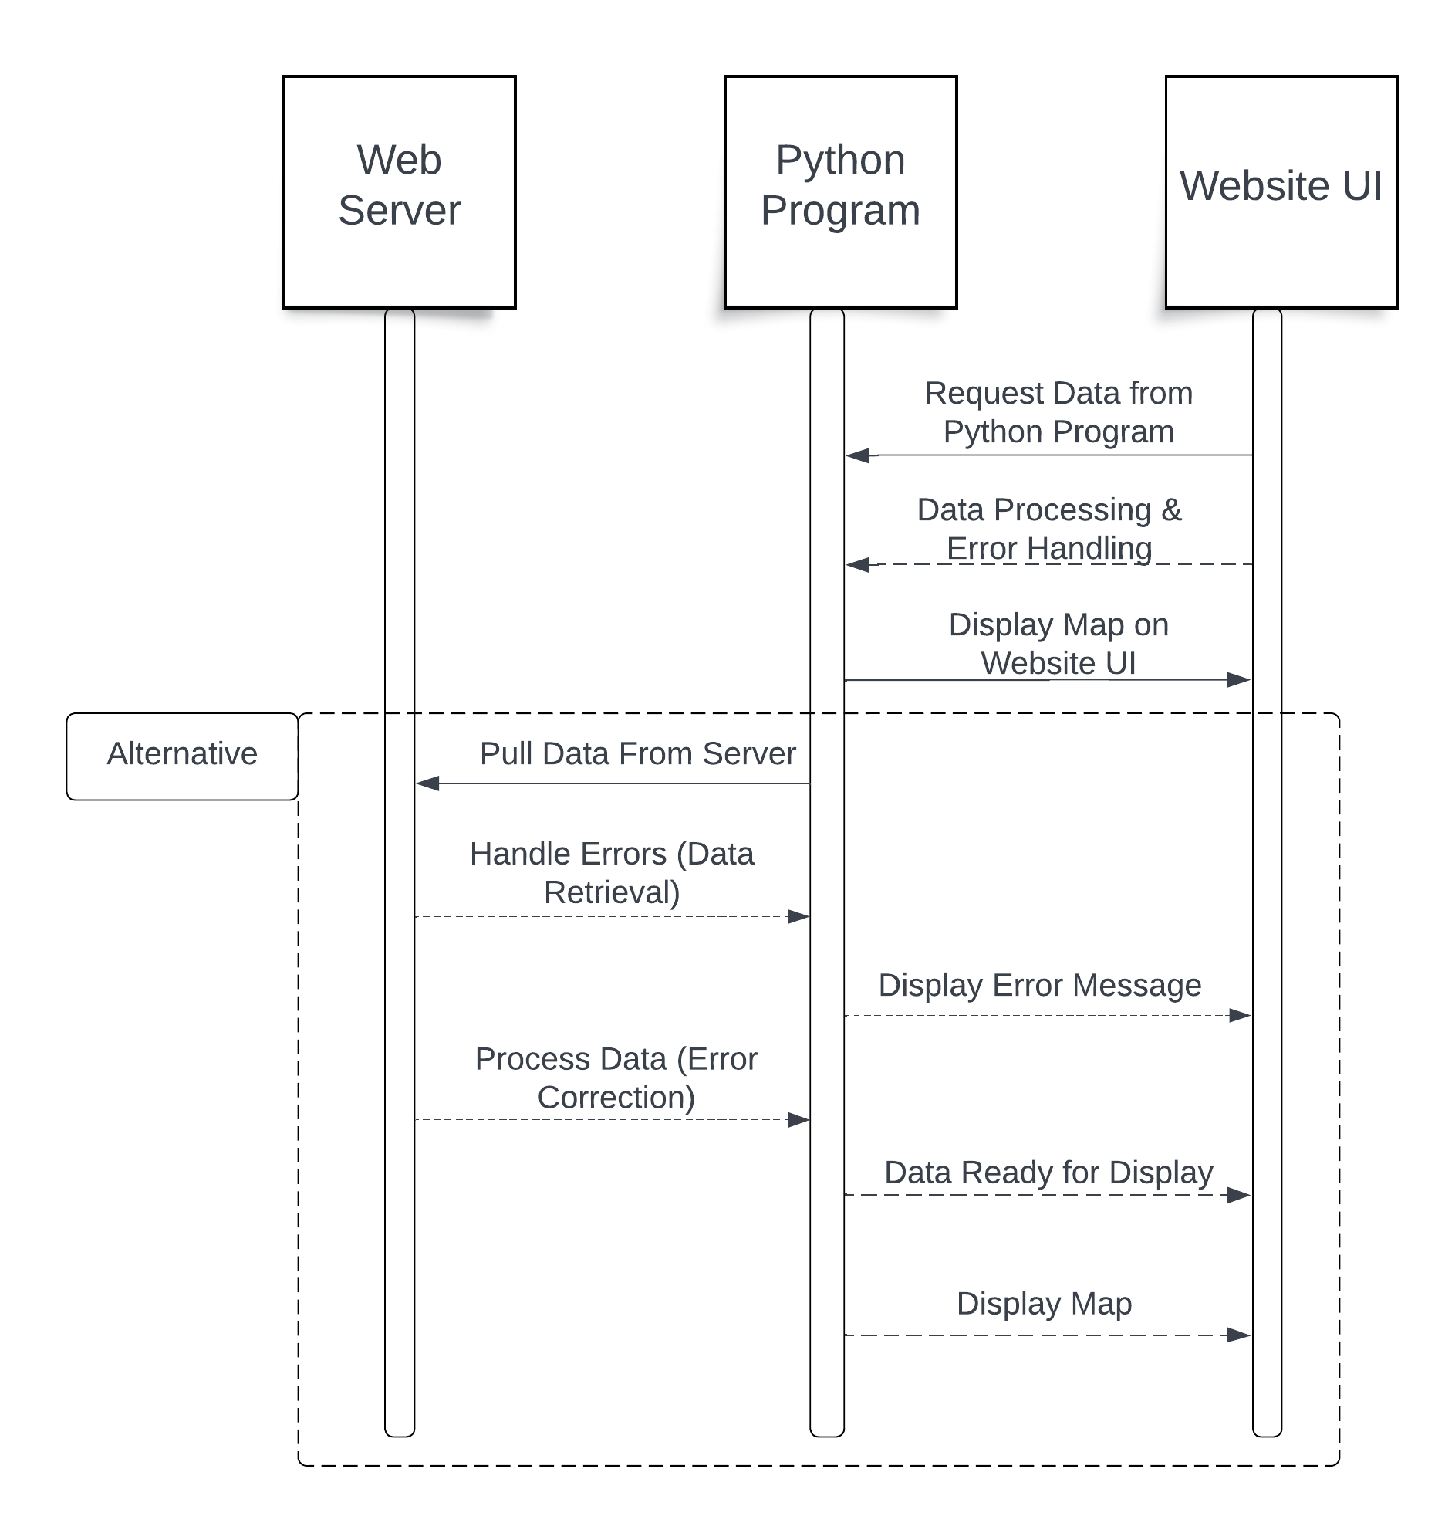

14.3.6. Displaying Topographical Maps to User Interface

ID | UC-06
Description | The collected data is displayed as a readable topographical map for the interpretation of the user.
Actors | User, Web Server
Secondary Use Cases | UC-05
Preconditions | Processed sensor data is available to be displayed.
Main Flow | - The topographical map’s initial state is blank  - As the Leviathan moves, the topographical map begins to plot a 3D map of the ocean floor as a function of height, longitude and latitude.  - The map becomes larger as Leviathan moves to different locations
Postconditions | An ocean floor topographic chart designed for data visualization
Alternative Flow(s) | 2b. If the map is not displayed on the UI  - An error message is displayed where the map would be to inform the user of the problem

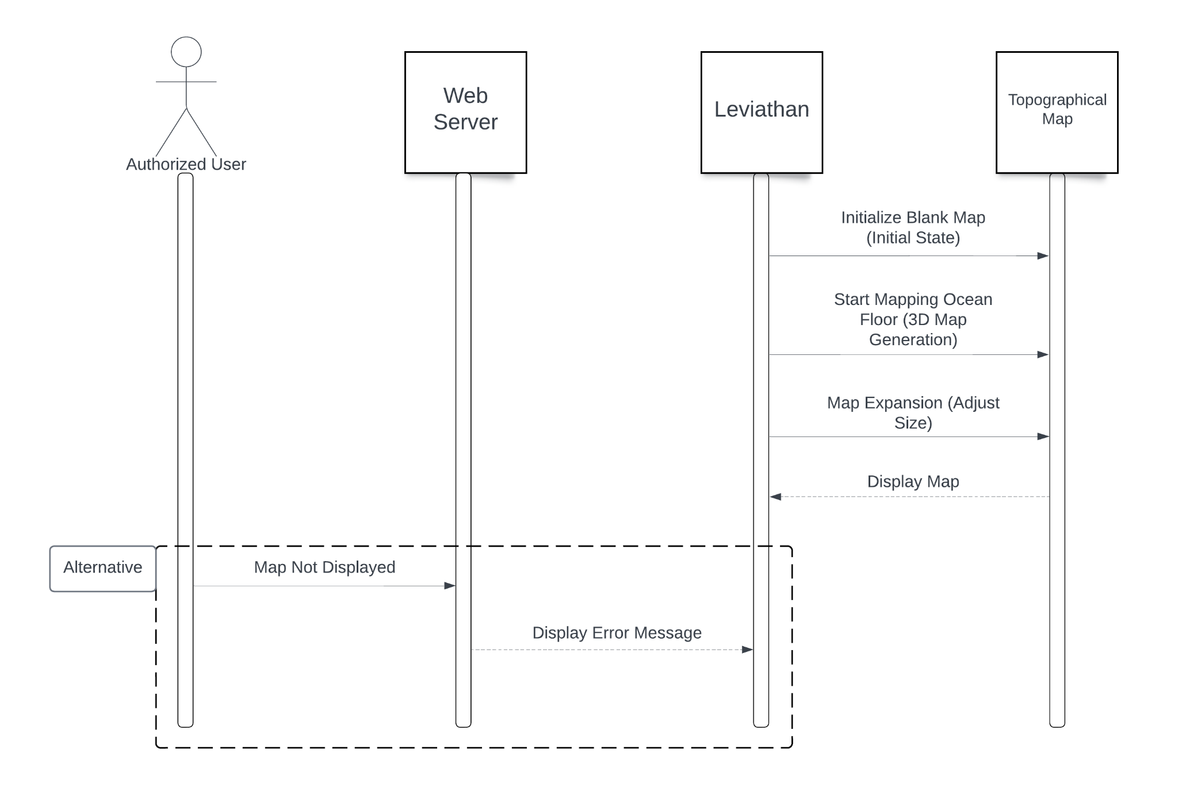

15. Test Case Document
The specified project requirements must be tested individually to ensure that each part of the product works as expected. Table 8 outlines the test cases for each of the defined requirements, including preconditions, post conditions, test steps, expected and actual results, and whether the test passed or failed.

Table 8. Test cases for project requirements
Test Type | ID | Title | Description | Preconditions | Testing Steps | Input Data | Expected Results | Actual Results | Postconditions | Pass/Fail
Functional | TC01 | Max depth detection | Ensure the sensor can measure accurately to a max depth of 4 meters. | Device is connected to the server and sensor is submersed in the water | 1. Go to a location with known depth of 4m (manually measured)  2. Start depth data collection  3. Confirm sensor measurements with manual measurements | N/A | Depth measurements match the manual measurements | Depth measurements match the manual measurements | N/A | Pass
Functional | TC02 | Min depth detection | Ensure the sensor can measure accurately to a min depth of 20cm (sensor accuracy specification) | Device is connected to the server and sensor is submersed in the water | 1. Go to a location with known depth of 20cm (manually measured)  2. Start depth data collection  3. Confirm sensor measurements with manual measurements | N/A | Depth measurements match the manual measurements | Depth measurements match the manual measurements | N/A | Pass
Functional | TC03 | Depth error | Ensure the sensor has a measurement accuracy within +/- 5cm | Device is connected to the server, sensor is submersed in the water and transmitting depth readings | 1. Go to a location where the depth can manually be measured (between 20cm and 4m)  2. Start depth data collection  3. Confirm sensor measurements are within 5cm of manual measurements  4. Repeat steps 1-3 at various different depths within the measureable range | N/A | Depth measurements are within +/- 5cm of the manual measurements (within the given sensor range) | Depth measurements are within +/- 5cm of the manual measurements (within the given sensor range) | N/A | Pass
Functional | TC04 | Waterproofing device casing | Ensure the device is housed within a fully waterproof chassis to ensure all electrical components are protected | N/A | 1. Fully submerse the casing in water with nothing in it  2. Check for any vulnerabilities/leaks in the casing | N/A | No leaks or vulnerabilities | Not tested | No leaks or vulnerabilities | Not tested
Functional | TC05 | SSH communication | Ensure the Raspberry Pi can communicate through SSH | Raspberry Pi is set up to transmit data | 1. Connect Raspberry Pi to Client (Personal Laptop) via Ethernet Cable  2. Open MacOS Terminal and type ssh pi@raspberrypi.local  3. Run the Python Program by running the command python sonar.py | N/A | Be able to run the Python Script named sonar.py and observe the output per the script | The Raspberry Pi is able to connect with the client through SSH and is able to run the script program and control the Raspberry Pi from the client | The Raspberry Pi is able to be controlled through SSH and is able to transmit data | Pass
Functional | TC06 | GPS location detection | Ensure the GPS module is measuring accurate longitude and latitude | GPS module is connected and can transmit longitude and latitude data to the terminal | 1. Go to a location with strong enough internet connection to accurately display location on an online map  2. Find GPS longitude and latitude using an application like Google Maps  3. Start GPS module data transmission to terminal  4. Confirm longitude and latitude data match the Google Maps data  5. Repeat steps 1-4 at various locations | N/A | GPS module latitude and longitude data match the Google Maps longitude and latitude for each testing location | GPS module latitude and longitude data match the Google Maps longitude and latitude for each testing location | N/A | Pass
Functional | TC07 | UI display | The UI must display accurate 3D topographical maps with respect to the gathered depth, longitude, and latitude data | Depth sensor and GPS module are accurately sensing and relaying data to the Raspberry Pi server | 1. Create a Python GUI  2. Use some test data to try and plot some points on the map  3. Import data from sensor and GPS module to Python GUI script  4. Display map in Python GUI | Sensor depth data, GPS module longitude and latitude data | 3D topographical map displayed on Python GUI | 3D topographical map displayed on Python GUI | Accurate 3D topographical map displayed on Python GUI | Not tested
Non Functional | TC09 | Device adaptability in extreme conditions | The device must be able to take accurate readings while withstanding waves up to 5ft | Depth sensor is functional and accurately reading depth data in ideal conditions, waterproof casing is implemented | 1. Take the device to a location where there are waves  2. Manually measure depth at highest wave height and lowest wave height  3. Start sensor data collection  4. Ensure program takes average of multiple depth readings when the GPS module returns the same longitude and latitude readings  5. Repeat steps 1-4 at various locations | Multiple depth readings at the same location | Resulting depth data for the specific location is an average of multiple depth sensor readings | Not tested | N/A | Not tested
Non Functional | TC10 | Program latency | The latency between gathering data and receiving data to the server should be less than 2s | Device is transmitting sensor and GPS data to front end and GUI is functionally displaying map | 1. Run the program through SSH  2. Time the data output response using a timer  3. Repeat the step 2 for 10 minutes for insurance | Sensor depth data, GPS module longitude and latitude data | Latency of less than 2s | Latency of less than 2s | N/A | Pass
Non Functional | TC11 | Power management | The device should have constant access to power since it is tethered | N/A | 1. Turn on Raspberry Pi  2. Plug Pi into power source  3. Confirm the device is properly connected to the power source | N/A | Raspberry Pi is properly connected to power source (tethered) | Raspberry Pi is properly connected to power source (tethered) | Device can continuously transmit sensor and GPS data | Pass
Non Functional | TC12 | Networking | The device is locally hosted through a fiber optic cable | N/A | 1. Connect Raspberry Pi to power source  2. Connect ethernet cable  3. Confirm ethernet connection is established between power source and Pi | N/A | Raspberry Pi is properly connected to local host through fiber optic cable | Raspberry Pi is properly connected to local host through fiber optic cable | Device can continuously transmit sensor and GPS data to front end | Pass
Safety | TC13 | Security from attempted infiltration | The device's local network must be secure from any attempted infiltration to protect against malicious users | Device is successfully connected to local network | 1. SSH to Raspberry Pi with another laptop by typing ssh pi@raspberrypi.local in an unpermitted MacOS terminal | N/A | No infiltration through local network is permitted | No infiltration through local network is premitted | The local network is not subjected to inflitration | Pass
Safety | TC14 | Device visibility | The device must include a blinking LED to make it visible to other vessels in the ocean | N/A | 1. Program an LED to blink at a frequency that is easily visible  2. Test blinking LED outside at night and ensure the light is visible from 50m away | LED brightness is 100 Lumens | LED is visible in the dark from 50m away | Not tested | N/A | Not tested

16. Implementation

16.1. Project Box Diagram
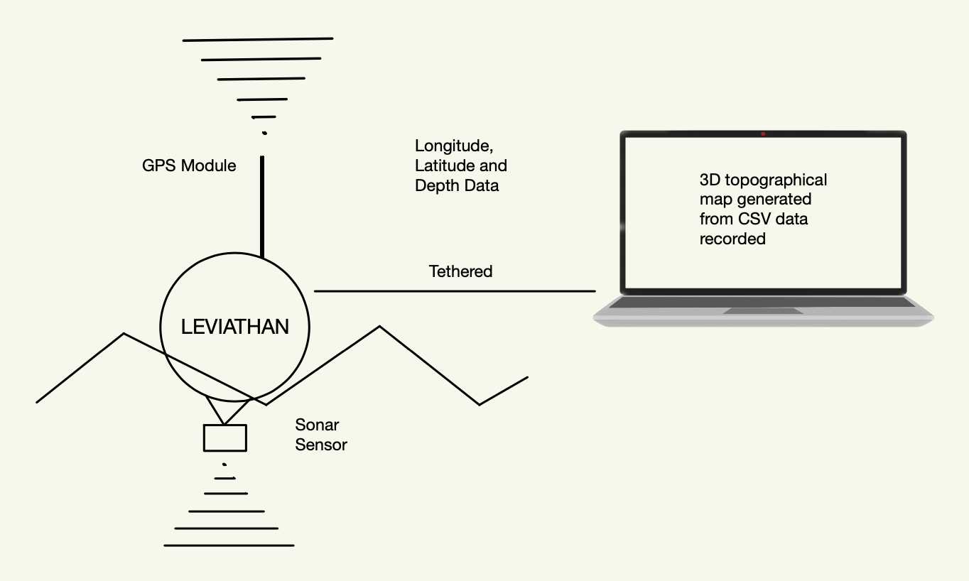

Our project is a prototype autonomous ocean floor mapping technology that can efficiently and cost-effectively map the topography of the ocean floor. There are three main components that interact with each other that comprise our system: A Raspberry Pi 4B acting as the onboard computer, an ultrasonic sensor that collects depth measurements, and a GPS module which transmits longitude and latitude coordinates to the Raspberry Pi. The depth sensor and GPS are both wired to the Raspberry Pi, which is tethered to the front-end via Ethernet connection. Python is used to extract and parse the data from the sensors, and then to create a topographical map on the front-end for the end-user.

16.2. Component Specification and Functionality

16.2.1. Microcontroller
The microcontroller used for this project is the Raspberry Pi 4 Model B, which has the following features:

- 1.5GHz 64-bit quad core ARM Cortex-A72 processor
- Onboard 802.11ac wifi
- Bluetooth 5
- Full gigabit Ethernet
- Two USB 2 ports and two USB 3 ports
- 4GB RAM
- Dual monitor support with two micro HDMI ports
The microcontroller acts as the onboard computer for the prototype, connecting all of the peripheral components.

16.2.2. GPS Module
The GPS module used for this project is the Adafruit 4279 Ultimate GPS with USB, which has the following features:

- GNSS module that can track up to 33 satellites on 99 channels
- High-sensitivity receiver
- Built on standard ceramic patch antenna
- Built-in USB-to-Serial converter
- Onboard indicator LEDs to convey satellite fix and data transmission statuses

The GPS module was used to gather longitude and latitude data of the prototype’s location to aid in the creation of the topographical maps.

16.2.3. Ultrasonic Distance Sensor
The depth sensor used for this project is the JSN-SR04T Waterproof Ultrasonic Distance Measuring Module, which has the following features:

- Suitable for wet and harsh conditions due to wire enclosed waterproof probe
- Measurement range of 20 cm to 600cm
- Measurement accuracy within 1 cm

The distance sensor was used to gather depth data of the ocean floor from the surface of the water to aid in the creation of the topographical maps.

16.3. Industry Standard & Compliance - Software Implementation
To ensure that our software development adhered to industry standards, we used a methodical approach. We maintained code quality through rigorous commenting and maintaining standard programming conventions to ensure readability and scalability. SSH communication was implemented between the Raspberry Pi and the computer to ensure data security and protect against any attempted infiltration. Utilizing the Test Driven Development approach, we successfully validated the functionality of all aspects of the device’s software components. Considering accessibility, usability, and ethical implications, our system’s software is designed to meet diverse user needs while maintaining industry standards. Completing regular maintenance on the software will ensure continued compliance and improvement to our system.

16.4. Industry Standard & Compliance - Hardware Implementation
Our prototype, which is built with a Raspberry Pi 4, ultrasonic sensor, and GPS module, adheres to all relevant industry standards and compliances. During the component selection process, we prioritized finding reputable manufacturers to ensure high quality hardware with rigorous electrical safety standards. Performing testing in various oceanic conditions ensured the prototype’s reliability. We also made sure to adhere to environmental regulations, opting to repurpose a decommissioned buoy as our prototype’s chassis to reduce ocean related waste. Collaboration with our mentor, a professional in marine technology, resulted in the creation of an ocean floor mapping technology which is compliant with all current industry standards.

16.5. Safety & Privacy Practices
Throughout the development of our project, we have prioritized safety and privacy considerations to ensure the creation of a secure and ethical product. Our design aims to avoid collisions with underwater obstacles and protect marine life. It is also adaptable to different weather conditions and if unexpected situations arise, our team employs emergency protocols that initiate human intervention to mitigate these challenges. In terms of privacy, we employ data anonymization, encryption, and transparent communication to protect information and ensure stakeholder awareness.

16.6. Final Implementation
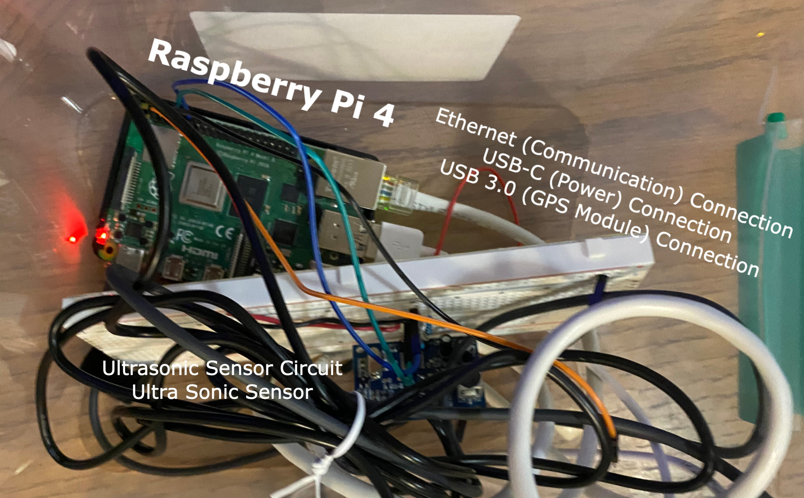

The Raspberry Pi 4 is powered through a USB-C connection to the laptop acting as the front-end. It is also connected to the front-end via Ethernet for secure, tethered data transmission. The ultrasonic sensor is connected to the Raspberry Pi using its pinout. The GPS module is connected through one of the USB ports onboard the microcontroller.

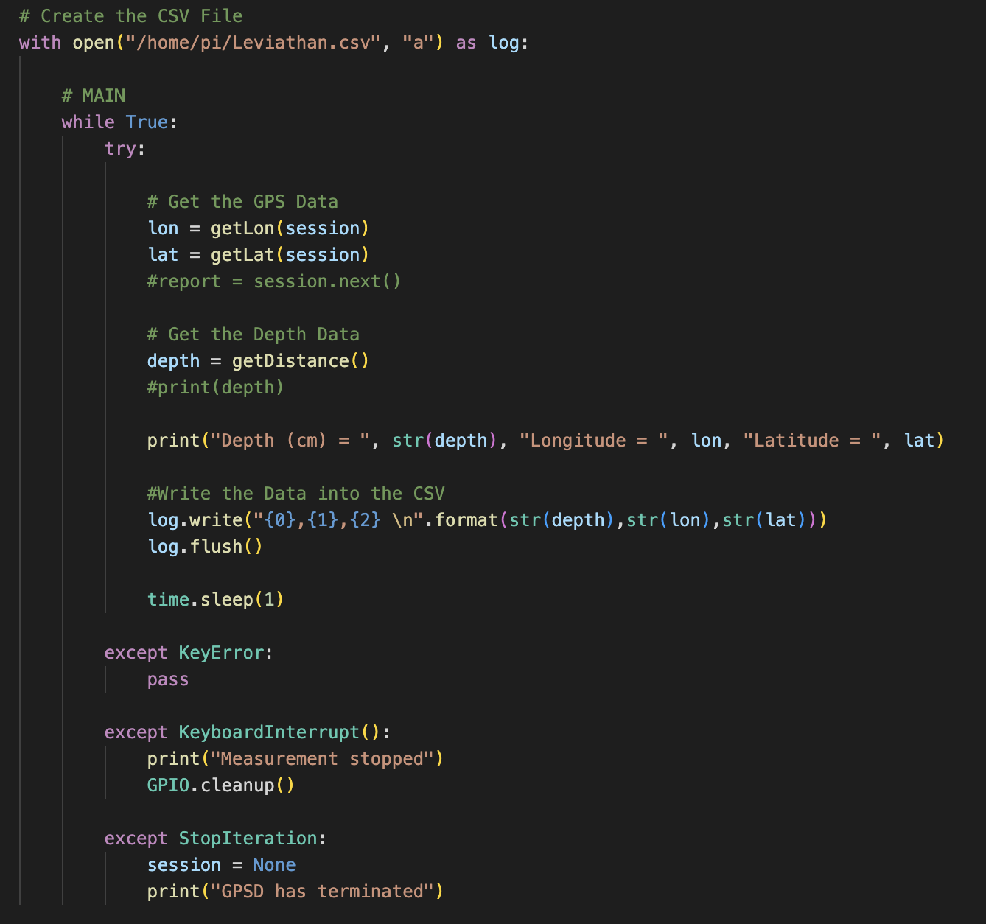

Python is used to extract and parse the data from the peripherals. The above code snippet shows the code that takes the GPS and sonar sensor data and writes it into a CSV file with columns for latitude, longitude, and ocean depth. This CSV file is then used to generate the topographical map. The program utilizes the getLon(session), getLat(session) and getDistance() methods to obtain and calculate the longitude, latitude and depth data from the sensors respectively. The code snippets below show the methods and other initializations required for the program to extract measurements.

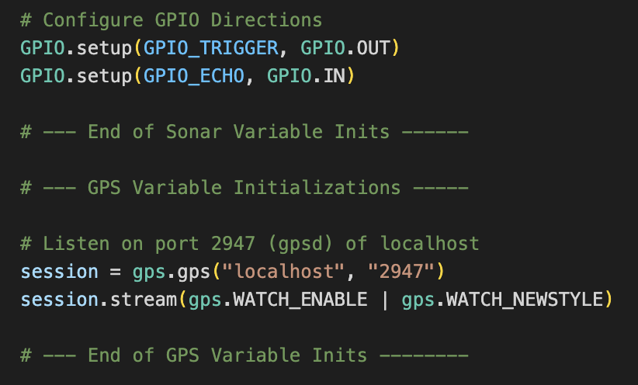
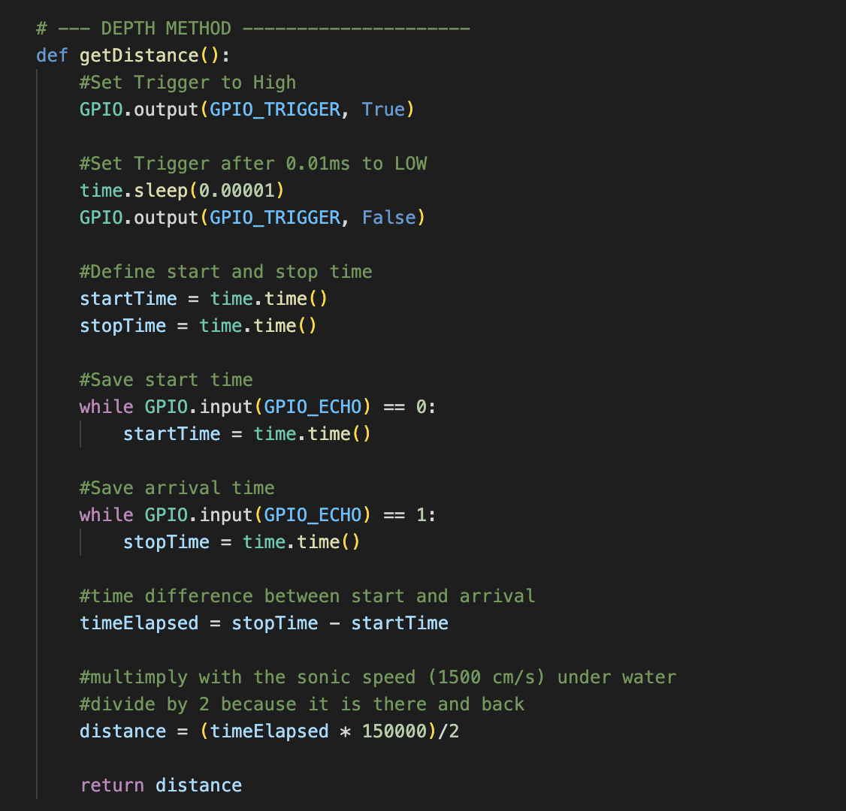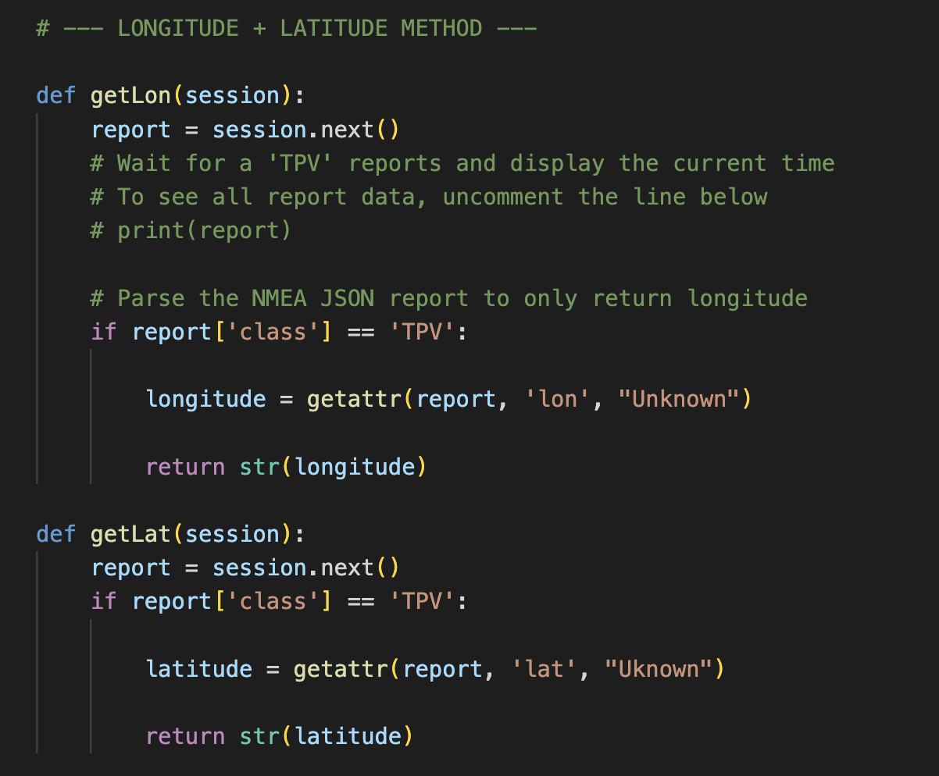
In our project, we employ 3D surface mapping to visualize ocean floor topography, utilizing latitude, longitude, and depth data. The graphical representation is generated through a Python program that reads the data from a CSV file using the Pandas library. The CSV file, which contains the necessary latitude ('x'), longitude ('y'), and depth ('z') coordinates, is loaded into a pandas DataFrame. Subsequently, the program utilizes the plotly.graph_objects library to create a 3D surface plot.

By leveraging the capabilities of the Plotly library, our visualization provides a comprehensive and visually intuitive representation of the ocean floor's topographical features. This approach facilitates a clearer understanding of the spatial distribution of depth across different geographic coordinates, contributing valuable insights to our ocean floor mapping technology.

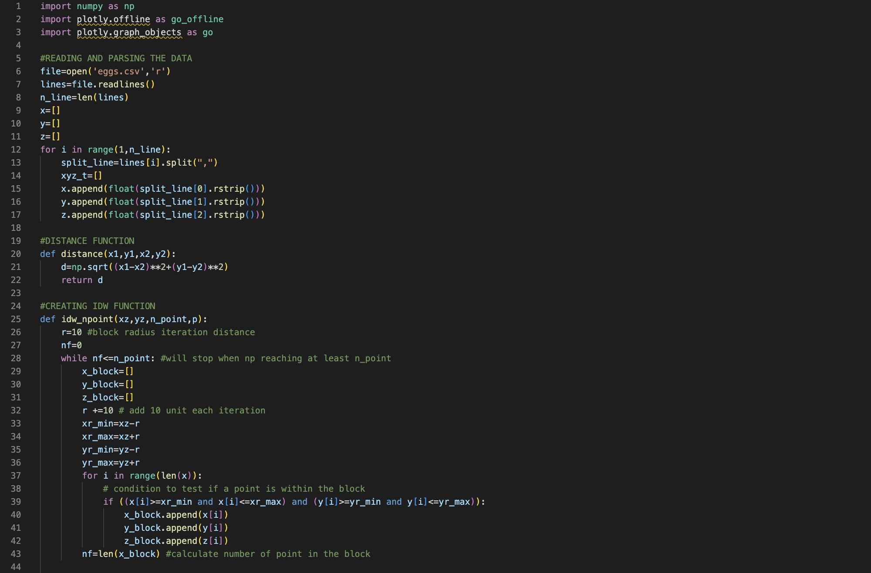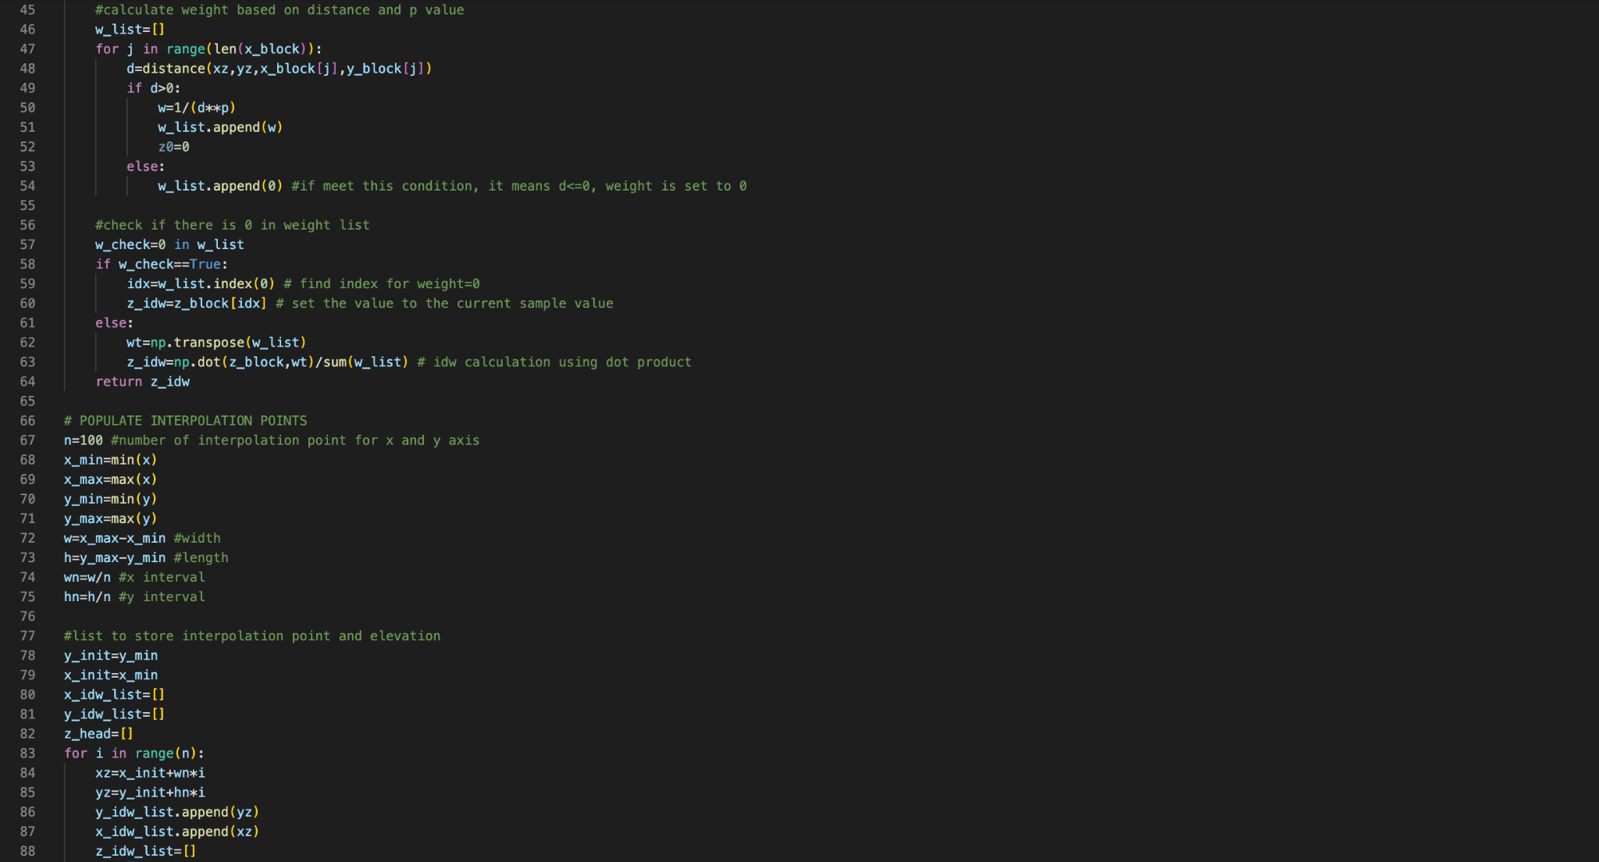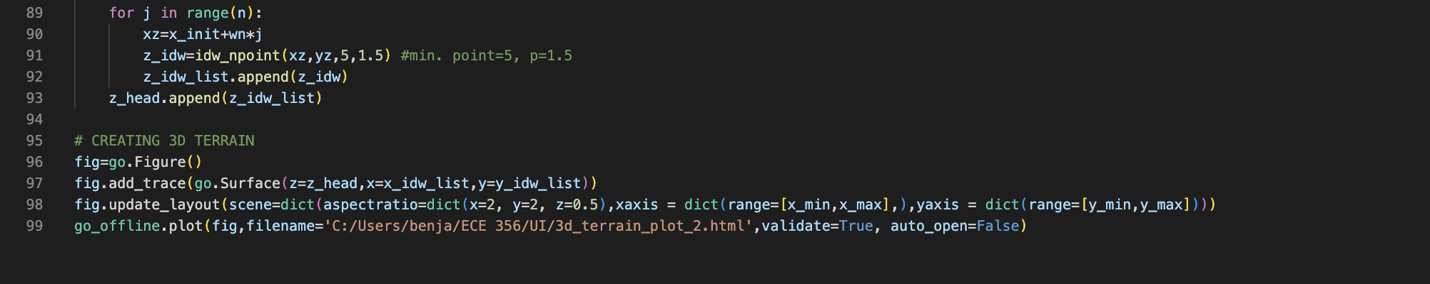

References

[1] “JSN-SR04T Waterproof Ultrasonic Distance Measuring Module Integrated Ultrasonic Detection Module DC 5V,” Amazon.ca. [Online]. Available: https://www.amazon.ca/JSN-SR04T-Waterproof-Ultrasonic-Measuring-Integrated/dp/B071VK1GQL. (accessed Sep. 15, 2023).

[2] “HiLetgo 5pcs ULN2003 28BYJ-48 4-Phase Stepper Motor with 5V Drive Board for Arduino PI PIC Raspberry Pi,” Amazon.ca. [Online]. Available: https://www.amazon.ca/HiLetgo-ULN2003-28BYJ-48-Stepper-4-Phase/dp/B00LPK0E5A/ref=sr_1_8?keywords=Raspberry+Pi+Motor&qid=1694757564&sr=8-8. (accessed Sep. 15, 2023).

[3] “SURPASSHOBBY Waterproof Combo 2440 4600KV Brushless Motor w/ 35A ESC + S0300P 3KG Servo for 1/16 1/18 RC Car Truck,” AliExpress. [Online]. Available: https://www.aliexpress.com/item/1005001562109190.html. (accessed Sep. 15, 2023).

[4] “Raspberry PI GPS Module,” electro{maker}. [Online]. Available: https://www.electromaker.io/shop/product/raspberry-pi-gps-module?gad=1&gclid=CjwKCAjw3oqoBhAjEiwA_UaLtqbKPbd4Gd2W28edq6gEC96nJBWXbWyOxP7RnJCqDCvmSbhgVgH9pRoCXA4QAvD_BwE. (accessed Sep. 15, 2023).

[5] “Adafruit FONA 808 - Mini Cellular GSM + GPS Breakout,” AdaFruit. [Online]. Available: https://www.adafruit.com/product/2542. (accessed Sep. 19, 2023).

[6] T. Kwasnitschka et al., “DeepSurveyCam—A Deep Ocean Optical Mapping System,” Sensors (Basel), vol. 16(2), no. 164, Feb. 2016, doi: 10.3390/s16020164. (accessed Sep. 20, 2023).

