Smart Chess Board
Complete Assembly & Build Guide
Arduino-Powered Board with Stockfish AI Move Recommendations
Project Overview
This board uses an Arduino Mega to scan 64 reed switches arranged in an 8x8 matrix, identify piece types via resistor voltage dividers, and control WS2812B RGB LEDs under each square. A laptop runs Stockfish chess engine via a browser app and communicates over USB serial to light up the best move for White.
Skill Level: Intermediate | Estimated Build Time: 20-40 hours | Estimated Cost: ~$150-180

1. Tools and Materials

1.1 Electronics Components
Component | Specification | Qty / Notes
Arduino Mega 2560 | KEYESTUDIO R3 with USB cable | 1 unit -- DO NOT use Uno (not enough pins)
Reed Switches | 2x14mm glass normally-open (HiLetgo 20-pack) | 4 packs -- 64 needed, 16 spares
WS2812B LED Panels | 8x8 = 64 LEDs per panel (BTF-LIGHTING) | 2 panels -- mount side by side
Neodymium Magnets | 6x2mm disc magnets | 100-pack -- one per piece base
Resistor Kit | 1/4W assortment (1K, 2.2K, 4.7K, 10K, 22K, 47K) | 1 kit -- covers all piece types + pull-ups
Power Supply | 5V 3A DC with 5.5x2.1mm barrel plug | 1 unit -- for LED power only
Barrel Jack | 5.5x2.1mm panel mount female | 2 pack -- one for LEDs, one spare

1.2 Wiring and Connection Materials
22 AWG Solid Core Wire | TUOFENG 6-color x 30ft kit -- solid core is essential for routing in channels
830-pt Breadboard + Jumpers | For bench testing before final assembly -- do NOT skip this step
Wire Stripper | Klein Tools 11057, rated 20-30 AWG -- fits 22 AWG perfectly

1.3 Board Construction Materials
- 3/4" plywood or MDF (base layer): one sheet cut to ~20" x 20" for a standard board
- 1/4" plywood (reed switch layer): same dimensions as base, this is where all the switches sit
- 3/8" plywood or MDF (top surface): this will be painted/stained as the chess board
- Copper tape 3-4mm wide: for contact pads on each square (about 10 feet needed)
- Wood stain or paint: two contrasting colors for light/dark squares
- Clear polyurethane coat: protects top surface and keeps copper tape adhered
- Epoxy (5-min cure): for securing magnets and resistors in piece bases
- Hot glue gun: for tacking wires in channels before final soldering

1.4 Tools Required
- Soldering iron (25-40W) + rosin-core solder -- absolutely required, there are 200+ joints
- Drill with 1/4" bit (for reed switch pockets) and 5/32" bit (for wire routing)
- Jigsaw or table saw (for cutting plywood to size)
- Router with 1/4" straight bit -- OR -- chisel + mallet (for wire channels in wood)
- Multimeter -- essential for testing continuity and measuring resistor values
- Helping hands / PCB holder for soldering
- Heat shrink tubing or electrical tape for wire insulation
TIP: If you do not own a soldering iron, a 40W Hakko FX-888D is a worthwhile investment for projects like this. A cheap iron from Amazon will frustrate you with cold joints.

2. Understanding the Design

2.1 How the Matrix Works
The 64 reed switches are arranged in an 8x8 grid. Instead of running a wire to each individual switch (which would require 128 wires), we use a scanning matrix that needs only 16 wires.
Each switch sits at the intersection of one row wire and one column wire. To read a switch, the Arduino:
- Pulls one row wire LOW while all others are HIGH (using digital output pins D2-D9)
- Reads all 8 column wires simultaneously using the analog inputs (A0-A7)
- Moves to the next row and repeats -- scanning all 8 rows takes less than 1 millisecond

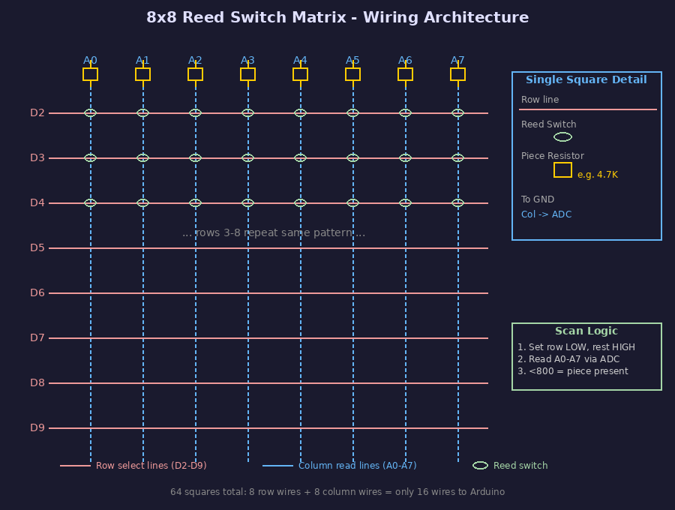
Figure 1: Reed Switch Matrix Wiring Architecture
WARNING: Never connect two row lines simultaneously to LOW -- this would create a short circuit through any closed switches. The Arduino must set one row LOW and all others HIGH at all times.

2.2 How Piece Identification Works
The system identifies not just that a piece is present, but WHICH type of piece it is. This is done using a voltage divider:
- Each piece has a unique resistor value glued into its base
- When a piece is placed on a square, the magnet closes the reed switch
- The closed switch connects the piece resistor in series with a 10K pull-up resistor
- The Arduino reads the resulting voltage -- different resistors produce different voltages
- By measuring the ADC value (0-1023), the Arduino can identify the piece type

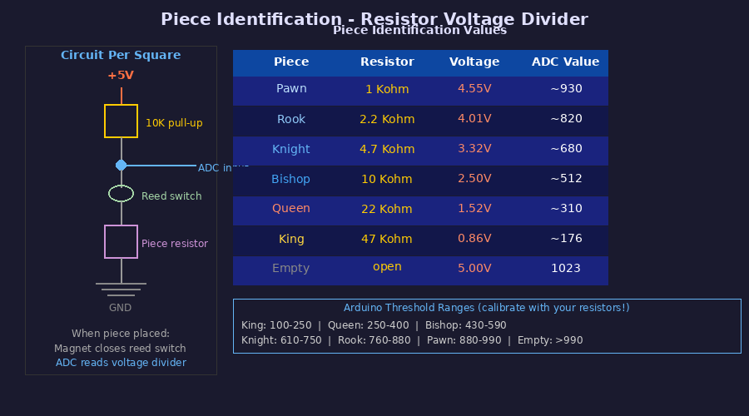
Figure 2: Piece Identification via Resistor Voltage Divider
TIP: Real resistors have a tolerance of +-5%, so the actual ADC values you measure will differ slightly from the theoretical values shown above. The calibration procedure in Section 7 will help you set accurate thresholds.

2.3 How the LEDs Work
Two WS2812B 8x8 LED panels are mounted underneath the board. The Arduino controls all 64 LEDs with a single data wire. Each LED can display any color independently.
- Green LED: the piece the AI wants you to move (pick up this piece)
- Blue LED: the destination square (place the piece here)
- Both LEDs pulse slowly to make them easy to spot during play
The WS2812B protocol sends 24-bit color data (8 bits each for R, G, B) in a precise timing pattern. The FastLED Arduino library handles this for you.

2.4 Board Layer Overview
The board is built as a stack of five layers. Understanding this before you cut any wood will prevent expensive mistakes:

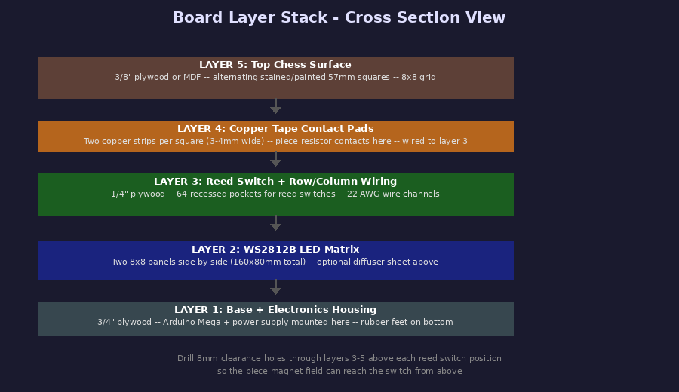
Figure 3: Board Layer Stack and Construction Order

3. Phase 1 -- Preparing the Chess Pieces
Do this first. It is tedious but straightforward, and having the pieces ready means you can test piece identification as soon as the matrix is wired.

3.1 Choosing Your Chess Set
You need a wooden chess set with weighted felt-bottomed pieces. The standard Staunton style is ideal. What you are looking for:
- Flat or nearly-flat felt pad on the bottom of each piece
- Base diameter of at least 30mm (standard pawns are typically 30-35mm, kings 40-50mm)
- Wood thick enough to drill without cracking -- cheap plastic sets will crack
WARNING: Do NOT use plastic chess pieces. The bases are too thin to drill, and epoxy does not bond reliably to smooth plastic. If your set has plastic pieces, get a new set.

3.2 Resistor Values Per Piece
Use these resistor values. They give well-separated ADC readings with minimal chance of misidentification:
Piece | Resistor | Color Bands (5-band)
Pawn (x8 each color) | 1K ohm | Brn-Blk-Blk-Brn-Brn
Rook (x2 each color) | 2.2K ohm | Red-Red-Blk-Brn-Brn
Knight (x2 each color) | 4.7K ohm | Yel-Vio-Blk-Brn-Brn
Bishop (x2 each color) | 10K ohm | Brn-Blk-Blk-Red-Brn
Queen (x1 each color) | 22K ohm | Red-Red-Blk-Red-Brn
King (x1 each color) | 47K ohm | Yel-Vio-Blk-Red-Brn

You have 32 pieces total (16 per color). You need the same resistor values for both White and Black pieces -- the board does not distinguish color, only piece type. Total resistors needed:
- 16x 1K ohm (16 pawns total)
- 4x 2.2K ohm (4 rooks)
- 4x 4.7K ohm (4 knights)
- 4x 10K ohm (4 bishops)
- 2x 22K ohm (2 queens)
- 2x 47K ohm (2 kings)

3.3 Step-by-Step Piece Modification
Work in a batch: do all 32 pieces at once to get into a rhythm. Lay out all resistors in labeled groups before you begin.
- Peel back the felt pad from the bottom of the piece. Use a flat screwdriver blade. Save the felt -- you will reglue it.
- Mark the center of the base with a pencil. Also mark two points 8-10mm to the left and right of center for the copper tape contacts.
- Drill a shallow hole at the center: 4mm diameter, 4mm deep. This is where the neodymium magnet will sit.
- Drill two contact holes: 1.5mm diameter, 3mm deep at your marked contact points. These will hold short wire stubs.
- Measure and note the actual resistance of your chosen resistor with a multimeter. Write this down for calibration later.
- Bend the resistor leads to right angles so it lies flat across the base. The body should bridge the two contact holes.
- Insert short wire stubs (20mm of stripped 22 AWG wire) into the contact holes. Solder the resistor leads to the tops of these wire stubs.
- Test the assembly: use your multimeter in resistance mode to measure from one wire stub to the other. You should read the resistor value.
- Apply a drop of 5-minute epoxy into the center magnet hole. Press in a 6x2mm neodymium magnet with north pole facing down (into the hole). Let cure for 10 minutes.
- Apply a thin bead of epoxy over the resistor and wire assembly to secure everything. Do not cover the wire stub tips.
- Once fully cured, reglue the felt pad over the base. Trim around the wire stubs if necessary.
TIP: Test the magnet polarity before gluing! Place the magnet near one of your reed switches while connected to a multimeter (continuity mode). If you hear a beep, that pole closes the switch -- that is the pole that should face downward (toward the board).

3.4 Piece Contact Design
The wire stubs on each piece base need to make electrical contact with matching pads on the board surface. Here is the contact geometry:
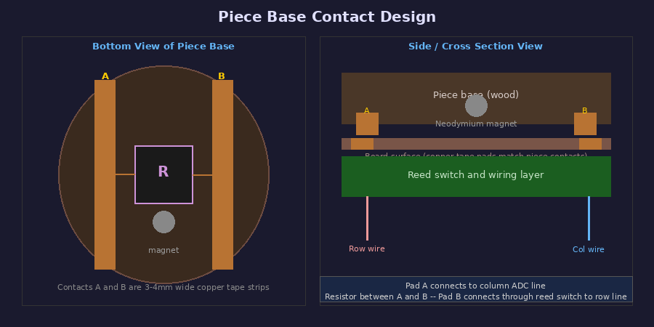
Figure 4: Piece Base Contact Geometry and Circuit Connection
The two contact pads on each board square must be spaced to match the wire stubs on your pieces. Measure the distance between your wire stubs before cutting the board copper tape. A consistent spacing of 16mm center-to-center works well for most piece sizes.

4. Phase 2 -- Building the Board

4.1 Dimensions and Cutting
Standard tournament chess squares are 57mm x 57mm, giving an 8x8 board of 456mm x 456mm (about 18"). Add 25mm border all around for a total board size of 506mm x 506mm (about 20").
Layer | Material | Dimensions (cut to)
Top surface (L5) | 3/8" MDF or plywood | 506mm x 506mm
Reed switch (L3) | 1/4" plywood | 506mm x 506mm
LED layer (L2) | (panels mount in base) | (no separate cut needed)
Base (L1) | 3/4" plywood | 506mm x 506mm

4.2 Laying Out the Grid
Accurate grid layout is critical. Errors here propagate to every subsequent step. Use a marking gauge and metal straightedge, not a ruler.
- On the 1/4" plywood (reed switch layer), draw the 8x8 grid of 57mm squares starting 25mm from each edge.
- Mark the exact center of each of the 64 squares. This is where reed switches will be placed.
- Mark the wire channel paths: 8 horizontal channels (row wires) and 8 vertical channels (column wires). Channels run along the grid lines between rows/columns.
- Transfer the center marks to the top surface (3/8" plywood) using a transfer punch or drill through both layers simultaneously (clamped together).
TIP: Make a 57mm x 57mm template from cardboard. Use it to check every square before cutting anything. One mm of error per square adds up to 8mm across the whole board.

4.3 Wire Channel Routing
Wire channels let you run 22 AWG solid core wires cleanly under the board without them shorting against each other. You have two options:

Option A: Router Channels (Recommended if you have a router)
- Set your router to cut 3mm wide x 5mm deep channels
- Route horizontal channels along each row grid line (8 channels)
- Route vertical channels along each column grid line (8 channels, perpendicular)
- At each crossing, one wire goes through the deeper part of the channel and one goes over. You will need to carve small bridges manually to keep them separated.

Option B: Chisel Channels (Hand tool method)
- Use a sharp 3mm chisel to cut channels 5mm deep along each grid line
- Work slowly and check depth with calipers -- consistent depth is important
- Sand the channels smooth so wires slide in without snagging
TIP: If routing makes you nervous, you can instead use self-adhesive cable channels (available from electronics suppliers) glued to the underside of the top board. They are less clean but work equally well.

4.4 Reed Switch Pockets
- At each of the 64 center marks on the 1/4" plywood, drill a 14mm diameter pocket 7mm deep using a Forstner bit or step drill
- The reed switch body is 14mm long x 2mm diameter -- it should sit recessed below the surface so the top plywood layer sits flush on top
- Test fit a reed switch in one pocket. It should sit fully below the surface with the leads sticking up through the channel.
- Drill a 3mm clearance hole at the center of each pocket, through the full thickness of the 1/4" plywood -- this lets the magnet field pass through to the switch from above.

4.5 Top Surface - Chess Square Pattern
- Lightly sand the 3/8" top surface board smooth
- Using your grid markings, tape off alternating squares using painters tape
- Apply your light-color stain or paint to all 32 light squares. Let dry completely.
- Tape off the light squares and apply dark stain to the 32 dark squares.
- Once both colors are fully dry, apply two coats of clear polyurethane. Let cure 24 hours.
WARNING: Do NOT apply polyurethane over the copper tape contact pads. Polyurethane is insulating and will prevent electrical contact. Apply copper tape AFTER the polyurethane has cured.

4.6 Installing Copper Tape Contact Pads
Each of the 64 squares needs two copper tape contact pads. These are what the piece base wire stubs touch when a piece is placed.
- Measure your piece contact spacing -- the distance between the two wire stubs on your finished pieces (typically 16mm center-to-center).
- Cut 64 pairs of 3-4mm wide copper tape strips, each about 25mm long.
- On each square, position one strip 8mm to the left of center and one strip 8mm to the right of center. The strips should run front-to-back across the square (not side to side).
- Press the copper tape firmly with a burnishing tool or pen barrel. The adhesive is pressure-sensitive.
- Each copper tape strip needs to connect down through the board to the wiring layer. Drill a 1.5mm hole through the end of each copper tape strip, through the top surface into the wiring layer.
- Push a short wire stub through each hole and solder it to the copper tape from above, then connect it to the appropriate wire in the channel below.
TIP: Buy 3M copper foil tape (not generic). The generic brands have adhesive that fails within weeks with the repeated pressure of piece placement.

5. Phase 3 -- Wiring the Matrix
WARNING: Complete the breadboard test in Section 6 BEFORE wiring the full matrix. Fixing a wiring error in a completed board is very difficult.

5.1 Arduino Pin Assignments
Arduino Pin | Function | Details
D2 | Row 1 (rank 1) | digitalWrite LOW to scan, INPUT_PULLUP otherwise
D3 | Row 2 (rank 2) | digitalWrite LOW to scan, INPUT_PULLUP otherwise
D4 | Row 3 (rank 3) | (same pattern for D4-D9)
D5 | Row 4 (rank 4)
D6 | Row 5 (rank 5)
D7 | Row 6 (rank 6)
D8 | Row 7 (rank 7)
D9 | Row 8 (rank 8)
A0 | Column 1 (file a) | Analog read, 10K pull-up resistor to 5V
A1-A7 | Columns 2-8 (files b-h) | (same as A0)
D10 | LED data out | Single wire to WS2812B DIN -- FastLED library
5V | Pull-up power rail | 10K resistors for A0-A7 connect here
GND | Ground | All GND connections -- do NOT mix with LED GND

5.2 Wiring the Pull-Up Resistors
You need EIGHT 10K resistors, one per column (not one per square). These provide the reference voltage for piece identification.
- Cut 8 lengths of red wire, about 100mm each
- For each column (A0-A7), solder a 10K resistor with one lead to the 5V rail and the other lead to the column wire
- The column wire will also connect to the corresponding Arduino analog input
TIP: Build a small terminal block from perfboard to organize the 8 pull-up resistors neatly. Mount it near the Arduino to keep wire runs short on the analog inputs.

5.3 Wiring the Reed Switches
Each reed switch has two leads. One lead connects to the row wire for that rank; the other connects to the junction between the column pull-up resistor and the Arduino ADC input.
- Working one row at a time, solder the first lead of all 8 switches in that row to the row wire (D2 for row 1, D3 for row 2, etc.)
- Solder the second lead of each switch to the corresponding column wire
- After completing each row, test continuity on the row wire (should read 0 ohms from one end to the other) and test each switch with a magnet
- Once all 64 switches are wired, test the full matrix with the breadboard test from Section 6 before closing up the board

5.4 LED Panel Wiring
The two WS2812B panels connect in series. LEDs draw significant current -- do NOT power them from the Arduino 5V pin.
- Mount the two panels side by side in the base, centered under the 8x8 square grid. The panels are 80x80mm each; two side by side = 160x80mm.
- The LED panels have a DIN (data in) and DOUT (data out) connection. Chain them: Arduino D10 -> Panel 1 DIN, Panel 1 DOUT -> Panel 2 DIN.
- Both panels share power: 5V from your external power supply to both panel 5V pads, GND to both GND pads.
- Also connect the external power supply GND to the Arduino GND. This provides a common ground reference.
- Install a 300-500 ohm resistor in series on the D10 data wire, directly at the Arduino. This prevents voltage spikes from destroying the first LED.
WARNING: The Arduino 5V pin can supply only 500mA total. 64 LEDs at full brightness need up to 3.8A. Always power the LED panels from the external 5V 3A supply, never from the Arduino.

5.5 Wiring to the Arduino
Once the matrix is complete, you need to bring all 16 wires (8 rows + 8 columns) plus ground and LED data to the Arduino Mega.
- Run all wires through a single cable exit point in the board side (drill a 20mm hole)
- Label every wire before routing. Use colored tape with written labels or use differently-colored wires
- Terminate all row wires to D2-D9 on the Arduino
- Terminate all column wires to A0-A7 via the pull-up resistor junction
- Terminate LED data wire to D10 via the 300-500 ohm resistor
- All grounds to GND on the Arduino
TIP: Use a 20-pin IDE ribbon cable to route all 16 matrix wires as a bundle. They are easy to separate and already color-coded.

6. Phase 4 -- Breadboard Testing (DO NOT SKIP)
Test ONE ROW of 8 switches on your breadboard before building the full board. This takes about an hour and will save you many hours of debugging later.

6.1 Single-Row Breadboard Test
- On your breadboard, place one row of 8 reed switches. Each switch bridges two separate columns.
- Wire the left lead of all 8 switches to a row wire (connect to Arduino D2)
- Wire the right lead of each switch to a separate column wire
- Add a 10K pull-up resistor between each column wire and 5V
- Connect each column wire to A0-A7 on the Arduino
- Place a piece resistor (say, 4.7K for Knight) on a small strip of wood with two wire stubs. Bridge it across one of the switch junctions to simulate a piece.
- Upload the test sketch below and open the Serial Monitor at 115200 baud
// Paste this into Arduino IDE
void setup() { Serial.begin(115200); }
void loop() {
pinMode(2, OUTPUT); digitalWrite(2, LOW);
delay(1);
for(int c=0; c<8; c++) {
int val = analogRead(c);
Serial.print(val); Serial.print("\t");
}
Serial.println();
pinMode(2, INPUT_PULLUP);
delay(100);
}

6.2 Expected Results
With no pieces placed (no magnets near any switch), all 8 columns should read approximately 1020-1023.
When you hold a magnet near a switch to close it, the corresponding column should drop to a lower value. With a 4.7K Knight resistor:
- Column with closed switch + 4.7K resistor: should read approximately 650-700
- All other columns: should still read approximately 1020-1023
TIP: If a column always reads 0, the pull-up resistor is missing or disconnected. If all columns read 0 when any magnet is near any switch, the row select wire is not releasing to INPUT_PULLUP between scans.

6.3 Testing All 6 Piece Types
Before you build the board, verify that all 6 resistor values give clearly separated and stable ADC readings:
- Place each piece type on a closed switch in turn and record the ADC value
- Calculate the midpoint between each adjacent pair of values -- these will become your threshold values
- Write down the thresholds -- you will enter them into the Arduino firmware in Section 7
- Verify no two piece types produce overlapping readings (they should not with the recommended resistors, but real tolerances sometimes surprise you)

7. Phase 5 -- Software Setup

7.1 Arduino Firmware
The Arduino firmware is already written and saved as chess_board.ino (provided separately). Key settings you need to adjust:

Calibrating Piece Thresholds
Open chess_board.ino and find the section labelled PIECE THRESHOLDS. Replace the default values with the midpoints you measured in Section 6.3:
#define THRESH_KING 250 // ADC < this = King
#define THRESH_QUEEN 400 // ADC < this = Queen
#define THRESH_BISHOP 590 // ADC < this = Bishop
#define THRESH_KNIGHT 750 // ADC < this = Knight
#define THRESH_ROOK 880 // ADC < this = Rook
#define THRESH_PAWN 990 // ADC < this = Pawn
// ADC >= THRESH_PAWN = empty square
Adjust these values based on your measured ADC readings from Phase 4.

LED Serpentine Pattern
WS2812B panels wire LEDs in a serpentine (snake) pattern. The squareToLEDIndex() function in the firmware maps chess squares to LED indices. Verify that the LED panel DIN connector is at the a1 corner (White king rook corner) of the board. If not, adjust the mapping.

7.2 Installing Arduino Libraries
- Open the Arduino IDE. Go to Tools > Manage Libraries.
- Search for "FastLED" and install the latest version by Daniel Garcia.
- No other libraries are required -- the firmware uses only FastLED and built-in Arduino functions.
- Connect the Arduino to your laptop via USB, select "Arduino Mega 2560" under Tools > Board, and the correct port under Tools > Port.
- Click Upload. The Arduino should respond with READY:chess_board_v1 in the Serial Monitor at 115200 baud.

7.3 Browser App (chess-advisor.html)
The chess-advisor.html file (provided separately) runs entirely in your browser. It uses Stockfish.js (WebAssembly chess engine) and the Web Serial API.
- Open chess-advisor.html in Chrome or Edge (these browsers support Web Serial API -- Firefox does not)
- Click "Connect to Arduino" and select your Arduino from the list
- The board display should show the starting position automatically once the Arduino sends its first board scan
- Stockfish will analyze the position and send the best move lighting command to the Arduino

7.4 Serial Protocol Reference
For troubleshooting, here is the complete serial protocol between Arduino and laptop:
Direction | Message | Description
Arduino -> PC | READY:chess_board_v1 | Sent once on startup
Arduino -> PC | BOARD:rnbqkbnr/pp... | FEN piece placement string, sent after each detected move
Arduino -> PC | MOVE:e2e4 | Physical move detected, sent when piece lifted and placed
PC -> Arduino | LED:e2:e4 | Light up from-square green, to-square blue
PC -> Arduino | RESET_LEDS | Turn off all LEDs
PC -> Arduino | SCAN | Request an immediate board state report
PC -> Arduino | PING | Health check; Arduino responds with PONG

8. Phase 6 -- Final Assembly

8.1 Assembly Order
Follow this sequence to avoid situations where a later step requires you to undo earlier work:
- Complete and test all 32 piece modifications (Phase 3)
- Cut all three plywood layers to size
- Route wire channels in the 1/4" reed switch layer
- Drill reed switch pockets in the 1/4" layer
- Paint/stain the 3/8" top surface and apply polyurethane
- Wire all reed switches in the 1/4" layer -- DO NOT glue yet
- BREADBOARD TEST the full matrix (modified version of Section 6, but now with 8 rows)
- Once matrix tests pass, glue the 1/4" layer reed switches in place
- Install copper tape contact pads on the 3/8" top surface
- Glue the top surface to the reed switch layer (wood glue, clamp overnight)
- Mount LED panels in the 3/4" base
- Mount Arduino Mega and barrel jack in the base
- Final wiring to Arduino
- Upload firmware and test

8.2 Gluing and Assembly
- Sand mating surfaces of the 1/4" and 3/8" layers with 120-grit sandpaper
- Apply wood glue evenly to one surface. Do not use too much -- squeeze-out can insulate contact pads.
- Clamp with even pressure across the full surface. Check that corners are flush. Wipe away any squeeze-out immediately with a damp cloth.
- Allow 24 hours minimum before removing clamps. Wood glue reaches full strength slowly.
- After the glue cures, check that all copper tape contact pads are still exposed and conductive (test with multimeter).
- Mount this combined top assembly onto the base with countersunk screws from underneath. Do not glue -- you may need to access the wiring later.

8.3 Power Wiring
- Mount the barrel jack on the side of the base. Drill a 12mm hole for the panel-mount socket.
- Connect barrel jack positive to: LED panel 5V pads (run thick wire, at least 20 AWG) AND Arduino Vin
- Connect barrel jack negative to: LED panel GND pads AND Arduino GND
- Before connecting any power, use a multimeter in continuity mode to verify there is no short between the 5V and GND rails.
- Connect the 5V 3A power supply and verify the Arduino powers on (green LED on the board).
WARNING: Never connect both a USB cable and the external power supply at the same time unless you are sure your Arduino version supports it. The KEYESTUDIO Mega has protection diodes that allow this, but check before doing it.

8.4 Final Checks Before First Use
[ ] | All 64 squares detected correctly when pieces placed (run SCAN command from Serial Monitor)
[ ] | All 6 piece types identified correctly (place each type on a square, read the BOARD response)
[ ] | LEDs light up at the correct squares when LED:e2:e4 command sent
[ ] | Browser app shows starting position correctly after SCAN
[ ] | Stockfish sends LED commands and green/blue lights appear on the board
[ ] | Power supply does not run warm after 10 minutes of operation (it should be cool or barely warm)
[ ] | No reed switches give false positives without a piece (walk around the board -- magnetic interference from power supply can cause this)

9. Troubleshooting

9.1 Matrix Problems
Symptom | Likely Cause and Fix
Column always reads ~0 | Pull-up resistor missing or disconnected. Check 10K resistor between that column and 5V.
Column always reads 1023 even with piece | Reed switch for that column not closing. Check magnet polarity and switch placement depth.
Whole row reads 1023 always | Row wire not reaching the Arduino. Check continuity from D2-D9 to the row wire.
Ghost pieces detected (false positives) | Magnetic interference or switching noise. Add 100nF capacitor from each column analog pin to GND.
ADC values unstable / jumping | Floating ground. Ensure external PSU GND is connected to Arduino GND.
Wrong piece type identified | Thresholds need calibration. Re-run the test sketch and measure your actual ADC values.
Multiple squares trigger when one piece placed | Row wire shorted to adjacent row. Inspect wire channel routing for shorts at crossings.

9.2 LED Problems
Symptom | Likely Cause and Fix
No LEDs light at all | Check 5V supply voltage at panel VCC pads with multimeter. Verify GND common with Arduino.
First LED works, rest do not | DOUT of panel 1 not connected to DIN of panel 2. Re-solder the chain connection.
LEDs show wrong color / random flicker | Missing 300-500 ohm resistor on data line. Add it directly at the Arduino D10 pin.
LEDs light wrong squares | Serpentine pattern mismatch. Check if panel DIN is at a1 corner. Adjust squareToLEDIndex() mapping.
LEDs stay on after move | RESET_LEDS command not being sent. Check browser app web serial connection is still open.

9.3 Software / Serial Problems
- "Web Serial not supported" error: Switch to Chrome or Edge. Firefox does not support Web Serial API.
- "Failed to open port" error: Arduino is connected to Serial Monitor in IDE. Close the IDE Serial Monitor first.
- Browser shows empty board: Send SCAN command manually from browser console. Check serial monitor for BOARD: messages.
- Stockfish not suggesting moves: Check that the FEN string in the browser is valid. Open browser Developer Tools > Console for error messages.

10. Quick Reference Card
Cut this page out and keep it near your build station.

Resistor Color Codes
Pawn: 1K = Brown-Black-Black-Brown-Brown
Rook: 2.2K = Red-Red-Black-Brown-Brown
Knight: 4.7K = Yellow-Violet-Black-Brown-Brown
Bishop: 10K = Brown-Black-Black-Red-Brown
Queen: 22K = Red-Red-Black-Red-Brown
King: 47K = Yellow-Violet-Black-Red-Brown
Pull-up: 10K (x8, one per column A0-A7)

Arduino Pin Summary
Row select: D2=rank1, D3=rank2, ..., D9=rank8
Col read: A0=file_a, A1=file_b, ..., A7=file_h
LED data: D10 (via 300-500 ohm series resistor)
LED power: EXTERNAL 5V 3A supply (NOT Arduino 5V)

Magnet Test
Reed switch closes when magnet is NORTH pole facing down
Test: continuity beep with multimeter when magnet approaches

Serial Commands (send from Serial Monitor at 115200 baud)
SCAN -- Request board state
RESET_LEDS -- Turn off all LEDs
PING -- Health check (expect PONG back)
LED:e2:e4 -- Light from/to squares

Good luck with your build! Document your calibration values and keep them somewhere safe.

