DSP Builder Advanced Blockset: Best Practices for Optimal Results
DSP Builder Advanced Blockset: Best Practices for Optimal Results 1
1 Why this Document 4
1.1 Architecture vs. Implementation 5
1.2 Key Features of DSPB-AB 8
1.3 A Mindset for Success 8
1.3.1 DSPB-AB vs. RTL 8
1.3.2 Leveraging DSPB-AB Features 8
1.3.2.1 Planning for Optimization 8
1.3.2.2 Folding and Timesharing 8
1.3.2.3 Automatic Pipelining 8
1.3.2.4 Support of Algorithmic Types 8
1.3.2.5 Automatic Processor Bus Generation 8
1.3.2.6 Automatic RTL Test Bench Generation and Verification 8
1.3.2.7 Algorithmic Design Space Explorer 8
1.3.3 TextBook based design 8
1.3.3.1 Revisiting Architecture vs. Implementation 8
1.3.3.2 Algorithmic IP generation 8
1.4 Is DSPB-AB the Right Tool? 8
2 Recommended Design Flow 9
2.1 Overview 9
2.1.1 Flow Outline 9
2.1.2 Simulink 11
2.1.3 Key DSPB-AB Blocks 12
2.1.3.1 Control 13
2.1.3.2 Signals 15
2.1.3.3 Run Quartus 16
2.1.3.4 Device 17
2.2 Setting Up the Simulink Testbench 17
2.2.1 How DSPB-AB Systems Benefit from Well Planned Testbenches 17
2.2.2 Creating a Plan 18
2.2.2.1 DSPB-AB Interface Protocol 18
2.2.2.2 Examples 19
2.2.2.2.1 Using Golden References 19
2.2.2.2.2 Setting up Stimulus 19
2.2.2.2.3 Analysis 19
2.2.2.2.4 Model Configuration 19
2.2.2.2.4.1 Managing Basic Parameters 20
2.2.2.2.5 Connecting Submodules 20
2.2.3 Testbench Checklist for Using Key Simulink Features 23
2.3 Model Design in DSPB-AB 24
2.3.1 Staging your Design into Subsystems 24
2.3.2 DSPB-AB IP vs. Primitive library 24
2.3.3 Using Primitive Blocks 25
2.3.3.1 When You need Channel In/Out 26
2.3.3.2 Rules for Using Channel In/Out with Subsystems 26
2.3.3.3 Rules for Using SynthesisInfo within Subsystems 26
2.3.3.4 Latency Management and Parameterization 27
2.3.3.4.1 Using Latency Constraints 28
2.3.3.4.2 Latency and fMAX Constraint Conflicts 28
2.3.3.4.3 Using Latency Parameters 28
2.3.3.5 Folding and TDM 30
2.3.3.5.1 Using Folding 31
2.3.3.5.2 Folded Subsystem without TDM De-muxing 32
2.3.3.5.3 Folded Subsystem with TDM De-muxing 32
2.3.3.5.4 When to use folding 34
2.3.3.5.5 Effects of folding 34
2.3.3.5.6 Effects on Manual Delays 35
2.3.3.5.7 Effects on Combinational Logic 36
2.3.3.6 Multichannel and Vectorized Signal Support 37
2.3.3.6.1 Vector Input for ModelIP and Primitive Subsystems 37
2.3.3.6.2 Key Benefits of Vector Support 38
2.3.3.7 Should a Design be Split into Separate Channel In/Out Blocks? 39
2.3.4 Using FIR IP and NCO IP 39
2.3.4.1 How It Differs from the Primitive Blocks 39
2.4 Managing Bit Growth 39
2.4.1 Fixed Point Representation 39
2.4.2 How to Decide Bit Width at Each Stage 39
2.4.3 Rounding and Saturation 40
2.4.3.1 Understanding DSPB-AB Output Data Type 40
2.4.3.2 Implementation Details and Options 40
2.4.3.3 How to Use the Scale Block 41
2.4.3.4 Design Tradeoffs 43
2.5 Verification and Debugging 44
2.5.1 Running Automatic Testbench 44
2.5.1.1 Running Automatic Testbench in ModelSim 44
2.5.1.2 Running Automatic Testbench in MATLAB 44
2.5.2 GUI Flow for ModelSim Simulation 46
2.5.3 Clock Domain Issues with Processor Bus 47
2.6 Managing your Designs 47
2.6.1 Leveraging Scripting 47
2.6.2 Creating User Libraries 47
2.6.3 Revision Control 47
2.6.3.1 Files to Include 47
2.6.3.2 Comparing against Earlier Revisions 47
3 Hardware Integration 47
3.1 Generated Files 48
3.2 Options for Adding to your Quartus Project 49
3.3 Quartus Settings 50
3.3.1 Physical Synthesis Suggestions 50
3.3.2 Other Fitter Directives 50
3.4 Interfacing with the Processor Bus 50
3.4.1 Assigning Base Address 50
3.4.2 Smart Use of Timing Diagrams 50
3.4.3 SOPC Integration 51
3.4.3.1 NIOS II Processor Example 51
3.5 Integration with DSP Builder Standard Blockset 52
3.6 Interfacing with the Real World Outside DSPB-AB 52
4 Information for Power Users 53
4.1 Achieving Good Quality of Results 53
4.1.1 Optimization Techniques to Include and to Avoid 53
4.1.1.1 Defering HDL-like Low Level Optimizations 53
4.1.1.2 Recommended Optimization Practices 53
4.1.2 Folding and Fmax 53
4.1.3 Folding Expectations 53
4.1.4 Constant Multipliers 54
4.1.5 Resource Optimization 54
4.2 Creating a Parameterizable Design 54
4.2.1 Simulink / MATLAB Access 54
4.2.2 Using Masks 54
4.2.3 Custom Libraries / Subsystems 54
4.2.4 Vectors vs. Arrays 54
4.3 Optimizing Performance and Resource Usage 55
4.3.1 Optimization 55
4.3.1.1 Thresholding 55
4.3.1.2 Clock Margin 55
4.3.1.3 Algorithm Design Space Explorer 55
4.3.2 Design Space Exploration 55
4.4 Compiler Optimization Directives 55
4.4.1 How to Avoid Minimum Latency in a Feedback Loop 55
4.4.2 How to Avoid State Machines 55
5 Lessons: CookBook Designs 56
5.1 Introduction 56
5.2 Delay Lines 56
5.2.1 Normal Use 56
5.2.2 with Enable 56
5.2.3 Variable Delay 56
5.3 FIR 56
5.3.1 Using Vectorization 56
5.3.2 Using Scalars 56
5.4 FIR Model IP 56
5.4.1 Flow control 56
5.4.2 Packet Reordering 56
6 Appendix 56
6.1 Common Issues and Errors 56
6.1.1 DSPB-AB vs. Simulink 56
6.1.2 NCO - What IS this Thing?? 56
6.2 Primitive Use Tables 56
6.3 Vector Support Tables for Primitive Library 56
6.4 Scripts Provided by DSPB-AB 58
6.5 Tips and Tricks 58
6.5.1 When Using Faster Speed Grade Devices Starts to Make Sense 58
6.5.2 Using Clock Margin to Tweak Sizes 58
6.5.3 Thresholding 58
6.6 Bus Format for the FIR and NCO IP 58
6.6.1 Why the Interface 58
6.6.2 Protocol 58
6.6.3 Tips for Interface to Primtive Subsystems 58
6.6.4 Tips for Changing Order for Channel Summing or Mixers 58
6.6.5 Tips for Flow Control 58
6.7 FAQ 58
6.8 RAQ 58
6.9 Simulink Tips 58

- Why this Document
Advanced DSP Builder is a new tool from Altera which has been designed with a different mindset in comparison to earlier Simulink-based tools from Altera or otherwise. Rather than an implementation focused tool which allows a user to manually craft the FPGA resources into a function system, Advanced DSP Builder (DSPB-AB) was constructed to allow algorithmic functions to be described naturally and apply rule based methods to generate hardware optimized code.

There are many ways this tool can be used to achieve better productivity, portability or even quality of results (QoR). While these claims are often and rightly met with skepticism, the reality of FPGA design is that it is highly implementation focused. Multipliers are exploited based on the available features, shift registers are cleverly mapped to memories, and overall device resources are balanced by the chosen implementation to make sure a design isn’t forced into a larger device based solely on suboptimal memory or multiplier implementations. State machines are handcrafted to match pipeline latencies of memory or multiplier structures, and routing registers are carefully placed in key structures to account for routing delays to and from various hard blocks which complicate FPGA placement. Floor planning is often used to reduce compile times and help shoehorn a marginal design fixed because board prototypes have already been finalized.

These techniques are critical to achieving an efficient design in modern FPGAs. All take time, reduce portability to different families, are inflexible to clock rate changes (re-pipelining), are difficult to change timesharing on elements like multipliers, and unfriendly to resource re-balancing when the requirements or other modules change.

This process, separating the algorithm from the simplistic yet tedious rules based implementation is the heart of DSPB-AB. This rethink of the design process results new opportunities for system level design, and as a result a new user can greatly benefit from considering these concepts.

  - Architecture vs. Implementation
<This tool is different. Focus on architecture.>
Advanced DSP Builder is designed to focus design architecture, not implementation. As a result, many features one might expect are simply not required, and many useful features, while intuitive to use, have no corollary in the hardware based design world. This is what DSPB-AB focuses on, textbook based entry where the design is described as naturally as possible. Because we can differ many hardware tasks to automation at the end, when can sweep a large range of options parametrically by using the power of MATLAB to explore a wider range of options. While for a given implementation, a hand crafted design will always beat an auto generated system like DSPB-AB, it is very hard to know what the highest amount of time-division multiplexing, or folding, one can apply to a design before you’ve done it. If you run too fast, the design won’t close timing, if you run too slowly, you are wasting multipliers.

This is a very common problem, but only one of many design tradeoffs a designer might need to consider. In a DSP based design there are many tradeoffs: bit precision, memory efficiency, etc, but the biggest is tradeoff of the algorithm itself. How much value does using a more sophisticated channel estimation algorithm give you in system vs. how much more it costs in FPGA resources? These are all important tradeoffs, but are generally made with incomplete information. DSPB-AB allows us to actually measure those tradeoffs as they can be parametrically swept, or quickly entered to measure real results in hardware. In this way, a tool like DSPB-AB can yield better than hand-coded-results in practice, even though it doesn’t when comparing two fixed designs

This approach needs to be considered when starting a design to maintain flexibility and parameterization in the core design, so these parameters can be swept. Let’s take a look at a simple FIR design. While this filter is far from a complex piece of IP, it is representative of the concept.

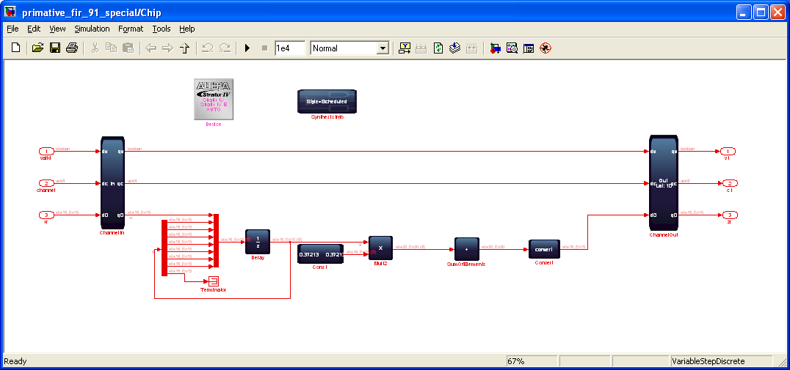
Figure 1 A simple FIR example implemented using DSPB-AB.

Moving from left to right we can see the delay line, in this case 8 taps, shifting the data in. The output of this delay line is an 8-element vector, which is multiplied against a constant vector (the coefficients), and finally those results are summed across the 8 element vector and rounded.

This design, consisting of 5 algorithmic blocks, implements a very simple FIR rather cleanly. With this base design, you can specify some parameters through a simple MATLAB script:

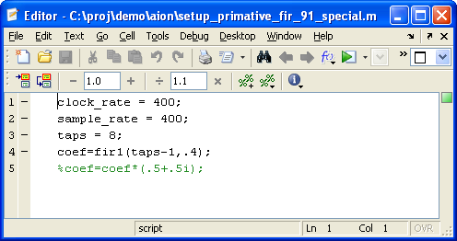
Figure 2 A simple setup script for the FIR example in Figure 1.

This allows us to retune the design for different clock rates, multiplier sharing, FIR tap lengths and precision bit widths and FPGA families.

Simply simulating the design generates hardware targeted as above to a Stratix 4 device running at 400MHz, which takes ~669 LUTs and 8 multipliers:

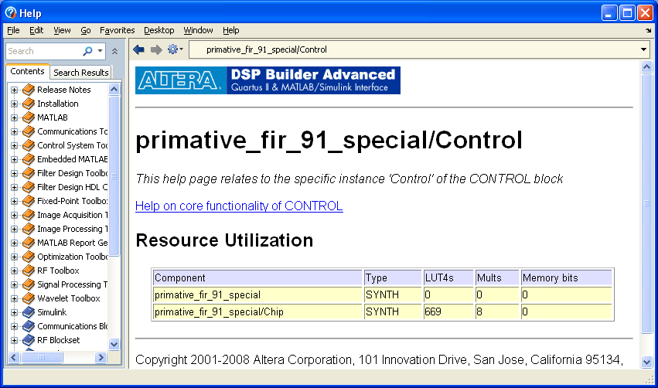

Figure 3 Content sensitive help page generated for the example in Figure 1.

The implementation details shown in the HELP page in Figure 3 is obtained via a click of button, and it is based on your choice of implementation parameters.

If we were then requested to use fewer multipliers, we can specify a tradeoff between multipliers and logic, and the tool will convert constant or full multipliers optimally based on this tradeoff. In this case, we exploit the constant multiplication to get rid of 4 multipliers at an expense of more logic. The performance is shown in the 2nd row of Table 1.

Table 1 Resource utilization summary of three design tradeoffs for Figure 1.
Design Iteration | LUT4s | Mults | Memory bits
1st (Figure 3) | 669 | 8 | 0
2nd | 835 | 4 | 0
3rd | 985 | 1 | 112

If a future product required a lower performance, lower cost version of this IP, we could simple change the target device to Cyclone, lower the FPGA clock rate to 200MHz, and specify the sample rate going into the filter at the new requirement of 25MHz. The performance figures are shown in the 3rd row of Table 1.

While the tool offers many more features, and typical designs are much more complicated, DSPB-AB allows a design to be entered concisely using natural mathematical elements and generate targeted results ad-hoc based on applied requirements.

While understanding how to efficiently implement a design in an FPGA is always useful and can augment the tools automated features, significant gains can be realized by starting from a point of algorithmic purity, and considering implementation specific optimizations as necessary. Architecture first, implementation second.
  - Key Features of DSPB-AB
  - A Mindset for Success
<Planning in advance for features.>
    - DSPB-AB vs. RTL
    - Leveraging DSPB-AB Features
      - Planning for Optimization
      - Folding and Timesharing
      - Automatic Pipelining
<pipelining based on device and desired Clock rate>
      - Support of Algorithmic Types
<Arrays, Vectors and Complex operators>
      - Automatic Processor Bus Generation
<Avalon MM Slave>
      - Automatic RTL Test Bench Generation and Verification
      - Algorithmic Design Space Explorer
    - TextBook based design
      - Revisiting Architecture vs. Implementation
      - Algorithmic IP generation
<Not one size fits all>
  - Is DSPB-AB the Right Tool?
<What are the right applications? You need streaming or flow control? Key is finding the right mix. When to use other flows?>
- Recommended Design Flow
  - Overview
    - Flow Outline
A typical design flow in DSPB-ABB takes a top-down approach.

The top level design in Simulink is a test bench. It must contain a few key DSPB-ABB blocks which define system parameters that one will encounter in a typical FPGA design. Once the basic configuration is completed, one can start drafting their top level test plan. With the test bench in place, people often model their algorithm using a hierarchical approach. The main entity in the top level test bench is often what will be implemented in a FPGA. Within this entity are many subsystems that model functions and modules.

During the design process one can simulate and debug in MATLAB and Simulink environment. Synthesizable VHDL codes are generated for the design at the start of every Simulink simulation. Once these subsystems and modules are verified, a system level verification and debugging can take place, in both Simulink and ModelSim. The final step is compilation in Quartus and hardware verification.

The typical design flow is graphed in Figure 4. The steps are outlined below:
- Develop golden reference models in MATLAB. The model can be either fixed point or floating point. This model can be used to gauge the results of the DSPB-AB design. This step is optional.
- Set up basic Simulink design.
- Create scripts for generating and analyzing your DSPB-AB design. This includes the basic setup of any DSPB-AB design, such as stimulus and output data gathering for analysis.
- Analyze the parts of a design you might wish to keep flexible, and place those and derived parameters in a ‘configuration’ script so these can be changed parameterically. This is typically a MATLAB script. Include in the script base addresses for registers and memory you may encounter in your design.
- Implement your design in DSPB-AB.
- Verify functionality of the design in Simulink and MATLAB environment. This early verification process focuses on functionality of your algorithm. Iterate design implementation and setup scripting if needed.
- Explore design tradeoffs. You can get early estimate of resource utilization before you go to hardware verification. This allows you to experiment with various implementation optimizations early. You can access memory-logic tradeoff, or logic-multiplier tradeoff by modifying threshold parameters the tool offers. You may not need to physically modify the design. The tool can automate design space exploration based on your tradeoff options.
- Verify the design in MATLAB and in ModelSim via automatic test bench flow. This is the final verification step before you port the design to system level integration. Ideally the chance of iterating from the beginning of the design flow is low, if you have sufficiently verified your design early in the design flow.
- Integrate your DSPB-AB design as a black box in your top level design. This can involved SOPC Builder integration with an processor, and eventually Quartus integration.
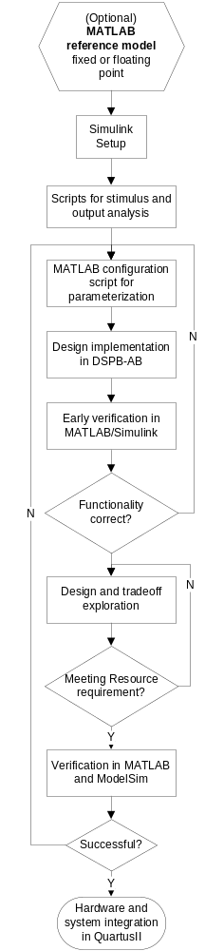
Figure 4 DSPB-AB design flow.
One important aspect of DSPB-AB is scripting. Combining importing and exporting data functions of Simulink, you can create batch testing using MATLAB .m scripts that execute design simulation and test results self-checking. Traditionally it is test sweeping in Simulink is not a trivial thing to do. With DSPB-AB you can automate sequential tests and explore design space options, all in a text script. We will cover this topic in more details in following chapters.

If it is the first time you design in DSPB-AB, we recommend you use one of the demo examples as a template. The demo examples can be found at
<installation directory >\altera\91\quartus\DSPB-AB\Examples.
    - Simulink

To simulate a DSPB-AB design in Simulink, one needs to configure the simulation parameters under Simulink -> Configuration Parameters.
- The solver needs to be Discrete (no continuous states).
- Use Fixed-step solver type unless you have folding turned on in some part of your design. In that case, you need to use Variable-step solver.
- Also should mention all the visualization that should be turned on, such as sample time colors, port types, etc.

One advantage of DSPB-AB is its support for scripting and parameterization of your design. By defining most of the parameters such as clock frequency, data sample rate, number of channels and bit width at various stages of your design in a script, you create a design that can be easily re-parameterized without even opening the actual Simulink model. We will elaborate on scripting later in this document. One such useful script is the setup script, which is usually an MATLAB .m file. The setup script may have clock rate, bit width and other important information that must be evaluated before you update your design in Simulink or start a simulation.

One method to evaluate the setup script is to use Callbacks functionality of Simulink. To configure Callbacks,
- In a Simulink model file .mdl, browse to File and open Model properties.
- Select Callbacks tap
- Select PreloadFcn and type in the setup script name to the window on the right hand side. By doing so you run the setup script when you open your Simulink design file.
- Select InitFcn and type in the setup script name to the window on the right hand side. Simulink will run your setup script first at the start of each simulation before it evaluates the model design file .mdl.

The use of callbacks will make managing your design more robust, and ensure all parameters are evaluated prior to hardware being generated.
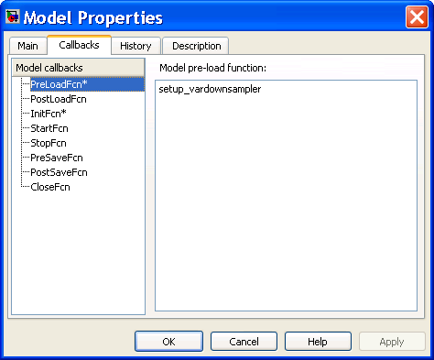

Figure 5 Configuring Callbacks in Simulink

Another important tip when designing in DSPB-AB is to leverage the visualization capability of MATLAB and Simulink. In addition to exporting data to work space for analysis, you can use Scope block to visualize a signal or multiple signals. It acts like a probe and displays data on a wire or a bus relative to the time samples. It comes in handy when debugging your design. You can also use Spectrum Scope in the Signal Processing Blockset, which displays the signal spectrum real time. It is useful when your design has filtering or FFT. When dealing with bit growth and quantization, the fixed point toolbox can be a valuable tool. You can even visualize the dynamic range of a signal by looking at the histogram of the signal. We will elaborate use of fixed point toolbox in the following sections and chapters.
    - Key DSPB-AB Blocks
The DSPB-AB base library has the most basic blocks of any DSPB-AB designs. First and foremost, every DSPB-AB design must have Control block and Signal block. Without the two, your design would not simulate or compile. Run Quartus block and Run ModelSim block provide an automated way of intiating compilation and simulation outside of Simulink. Figure 6 shows a typical top level test bench that includes the key DSPB-AB blocks.

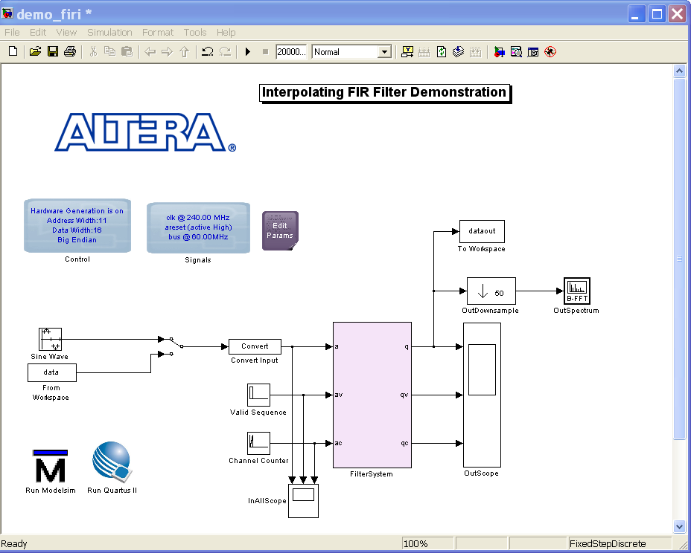

Figure 6 The top level test bench of a typical DSPB-AB design showing key DSPB-AB blocks.
      - Control
Every design must have a single Control block in the top-level of model. The options in this block are applied globally to your design.

The Control block traverses your design, synthesizes the individual primitive or ModelIP blocks into RTL, and maintains an internal data flow representation of your design. The internal representation of your design is then used for Simulink simulation and to write out the RTL and scripts for other tools.

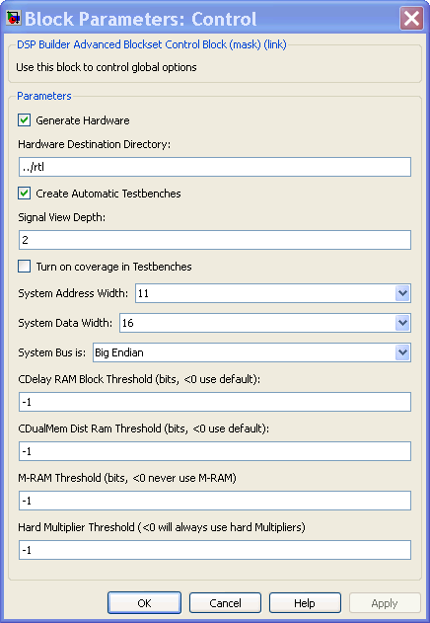

Figure 7 DSPB-AB Control block.

Hardware Generation
Options in the Control block specify whether hardware is generated for your model and the location of the generated RTL. You can also choose to create automatic RTL testbenches for each subsystem in your model and specify the depth of signals that are included when your model is simulated in ModelSim.

Memory-Mapped Bus Interface
You can specify the address and data bus widths used by the memory-mapped bus interface and choose whether the high-order byte of the address is stored in memory at the lowest address and the low-order byte at the highest address (Big Endian), or the high-order byte at the highest address and the low-order byte at the lowest address (Little Endian).

Memory and Multiplier Trade-Off Options
When your design is synthesized to logic, delay blocks are often created, whether explicitly from primitive delays, or in the ModelIP blocks. DSP Builder tries to balance the implementation between logic elements (LEs) and block memories (M512, M4K, M9K, or M144K). The trade-off depends on the selected FPGA family, but as a rough guideline the trade-off is set to minimize the absolute silicon area used. For example, if a block of RAM occupies the silicon area of two logic array blocks (LABs), then a delay that requires more than 20 logic elements (two LABs) is implemented as a block of RAM. This is generally appropriate, but there may be cases when you want to influence this trade-off. For a detailed list of threshold values for tradeoff, please refer to the appendix.

If you chose to use a script to manage your parameters flexibly, it is possible to set these parameters in that configuration script. You can also use scripting to sweep different values and re-generate hardware at each step, capturing the results. This can be used to quickly review the design space of your custom IP block.
      - Signals
Each model must have a Signals block and this should be placed at the top-level of your model. The Signals block specifies the details for the clocks and resets that are used to drive the generated logic.

The DSPB-AB uses a single system clock to drive the main datapath logic, and, optionally, a second bus clock to provide an external processor interface. The rationale for this is that it is most efficient to drive the logic at as high a clock rate as possible. The DSPB-AB does not support multiple clock domains on the datapath. Applications which require a clock transition to some external device or IP block are best handled through traditional RTL design techniques. Advanced Blockset is intended to create optimized datapaths and the best results are seen when the tool is used.

Please note that Cyclone device families do not support a separate bus clock due to the limited multiple clock support in block RAMs on those devices. For this reason, you must de-activate the separate bus clock option for the Signals block when using Cyclone device families.

The Signals block provides a mechanism to name the clock, reset, and memory bus signals used in the RTL, and also provides information about the clock rate. This is important for two reasons:
- To calculate the ratio of sample rate to clock rate used to determine the amount of folding (time-division multiplexing) in the ModelIP filters.
- To determine the pipelining required at each stage of logic. For example, the amount of pipelining used in hard multipliers is modified, and also long adders are pipelined into smaller adders based on the absolute clock speed in relation to the FPGA family and speed-grade specified in the device block.

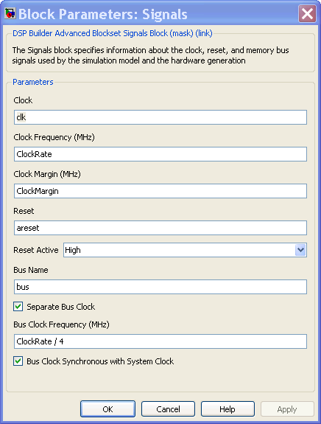

Figure 8 DSPB-AB Signal Block.
      - Run Quartus
The Run Quartus II block allows the automatic launching of the user system in the Quartus II software, where your design can be verified for performance and logic utilization.

Drop the Run Quartus II block into the top-level of any design containing an Altera Device block. Double-click the Run Quartus II block to launch the Quartus II software with the user system as the top-level entity.

DSP Builder creates the Quartus II project file (.qpf), Quartus II settings file (.qsf), and Quartus II IP file (.qip) for the Quartus II project in your design directory that contains the .mdl file. These files contain all required references to the files in the hardware destination directory that the the Control block specifies and are generated when you run a Simulink simulation. After loading the project in the Quartus II software, you should check the required device settings. You can then compile your design by clicking Start Compilation on the Processing menu.

The project compiles with the .tcl scripts in the hardware destination directory. DSP Builder creates the generated files and scripts in a hierarchy of directories that match the hierarchy of your design and calls lower level scripts from the scripts in the top-level directory.

The Run Quartus block is intended to be used to quickly validate the performance of the design and the corresponding resources. As such, the project is created with default settings and is regenerated each time the block is run. This flow is not intended as a means to generate the final deliverable. There are more details in Chapter 3, Hardware Integration. In general it is intended that the user will instantiate the top level RTL design directly, and use the .tcl or .qip flow to incorporate the DSPB-AB design into the top level Quartus project.
      - Device
The Device block is critical as it marks a particular Simulink subsystem as the top-level of an FPGA device and allows you to specify the target device and speed grade for the device. Indicating the correct device as fully as possible is important as it will ensure the design is pipelined correctly, as well as trigger any device specific optimizations that might be available.

The tool generates project files and scripts that relate to this level of hierarchy. All blocks in subsystems below this level of hierarchy, become part of the RTL design. All blocks above this level of hierarchy become part of the testbench.

The base block library has a few other useful blocks and you can refer to DSPB-AB User Guide or Reference Manual for more information.
  - Setting Up the Simulink Testbench
Aside from the importance of having a testbench to validate your design, it is also important to realize that many of the features of DSPB-AB will be more accessible if the testbench developed in a flexible manner. For the purposes of an DSPB-AB design, the testbench is all the subsystems above the subsystem with the ‘Device’ Block
    - How DSPB-AB Systems Benefit from Well Planned Testbenches
Before you start implementing your algorithm, it pays off to think about the modules that connect to and from your current design. Understanding the interface to neighboring modules will help you to use correct stimulus. Think about the sequence of events that you would like to test. In the case of multiple channels of data entering your current design, it is important to align them properly to follow the DSPB-AB data format. The more you think about how you would like to test your design, the more likely you will have a well defined interface and framework to your actual design, and in turn less iteration of significant modifications to your implementation.

On the other hand, having a well planned testbench in place before you start your actual design allows you to verify and debug your implementation from the very beginning. DSPB-AB uses a standard interface protocol, and every ModelIP or customized module needs to follow this protocol. It supports highly modular designs. Consequently, the input and output signals of your hierarchical design have a common interface. Regardless of which hierarchical level you are currently at, you can easily bring the output signals of submodules to even the top level. If you have the top level test bench in place, you can conveniently debug your submodules at all levels, and fully utilize the visualization capabilities of Simulink and MATLAB.
    - Creating a Plan
Before scoping out your test bench, you need to understand the interface protocol used in DSPB-AB first. With that knowledge, you can plan your stimulus accordingly.
      - DSPB-AB Interface Protocol
A DSPB-AB design must have three basic interface signals, data, valid, and channel. This simple protocol is used to connect both internally ModelIP and synthesized subsystems, and externally with upstream and downstream blocks. Only one set of valid and channel can exist in a ModelIP and synthesized subsystem. But multiple data signals can present in a customized synthesizable subsystem.

cos
q

sin
i
cos
sin
q

i
data
cos
sin
q

i
data
channel
valid
data
channel
valid

FIR
data
channel
valid
data
channel
valid

CIC
channel
valid
channel
valid
channel
valid
channel
valid
channel
valid
channel
valid

NCO

Real
Mixer

Complex
Mixer
Filter Library
Waveform Synthesis Library
data
channel
valid
data
channel
valid
Primitive Subsystem
ModelPrim Library

Figure 9 Interface protocols of DSPB-AB blocks.

Data on the data wire is only valid when the valid wire is asserted high. During this clock cycle, the channel carries an 8-bit integer channel identifier. This channel identifier is preserved through the data path so that data can be easily tracked and decoded.

This simple protocol is easy to interface with external circuitry when required and avoids the necessity of balancing delays, and counting cycles, because you can simply decode the valid and channel signals to determine when to capture the data in any downstream blocks. The control structures are distributed in each block of your design. This interface protocol is discussed in more details in Bus Format section in the appendix.
      - Examples
        - Using Golden References
In many cases you need to compare your implementation against a golden reference. It may be a C/C++ bit accurate model, a MATLAB model, or a Simulink design. If it is a C/C++ model you are comparing against, you can save your output into a text file and write your C/C++ comparison script. If the golden reference is in MATLAB, you can simply output the DSPB-AB test bench data into workspace or save them into data files. You can leverage the visualization tools that MATLAB provides such as figures. If you are comparing against a Simulink implementation, you can put the Simulink model in parallel with your synthesizable design. You can use Simulink Scope to display side by side comparison.

Note that all the signals in a DSPB-AB design are specified using the built-in Simulink fixed point types. Be mindful when you are comparing your design with a golden reference that is implemented in floating point.
        - Setting up Stimulus
In your top level test bench, you can generate stimulus at real time for both data and control signals. Commonly used test data signals are sine waves, random noise, step function and constant. Channel signal and valid signal in most cases can be generated as repeated sequences.

For simulation and test purposes, you can format your <data, valid, channel> pair according to the DSPB-AB interface protocol. This can be done in MATLAB or Simulink.
        - Analysis
To verify the functionality of your implementation, you can leverage Simulink visual aid. Anywhere in your design, you can drop in Simulink Scope blocks to check on the time series of signals in your design. Spectrum Scope block from Simulink Signal Processing Blockset is very useful in checking signal spectrum property, especially in evaluating filter performance.
        - Model Configuration
DSPB-AB supports extensive parameterization of your design. Before you start implementing your design, you should consider defining key parameters in a script.
          - Managing Basic Parameters
Key parameters of a typical DSPB-AB design include the following:
- FPGA clock rate
- Data sample rates at various stages of your design
- Number of channels or data sources
- Bit widths of signals at various stages of your design, including possible bit growth throughout the computational data path
- Coefficients of filters

Based on FPGA clock rate and data sample rates, you can derive how many clock cycles are available to process unique data samples. This parameter is naturally called as Period in many of the demo examples. For example, Period of 3 means that a new sample for the same channel appears every 3 clock cycles. If you are doing multiplication for instance, you have 3 clock cycles to compute one multiplication for this channel. In a multiple channels scenario, it means you can accommodate 3 different channels using just one multiplier. Immediately we observe that there is resource reuse potential when Period is greater than one. We will elaborate on resource sharing in more details throughout this document. At this point, we recognize the importance of scoping out these key parameters early in the design stage.

        - Connecting Submodules
The key to properly connecting submodules such as a ModelIP or a primitive subsystem in DSPB-AB is to use valid and compatible <data, valid, channel> pairs. Previously we briefly discussed the interface protocol used in DSPB-AB. A very important concept is Period. For any data signal in a DSPB-AB design, the FPGA clock rate to sample rate ratio determines the Period value of this data signal. Note that in a multirate design, the signal sample rate could change as the data travels through a decimation or interpolation filter. Therefore Period at different stages of your design may be different.

In a multi-channel design, Period value also decides how many channels you can process on a wire, or on one signal. There may be cases where you have more channels than you can process on one path, or wire. In a conventional design when this happens, you need to duplicate the data path and hardware to accommodate the channels that do not fit in a single wire. If the processing for each channel or path is not exactly the same, it may not be more complicated than simple replication. Fortunately, DSPB-AB supports vector or array data and does the hardware and data path duplication for you. You can use a wire with a one dimensional data type to represent multiple parallel data paths. DSPB-AB ModelIPs and primitive blocks, such as adder, delay and multiplier blocks, all support vector inputs, or fat wires, so that you can easily connect models using a single bus as if it were a single wire. This makes your design much cleaner and easier to manage.

On the other hand, there are cases where the sample rate exceeds the FPGA clock rate, such as in a super sample rate system commonly seen in high speed wireless front end designs. For instance, in an Radar or DirectRF system with GHz digital to analog converters (DAC), the signal driving the DAC can have a sample rate in the GHz range. These high speed systems require innovative architectural solutions in addition to support for high speed parallel processing. DSPB-AB interpolation filter IP has built in support for super sample rate signals, and the vector support of its primitive library makes it easy for you to design your super sample rate module. However to facilitate a super sample rate design, you must understand how channels are distributed across multiple wires as arrays, and how they are allocated among time slots available on each wire.

This brings us to two important concepts when designing DSPB-AB: wire count and cycle count. Let’s first look at a Wideband CDMA digital up conversion example to understand how channel’s distribution on wires change in a multi-rate system. In a typical Wideband CDMA macro-cell system, the digital up conversion (DUC) module in the RF card needs to process 8 inphase (I) and quadrature (Q) data pairs, resulting in 16 independent channels on the data path. The input sample rate to a DUC is at sample rate 3.84MHz as defined in the 3GPP specification. A high performance FPGA running at 245.76MHz is typically used to maximize parallel processing power. The following figure illustrates the sample rate and channel distribution along a digital up conversion data path.

CIC 8

FIR1
↑2
data
valid
channel
data
valid
channel
data
valid
Input to FIR1:
Clock Rate = 245.76 MHz
ChanCount = 16
Input Sample Rate = 3.84 MSPS
Input Period = 245.76/3.84 = 64
Input Signal Pattern =
I1,I2, ... I8, Q1,... Q8, zeros(1,64-16)
Interpolation factor: 2
Output of FIR1 and Input to FIR2:
Clock Rate = 245.76 MHz
ChanCount = 16
Data Sample Rate = 7.68 MSPS
Period = 245.76/7.68 = 32
Data Signal Pattern =
I1,I2, ... I8, Q1,... Q8, zeros(1,32-16)
Interpolation factor: 2
Output of FIR2 and Input to CIC:
Clock Rate = 245.75 MHz
ChanCount = 16
Data Sample Rate = 15.36 MSPS
Period = 245.76/15.36 = 16
Data Signal Pattern =
I1,I2, ... I8, Q1,Q2, ... Q8
Interpolation factor = 8
data (8)
valid
channel
Output of CIC:
Clock Rate = 245.75 MHz
ChanCount = 16
Data Sample Rate = 122.88 MSPS
Period = 2
Data Signal Pattern =
I1, I2
I3, I4
I5, I6
I7, I8
Q1, Q2
Q3, Q4
Q5, Q6
Q7, Q8
Interpolation factor = 8

FIR2
↑2
Figure 10 Wire count and cycle count illustration of a 16-channel WCDMA DUC design.

In this example, the input data at low sample rate 3.84 can accommodate all channels on a single wire. So the wire count is 1. In fact there are more time slots available for processing, since Period is 64 and only 16 channels are present to occupy the 64 time slots. Therefore the cycle count is 16, which is the number of cycles occupied on a wire. As the data travels down the up conversion chain, its sample rate increases and in turn Period reduces to a smaller number. At the output of CIC filter, the data sample rate increases to 122.88Msps, which means only two time slots are available on a wire. Since there are 16 channels, we need to spread them out on 8 wires, where each wire supports two channels. At this point, the wire count becomes 8, and cycle count becomes 2. Note that cycle count does not always equal Period, as the input data to FIR1 has shown.

In the following, we summary the key definitions used in connecting models in DSPB-AB.

Parameters | Defintion | Description
WireGroups | ceil(ChanCount/ Period) | The number of wire groups required to carry all the channels. See further explanation below.
WiresPerChannel | ceil(SampleRate/ClockRate) | The number of wires per channel.
ChanCycleCount | ceil(ChanCount/WireGroups) | The number of channels carried per wire. NOTE: The channel signal counts through 0 to ChanCycleCount – 1.
ChanWireCount | WiresPerChannel × WireGroups | The number of wires required to carry all the channels, taking into account the sample rate and clock ratio.

Note that for most systems, sample rate is less than clock rate, which gives WirePerChannel=1. In this case, ChanWireCount is the same as WireGroups, and it is the number of wires to accommodate all channels. That is the case in the WCDMA example in Figure 6. In a super sample rate system however, a single channel’s data need to be splited onto multiple wires, i.e. a parallel of signals at clock rate to give an equivalent sample rate that exceeds the clock rate. In this case, WiresPerChannel is greater than one, and ChanWireCount is WireGroups x WiresPerChannel because one channel requires multiple wires.

As illustrated in Figure 10, when connecting two modules in DSPB-AB, the output interface of the upstream module must have the same wire count and cycle count parameters as the input interface of the downstream module.

    - Testbench Checklist for Using Key Simulink Features
The following checklist provides a quick reference to the key Simulink features when setting up your DSPB-AB design.

- Properly configure Simulink simulation solver and type
- Configure callback functions to load setup script prior to running simulation
- Include Scope or other visualization tools
- Displays various port/signal properties to aid debugging and visualization
  - In Simulink, select Format tab then Port/Signal Displays from Model Editor.
  - Sample Time Colors option changes the color of blocks and wires in particular clock domain. It is useful when creating multi-rate designs
  - Port Data Type option displays the data type of the blocks. You can only connect ports of same data type.
  - Signal Dimensions displays the dimensions of particular signal wire
- Use a “From Workspace” block (under Simulink Source block) to import data from workspace. It is a quick way to setup controlled stimulus in your test bench.
- Use a “To Workspace” block (under Simulink Sink block) to export data to workspace. It allows further data processing and comparison outside of the test bench.
- Update Diagram (from Model Editor’s menu bar Edit tab) to display signal properties and check ‘syntax’ errors prior to running simulation
  - Hot key is Ctrl + D

  - Model Design in DSPB-AB
    - Staging your Design into Subsystems
Before you start the actual implementation of your algorithm in DSPB-AB, you should consider how to stage your design into subsystems. A hierarchical approach makes a design easier to manage, more portable thus easier to update, and easier to debug. If it is a large design, it also makes design partition more manageable. This is even more so the case in DSPB-AB designs, since the tool is highly parameterizable and constraint driven.

DSPB-AB achieves timing closure based on customer provided timing constraints, namely sample rate and clock rate. A modular design where boundaries of subsystems are well defined, allows you to precisely manage latency and speed of different modules thus achieving time closure effortlessly.

There are several factors to consider when staging your design into subsystems. First identify the functionality of each submodule of your algorithm, and it is a natural solution to partition your design into different functional subsystems. One factor to consider in a multi-rate design is the sample rate variation at different stages of a data path. It may be a good habit trying not to involve too many different sample rates within a subsystem unless absolutely needed. An example is a synchronization block when merging data paths of different sample rates. If your design has very tight latency requirement, you may want to use latency management as a criteria in defining the boundary of a subsystem, because DSPB-AB applies latency constraints on a subsystem basis. However there is not one universal rule as how you should partition your design into subsystems.

It also simplifies synchronization of the system if modules which can be computed in parallel are implemented in the same subsystem. While not necessary, the automated features of the tools can apply the same rules more easily to each of the parallel paths. This way, you wouldn’t have to worry about constraining the two paths which may otherwise have different latencies.
    - DSPB-AB IP vs. Primitive library

DSPB-AB offers two distinctive options to implement your algorithms. First it has an IP library that has the most commonly used functions such as an FIR filter and a NCO, ready to be plugged in to your design via drag-and-drop. On the other hand the primitive library has all the handy bits and pieces you need to build a customized logic, such as multipliers, memories and simple control blocks.

ModelIP library offers several commonly used IPs including:
- Filters library, there are Single rate, multi-rate, fractional rate FIR filters, and Decimating and interpolating cascaded integrator comb (CIC) filters.
- Waveform Synthesis Library, there are NCO, complex mixer, and real mixer.
The IPs are generated on the fly while running simulation in Simulink. They don’t have pre-determined architecture. Based on the system clock frequency, they could further be optimized by time sharing the internal resources. All the IPs accept system parameters in the menu GUI. Using the interpolating FIR as an example, it accepts system variables as parameters such as input rate per channel, rate change factor, and number of channels. It also accepts MATLAB function to generate coefficient. You can specify the base address for the memory mapped interface to reload coefficient.

The ModelPrim (Primitive) library contains basic operators such as add, multiply, and delay, as well as signal type manipulation functions to provide support for building hardware functions using the Mathworks fixed point types. You do not need to understand the details of the underlying FPGA architecture, as the primitive blocks are automatically mapped into efficient FPGA constructs.
    - Using Primitive Blocks
The ModelPrim library allows you to create fast efficient designs captured in the behavioral domain rather than the implementation domain by combining primitive functions. For example, you can use a Delay block and let the tool decide how to implement that delay. You do not need to understand the details of the underlying FPGA architecture,. This is most directly visible by virtue of the fact that the blocks have no latency associated with them (aside from delays). As such, you will not pipeline your design when using DSPB-AB.

As DSPB-AB will manage the pipelining for us, it also ensures that signals pass through a single ChannelIn, ChannelOut, GPIn, or GPOut block are line up correctly in time at their boundaries. The precise number of clock cycles needed is based upon the device selected and the design itself. This information is annotated into the design so it can be quantified if needed, but in most cases cascaded blocks will operate only on the valid signal and thus unaffected by changes in latency. . You should use the DSPB-AB protocol <data, channel, valid> to decode outputs, rather than exact clock counting where possible.

The primitive blocks are considered zero-latency blocks, except for sample delay block which explicitly introduce a controlled delay. You can design and debug quickly with zero-latency blocks, focusing on the functional behavior of the algorithm only. You don’t have to track block latencies around your design. Based on your target Fmax, the tool may automatically insert delays to meet timing. The additional latency required to meet the timing constraints for your design is calculated and displayed as a parameter on the ChannelOut block. You could view it, and fine tune the latency constraint; however you implement your algorithm without having to keep track of the latency information of each primitive subsystem. You can also programmatically query the ChannelOut block and use the actual latency to calculate a needed offset in cases where that is necessary.

      - When You need Channel In/Out
The Channel In and Channel Out blocks delineate the boundary of a synthesizable primitive subsystem. They pass inputs through to the outputs unchanged, with types preserved. The main purpose of these blocks is to indicate to the tools that these signals arrive synchronized from their source, and depart from this subsystem synchronized. The synthesis tool can ensure this.

Parameters on the ChannelIn and ChannelOut blocks allow the control of automated folding for the primitive subsystems. Folding allows the design to be implemented generally using fewer expensive resources, such as multipliers, at the expense of a little more logic by sharing them when the sample rate is below the clock rate.

As a result, you use Channel In/Out blocks in a primitive subsystem of your design that you want to explicitly control latency and Fmax, or when folding is considered.

Note that you cannot mix and match primitive blocks with ModelIP blocks in the same subsystem. Therefore if you need customized blocks between ModelIPs, you need to put your custom logic inside a primitive subsystem that is bounded by Channel In/Out blocks.

Primitive blocks must be used within a subsystem bounded by Channel In/Out blocks, the only exception being a constant used to drive a top level signal.
      - Rules for Using Channel In/Out with Subsystems
Channel In/Out blocks must be in their own subsystem and directly connected to the subsystem in/out ports. Within the channel in/out pair, nested subsystems can be used, but without the channel in/out pairs. That is, you cannot nest channel in/out blocks.
      - Rules for Using SynthesisInfo within Subsystems

The ModelPrim library includes a SynthesisInfo block that sets the synthesis mode and labels a subsystem described by primitive blocks as the top-level of a synthesizable subsystem tree. The subsystem, and all those below it are flattened and synthesized as a unit. If no SynthesisInfo block is present, the style defaults to WYSIWYG and error messages may issue if there is insufficient delay.

The inputs and outputs to this subsystem become the primary inputs and outputs of the RTL entity that creates. After running a Simulink simulation, the online Help page for the SynthesisInfo block updates to show the latency, port interface, and estimated resource utilization for the current primitive subsystem.
The SynthesisInfo block can be at the same level as the Device block (if the synthesizable subsystem is the same as the generated hardware subsystem). However, it is often convenient to create a separate subsystem level that contains the Device block.

Two styles of operation exist during synthesis: WYSIWYG and Scheduled.

The Scheduled style of operation uses a pipelining and delay distribution algorithm that creates fast hardware implementations from an easily described untimed block diagram. This style takes full advantage of the automatic pipelining capability.

Altera recommends the Scheduled style of operation.

WYSIWYG is the default style of operation. Use when you want full control over the pipelining in a system. Every primitive that requires registering (such as an adder or multiplier) must be followed immediately by a Delay primitive. The delay primitive is absorbed in the preceding block to satisfy its delay requirements. Error messages issue if there is insufficient delay provided. Note that the primitive logic blocks (And, Or, Nand, Not, Nor, Xnor, Xor) and the Simulink Mux and Demux blocks do not require a register. This flow is generally not recommended.

The algorithm performs the following operations:
- Reads in and flattens your design example for any subsystem that contains a SynthesisInfo block.
- Builds an internal graph to represent the logic.
- Based on the absolute clock frequency requested, adds enough pipeline stages to meet that clock frequency. For example, long adders may be pipelined into several shorter adders. This additional pipelining helps reach high clock frequencies.

When you select the Scheduled style, you can optionally specify a latency constraint limit that can be a workspace variable or expression but must evaluate to a positive integer.
      - Latency Management and Parameterization
Latency is the number of delays in the valid signal across the subsystem. You may want to fix or constrain the latency after you have completed part of a design, for example on a ModelIP block or for a primitive subsystem. In other cases, you may want to limit the latency in advance, which allows future changes to other subsystems without causing undesirable effects upon the overall design.

The advanced blockset balances delays in the valid and channel path with delays inserted for auto-pipelining in the datapath. To accommodate extra latency you can insert registers. This feature applies only to primitive subsystems. User-inserted sample delays in the datapath are part of the algorithm, rather than pipelining, and are not balanced. However, any uniform delays that you insert across the entire datapath optimize out. If you want to constrain the latency across the entire datapath, you can specify this latency constraint in the SynthesisInfo block.

        - Using Latency Constraints
You can set a latency constrain for a primitive subsystem using the SynthesisInfo block. If you select Scheduled synthesis style in the Block Parameters dialog box, you can optionally turn on Constrain Latency and constrain the latency to >, >=, =, <=, or < a specified limit. You can specify the limit using a workspace variable or expression but it must evaluate to a positive integer.

You can use the SynthesisInfo block to specify a latency constraint for a ModelIP block or primitive subsystem. However, any constraints set by fMAX targets have priority over latency constraints. An error issues if you are setting a latency that is smaller than that required to reach the target fMAX.

For example, if you set a latency constraint of ten in a subsystem that used four pipelining stages to reach the target fMAX, the tool will add an extra six pipelining stages to meet the latency constraint. This action is balanced on the channel and valid paths so that all signals remain synchronized.

Note however do not use latency constraints in subsystems where folding is enabled.
        - Latency and fMAX Constraint Conflicts
Some blocks need to have a minimum latency, either because of logical or silicon limitations. In these cases, it may be possible to create an abstracted design which cannot be realized in hardware. While these cases can generally be addressed, in some cases like IIRs one has to find algorithmic alternatives.

Generally these problems will occur in feedback loops. These issues can be addressed by lowering the fmax target, or by restructuring the feedback loop to reduce the combinatorial logic or increasing the delay. Some control structures which have feedback loops can be redesigned to make them completely feed forward.
Preliminary
        - Using Latency Parameters
Primitive subsystems are cycle accurate on the boundary. The latency of a subsystem automatically shows on the Channel Out block after running a simulation in Simulink.

To display the latency added by a ModelIP block, add the %<latency> parameter as annotation on the block. After you run a simulation, the added latency shows as a text annotation below the block.

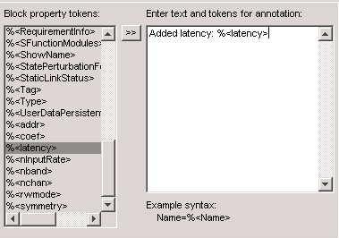

You can get the latency value programmatically by using the following command:
eval(get_param(<full path to block>, 'latency'))

For example:
eval(get_param('design/latencydemo/ChannelOut','latency'))

The latency is calculated in the initialization of the model, at the start of simulation. Because all latencies are calculated at the same stage, you cannot use the latency of one block to set the constraint on another and expect to see the changes propagated in the same simulation. For example, suppose you want to always have a latency of 40 for the CIC block in the demo_dcic design that comes with DSPB-AB installation. Add a primitive subsystem after the CIC block as shown below.

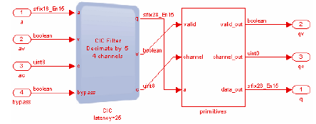

This subsystem consists only of ChannelIn, ChannelOut, and SynthesisInfo blocks.

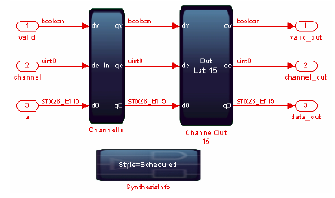

On the SynthesisInfo block, set the following latency constraint derived from the CIC
block:
40 – eval(get_param(‘demo_dcic/CICSystem/CIC’, ‘latency’))

Any changes to the CIC block that change the latency do not display as immediate latency changes in the primitive subsystem; but only on the subsequent simulation and hardware generation cycle. The latency for the CIC block is only available after the initialization step in which it is set in the primitive subsystem. Thus, you must simulate until after cycle 0, stop and re-start simulation (without making any changes) to guarantee that the correct latency is applied in the primitive subsystem. The SynthesisInfo block uses the evaluated CIC block latency from the previous simulation.

After running a simulation in Simulink, the additional latency that is added to meet the specified timing constraints for your model is shown on the Channel Out block. (Any delay explicitly added to your model, by for example a Sample Delay block, is not included in this latency.)

You can also access the value of the latency parameter by typing a command of the following form on the MATLAB command line: get_param(gcb,’latency’)
      - Folding and TDM
Time division multiplexing (TDM) is used to optimize hardware utilization. For ModelIP Blocks, TDM hardware re-use is already built-into ModelIP blocks. Optimized ModelIP blocks (including TDM hardware re-use) are generated automatically during hardware generation. For primitive subsystems, depending on the channel/wire structure, the primitive blocks might be reused via primitive folding.

Folding is closely related to time division multiplexing. When the system clock rate is faster than the data rate or sample rate, the same piece of hardware such as a multiplier can potentially be reused to process multiple data points. Different data points access the shared hardware resource via time division multiplexing. Similarly, in a system with multiple parallel data sources or data channels, instead of duplicating hardware for each channel or data source, in many cases one data path could be used to process multiple data channels. Folding allows multiple channels to access system resources such as multipliers and adders in a TDM fashion, thus resulting in resource savings.

By default, the hardware generated for a primitive subsystem by DSP Builder Advanced Blockset is capable of receiving and processing new data every clock cycle. However, this might not be required for some designs. For those designs with a sample rate lower than their clock rate, DSP Builder Advanced Blockset’s folding functionality can take advantage of the disparity between both rates to optimize the generated hardware. Users on the other hand, can implement their core algorithm in the most intuitive way as if there was no folding or TDM. They do not have to explicitly implement signal muxing and data buffering schemes which are normally required in a manually folded design.

The TDM factor (or folding factor) is the ratio of the clock rate to the sample rate. It is an integer.
        - Using Folding
Folding is enabled and configured in the primitive subsystem’s ChannelIn and ChannelOut blocks:
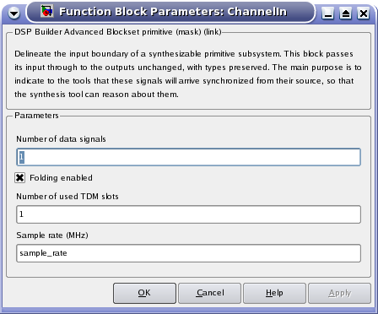
Figure 11: ChannelIn/ChannelOut block parameters
By ticking the “Folding enabled” checkbox, the “Number of used TDM slots” and “Sample rate” parameters become editable. The correct values for these parameters depend on the desired type of folded subsystem, and will be explained in the following sections.

Note: the “Folding enabled”, “Number of used TDM slots” and “Sample rate” parameters must be set to identical values for all ChannelIn and ChannelOut blocks in the same primitive subsystem.

Note: You need to set the Simulink solver to VariableStep Discrete in order to use the folding feature. Furthermore, you should turn on Hardware generation in Control block on the top level of your design.
        - Folded Subsystem without TDM De-muxing
This is the simplest type of folded subsystem. One piece of new data (per input port) is received, processed and output every “folding factor” clock cycles, where folding factor is a constant integer number. The folding factor is completely determined by the FPGA clock rate and input data sample rate. For instance, at 200MHz system clock rate, a data source at 50M samples per second implies a folding factor of 4. It means a new data sample arrives every 4 clock cycles, thus there are 4 times slots available for TDM.
In this case, the data format expected at ChannelIn inputs and produced at ChannelOut outputs is:
a0, x, x, x, a1, x, x, x, a2, x, x, x, a3, x, x, x, …
Where a0, a1, a2, a3, …, are taken as the input data to the design, and data received during the cycles marked as “x” is ignored.
In this type of folded subsystem, “Number of used TDM slots” must be set to 1, and “Sample rate” must be set to the clock rate divided by the folding factor. No other changes are needed with respect to the unfolded version of the same subsystem. In this setting, there is no time division multiplexing since only 1 data source or data channel is present. A typical example of such a system is one that processes a single channel or a single data source.

The primitive_fir design is an example of a folded subsystem without TDM de-muxing.
        - Folded Subsystem with TDM De-muxing
Folded subsystems can also accept and produce a TDM version of the data format described in the earlier subsection, where the total number of available TDM slots is the folding factor. This is enabled by configuring the “Number of used TDM slots” parameter to a number greater than 1 but smaller or equal to the folding factor.

For example, for a folding factor of 4, and the number of used TDM slots set to 3, the data format expected at ChannelIn inputs and produced at ChannelOut outputs is:
a0, b0, c0, x, a1, b1, c1, x, a2, b2, c2, x, a3, b3, c3, x, …
The received data is de-muxed at ChannelIn blocks; the de-muxed data is presented at ChannelIn outputs as a Simulink vector that has as many elements as TDM slots are used. In the example above, the Simulink vector would have three elements, the first corresponding to the “a” channel or TDM slot, the second one to “b” and the third one to “c”.

Although the signal coming out of the ChannelIn block is a 3-element vector, it does not imply the logic between ChannlIn and ChannelOut is duplicated three times. For example, assume there is a single multiplier in this subsystem that multiplies each input a, b and c with a constant. Therefore a 3-element signal goes into a multiplier block. Internally, the advanced blockset turns that single multiplier block into 4 multiplier “function units”. The folding engine then combines those 4 multiplier function unites into a single one, and when the hardware is generated there is a single hardware multiplier.

The reverse process occurs at the system’s ChannelOut blocks. A Simulink vector with the same number of elements is expected at ChannelOut’s inputs; those elements are then muxed by the ChannelOut block and presented in the same TDM format described above.

Figure 12 shows a ChannelIn block configured with “Number of used TDM slots” set to 3. A Simulink Demux block has been used to provide access to the elements of the vector, here called “r”, “g” and “b”. The converse structure, with a Simulink Mux block preceding the ChannelOut block, is used at the system’s output.

This figure is taken from the color space converter demo design (demo_fold_csc.mdl) , which is an example of a folded subsystem with TDM de-muxing. In this example, the three elements “r”, “g” and “b” represent three independent channels. By demuxing them onto three parallel datapaths inside the folded subsystem, we can apply distinct coefficients to each channel. The conversion algorithm in demo_fold_csc involves 9 multiplications. However, the actual number of multipliers used when folding is enabled depends on the folding factor, or the ratio of the clock rate and sample rate.
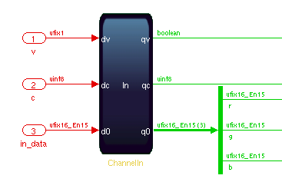
Figure 12: ChannelIn block with TDM de-muxing
When enabling TDM de-muxing, Simulink vectors will appear as described. Care (and possibly some changes such as the introduction of Mux/Demux blocks) is needed to ensure that the design continues to work as expected in the presence of these vectors.

The number of used TDM slots must be smaller or equal to the folding factor. The greater the difference of folding factor and used TDM slots, the greater hardware reuse and resource saving. If they are equal, new data is received and processed every cycle. The used hardware resource is reduced by a factor of the available TDM slots, i.e. the folding factor. In the multichannel context, this means that instead of duplicating hardware for each channel, multiple channels can in many cases share a single signal path for data processing. For instance, in the demo_fold_csc example, if the folding factor is 3 and all 3 slots are occupied by “r”, “g” and “b”, the number of multipliers in the generated hardware is 3, down by 3-fold from the 9 multiplications in the algorithm.

If the FGPA clock rate increases, which allows more folding or resource sharing, then the number of multiplier hardware can be reduced even further. For example, when the folding factor increases to 10, a single multiplier is sufficient to complete the 9 multiplications in the algorithm. There are enough idle clock cycles between adjacent data bursts that allow repeated reuse of the same hardware. DSP Builder Advanced Blockset recognizes this and generates optimized hardware that instantiates a single multiplier.

        - When to use folding
Folding can be used to reduce resources when the sample rate is below the clock rate. Because folding requires memories to store the TDM factor, the actual resource savings is highly design dependent. Further, some mathematical structures are so regular that there are highly optimized kernels which can be more efficient than an automated folding algorithm.

Generally, DSPB-AB folding will work best when:
- There is a high degree of folding and the number of inputs is relatively limited
- There are already a large number of delays (memories)
- You have a design with less regularity, making manual folding difficult

Generally, DSPB-AB folding may not be the best solution when:
- You are dealing with highly regular structures which can be easily folded (still in a fully parameterizable fashion). Matrix multiplies, FIR, FFTs are good examples
- Designs which have a large folding factor and large number of inputs

The key is to exploit the fact that folding is relatively easy to try in DSPB-AB, and some experimentation can allow big gains in quality of results.
        - Effects of folding
As described in section above, when folding is enabled and folding factor is greater than one, DSP Builder Advanced Blockset can reuse hardware resources in a TDM fashion to perform computation. This can result in hardware savings, which is usually the intended result of enabling folding for some particular design. DSP Builder Advanced Blockset uses a stochastic algorithm to maximize resource sharing behind the scene. Though you may not be able to predict the exact amount of resource utilization due to the random nature of the optimization algorithm, the tool can often achieve near optimal or the optimal resource reuse.

However, enabling folding also induces other changes in the resulting hardware, as explained in the following sections. In certain cases these changes can result in hardware that is less desirable in some way than the one obtained with folding disabled. A general understanding of these changes can help to predict cases where usage of folding might not be advisable.
        - Effects on Manual Delays
When folding is enabled, the reception times for two consecutive pieces of data (for the same channel or slot, if TDM de-muxing is used) are separated by a number of clock cycles equal to the folding factor. This means that, to produce their expected behaviour, z^{-n} manual delay blocks in the design will delay by a number of clock cycles equal to n times the folding factor. That is, compared to the unfolded case, the length of these delays in clock cycles gets multiplied by the folding factor.

In the example shown in Figure 13, within the bounded subsystem the delays behave exactly like they should at the target sample rate. For example, if the subsystem is configured with a folding factor of 4, data at ChannelIn’s q0 port will follow this pattern:
a0, x, x, x, a1, x, x, x, a2, x, x, x, a3, x, x, x, …
If SampleDelay only delayed by one clock cycle, the adder does not add a sample to the previous one as expected. For example, when q0 is equal to a1, the output of SampleDelay would correspond to the “x” that was received in the previous clock cycle, and the output of the adder wouldn’t be meaningful.

To avoid this problem, DSP Builder Advanced Blockset implements SampleDelay as a 4-cycle delay behind the scene. The user should configure SampleDelay in their algorithm as if there were no folding. For example, in demo_prim_fir.mdl, the SampleDelay should always be configured as 1-cycle delay regardless of folding factor. This allows the design to match the algorithm when viewed directly by the user. The tool will configure SampleDelay internally based on the folding factor.
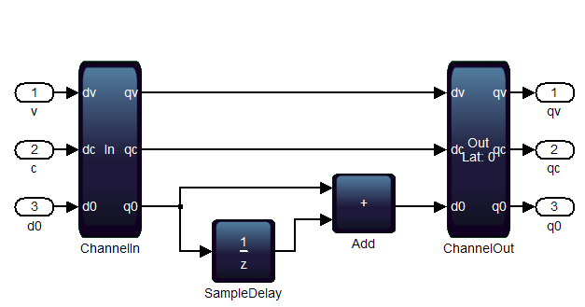
Figure 13: Example of folded manual delay

If the subsystem’s highest latency path is one that contains manual delays, the subsystem’s global latency will be affected by enabling folding.

Although the length in cycles of manual delays is multiplied by the folding factor, their cost in hardware resources grows by a smaller factor that is typically only slightly above the number of used TDM slots.

The effect of folding on manual delays can be used to solve the situation where DSP Builder Advanced Blockset cannot implement a certain feedback loop in hardware due to insufficient delays being specified. A sufficiently large folding factor will increase the length in clock cycles of existing delays so that they can compensate for the required pipelining of other blocks.

        - Effects on Combinational Logic
One of the methods that folding can use to reduce hardware is the combination of blocks that are not used every cycle. For example, consider the blocks in Figure 14.
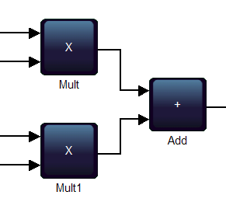
Figure 14: Example of folded multipliers
With folding disabled, the resulting hardware could closely resemble the original Simulink blocks, as shown in Figure 15.
×
×
+
A
B
C
D
Figure 15: Example of unfolded hardware
Assume that folding is enabled with a folding factor of 2. Each of the A, B, C, D inputs in Figure 15 would only receive data every second clock cycle; as the hardware multipliers can perform one multiplication per clock cycle, in this example each one of them would only be used half of the time.

In this example, DSP Builder Advanced Blockset can use a single hardware multiplier to implement the two Simulink multiplier blocks. To be able to timeshare the hardware multiplier between performing (A × B) and (C × D), DSP Builder Advanced Blockset must insert some extra delays and muxes. The resulting hardware could look like Figure 16.

×
+
z⁻¹
z⁻¹
A
C
z⁻¹
B
D
Figure 16: Example of folded hardware
The folded hardware in Figure 16 might appear more expensive than the unfolded hardware in Figure 15. However this observation typically is not true. The saved multiplier would normally require more hardware resources than the delays and muxes it is replaced by. DSP Builder Advanced Blockset implements heuristics that limit block combination to those cases where it is expected to be beneficial.

      - Multichannel and Vectorized Signal Support
You can build multichannel systems directly using the required channel count, rather than creating a single channel system and scaling it up. The block diagrams of DSPB-AB use vectors of wires to scale without having to cut and paste multiple blocks. This makes the design much more manageable and easier to debug.

        - Vector Input for ModelIP and Primitive Subsystems
When the clock rate is insufficiently high to carry the total aggregate multichannel data, the data inputs and outputs for the ModelIP blocks and primitive subsystems become vectors. For example, 10 channels at 20 MSPS require 10×20 = 200 MSPS aggregate data rate. If the system clock rate is set to 100 MHz, two wires carry this data, and so the Simulink model uses a vector of width 2.

The ModelIP blocks are vectorizable, meaning that if data going into a block is a vector requiring multiple instances of, for example a FIR filter, then multiple FIR blocks are created in parallel behind a single ModelIP block. If a decimating filter requires a smaller vector on the output, data from individual filters use the TDM factor onto the output vector automatically, to avoid using glue filters for custom logic.

Each ModelIP block determines the input and output wire counts, based on the clock rate, sample rate, and number of channels. Any rate changes in the ModelIP block affect the output wire count. If there is a rate change, such as interpolating by two, the output aggregate sample rate doubles. DSP Builder packs the output channels into the fewest number of wires (vector width) that supports that rate. For example, an interpolation by two FIR filter may have two wires at the input, but three wires at the output.

The ModelIP block performs any necessary multiplexing and packing. The blocks connected to the inputs and outputs must have the same vector widths, which Simulink enforces. Resolve vector width errors by carefully changing the sample rates.

ModelIP blocks typically take a channel count as a parameter. This is simple to conceptualize. The channels are numbered 0 to (N-1), and you can use the channel indicator at any point to filter out some channels. To merge two streams, some logic must be created to multiplex the data together, and sequence and counter blocks regenerate valid and channel signals.

On the other hand, the primitive subsystems contain Channel In and Channel Out blocks, but do not have explicit support for multiple channels. However, it is very easy to create multichannel logic: Simply draw out the logic required for your design to create a single channel version. To transform this to a multichannel system, increase all the delays by the channel count required. This can be parameterized using a mask variable to create a parameterizable component.

Most arithmetic and memory ModelPrim blocks allow Simulink 1-D vector (array) and complex types to be used. Where supported using a vector input of width N has the same affect as connecting N copies of the block with a single scalar connection to each.
        - Key Benefits of Vector Support
A previous sticking point for creating parameterizable designs - that is designs that can be controlled from just a few top level parameters, such as the data rate and system clock rate and would not require re-editing when these changed – were that the primitive blocks did not handle arrays of connections (vectors in the language of the Simulink tool). Often this would require the user to ‘cut & paste’ to replicate parts of their design. The number of copies might depend on the parameterization, to the user might have to edit the design each time this change. With vector support, the need to do this has been largely mitigated; and will be removed completely in future follow-up releases supporting arrays of vectors for example.

This makes tool a much more powerful tool for design and design space exploration. For example, combining this with the folding feature, it is now possible to create a single parallel FFT design that can be switched between fully parallel and fully serial just by changing the folding factor (the ratio of system clock rate to input data rate).

    - Using FIR IP and NCO IP
      - How It Differs from the Primitive Blocks
  - Managing Bit Growth
    - Fixed Point Representation
DSP Builder uses the built-in Simulink fixed-point types to specify all the signals in a DSP Builder advanced blockset design. Thus it is easy to debug your design, because you can display the signals as familiar floating-point types.

A more subtle advantage of using fixed-point types is that the extra information of binary point position can be preserved through hardware blocks, so that it is easy to perform rounding and shifting operations without having to manually track the interpretation of an integer value. This is important when you start to tune the performance of your model, because a fixed-point type change propagates through your design, with all downstream calculations automatically adjusted.

    - How to Decide Bit Width at Each Stage
After an update of your design (Ctrl+D) or a simulation run, the signal type and width are displayed if you have turned on Simulink display of signal types. In a typical mathematically algorithm involving multiplication and addition, data width grows as signals travel through the arithmetic blocks. A large data width implies better performance in general, at the price of more hardware resources and potentially slower Fmax (such as in large adders). Often times you need to manage and control bit width at various stages of your design, either due to hardware resource limitation or Fmax speed concerns.

A designer can keep track of bit growth by studying the algorithm carefully, and determine bit width at various stage of the design from the mathmetically model of the design. A heuristic approach is to utilize Simulink Fixed Point Toolbox to visualize the bit width distribution at various places of the design.

The fixed point toolbox embedded in Simulink can display the histogram of data path signals you have logged. You can log a data signal in your Simulink design by right click on the wire and select Signal Properties. With the histogram you can decide how many MSBs are unused in current fixed point representation, which helps you decide how many MSBs to discard thus maximizing the dynamic range of your scaled data.

    - Rounding and Saturation
      - Understanding DSPB-AB Output Data Type

Many of the primitive blocks provide the following options in their Block Parameters dialog box to inherit or specify the output data type:
- Inherit via internal rule: the number of integer and fractional bits is equal to the maximum of the number of bits in the input data types. Word growth occurs if the input data types are not identical.
- Inherit via internal rule with word growth: the number of fractional bits is equal to the maximum of the number of fractional bits in the input data types. The number of integer bits is the maximum of the number of integer bits in the input data types plus one. This additional word growth allows for subtracting the most negative number from 0 which exceeds the maximum positive number that can be stored in the number of bits of the input.
- Specify via dialog: additional fields that allow you to set the output type of the block explicitly.
- Boolean: the output type is Boolean.

In general, the output type of a primitive block can be set to Inherit via internal rule, or Inherit via internal rule with word growth. The type propagates through your design naturally, with blocks potentially growing the word length where necessary. If there are loops in your design, use the dialog box to specify the output type for at least one block in the loop.

Specifying the output type with the dialog box is a casting operation. This operation does not preserve the numerical value. It simply uses the underlying bits and never adds hardware to a block. Thus it only changes the interpretation of the output bits. For example, a Mult block with both input data types specified as sfix16_En15 naturally has an output type of sfix32_En30. If you specify the output data type as sfix32_En28, all bits are retained, but the output numerical value is effectively multiplied by four, and a 1*1 input gives an output value of 4.

If you specify output data type of sfix32_En31, a zero is padded to the LSB, and the output numerical value is effectively divided by two and a 1*1 input gives an output value of 0.5. If you want to change the data type format in a way that preserves the numerical value, use a Convert block, which adds the corresponding hardware. Adding a Convert block directly after a primitive block allows you to specify the data type in a way that preserves the numerical value. For example, a Mult block followed by a Convert block, with input values 1*1 always gives output value 1.

      - Implementation Details and Options
ModelIP blocks such as FIR filters output data use full resolution, that is, no rounding or saturation is performed on the output data. You can use a Scale block to provide scaling and control your bit growth before data enter the next stage ModelIP or primitive subsystems.

For primitive subsystems, you can use a Convert block to apply rounding and saturation. Convert block itself does not perform scaling.

There are three rounding options in Convert block and Scale ModelIP. They decide how the least significant bits are to be discarded:
- Truncate: truncates the least significant bits. This has the lowest hardware usage, but introduces the worst bias.
- Biased: rounds up if the discarded bits are 0.5 or above.
- Unbiased: rounds up if the discarded bits are greater than 0.5, and rounds to even if the discarded bits equal 0.5. The algorithm is also called round half to nearest even.

There are three ways to perform saturation also. They decide how the most significant bits are to be discarded:
- None: No saturation is performed.
- Asymmetric: The range of the number produced occupies the whole of the two's complement range (for example –1.0 to 0.999). There is one more negative number available, so this will introduce a slight bias.
- Symmetric: The range of the result is clipped to between symmetrical boundaries (for example -0.999 and 0.999). This ensures no bias enters the dataflow.

As an example, let’s investigate the rounding and saturation results of some tests. Suppose we have two decimal numbers 5.6875 and -5.6875. This number needs 8 bits to represent in two’s compliment format, that is, sfix8_en4 in Mathworks fixed point format.
5.6875 = bin (0101.1011)
-5.6875 = bin (1010.0101)

We experiment different output data types setting in Convert block (the same applies to Scale IP Block if shift port has input ‘0’ and we only specify output data types.)

Values | Unbiased Rounding | Unbiased Rounding | Saturation | Saturation
 | Sfix7_en3 | Sfix6_en2 | Sfix8_en7 | Sfix7_en4
5.6875 | 0101.110 | 0101.11 | 0.1111111 | 011.1111
-5.6875 | 1010.010 | 1010.01 | 1000.0001 | 100.0001

      - How to Use the Scale Block
The Scale IP block provides scaling in addition to rounding and saturation to help you manage bit growth. The basic functional modules of a Scale block are shifts followed by rounding and saturation. The following figure shows the GUI options:

The Multiplication factor is simply a constant scale to apply to the input. Normally this would be 1.

The Number of bits to shift left allows you to select the most meaningful bits of a wide word, and toss out unused MSBs. You can specify the number of shifts as a scalar or a vector. The block relies on Shift input port to decide which value to use if you specified the number of shifts as a vector. The shift input signal to select which gain to use on a cycle per cycle basis. For example, in the above figure, Scale block GUI parameter page has 4 possible shift values [0 1 2 -1]. Correspondingly the Shift input port is a 2-bit vector. When Shift is ‘00’, the first value of the vector in the GUI is used, thus no left or right shift is performed. When Shift is ‘10’, the 3rd value of vector [0 1 2 -1] is used, and the block tosses out 2 MSBs of the input data (with proper sign extension in the signed data case).

In a multi-channel scenario, changing Shift value on a cycle basis allows you to use a different scaling factor for different channels.

A positive number of Number of bits to shift left field indicates that the MSBs are discarded, and scale block introduces a gain to the input. A negative number means that zeros (or ‘1’ in the signed data case) are padded to the MSBs of the input data signal, and the output signal is attenuated.
      - Design Tradeoffs
To reduce bit width of a wide word, we recommened using a Convert block instead of just forcing output data type in an arithmetic block.

Whether you choose Scale ModelIP block or Convert primitive block to perform rounding and saturation, depends on your algorithm and resource requirement. The Convert primitive block does not support scaling, although you can combine a few primitive blocks to implementing scaling. Scale ModelIP allows you to use a different scaling factor on a cycle basis. As an IP block it supports both amplification and attenuation of data.

Always use Scale blocks to change data types in preference to Convert blocks, because they vectorize, and automatically balance the delays with the corresponding valid and channel signals.

You can also build your own run-time reconfigurable scaling using primitive blocks, as shown below. The left shift operation removes redundant MSBs while Bit Extract removes LSBs and preserves the most significant bits. The number of MSBs to discard is a run-time reconfigurable parameter that comes from an input port. You can use a control register to connect to this port, and update the shift value by a processor such as a NIOSII processor. If the FPGA clock is low, you could use this implementation to realize different scaling for different channels. If it is a high speed application and your processor bus updates much slower than logic clock rate, you cannot use this circuit to apply different scaling for different channels.

The above figure followed by a Convert block and bounded by scheduled ChannelIn/Out blocks, gives you a simplified version of Scale block. However it does not automatically balance delays as in the Scale block.

  - Verification and Debugging
Functional verification of a design can be done in Simulink as well as in ModelSim. You can further compare Simulink results with the generated RTL, on all synthesizable ModelIP and primitive subsystems. There are two flows to conduct RTL simulation. One is text based automatic testbench flow; the other is interactive ModelSim session. We highly recommend the automatic testbench flow for its convenience.
    - Running Automatic Testbench
Each ModelIP block, and each synthesized primitive block writes out test vectors to a stimulus file (*.stm) during a Simulink simulation run. DSP Builder creates an RTL testbench for each separate entity in your design (that is, for each ModelIP block and primitive subsystem). These testbenches replay the test vectors through the generated RTL, and compare the output from the RTL to the output from the Simulink model. If there is a mismatch at any cycle, the simulation stops and an error issues. By using these automatic testbenches, you can easily verify the correct behavior of the synthesis engine.

The automatic testbench flow uses a stimulus-and-capture method and is therefore not restricted to a limited set of source blocks. The Simulink simulation stores data at the inputs and outputs of each entity during simulation, then the testbench for each entity uses this data as a stimulus and compares the ModelSim output to the Simulink captured output. A result returns that indicates whether the outputs match when the valid signal is high.

To get a list of the blocks in a design that have automatic testbenches, run the following command in MATLAB:
getBlocksWithATBs(‘model’)

You must have run a simulation on the design before running this command (or set the runSimulation argument to true). If directed to simulate, the script deletes any existing RTL directory before simulating. If it cannot delete the directory, for example if the files are in use, the script fails with an appropriate error message.

      - Running Automatic Testbench in ModelSim
To load an automatic testbench from ModelSim, use
source <subsystem>_atb.do
You can also click Execute Macro on the Tools menu in ModelSim and select the required .do file. For example, to run the automatic testbench for the NCOSubsystem in the NCO design example, select the demo_nco_NCOSubsystem_NCO_atb.do file.

      - Running Automatic Testbench in MATLAB
You can run automatic testbench targeting a subsystem or a ModelIP of your design, or you can run automatic testbench on all modules of your design.

To run an automatic testbench from the MATLAB command line on a single entity, use the command run_modelsim_atb. This command has the syntax:
run_modelsim_atb('model', 'entity', ['rtl_path']);
where
model = design name (without extension, in single quotes)
entity = entity to test (the name of a primitive subsystem or a ModelIP block, in single quotes)
rtl_path = optional path to the generated RTL (in single quotes, if not specified the path is read from the Control block in your model)

For example:
run_modelsim_atb('demo_fft16_radix2', 'FFTChip');
The return values are in the format [pass, status, result] where:
pass = 1 for success, or 0 for failure
status = should be 0
result = should be a string such as:
"# ** Note: Arrived at end of stimulus data on clk <clock name>"

An output file with the full path to the component under test writes in the the working directory. DSP Builder creates a new file with an automatically incremented suffix each time the testbench is run. For example:
demo_fft_radix2_DUT_FFTChip_atb.6.out
This output file includes the ModelSim transcript and is useful for debugging if you encounter any errors.

To automatically run all the individual automatic testbenches in a design use the command run_all_atbs. Run this command from the same directory that contains the .mdl file. This command has the syntax:
run_all_atbs('model', [runSimulation], [runFit]);
where
model = design name (without extension, in single quotes)
runSimulation = optional flag that runs a simulation when specified (if not specified, a simulation must run previously to generate the required files)
runFit = optional flag which runs the Quartus II Fitter when specified

For example:
run_all_atbs('demo_agc');
run_all_atbs('demo_agc', true);
run_all_atbs('demo_agc', false, true);
run_all_atbs('demo_agc', true, true);
The return value is 1 if all tests are successful or 0 if any tests fail. The output is written to the MATLAB command window.

Typical error messages have the following form:
# ** Error (vcom-13) Recompile <path>altera_mf.altera_mf_components because <path>iee.std_logic_1164 has changed.
...
# ** Error: <path>mdl_name_system_subsystem_component.vhd(30): (vcom-1195) Cannot find expanded name: 'altera_mf.altera_mf_components'.
...
# ** Error: <path>vcom failed.
...
# At least one module failed to compile, not starting simulation.

These errors may occur when a ModelSim precompiled model is out of date, but not automatically recompiled. A similar problem may occur after making design changes when ModelSim has cached a previously compiled model for a component and does not detect when it changes. In either of these cases, delete the rtl directory, resimulate your design and run the run_modelsim_atb or run_all_atbs command again.

If you run the Quartus II Fitter, the command also reports whether the design achieves the target fMAX. For example:
Met FMax Requirement (FMax(291.04) >= Required(200))

A summary also writes to a file results.txt in the current working directory. For example:
Starting demo_agc Tests at 2009-01-23 14:58:48
demo_agc: demo_agc/AGC_Chip/AGC hardware matches simulation (atb#1):
PASSED
demo_agc: Quartus II compilation was successful.
(Directory=../quartus_demo_agc_AGC_Chip_2): PASSED
demo_agc: Met FMax Requirement (FMax(291.04) >= Required(200)):
PASSED
Finished demo_agc Tests at 2009-01-23 15:01:59 (3 Tests, 3 Passes, 0 Skipped, 0 Failed (fmax), 0 Failed (non-fmax))

    - GUI Flow for ModelSim Simulation
To use the ModelSim simulator to compare the complete Simulink model with hardware, double-click on the Run ModelSim block from Base Blocks library. This comparison uses the same stimulus capture and comparison method as the automatic testbenches.

DSP Builder captures stimulus files on the device level inputs and records Simulink output data on the device level outputs. It creates a ModelSim testbench that contains the HDL generated for the device that the captured inputs feed. It compares the Simulink outputs to the ModelSim simulation outputs in an HDL testbench process, reports any mismatches, and stops the ModelSim simulation.
    - Clock Domain Issues with Processor Bus
  - Managing your Designs
As a productivity tool, DSPB-AB provides several features that ease the design management task. Most evidently is its support for parameterization through scripting.
    - Leveraging Scripting
Many of the parameters used in DSPB-AB such as clock rate, sample rate, bit width etc can be defined as a MATLAB workspace variable. You can aggregate the definition of these variables in a .m file, and execute this setup script prior to running your design. This allows you to explore different values for various parameters, without having to modify the actual Simulink design.

For instance, if you want to evaluate the performance impact of varying bit width at different stages of your design, you can define the data type and width of primitive blocks in the script and experiment with different values. DSPB-AB vector signal and folding support allows you to use the same design file to target single and multiple channels scenarios. You can even script device options in your setup script. This makes design migration particularly easy, whether you are targeting a new device or you are upgrading the design to support more data channels. Advanced scripting is also available to fine tune Quartus settings. We will cover scripting in more details in the appendix.

Advanced scripting also allows you to build automatic test sweeping, including parameter changes and device changes. We will cover more on advanced scripting in the power user section.
    - Creating User Libraries
Frequently used custom blocks can be grouped into libraries for future use. Once you have a DSPB-AB primitive subsystem that models the desired behavior, you can convert it into a custom block by:
- Masking the block to hide the block's contents and provide a custom block dialog.
- Placing the block in a library to prohibit modifications and allow for easily updating copies of the block.
It is the same procedure as creating a Simulink custom block and custom library.
You can also add a custom library to the Simulink Library Browser. The instruction is available from Mathworks website and a link is provided here:
http://www.mathworks.com/access/helpdesk/help/toolbox/simulink/ug/f13-85323.shtml .

    - Revision Control
You can use Simulink revision control to manage your DSPB-AB design revision control.

The Model Info block of Simulink displays revision control information about a model as an annotation block in the model's block diagram. It shows revision control information embedded in the model itself and/or information maintained by an external revision control or configuration management system.

You can customize some revision control tools to use the Simulink Report Generator XML comparison. This allows you to do a side by side comparison of two versions of the same file. Refer to Mathworks documentation for more information on Simulink revision control.

The files you need to add to a revision control tool are your setup script (.m file) and model design files .mdl. You need to include all the customized library files as well. You do not need to archive auto-generated files such as Quartus project files or synthesizable RTL files.

- Hardware Integration
The model you implement in DSPB-AB can be incorporated into SOPC Builder to create a complete project that integrates a processor, memory, data path and control.
  - Generated Files
DSP Builder generates the files in a directory structure at the location you specify in the Control block, which defaults to ..\rtl (relative to the working directory that contains the .mdl file). This directory structure uses the same hierarchy as the subsystems in your design with the files in lower level directories referenced from a corresponding file in its parent directory. The following figure shows the hierarchy of the generated files based on the hierarchy of your design.
my_project
matlab_design_files
rtl
my_design
Contains generated files for my_design model
ModelIP1
Contains generated files for ModelIP1
ModelIP1
Contains generated files for ModelIP1
ModelPrim subsystem1
Contains generated files for ModelPrim Subsystem1
ModelPrim subsystemN
Contains generated files for ModelPrim subsystemN
…
…

The generated files within each directory is summarized in the following table:

rtl directory
- XML describing attributes of the model
- XML describing boundaries of the model (when used with standard blockset)
rtl/<model> subdirectory
- ModelSim .do file (to compile, load and simulate design)
- Top level testbench .vhdl file
- Tcl scrip to add the files to existing Quartus II project
- Qip file that contains all necessary files for Quartus II software
- VHDL file for each component in the model
- XML files describing boundaries of subsystems
- XML files describing attributes of subsystems
- XML files containing information about Advanced DSP Builder blocks that are translated to HTML and displayed in MATLAB help viewer
rtl/<model>/<subsystem> subdirectory
- ModelSim .do files for the subsystem (used for automatic testbench flow)
- Intel .hex files used to initiate memories used by subsystem
- .sdc TimeQuest constraint file
- .tcl (only exists for the subsystem containing device) to set up Quartus II project
- <model>_hw.tcl needed for SOPC Builder integration

  - Options for Adding to your Quartus Project

DSPB-AB creates a Quartus II project in the design directory that contains the .mdl file when you click on the Run Quartus II block.

The Quartus II project file (.qpf), Quartus II settings file (.qsf), and .qip files have the same name as the subsystem in your design that contains the Device block. For example, DSP Builder creates the files DDCChip.qpf, DDCChip.qsf, and DDCChip.qip for the demo_ddc design.

These files contain all required references to the files in the hardware destination directory that the Control block specifies and generate when you run a Simulink simulation. The project automatically loads into the Quartus II software.

To compile your design, click Start Compilation on the Processing menu. The project compiles with the .tcl scripts in the hardware destination directory. The .qip file references all the files that the project requires. Use the Archive Project command in the Quartus II software to use this file to archive the project.

To add an advanced blockset design to an existing Quartus II project, you have two options:
- Source the .add.tcl file in the subsystem that contains the Device block.
- Alternatively, add a reference to the .qip file in this subsystem from the .qip file for the top-level Quartus II project.
  - Quartus Settings
    - Physical Synthesis Suggestions
    - Other Fitter Directives
<1. fan-out/ register duplication
2. reset recovery>
  - Interfacing with the Processor Bus
One key advantage of DSPB-AB is the ease of use when interfacing with the processor bus. You can drag and drop any register in your design without having to worry about manually creating address decoding logic and memory mapped switch fabric generation.
    - Assigning Base Address
You can add or drop ModelIPs, primitive control register fields and memory into your design freely. The only extra work is to keep track of the base address of the modules that hook on Avalon memory mapped interface.

The base address is a relative address and is expressed as an integer. You can start from address 0 in your model design, or any other arbitrary integer. You only need to keep track of the relative base addresses of modules within your DSPB-ABB design. When you integrate your DSPB-ABB model into SOPC system, SOPC Builder will generate a base address for the entire DSPB-ABB model. Individual modules within .mdl design are referenced by SOPC based on the model base address (auto-generated) and relative base address you assigned in the .mdl file or its setup script.

To manage base address, consider the following questions:
- What is the bus data width you specified in Control block?
- For ModelIP cores:
  - How many registers does each IP core need?
  - How many words does each register require?
- For primitive subsystems, treat registers independedly:
  - How many words does each register require?

The base address depends on data width of the bus and the width of the parameterizable variables (i.e. FIR coefficient). For example: a register for a 32-bit FIR coefficient would require two words on a 16-bit bus.

Each ModelIP and register or memory in a primitive subsystem should have unique base address.
    - Smart Use of Timing Diagrams
<a general timing diagram; figure out wait cycles; figure out all signals;which signals to use... throw away readdatavalid, etc. e.g. different layers of hierarchy, delay is different, and need to figure out how many cycles to wait etc; beware of variable latency>
    - SOPC Integration
After you run simulation of your design with Hardware Generation option turned on in Contrl block, <model>_hw.tcl file is generated for the subsystem containing the Device block. This marks the boundry of the synthesizable part of your design and ignores the test bench blocks. To add the synthesizable model to SOPC, include <model>_hw.tcl at IP search path. The following screen capture shows an example after demo_ddc.mdl and demo_duc.mdl data paths are added to a SOPC system. One slave port and one base address are generated for each DSPB-AB module.

SOPC Builder native streaming data interface is Avalon Streaming interface and is not supported in DSPB-AB yet. DSPB-AB native interface <valid, channel, data> ports are therefore exported to the top level as conduit signals.
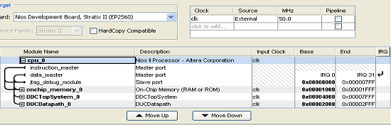

      - NIOS II Processor Example
You can use a processor such as a NIOSII processor to read or modify a control register, or to update memory contents. To perform a register update, follow the steps listed below:
- Identify SOPC Builder base address assigned to your DSPB-ABB design. You can find it in your SOPC Builder project in Quartus, and an example is shown in the figure above. You can also find the base address information in system.h file in your NIOSII project, after you have loaded the SOPC library information into your NIOSII IDE.
- Identify the base address for the ModelIP of interest in your DSPB-AB design. It is the base address assigned to your DSPB-AB model which is identified in Step 1, plus the address offset you specified in your ModelIP or in your setup script. You can also conveniently identify the address offset from Help documentation by right clicking on the ModelIP and select HELP.
- Identify the base address for the register of interest in your DSPB-AB design. It is the base address assigned to your DSPB-AB model which is identified in Step 1, plus the address offset you specified in your register or in your setup script. You can also conveniently identify the address offset from Help documentation by right clicking on the register and select HELP.

The following figure illustrates the relationship of base address and address offset for various memory mapped interfaces.

…
FIR
…
base_addr_SOPC
end_addr_SOPC
COEF x
base_addr_FIR
coef_x_offset

Once the base address is identified, you can use IOWR and IORD commands to write and read registers and memory. For example, commands to use to access coef_x in the above example are

IOWR(base_addr_SOPC + base_addr_FIR, coef_x_offset, data)
IORD(base_addr_SOPC + base_addr_FIR, coef_x_offset)

  - Integration with DSP Builder Standard Blockset
  - Interfacing with the Real World Outside DSPB-AB
<rtl showing how to convert say a parallel multiple channel interface to interleaved data matrix format DSPB-AB requires and vice versa; how to write your own data format converter>

- Information for Power Users
  - Achieving Good Quality of Results
    - Optimization Techniques to Include and to Avoid
      - Defering HDL-like Low Level Optimizations
<In some cases, trying to outsmart the synthesizer can lead to worse results:
-plus makes the design less portable.
-give examples, such as minimum latency>
      - Recommended Optimization Practices
< 1. Algorithmic simplifications
2. simplifying memory contents, or combining with multipliers (i.e. Fs/4) (compared to a constant being driven to a multiplier)
3. optimizations that will minimize added latency (pipelining) or allow scheduling a feedback loop with less latency>
    - Folding and Fmax
<non-obvious results often, folding can reduce resources (delay lines, mults, memory blocks), but higher fmax can increase registers.. . try it!>
    - Folding Expectations
<Folding may result in untraditional sharing of resources.

a few things to consider: unrelated blocks may benefit from being combined, and sharing can occur between them that otherwise is difficult

describe types of blocks which are shared (mults/mem)

descirbe types of blocks not shared today

QoR trends by folding>

In addition to saying combinatorial logic may grow, would it make to have a section or increase the scope here to say what blocks get folded? I.e. mults and memories get folded, but nothing else? Explain this rule is very important because it may say for a given deisgn which looks regular, we don’t realize we can fold some of the adjacent logic around mults for example can be folded with the mult. So for a FIR with 8 taps and a folding of 4, you don’t necessarily cut the number of adders from 7 to 2…

Also mention regbus blocks don’t fold

    - Constant Multipliers
<lower latency, may result in few adders and LEs relative to DSP block and routing registers

useful for small bitwidth operations

using DSPB-AB Features can help prevent Sum of Two orphans>
    - Resource Optimization
<thresholding (just mention, covered elsewhere)

using faster speedgrades to reduce latency

using negative clock margin to reduce pipelining.. design dependent.>
  - Creating a Parameterizable Design
    - Simulink / MATLAB Access
<scripting:1. what fields can be accessed directly (scripted directly) and what fields are to be accessed indirectly;
2. examples of Matlab setup scripts and talk about preloading callback functions>
    - Using Masks
    - Custom Libraries / Subsystems
    - Vectors vs. Arrays
<address how using arrays can prevent use of vectors later... i.e. no multi-dimensional support; use an example>
  - Optimizing Performance and Resource Usage
    - Optimization
      - Thresholding
      - Clock Margin
      - Algorithm Design Space Explorer
    - Design Space Exploration
  - Compiler Optimization Directives
    - How to Avoid Minimum Latency in a Feedback Loop
< avoid minimum latency issues with feedback, Similar problem to single channel iir, but there are some cases where you can actually fix the math. the signle channel IIR case is hard to do because you cant refactor the math>

Consider the following two main cases:
- The simpler case is feed-forward. When no loops exist, feed-forward datapaths are balanced to ensure that all the input data reaches each functional unit in the same cycle. After analysis, DSP Builder inserts delays on all the non-critical paths to balance out the delays on the critical path.
- The case with loops is more complex. DSPB-AB creates all loops with a delay to avoid combinational loops that Simulink cannot analyze. Typically, one or more lumped delays exist. Preserve the delay around the loop for correct operation; therefore the functional units borrow delays from the lumped delay that need them. Because loops can intersect or be nested with each other, observe a set of simultaneous constraints. The synthesis engine solves these constraints, distributes delay around the functional units as required, and leaves any residual delay as lumped delay elements. When there is insufficient delay to distribute, an error generates. The following list gives the delay requirements for some typical blocks:
  - Boolean logic operations: 0 delay
  - Adders: 1 delay, but potentially more at higher clock rates
  - Two input multiplexers: 1 delay with potentially more for large number of inputs and at high clock rates
  - Multipliers: 3 cycles or 4 at higher clock rates

    - How to Avoid State Machines
<coding techniques to avoid statemachines... why this is good (i.e. faster, more scalable) and how to do it with examples... (i.e. using LUTs to sequence, not statemachines)>
- Lessons: CookBook Designs
  - Introduction
<because DSPB-AB allows designs to be described independent of the implementation, there are many ways to implment even simple functions, which allow varying degrees of fleixbility down the road, either in portability or extention thru features like vectorization.>

  - Delay Lines
    - Normal Use
    - with Enable
    - Variable Delay
  - FIR
    - Using Vectorization
    - Using Scalars
<so arrays can be used...>
  - FIR Model IP
    - Flow control
    - Packet Reordering
- Appendix
  - Common Issues and Errors
    - DSPB-AB vs. Simulink
    - NCO - What IS this Thing??
  - Primitive Use Tables
<the folding, vector and complex support tables>
  - Vector Support Tables for Primitive Library
In the following tables, green indicates supported, grey means not supported.
2-Input Blocks | Vector Input | Vector and Scalar Inputs | Complex Data Inputs | Vector Control Inputs | Comments
Add |  |  |  |  | Will support n inputs, will perform ‘Sum of Elements’ if n is 1
Add Sload |  |  |  |  | No complex support for ‘s’ input  Can have vector ‘s’ input.
CmpEQ
CmpGE
CmpLT
CmpNE
CORDIC |  |  |  |  | No complex support for ‘v’ input  Can have vector ‘v’ input
Max
Min
Mult | ⁽¹⁾ | ⁽²⁾ | ⁽³⁾ |  | ¹ performs ‘element by element’ multiplication  ² performs scalar multiplication  ³ performs complex multiplication
Sub

Single-Input Blocks | Vector Input | Complex Data Inputs | Comments
Abs |  |  | No complex support : Requires sqrt

Single-Input Blocks | Vector Input | Complex Data Inputs | Comments
Bit Extract
Bit Reverse
CLZ

2-Input  Blocks | Vector Input | Vector and Scalar Inputs | Complex Data Inputs
And
Bit Combine
LShift
Nand
Nor
Not
Or
Shift
Xnor
Xor

  - Scripts Provided by DSPB-AB
just list
  - Tips and Tricks
    - When Using Faster Speed Grade Devices Starts to Make Sense
<can be an alternative to a design which grows too much (register reduction/folding)>
    - Using Clock Margin to Tweak Sizes
    - Thresholding
  - Bus Format for the FIR and NCO IP
    - Why the Interface
justification... i.e. makes cascading easy.
    - Protocol
point to the documentation or add more detail if needed
    - Tips for Interface to Primtive Subsystems
    - Tips for Changing Order for Channel Summing or Mixers
    - Tips for Flow Control
  - FAQ
  - RAQ
  - Simulink Tips
key shortcuts

perhaps Simulink scripting overview?

