Delay Functional Unit Specification

This functional unit can be used to insert a delay of specified length. The output data at time T will be equivalent to the input data at time T-DELAY. The user can select to implement the delay using either LE’s (registers) or Memory. The type of memory to use is selected by the user.

The memory type selection is left to the designer as it is anticipated that the designer will want to be able to choose a memory type best suited to the application. For example, if a design makes heavy use of M4K memories and M512 is underused, the designer may with to implement the delay in M512s. Additionally; the designer can configure the memory types to most efficiently use memory bits. This is different to allowing Quartus to auto select the memory type. For example:

A designer has data of width 8, and wishes to implement a delay of 128. Therefore the total number of memory bits required is 1024. If Quartus is left to select the ram type using the “AUTO” parameter, then the delay will be implemented in a single M4k, using only ¼ of the memory bits available. A more efficient use of memory would be to use 2x M512’s.

The delay unit reset is working as if all memory elements had a reset. This is a requirement where the delay unit is used in an accumulator structure, as is the case in the CIC. For this purpose, the output from the memory is replaced with 0 for the first n clock cycles after reset, where n is the memory depth.

Parameters (Generics)

Generic | Type | Default value | Description
WIDTH_g | Natural | 18 | Width of the input/output data.
DELAY_g | Natural | 16 | This is equivalent to the number of clock cycles you wish to delay the output data from the input data.
USE_MEMORY_g | Natural  (range 0 to 1) | 1 | If this is set to 1, the delay will be implemented in memory. If this is set to 0, then the delay will be implemented in LE’s.
MEMORY_TYPE_g | String | “M4K” | The type of memory you wish to use in to implement the delay. This is only valid if USE_MEMORY_g is set. The valid of this string is not confined to specific values as it is anticipated that new memories will be defined. If the string does not match a valid memory type an error will be asserted (internally during simulation or synthesis).
REGISTER_FIRST_g | Natural (range 0 to 1) | 0 | Register the last data (after the memory). Only really makes sense if the delay is implemented in Memory. If the delay is implemented in LE’s then the data will be registered regardless.
REGISTER_LAST_g | Natural (range 0 to 1) | 1 | Register the last data (after the memory). Only really makes sense if the delay is implemented in Memory. If the delay is implemented in LE’s then the data will be registered regardless.

Ports

Port Name | Type | Description
clk | std_logic | Clock
reset | std_logic | Reset. Only resets LE’s.
enable | Std_logic | Enable.
datain | std_logic_vector(WIDTH_g -1 downto 0) | Input data.
dataout | std_logic_vector(WIDTH_g -1 downto 0) | Output data, equivalent to datain(t-delay), where t is time units.

Timing diagram

For when DELAY_g = 3. From t=0, data is undefined until at 3 data words have been written.

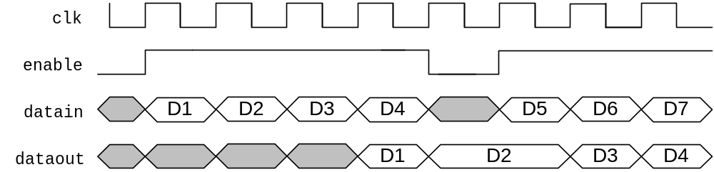

If new memory types are defined, the interface to the Functional unit can remain the same, and the internal architecture can change.
This can help with timing closure. The synthesiser may move this register closer to the signal source, thereby reducing the delay path between the source and the memory (which has fixed locations).
This can help with timing closure. The synthesiser may move this register closer to the destination register, thereby reducing the delay path between the memory (which has fixed locations) and the destination register.

