Fast Accumulator Functional Unit Specification

Introduction

This functional unit is to be deployed as accumulator when the performance regarding maximum frequency is critical. It can be used to perform an accumulation in a single clock however it will introduce latency to the output.

The adder is split in stages of labwidth_g bits each. The carry between the stages is registered. The input data is split the same way with extra delay for each partition. See the definition of constant STAGES_ADD_c down below. It will need {number of partitions} clock cycles to complete the first summation / accumulation but from there on it should be able to do 1 accumulation per clock cycle. See the timing diagram.

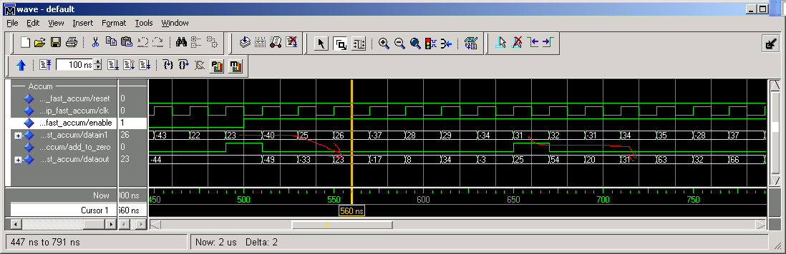
Figure 1 Timing diagram of accumulator with STAGES_ADD_C = 3

There is a device dependency on the lab width. For Stratix III having 10 ALM per LAB (20 bits) the value of 18 (19) is recommended. The 20th bit will be the carry out being registered.
For other device families like Stratix II and Cyclone which have 8 ALM per LAB, a value of labwidth 14 (15) is recommended. However this Functional Unit is coded in a generic way so it is possible to increase or decrease depending on requirements.

Constant (Defining architecture & behavior)

STAGES_ADD_c: This constant defines de number of stages the accumulator is going to partition into. Also it defines the latency between input and valid corresponding output. This constant depends upon the accumulator output bit width, the lab width selected. The formula is as follows (IN_OR_OUT has to be 1):

function calc_number_of_stages(FULL_WIDTH, LABWIDTH, IN_OR_OUT : natural) return natural is
variable tmp : natural;
variable result : natural;
begin
tmp := FULL_WIDTH;
result := 0;
while tmp > LABWIDTH+IN_OR_OUT loop
tmp := tmp - LABWIDTH;
result := result + 1;
end loop;

return result;
end calc_number_of_stages;

Parameters (Generics)

Generic | Type | Default value | Description
DATA_WIDTH_g | Natural | 44 | Width of the input data.
LABWIDTH_g | Natural | 19 | Width of the lab in the selected device.  For Stratix III it is recommented 18 (20-2). That last one in the LAB is used to latch the carry out and the first is the carry in. Possible values are from 2 to any value. If LABWIDTH_g >= ACCUM_OUT_WIDTH_g then no pipeline architecture is generated.
NUM_OFF_CHANNELS_g | Natural | 1 | For multi-channel support. Set the number of channels.
ACCUM_OUT_WIDTH_g | Natural | 48 | Width of accumulator output. It has to be greater than DATA_WIDTH_g
ACCUM_MEM_TYPE_g | string | auto

Ports

Port Name | Width | Description
clk | 1 | Clock
reset | 1 | Reset. Only resets LE’s.
enb | 1 | Enable. When de-asserted it stops fully the accumulator.
add_to_zero | 1 | When asserted the accumulator output will be datai. When not asserted, accumulation occurs.
datai | DATA_WIDTH_g -1 ..0 | Input data. It is SIGNED
datao | ACCUM_OUT_WIDTH_g-1 ..0 | Output accumulated data. It is SIGNED

Test Plan

- Tested with data_width=7, labwidth=3, output width=10. That results in same stage partition for input and output.
- Need to test with data_width=7, labwidth=3, output width=16. That results in stage input = 2 partition but stages= 5 for output. Hence sign extension for input takes place (to be done)

Improvement Roadmap

- Support for any valid combination of data input width and data output width. (Intend to do) still remains to implement sign extension pipeline for input data should #input_stages < #output_stages.
- Should carry out be provided for overflow?
- Data input and output can only be SIGNED. Would it a be necessary to have UNSIGNED support as well?
- (Suggestions here please)

