虚拟机VMware Workstation中安装VMware Tools
虚拟机VMware tools的用途
- 更新虚拟机中的显卡驱动, 使虚拟机中的XWindows可以运行在SVGA模式下。在客户操作系统中安装VMware Tools非常重要。如果不安装VMware Tools，虚拟机中的图形环境被限制为VGA模式图形(640x480，16色)。使用VMware Tools，SVGA 驱动程序被安装，VMware Workstation 支持最高 32 位显示和高显示分辨率，显著提升总体的图形性能。
- 在主机和客户机之间时间同步。只有当你在客户操作系统中设置时钟为一个比在主机中设置的时间更早的时间时，才可以在客户和主机操作系统之间同步时间。
- 支持同一个分区的真实启动和从虚拟机中启动, 自动修改相应的设置文件。自动捕获和释放鼠标光标。未安装VMware Tools的时候只能用Ctrl+Alt来释放鼠标，安装VMware Tools后可以实现虚拟机和主机图形用户界面之间平滑移动鼠标光标。
- 在主机和客户机之间或者从一台虚拟机到另一台虚拟机进行复制和粘贴操作。
- 改善网络性能，使虚拟机网卡从百兆变成千兆网卡。

安装VMware tools的方法：
虚拟机开机自动连接镜像
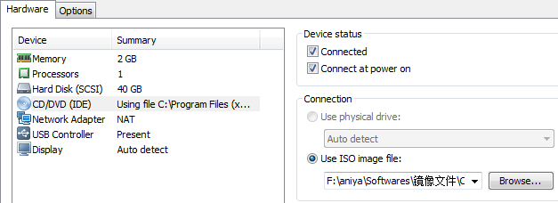
第一步：点击VM---->Install VMware Tools
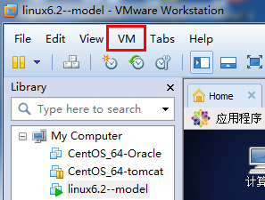

第二步：弹出来文件夹
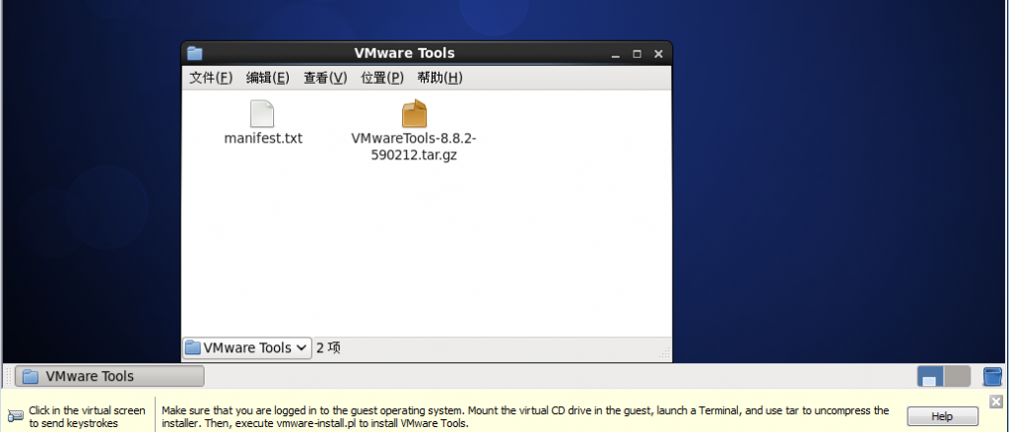

第三步：查看tar包的属性，即它所在的目录
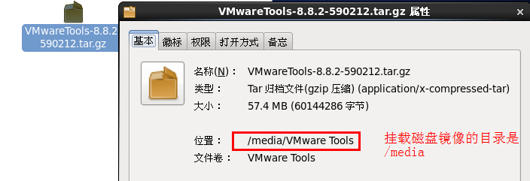

注意：如果下载出现问题，可以直接从实验工具包中复制VmwareTools安装包到/tmp目录下。

第四步：进入源码包所在的目录，从镜像中复制到/tmp文件夹中
[root@linux6-2 ~]# df -h |grep -i vmware
/dev/sr0 58M 58M 0 100% /media/VMware Tools
[root@linux6-2 ~]# cd /media/VMware\ Tools/
[root@linux6-2 VMware Tools]# ls
manifest.txt VMwareTools-8.8.2-590212.tar.gz
[root@linux6-2 VMware Tools]# cp VMwareTools-8.8.2-590212.tar.gz /tmp

第五步：解压包，解压后生成vmware-tools-distrib目录
[root@linux6-2 VMware Tools]# cd /tmp/
[root@linux6-2 tmp]# chmod +x VMwareTools-8.8.2-590212.tar.gz
[root@linux6-2 tmp]# tar zxf VMwareTools-8.8.2-590212.tar.gz
[root@linux6-2 tmp]# ls |grep -i vmware
VMwareTools-8.8.2-590212.tar.gz
vmware-tools-distrib
[root@linux6-2 vmware-tools-distrib]# ls
bin doc etc FILES INSTALL installer lib vmware-install.pl

第六步：用vmware-install.pl安装，
./vmware-install.pl
基本上都是默认选择，一直回车即可
Creating a new VMware Tools installer database using the tar4 format.
Installing VMware Tools.

In which directory do you want to install the binary files?
[/usr/bin]

What is the directory that contains the init directories (rc0.d/ to rc6.d/)?
[/etc/rc.d]

What is the directory that contains the init scripts?
[/etc/rc.d/init.d]

In which directory do you want to install the daemon files?
[/usr/sbin]
In which directory do you want to install the library files?
[/usr/lib/vmware-tools]
The path "/usr/lib/vmware-tools" does not exist currently. This program is
going to create it, including needed parent directories. Is this what you want?
[yes] yes
In which directory do you want to install the documentation files?
[/usr/share/doc/vmware-tools]

The path "/usr/share/doc/vmware-tools" does not exist currently. This program
is going to create it, including needed parent directories. Is this what you
want? [yes] yes

The installation of VMware Tools 8.8.2 build-590212 for Linux completed
successfully. You can decide to remove this software from your system at any
time by invoking the following command: "/usr/bin/vmware-uninstall-tools.pl".
Before running VMware Tools for the first time, you need to configure it by
invoking the following command: "/usr/bin/vmware-config-tools.pl". Do you want
this program to invoke the command for you now? [yes] yes
Initializing...

Making sure services for VMware Tools are stopped.

[EXPERIMENTAL] The VMware FileSystem Sync Driver (vmsync) is a new feature that
creates backups of virtual machines. Please refer to the VMware Knowledge Base
for more details on this capability. Do you wish to enable this feature?
[no] yes
Found a compatible pre-built module for vmsync. Installing it...
Found a compatible pre-built module for vmci. Installing it...
Found a compatible pre-built module for vsock. Installing it...
The module vmxnet3 has already been installed on this system by another
installer or package and will not be modified by this installer. Use the flag
--clobber-kernel-modules=vmxnet3 to override.

The module pvscsi has already been installed on this system by another
installer or package and will not be modified by this installer. Use the flag
--clobber-kernel-modules=pvscsi to override.
The module vmmemctl has already been installed on this system by another
installer or package and will not be modified by this installer. Use the flag
--clobber-kernel-modules=vmmemctl to override.

The VMware Host-Guest Filesystem allows for shared folders between the host OS
and the guest OS in a Fusion or Workstation virtual environment. Do you wish
to enable this feature? [yes]
Found a compatible pre-built module for vmhgfs. Installing it...
Found a compatible pre-built module for vmxnet. Installing it...
!!! [EXPERIMENTAL] !!!
VMware automatic kernel modules enables automatic building and installation of
VMware kernel modules at boot they are not already present. By selecting yes,
you will be enabling this experimental feature. You can always disable this
feature by re-running vmware-config-tools.pl.
Would you like to enable VMware automatic kernel modules?[no]
Disabling timer-based audio scheduling in pulseaudio.
Detected X server version 1.10.4
Distribution provided drivers for Xorg X server are used.

Skipping X configuration because X drivers are not included.

Creating a new initrd boot image for the kernel.
vmware-tools start/running
The configuration of VMware Tools 8.8.2 build-590212 for Linux for this running
kernel completed successfully.

You must restart your X session before any mouse or graphics changes take
effect.
You can now run VMware Tools by invoking "/usr/bin/vmware-toolbox-cmd" from the
command line or by invoking "/usr/bin/vmware-toolbox" from the command line
during an X server session.

To enable advanced X features (e.g., guest resolution fit, drag and drop, and
file and text copy/paste), you will need to do one (or more) of the following:
1. Manually start /usr/bin/vmware-user
2. Log out and log back into your desktop session; and,
3. Restart your X session.

Enjoy,

--the VMware team
Found VMware Tools CDROM mounted at /media/VMware Tools. Ejecting device
/dev/sr0 ...
umount: /media/VMware Tools: device is busy.
(In some cases useful info about processes that use
the device is found by lsof(8) or fuser(1))
eject: unmount of `/media/VMware Tools' failed
Eject Failed: If possible manually eject the Tools installer from the guest
cdrom mounted at /media/VMware Tools before canceling tools install on the
host.

安装完毕

