# NUMBER CONVERSION

## Binary-to-Decimal Conversion

Binary numbers are represented as a logical 0 or logical 1 in base 2 format. This means that each number has a place value of 2*N*, where *n* is the place value position of the binary digit. The place values start at 20 with the least significant bit (LSB) position. For example, the binary number 1 0 1 1 has the place values of 20 for the LSB position to 23 for the most significant bit (MSB) position.

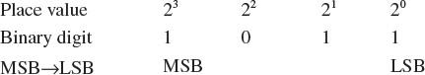

The 1 and 0 are used as a multiplier times the place value. For example, the conversion of 1 0 1 1 to decimal is as follows:

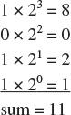

This is shown in [Table 6-5](https://learning.oreilly.com/library/view/Networking+Essentials:+A+CompTIA+Network+N10-006+Textbook,+4_e/9780134299761/ch06.xhtml#ch06tab05).

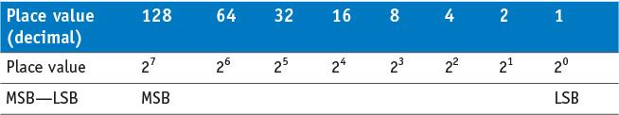

TABLE 6-5 **Place Values for Eight Binary Numbers (an Octet)**

Every place value that has a binary digit of 1 is used to sum a total for determining the decimal equivalent for the binary number.

**Example 6-1**

Given a 32-bit IP address number expressed in binary format, convert the number to a dotted-decimal format.

Image

**Solution:**

First, assign the place value for each binary position.

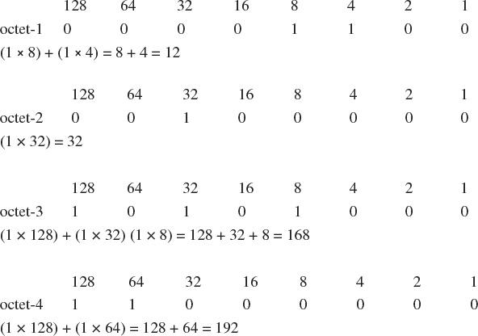

Therefore, the dotted decimal equivalent is 192.168.32.12.

## Decimal-to-Binary Conversion

The simplest way to convert a decimal number to binary is using division, repeatedly dividing the decimal number by 2 until the quotient is 0. The division steps for converting decimal numbers to binary are as follows:

**1.** Divide the decimal number by 2, record the remainder of 0 or 1, and write the quotient or result of the division by 2.

**2.** Divide the quotient by 2 and record the remainder of 0 or 1. Write the quotient and repeat this step until the quotient is 0.

**3.** Write the remainder numbers (0 and 1) in reverse order to obtain the binary equivalent value.

## Hexadecimal Numbers

Hexadecimal numbers (hex) are base 16 numbers. The simplest way to convert hexadecimal numbers to binary is through the use of either a calculator or a lookup table.

**Example 6-5**

Convert the hexadecimal number 0x48AF to binary.

**Solution:**

Use [Table 6-6](https://learning.oreilly.com/library/view/Networking+Essentials:+A+CompTIA+Network+N10-006+Textbook,+4_e/9780134299761/ch06.xhtml#ch06tab06) to convert the hex numbers.

Image

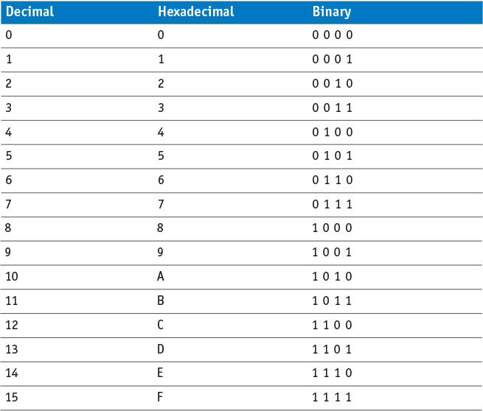

# IPV4 ADDRESSING

IP addressing provides a standardized format for assigning a unique routable address for every host. The IP address is similar to a telephone number. The network portion of the IP address is similar to the telephone’s area code. The host portion of the IP address is similar to the telephone’s 7-bit local exchange number.

There are five classes of IPv4 addresses: [**class A, B, C, D, and E**](https://learning.oreilly.com/library/view/Networking+Essentials:+A+CompTIA+Network+N10-006+Textbook,+4_e/9780134299761/gloss01.xhtml#gloss_82).

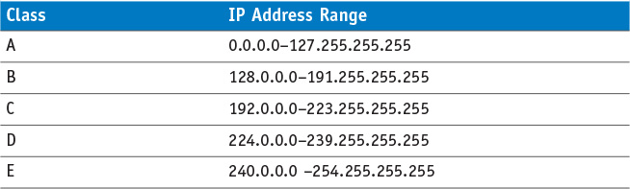

The 0.0.0.0 and 127.x.x.x addresses are special-purpose addresses. The 0.0.0.0 IP address refers to the source host on this network. The 127.x.x.x addresses are used as the Internet loopback address

Each IP address consists of four 8-bit octets, providing a total binary data length of 32 bits.

Each of the four octets of the IPv4 address represents either a network or a host portion of the IP address. Class A has 8 bits assigned for the network address and 24 bits for the host. Class B has 16 bits for the network address and 16 bits for the host. Class C has 24 bits assigned for the network address and 8 bits for the host.

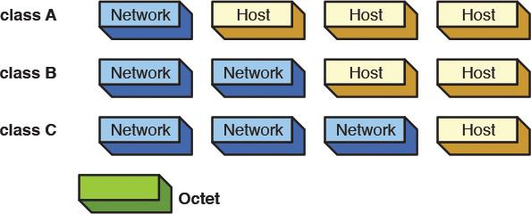

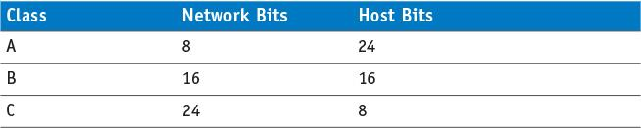

The number of host bits in the IP address classes determines how many hosts can be created for each class of address. The equation

2*n* – 2, where *n =* number of host bits For example, a class C address has 8 host bits; therefore, 28 – 2 = 254 host IP addresses can be assigned to a class C network. The reason for the “– 2” value in the equation when calculating the number of host addresses is the host IP address cannot be all 1s or all 0s. The all 1s state is reserved for network broadcasts, and the all 0s state is reserved for the network address.

## Private IP Addresses

Address ranges in class A, B, and C have been set aside for private use. These addresses, called *private addresses*, are not used for Internet data traffic but are intended to be used specifically on internal networks called *intranets.* [Table 6-11](https://learning.oreilly.com/library/view/Networking+Essentials:+A+CompTIA+Network+N10-006+Textbook,+4_e/9780134299761/ch06.xhtml#ch06tab11) lists the private address ranges.

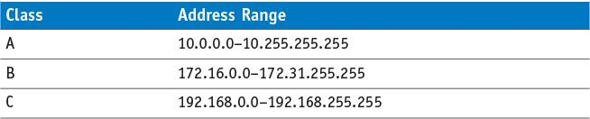

IP address allocation is governed by the Internet Assigned Number Authority ([IANA](https://learning.oreilly.com/library/view/Networking+Essentials:+A+CompTIA+Network+N10-006+Textbook,+4_e/9780134299761/gloss01.xhtml#gloss_221)).

# SUBNET MASKS

*Subnetting* is a technique used to break down (or partition) networks into subnets. The subnets are created through the use of subnet masks. The [**subnet mask**](https://learning.oreilly.com/library/view/Networking+Essentials:+A+CompTIA+Network+N10-006+Textbook,+4_e/9780134299761/gloss01.xhtml#gloss_477) identifies which bits in the IP address are to be used to represent the network/subnet portion of an IP address.

Subnets are created by borrowing bits from the host portion of the IP address.

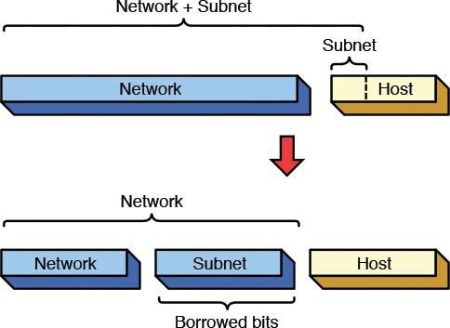

**FIGURE 6-14** Borrowing bits from the host to create subnets.

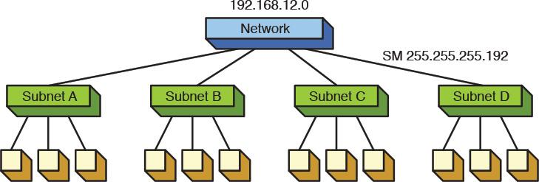

**FIGURE 6-15** Partitioning a network into subnets.

Assume that the network has an IP address of 192.168.12.0. The 2 bits are borrowed from the host portion of the IP address to create the 4 subnets. The class C network has 24 network bits and 8 host bits. Then 2 bits are borrowed from the host address to create the 4 subnets. The network plus subnet portion of the IP address is now 24 + 2, or 26 bits in length, and the host portion is now 6 bits. The breakdown of the 32-bit IP address is shown in [Figure 6-16](https://learning.oreilly.com/library/view/Networking+Essentials:+A+CompTIA+Network+N10-006+Textbook,+4_e/9780134299761/ch06.xhtml#ch06fig16).

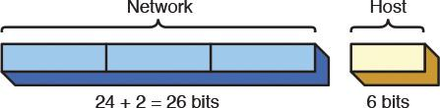

The equations for calculating the number of subnets created and the number of hosts/subnet are provided in Equations 6-1 and 6-2.

Image

where *x =* # of bits borrowed from the host bits

*y =* # host bits for the class of network (A = 24, B = 16, C = 8)

Breaking down the 192.168.12.0 network into four subnets requires borrowing two host bits. Therefore, *x* = 2, and because this is a class C network, *y* = 8.

*x* = 2 (the number of bits used from the host)

*y* = 8 (number of bits for a class C network)

Applying these values to equation 6-2 yields

The number of subnets created = 2*x* = 2(2) = 4

The number of hosts/subnet = 2(*y - x*) = 2(8 - 2) = 64

When creating subnets, it is important to note that each subnet will have both a network and a broadcast address. The equations for calculating the number of hosts/subnet are modified to account for the number of usable hosts/subnet

The number of **usable hosts/subnet** = 2(*y - x*) – 2

The next step is to determine the subnet mask required for creating the four subnets. Recall that creating the four subnets required borrowing 2 host bits. The purpose of the subnet mask is to specify the bit positions used to identify the network and subnet bits. Applying the subnet mask is basically a logical AND operation. Setting the subnet mask bit position to a 1 enables the bit value from the IP address to pass. Setting the subnet mask bit value to 0 disables the IP address from appearing on the output. This is shown in the truth table for a logical AND operation:

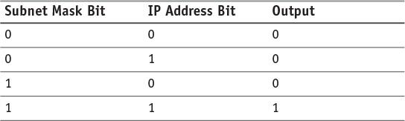

Notice that when the subnet mask bit is set to 0, the output is forced to 0. When the subnet mask bit is set to 1, the output follows the IP address bit.

The subnet mask consists of bit position values set to either a 1 or a 0. A bit position set to a 1 indicates that the bit position is used to identify a network or subnet bit. The subnet mask for identifying the class C network 192.168.12.0 will be 255.255.255.x. This conversion is shown next.

Image

The subnet mask also identifies the subnet bits. The two MSBs were borrowed from the host bits; therefore, the last octet of the subnet mask will be

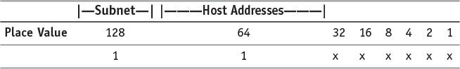

where the 1 indicates this place is used for the subnet mask and the *x* means that the place value is left for the host address. Summing the two bit position values that have a 1 yields 128 + 64 = 192. The 192 is placed in the last octet of the subnet mask. The complete subnet mask is 255.255.255.192.

The two subnet bits create four subnets, and each subnet has its own network address. The network addresses are used to route data packets to the correct subnet. [Table 6-12](https://learning.oreilly.com/library/view/Networking+Essentials:+A+CompTIA+Network+N10-006+Textbook,+4_e/9780134299761/ch06.xhtml#ch06tab12) shows the four subnet addresses listed in both binary and decimal format.

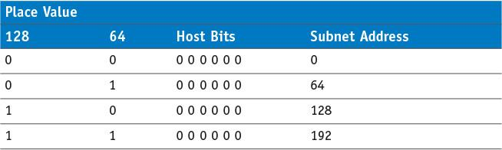

TABLE 6-12 **Binary and Decimal Equivalents for the Subnet’s Network Address**

(Note: The six host bits are all set at 0 in a subnet’s network address.)

Each subnet will also have its own broadcast address. The broadcast address for the subnet is used to broadcast packets to all hosts in the subnet. (*Note:* All host bits are set to 1 for a broadcast.) [Table 6-13](https://learning.oreilly.com/library/view/Networking+Essentials:+A+CompTIA+Network+N10-006+Textbook,+4_e/9780134299761/ch06.xhtml#ch06tab13) shows the binary and decimal equivalents for the subnet’s broadcast address.

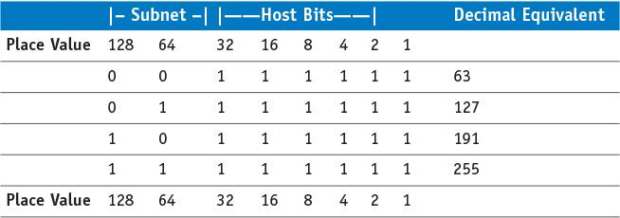

TABLE 6-13 **Binary and Decimal Equivalents for the Subnet’s Broadcast Address**

Given this information, the network and broadcast address can be defined for the four subnets of the 192.168.12.0 network. [Table 6-14](https://learning.oreilly.com/library/view/Networking+Essentials:+A+CompTIA+Network+N10-006+Textbook,+4_e/9780134299761/ch06.xhtml#ch06tab14) provides these addresses for the four subnets.

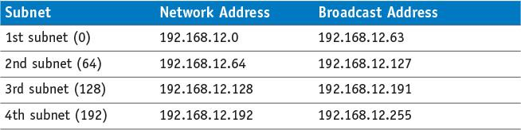

### Example 6-8

Given a network address of 10.0.0.0, divide the network into 8 subnets. Specify the subnet mask, the network and broadcast addresses, and the number of usable hosts/subnet.

**Solution:**

Creating 8 subnets requires borrowing 3 host bits; therefore, *x* = 3. This is a class A network, so *y* = 24.

Using Equation 6-1, the number of subnets = 23 = 8.

Using Equation 6-3, the number of usable hosts = 2(24-3) – 2 = 2097150

The 8 subnets will be:

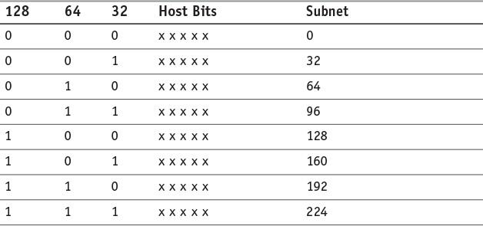

Therefore, the network and broadcast addresses for the 8 subnets will be

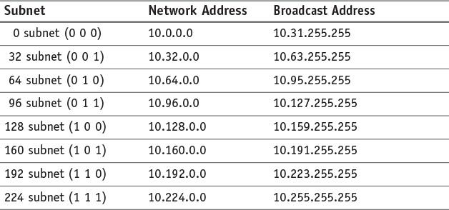

The subnet mask for creating the 8 subnets will be 255.224.0.0.

### Another way

to look at selecting a subnet mask is by specifying how many usable hosts are available to be assigned in a subnet. For example, assume that 62 usable host addresses are to be available in a subnet. Assume this is for a class C network. Using Equation 6-2,

62 = 2(8-*x*) – 2

64 = 2(8-*x*)

Using logarithms to solve for *x:*

log 64 = (8–*x*) (log 2)

log 64/(log 2) = 8–*x*

6 = 8–*x* therefore, *x* = 2

Instead of using logarithms, a table such as that shown in [Table 6-15](https://learning.oreilly.com/library/view/Networking+Essentials:+A+CompTIA+Network+N10-006+Textbook,+4_e/9780134299761/ch06.xhtml#ch06tab15) can be used. [Example 6-9](https://learning.oreilly.com/library/view/Networking+Essentials:+A+CompTIA+Network+N10-006+Textbook,+4_e/9780134299761/ch06.xhtml#ch06ex09) shows how the table can be used to determine the subnet mask.

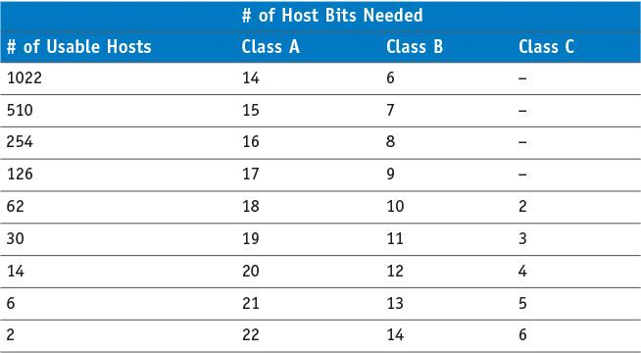

TABLE 6-15 **Number of Bits Borrowed to Create a Specific Number of Usable Hosts**

# CIDR BLOCKS

*Classful* means that the IP addresses and subnets are within the same network. The problem with classful addressing is that there is a lot of unused IP address space. For example, a class A IP network has more than 16 million possible host addresses. A Class B network has more than 65,000 host addresses, but the fact is that only a limited number of Class A and B address space has been allocated for Internet use.

A technique called [**supernetting**](https://learning.oreilly.com/library/view/Networking+Essentials:+A+CompTIA+Network+N10-006+Textbook,+4_e/9780134299761/ch06.xhtml#ch06key25a) was proposed in 1992 to eliminate the class boundaries and to make available the unused IP address space. Supernetting allows multiple networks to be specified by one subnet mask. In other words, the class boundary could be overcome.

The technique developed is called classless interdomain routing ([**CIDR**](https://learning.oreilly.com/library/view/Networking+Essentials:+A+CompTIA+Network+N10-006+Textbook,+4_e/9780134299761/gloss01.xhtml#gloss_78)). CIDR (pronounced “cider”) notation specifies the number of bits set to a 1 that make up the subnet mask. For example, the Class C size subnet mask 255.255.255.0 is listed in CIDR notation as /24. This indicates the 24 bits are set to a 1. A Class B size subnet is written as /16, and a Class A subnet is written as /8. CIDR can also be used to represent subnets that identify only part of the octet bits in an IP address. For example, a subnet mask of 255.255.192.0 is written in CIDR as /18. The /18 comes from the 18 bits that are set to a 1 as shown:

Image

This is another shorthand technique for writing the subnet mask. For example, the subnet mask 255.255.255.192 is written as /26.

A network address and the subnet mask of 192.168.12.0 255.255.252.0 can be **written** in CIDR notation as 192.168.12.0/22. [Table 6-16](https://learning.oreilly.com/library/view/Networking+Essentials:+A+CompTIA+Network+N10-006+Textbook,+4_e/9780134299761/ch06.xhtml#ch06tab16) provides the CIDR for the most common subnet masks.

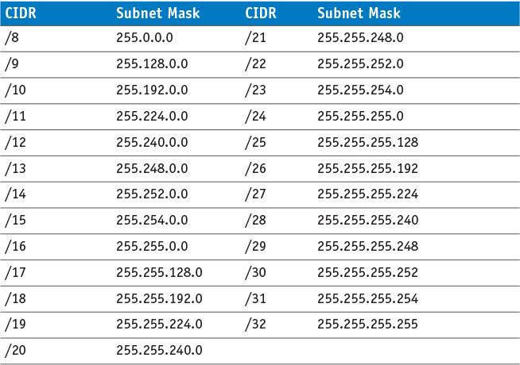

CIDR blocks are used to break down the class barriers in IP addressing. For example, two Class C networks (192.168.78.0/24 and 192.168.79.0/24) can be grouped together as one big subnet. These two networks can be grouped together by modifying the /24 CIDR number to /23. This means that one bit has been borrowed from the network address bits to combine the two networks into one supernet. Writing these two networks in CIDR notation provides 192.168.78.0/23. This reduces the two Class C subnets to one larger network. When you group two or more classful networks together, they are called [**supernets**](https://learning.oreilly.com/library/view/Networking+Essentials:+A+CompTIA+Network+N10-006+Textbook,+4_e/9780134299761/gloss01.xhtml#gloss_479). This term is synonymous with CIDR blocks.