Assignment 2- Case Study

Stage 3 Lab Activities

SmartCare Domain Modelling
AI OFF -> AI ON -> COMPARE -> VERIFY | 1 hour

A - Requirements Review
Highlight nouns, verbs and business rules in SmartCare v0.2.
DONE

B - Candidate Classes
Record candidate concepts, supporting requirements, state and behaviour.
Candidate | Class? | Reason
Patient | Yes | The candidate does have their own unique identity that must be distinguished from other patients. It is planned to have a patient ID, contact info, and history connected to them and exist outside of the system and singular appointment
Practitioner | Yes | Similar to the patients they have their own identity and must be distinguished from other staff and patients. The practitioner should have a practitioner ID, contact info, and history as well. They do exist independent of the system but are required for the system to function.
Appointment | Yes | It does not have an identity outside of the system and exists as a function to be filled with details of other candidates. The data it holds is from patients, practitioners, time etc. It will be needed to look up appointments and distinguish them from others with a broader appointment ID
Name | No | Not its own thing, but an attribute assigned to a Patient or Practitioner. Does not have an identity or lifecycle of its own.
Clinic | No | For a single clinic that does not need to be distinguished from other locations this is not a class. This is an implied candidate for the system that should not need to be created, stored, or referenced.
Database | No | This is part of the infrastructure. It is not part of the real-world clinic.
Cancellation | No | Could be considered a class for tracking history through it. For now it will remain as a simple status value.
Status | No | This is also an attribute applied to something else rather than its own class

Requirement | Concept | State/behaviour | Decision
Each appointment records patient name, practitioner name and appointment time | Appointment | Hold its own ID, time, status, and hold which patient and practitioner it involves | Time stored as a datetime object rather than a string to allow for sorting, validation, and conflict-checking
Practitioners must be uniquely identifiable | Practitioner | Unique ID, name and role | The same as with patient, the system will assign an ID rather than relying on names
Receptionists must be able to detect double bookings | Appointment | Able to compare time and practitioner against existing appointments | Conflict check should be left to appointments for right now
Cancelled appointments shouldn’t be wiped form record history | Appointment | Status attribute (cancelled/booked/completed) | Status on appointments rather than a separate class
Support for many appointments per patient and practitioner | Patient, Practitioner, Appointment | Association relationships with multiplicity | Patient cand Practitioner can have multiple appointments but only one patient and practitioner per appointment

C - CRC Cards
Create CRC cards for Patient, Practitioner and Appointment.

Patient
Responsibilities | Collaborators
Know their own name, contact information and unique identification number. | Appointment
Hold it’s own appointment history and provide them for booking

Practitioner
Responsibilities | Collaborators
Know its name, role, and unique ID. | Appointment
Holds its own schedule of appointments and show availability

Appointment
Responsibilities | Collaborators
Have its own ID, time, status, and hold which patient and practitioner it involves | Patient
Be able to detect a scheduling conflict | Practitioner

D - UML Model
Draw classes, attributes, operations, associations and multiplicities.
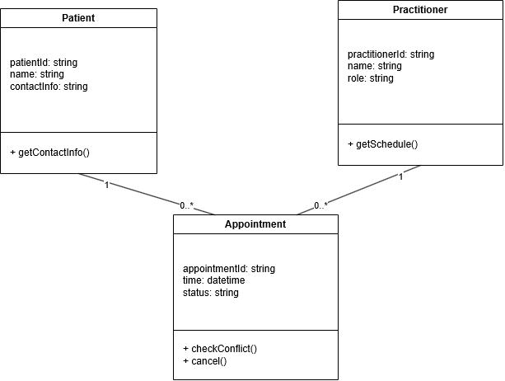

E - AI Design Review
Ask AI to suggest classes and relationships using only confirmed requirements; require supporting requirement IDs.
ID | Requirement
R1 | Appointment records patient name, practitioner name, and time
R2 | Patients must be uniquely identifiable
R3 | Practitioners must be uniquely identifiable
R4 | The receptionist must be able to detect double booking
R5 | Cancelled appointments shouldn’t disappear from records entirely
R6 | The system must support many appointments per patient and per practitioner

AI suggestion | Supporting requirements ID(s) | Evidence | Decision | Reason | Model change
PatientManager | None | None of the requirements require a coordinating class. R2 does require the patient to be uniquely identifiable, however, Patient itself fulfils this requirement | Reject | None of the requirements are fulfilled by this, it would duplicate what the patient CRC already does | None, patient operations remain on the patient
PracititionerManager | None | None of the requirements need a separate PractitionerManager. R3 does require the Practitioner to be uniquely identifiable, however, Practitioner itself fulfils this requirement | Reject | None of the requirements are fulfilled by this, it would duplicate what the Practitioner CRC already does | None
AppointmentManager | R1, R4, and R5 | R1, R4, and R5 decribe things that Appointment must manage but none require a separate class to do them | Reject | Any function this would have already belongs to Appointment | None
ClinicController | None | Proposed to coordinate clinic-level operations | Reject | ClinicController shouldn’t be needed as it has been decided that there is one fixed clinic | None
NotificationManager | None | Proposed to send booking reminders or confirmations | Modify | This doesn’t belong on Patient, Practitioner, or appointment but not needed for now. Outside of scope | Not implemented
ScheduleEngine | R4 | R4 requires detection of double booking. However, this shouldn’t require a dedicated class | Modify | Could be done separately or as part of appointment. For a prototype appointment is likely fine but should be moved for expansion. | Conflict detention will be kept as an Appointment method for now. May be moved to separate class as the system grows.

AI Model Critique & Compare and decide
Critique AI proposals: PatientManager, PractitionerManager, AppointmentManager, ClinicController, NotificationManager, ScheduleEngine.

PatientManager
Reject. A patient manager is not necessary as this could be done by the patient or receptionist. Patient related operations should be handled by the patient or receptionist.
PracititionerManager
Reject. This can just be done in Practitioner
AppointmentManager
Reject. Any function this would have already belongs to Appointment
ClinicController
Reject. ClinicController shouldn’t be needed as it has been decided that there is one fixed clinic
NotificationManager
Modify. This doesn’t belong on Patient, Practitioner, or appointment but not needed for now. Outside of scope
ScheduleEngine
Modify. Could be done separately or as part of appointment. For a prototype appointment is likely fine but should be moved for expansion.

F - Compare and Decide
Record at least one accepted, modified and rejected AI suggestion.
DONE ABOVE ^ IN AI MODEL CRITIQUE

G - Python Skeletons
Create simple Patient, Practitioner and Appointment class skeletons.
DONE IN CODE
class Practitioner:
def __init__(self, practitioner_id: str, name: str, specialty: str):
self.practitioner_id = practitioner_id
self.name = name
self.specialty = specialty

def get_schedule(self):
"""Return practitioner's schedule. Not yet implemented."""
pass

from datetime import datetime

class Appointment:
def __init__(self, appointment_id: str, patient, practitioner, time: datetime, status: str = "booked"):
self.appointment_id = appointment_id
self.patient = patient
self.practitioner = practitioner
self.time = time
self.status = status

def check_conflict(self, other_appointment):
"""Check whether appointment conflicts with another. Not yet implemented."""
pass

def cancel(self):
"""Cancel appointment. Not yet implemented."""
pass

H - Consistency Check
Check model-code consistency; do not implement full behaviour yet.
Class | UML attribute/method | Code | Match
Patient | patientId, name, contact info  + getContactinfo() | Patient_id, name, contact_info  Get_contact_info() | Yes
Practitioner | Practitioner_id, name, speciality  + getSchedule() | Practitioner_id, name, speciality  Get_schedule() | Yes
Appointment | appointmentId, time, status  + checkConflict()  + cancel() | Appointment_id, time, status  Check_conflict()  Cancel() | Yes
Association: Patient 1—0..* Appointment | Appointment holds a reference to a patient object | Self.patient = patient | Yes
Association: Practitioner 1—0..* | Appointment holds a reference to a Practitioner object | Self.practitioner = practitioner | Yes

Reflection
What modelling decision was hardest? Where did AI over-design? What evidence supported your final choices?
Making the decision to not a schedule engine was a hard decision to make because it is not necessary right now, however, when the time comes that it is necessary, it may be harder to implement. I made the decision that for now, with a simple system the class was not needed. AI over designed by suggesting managers for already existing classes that could have that attribute assigned to them. This would over complicate the system. My finial choice was made using the evidence that overcomplicated systems make it hard to navigate and manage, creating confusion for staff.

