SmartCare v0.3 - Domain Model Workbook
Week 6 student resource

Requirement-to-Concept Trace
Requirement | Concept | State/behaviour | Decision
Each appointment records patient name, practitioner name and appointment time | Appointment | Hold its own ID, time, status, and hold which patient and practitioner it involves | Time stored as a datetime object rather than a string to allow for sorting, validation, and conflict-checking
Practitioners must be uniquely identifiable | Practitioner | Unique ID, name and role | The same as with patient, the system will assign an ID rather than relying on names
Receptionists must be able to detect double bookings | Appointment | Able to compare time and practitioner against existing appointments | Conflict check should be left to appointments for right now
Cancelled appointments shouldn’t be wiped form record history | Appointment | Status attribute (cancelled/booked/completed) | Status on appointments rather than a separate class
Support for many appointments per patient and practitioner | Patient, Practitioner, Appointment | Association relationships with multiplicity | Patient cand Practitioner can have multiple appointments but only one patient and practitioner per appointment

CRC Cards

Patient
Responsibilities | Collaborators
Know their own name, contact information and unique identification number. | Appointment
Hold it’s own appointment history and provide them for booking

Practitioner
Responsibilities | Collaborators
Know its name, role, and unique ID. | Appointment
Holds its own schedule of appointments and show availability

Appointment
Responsibilities | Collaborators
Have its own ID, time, status, and hold which patient and practitioner it involves | Patient
Be able to detect a scheduling conflict | Practitioner

UML Class Diagram
Insert/draw UML here. Include defensible relationships and multiplicities.
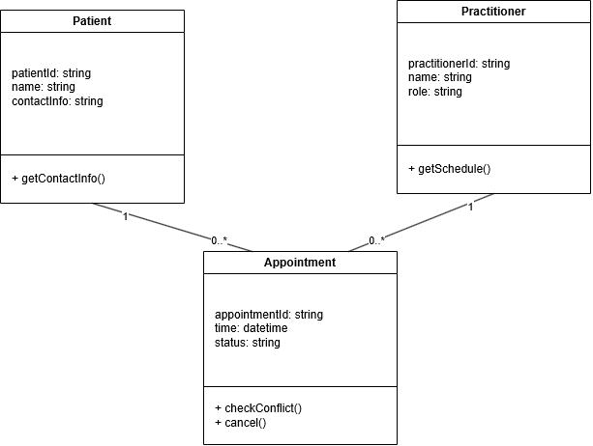

Design Rationale
Explain class selection, responsibility allocation and key relationships.
There were three core classes identified. Patient, Practitioner, and Appointment. Each has a unique identifier holding its own meaningful data and has a lifecycle independent of any single interaction. Practitioner and patient exist before and after appointments. Appointment is outside of the real world but needs a unique ID and must be edited. The others were judged as either out of scope (for now) or were deemed redundant.
Each class only has one responsibility that it can fulfil using its own data.
Patient must hold it’s own ID and contact information and be able to provide it to make a booking.
Practitioner holds its own ID and availability
Appointment holds the time, status, and connects the practitioner and patient involved and detects scheduling conflicts.
Patient and Practitioner have a 1-0 association with Appointment. One patient and practitioner may be linked to many appointments but only one patient or practitioner per appointment. An appointment does not have its own lifecycle outside of patient and practitioner and neither are lost if an appointment is cancelled. Patient and Practitioner are not connected directly.

AI Design Review Record
AI suggestion | Evidence | Decision | Reason | Model change
PatientManager | Proposed to handle patient creation or lookup | Reject | A patient manager is not necessary as this could be done by the patient or receptionist. Patient related operations should be handled by the patient or receptionist. | None
PracititionerManager | Proposed to handle practitioner creation or lookup | Reject | This can just be done in Practitioner | None
AppointmentManager | Proposed to handle booking/cancelling | Reject | Any function this would have already belongs to Appointment | None
ClinicController | Proposed to coordinate clinic-level operations | Reject | ClinicController shouldn’t be needed as it has been decided that there is one fixed clinic | None
NotificationManager | Proposed to send booking reminders or confirmations | Modify | This doesn’t belong on Patient, Practitioner, or appointment but not needed for now. Outside of scope | Not implemented
ScheduleEngine | Proposed to handle conflict detection | Modify | Could be done separately or as part of appointment. For a prototype appointment is likely fine but should be moved for expansion. | Not implemented

