Assignment 2-Case Study

Stage 4 Lab Activities

Implementing the SmartCare Domain Layer
DESIGN FIRST -> AI PAIR PROGRAMMING -> REVIEW -> VERIFY | 1hour

A - Revisit Approved UML
Confirm responsibilities, attributes and relationships before coding.
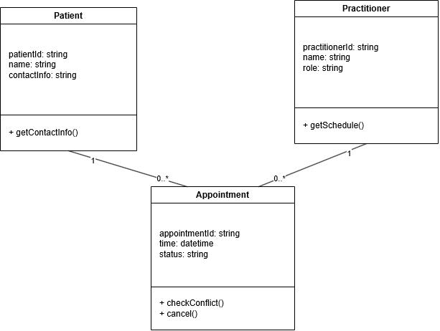
Patient: patientId, name, contactInfo (strings) +getContactInfo()
Practitioner: practitionerId, name, speciality (strings) +getSchedule()
Appointment: appointmentId, time (datetime), status, holds Patient and Practitioner references +getConflict(), cancel()
Relationships: Patient 1—0..* Appointment, Practitioner 1—0..* Appointment, association

B - Implement Patient: AI OFF
Implement Patient with type hints and basic validation.
class Patient:
def __init__(self, patient_id: str, name: str, contact_info: str):

if not patient_id:
raise ValueError("Patient ID cannot be empty")
if not name:
raise ValueError("Patient name cannot be empty")
if not contact_info:
raise ValueError("Contact Information cannot be empty")
self.patient_id = patient_id
self.name = name
self.contact_info = contact_info

def get_contact_info(self):
"""Return patient's contact information. Not yet implemented."""
pass

C - Implement Practitioner: AI OFF
Implement Practitioner with identifier, name and specialty; no database logic.
class Practitioner:
def __init__(self, practitioner_id: str, name: str, specialty: str):

if not practitioner_id:
raise ValueError("Practitioner ID cannot be empty")
if not name:
raise ValueError("Practitioner name cannot be empty")

self.practitioner_id = practitioner_id
self.name = name
self.specialty = specialty

def get_schedule(self):
"""Return practitioner's schedule. Not yet implemented."""
pass

D - Implement Appointment: AI ON
Give AI the approved Appointment UML, business rules and explicit constraints. Ask it to implement only Appointment and agreed enum/exception.
from datetime import datetime
from enum import Enum

class AppointmentStatus(Enum):
SCHEDULED = "scheduled"
CANCELLED = "cancelled"
COMPLETED = "completed"

class Appointment:
def __init__(self, appointment_id: str, patient, practitioner, time: datetime):
if not appointment_id:
raise ValueError("Appointment ID cannot be empty")
if patient is None:
raise ValueError("Appointment must have a patient")
if practitioner is None:
raise ValueError("Appointment must have a practitioner")

self.appointment_id = appointment_id
self.patient = patient
self.practitioner = practitioner
self.time = time
self.status = AppointmentStatus.SCHEDULED

def cancel(self):
if self.status == AppointmentStatus.CANCELLED:
raise ValueError("Appointment is already cancelled")
self.status = AppointmentStatus.CANCELLED

def complete(self):
self.status = AppointmentStatus.COMPLETED

def check_conflict(self, other: "Appointment") -> bool:
if self.practitioner != other.practitioner:
return False
return self.time == other.time

E - Review Generated Code
Check model consistency, unsupported features, public state mutation, unnecessary inheritance, invented dependencies and error handling.
Status has been given its own separate type. On the UML it was status: string, now it’s a separate class. This is inconsistent and is a case of AI changing the system rather than implementing it as per my instructions.
The new AppointmentStatus enum class will be modified and accepted as it is an improvement to the system design and prevents small errors and inconsistencies in invalid string status’. However, the UML diagram will need to be changed to reflect this.
self.status is public meaning it can be set directly and bypasses cancel() or complete().
Also, check_conflict() doesn’t handle other being none; complete() has no guard, meaning that someone can complete an already cancelled appointment.

F - Manual Behaviour Checks
Create valid objects, test invalid input, cancel a scheduled appointment and attempt an illegal repeated transition.
After testing, I found that a cancelled appointment can still be completed. And status can be completed overwritten.

G - Refactor
Remove unnecessary code and make implementation simpler and design-consistent.
from datetime import datetime
from enum import Enum

class AppointmentStatus(Enum):
SCHEDULED = "scheduled"
CANCELLED = "cancelled"
COMPLETED = "completed"

class Appointment:
def __init__(self, appointment_id: str, patient, practitioner, time: datetime):
if not appointment_id:
raise ValueError("Appointment ID cannot be empty")
if patient is None:
raise ValueError("Appointment must have a patient")
if practitioner is None:
raise ValueError("Appointment must have a practitioner")

self.appointment_id = appointment_id
self.patient = patient
self.practitioner = practitioner
self.time = time
self._status = AppointmentStatus.SCHEDULED # protected: no direct external mutation

@property
def status(self):
return self._status

def cancel(self):
if self._status == AppointmentStatus.CANCELLED:
raise ValueError("Appointment is already cancelled")
self._status = AppointmentStatus.CANCELLED

def complete(self):
if self._status == AppointmentStatus.CANCELLED:
raise ValueError("Cannot complete a cancelled appointment")
if self._status == AppointmentStatus.COMPLETED:
raise ValueError("Appointment is already completed")
self._status = AppointmentStatus.COMPLETED

def check_conflict(self, other: "Appointment") -> bool:
if other is None:
raise ValueError("Cannot check conflict against None")

_status is now private, exposed read-only with @property. a.status = X from outside the class will now raise AttributeError instead of bypassing all the rules.
complete() has a guard. It rejects completing an already cancelled or already completed appointment.
check_conflict() now rejects None instead of crashing with an unclear AttributeError.

H - AI Engineering Log
Record prompt, generated contribution, decisions and verification evidence.
Field | Content
Prompt | Can you please implement Appointment as per the UML, type hints, AppointmentStatus enum, protect transitions and with no extra classes.
AI contribution | Full first-pass Appointment class with enum status and cancel()/check_conflict()
Decisions | I kept the AppointmentStatus enum (it was unapproved but an identified improvement that needs to be updated in the UML). Status was made protected via property and added missing guard on complete(). Added None check on check_conflict()
Verification evidence | Reran the code after restructuring and all bugs are fixed.

Suggested AI prompt
Act as a Python pair programmer. Implement only the Appointment class from the approved SmartCare UML. Use type hints and an AppointmentStatus enum. Cancelled appointments remain as objects. Do not add database, UI, notification or service classes. Protect status transitions and explain any decision not directly visible in the UML.

Reflection
Which AI-generated part did you modify or reject? Why? How did the approved design constrain the AI?
I rejected the public status mutation. I modified complete() by adding a guard. I modified check_conflict() to handle None.
The approved design constrained the AI

Note: I wasn’t sure whether section G was meant to be done with or without AI, it wasn’t specified

