Neural Networks & Deep Learning
Revision cards: the key concepts of the course
MSA-DATB09-03, sessions 2 to 8
How each card works
IN ONE LINE: what it is
EXAMPLE: the idea in everyday words, then a diagram
THE MATHS: the formulas, as in the course
WORKED EXAMPLE: small numbers, all recomputed
IN PYTORCH: the line of code
IN OUR PROJECT: where we met it in the museum project
REMEMBER: the trap or the sentence to keep

Contents
Session 2 · The sigmoid neuron 3
1. The sigmoid neuron 3
2. The log loss (binary cross-entropy) 4
3. The gradient (a − y) x 5
4. From NumPy to PyTorch 6
Session 3 · A network and backpropagation 7
5. A neural network (MLP) 7
6. Backpropagation by hand 8
7. Autograd 9
Session 4 · PyTorch in depth 10
8. Tensors 10
9. Modules (nn.Module, nn.Linear, nn.Sequential) 11
10. Losses: softmax and cross-entropy 12
11. Optimisers and the training loop 13
Session 5 · Activations and the vanishing gradient 14
12. ReLU 14
13. The vanishing gradient 15
Session 6 · Better training 16
14. Weight decay (L2 regularisation) 16
15. Dropout 17
16. Early stopping 18
17. Batch normalisation 19
18. Momentum and Adam 20
19. Diagnosing a training run 21
Session 7 · Convolutional networks 22
20. Convolution 22
21. Pooling 23
22. ResNet 24
23. Transfer learning 25
Session 8 · Sequences and attention 26
24. Recurrent neural network (RNN) 26
25. LSTM 27
26. Attention 28
27. Embeddings 29
One-line summary 30

Session 2 · The sigmoid neuron
What we built: Sigmoid neuron: log loss, gradient (a − y)x, NumPy then PyTorch
Its limit, fixed next: still one straight line

1. The sigmoid neuron
IN ONE LINE A neuron computes a weighted sum of its inputs, then squeezes it into a probability between 0 and 1.
EXAMPLE Is this painting Baroque? The neuron weighs the clues (dark colours push up, bright colours push down), adds them, and the sigmoid turns the total into a probability, for example 0.73.
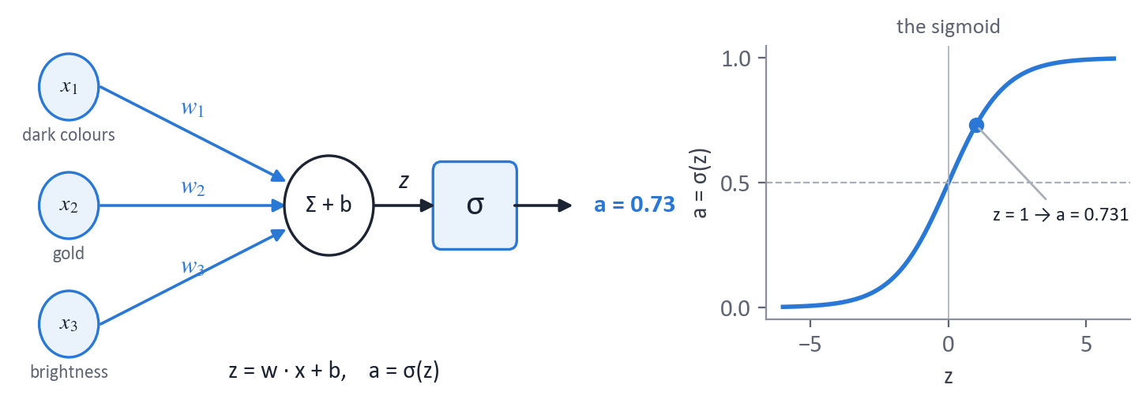
THE MATHS
z = w · x + b (weighted sum)
a = σ(z) = 1 / (1 + e^(−z))
σ(0) = 0.5, σ(large z) → 1, σ(very negative z) → 0
decide class 1 if a > 0.5, that is if w · x + b > 0: a straight line
WORKED EXAMPLE
x = 2, w = 0.5, b = 0 → z = 1 → a = σ(1) = 0.731
IN PYTORCH
a = torch.sigmoid(w * x + b)
IN OUR PROJECT Our broken run with 8 sigmoid layers could not learn (see the vanishing gradient). For our 5 styles we use the softmax, the multi-class cousin of the sigmoid.
REMEMBER One neuron draws one straight boundary. To draw curves, we need hidden layers (session 3).

2. The log loss (binary cross-entropy)
IN ONE LINE The error of a probability: small when the neuron is confident and right, huge when it is confident and wrong.
EXAMPLE A forecaster who said "90 % sun" on a rainy day should be punished much more than one who said "50 %".
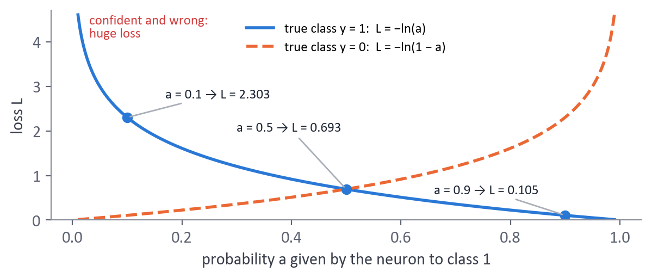
THE MATHS
L = −[ y · ln(a) + (1 − y) · ln(1 − a) ]
only one term is active: y = 1 → L = −ln(a); y = 0 → L = −ln(1 − a)
cost J = mean of L over the m examples (it comes from maximising the likelihood)
why not the squared error? with a sigmoid its gradient has a factor a(1 − a) ≈ 0 when very wrong
WORKED EXAMPLE
y = 1: a = 0.9 → L = 0.105; a = 0.5 → L = 0.693; a = 0.1 → L = 2.303
y = 1, a = 0.01: squared-error gradient factor −0.0196, log loss −0.99: 50 times more correction
IN PYTORCH
loss_fn = nn.BCEWithLogitsLoss() # takes the raw z: more stable
IN OUR PROJECT Our loss for 5 styles is the same idea: L = −ln(probability of the right style).
REMEMBER Confident and wrong costs a lot. With a sigmoid output, use the log loss, not the squared error.

3. The gradient (a − y) x
IN ONE LINE How much, and in which direction, to change each weight to reduce the log loss.
EXAMPLE The neuron said 0.73 for a true Baroque painting (y = 1): it was 0.27 too low, so the weights of the clues that were present get pushed up.
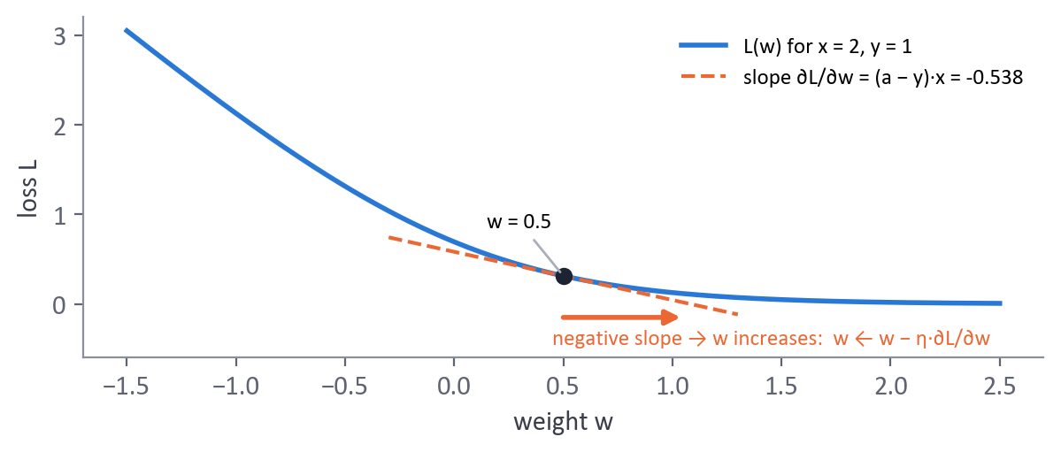
THE MATHS
chain rule: ∂L/∂w = ∂L/∂a · ∂a/∂z · ∂z/∂w
∂L/∂a = −y/a + (1 − y)/(1 − a), ∂a/∂z = a(1 − a), ∂z/∂w = x
everything simplifies: ∂L/∂z = a − y, so ∂L/∂w = (a − y) · x, ∂L/∂b = a − y
update (gradient descent): w ← w − η · (a − y) · x
WORKED EXAMPLE
a = 0.731, y = 1, x = 2 → ∂L/∂w = (0.731 − 1) × 2 = −0.538
with η = 0.1: w = 0.5 − 0.1 × (−0.538) = 0.554
IN PYTORCH
loss.backward() # w.grad now holds −0.538
IN OUR PROJECT Softmax + cross-entropy gives exactly the same form: ∂L/∂z = p − y (see the losses card).
REMEMBER Error × input. A big error or a big input gives a big correction; a correct prediction gives none.

4. From NumPy to PyTorch
IN ONE LINE First write the maths by hand with arrays (NumPy), then let PyTorch do the same with tensors and automatic gradients.
EXAMPLE Like doing long division by hand before using a calculator: you know exactly what the calculator does.
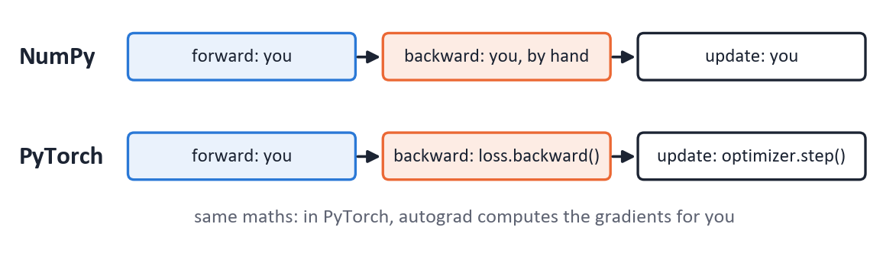
THE MATHS
vectorised over m examples (X of shape (n, m)), no Python loop:
Z = wᵀX + b, A = σ(Z)
dZ = A − Y, dw = (1/m) · X · dZᵀ, db = (1/m) · Σ dZ
WORKED EXAMPLE
the hand-made gradient and the autograd gradient must be equal: check it once on a small example
IN PYTORCH
A = 1 / (1 + np.exp(-(w.T @ X + b))) # NumPy
loss = loss_fn(model(X), Y); loss.backward(); optimizer.step() # PyTorch
IN OUR PROJECT The brief asks for networks built from PyTorch primitives: nn.Linear and our own training loop, no magic library.
REMEMBER PyTorch = NumPy + automatic gradients (+ GPU). Vectorise: one matrix product instead of a loop.

Session 3 · A network and backpropagation
What we built: A network, backpropagation by hand, autograd
Its limit, fixed next: we need a clean pipeline

5. A neural network (MLP)
IN ONE LINE Layers of neurons: each layer transforms the output of the previous one, with a non-linear activation in between.
EXAMPLE XOR (true when exactly one input is true) cannot be separated by one straight line. Two hidden neurons each draw a line, and the output neuron combines them.
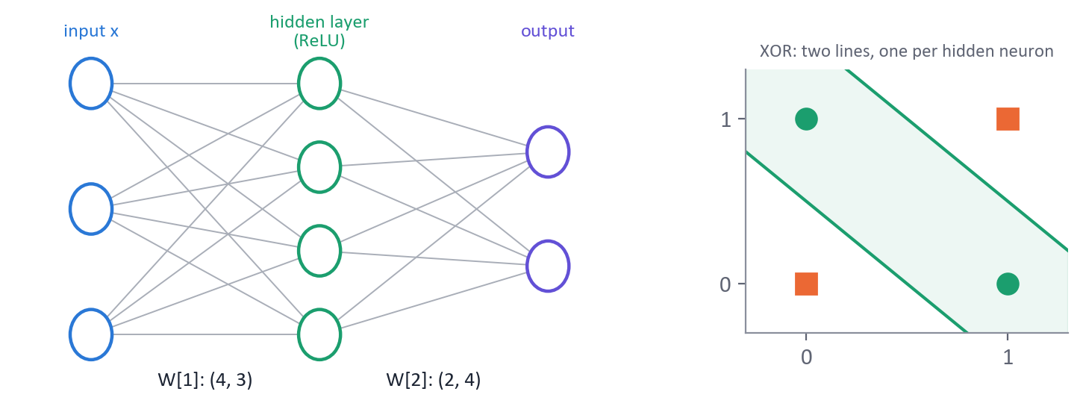
THE MATHS
layer l: z[l] = W[l] · a[l−1] + b[l], a[l] = g(z[l]), with a[0] = x
shapes: W[l] is (n[l], n[l−1]), b[l] is (n[l], 1)
without g, two layers collapse into one: W2 (W1 x) = (W2 W1) x
parameters of a dense layer: n_in × n_out + n_out
WORKED EXAMPLE
28 × 28 image → 784 inputs → 128 hidden → 10 outputs
W[1]: (128, 784) = 100 352 weights + 128 biases; W[2]: (10, 128) = 1 280 + 10; total 101 770
IN PYTORCH
nn.Sequential(nn.Flatten(), nn.Linear(784, 128), nn.ReLU(), nn.Linear(128, 10))
IN OUR PROJECT Our MLP: 12 288 pixels → 512 → 256 → 5, 6.4 million parameters: it learned the paintings by heart (99.7 % train, 40.6 % validation).
REMEMBER The non-linear activation is what makes depth useful.

6. Backpropagation by hand
IN ONE LINE The chain rule applied from the output back to the input, to get the gradient of the loss for every weight in one backward pass.
EXAMPLE After a wrong answer, the blame travels back through the network: each layer receives its share, in proportion to its contribution.
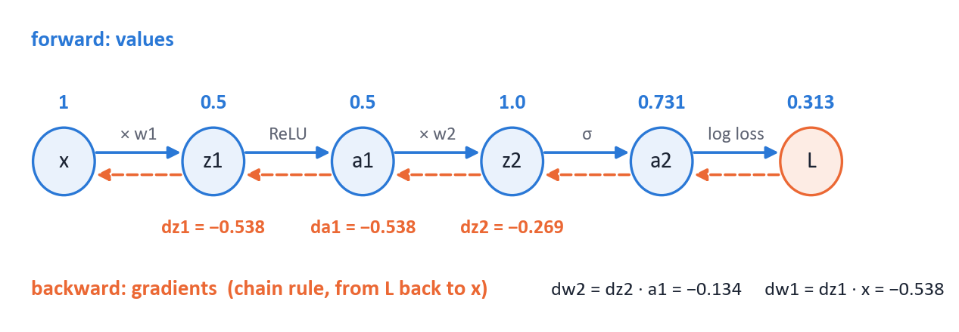
THE MATHS
output layer (sigmoid + log loss): dz[L] = a[L] − y
every layer: dW[l] = dz[l] · a[l−1]ᵀ, db[l] = dz[l]
one layer back: da[l−1] = W[l]ᵀ · dz[l], dz[l−1] = da[l−1] ⊙ g′(z[l−1])
⊙ = element by element
WORKED EXAMPLE
x = 1 → hidden ReLU (w1 = 0.5) → output sigmoid (w2 = 2), y = 1
forward: z1 = 0.5, a1 = 0.5, z2 = 1, a2 = 0.731, L = 0.313
backward: dz2 = −0.269, dw2 = dz2 · a1 = −0.134, da1 = w2 · dz2 = −0.538, dz1 = −0.538 (ReLU slope 1), dw1 = dz1 · x = −0.538
IN PYTORCH
loss.backward() # gives exactly dw1 = −0.538 and dw2 = −0.134
IN OUR PROJECT The gradient per layer is one of our monitoring tools: it revealed the vanishing gradient of the sigmoid network (6 × 10⁻⁷).
REMEMBER Error of the layer × its input. On the way back, the gradient is multiplied by g′ at every layer.

7. Autograd
IN ONE LINE PyTorch records every operation on tensors and computes all the gradients automatically with .backward().
EXAMPLE A cashier who keeps every receipt: at the end of the day, he can trace exactly where each euro came from.
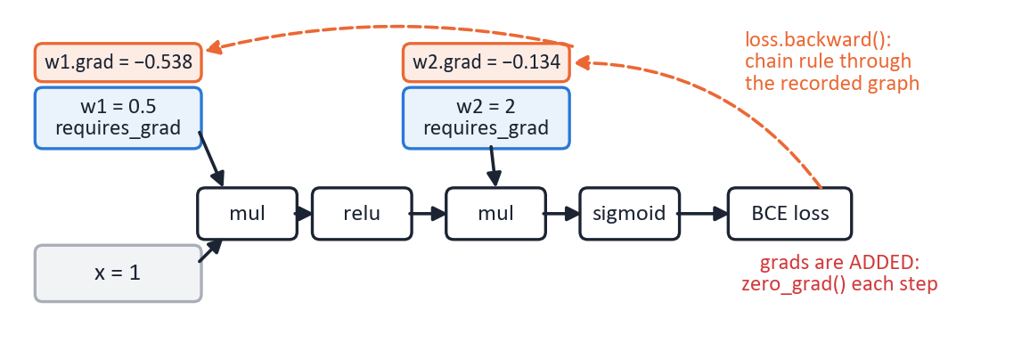
THE MATHS
forward: PyTorch builds a computation graph; each node knows its local derivative
backward: chain rule from the loss to every tensor with requires_grad = True
gradients are ADDED into .grad, hence zero_grad() before each step
WORKED EXAMPLE
on the network of the previous card, autograd gives dw1 = −0.538 and dw2 = −0.134: the hand values
IN PYTORCH
w = torch.tensor(0.5, requires_grad=True)
loss.backward(); print(w.grad)
with torch.no_grad(): ... # evaluation, no graph
IN OUR PROJECT Our broken run "zero_grad forgotten": the gradients piled up, 26 times bigger after 2 epochs. Frozen layers have requires_grad = False: no gradient, no change.
REMEMBER backward() adds to .grad: always zero_grad(). requires_grad = False freezes a layer.

Session 4 · PyTorch in depth
What we built: Tensors, modules, losses, optimisers, the training loop
Its limit, fixed next: deep sigmoid networks do not learn

8. Tensors
IN ONE LINE Multi-dimensional arrays of numbers, the basic object of PyTorch: inputs, outputs and weights are all tensors.
EXAMPLE A number, a list, a spreadsheet, a pile of spreadsheets (a colour image), a box of piles (a batch of images).
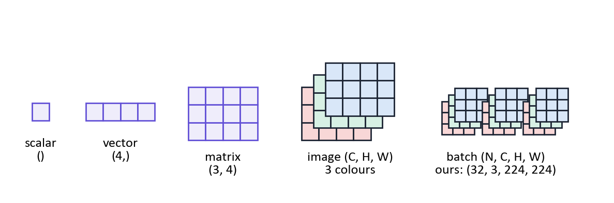
THE MATHS
shape: scalar (), vector (n,), matrix (m, n), image (C, H, W), batch (N, C, H, W)
dtype: uint8 for raw pixels, float32 for the maths, int64 for class labels
broadcasting: a (1, 3, 1, 1) tensor of means is stretched over a (N, 3, H, W) batch
WORKED EXAMPLE
one batch of our paintings: (32, 3, 224, 224) = 4 816 896 numbers, 19.3 MB in float32
IN PYTORCH
x.shape, x.float() / 255, x.flatten(1), x.to("cuda")
IN OUR PROJECT ResNet features (1 061, 512); logits (32, 5); labels (32,) in int64.
REMEMBER Most bugs are shape bugs: print .shape. CrossEntropyLoss wants int64 class numbers, not one-hot vectors.

9. Modules (nn.Module, nn.Linear, nn.Sequential)
IN ONE LINE The building blocks of a network: each module holds its weights and defines its forward computation.
EXAMPLE Lego bricks: nn.Linear, nn.ReLU, nn.Conv2d are bricks; nn.Sequential snaps them together in order.
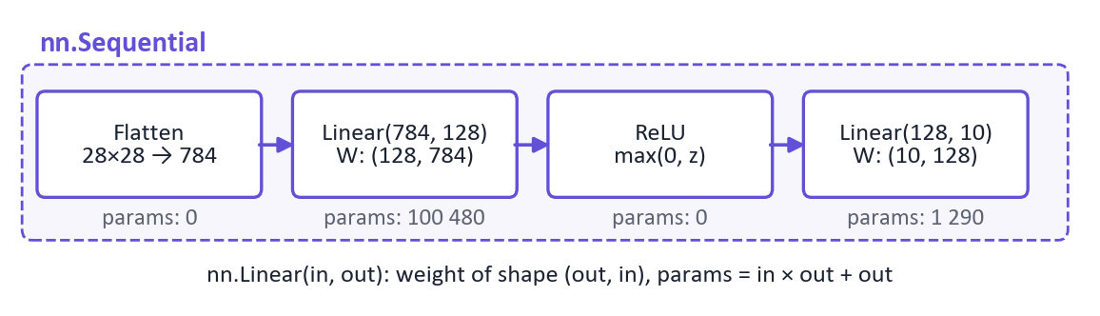
THE MATHS
nn.Linear(n_in, n_out): y = x · Wᵀ + b, W of shape (n_out, n_in), b of shape (n_out,)
parameters = n_in × n_out + n_out
model.parameters() lists every weight for the optimiser
model.train() / model.eval() switch dropout and batch norm on and off
WORKED EXAMPLE
nn.Linear(512, 5): W (5, 512) + b (5) = 2 565 parameters: our head on top of the ResNet
IN PYTORCH
class Net(nn.Module):
def __init__(self): super().__init__(); self.fc = nn.Linear(512, 5)
def forward(self, x): return self.fc(x)
IN OUR PROJECT Our MLP is an nn.Sequential of nn.Linear; our ResNetClassifier replaces ResNet's last layer by nn.Linear(512, 5).
REMEMBER Weight shape is (out, in). Call model.eval() before predicting.

10. Losses: softmax and cross-entropy
IN ONE LINE For C exclusive classes, the softmax turns the raw scores (logits) into probabilities, and the cross-entropy punishes a low probability on the right class.
EXAMPLE Betting 100 chips on 5 styles: all chips on the right one costs nothing; spread evenly costs ln 5; all on a wrong one costs a lot.
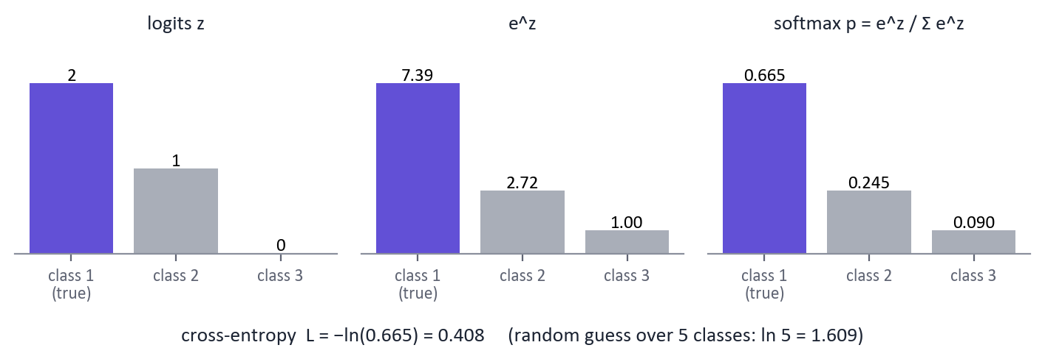
THE MATHS
softmax: p_k = e^(z_k) / Σ_j e^(z_j) (all positive, sum = 1)
cross-entropy: L = −ln(p_true)
gradient: ∂L/∂z_k = p_k − y_k (y one-hot): the same "prediction − truth" as session 2
random guess over C classes: L = ln C (ln 5 = 1.609)
WORKED EXAMPLE
logits (2, 1, 0) → p = (0.665, 0.245, 0.090)
true class = the first: L = −ln 0.665 = 0.408; gradient (−0.335, 0.245, 0.090)
IN PYTORCH
loss = nn.CrossEntropyLoss()(logits, labels) # softmax inside: no softmax in the model
IN OUR PROJECT First-loss check: our MLP started at 1.99, too confident; scaling its last layer by 0.1 gave 1.59 ≈ ln 5.
REMEMBER Give raw logits to CrossEntropyLoss. A loss stuck at ln C means the network guesses at random.

11. Optimisers and the training loop
IN ONE LINE The optimiser moves every weight a small step against its gradient; the training loop repeats predict, measure, backpropagate, update.
EXAMPLE Walking down a mountain in the fog: feel the slope (the gradient), take a step (the learning rate), repeat.
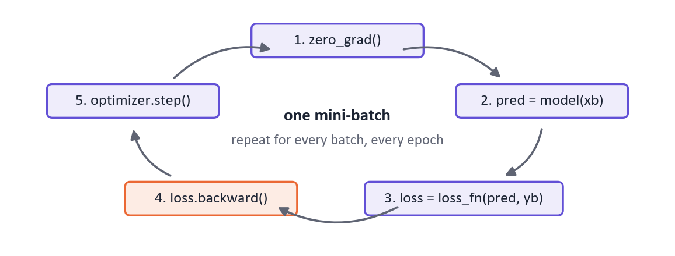
THE MATHS
gradient descent: w ← w − η · ∂L/∂w
stochastic (mini-batch): the gradient is computed on a batch (e.g. 64 images): faster, a bit noisy
one epoch = one pass over all the training images
η too large: jumps over the valley (nan); η too small: crawls
WORKED EXAMPLE
w = 0.5, gradient −0.538, η = 0.1 → w = 0.554
our MLP: 1 061 images / batches of 64 = 17 steps per epoch
IN PYTORCH
optimizer.zero_grad() # 1. forget the old gradients
pred = model(xb) # 2. forward
loss = loss_fn(pred, yb) # 3. loss
loss.backward() # 4. gradients
optimizer.step() # 5. update
IN OUR PROJECT Learning-rate sweep: 8 values tried, 0.0001 kept. Adam at 0.01 killed 99.6 % of the neurons of layer 2.
REMEMBER zero_grad, forward, loss, backward, step. Evaluate with model.eval() and torch.no_grad().

Session 5 · Activations and the vanishing gradient
What we built: ReLU and other activations, vanishing gradient
Its limit, fixed next: big networks overfit

12. ReLU
IN ONE LINE The default activation of hidden layers: it keeps positive values and sets negative ones to 0.
EXAMPLE A one-way valve on a water pipe: positive flow passes unchanged, negative flow is blocked.
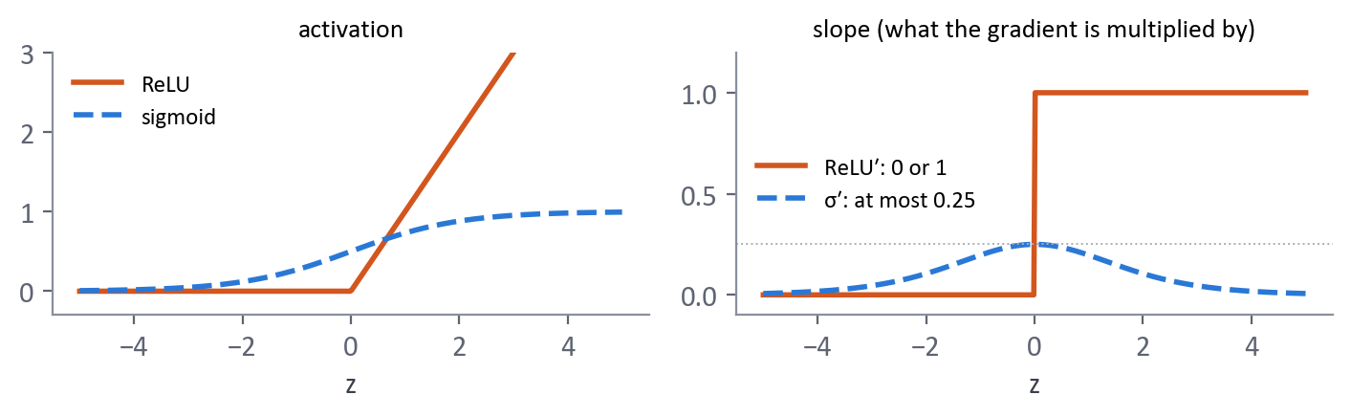
THE MATHS
ReLU(z) = max(0, z)
ReLU′(z) = 1 if z > 0, 0 if z < 0
on an active path the derivative is exactly 1: the gradient does not shrink with depth
sigmoid instead: σ′(z) = σ(z)(1 − σ(z)) ≤ 1/4
still non-linear (the kink at 0), and cheap (no exponential)
WORKED EXAMPLE
z = (−2, 0.5, 3) → ReLU = (0, 0.5, 3), slopes = (0, 1, 1)
IN PYTORCH
nn.ReLU() or torch.relu(z)
IN OUR PROJECT Dead ReLUs: a learning rate too large killed 99.6 % of layer 2; with 0.0001, only 4 % were dead.
REMEMBER A ReLU that outputs 0 for every input is dead: zero gradient forever. Causes: a learning rate too large, a bad initialisation.

13. The vanishing gradient
IN ONE LINE In a deep network the gradient shrinks layer after layer on its way back, so the first layers stop learning.
EXAMPLE The whisper game: each person passes the message on a bit more quietly, and the first in the line hears nothing.
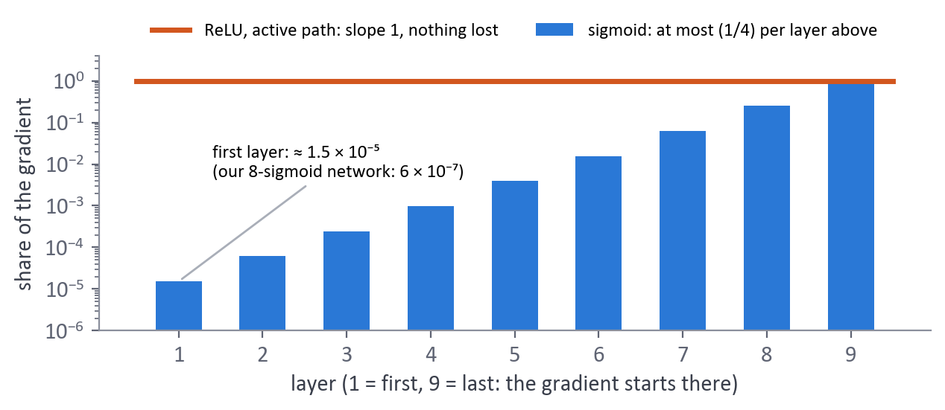
THE MATHS
the gradient reaching layer 1 contains one factor g′(z) per layer (chain rule)
sigmoid: g′ ≤ 1/4, so 8 layers give at most (1/4)⁸ ≈ 1.5 × 10⁻⁵
fixes: ReLU (g′ = 1 when active), He initialisation, batch norm, residual shortcuts (ResNet)
WORKED EXAMPLE
our 8-sigmoid network: gradient of layer 1 / layer 9 = 2.7 × 10⁻⁶ / 4.3 ≈ 6 × 10⁻⁷
loss stuck at ln 5 = 1.609: the network guesses at random
IN PYTORCH
for name, p in model.named_parameters(): print(name, p.grad.norm()) # after backward()
IN OUR PROJECT ReLU + He initialisation brought the ratio to 0.17, and the network learned (39.3 %).
REMEMBER Loss stuck at ln C + tiny gradients in the first layers = vanishing gradient. Dead ReLUs give the same loss: the gradient per layer tells them apart.

Session 6 · Better training
What we built: Weight decay, dropout, early stopping, batch norm, momentum, Adam, diagnosis
Its limit, fixed next: dense layers ignore the structure of images

14. Weight decay (L2 regularisation)
IN ONE LINE A penalty on large weights: at every step each weight shrinks a little, so only the useful weights stay large.
EXAMPLE A tax on big weights: a weight must "earn" its size by really reducing the error.
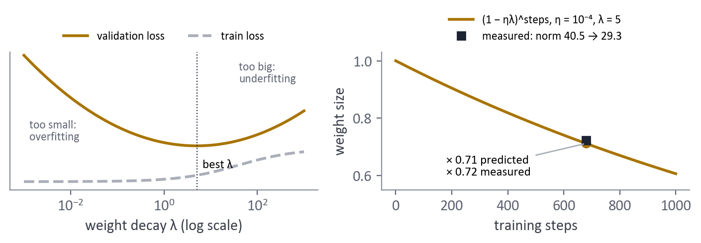
THE MATHS
J_reg = J + (λ/2) · Σ w²
gradient: ∂J/∂w + λ · w
update: w ← (1 − ηλ) · w − η · ∂J/∂w (the weight first decays towards 0)
AdamW applies the decay directly to the weights (decoupled): the right version with Adam
choose λ on validation: too small overfits, too large underfits (U-shaped validation loss)
WORKED EXAMPLE
our MLP: η = 0.0001, λ = 5 → each step multiplies the weights by 0.9995
680 steps → × 0.71 predicted; measured weight norm 40.5 → 29.3 (× 0.72)
IN PYTORCH
torch.optim.AdamW(model.parameters(), lr=1e-4, weight_decay=5)
IN OUR PROJECT Alone: 38.8 % → 39.7 % on validation. Combined with the other tools: 45.5 %.
REMEMBER Read λ together with η: the shrink per step is η × λ.

15. Dropout
IN ONE LINE During training, switch off each neuron at random with probability p, so the network cannot rely on a few neurons.
EXAMPLE A team where half of the players are absent each day, at random: everyone must learn to be useful; on match day the full team is stronger.
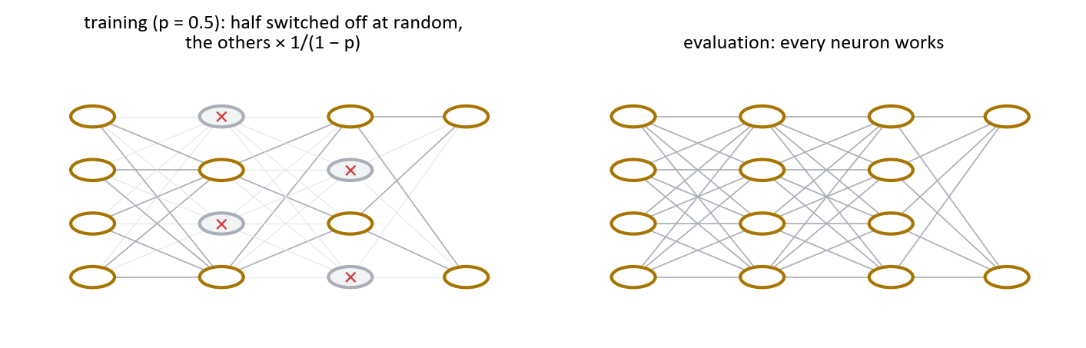
THE MATHS
mask mᵢ ∈ {0, 1}, P(mᵢ = 1) = 1 − p
training: ãᵢ = mᵢ · aᵢ / (1 − p) (inverted dropout)
on average E[ãᵢ] = aᵢ: the next layer gets the same signal in training and at test time
evaluation: ãᵢ = aᵢ, nothing is switched off
another view: it trains many sub-networks and averages them
WORKED EXAMPLE
p = 0.5, a = (2, 4, 6, 8), mask (1, 0, 1, 0) → ã = (4, 0, 12, 0)
averaged over many random masks: (2, 4, 6, 8)
IN PYTORCH
nn.Dropout(0.5) # active in model.train(), off in model.eval()
IN OUR PROJECT Dropout 0.5 (0.2 on the inputs): gap train − validation 0.61 → 0.38, validation 38.8 % → 41.7 %.
REMEMBER Dropout acts only during training. Forgetting model.eval() gives random, worse predictions.

16. Early stopping
IN ONE LINE Stop training when the validation loss stops improving, and keep the weights of the best epoch.
EXAMPLE A student stops revising when the mock-exam grades stop rising, instead of learning the answer sheets by heart.
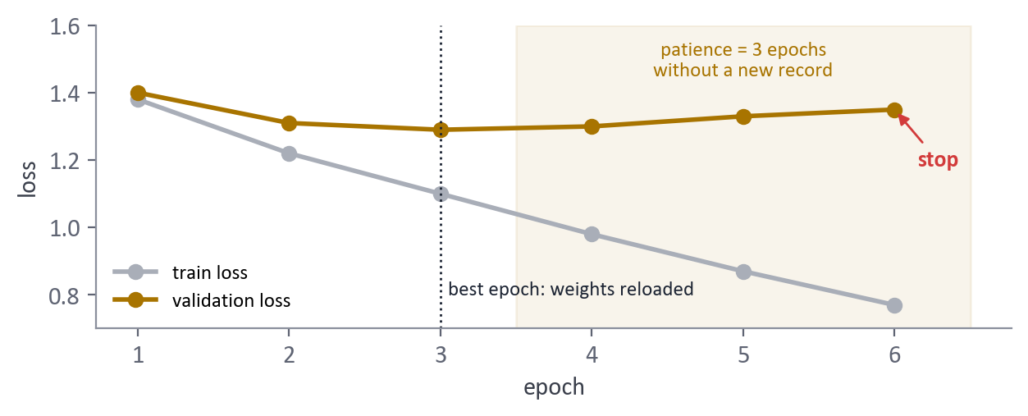
THE MATHS
after each epoch: if the validation loss beats its record, save the weights and reset the counter
otherwise add 1 to the counter; stop when it reaches the patience k
reload the best weights
watch the validation loss: finer than the accuracy
WORKED EXAMPLE
patience 3, validation losses 1.40, 1.31, 1.29, 1.30, 1.33, 1.35
→ best epoch 3, stop after epoch 6, reload the weights of epoch 3
IN PYTORCH
history = fit(model, optimizer, loaders, 100, patience=5) # our fit() keeps the best state_dict
IN OUR PROJECT Alone: stopped after 13 epochs (1.8 s), gap 0.61 → 0.27. Our plain MLP's validation loss rose after epoch 3.
REMEMBER Stop on the validation loss, never on the test. If both curves still go down, train longer.

17. Batch normalisation
IN ONE LINE Re-centre and re-scale each neuron on every mini-batch, then let the network learn its own scale.
EXAMPLE Grades from teachers who mark out of 20 or out of 100: put them on the same scale before comparing them.
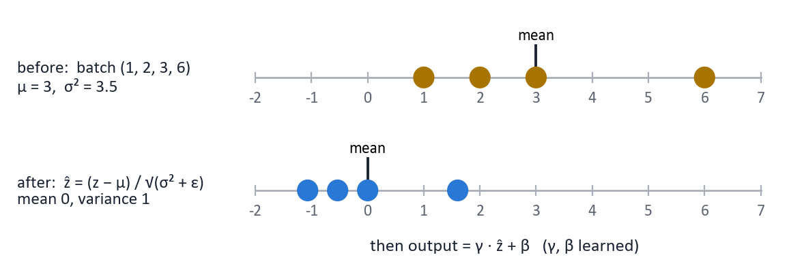
THE MATHS
over a mini-batch z⁽¹⁾ … z⁽ᵐ⁾ of one neuron: μ_B = mean, σ²_B = variance
ẑ = (z − μ_B) / √(σ²_B + ε) (mean 0, variance 1)
output = γ · ẑ + β (γ, β learned, one pair per neuron)
placed Linear → BatchNorm → ReLU
evaluation: running averages of μ and σ², not the batch
WORKED EXAMPLE
batch (1, 2, 3, 6): μ = 3, σ² = 3.5 → ẑ = (−1.07, −0.53, 0, 1.60)
IN PYTORCH
nn.BatchNorm1d(256) # dense layers
nn.BatchNorm2d(64) # convolutions
IN OUR PROJECT Forgetting model.eval() when extracting the ResNet features: batches of mostly one style erased the style, 12.8 % instead of 88.1 %. Alone on the MLP: best validation loss (1.350).
REMEMBER Faster, more stable training that tolerates larger learning rates. Always model.eval() at test time.

18. Momentum and Adam
IN ONE LINE Momentum averages the recent gradients to keep a direction; Adam adds a step size adapted to each weight.
EXAMPLE Momentum: a ball rolling downhill keeps its speed and ignores small bumps. Adam: a hiker who adapts his stride, small on steep ground, large on flat ground.
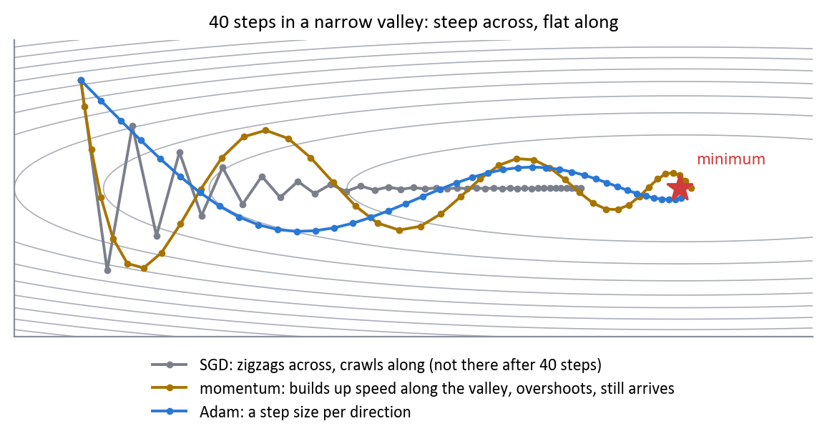
THE MATHS
momentum (PyTorch): v ← β · v + g, w ← w − η · v (β = 0.9: up to 10 × bigger steps in a steady direction)
Adam: m ← β₁ · m + (1 − β₁) · g (average gradient: the momentum)
s ← β₂ · s + (1 − β₂) · g² (average squared gradient: its typical size)
bias correction: m̂ = m / (1 − β₁^t), ŝ = s / (1 − β₂^t)
w ← w − η · m̂ / (√ŝ + ε) defaults η = 10⁻³, β₁ = 0.9, β₂ = 0.999, ε = 10⁻⁸
WORKED EXAMPLE
first Adam step, η = 0.001: gradient 0.5 → m̂ = 0.5, ŝ = 0.25, step = 0.001
gradient 50 → m̂ = 50, ŝ = 2 500, step = 0.001: every weight moves by about η, whatever its gradient
IN PYTORCH
torch.optim.SGD(model.parameters(), lr=0.1, momentum=0.9)
torch.optim.Adam(model.parameters(), lr=1e-3) # or AdamW, with weight decay
IN OUR PROJECT AdamW everywhere. Because Adam moves every weight by about η, Adam at 0.01 pushed every ReLU of layer 2 below 0 (99.6 % dead).
REMEMBER Adam = momentum + a step per weight (ADAptive Moment estimation). Less tuning, but the learning rate still matters.

19. Diagnosing a training run
IN ONE LINE Go from a measured symptom to a likely cause, then change one thing and measure again.
EXAMPLE A doctor: the same fever can come from different illnesses; the right test tells them apart.
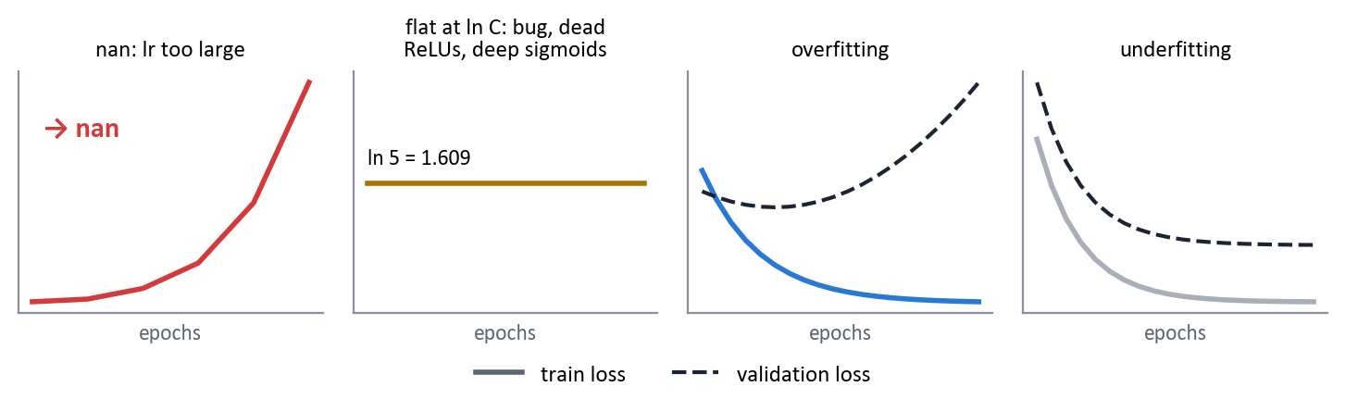
THE MATHS
loss huge, then nan → learning rate too large, exploding gradients → divide η by 10, normalise the inputs
loss flat at ln C → a bug (no step, no zero_grad), dead ReLUs, deep sigmoids → overfit one small batch, ReLU + He, batch norm
train down, validation up → overfitting → more data, weight decay, dropout, early stopping
both high and close → underfitting → bigger model, train longer, less regularisation
very noisy loss → η too large for the end → a learning-rate schedule
WORKED EXAMPLE
checklist: first loss ≈ ln C; one batch learned by heart; gradient per layer; share of dead neurons; train and validation curves
IN PYTORCH
evaluate(model, loaders.train_eval, loss_fn); evaluate(model, loaders.val, loss_fn) # both in eval mode
IN OUR PROJECT Our MLP: 99.7 % train, 40.6 % validation, with healthy gradients (4 % dead): overfitting, not a bug. The session 6 tools gave 45.5 % and a gap of 0.12.
REMEMBER The loss alone is not enough: a learning rate too large and 8 sigmoid layers both give a loss stuck at ln 5.

Session 7 · Convolutional networks
What we built: Convolution, pooling, receptive field, ResNet, transfer learning
Its limit, fixed next: fixed-size inputs, no notion of order

20. Convolution
IN ONE LINE A small learned filter slides over the image and computes a weighted sum at each position: a map of where a pattern appears.
EXAMPLE A small magnifying glass moved over the whole painting, always asking the same question: "is there a vertical edge here?".
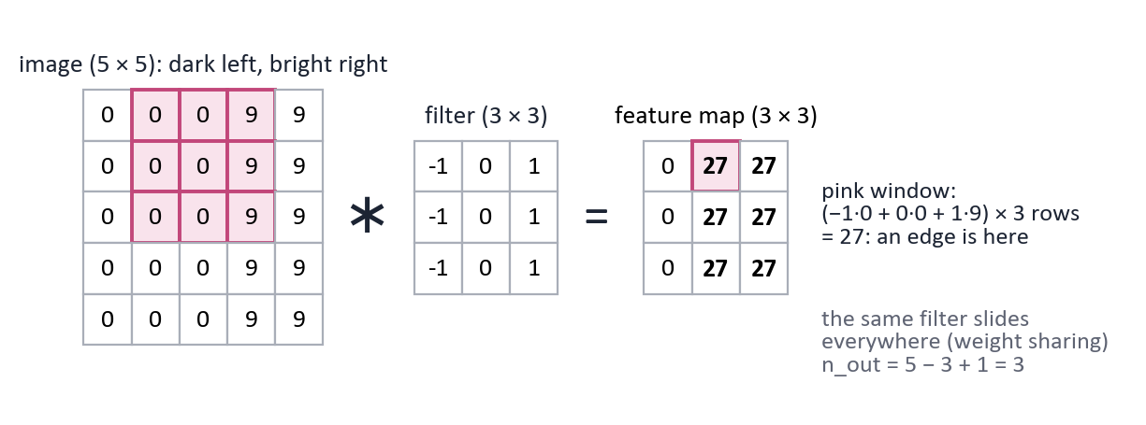
THE MATHS
Y[i, j] = Σ_u Σ_v K[u, v] · X[i + u, j + v] (+ a bias)
output size: n_out = ⌊(n + 2p − k) / s⌋ + 1 (k kernel, p padding, s stride)
parameters: c_out × (c_in × k × k + 1), whatever the size of the image
receptive field (input area one output sees): r ← r + (k − 1) · j, j ← j · s
the same filter everywhere (weight sharing) + local connections
WORKED EXAMPLE
28 × 28 image, 3 × 3 filter: no padding → 26 × 26; p = 1 → 28 × 28; p = 1, s = 2 → 14 × 14
16 filters on 1 channel: 16 × (9 + 1) = 160 parameters; three 3 × 3 layers see 7 × 7
edge filter (−1 0 1 on each row) on a patch dark-left / bright-right (0 0 9) → 27; on a flat patch → 0
IN PYTORCH
nn.Conv2d(1, 16, kernel_size=3, padding=1)
IN OUR PROJECT ResNet18's first layer: 64 filters of 7 × 7 × 3 = 9 408 weights, against 1 573 376 for the first layer of our MLP on 32 × 32 images.
REMEMBER A dense layer ignores neighbours and positions; a convolution looks at neighbours and finds a pattern anywhere, with few weights.

21. Pooling
IN ONE LINE Shrink a feature map by summarising each small window, usually by its maximum.
EXAMPLE Summarising a city map by keeping, in each district, only the tallest building: you lose details but keep "is there something tall here".
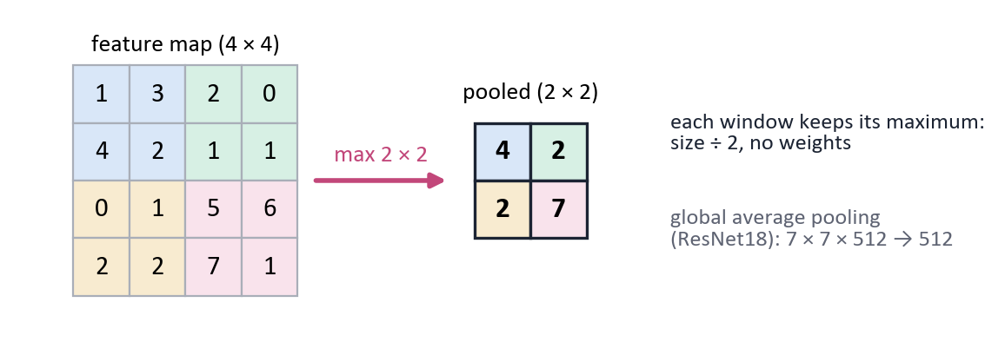
THE MATHS
max pooling 2 × 2, stride 2: each 2 × 2 window → its maximum; the size is divided by 2
no weights to learn
global average pooling: one mean per channel (H × W → 1)
same output-size formula as a convolution
tolerance to small shifts, and a larger receptive field
WORKED EXAMPLE
(1 3 2 0 / 4 2 1 1 / 0 1 5 6 / 2 2 7 1) → max pool (4 2 / 2 7); average pool (2.5 1 / 1.25 4.75)
IN PYTORCH
nn.MaxPool2d(2) nn.AdaptiveAvgPool2d(1)
IN OUR PROJECT ResNet18 ends with a global average pooling: 7 × 7 × 512 → 512 numbers per painting, the input of our head.
REMEMBER Pooling has no weights. Each pooling halves the size, so the number of filters usually doubles after it.

22. ResNet
IN ONE LINE A very deep CNN whose blocks add their input back to their output (a shortcut), so the gradient can always flow.
EXAMPLE A building with a lift next to the stairs: information can go up and down without climbing every floor.
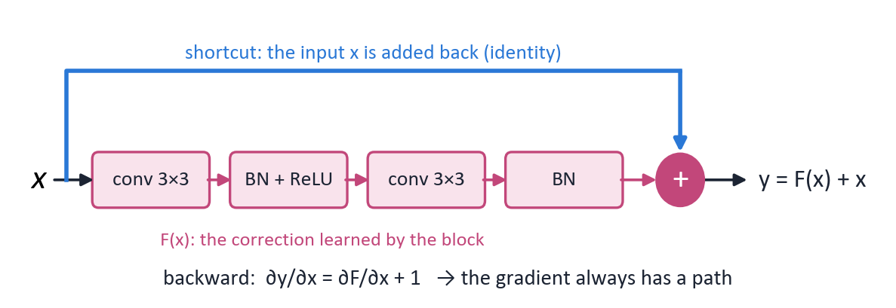
THE MATHS
residual block: y = F(x) + x, F = conv 3×3 → BN → ReLU → conv 3×3 → BN
backward: ∂y/∂x = ∂F/∂x + 1: the "+ 1" keeps the gradient alive
each block only learns a correction to its input
ResNet18 = conv1 + 8 blocks × 2 convolutions + the last layer = 18 layers; 64 → 128 → 256 → 512 filters
WORKED EXAMPLE
if each block's own derivative is 0.01: 8 blocks without shortcut → 0.01⁸ = 10⁻¹⁶; with it → 1.01⁸ ≈ 1.08
IN PYTORCH
torchvision.models.resnet18(weights="IMAGENET1K_V1")
IN OUR PROJECT ResNet18 (11 M weights, 45 MB, 53 ms per photo on one CPU thread) found 71 % of the Cubist paintings, against 7 % for our MLP.
REMEMBER Res = residual = shortcut. The 18 is the number of layers with weights, not the number of filters.

23. Transfer learning
IN ONE LINE Reuse a network trained on a huge dataset, and only adapt its last part to our small dataset.
EXAMPLE Hiring an experienced art expert and teaching them our five style names, instead of teaching a newborn to see.
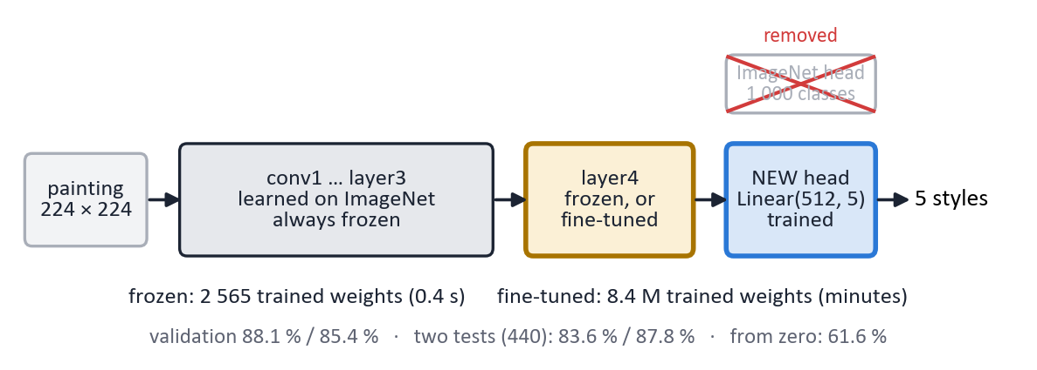
THE MATHS
start from ResNet18 trained on ImageNet (1.2 million photos)
remove its last layer (1 000 classes), add ours: nn.Linear(512, 5)
frozen (linear probe): requires_grad = False except our layer → 2 565 trained weights
fine-tuned: also unfreeze the last block (layer4), small η = 10⁻⁴ → 8.4 M trained weights
keep the ImageNet normalisation, and eval mode for the frozen parts
WORKED EXAMPLE
validation: frozen 88.1 %, fine-tuned 85.4 %
two tests, 440 new paintings: fine-tuned 87.8 %, frozen 83.6 %
same ResNet18 from zero (random weights): 61.6 % on validation
IN PYTORCH
for p in model.parameters(): p.requires_grad = False
model.fc = nn.Linear(512, 5) # new layer: trainable
IN OUR PROJECT Our choice: ResNet18 with its first layers frozen and its last block fine-tuned.
REMEMBER With little data: pretrained, frozen first, then fine-tune the last block. Never retrain everything from zero.

Session 8 · Sequences and attention
What we built: RNN, LSTM, attention, sentence embeddings
Its limit, fixed next: sequential: transformers come next

24. Recurrent neural network (RNN)
IN ONE LINE A network for sequences: it reads one step at a time and keeps a hidden state, a memory updated with the same weights at every step.
EXAMPLE Reading a book word by word while keeping a summary in your head, updated after each word.
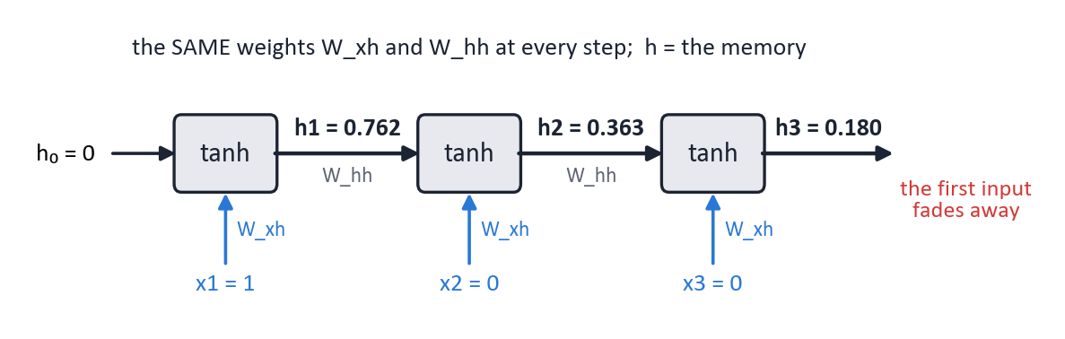
THE MATHS
h_t = tanh(W_xh · x_t + W_hh · h_(t−1) + b)
the same W_xh and W_hh at every step: any sequence length
backpropagation through time (scalar case): ∂h_T/∂h_0 = Π_t w · (1 − h_t²)
parameters per block: H × n_in + H × H + 2H (PyTorch keeps two biases)
WORKED EXAMPLE
scalar cell, w = 0.5, inputs (1, 0, 0), h_0 = 0 → h = 0.762, 0.363, 0.180: the first input fades
over 20 steps with w = 0.5 the gradient falls below 0.5²⁰ ≈ 10⁻⁶
IN PYTORCH
nn.RNN(n_in, H, batch_first=True)
IN OUR PROJECT Not used: a painting is an image, not a sequence. Visitors' questions (part 2 of the brief) would need a sequence model.
REMEMBER A vanishing gradient through time: an RNN forgets what happened long ago.

25. LSTM
IN ONE LINE An RNN cell with a separate memory line (the cell state) and gates that decide what to forget, what to write and what to output.
EXAMPLE A notebook next to your short-term memory: you decide what to erase, what to write down and what to read out.
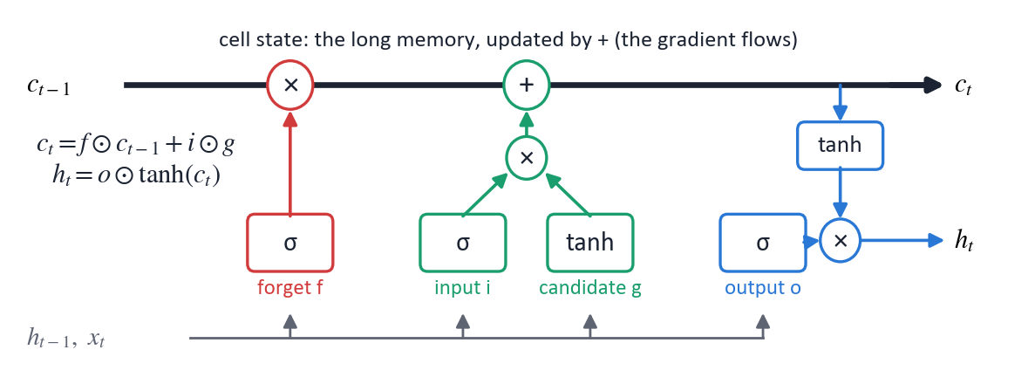
THE MATHS
gates (sigmoid, between 0 and 1): forget f, input i, output o; candidate g = tanh(…)
c_t = f ⊙ c_(t−1) + i ⊙ g
h_t = o ⊙ tanh(c_t)
the cell state is updated by addition: ∂c_t/∂c_(t−1) = f ≈ 1 when the network keeps a memory
4 blocks (i, f, g, o): 4 times the parameters of an RNN
WORKED EXAMPLE
n_in = 8, H = 32: RNN 1 344 parameters; LSTM 4 × 1 344 = 5 376 (checked with PyTorch)
IN PYTORCH
out, (h_n, c_n) = nn.LSTM(n_in, H, batch_first=True)(x)
IN OUR PROJECT In TP08's memory task, the LSTM carries a token over many steps where the plain RNN fails.
REMEMBER An additive cell state and a forget gate give a long memory. Sigmoid and tanh are still used here, inside the gates.

26. Attention
IN ONE LINE Instead of squeezing everything into one memory, each output looks back at all the inputs and takes a weighted mix of the most relevant ones.
EXAMPLE Translating a sentence: for each word you write, you glance back at the words of the original that matter for it.
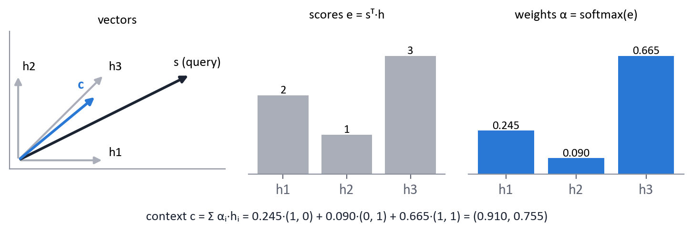
THE MATHS
scores: e_i = sᵀ · h_i (similarity between the current state s and each input h_i)
weights: α = softmax(e) (positive, sum to 1)
context: c = Σ_i α_i · h_i
transformer: Attention(Q, K, V) = softmax(Q · Kᵀ / √d) · V (√d keeps the scores reasonable)
WORKED EXAMPLE
course exercise: h1 = (1, 0), h2 = (0, 1), h3 = (1, 1), s = (2, 1)
e = (2, 1, 3) → α = (0.245, 0.090, 0.665) → c = (0.910, 0.755)
IN PYTORCH
F.scaled_dot_product_attention(Q, K, V)
IN OUR PROJECT The transformers of our bonus (ViT, CLIP) are built on attention; CLIP reached 94.7 % on validation, but has probably seen WikiArt.
REMEMBER Attention = similarity scores → softmax → weighted average. Transformers stack it and drop the recurrence.

27. Embeddings
IN ONE LINE Vectors of numbers that represent words, sentences or images, so that similar meanings get close vectors.
EXAMPLE "ocean" and "wave" end up close, "ocean" and "tax return" far apart, even though they share no letters.
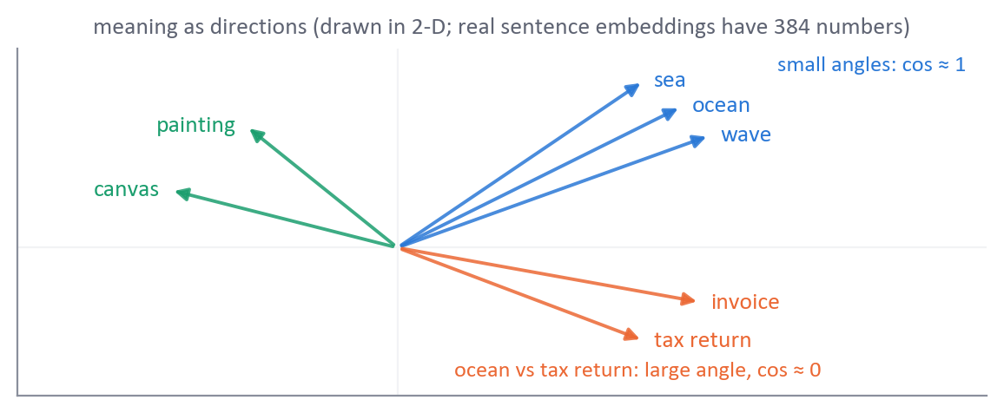
THE MATHS
a pretrained model maps a sentence to a vector: 384 numbers for all-MiniLM-L6-v2
cosine similarity: cos(u, v) = u · v / (‖u‖ · ‖v‖): 1 = same direction, 0 = unrelated
retrieval: encode the question, return the item with the highest cosine
classical baseline: TF-IDF, which only sees shared words
WORKED EXAMPLE
u = (1, 2, 0), v = (2, 4, 1): cos = 10 / (√5 × √21) = 0.976 (almost the same direction)
(1, 0) and (0, 1): cos = 0
IN PYTORCH
SentenceTransformer("all-MiniLM-L6-v2").encode(sentences) # shape (n, 384)
IN OUR PROJECT Our 512 ResNet numbers are an image embedding. Part 2 would match questions and artwork descriptions by cosine, against a TF-IDF baseline.
REMEMBER Embeddings capture meaning, not only words. Compare them with the cosine similarity.

One-line summary
The whole course in one table: read it the night before.
Concept | Key formula | Remember
Sigmoid neuron | a = σ(w · x + b) | one straight boundary
Log loss | L = −[y ln a + (1 − y) ln(1 − a)] | confident and wrong costs a lot
Gradient | ∂L/∂w = (a − y) · x | error × input
MLP | a[l] = g(W[l] a[l−1] + b[l]) | no activation, no depth
Backpropagation | dz[l−1] = W[l]ᵀ dz[l] ⊙ g′(z[l−1]) | multiplied by g′ at each layer
Autograd | loss.backward() fills .grad | grads add up: zero_grad()
Tensors | (N, C, H, W) | print .shape
nn.Linear | W of shape (out, in) | params = in × out + out
Softmax + cross-entropy | L = −ln p_true, ∂L/∂z = p − y | random guess = ln C
Training loop | w ← w − η ∂L/∂w | zero_grad, forward, loss, backward, step
ReLU | max(0, z), slope 0 or 1 | dead ReLU: zero gradient forever
Vanishing gradient | (1/4)⁸ ≈ 1.5 × 10⁻⁵ | ReLU, He, batch norm, shortcuts
Weight decay | w ← (1 − ηλ) w − η ∂J/∂w | shrink per step = η × λ
Dropout | ã = m · a / (1 − p) | only in train mode
Early stopping | stop after k epochs without a record | reload the best epoch
Batch norm | ẑ = (z − μ_B) / √(σ²_B + ε), then γ ẑ + β | running stats in eval mode
Adam | w ← w − η m̂ / (√ŝ + ε) | momentum + a step per weight
Diagnosis | symptom → cause → fix | the loss alone is not enough
Convolution | n_out = ⌊(n + 2p − k) / s⌋ + 1 | params = c_out (c_in k² + 1)
Pooling | 2 × 2 max → size / 2 | no weights
ResNet | y = F(x) + x | the + 1 keeps the gradient
Transfer learning | new head on a pretrained body | frozen first, then fine-tune
RNN | h_t = tanh(W_xh x_t + W_hh h_(t−1) + b) | forgets long-range information
LSTM | c_t = f ⊙ c_(t−1) + i ⊙ g | additive memory
Attention | softmax(Q Kᵀ / √d) V | scores → softmax → weighted mean
Embeddings | cos(u, v) = u · v / (‖u‖ ‖v‖) | meaning, not only words

