**CSCI 212  
Assignment 1**

**Name: Benjamin Erh  
Student Number: 5709635**

**Setting Up Server**

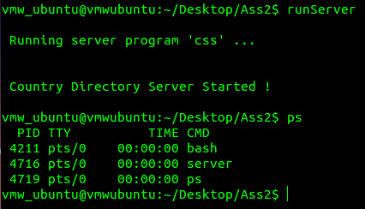  
We start off by compiling and running server program ‘css’ in the background  
Display running processes and PID ps

Now, the server has started and waiting for a client connection.

**Setting Up Client**

All user’s input will be underlined to differentiate it against program’s output with the use of the code snippet shown above.

**1) Add new book**

**1.1) Non-Existing Book Info**

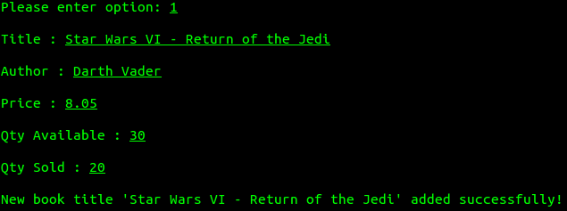

When entering option 1, user will be prompted to enter the Title and Author of the new book. If user input Title and Author is not already existing, the user will be prompted to enter the Price, Qty Available and Qty Sold of the book. The user will then be notified that the new book has been added successfully and brought back to the Main Menu.

**1.2) Existing Book Info**

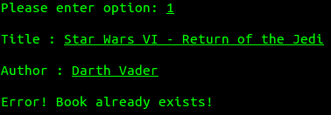

If user input Title and Author is already existing, the user will be notified and brought back to the Main Menu.

**2) Remove existing book info**

**2.1) Removing Non-Existing Book**

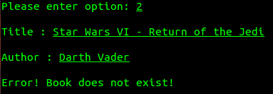

When entering option 2, user will be prompted to enter the Title and Author of the book to be removed. If user input Title and Author is not already existing, the user will be notified and brought back to the Main Menu.

**2.2) Removing Existing Book**

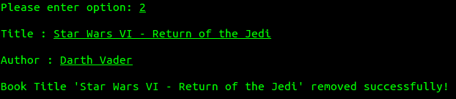

If user input Title and Author is already existing, the user will be notified that the book has been removed successfully and brought back to the Main Menu.

**3) Update book info and quantity**

**3.1) Updating a Non-Existing Book**

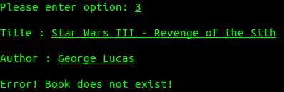

When entering option 3, user will be prompted to enter the Title and Author of the book to be updated. If user input Title and Author is not already existing, the user will be notified and brought back to the Main Menu.

**3.2) Updating an Existing Book**

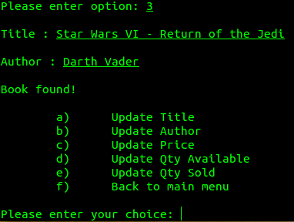

If user input Title and Author is already existing, the user will be brought to the Update Book Sub Menu.

**3.2) Updating an Existing Book**

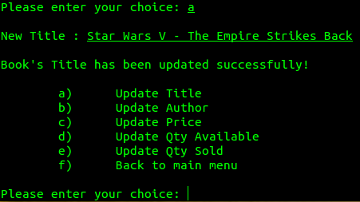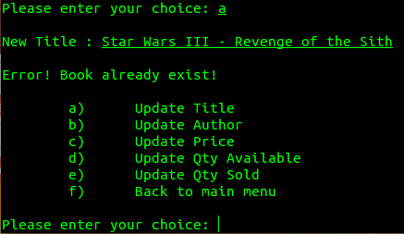**3.2a) Updating Title**

When updating the title of an existing book, if the new title already exists with the same author, the user will be notified and brought back to the Update Book Sub Menu.

If the new title already exists with a different author or does not exist, the user will be notified that the title has been successfully updated and display the Update Book Sub Menu again.

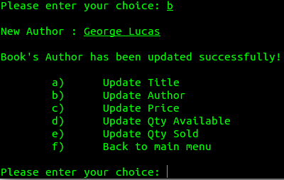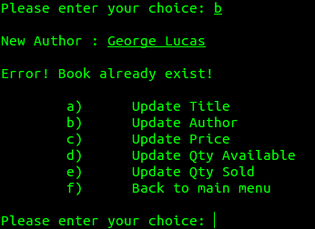 **3.2b) Update Author**

When updating the author of an existing book, if the new author already exists with the same title, the user will be notified and brought back to the Update Book Sub Menu.

If the new author already exists with a different title or does not exist, the user will be notified that the author has been successfully updated and display the Update Book Sub Menu again.

**3.2c) Updating Price**

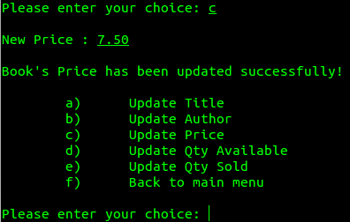

When choosing option c, the user will be prompted to enter the new price and the user will be notified that the book’s price has been updated successfully. After which the Update Book Sub Menu is displayed again.

**3.2d) Update Qty Available**

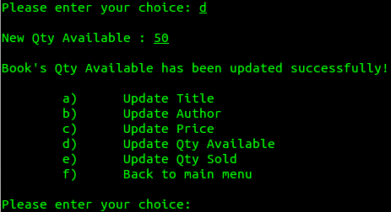

When choosing option d, the user will be prompted to enter the new available quantity and the user will be notified that the book’s available quantity has been updated successfully. After which the Update Book Sub Menu is displayed again.

**3.2e) Updating Qty Sold**

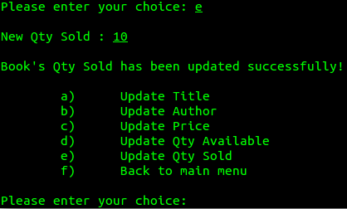

When choosing option e, the user will be prompted to enter the new quantity sold and the user will be notified that the book’s quantity sold has been updated successfully. After which the Update Book Sub Menu is displayed again.

**3.2f) Back to main menu**

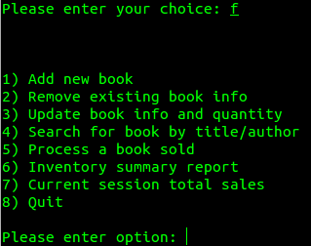

When choosing option f, the user will be brought back to the main menu.

**4) Search for book by title/author**

**4.1) Searching for an Existing Book**

**4.1.1) By Title Only**

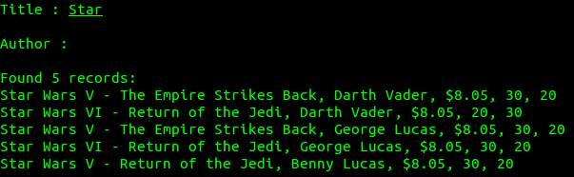

Entering the search for book by title/author option, the user will be prompted to enter the Title and Author of the book to be searched. If only the title input is entered, all books with the matching input title will be displayed.

**4.1.2) By Author Only**

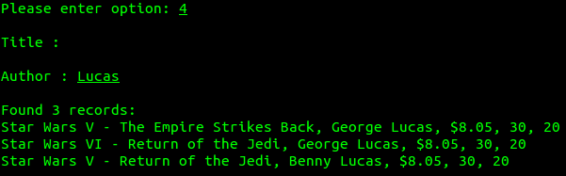

If only the author input is entered, all books with the matching input author will be displayed.

**4.1.3) By Title and Author**

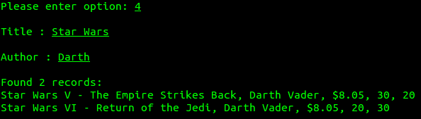

If both the title and the author input is entered, books with the matching title and author input will be displayed.

**4.2) Searching for a Non-Existing Book**

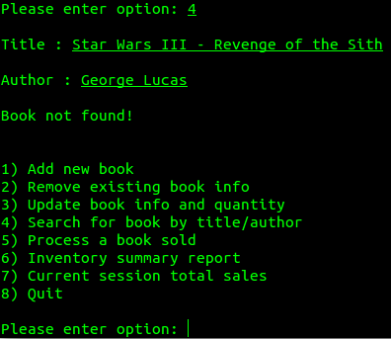

If there is no record found of the user input title or author, the user will be notified and brought back to the main menu.

**5) Process a book sold**

**5.1) Processing an Existing Book**

**5.1.1) Quantity Available is More Than Copies Sold**

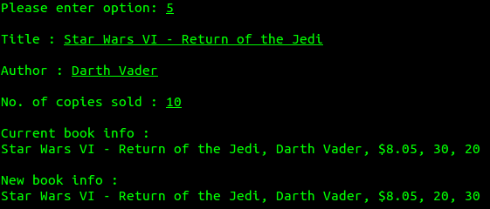

Entering option 5 from the main menu, the user will be prompted to input the Title and Author of the sale of the book to be processed. If the book is found, the user will then be prompted to enter the number of copies sold and the details of the process will be displayed to the user.

**5.1.2) Quantity Available is Less Than Copies Sold**

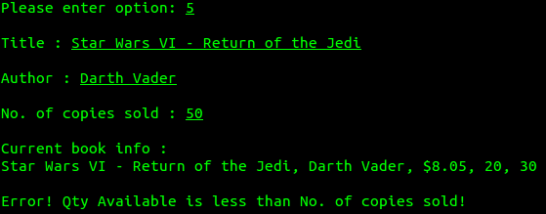

If the user enters a value which is more than the available quantity of the book, the user will be notified and brought back to the main menu.

**5.2) Processing a Non-Existing Book**



If the user input Title and Author is not found, the user will be notified and brought back to the main menu.

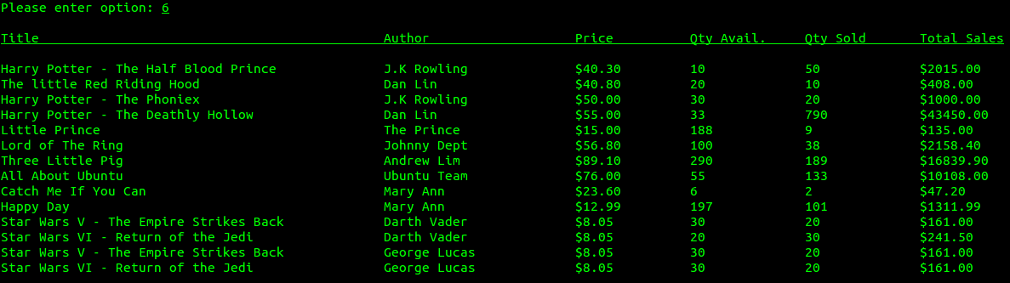**6) Inventory summary report**

When the user enters the Inventory Summary Report option, the summary report of the list of total sales of all the books will be displayed and written into the text file ‘BookDB.txt’.

**7) Current session total sales**



When the user selects the option ‘Current session total sales’, the total sales from the start of the program to the present time will be displayed.

**8) Quit**

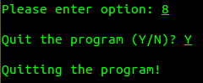

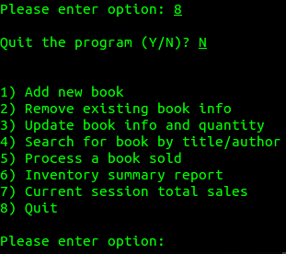

In order to prevent accidental exiting of the program where the user has yet to update the summary report to BookDB.txt, the user will be prompted whether they want to quit the program.

**Overall Reflection**

An assumption that there is no ‘:’ in any record is made in order to smoothly read in the data from BookDB.txt and store them in the array for processing. Also, assuming that the book keeper wants to keep the book record case-sensitive, the program will allow a more accurate searching of book function.

During this assignment, I have learned to use my understandings of C++ language, shell script lecture slides and references to guide me through the implementation in shell, bash programming.