Objectives Students will be able to…

* **Implement and use** interfaces.

Assessments Students will...

* **Complete** an in-class competition

Homework Students will...

* **Read** HW 9.6
* **Summarize notes** in notebook for tomorrow’s notebook check
* **For extra credit:**
  + - * Generate your own class hierarchy that demonstrates the same concepts illustrated by the Financial Class Hierarchy outlined in the book. The extra-credit project is due [one week from assignment].

# Materials & Prep

* **Projector and computer** (if you are able to/opt to use Eclipse with your students)
* **White paper** **and** **markers**
* **Poster** 6.6
* **Small group assignments** (~4 people per group)

# Pacing Guide

|  |  |
| --- | --- |
| Section | Total Time |
| Bell-work and attendance | 5min |
| Introduction | 15min |
| Class competition (small groups) | 20min |
| Whole group review and competition judging/award | 15min |

# Procedure

*Hook your class by announcing a class competition. Feature TEALS swag, extra credit points, free homework passes, or raffle tickets as prizes. Break students into their small groups before beginning your introduction.*

## Bell-work and Attendance [5 minutes]

## Introduction [10 minutes]

1. Begin with a lecture/discussion about inheritance and interfaces.

2. We’ve seen that inheritance is a useful tool for programming. (Ask students why inheritance is useful: it enables polymorphism and code sharing.)

* But inheritance has limitations:
  + Ask students if we can inherit code from more than one superclass. (No)
  + If you want an is-a relationship or polymorphism, but you don’t want to give a subclass access to the code, inheritance won’t give you the encapsulation you need.

3. There’s a special tool we can use called an *interface* that allows you to represent a common *supertype* between classes without actually sharing code.

* An **interface** consists of a set of method declarations without a method body.
* Think of the interface as a *promise* of behavior; the method is declared, but not defined. The method *will be* (is promised to be) defined in the subclass method.
  + If you don’t define the method in your subclass (if you don’t follow through on your promise), you’ll get an error.

4. Demonstrate what this looks like in practice. You can use the example given below, or ask the class to help you generate an example of their own choosing. Start with a sketch so students can visualize the relationships between interfaces and classes, and review inheritance vocabulary as you construct the diagram:

Edible

Greasy

Aromatic

Pork

Bacon

Lard

Salty

* Interfaces are represented by dotted boxes and arrows, class and class hierarchies are represented by solid lines and boxes.
* If you wish to show your students that interfaces can be shared by unrelated class hierarchies, you can add to the diagram above as shown below. The color of the interface arrows has been changed to red so it’s easier to see where to draw the lines.

Snack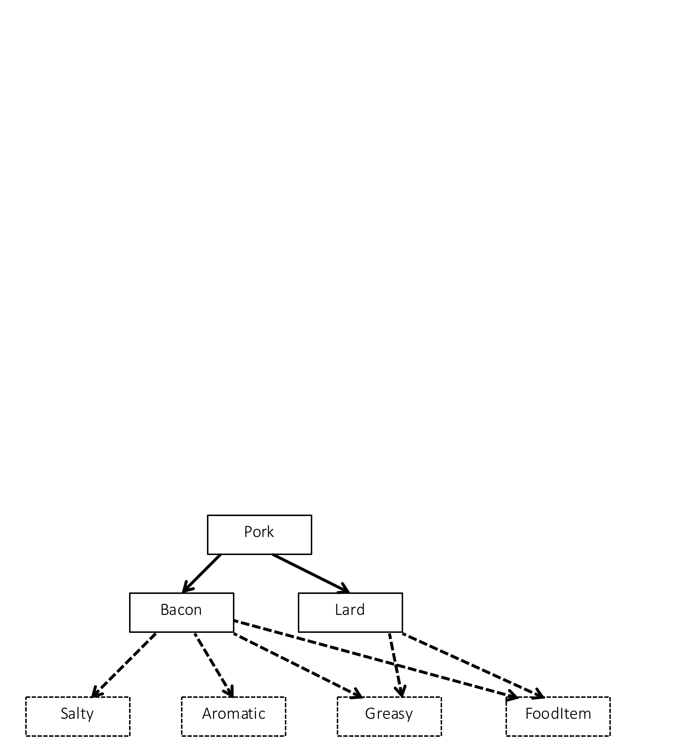

Edible

Greasy

Aromatic

Pork

Bacon

Lard

Salty

Potato Chip

public interface Salty{

double sodiumContent(); 🡨this is a promise to implement the sodiumContent

} in the class that implements the Salty interface.

public interface Aromatic{

String describeAroma(); 🡨 Notice the lack of “public”! Public is *assumed*.

}

public interface Greasy{

double amountOfGreaseInMg(); 🡨point out that interfaces look just like classes

} but without fields or method bodies

public interface Edible{

double calories();

}

5. As you write the class header below, point out the keyword *implements* and match up the interfaces in the header with the interfaces in the diagram.

public class Bacon extends Pork implements Salty, Aromatic,

+ Greasy, Edible {

private double amountInKg;

public Bacon(double amount) {

amountInKg = amount;

}

public double calories() {

return amountInKg * CALORIES_PER_KG_OF_BACON;

}

* Ask students to point out the header and the constructor. Ask them if they can guess why you included a *calories* method. If they don’t remember the answer from their reading assignment, point to the interfaces without any additional comment (you’re following through on your *promise* to implement the method).
* Ask students if the *Bacon* class is complete. Have them help you fix it by adding the other methods you promised to implement in the *Aromatic*, *Greasy*, and *Salty* interfaces. Point out Poster 6.6 as an aid to help students write interfaces correctly.

## Class Competition (Small Groups) [20 minutes]

1. On the board or overhead, project a series of five interfaces on a theme that you feel will creatively engage your class (you should blank out the parts that you feel will make the example most engaging). Some sample classes and interfaces with suggested methods:

a. Subclasses: Red, Orange, Yellow, Green, Blue

Interface: color

Sample Methods: double wavelengthInNm, Boolean isPrimaryColor

b. Subclasses: Wood, Brick, Adobe, Stone, Canvas

Interface: buildingMaterial

Sample Methods: String movableHousing, double costPerLb

c. Subclasses: Boeing 747, Pheasant, PaperAirplane, Cannonball

Interface: flies

Sample Methods: getMaximumAltitude, getRange, getSpeed

2. Invite each team to provide a team name, and explain the challenge:

a. Students should define classes to implement as many combinations of interfaces as possible.

b. Students must include at least 1 method for each interface.

c. Each class has to implement the interface methods and include a constructor.

3. The team with the most combinations of interfaces at the end of the time limit (~20 minutes) win the competition.

## Whole Group Review & Competition Judging/Award [15 minutes]

1. Leave time to have groups share their interfaces with the rest of the class during whole group discussion. Pay attention to any particularly creative or wacky examples that students come up with.

# Accommodation and Differentiation

If your students require additional practice with interfaces before beginning the class competition, work through building a class *Lard* that implements the interfaces *Greasy* and *FoodItem*.

*During the Activity*

If your students require extra scaffolding, generate 1 method for each interface as a whole group before the competition begins. Write these methods on the board with the interfaces for easy reference.

If your students require an extra challenge, change rule *c* (in step 2 of *Activity*) to include additional methods and/or fields.