**Data Loading and Storage**

Benjamin Batte

University of the Cumberlands

ITS-836 Data Science & Big Data Analytics

Dr. Charles Edeki

21 Sept 2025

**Part 1: CSV Handling**

Q1–Q2: Load Dataset into Pandas

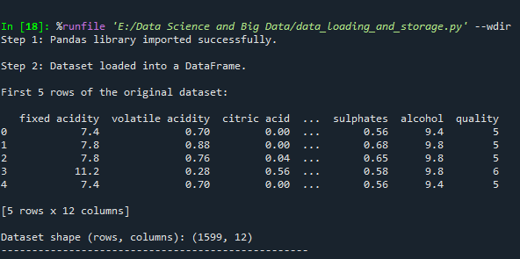

Q3: Add Unique ID Column

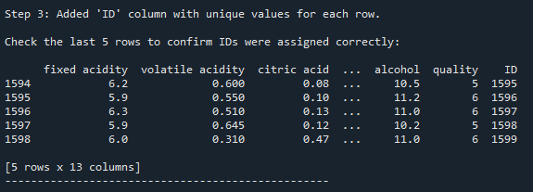

Q4: Display First 10 Rows

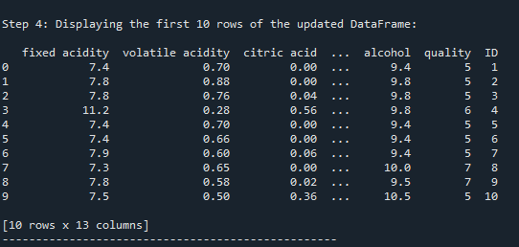

Part 2: JSON Operations

Q7–Q10: JSON Conversions and Formatted Output

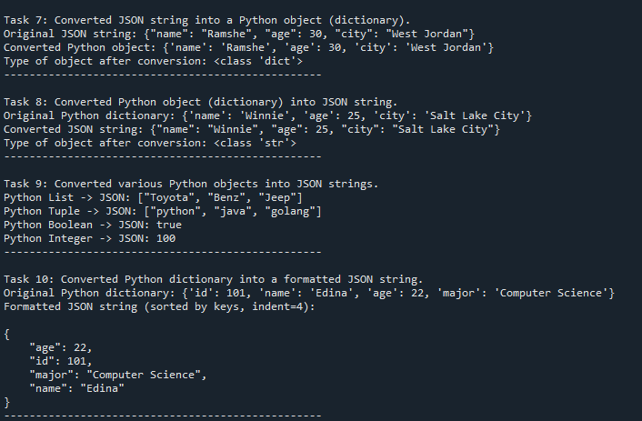

Part 3: NBA API

Q11–Q12: Player and Team IDs (LeBron James & Golden State Warriors)

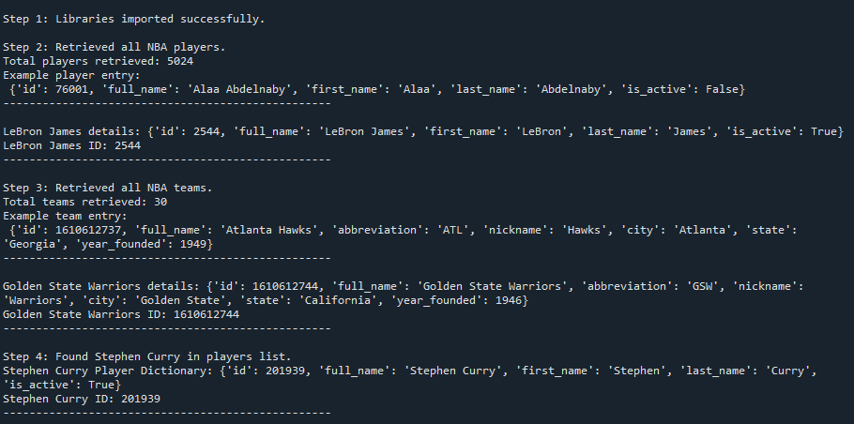

Q13: Game Data for Stephen Curry (2022–23)

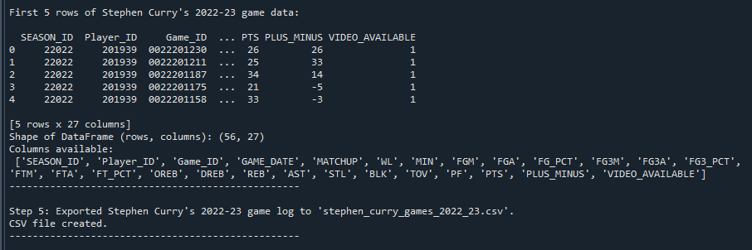

**References**

McKinney, W. (2022). *Python for Data Analysis* (3rd ed.). O’Reilly Media.

Kaggle. (2009). *Wine Quality Dataset*. Retrieved from https://www.kaggle.com/datasets/uciml/red-wine-quality-cortez-et-al-2009

NBA Stats API. (2025). *nba_api Documentation*. Retrieved from <https://github.com/swar/nba_api>