**Data Cleaning and Preparation**

Benjamin Batte

University of the Cumberlands

ITS-836 Data Science & Big Data Analytics

Dr. Charles Edeki

21 Sept 2025

**Lab 6 Results**

**Figure 1. Preview of Dataset and Item Price Conversion**

The figure below shows the first five rows of the Chipotle dataset and confirms the successful conversion of the 'item_price' column to a numeric format.

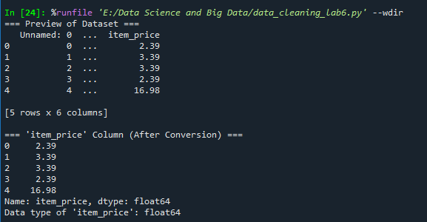

**Figure 2. Average Price Comparison of Chicken vs Steak**

The analysis indicates that chicken items have an average price of $10.13, while steak items have an average price of $10.52.

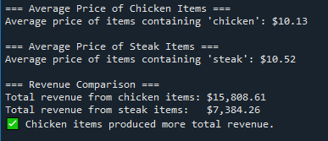

**Figure 3. Revenue Analysis and Missing Values**

Chicken items generated more total revenue ($15,808.61) than steak items ($7,384.26). The missing values analysis also shows that 1,246 missing entries occur only in the 'choice_description' column, while all other columns have complete data.

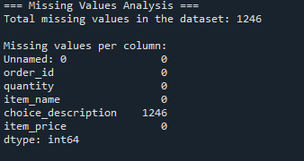

**References**

McKinney, W. (2022). Python for data analysis: Data wrangling with Pandas, NumPy, and Jupyter (3rd ed.). O’Reilly Media.

University of the Cumberlands. (2025). ITS-836: Data Science & Big Data Analytics Course Materials.