Predicting Students' Final Grades Using Machine Learning
Benjamin Batte
University of the Cumberlands
ITS-836 Data Science & Big Data Analytics
Dr. Charles Edeki
October 5, 2025

Introduction
Predicting students’ final grades is a critical domain of educational data science because it enables institutions to design proactive interventions and deliver personalized support mechanisms. Accurately identifying at-risk students has mitigated dropout rates and improved overall academic achievement (Al-Barrak & Al-Razgan, 2020). Empirical studies consistently demonstrate that predictors such as study time, attendance, family support, and prior academic performance exert significant influence on student outcomes (Shorfuzzaman et al., 2021). By systematically analyzing these factors, educators and policymakers can better enhance resource allocation and target support services more effectively. This project extends earlier investigations using traditional machine learning for student performance forecasting (Panigrahi et al., 2021) and ensemble learning frameworks for academic prediction tasks (Manhães et al., 2022).
The overarching objective is to apply advanced regression methodologies to predict final grades with higher accuracy while isolating the most influential variables driving student success. The central hypothesis guiding this research is that prior academic performance (G1 and G2) will emerge as the strongest predictor of final performance (G3). At the same time, socio-behavioral and demographic factors will exert comparatively weaker influence.
Methods
Data Source
The analysis employed the Student Performance dataset from the UCI Machine Learning Repository, aggregating academic records from two Portuguese secondary schools (Cortez & Silva, 2008). The dataset contains 649 observations and 33 attributes for the Portuguese language course, and 395 observations with the same 33 attributes for the mathematics course. These features span demographic, social, and academic dimensions, including parental education, study time, alcohol consumption, and prior grades, providing a comprehensive basis for multi-factorial performance prediction.
Data Wrangling and Preprocessing
Data wrangling represented a critical component of the methodological framework, given that data cleaning and transformation processes can consume up to 80% of the data science lifecycle (McKinney, 2022). In this study, preprocessing followed a structured, multi-stage approach. Categorical variables were encoded to convert nominal and ordinal data into numerical formats suitable for machine learning models. Numerical variables were scaled to normalize distributions and reduce sensitivity to variance, thereby improving model stability and performance. The datasets were subsequently partitioned into stratified training and testing subsets to preserve class balance and ensure generalizability across unseen data. These transformations were systematically implemented through a Column Transformer pipeline within scikit-learn, ensuring reproducibility, modularity, and scalability throughout the experimental workflow (Kumari & Singh, 2023).
Analytical Techniques and Tools
Python served as the primary computational environment due to its extensive ecosystem of libraries optimized for data-intensive research. Data handling was performed using Pandas and NumPy (McKinney, 2022). Model development, training, and validation were conducted in scikit-learn (Kumari & Singh, 2023), while data visualization and exploratory analysis were implemented using Matplotlib and Seaborn (Sasikala & Renuka Devi, 2023).
The predictive analysis was conducted using two supervised learning paradigms: Linear Regression, chosen for its interpretability, and Random Forest Regression, selected for its robustness in handling complex, non-linear data structures. As a baseline algorithm, Linear Regression provides interpretable coefficient-based insights into variable influence but is limited in handling nonlinearity and categorical complexity. Random Forest Regression, an ensemble method based on bootstrap aggregation of decision trees, was included to address these limitations and has demonstrated robust predictive accuracy in prior educational modeling studies (Shorfuzzaman et al., 2021). Complementary research employing ensemble learning further validates the suitability of tree-based models for student performance prediction (Manhães et al., 2022).
Results
Exploratory Data Analysis
Exploratory data analysis was conducted separately for the Mathematics and Portuguese datasets to examine grade distributions and assess potential predictors of student performance.
Figure 1 illustrates the distribution of absences in the mathematics dataset, which was highly right-skewed, indicating that while most students had relatively few absences, a small subset exhibited extreme absenteeism. This skew suggests that absenteeism may disproportionately affect a minority of students.
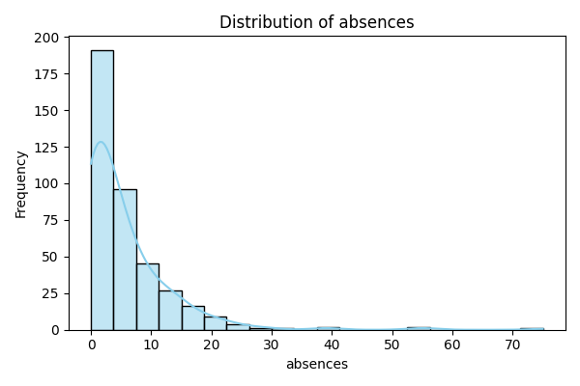
Figure 1. Distribution of absences in the mathematics dataset.
Figure 2 shows the Portuguese dataset's final grades (G3) distribution. Grades followed an approximately normal distribution, clustering 10–12 points out of 20. A non-trivial number of students scored zero, reflecting complete course failure and underscoring the necessity of early intervention strategies.
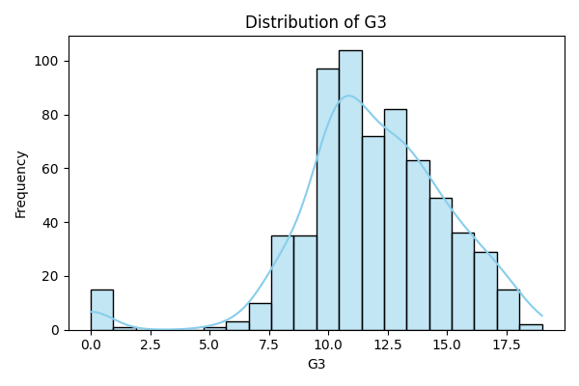
Figure 2. Distribution of final grades (G3) in the Portuguese dataset.
Correlation analysis was also performed to examine relationships among features. As shown in Figure 3, the Portuguese dataset’s correlation heatmap confirmed that first- and second-period grades (G1 and G2) exhibited the strongest correlations with final grades (G3). At the same time, demographic and lifestyle features (e.g., alcohol consumption, family relations, travel time) displayed weak or negligible correlations. These findings are consistent with prior studies demonstrating the dominant role of earlier academic performance in predicting outcomes (Shorfuzzaman et al., 2021).
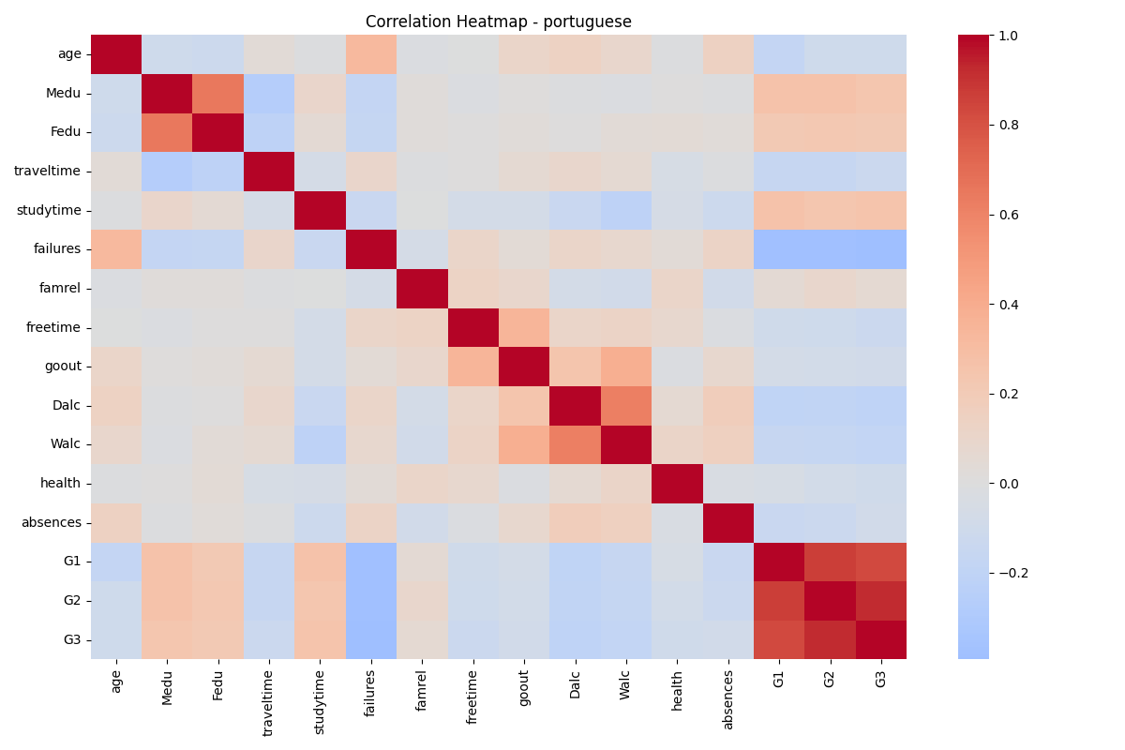
Figure 3. Correlation heatmap of the Portuguese dataset.
Model Evaluation
Two supervised learning algorithms, Linear Regression and Random Forest Regression, were applied to both datasets to assess predictive performance.
Mathematics Dataset.
As shown in Table 1, Linear Regression achieved moderate performance, with an R² value of 0.724, RMSE of 2.38, and MAE of 1.65, indicating it could explain some variance but struggled with nonlinearities. Random Forest Regression performed substantially better, with an R² of 0.813, RMSE of 1.96, and MAE of 1.18, reflecting its superior ability to capture complex patterns.
Interpretation: An RMSE of 1.96 indicates that the Random Forest model is typically off by about two grade points on a 0–20 scale, a meaningful level of predictive accuracy in an educational context.
Model | R² | RMSE | MAE
Linear Regression | 0.724 | 2.38 | 1.65
Random Forest | 0.813 | 1.96 | 1.18
Table 1: Model evaluation metrics for the mathematics dataset.
Portuguese Dataset.
A similar pattern was observed in the Portuguese dataset (see Table 2). Linear Regression achieved an R² of 0.849, RMSE of 1.22, and MAE of 0.77. Random Forest Regression also performed strongly, with an R² of 0.842, RMSE of 1.24, and MAE of 0.75. Both models provided robust predictions, though the ensemble approach again delivered stable performance across nonlinear feature interactions.
These findings reinforce the limitations of linear approaches when dealing with complex, categorical-heavy educational datasets (Panigrahi et al., 2021). Conversely, the strong performance of Random Forest models aligns with prior ensemble-based studies in educational data mining, where tree-based methods consistently outperformed linear baselines (Manhães et al., 2022).
Interpretation: An RMSE of around 1.2 means the models are typically off by just over one grade point, underscoring their reliability for academic forecasting.
Model | R² | RMSE | MAE
Linear Regression | 0.849 | 1.22 | 0.77
Random Forest | 0.842 | 1.24 | 0.75
Table 2: Model evaluation metrics for the Portuguese dataset.

Discussion
The comparative analysis clearly demonstrated that Random Forest Regression consistently outperformed Linear Regression in the Mathematics dataset, while both models achieved strong results in the Portuguese dataset. This performance gap highlights the limitations of linear approaches in handling the categorical-heavy, nonlinear relationships that characterize educational data, and conversely underscores the strength of ensemble methods in capturing these complexities (Manhães et al., 2022). The ability of Random Forests to average across multiple decision trees mitigates overfitting while enabling the model to capture diverse interactions among predictors, which explains its superior performance in the mathematics dataset.
Notably, the results confirmed the central hypothesis: prior academic performance (G1 and G2) emerged as the most influential determinant of final grades (G3). This outcome is consistent with cumulative knowledge theories, emphasizing that academic learning is scaffolded over time and that earlier mastery provides the strongest foundation for subsequent achievement (Shorfuzzaman et al., 2021). In both datasets, G1 and G2 displayed the highest correlations with G3, reinforcing the role of continuous assessment as a key predictor of final performance.
In contrast, lifestyle and demographic variables such as alcohol consumption, family relations, parental education, and travel time exerted only weak or negligible influence on student outcomes. While these socio-behavioral attributes add valuable context regarding students' lived experiences, their explanatory power in forecasting academic achievement was marginal. This finding supports prior studies arguing that non-academic factors serve as secondary moderators rather than primary drivers of student performance (Al-Barrak & Al-Razgan, 2020). It also suggests that educational interventions should prioritize academic scaffolding strategies, such as strengthening performance in earlier periods (G1 and G2), rather than focusing exclusively on lifestyle or demographic characteristics.
Another notable finding was the distributional skewness in variables such as absences and alcohol consumption. While most students reported low levels, a small minority exhibited extreme values. This long-tailed distribution indicates that interventions may need to be targeted toward outlier subgroups, where absenteeism or substance use risks significantly undermine academic achievement. For most students, however, these factors do not appear to systematically drive performance, which may explain their limited predictive role in the models.
By integrating these findings into institutional frameworks, schools could adopt data-driven early warning systems that combine predictive modeling with continuous monitoring of interim grades. For instance, students with low G1 or G2 performance could be flagged for targeted tutoring or mentoring programs, while extreme absenteeism cases could trigger personalized intervention plans. Such applications exemplify the practical value of predictive analytics in education, supporting more efficient resource allocation, reducing dropout risk, and promoting equitable learning opportunities.
Additional exploratory data analysis (EDA) figures for the Mathematics and Portuguese datasets are included in the Appendix (Figures A1–A33) to provide transparency. These visualizations demonstrate how key academic and socio-behavioral features are distributed across the student populations, reinforcing the dominance of prior grades in predictive strength and offering actionable insights into student behaviors and risk factors.
Conclusion
This study provided robust evidence that Random Forest Regression consistently outperforms Linear Regression in predicting student performance, particularly in the mathematics dataset, where nonlinear interactions between variables were more pronounced. The analysis reaffirmed the central hypothesis in the Mathematics and Portuguese datasets: prior academic performance (G1 and G2) emerged as the strongest predictor of final grades (G3). These results highlight the cumulative nature of learning and the importance of early academic success in shaping longer-term outcomes. Additional variables, such as absences and prior course failures, also contributed to prediction accuracy, though their effects were comparatively modest.
The practical implications are significant. Ensemble models such as Random Forest demonstrated the ability to forecast student performance within a two-grade margin of error, a level of accuracy that is highly actionable in real-world educational settings. By integrating these models into institutional risk assessment frameworks, schools and universities could proactively identify students at risk of underperformance, allocate academic support more strategically, and implement timely interventions such as tutoring, mentorship, or attendance monitoring. In doing so, institutions mitigate dropout risks and foster more equitable educational outcomes by targeting resources for those needing them most.
From a policy perspective, the findings underscore the value of embedding data-driven predictive analytics within decision-making processes. Rather than relying solely on retrospective performance reviews, educational institutions can leverage predictive modeling to transition toward preventive and personalized education strategies. This aligns with broader shifts in educational technology toward adaptive learning platforms, where real-time data informs tailored instructional pathways.
Nevertheless, several limitations must be acknowledged. The dataset was confined to Portuguese secondary schools during a specific period, which may constrain the generalizability of the findings to other cultural or institutional contexts. Moreover, the dataset was static and did not include dynamic engagement indicators such as online learning behavior, participation metrics, or real-time classroom interactions. Future research should address these gaps by incorporating cross-institutional datasets, exploring temporal and behavioral features, and applying advanced hybrid approaches, including deep learning architectures combined with interpretable ensemble methods, to enhance predictive accuracy and interpretability.
Ultimately, this project validates the hypothesis that machine learning can be a powerful tool for academic forecasting. More importantly, it demonstrates how predictive analytics can transform educational practice, enabling earlier, smarter, and more targeted interventions that support student success. By building upon these findings, future work can help advance a new generation of educational systems that are reactive and genuinely proactive in shaping student achievement trajectories.
References
Al-Barrak, M. A., & Al-Razgan, M. (2020). Predicting students’ performance through classification: A case study. International Journal of Advanced Computer Science and Applications, 11(1), 1–7. https://doi.org/10.14569/IJACSA.2020.0110101
Batte, B. (2025). Student grade prediction [Computer software]. GitHub. https://github.com/BenjaminBatte/student-grade-prediction
Cortez, P., & Silva, A. M. G. (2008). Student performance dataset. UCI Machine Learning Repository. https://archive.ics.uci.edu/dataset/320/student+performance
Kumari, A., & Singh, V. (2023). Comparative analysis of machine learning techniques for student performance prediction. International Journal of Emerging Technologies in Learning, 18(4), 22–34. https://doi.org/10.3991/ijet.v18i04.35575
Manhães, L. M. B., Souza, L. A., Moreira, E. D., & Rocha, Á. R. (2022). Using ensemble learning to predict academic performance. Education and Information Technologies, 27(3), 3259–3278. https://doi.org/10.1007/s10639-021-10733-4
McKinney, W. (2022). Python for data analysis (3rd ed.). O’Reilly Media.
Panigrahi, S., Srivastava, P. R., & Sharma, S. (2021). Predictive modeling in education: A review of trends, techniques, and applications. Education and Information Technologies, 26(1), 725–749. https://doi.org/10.1007/s10639-020-10254-6
Sasikala, S., & Renuka Devi, D. (2023). Research practitioner’s handbook on big data analytics. Taylor & Francis.
Shorfuzzaman, M., Hossain, M. S., & Nazir, A. (2021). Performance prediction of students using machine learning algorithms: A case study. Computers, 10(8), 93. https://doi.org/10.3390/computers10080093
Appendix
This section provides additional exploratory data analysis (EDA) figures for the Mathematics and Portuguese datasets.
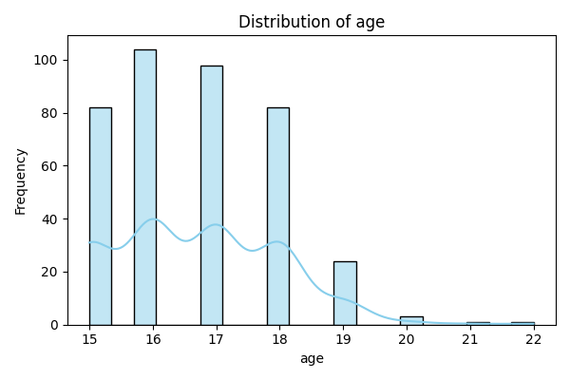
Figure A1—age distribution in the mathematics dataset.
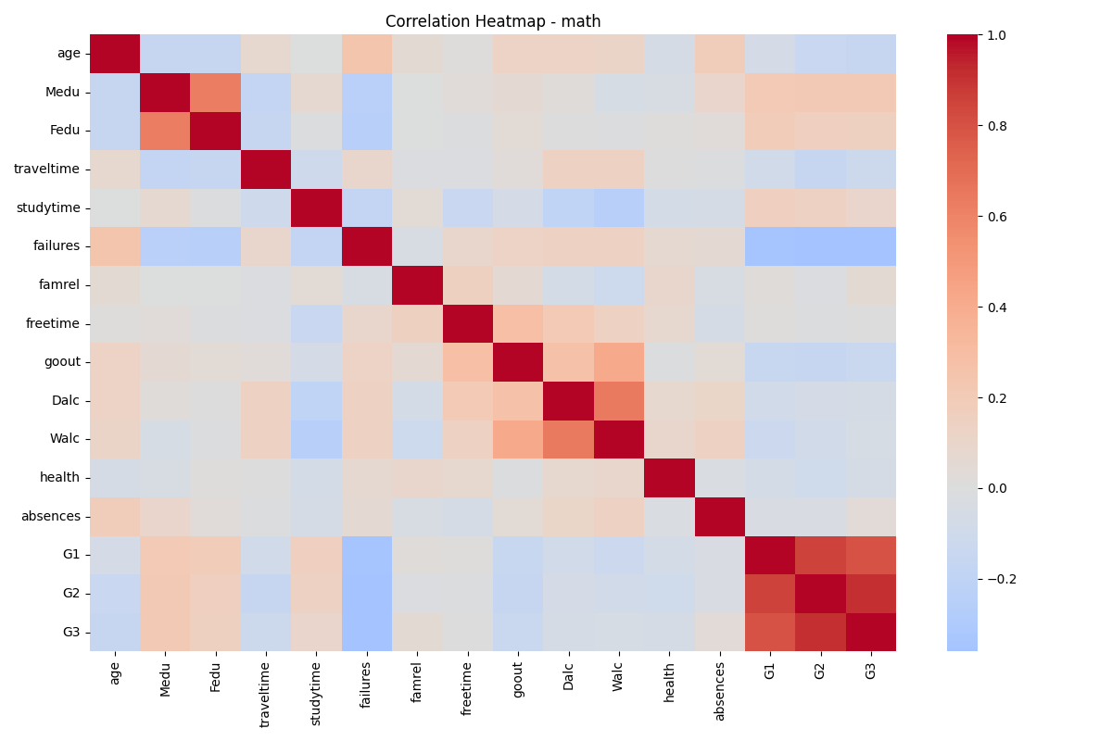
Figure A2. Correlation heatmap for the mathematics dataset.
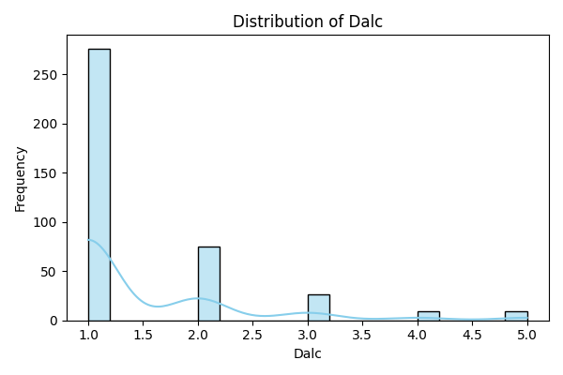
Figure A3. Weekday alcohol consumption distribution (Math).
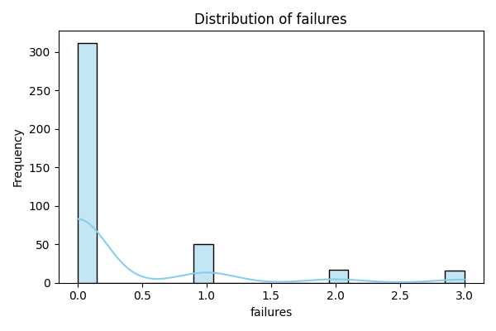
Figure A4. Distribution of prior class failures (Math).
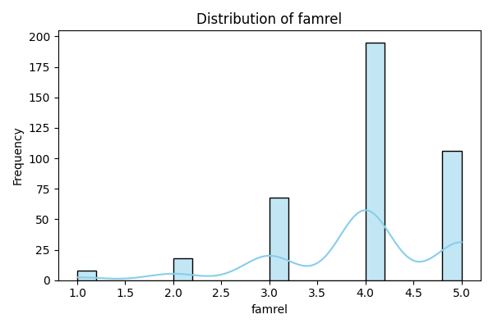
Figure A5. Family relationship quality distribution (Math).
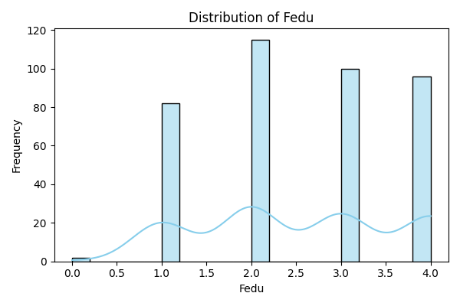
Figure A6. Father’s education distribution (Math).
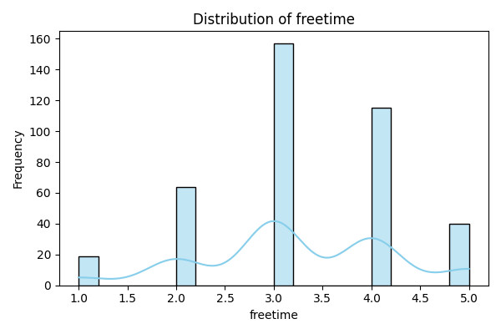
Figure A7. Free time distribution (Math).
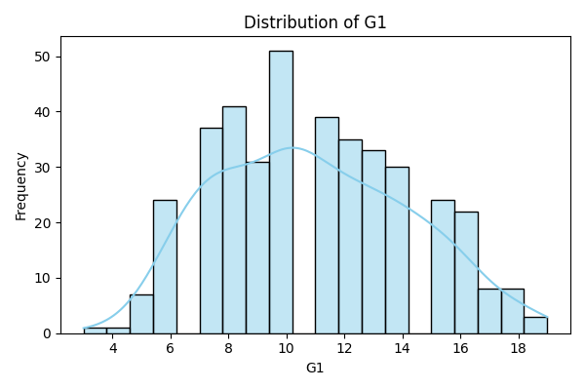
Figure A8. First period grade distribution (Math).
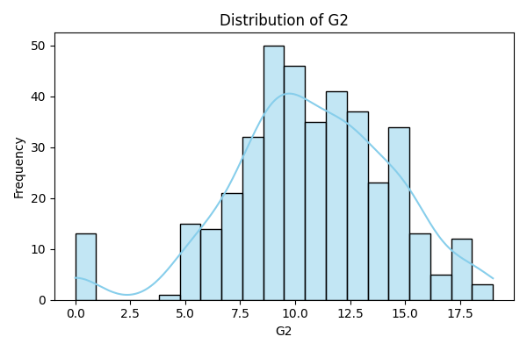
Figure A9. Second period grade distribution (Math).
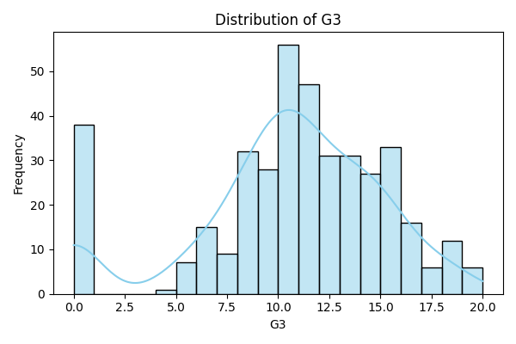
Figure A10. Final grade distribution (Math).
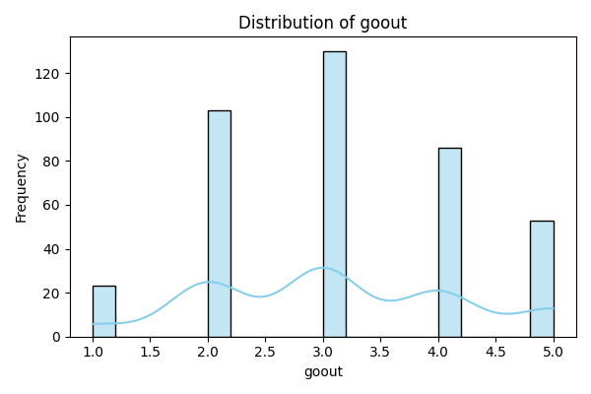
Figure A11. Going out with friends’ distribution (Math).
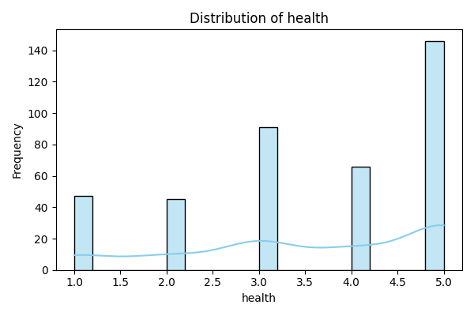
Figure A12. Health status distribution (Math).
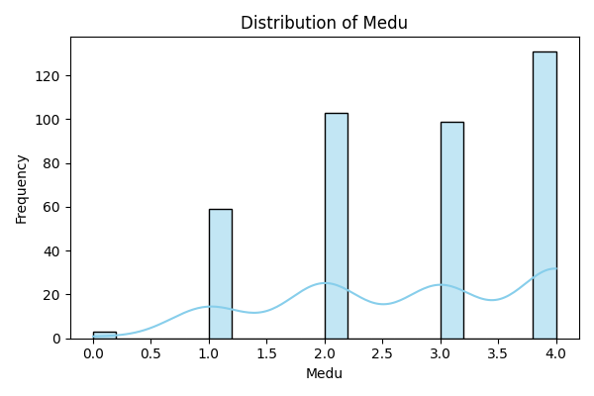
Figure A13. Mother’s education distribution (Math).
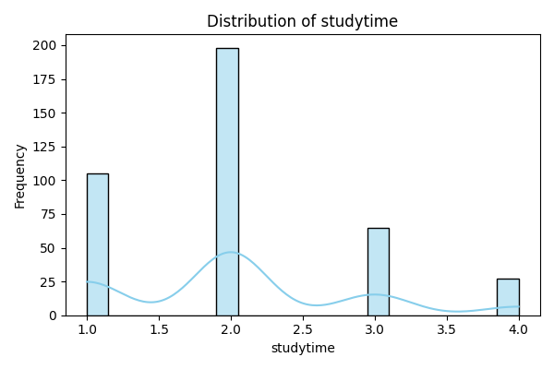
Figure A14. Study time distribution (Math).
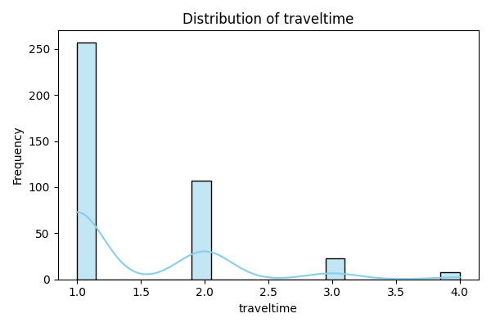
Figure A15. Travel time distribution (Math).
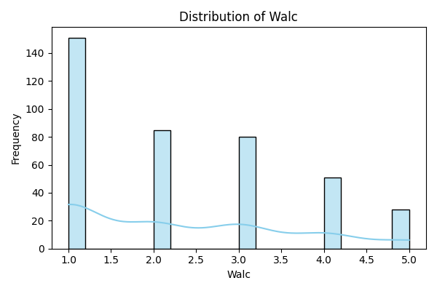
Figure A16. Weekend alcohol consumption distribution (Math).
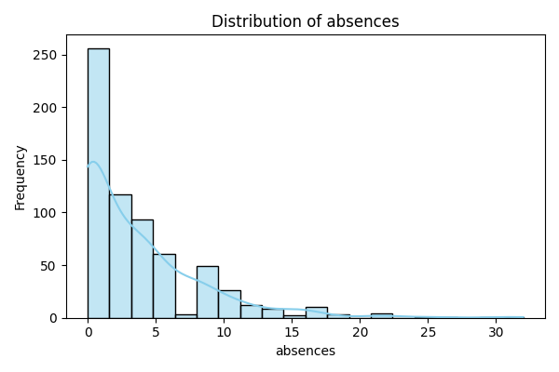
Figure A17. Absences distribution (Portuguese).
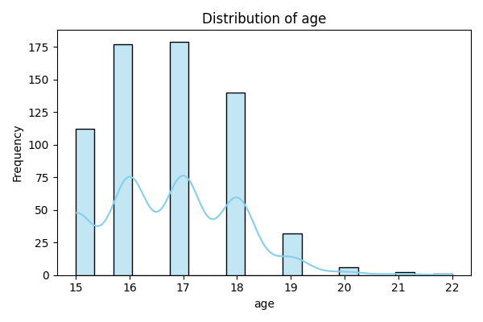
Figure A18. Age distribution (Portuguese).
Figure A19. Correlation heatmap (Portuguese).
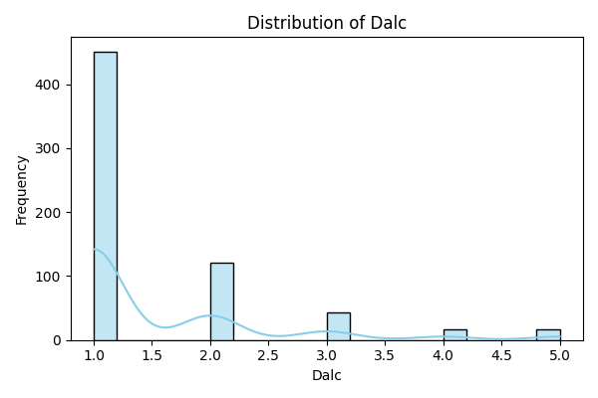
Figure A20. Weekday alcohol consumption distribution (Portuguese).
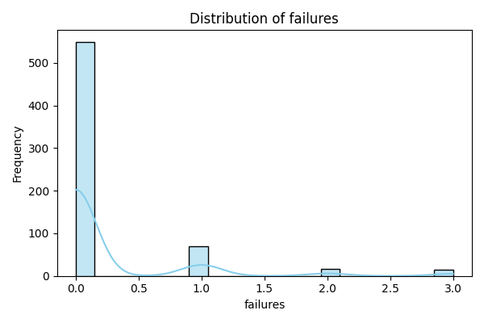
Figure A21. Distribution of prior class failures (Portuguese).
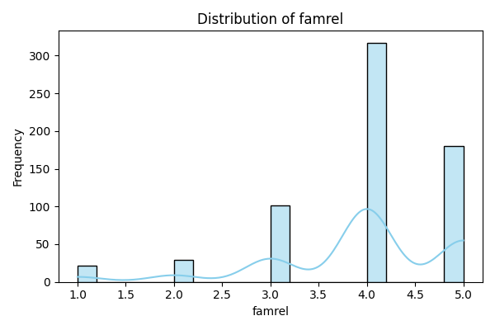
Figure A22. Family relationship quality distribution (Portuguese).
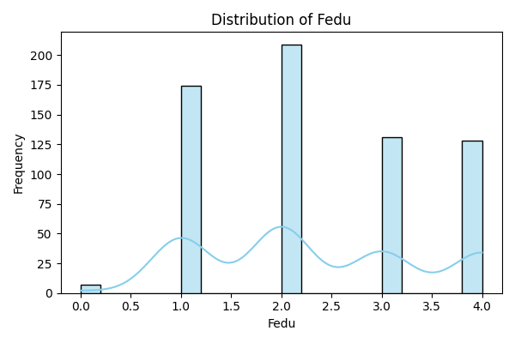
Figure A23. Father’s education distribution (Portuguese).
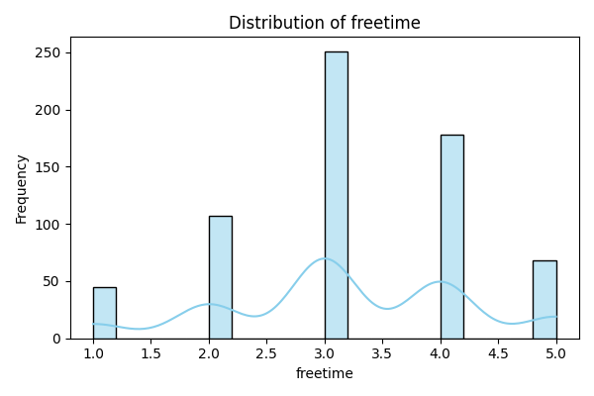
Figure A24. Free time distribution (Portuguese).
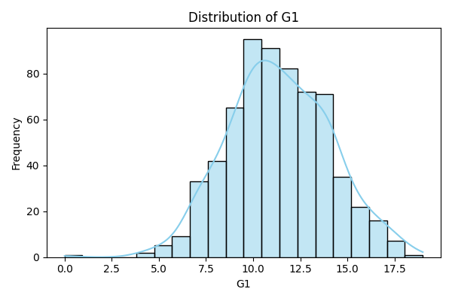
Figure A25. First period grade distribution (Portuguese).
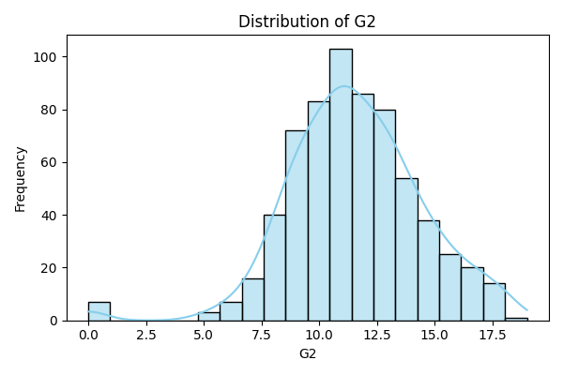
Figure A26. Second period grade distribution (Portuguese).
Figure A27. Final grade distribution (Portuguese).
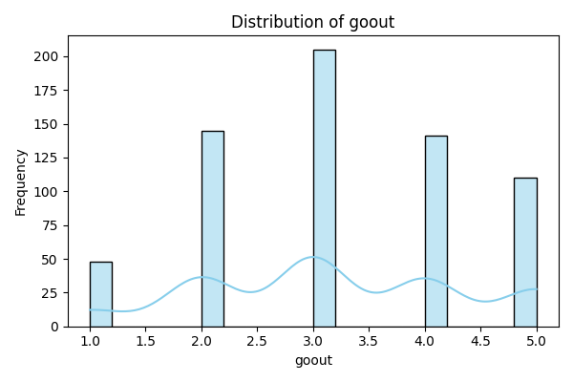
Figure A28. Going out with friends’ distribution (Portuguese).
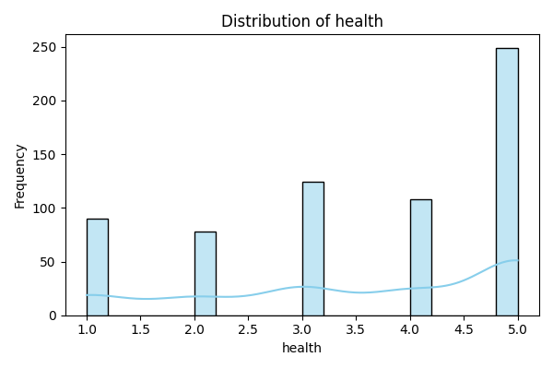
Figure A29. Health status distribution (Portuguese).
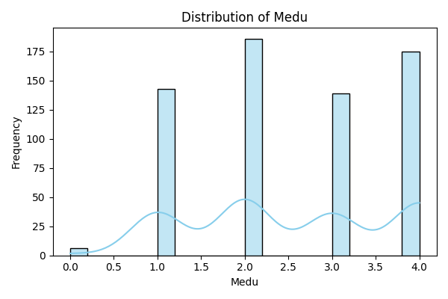
Figure A30. Mother’s education distribution (Portuguese).
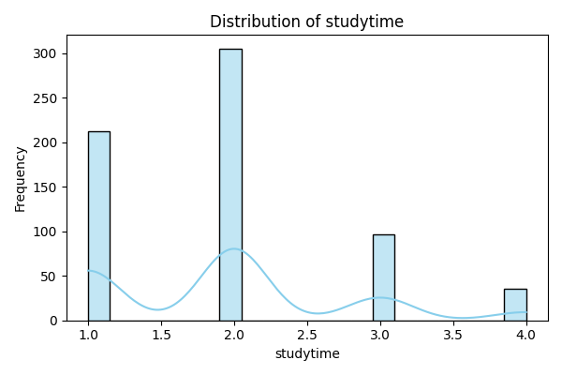
Figure A31. Study time distribution (Portuguese).
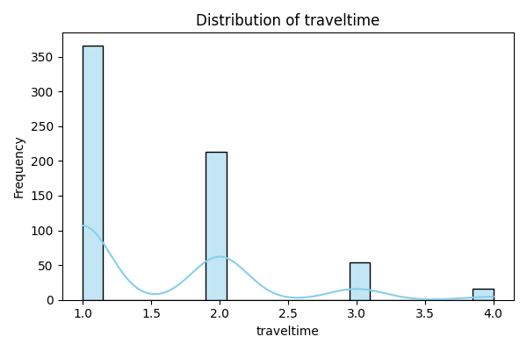
Figure A32. Travel time distribution (Portuguese).
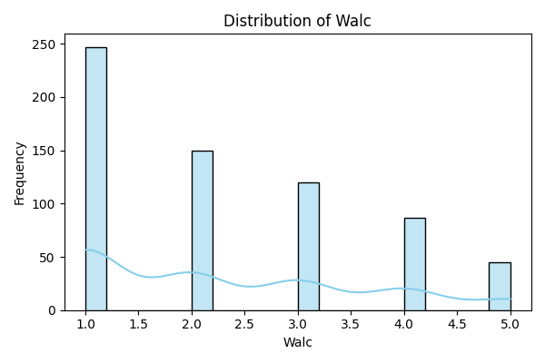
Figure A33. Weekend alcohol consumption distribution (Portuguese).

