USER MANUAL

Contents

Introduction 0

First Time Use. 0

Data Imported, Lets go further. 1

New Repair 2

Edit Repair 4

Manufacturers 5

Suppliers 5

Parts 6

FAQ 6

# Introduction

Thanks for purchasing the Admin Panel! My name is Benjamin Britcliffe, the creator and designer of this system. You have come to the right place for a starter taste into the system! The system was created originally for a bespoke reason, and have been given the opportunity to share this with you. This was done as my final project at UCLAN Burnley.

# ⚠ IMPORTANT INFORMATION: ⚠

## Localhost default details:

Username: root

Password:””

Database: “pcrepair”

## Login Details for the website:

Username: Admin (Notice the capital A)

Password: password (No Capital)

# First Time Use.

Step 1:

Go to the root folder and find a document called: “Connect-DB.php” this is the MAIN connection page, change the details to yours described below:

For Non Localhost: Ask your service provider for your credentials and to create a DB and you want to import data into it. and then get the url. “Skip to Data Imported lets go further stage”

**<?php**

**ELSE**

**(“Sorry couldn’t resist”)….**

**?>**

Local host: For a localhost simply leave the details in both connection files the same and follow this to the tee☕. startup WAMP,LAMP,XAMPP or whatever AMP/P you are using! Then simply move the AdminPanel folder to your WWW or HTDOCS folder. Then open up your browser. Go to <http://localhost/phpmyadmin> (It may be different for you). Now the tricky bit…

**REPEAT THE STEPS ABOVE for the other Connection page, situated in the Connections folder “Connections/localhost.php”**

This was done due to a dreamweaver error and limitation, but trust me it works.

1. Click on new and name the database “pc repair” like the image below… hit create.

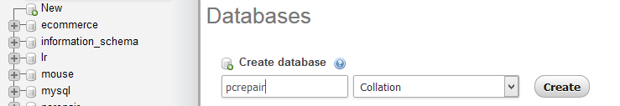

1. Now click Import then click Browse

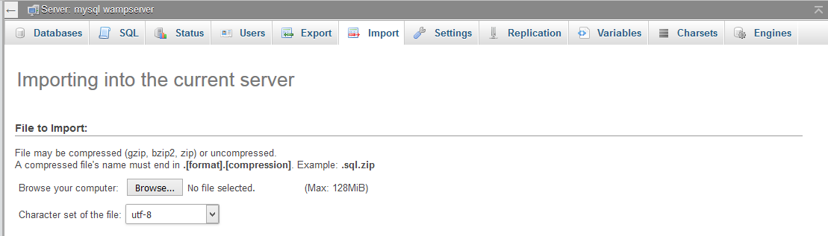

1. Browse for the SQL file inside the Admin Panel CONFIGS folder. Select the config.sql file and hit go!
2. Once you have hit go it will populate the database with tables and dummy data. Leave it for now and follow on.

# Data Imported, Lets go further.

Great! You have imported the data and are ready to use the system! Lets go and use it.

1. Go to <http://localhost:/AdminPanel> unless you have a port number then it is <http://localhost:[PORTNUMBER]/AdminPanel>
2. You will see a Login Screen

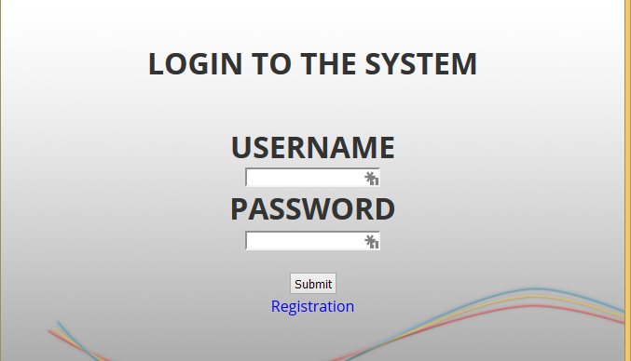

1. 3. Default login details are: (for the second time…)

USERNAME: Admin

Password : password

Use these for now.

1. You will then be greeted by a Homepage!

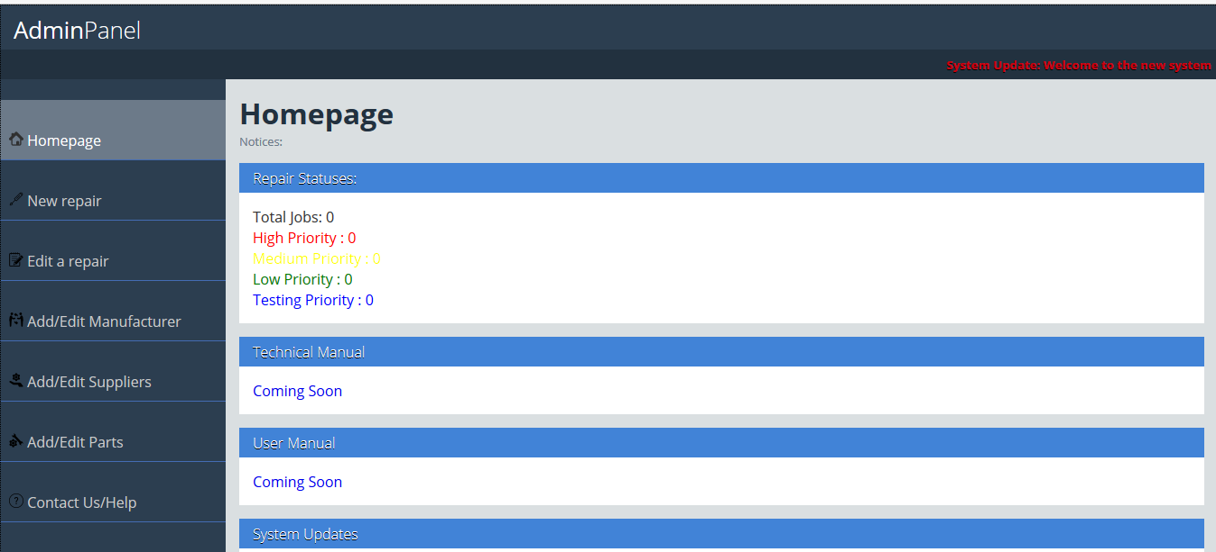

1. Congratulations you are in the system!

# New Repair

Head over to the New Repair button on the sidebar.

When there, Simply enter the details into the fields, If you do not enter the REQUIRED FIELDS the details the form will not enter, and will show a failed message. Below is a description of the fields and what they mean:

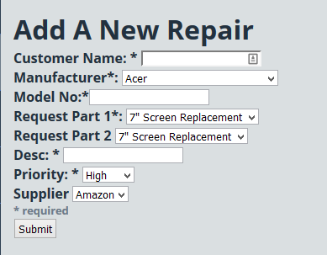

**Customer Name:** This is the Name of the customer, an Order number is automatically generated and is LINKED to the CUSTOMER NAME.

**Manufacturer:** This is the Laptop/PC model name and manufacturer, for example a user brings in an Apple Mac you would use the Manufacturer as “Apple”.

**Model No:** This is the Model No or Model Name of the laptop/PC for example Apple Mac, the Apple would be the Manufacturer and “Mac” would be the Model No.

**Request Part 1:** For the inbuilt link generator for parts, if you need 1 part you would select the wanted part from the list. If you need no parts just put it as ALL.

**Request Part 2:** Part 2 is If you want more than 1 part and need 2 parts, you would select the second wanted part. If you just need 1 just put as all.

**Desc:** Due to a limitation with PHP If you want more than 2 parts, use the link sections more than once over and put here what parts have already been purchased. Also can be used to explain the situation/fault.

**Priority:** Used to select the Priority status of the repair, will be used to link and sort the status of repairs by priority.

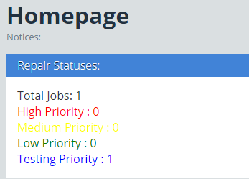

**Supplier:** Finally, who do you want to buy your parts from? Select your favourite supplier here!

# Edit Repair

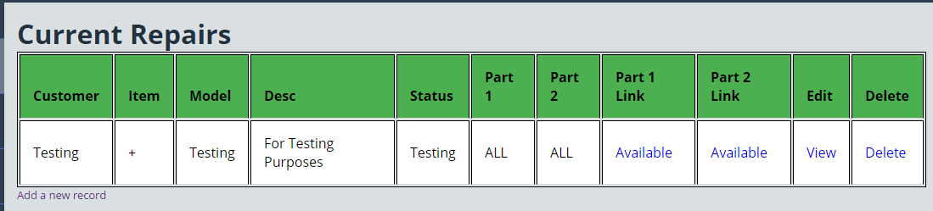

Click the Edit a Repair Button on the sidebar.

This will show all the repairs that are currently active. You will see the screen similar to above. Description of all the sections is below:

**Customer:** The name of the customer will be situated here.

**Item:** The name of the item that you are repairing

**Model:** The Laptop/PC model number

**Desc:** Description of previous parts bought as well as a short description

**Status:** Status of the Order including Priority

**Part 1 and Part 2:** The parts that were recently searched for.

**Part 1 and Part 2 Link:** Links to the latest two searched parts for this order.

**Edit:** Edit the order such as edit the description etc.

**Delete:** Delete the order once completed or otherwise.

# Manufacturers

Also Known As: Laptop Manufacturers

This is where a list of the Manufacturers can be seen, they can be edited and deleted here. Description of the manufacturers can be seen here:

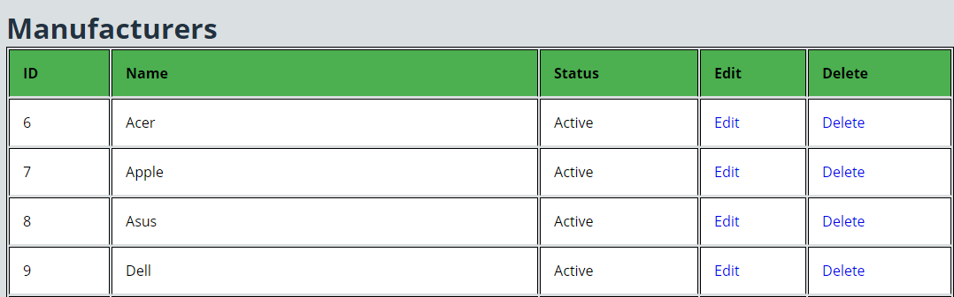

**Name:** The name of the Laptop company can be seen here eg. Apple .

**Status:** Is the company still manufacturing Laptops? Will be stated here.

**Edit:**  Edit the manufacturer details.

**Delete:** Delete the manufacturers details, would be rarely used.

# Suppliers

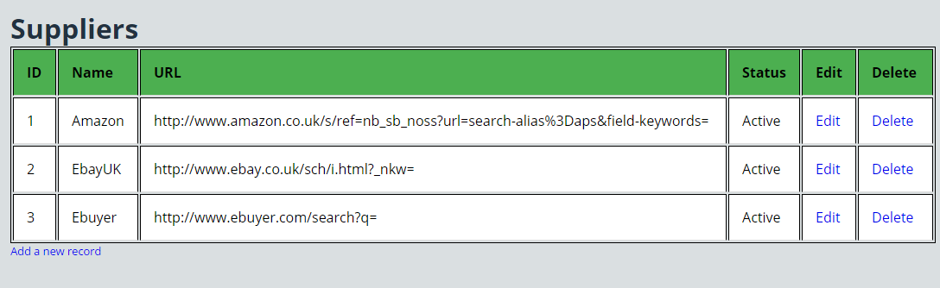

Suppliers is where the generated URLS will be used from, this is where updates could be done to update and add suppliers on request, Also there is a manual feature to add a supplier, along with instructions so the user can put their favourite supplier in the list of possible suppliers.

**Name:** The suppliers name, eg. Amazonhttps://encrypted-tbn0.gstatic.com/images?q=tbn:ANd9GcQGt0tTGDyexXIoIz7PZPSqSgYer7XHO_DCfpsmHU8rqTWIq95BFfwTqOhySA.

**URL:** This is the URL of the search bar of the website, Instructions provided to show how to get this.

**Status:** The status of the Supplier, are they active or otherwise?

**Edit:** Edit the supplier’s details

**Delete:** Remove the supplier from the database.

# Parts

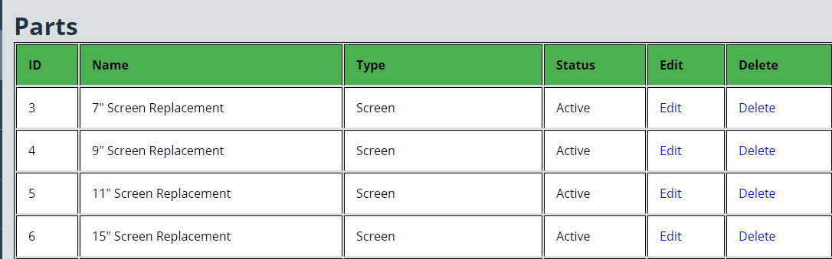

Has a new part been released? Or need a specific part that you will buy on a regular basis? This is where you can add it to the dropdown boxes.

**Name:** The parts name and description. Eg: DDR3 RAM.

**Type:** What type of product is it? Is it a screen,HDD , RAM etc.

**Status:** Is it a new part or a legacy part?.

# FAQ

# Adding a new supplier?

Under the _Notes section, there is a description called “SupplierIns.docx” click that and read the instructions ALONGSIDE the application.

## Registering for a new user.

Logout of the system if you are logged in. Then go to the login page, just go to localhost:/AdminPanel/

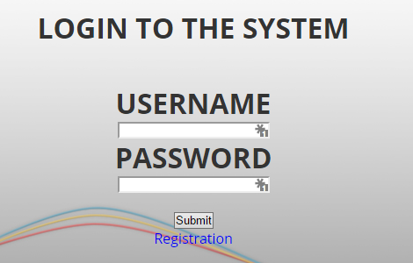

Click the registration button, and fill in the details:

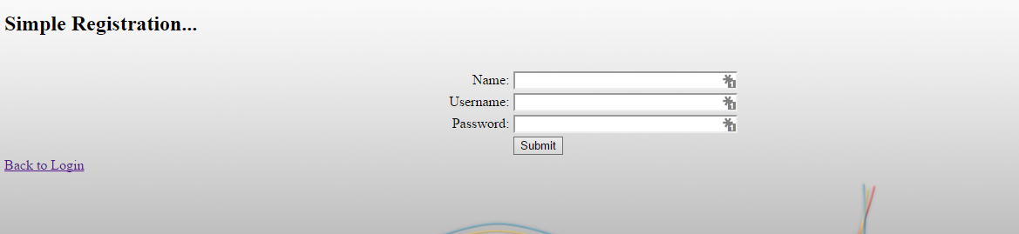

It will auto login, if not use the details to login! Very simple!

# Removing the Registration Link

I usually suggest that you DO this, For the first time, Register using your details then remove the link! Well how do you remove the link?

Open up the login.php with a simple text editor and change the HTML where it shows a href=register.php.



Then reupload the files if you’re using non localhost. Then also change the name of the “register.php” file to “_Register.bak”.

# Removing Default Credentials

Create a new username, password and Name. Submit this, then come back to the register.php page and click the  this will delete the default user.

WARNING: DO NOT do this and NOT create a new user then delete the register file, you will lock yourself out, the only way to then gain access would be a manual creation of a user via PHPMYADMIN.