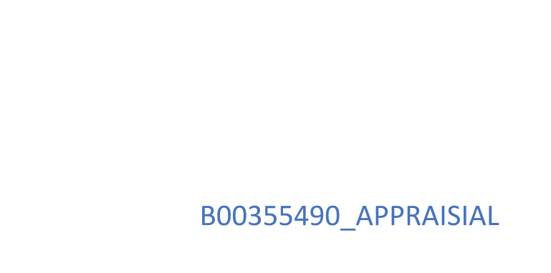



## Table of Contents

Introduction 2

Team Work 2

Resources 3

Conclusion 3

# Introduction

As a team, we have been assigned the task to design and implement a specialised software for the client PPEC (Paisley Precision Engineering Company). The client produces three different types of a component which must be trackable throughout their lifetime, including the ability to apply a finish to components, allocate batches to locations, perform search queries on the client’s database and view details of batches and components. This paper will describe how we worked as a team and what I have learned from the assignment.

# Team Work

Throughout our time working on this project, our team of two people arranged meetings once a week to ensure team members were satisfied with the production of work. During our time working as a team, it was agreed that I would undertake the role of lead programmer, while the other member would verify and help when coding and problem-solving. During the assignment, we regularly connected and communicated remotely, which was extremely helpful when resolving flaws in our code. GitHub proved to be an extremely useful resource during our time working as a team; the code was more accessible to the team, and bugs were tracked and assigned in the “issues” section in our repository. In the first stage of the assignment, our team set self-set deadlines and published them as a road map on GitHub, ensuring that if any issues or problems occurred, we would have more than adequate time to address and resolve them. Analysing our teamwork in the final stages has led me to believe that we worked well as a team. The main negative aspect that I can identify in terms of teamwork is that being the lead programmer was sometimes stressful, as implemented code would not function as expected. When experiencing these issues at home, it was usually resolved personally, or as a team; when issues took longer to resolve than expected, self-set deadlines had to be changed. One other aspect of the final product that I would alter in my future work is to plan how data is stored before starting the development. As we had not correctly prioritised this, some of our nested list data were stored in an overall double list, meaning we had to create code to combat this, which in my opinion was not the most efficient way of resolving the issue.

# Resources

During the software development phase, as a team, we accessed many resources such as Udemy’s introduction to Python course helping us solidify the skills and techniques that we had already learned. YouTube was also a great learning resource for us as we were able to learn how to use specific modules that we introduced into our coursework such as the Pretty Tables library. My understanding of Python developed through the assignment and built on the knowledge I had obtained through the lectures. The project also developed my project management skills while allowing me to incorporate what I have learned into a much larger project. Every day that was spent creating functions to meet the client’s specifications something new was discovered using many different platforms: YouTube, GitHub, Stack Overflow and Udemy. It has become apparent to me that every day in the field of programming new techniques and libraries are being developed, meaning that your personal field of knowledge in programming must be improved on continuously growing with the new technologies and advancements in the world’s number one developing field.

# Conclusion

In conclusion, the assignment has highlighted what I feel went well and did not go as well as expected and from this experience I would ensure that more time was spent on the planning and analysis stage, indirectly creating cleaner code and a faster implementation process. GitHub proved to be an invaluable tool during development, which I would now feel comfortable using in future teamwork assignments. As a team we worked well together, without any conflicts within the team; any suggestions were presented in a constructive and supportive manner. I feel that my software development skills have improved due to the assignment and in future, I will have a more structured and concrete planning stage before proceeding to develop software. Another crucial factor which has become clear to me is that software skills become quickly outdated. Programming is a skill that must be improved upon and practised on a regular basis to ensure you personally can provide a client or company with the most effective, up to date versions of code.